Influence of Brand Advertising on the nature of interpersonal

communication in Ukrainian Society

Andriy Koval

In completion of requirements of the Honors College

Undergraduate Thesis

Middle Tennessee State University, 2004

Acknowledgment

I would like to thank my advisor, Dr. Edward Kimbrell, who supplied me with enthusiasm and inspiration, which carried me along. Being under his guidance was a priceless learning experience for me.

I also would like to thank Dr. Stuart Bernstein, Dr. Sonja Hedgepeth and Dr. Ron Bombardi who supported me throughout this effort by providing advise, help, encouragement, criticism, and, sometimes, coffee.

My special thanks to my friends in Ukraine, who helped with gathering information and administering the survey: Dmitriy Koval, Olexandra Hararuk, Marina Lacis, Ludmila Koval, Evgeniy Tolochin, T.O.Yaroshenko, Natalia Bolhovskaya and many others.

Table of Content

Part I. Advertising and Branding : History, Concepts, Psychology
Section 1. Introduction and major concepts
Section 2. Origins of consumer culture 1865-1917
Section 3. Evolutions in the market place

Section 4. Depersonalization of markets and growth of individualism
Section 5. Advertising/Branding - Psychological concepts and applications

Section 6. Model of brand advertising

Function 1. Informational and pseudo-information
Function 2. Self-identification
Function 3. Self-expression
Part II . The Brandless Country
Section 7. Advertising in the Soviet Union
Section 8. Advertising in Independent Ukraine
A. Who owns advertising industry in Ukraine?
B. Who owns business in Ukraine?
C. Who spends the most on advertising?
D. Who has most popular brands?
Part III. Research and analysis
Section 9. Purpose, Design, Makeup, Hypotheses
Section 10. Results and Analysis
Section 11. Conclusion
Bibliography

Appendix
List of tables

Table A1 Top 10 Leading Advertising Agencies in Ukraine
Table A2 Direct Investments in Ukraine
Table A3 Top Advertisers in Ukraine, Investments, $ million
Table A4 The most popular Ukrainian brands in 2003.
Table 1-1 Demographics of respondents
Table 1-2 What influences your opinion about the product the most?
Table 1-3 What influences your opinions about the product the most?
Table 1-4 What influences your opinion about product the most? 25+
Table 1-5 What influences your opinion about the product the most?
Table 2-1 Can products vary in quality by the place where they are sold?
Table 2-2 Can quality of the same products vary by place where they are sold?
Table 3-1 Guarantee of quality for low and high-band products for all ages
Table 3-2 Guarantee of quality for 25+
Table 3-2 Guarantee of quality for 25+
Table 3-3 Guarantee of quality for 18-24
Table 3-4 Brand name as guarantee for sugar
Table 5-1 How often do you follow advice of seller?
Table 5-2 How often do you follow seller's advice?
Table 6-1 What feature of shop is most important to you?
Table 7-1 Do you know sellers of shop you frequent by name or in face?
Table 8-1 How often do you meet your friends while shopping?
Table 8-2 How often do you meet friends while shopping?

Part I. Advertising and Branding : History, Concepts, Psychology

Chapter 1. Introduction and major concepts
It is not my desire to begin this work with a definition. Like many other abstract notions, brand advertising is best described through what it does, rather than by what it is. It is nothing. A thought. An approach. A concept. A method. While the word is empty, what stands behind it is one of the most powerful social and economic forces of our times. It changes the way people dress, eat, drive, rest, read, work. It influences how we think. It supplies feelings and emotions. It gets into our memory, sometimes with our permission, sometimes without it. It affects relationships among countries and governments. It alters the face of civilization. But what is it?
The most exact definition of a brand I have ever read is this: “Brand is a name given to a product or service.” Primitive from the first glance, it cuts to the heart of it. When we name something, we admit it exists and that we are aware of its existence. When we name something, we differentiate it from the rest of the world. On Earth there are more than six billion protein based bipedal organisms, which despite superfluous variations in skin color and limb size bear an astonishing similarity to one another. Yet, we recognize the uniqueness of each human being and call him or her by name.
Human cultures assign a great significance to names. Rites of passages of many tribes include toils and test through which a youngster must succeed in order to acquire a name. Only after receiving an adult name would he be considered a rightful member of the group. Christian tradition approaches the issue of name with awe. The responsibility of the first man was to give names to animals, and thus authorize their existence. The Jews were not to speak the name of the deity. The early church made the followers memorize the names of demons, knowing which soul would have power over them when it travels through the air, filled with dark angels, to heaven. The warriors of Islam inscribe the name of Allah and Mohammed on their swords and bows. Other religions and cultures ascribe to the name various powers and significance. Buddha and Vishnu have many names, which represent their many powers. Scythians and Slavs would not tell their name to a stranger for a fear he or she might put a curse on them.
Today, society is almost free of superstition; we do not believe that a name defines a person. Yet we defend our good name, do not let our children call their friends bad names, and encourage them to be industrious and make a name for themselves. Or is it just a figure of speech?
Names in general (not just personal names) are vital to our experiencing the world and making sense of it. They serve mainly two purposes: to differentiate from what is outside, and to summarize what is within. No matter how the object and the name are related, whether the name’s etymology contains references to the qualities of the object, or the object itself creates associations with and meanings of its name, the name differentiates or individuates the object from other objects and describes it.
When a child learns a language, he or she creates association between words and objects. The word “chocolate” stirs memories of certain visual, tactile and, most importantly, taste experiences. But there is nothing inherently chocolaty about the group of letters that spell “chocolate.” Yet the name tells us how it is different from peanut butter and sugar, in color, shape, texture, taste; what color, shape and taste characterize it and what we should expect from it. The name differentiates and describes.
Names make objects recognizable and frequently unique. Brand advertising is a process by which products are named There are various tools and methods available to execute this “name giving.” The purpose of this thesis is to look at what happens to individuals and societies as the result of brand advertising, whether with the intent of advertisers, or as a by-product of their effort. From this investigation I should derive a collective definition of brand advertising.
The following chapter presents the historical context that allowed for the emergence and proliferation of brand advertising in the consumer environment of the United States.

Chapter 2. Brief history of advertising. Origins of consumer culture 1865-1917
Although the history of advertising goes back thousands of years, brand advertising in its present form is a fairly recent development. Many critics agree that positioning and brand advertising emerged and became popular in the 1880’s and 1890’s.
After the end of Civil War, certain developments in the economy, technology and demographics facilitated and, to a certain degree, caused the emergence of a new market reality in the United States.
Following the postwar depression, the 1870’s gave rise to the wave of new technologies, also known as the second industrial revolution. New technologies enabled the completion of national transportation and communication frameworks, namely the railroad, steamship, telegraph, and cable. The advent of electrical power revolutionized the metallurgical and chemical industries.
Numerous inventions and innovation changed the manufacturing industry and the process of production of goods. Growing increasingly industrial, in comparison to the antebellum agrarian economy, American manufacturers were enabled to create economies of scale, in which variable costs of goods could be lowered by the increasing the volume of production. Specialization of labor, expansion of plant size, increasing output per unit of labor and other technological and administrative advances allowed for a greater production rate with a decreased final cost of goods.
An intensified and reorganized production process, however, came at a cost. By aggrandizing the plant size, the manufacturer increased the fixed costs, which had to be compensated by the augmentation of the number of units produced, thus distributing the weight of production costs over more units. To be able to compete on the basis of price, a manufactures had to press the production rates to the highest possible level in order to create a smaller margin, offer a lower price for a product, and yet cover the production expenses and make a profit.
In such industrial system, however, the manufacturer was dependent on heavy consumption. If consumption was not sustained at a certain level, the profitably and even self-repayment of an enterprise might be endangered; for a low margin of profit without mass production would not justify the production effort.
Though the new technologies and reorganization of labor allowed for a higher production potential, the manufacturers were now faced with a problem of finding a market, which extent would be able to accommodate the capacities of their economies of scale. The expansion of the customer base became possible due to other major developments.
The network of transportation witnessed an exponential growth during the second half of the 19th century. From 1860 to 1890 alone the railroad mileage increased almost 430%, rising from 30,626 to 129,774 miles (Depew, V.1, p.111). This constitutes 60% of the total American railroad mileage of today.
Along with development of the transportation system, the population of the United States experienced rapid growth. By 1920 almost 107 million people lived in the United States’ territories, which comprised 266% of the population in 1870. Immigration alone was bringing average of 400,000 people each year. The nation also was becoming older, due to the increased life expectancy.
Not only did the population increase in numbers, it also enjoyed certain quality changes. Literacy, for instance, was on the rise, increasing from 84% in 1870 to 94% in 1920 (Norriss, 9). Per capita income increased almost four times, leaving the increasing number of customers with a larger disposable income. The last quarter of the 19th century was also characterized by a strong tendency of rural residents to move into urban areas. By the 1920, 51% of the United States’ population resided in cities.
Manufacturers and merchants had all the prerequisites for business development. They had the population to augment the customer base; they had the technology of mass production to saturate the potentional market, and the transportation system that could solve a majority of the logistics problems. The growing population was more educated than ever, thus being able to respond to advertising messages, which at that time predominantly consisted of solid copy. Not only were people more likely to learn about the products from advertisements, they also had the financial ability to buy, due to increased income.
Then, they were faced with a new problem. Not only had they to manufacture and distribute the products, they also had to secure the volume of consumption required from the customer. The customer had, therefore, to be aware of and informed about the product because most goods were not manufactured at the site, where a majority of consumers lived. Customers also had to be persuaded or assisted in their preference of the goods. Due to this and other factors, there came a huge communication problem, without solving, the manufacturer could not hope to maintain and increase the level of consumption.
The growth of media and emergence of national newspapers provided increasingly large amounts of advertising space. Svennik Hǿyer, a Norwegian media theorist, writes about American media of that time: “US total readership increased almost tenfold from 3.5 million by 1880 to 33 million copies by 1920. This limited period of exponential growth – mainly between 1880 and 1920 – overlaps nicely with the so-called second industrial revolution.”
But the availability of the media alone would not suffice. There must have been a tool developed, a communication tool that would allow proficiently informing, educating and persuading the consumers about the products that were manufactured thousands miles away, of which they have never even heard, which consumers did not know they needed at all.
These economic and demographic conditions fostered the emergence of the new instrument of marketing communication – brand advertising. It would be safe to say, after inspecting the historical data presented here, that brand advertising came about as a response to the needs of advertisers and the socioeconomic situation of that time. On this hypothesis my major points rest.
The important thing to understand is that brand advertising did not emerge because some powerful body, private or governmental, decided to make it the most fashionable way to advertise. It did not emerge as a cabal of manufacturers or by the evil (or good) will of merchants. It emerged and survived because there was a need for it, because it fitted the environment better that other tools and because it had the ability to survive.

Chapter 3. Evolutions in the market place.
[It is an] erroneous assumption that the important thing in evolution is the good of the species rather than the good of the individual. (Richard Dawkins, The Selfish Gene)

Both products and markets are essentially selfish.
The analogy between the theory of evolution and the development of markets is prone to incorrect interpretation. The major difficulty lies in comparing physically concrete objects (species) to a very broad and vague abstract concept (form of selling or advertising). But I am not trying to argue that there are corresponding elements in these two systems that mimic each other; and that by defining the role of the element in one system we can predict the “behavior” of the corresponding element in the other system. That would be logically fallacious, for by analogies we cannot prove anything. My intent is to point out certain similarities in the process of development that come into our attention when we compare these two models, the model of evolution and the model of market development.
One of the major postulates of evolution theory states that a trait not fit for the current environment does not perpetuate. This axiom would later find a resonance in the theory of social exchange, averring that a behavior not reward is not repeated. I assume that it is safe to apply this principle in the field of market development. Ideally, any phenomenon in the market place, whether an Internet shop, direct marketing, a department store, a mall, etc., cannot exist if it is not fit for the current marketing environment, i.e. they are not rewarded by the customers in form of sales.
To illustrate the balance of power between customers and businesses, let us consider two hypothetical communities. The first community is highly urbanized. It is a city with cut-line limits, with no suburban areas. The residents live in apartments, do not own cars and use public transportation or walk to get around the city. This is much more practical for short distances than to own a car, and to have to pay for the highly limited garage space, if one lucky enough to find one. Let us assume that a large supermarket like Wal-Mart opens in the city. Would it be able to survive in such environment?
Let us consider the following facts. One of the major conveniences of supermarkets is that the customer can purchase practically any product under the same roof and do it for lower price. It is not a secret that most of the purchases in shopping centers are impulsive. “Supermarkets are places of high impulse buying… fully 60 to 70 percent of purchases there are unplanned, grocery industry studies have shown us” (Underhill, 101). In sum, when customers come into the supermarket they are expected to make a large number of purchases. This is the way to secure low prices, which is a major advantage of a supermarket over small, privately owned stores. In other words, if customers buy only what they need, and do not buy a large quantity of goods, the store goes out of business, because it will lose its competitive advantage.
This community poses certain limitations on the purchasing behavior of its residents. Remember, most of them do not have cars. Would you buy from Wal-Mart as much as you do if you had to carry the groceries home yourself? How about just take it to the car in one load without a cart? Even though the residents of this community might not live far from the store, they have to be comfortable with carrying everything they buy. And there is only so much one person can carry. Their decision is limited by the amount of goods they can carry.
With this limitation, let us try to imagine a possible scenario for the newly opened supermarket. The customers are thrilled with the low prices the supermarket has to offer, but if the costs associated with buying from that store do not compensate for the benefits from the savings, and the customers do not buy enough for the store to justify its low margin policy, the store would be forced to raise prices. If prices are raised, the only remaining advantage it has over small shops is the convenience of buying everything under the same roof. But remember, the amounts of goods customers in this community can buy is restricted a physical limit. In other words, they cannot buy the groceries for the week. If prices are not the issue, and small shops offer the same level quality of products, it would be more convenient for customers to visit the store closest to them and make their preference based on physical proximity. A mile behind a steering wheel is nothing, but a mile hike is much more daunting.
In this scenario, “to sell goods” is a species, if we use Darwinian terminology and the supermarket and small privately owned stores are variation of this species, or “market organism” if taken individually. Both of these varieties sell goods, but do it differently. Carrying capacity is an environmental factor to which the variations have to be best fit in order to survive. If, for the sake of the argument, we limit the situation to one singe environmental factor as the determinant of the survival of the variations, we can safely predict that the supermarket would be less fit and therefore would not survive. Of course, in real life there are more factors that would determine the survival of a given species, but the point here is not proposing new selling polices for Wal-Mart.
Now let us consider another community. The amount of population is the same as in the previous example. But it is very rural and therefore spread over large territory. It has large suburban sectors and a small downtown area which serves mostly as a cultural rather than a buying center. A car is a must. You have to drive if you want to get anywhere. The variable of the distance between the house and the store is practically unimportant, compared to the urban community. Whether it is a three or a five mile trip makes little if any difference. This community is not hard to imagine for a Tennessee resident.
This environment does not impose the limitation of carrying capacity on the customers as in the urban community, but it has some limitations of its own. The effort of getting into the car (does not matter if you go on a half a mile or ten mile trip, the effort of getting into your car is the same) and traffic create conditions under which a supermarket variety of selling goods is the best fit.
In Darwin’s theory a species by trial and error over the span of many generations produces a variety that due to chance would be best fit to survive and then accumulate the survival qualities and create a new species. It is erroneous to say that bio-organisms actually “adapt” to the environment, for no structural, genotypic changes occurs in the organism during its lifetime. It is the offspring that can have higher or lower chances of survival due to slight deviation from the ancestor. The natural selection then would determine whether a bearer of the given deviation survives. Metaphorically, the species has a “choice”: adapt to the environment or to die out. The word choice must be used very carefully, for it allows for many misinterpretations. Darwin himself addresses this semantic pitfall: “[Some] have objected that the term selection implies conscious choice in the animals which become modified; and it has even been urged that, as plants have no volition, natural selection is not applicable to them! In the literal sense of the word, no doubt, natural selection is a false term; but who ever objected to chemists speaking of the elective affinities of the various elements?--and yet an acid cannot strictly be said to elect the base with which it in preference combines” (Darwin, 194).
So the dichotomy of the biological species is clear: extinction or survival through adaptation, which occurs by natural selection over the course of thousands of generations. But does this apply to the “market species?” Obviously, a “market species” must fit the environment in order to stay around, but how does it achieve its fitness? Definitely not by trail and error.
Pointing out the importance of the market environment for the success of the business would be unnecessary for a marketing practitioner, not to say redundant, and slightly offensive. It would be a financial suicide to start a business without the assurance that the market is capable of accepting and supporting such business, in other words, that this market has necessary environmental factors that could ensure the survival of the business. It does not mean that it does not happen, but abundance of wrong and unplanned market decisions followed by deplorable results only proves this common rule. Emergence of a new business or a new approach to selling is usually a result of research and planning of specialists and consultants, who by careful examination and study of the environment create a list of qualities the business must possess in order to survive. It could be said then, that in the most cases a “market species,” such as Wal-Mart, enters a welcoming environment that was selected in advance.
It is important to reverse the vector of thought now. An organism, whether biological or economic, can be defined as a set or a combination of survival qualities. In other words, an organism is what an organism can do. It is extremely difficult to give an example, for even a primitive organism as amoeba is capable of thousand of things, from the ability to decompose food chunks into dissolvable elements for nutrition, to the ability of absorbing oxygen contained in water and secreting carbon dioxide for breathing, to the ability of dividing the nucleus for reproduction. To list everything a biological organism is capable of is, perhaps, impossible, but really unnecessary in this context.
It is much easier to list such qualities for a “market organism.” Wal-Mart, for example, can be defined through possessing the capabilities for low prices, large spectrum of products, simple return policy, benefits for bulk buyers, availability of products, etc, etc. Whatever the combination is, the environment must have a room for a given combination of survival qualities. If the planet is covered in water there would be no room or nor incentive for development of amphibian animals. The trait of being able to breath in and outside of water would not receive a reward from the environment (increased chances of survival) and thus would not be repeated. When the vast areas of dry land emerge there opens a possibility for organisms with such amphibian qualities to survive and proliferate. But without this room in the environment - an open niche for a certain set of survival qualities, the organism has no space to evolve to.
If we assume that life forms have general tendency to spread into every environment in which existence is possible, it would not be naïve to conclude that emergence of new environments or changes in the current environment would facilitate or drive the emergence of new forms of life that are fit to exist in it.
It could be argued alike that the emergence of a “market organism” or a “market species” is defined by the degree to which the environment can encompass it and “reward” the qualities of which this organism consists. The supermarket in our first community has certain survival qualities (low prices, everything under one roof, return policy etc.) that give it advantages in some environments. However, there is no room for this set of qualities in the market environment in our urban community, and therefore the supermarket is doomed for extinction. In the conditions of our first community the supermarket could not emerge.
At this point we have to admit that if a certain organism currently exists, then at some point in time, in a certain environment there must have been conditions which allowed and driven the emergence of this organism.
If a biological organism is removed from its native habitat into a different environment its algorithm of action is limited to the adaptation to the environment or extinction. But a market organism has a third option: to change the environment. A biological organism, of course, also has a power to change the environment. However, a biological organism can change the environment, but does not necessarily make it more favorable to the survival of its species. For example, when sheep were first introduced to Australia, they almost caused an ecological disaster. Proliferating and spreading across the continent, sheep filled the pasture with manure. However, there were no dung-beetles to process and dispose it, which naturally occurs in European ecosystems. From this point of view, of course, the sheep species changed the environment, but this change did not improve their chances of survival. If the situation had been neglected, and by human intervention the dung-beetle had not been introduced to the Australian ecosystem, it would have resulted in the extinction of the sheep, for the pasture would have soon become unfit for grazing.
Unlike biological organisms, their market counterparts are capable of changing the environment in a way that can benefit their financial survival. Consider the “supermarket species.” It starts offering the products by considerably lower prices that drastically increase the likelihood that consumers would shop there. In other words, it changes the ratio of costs and benefits, in which going through the pain of the environmental factor, such as carrying capacity, is worth the savings. If the savings are considerable, this may result on the consumer’s decision to purchase a car. This, in its turn, may influence the choice of residence, where parking is more available, or free at all, as in suburbs.
If the CEO of this supermarket chain calculates that investment into lowering the prices would be returned and multiplied in the long run, after the environment is changed, stabilized and made supportive of supermarket form of selling, with the availability of financial resources to implement proposed strategy, this indeed may be a possible course of actions. The major difference between a market organism and a biological one lies in the ability of the former for a conscious and purposeful control over its adaptation process to the environment within the course of its life. Moreover, such marketing organism, with a sufficient financial leverage, can alter the environment to fit itself and its own survival.
If we look at brand advertising as a marketing organism, which emerged into and in a specific environment, what will happen if it taken to a new habitat? Would it die out? Would it be able to adapt to the new conditions of existence? What if the cultural and historical traditions exclude or limit its presence and practice? Could it have enough financial and economic force to change the environment? What would happen if indigenous products of a capitalist system are brought to an economically disheveled nation of Ukraine, a former Soviet Republic?

Chapter 4. Depersonalization of markets and growth of individualism
With the growth of human population in early ages and with sophistication of tools of labor, which made work more productive, the natural economy started growing obsolete. This gave room for the emergence of a marketplace. The exchange of goods - the purpose of markets- revolutionized the society by allowing further division and specialization of labor and the creation of surplus. This, in its turn, enabled development of workmanship and science, fostered institutionalized government and religion. The marketplace had an immense influence on structure of the society, the nature of relations among its members, and the culture.
Many societies of old saw the market as a social place, where people shared news, where decrees and edicts were announced, where various social occasions took place. Public criers to whom we attribute the first advertisements, preferred markets to all other places as the most crowded ones, and, therefore, the most efficient for their purposes (Presbrey, 11). A big part of social life took place at markets. It would, perhaps, be an exaggeration to name the market the center of social life of the early society, but it is difficult to underestimate its many-sided influences on culture.
The very concept of market in early society implied intense social interaction. People haggled, gossiped, chatted, learned, rested, and entertained there. The discussion of what particular needs gave birth to the institution of the market place (communication or the exchange of goods), requires a much deeper socio-historical analysis. However, we still can quite safely, without an attempt to establish a cause-and-effect relationship, identify the correlation between these two functions of markets. For our purposes, we would disregard whether goods exchanged fostered communication or vice versa. We shall, however, underline the association between these two. Where markets were, active communication/interaction had been taking place.
We can imagine that the pre-industrial consumer had to make similar buying decisions as his present day counterpart. It is obvious that the variety of products in same category lines at pre-industrial markets was much more modest; even so the customer had to prefer one product over another. To do that, a differentiation of products must have been made. Indeed, if all products in the same category line are the same and appear the same, there should be no reason to prefer one over another, except for the factors not defined by physical characteristics.
At this point, to avoid redundant specifications in future means a certain group of products that are identical in essence and purpose. Seven-inch nails, sugar-free lemonade, black ink are some examples. Seven-inch nails and five-inch nails, however, belong to different category lines. Though the quality of these products may vary greatly from one manufacturer to another, they are all equal in an ideal sense.
The pre-industrial customer had to differentiate products somehow. It was a key to successful purchase. The only way to do that was by involvement with the producer or the seller, who quite often were the same people. Jafar’s apples were famous in all Ankara, while Mustafa struggled to sell enough to pay the taxes, while both sold the same things: apples. These seller/producer identities were the prototypes of modern brands, in terms of which the differentiation of products occurred. There were Jafar’s apples and there were Mustafa’s apples. Today there is Coke and there is Pepsi. The important difference is that Jafar and Mustafa were real people, while Coke and Pepsi are names of impersonal corporations.
Therefore, the very nature of operations at the pre-industrial markets implied a fair degree of interpersonal communication. It was mutual communication between the buyer and the seller that gave birth to purchases. In the language of this system, brand loyalty can be defined as a good relationship with the seller, and brand identity as the personality of the seller. In this system the “brands” of products and “places of purchase” merged into one thing: the person of the seller.
The new age of mass production and mass communication weakened the social importance of markets. The market place became an economical notion. A hundred years ago the word “market” meant a physical place where people bought and sold things. Today, it is an abstracted concept of the production-consumption theory. In the early stages of industrial age, when the first national brands began to emerge, the producer became the dominant element in the identity of the product. The product would commonly be named after the producer. The immediate seller would still be associated directly with the producer; but with time this association would weaken.
Today, in the heyday of branding, we can see the almost complete separation of the producer and the immediate seller. People began to differentiate the product by brand identities. This appears logical, for the brand becomes the only true constant in the purchasing process. For instance, if we would like to buy some potato chips, the immediate place of purchase would mean little or nothing in regard to the quality, promised or actual, of the product. Because Lays would taste the same if bought from Wal-Mart, or Kroger, or Tigermart, or a vending machine. The brand, therefore, serves as a guarantee of predictably of experience (in this case – taste) and of consistent quality. The importance of the place of purchase for the purpose of differentiating the product is thus being greatly diminished if not completely gone.
The giants of retailing created the system in which the person of the seller did not influence in any way the perception and differentiation of products. Moreover, the very occupation of the seller was transformed into a register job. We do not buy our milk from Mary who is a Wal-Mart cashier; we buy it from Wal-Mart, for which Mary happened to work at that time. Therefore, why should we want to know anything about her? Neither does she need or want to know anything about us, for that would have no effects on the sales. And, even if she did, there is nothing in it for her.
Thus, we can see, that interaction between real people in the market place is discouraged, for there is no apparent need or demand for it; neither are there auspicious conditions. The market place itself grew very impersonal. The exchange of goods (or more specifically, money for goods) became a utilitarian and unsociable event. Indeed, today we do not think of shopping as a way of socializing or exchanging some kind of information, whether political or community news, or as of a learning experience.
Perhaps, the removal of the communication element from the market place is indeed being compensated by new forms of dissemination of information, such as modern media. The media, however, although rendering the exchange of information easier and more effective, reduces importance and intensity of personal communication that used to dominate the markets. Allowing ideas of Marshal McLuhan into these polemics, we have to make a distinction between these two kinds of information. That is, even acquiring the same information, the receiver of the message would be effected differently depending on the medium that carried that message.
It is my assumption that the brand approach to selling goods, in which the immediate place of purchase and the person of the seller plays little of no importance, helps create individualistic trends in the society and changes interpersonal communication to be much less important and prevalent.
We can only see the general outlines of such trends. Even without bringing historical perspective into the picture, we can observe a growing depersonalization of the consumption process. Shopping nowadays becomes a hobby, sport, or a kind of entertainment, thus transcending from survival to leisure activity. However, the nature of this activity is no longer “person-to-person” but rather “person-to-product/service.”

Chapter 5. Advertising/Branding - Psychological concepts and applications
Everyone has an opinion about advertising. Rarely do you find a person who is not eager to share his or her personal views on how advertising works, what is the best way to advertise this or that product, which commercials are ineffective, which ones are plain stupid, what advertisers are doing wrong, and what’s wrong with the world in general.
The only subject that can surpass advertising in the intensity of laymen’s opinion is psychology of advertising. It is commonly believed that advertising uses psychology - mostly with malicious intent - to con consumers to buy what they do not need, to brainwash them, to deceive and control the innocent minds. Such a view, though taken to an extreme, is not totally unfounded.
From the earliest days of modern advertising ( late 19th - early 20th century), advertising professionals were on a quest to discover a formula of persuasion that would subdue the consumer into perceptions about certain products and services. Psychological theory at the time facilitated belief in a persuasion panacea by going into two different extremes of explaining human behavior and motivation.
The beginning of psychology is closely associated with structuralism and psychoanalytical theory, which emphasized the structural elements of awareness and the relationships among them. The psychodynamic school (another word for psychoanalysis) dealt in particular with unarticulated fears and desires, which occurred on the subconscious level, but projected their presence into human behavior. None of the approaches, however, was based on solid data produced by experiments, thus leaving much doubt regarding the validity of its assumptions.
Another approach that developed in the same time was behaviorism. It did not recognize the concept of the subconscious, because of the absence of empirical data and “biased” ways of gathering information. Behaviorism condensed human ( and, for that matter, animal) behavior to the system of stimulus-response sequences, which we accumulate during our interaction with the world. These two psychological approaches were poles apart. But they were similar in one important respect: both promised a way to manipulate and control human behavior. It is no wonder that advertising minds of the early 1900’s saw an opportunity in psychological science to improve the quality of persuasion in advertising.
The advertising world accepted the new science with enthusiasm. The first book published that dealt specifically with the psychology of advertising was published in 1908. It was written by Dr. Walter Dill Scott, who tested basic psychological theories and attempted to adopt them to the advertising practices. Scott also did one of the first attempts to popularize psychological science and made it available to the public. One of the main advantages of his book was the use of simple language that could be understood by men and women in the advertising industry, who, most probably, did not have any background in psychology, or any of the sciences.
Another major milestone in the marriage of psychology and advertising came about because of a sex scandal. In early 1920’s John Watson, a professor at John Hopkins University, became involved in a love affair with his assistant. The affair leaked the relationship to the public, and, left with no choice, Watson resigned from his chair. The personal misfortunes of the most famous American psychologist and the father of behaviorism came very serendipitous to the advertising industry, which employed Watson and kept his genius focused on non-academic matters. Other famous names in psychology that found avocational carriers in advertising included William James, who applied paired association methods to glamorize cigarettes and other products.
The advertising industry after the World War II became enchanted with the new psychological method that claimed to be able to find out, define, appeal to and, consequently, satisfy the needs and wants of consumers, or to produce those needs and desires. Dr. Ernest Dichter, the father of the newly born “depth approach,” also known as motivational analysis or motivational research created a model in which he stratifies consumers’ attitudes into three levels of awareness. (Packard, 25)
The first level is comprised of conscious, rational attitudes toward the product, of which the consumer is aware and can provide an etymology of such attitude.
The second level goes deeper into the psyche of the consumer and investigates the attitudes, of which consumer is vaguely aware. He or she understand only obscurely what is happing with her feelings, sensation and attitudes, but would not be willing to tell it. This would include prejudice, fears, stereotypes, and learned responses.
The third, final level, sees into the unspoken and the unknown to consumers. Motivational research recognizes that consumers might not even be aware of their true feelings and attitudes toward the product, or that consumers are not willing to admit it even to themselves. Motivational research attempts to explore these concealed attitudes and eventually bring them to the surface, where the advertising practitioners can appeal to them.
In the 1950 and 1960s, Wilson Bryon Key made a fortune by writing books on subliminal advertising. Judging from the titles, they sold very well, especially remembering the passion of many Americans for conspiracy theories. Here some of the titles: Media Sexploitation, Subliminal Adventures in Erotic Art, The Age of Manipulation, Subliminal Seduction: Ad Media's Manipulation of a Not So Innocent America, The Clam-Plate Orgy and Other Subliminals the Media Use to Manipulate Your Behavior.
Key claimed the entire advertising industry was conspiring to subdue the consciousness of innocent consumers and corrupt their morals by embedding sexually explicit pictures in print advertisements or inserting a 25th frame in the video stream, thus avoiding people’s conscious perception, but influencing them subconsciously. James Vicary, an advertising expert, decided to test Key’s bold claims about the effectiveness of subliminal advertising and set up an experiment. Vicary rented a small movie theater and exposed the subjects to subliminal messages. He would show a video fragment in which with a help of tachitoscope (projector that can show images at a very high rate) he would flash messages such as “ EAT POPCORN" and "DRINK COKE," which could not be registered at the conscious level. Vicary claimed Coke sales jumped 18.1% and popcorn sales leaped 57.7%. None of the experiments conducted later couldn’t recreate the results, including Vacary himself. Later, Vicary admitted he manipulated the results.
Though Key’s claims could not withstand scientific testing or industry survey (only 4% of surveyed advertising practitioners admitted that practiced subliminal advertising at least once) subliminal advertising became an integral part of public opinion on advertising, adding to the mystique of the arcane industry and fueling speculations, rumors and myths (Haberstroh, 28). Ernest Dichter, the founder and president of the Institute for Motivational Research, responded in 1941 about advertising agencies: “they [advertising agencies] are… the most advanced laboratories in psychology” (Packard, 27).
The idea of subduing people by degrading their morals isn’t new. Goebbels, Hitler’s propaganda chief of staff, practiced dropping pornographic images from airplanes over the territories into which the Nazi army planned to move. This, according to the evil mind of the Third Reich, would have lowered the resistance of people and brought down their spirits. Sex not only sells, but also can serve ideological warfare.
The alleged marriage of advertising and psychology has created many myths and unfounded beliefs among both laymen and professionals. It was ascribed astonishing and often sinister influence of the minds of consumers. Advertising was accused of reinforcing and creating various social vices. Avarice. Consumerism. Weak moral norms. Sexual promiscuity. Alcoholism. Jean Kilbourne created a marvelous case against the tobacco companies and their effort to spread this lethal habit.
Most of these accusations are true. But behind them, less noticeable influences and changes get lost. Changes that happen over years and decades, and therefore draw less attention. Changes that occur in the genotype of society, letting the phenotypical changes get the publicity. One of such changes is the way people communicated with each other.

Chapter 6. Model of brand advertising.
Advertising psychologically affects people. This influence, however, is not limited to persuasion only, as many believe. Because advertising involves our thoughts, feelings and behaviors, it does not merely steer us toward the beliefs and attitudes desired by the advertising professional, it becomes part of our experience of the world and society. It cultivates ways of thinking, patterns of behavior, and learned responses that are not associated only with consumer functions, but make their presence known or felt in many areas of our lives, both private and social.
This chapter addresses the proneness of the structure of brand advertising to affect our psychological world. This affect, however, is not something advertisers had in mind. This affect is not the purpose of the promotional effort of advertisers. But as in any action, brand advertising has its own by-products.
“Proneness of the structure” is a somewhat ambiguous concept and should be explained more carefully, in spite of the risk to be repetitive. The best way to understand it is to come back to Marshal McLuhan’s “The medium is message” concept. The media technology, he argued, had more effects on societies and cultures than the content the media carried. In the same way the brand advertising is a “technology” of market communication. It can communicate capitalistic values or communist approaches, impose religious beliefs or promote hedonism, make a case for SuperGlue or sell Swiss watches; the influence in question comes not from the content of the market communication, but from the structure, the “technology,” the medium itself.
What unites the functions of brand advertising listed in this chapter is a common by-product. All three of them contribute to a less personal society, discouraging interpersonal communication and creating frameworks in which such communication would bear less individual or communal importance. The model presented here is tested later.

Function 1. Informational and pseudo-informational value of brand advertising
In psychological terms, a consumer strives to be a “wise buyer.” Psychological explanations for such tendency involve such phenomena as a drive to evaluate his or her abilities and opinions (Festinger, 1954), a desire to obtain and sustain positive self-concepts (Swann,1987) , feeling of mastery or expertise and of a productive work (Csikszentmihalyi, 1990) desire to be unique. It is safe to assume that usually a consumer derives pleasure from the realization he has got a better deal than an “average consumer,” that his purchasing decision was smart, that he was right about the choice of product.
In the framework of imperfect competition ( e.g. a system in which consumers do not possess an exhaustive knowledge of relevant information such as what products are available, where, by what price, of what quality, what seller can be trusted and so on) to obtain such information requires an effort a present day consumer is usually not willing to invest, unless the purchase ignites a high personal involvement or a high price. Also, without such knowledge the consumer cannot arrive at the cognition that he “has done well.”
At this point two options are available. The consumer can come to such a point by avoiding his “logical self” and employing emotional reasoning. Effort-justification phenomenon (Chialdini) is a great illustration. “The purchase is good because I have made it.”
Another option, however, is to lure the logical self into a framework where just enough information is available in order to make a completely valid, logical decision. Advertisements and other promotional tools serve as a easy, effortless way to gather information that the consumer will require to make a “sound and logical judgment.”
The assumption that the average consumer is distracted or too busy or lazy to be informed doesn’t seem to be naïve. Neither does the assumption that the consumer needs pertinent product information to make a wise purchase and consequently feel good.
Because many scholars and advertising practitioner argue that new-age advertising is less informative in its nature, and more persuasive, the term “information” must be clarified. In the narrow meaning it refers to the facts about the product of the advertiser. Physical characteristics, price, quality and where and when it can be purchased, are some examples. Dissemination of information about the product is the oldest purpose of advertising and remains one of the most important functions of it today. However, in most advertisements for established brands, and brand advertising in general, facts about the product are completely omitted. By positioning and branding, advertising messages emphasize benefits of the product (mostly psychological) or/and associate them with pleasant ideas, symbols or feelings. Many of them resort to explicitly fallacious logic such as “If you smoke Marlboro you would be manly” and so forth.
Advertisements of such a sort are surely intentionally persuasive, and change of opinion is their initial and ultimate goal. But do advertisers really expect that people are going to believe that Pepsi makes them sexy or that a Silverado truck will make them tough? If people do not accept the validity of the advertising overall message, how can they move them in the direction of buying the product? Apart from their persuasive schemes and intentions, such advertisements carry a load of other information about the product that might not be accepted by consumers but at least gets into their minds.
Advertising messages, therefore, even when failing to achieve their immediate goal of persuasion, create a pool of accessible information to which the customer can resort when faced with a problem to rationalize a given purchase or create a basis for a wise purchase. The fact that information suggested by the advertisers in promotional pieces is not always to be trusted (or even taken seriously) should not obscure this point.
Of course, most customers are not mindless and naïve, and would not accept commercial messages blindly. Today consumers have embraced overt cynicism. (The slogan “the best toothpaste on the market” is more likely to produce an antagonistic reaction than enthusiastic acceptance.) However, if an advertising message is not believed, we can surely say that it was at least heard.
The consumer doesn’t have to believe that Avis really tries harder, or that Pepsi is really the cola, or any other claim of the advertisers. But when the moment comes to make a purchasing decision, the consumer would have these claims in the cognitive pool of available information, the so-called facts about the product.
From this point of view, it is not the level of trust that the consumer has for the commercial message, and neither is it the success of the persuasive message that ultimately matters. What does matter is whether any information about the product exists in the information pool of the customer, and whether this information can be used to avoid laborious decision process and avoid uncertainty.
This model of persuasion looks at the commercial messages as pieces of information that the consumer uses to justify purchasing behavior or to improve the quality (actual or virtual) of the purchasing decision, and satisfaction from it. It is easier for the consumer to use this information that is available to him through incidental learning than to invest into gathering necessary information on his own.
In other words, advertisements present a short cut to “reasoned and logical” purchases that bring satisfaction to the consumer. Satisfaction obtained not from the direct use of the product, but from the realization of a smart, wise, successful, maybe even lucky purchase. Most importantly, the information used to achieve these ends so does not have to be truthful or reasonable stated. It must simply exist in the consumer’s memory.

Function 2. Self-identification
An individual has needs cognitions about his or her self and is concerned with cognitions of others. Self-cognitions are those pieces of information that help us define and understand who we are, and who we are in relation to others. In other words a person wants to know “who am I?” and “what do others think of me?”
The nature of identity implies differentiation from the rest of the world and connections held to it. Differentiation gives birth to an individual, who can possess an identity. Connections to the world define this identity. Just as words are defined by words, people are defined by people. What is a nail? Well, it’s a slender usually pointed and headed fastener designed to be pounded in. Who is Joe? His is the son of Martha, captain of the football teem, a lover of Mary, an inspiration to Bob, and a complete jerk to Joseph. Identities are also defined by situations, which are complex relationship of a large number of people (Goffman, 37). Joe is a student, for example. In any case, the thing-in-itself concept doesn’t work in the context of social psychology.
We are motivated to have/acquire cognitions about ourselves and also want these cognitions to be positive. In order to accept any cognition about ourselves, we need a ground, a reason, or an evidence to justify such cognition and to avoid inner conflict. We interact with the society and by their feedback provide these reasons. Reactions of others to us compile a vocabulary by which we define ourselves. In addition to that, in order to bear forth any qualitative judgment, an evaluation must take place, for which a comparative scale is necessary. Therefore, an individual who wishes to acquire cognitions about himself is forced to interact with other members of the society. The system of brand images, however, gives us an alternative way to acquire these cognitions.
For example, one can create a cognition of himself as of “a guy whose cheeks girls like to touch” by actually having the girls touch his cheek and learning if they like the feel of it. He can resort, however, to a different means. He can do it by purchasing a Gillette razor, identifying himself as “a guy who shaves with Gillette,” which would yield the same cognitive information: “I am a guy whose cheek girls like to touch.”
Though these two cognitions are essentially equal (e.g. they produce identical cognitive information), they differ in the way they were acquired. The first emerged from personal interaction with members of the society, while the other was acquired through letting the brand project its personality onto an individual.
By resorting to acquiring our cognitions through consumption of certain brands, we render our social interaction less important by diminishing the necessity in other members of the society in the process of acquiring these cognitions. In other words, we depend less on the society to know who we are, and thus place less weight on importance of personal communication.
To think of it from the practical point of view, it makes perfect sense to use these “shortcuts to cognitions” and avoid the demanding and sometimes highly stressful interaction with the society.

Function 3. Self-expression
When an individual makes a purchase, he defines himself in terms of brand images. In other words, when a choice has to be made whether to purchase Coke, Pepsi, Sobe, or Sam’s Choice a person finds himself in a position to decide who he wants to be: a Coke drinker, a Pepsi drinker, or someone else. Thus, self-identification in relation to brands occurs. At the same time, another process takes place. When a person identifies himself as a Coke drinker, he simultaneously presents himself to others as one, and makes a statement, which expresses his identity, whether actual or desired. He does that in the language of brands.
Language is a great analogy to branding. Words themselves do not possess meanings, rather they mean what people decided and agreed they would mean. In the same way, the meanings of brand names are cultivated by the advertisers and disseminated through media. A vocabulary of brands is being compiled and preserved by advertising efforts. Some brands succeed so well in “meaning something” that they substituted the original words. But not only do the brand names creep into our language, making us go krogering, start swiffering, and feel pepsi, they incorporate themselves into our system of self-expression and sense of self.
When we wish our identity to become known to others, we can choose various tools of communicating the message. If one wishes to convey to others that he is a “tough, self-confident, youthful minded guy, who doesn’t like to appear cheap” he can explicitly verbalize it, demonstrate a behavior that would make us infer all those qualities, or he can drive his Chevy truck to Harris Teeter with a Marlboro cigarette in teeth and a can of Pepsi in hand.
Certainly it is easier to show up to your date wearing a pair of Adidas shoes and drinking Gatorade, than to arrange for the object of your affection to watch you climbing a mountain or canoeing a dangerous river. It is easier than spending half hour describing your athletic achievements, or to bring your hiking arsenal with you; especially if you are not sure you can do all that. Nevertheless, it is very likely that the girl would infer all these things, if the images with which the Gatorade brand is associated are well-rooted in her mind. But if she does not, what did you lose? If what you wanted to communicate was a lie, it was a lie for which you cannot be held responsible.
Brand language creates an alternative means of communication and self-expression. It would be interesting to explore to what degree this language already substitutes for traditional communication or augments it. By competing with traditional means of self-expression, the brand-image language undermines our motivation, and consequently our ability, to seek in interpersonal communication with the members of the society a way to define our self and to make our self known to others. In other words, we let the brands do talking for us. The names of products are now occupying the niches that were usually possessed by personal attributes: religion, family name, education, community (Twitchel, 163).
If we continue to do so, where are the guaranties we will not forget how to talk at all?
Today, brands not only fulfill the marketing practical purposes, that is, to foster consumption of products and to direct the preference of the customers, but they also play a role in the psychological life of the society. Brand images and brand language serve as an alternative language for an individual to acquire cognitions and to express his or her identity unto others.

Part II. The Brandless country

Chapter 7. Advertising in the Soviet Union
The absence of advertising and advertising agencies in the Soviet Union prior to liberalization in 1988 is a view held common. Indeed, how can a country that regarded free competition as “ideologically wrong” and hurtful to economy practiced advertising, which is a tool of competition among products?
This misconception is popular among international businesses now inside the former Soviet Union. To deny history in promotion and advertising is easier from a practical and organizational point of view. Companies entering the post-Soviet market would not have to adapt to the promotional traditions of the land, assuming that they do not exist, and can simply start building advertising infrastructures from scratch, without much consideration of what ruins lie beneath. Of course, there is a foundation to such assumption.
However, advertising and promotion in the Soviet Union from 1960 to 1980 was far from absent. Professor Natalia Golovkia from Kyiv International Management Institutes analyzes the advertising industry in the Soviet Union and lists some of its main features:
- Marketing decisions were centralized and based on products which met the needs of the centrally planned economy. Advertising was managed largely by six state-owned advertising agencies, and several government committees based in different Ministries to promote their goods and products.
- Advertising efforts were undertaken primarily for industrial products and were directed at organizational buyers.
- Consumer product advertising did not just promote the usage of products but imposed repeat purchase of products which were obtainable in surplus.
- The content of advertising was informative but not aimed at individual satisfaction
- The advertising was limited to single product promotion. In a demand-driven economy few products existed in the same category that could compete against each other.
The Soviet advertising that promoted products and services did not perform one of the most recognizable functions of advertising in the western world – differentiation of products in one category line for competitive advantage. Since there was no competition of product, such function, of course, did not find a niche in the promotional machine of socialistic economy.
The absence of competition left a mark on consumer attitudes as well. In the economy of shortage, why would one advertise the only thing that is available? Aeroflot, the only airline in the USSR, was famous for their ironic slogan “Fly with Aeroflot!”, as if Lufthansa and KLM threatened to take a lump from their 100 percent market share.
This is where socialistic advertising gets misunderstood. Soviet advertising did not mimic its western counterpart. Moreover, it tried to make their distinctions obvious. Western advertising was viewed as “wasteful” because it helped a company to generate sales in an excess supply situation. In other words, it made people buy more than they needed. The purpose of socialistic advertising, on the other hand, was to redirect consumer demand for a greater and social welfare (Ostlund 1973). The practice of brand equity, the increase of the value of a product by advertising, was considered ideologically wrong (Hanson 1974).

Chapter 8. Advertising in Independent Ukraine

A. Who owns advertising industry in Ukraine
When the Soviet Union fell, and the borders of the former empire became open to foreign investors and businesses, a new economic reality was forged: a free competitive market in which everyone had equal opportunity to succeed and flourish. So, at least, it seemed.
The new era obliterated the trade iron curtain. Western products, such as clothes, electronics, candies - recently sold and traded in secret - filled up the shelves of now numerous and street markets. Western companies such as Coca-Cola, Procter&Gamble, McDonalds, Nestle, and many others opened their offices in Ukraine and began operating in the newly formed market. Of course, the problem of advertising became apparent.
It appeared only logical to the western companies to trust the creation and dissemination of advertising messages to the advertising professionals they worked in the past in other countries. International advertising agencies seized the opportunity and provided the advertisers with their services. Along with Phillip Morris, Levi’s, and Pepsi agencies such as BATES, BBDO and McCain Ericsson mushroomed in the new market. These agencies had what it took to get the clients: long histories in the advertising business, western standards of professionalism, and most importantly, they new how to work with western advertisers, because they were the product of the same culture.
Just how predominant the presence of western-type advertising agencies was and is in the Ukrainian advertising industry? The Ukrainian professional association of advertising “Circles on Water” (“Krugi na vode”) recently published a rating of agencies, which selected the biggest, most successful, and most professional houses.

Table A1. Top 10 Leading Advertising Agencies in Ukraine
 | Rank by year | Rank by year
 | 2003 | 2002
D’Arcy | 1 | 2
Bates Ukraine | 2 | 1
Provid/BBDO | 3 | 3
Adell Saatchi&Saatchi | 4 | 4
Four Plus (Rus) | 5 | 9
Adventa Lowe | 6 | 5
Dialla | 7 | 6
MEX | 8 | 7
Apricot (Rus) | 9 | 14
The Willard Group | 10 | 16
Source: Korespondent Magazine, November 22, 2003

The top ten agencies are all owned by foreign companies. In fact, only two of the listed agencies even bothered to have their name written in Ukrainian. The official language of Ukraine is Ukrainian, not English.
Evgeniy Tolochin, Business Development Director for the Ad World advertising agencies puts it this way:
“Today, in the advertising industry of Ukraine about 50 percent of all advertising agencies are those which were founded by the western companies. They have been the first who began offering advertising services in the country shortly after the beginning of free market era and belong to the network of western agencies. Not only they have a pioneer advantage in the industry, but all the western companies interested in entering the Ukrainian market go to those agencies who “speak the same language” with them, with whom it is easier to do business, who “work in the western way.” Consequently, all the adverting money of western companies goes to such agencies. BBDO, BATES, McCann Erickson to name the few agencies, which have offices in Ukraine.”
Furthermore, not only do the western advertising agencies have a pioneer advantage, they are capable of sustaining leading positions in the Ukrainian market because of a greater financial leverage. Such agencies were established by the western capital with highly fluent cadres and fairly large salaries, in comparison to their Ukrainian counterparts. This ensures that they employ the best Ukrainian specialists in this industry. It is also easier to make a carrier in such agency. Due to their strong financial base, such agencies are capable of offering competitive media rates (because of the volume of the media space being bought), and sometimes even Ukrainian-based agencies are forced to work with them in order to get a better media-buying offer.
But besides the ownership what is the difference among advertising agencies in Ukraine? Of course, ownership imposes certain formats of performance, certain procedural codes, ethics, and management policy. But to name such agencies “different” we must recognize the existence of the Ukrainian school of advertising, which would have a structurally different make-up. Such comparison is appropriate when we talk about Soviet advertising.
We cannot talk of Ukrainian advertising as an heir to the Soviet one. The bequest could not have occurred due to certain reasons. First of all, because the primary purpose of socialist advertising was to promote the socialist way of life and was aimed at greater economic and social welfare, not to help individual products increase profits and market share (Golovkina). Secondly, because the system was in the direct control of the Communist party and was highly centralized, the demise of the party, the axle of the advertising wheel, caused the collapse and discredit of the industry.
The political system has changed, the economy of Ukraine was divorced from the economy of the USSR with Moscow its center. It was decentralized and recentralized, undergoing privatization of the state assets. The type of economy has changed. Even though, there remains concepts of socialistic advertising, it not a functional model today. There remain approaches and views of advertising which are the remnants of the socialistic predecessor. They are more a description of the culture’s mentality than features of the advertising industry today. Though ideas and concepts might have survived, they are no use for being in advertising business in Ukraine.
So, how do Ukrainian advertising agencies differ from those founded by western investors? They do not. Except in quality of service and the professionalism of the staff. While such a claim cannot be verified empirically, we can draw such a conclusion from various observations and statistic.

B. Who owns business in Ukraine?
The success of an advertising agency depends on its ability to attract and keep clients. So, if an agency would like to compete in the advertising industry in Ukraine, whom would they have to lure?
First let us look at the parties that are most prevalent in the market. According to the National Statistics Committee of Ukraine, total amount of foreign investments in Ukraine by 2003, for the twelve years of independence, comprised almost $7 billion. The largest investor is USA, followed by Cyprus, Great Britain, and the Netherlands. Investments from these nine nations add up to 71% of total foreign investment in Ukraine. The only non-western country in this list is Russia.
Table A2. Direct Investments in Ukraine
№ | Country | Amount in thousands $ | %
1 | USA | 1,019,0 | 16.4
2 | Cyprus | 647,6 | 10.4
3 | Great Britain | 628,9 | 10.1
4 | Neitherland | 434,5 | 7.0
5 | Germany | 387,6 | 6.2
6 | Virgin and British Islands | 371,8 | 6.0
7 | Russia | 377.6 | 5.7
8 | Switzarland | 319.5 | 4.8
9 | Austria | 252.1 | 3.8
Source: http://ukrindustrial.com/news/index.php?newsid=2997

There is a clear evidence of a strong financial presence of foreign companies in the Ukrainian market. Yet, if you compare it to the gross fixed investment of $53 billion, which amounts to 21% of the GDP (Gross Domestic Product) of $256.5 billion, it doesn’t seem very much. However, it is not those companies that own most of the property in the country that define the advertising climate, but those who make heavy use of marketing communication tools to foster their business. The heavy metal industry, for example, the strongest and the richest industry in Ukraine, utilized little if any promotion, having a low advertising budget.

C. Who spends the most on advertising?
So, who spends the most on advertising? Starting from the early 1980’s to the early 1990’s the presence of western companies grew stronger in Ukrainian market. Companies such as Procter&Gamble, Nescafe, Coca-Cola, Phillip Morris, and others were the largest buyers of media space. In fact, in television advertising especially, the 1990’s had virtually no Ukrainian advertisers. With enormous given odds, these advertiser not only prevailed and flourished, but also established their leadership for years to come. In 2003, advertising expenditures of only Procter&Gamble accounted for 16% of expenditures of the entire advertising industry.
Having spent $66.4 million in advertising Procter&Gamble increased their advertising output from the previous year by $8.73 million!

Table A3. Top Advertisers in Ukraine, Investments, $ million
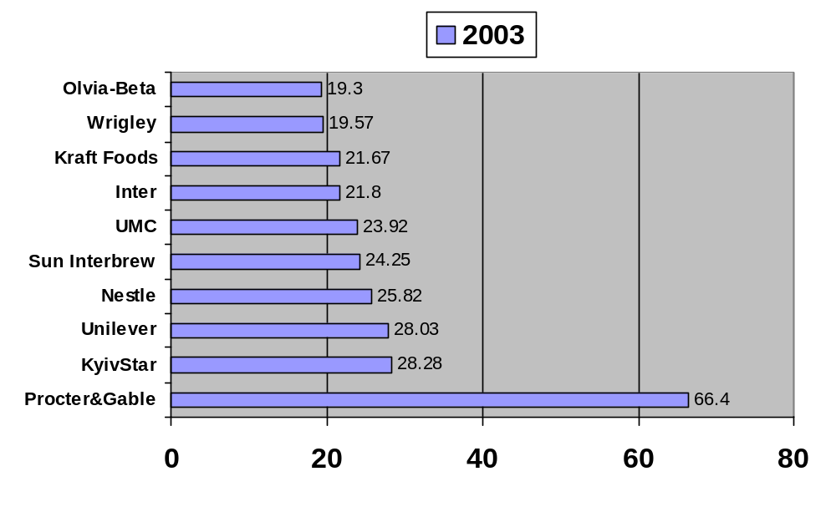 Source: Korespondent Magazine, November 15, 2003
The total advertising industry budget in Ukraine in 2003 was $420 million. Of that total, $260 million, 61% was spent by western companies. That is not counting smaller advertisers.
The advertising industry in Ukraine steadily grows between 30-40 percent annually. This huge growth is surpassed only by Russian market, where the growth rate reaches 50 percent and more every year.

D. Who has most popular brands?
Not only the western companies are the most powerful businesses in Ukraine, they also take leading positions in popularity of their products. This might be the most influential factor of all in determining who has the most influence in advertising industry.
In 2003 GFK-USM - a marketing research company - conducted a sociological survey in which 1,000 people, ages 15 to 59, were asked to name the five most popular Ukrainian trade marks. The results are displayed in the Table 4. Ukraine-owned brands are in bold.

Table A4. The most popular Ukrainian brands in 2003.
Rank | Trade mark/ Brand | Awareness | Company/Country | Product Type
1. | Cвіточ | 38,80% | Nestle, Switzуrland | Chocolate
2 | Корона | 35,20% | Kraft Foods, USA | Chocolate
3 | Олейна | 34,00% | Eridania Beghin-Say, France | Vegetable Oil
4 | Чумак | 33,40% | Chumak, Sweeden-Ukraine | Ketchup
5. | Оболонь | 22,20% | Obolon, Ukraine | Beer, Water
6. | Торчин-продукт | 17,00% | Nestlе, Switzеrland | Ketchup, Mayoneise
7. | Рошен | 12,60% | Ukrprominvest, Ukraine | Chocolate
8. | Славутич | 12,30% | Baltic Beverages, Russia | Beer
9. | АВК | 10,70% | AVK, Ukraine | Chocolate
10. | Рогань | 9,10% | Sun Interbrew, Russia | Beer
11. | Союз Виктан | 8,20% | Soyuz-Viktan, Ukraine | Vodka
12. | Галка | 7,70% | Kraft Foods, USA | Coffee
13. | Немиров | 7,40% | Nemoroff, Cyprus | Vodka
14. | Верес | 6,80% |  | Ketchup
15. | Мівіна | 6,20% |  | Noodles
16. | Черниговское | 6,20% | Sun Interbrew, Russia | Beer
17. | Сармат | 5,90% |  | Beer
18 | Гетьман | 5,60% |  | Vodka
19. | Наша ряба | 3,90% | Ukraine | Meat
20. | Прилуки особливі | 3,80% | British American Tobacco, Great Britain | Cigarettes
21. | Злагода | 3,40% |  | Vodka
22. | Президент | 3,30% |  | Butter
23. | Фанни | 3,20% |  | Yogurt, Sour Cream
24. | Мягков | 3,10% |  | Vodka
25. | Рейнфорд | 3,10% |  | Yogurt
Source:http://www.business.dp.ua/rusprod/prodmarka2.htm;
Korrespondet Magazine, October 31, 2003

A majority of the Ukrainian brands currently present on Ukrainian market are the products of western companies. However, further analysis allows us to gain some interesting insights about consumers’ perception of brands.
First of all, these brands are perceived by consumers as Ukrainian brands. Respondents were asked to name the most popular Ukrainian brands, not brands produced by Ukrainian manufacturers. Whatever their ownership might be, these brands are viewed as Ukrainian products. Besides, all but one of the listed brands have Ukrainian names, from which it is impossible to derive foreign ownership.
Secondly, the category of products is limited to food products and alcoholic beverages. It implies that in other categories foreign brands possess the predominant share of the market, if not reign undividedly, at least if you measure their market share in terms of awareness.
Of course, most of these products are manufactured in Ukraine. That justifies the manufacturer’s calling them Ukrainian products. What is truly interesting is that the brands of western companies, which use western advertising agencies, which operate according to western standards of marketing communications, are perceived as Ukrainian as those brands which have no association with western capital and do not have to employ western type advertising agencies. It can only mean that genuinely Ukrainian brands have the same approach to advertising and promotion as their western counterpart. It means that there is not Ukrainian advertising. To be more precise, it means that a form of advertising different from the established western standards cannot survive in Ukrainian market.

Part III. research and analysis

Chapter 9. Purpose, Design, Makeup, Hypotheses
The theoretical framework of this study explores brand advertising as it performs three important functions in the lives of individuals, which were presented in the previous sections. The first one is pseudo-informational function, through which a person acquires information about the product, which aids in the decision making process. The second function is self-identification, a means by which a person defines him- or herself in terms of consumption of certain products. The third function is self-expression. It provides an alternative language of projecting one’s self into the society and communicating the self to others by the means of affiliation to or consumption of products.
If such a model of brand advertising’s functioning is valid, then it would have a direct impact on the way people acquire and share information about themselves and other objects. In order to study the nature of influence brand advertising has on interpersonal communication and to define how its influence affects individuals, the following research project was designed.
Ukraine, a country that was not exposed to brand advertising until eleven years ago, presents an opportunity to study how this marketing practice affects individuals. Young Ukrainian consumers, which did not witness and or participate in the old economical regime, must reflect those consumer qualities and habits that were cultivated, expected, and encouraged by the new marketing reality, in which brand advertising is the predominant player. The older generation, on the other hand, would carry the consumer attitudes and mindsets that were formed during the Socialistic consumer culture. By looking at differences and similarities of these two groups, we would be able to see how the economy and consumer culture changed after the introduction of brand advertising, and to study what affects it imposed on individuals and society.

Design of the survey
The survey was designed to provide information on four inquiries:
- How consumers differentiate products in the category line
- Who or what serves as a guarantee of the successful purchase
- What role the immediate seller plays in purchasing process.
- What role the market plays in social life of the population
The survey contains ten questions. The question were asked of the respondents in Russian language, and later translated into English for this thesis. The translations of the questions that appear on the survey are:
1. What influences your opinion about the product the most?
2. Do you agree with the following statement “The same products can differ in quality depending on the place where they are sold”?
3. You want to buy a kilogram of sugar. What would serve you as a guarantee of quality for this product?
4. You want to buy a bar of chocolate. What would serve you as a guarantee of quality for this product?
5. How often do you follow the seller’s advice?
6. What feature/quality of a shop is the most important to you?
7. Among the shops you visit most frequently, do you know any seller’s name or could you recognize him/her in face?
8. How often do you meet your friends while shopping?
Two additional questions obtained demographic information about the age and gender of the respondents. The questions were presented in a closed format and presented with a finite number of available options from which to chose. For the detailed list of options for each question and a copy of the translation of the survey see the Appendix.
There were 171 people surveyed. Of that total, 56 were males and 115 were females, ranging in age from 18 to 70. For the analysis the respondents were clustered into three age categories: 18-24, 25-44, and 45 and older. Each of the categories contains 58, 55, and 58 respondents respectively. The distribution of sex and age among the respondents is presented in table 1-1.
Table 1-1
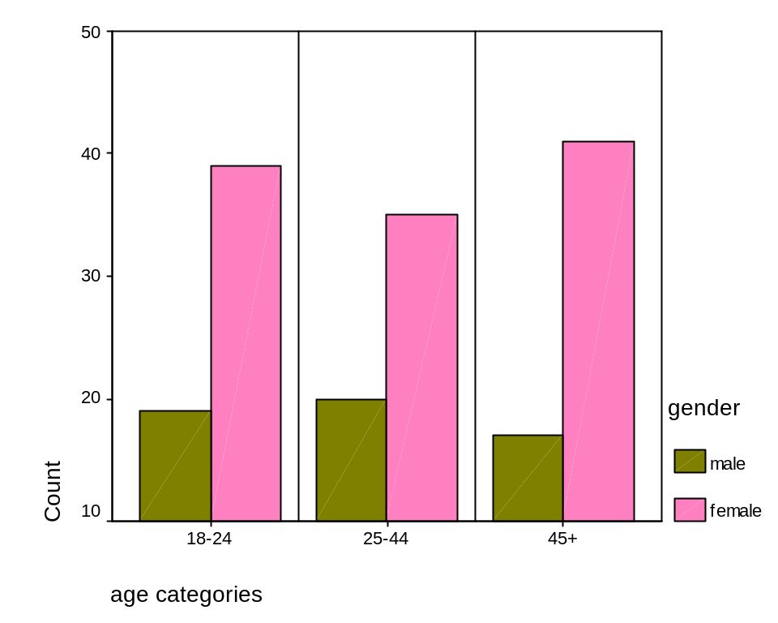
The Appendix provides more detailed information on the makeup of the respondents, including case-by-case transcripts of answers to the surveys and demographics. The data was analyzed using SPSS and SAS software.

Hypotheses and expectations
During the process of designing the study and research I had the following set of hypothesis I expected to test.
Hypothesis 1. Products are differentiated from one another:
in older generation: by seller (specific place of purchase), or by producer
in young generation: mostly by brand names, sometimes by the seller or producer
Hypothesis 2. A guarantee of the successful purchase is
in older generation: the persona of the seller, word of mouth, place of purchase
in young generation: the brand name
Hypothesis 3. The role of the immediate seller is
in older generation: provider of information about the product, guarantor of quality
in young generation: predominantly functional ( money-goods exchange)
Hypothesis 4. Role of a market in society:
in older generation: encourages social interaction among people
in young generation: utilitarian

Chapter 10. Results and Analysis
Establishing causality is always tempting to a researcher, and it must be made clear that this research does not make such attempts. The data describe differences in thinking patterns and consumer behaviors of different age categories of Ukrainian consumers. These age groups represent different breeds or generations of consumers; each of them formed under different economical and political conditions, which were tumultuously changing in the last 20 years. However, it is true about any society that generations would have great differences even if they were formed during consistent and stable socio-political and economic conditions.
This research attempts to look at these differences and consider the role of brand advertising in their development. This is hard to approximate, for countless factors interfere, yet a version of explanation of why such differences exist, and what might have been the agent of their crystallization would be provided in this analysis.
The names of the tables do not represent the exact wording of questions on the questionnaire. They serve for identification purposes only. For the question as they were presented on the questionnaire see the Appendix.

Question I. What influences your opinion about the product the most?
The first function from the brand advertising model presented in chapter 6 is the informational function. According to the model, brand advertising creates alternative avenues of getting information about the product, in contrast with the traditional ways involving interpersonal communication and social participation. If a customer can satisfy his or her informational needs for making a satisfying purchasing decision from the sources that require less involvement and work, which is just what brand advertising provides, the other, traditional sources of such information become less needed and less used.
To test this function, the first question of the survey asked the respondent about the sources of information they use to form their opinion about the product. Respondents were specifically asked to name the most influential factor that defines such opinion. Among the choices were: place of purchase, name of manufacturer, brand name, consultation of seller, and advice of friends.
When taken as one group, with no differentiation made by age, the hierarchy of factors influencing opinions about the products ranks the factors as follows (Table 1-2).
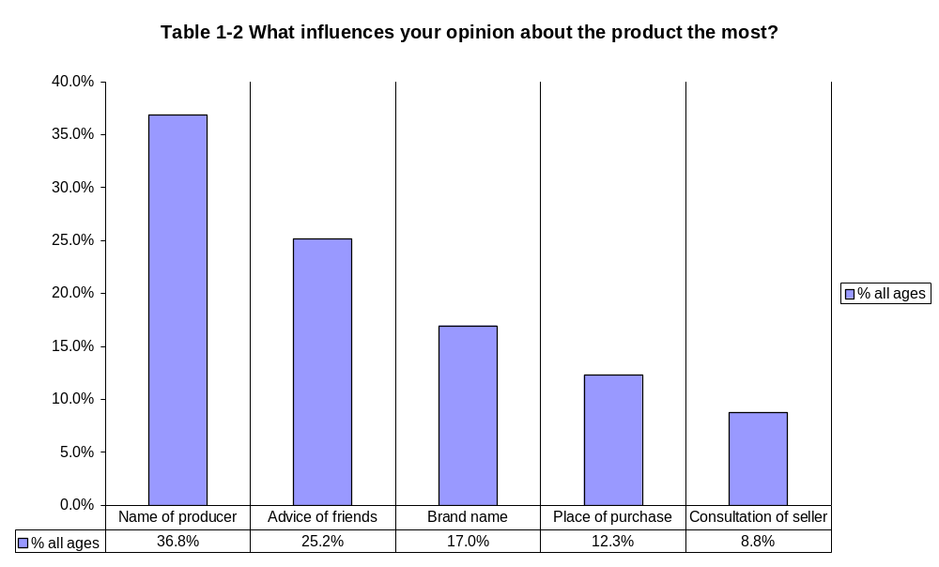

As we can see, NAME OF PRODUCER is the leader (37%), followed by ADVICE OF FRIENDS (25%). Only 17% of respondents of all ages named BRAND NAME as the most influential factor forging their opinion about the product. We need to remember that the respondents could choose only one answer, placing it above all others. There was no weighted scale. The data shows the percentage of respondents who chose one specific factor for an answer.
This data gives us a snapshot at the general behavioral trends of Ukrainian consumers and support one of the hypotheses. What we see here is the strong presence of Soviet consumers’ pattern of thinking, namely how consumers differentiated the products. Because most of the industries during the Soviet regime were unified and standardized, managed by a single administrative body, the use of government standards or gosstandarts was a criteria by which plants and fabrics were sanctioned for operation. For example, the production of sweets and candies was managed by the Ministry of the Food Industry, which developed and enforced a list of gosstandarts to which all confectionary plants had to adhere in their production. It meant that confectionary plants produced the same products, using the same formula, under the same name. The ingredients and their proportions, as well and the manufacturing process, were prescribed by the government standards. The production plants, it is important to mention, did not handle the distribution of goods, so candies produced in Ukraine could be sent to shops in Siberia, Georgia, or the Baltic Republics.
However, despite the system of such intense and thorough standardization, the products did vary in quality. It could be due to the quality of ingredients or the quality of manufacturing process, or other factors. The only available criteria of product differentiation in such system was the specific factory that manufactured the product. The name of manufacturer was required to appear on the product’s packaging, as well as the code of the gosstandart, under which is was produced.
Data provided in Table 1-2 supports my Hypothesis 1 on the criteria of differentiation of products in the Soviet system. The respondent ages 25 and older, who lived in Soviet Union and formed the basis of their consumer behavior in the system of gosstandarts, show much greater proneness to seek the necessary information to differentiate products in the name of the manufacturer, while the younger consumers attribute a much lesser importance to this information source. From all the respondents who chose NAME OF PRODUCER as the primary factor of influence on 74% were people 25 year and older. Table 1-3 shows how importance of this and other factors of influence differs by the age group.
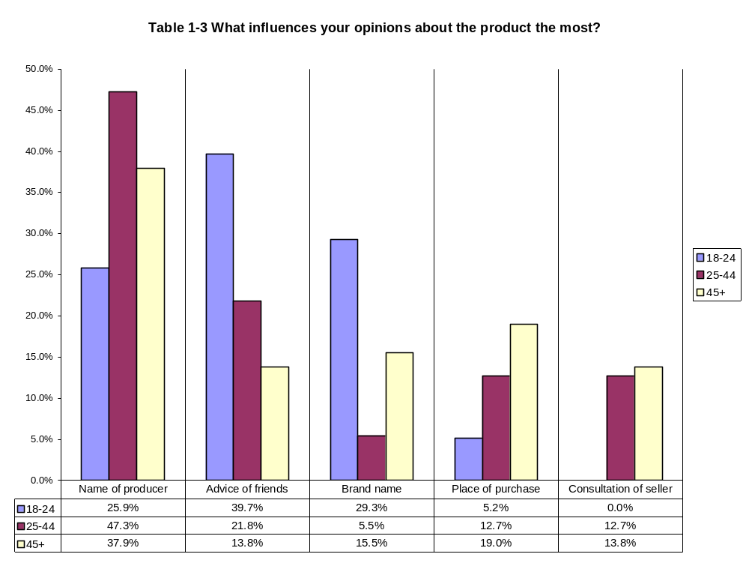
The bars in this chart refer to the percentages of respondents from the age category, who marked a certain answer on the survey. Rows in the data table represent the 100% of the respondents in the age category.
When prioritizing the use of various factors in forming an opinion about products both older age groups mention the NAME OF PRODUCER as the most influential considerably more frequently than the 18-24 group. The latter ranked this factor only the third most important after ADVICE OF FRIENDS and BRAND NAME, only 26% of respondents in the 18-24 group chose this answer.
One of the greatest discrepancies among the age groups is found in the factor BRAND NAME. It is mostly due to the strong preference of the 18-24 group that it was brought to the third position in the overall ranking. By ranking I mean the number of times a specific factor was chosen as an answer. In fact, if the 18-24 group were omitted in the computation of percentages, BRAND NAME would be the least important factor (Table 1-4), being chosen only by 10.6% of respondents. Interestingly enough, no other category suffers a change in ranking under such computation. This sets BRAND NAME aside from other factors.
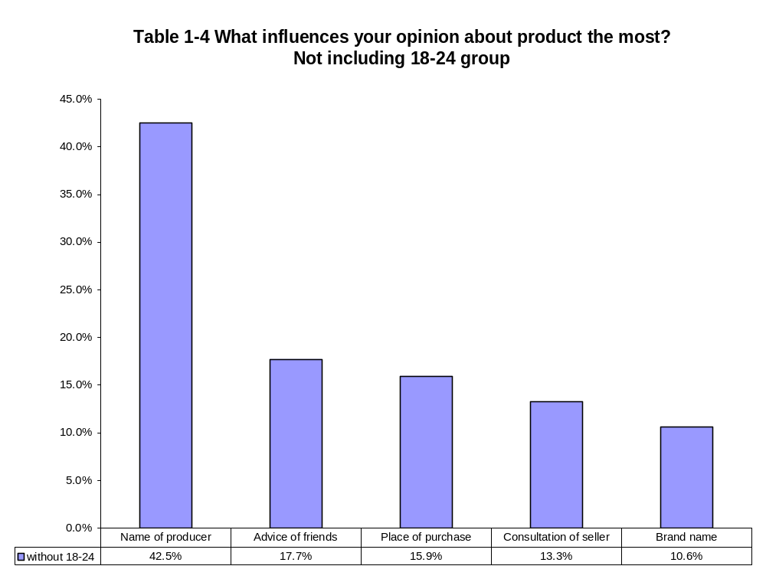
Another important observation supporting Hypothesis 1 can be made form this set of data. Both older groups chose PLACE OF PURCHASE more times than the 18-24 group, with the 19% of respondents of 45+ group and 13% of 25-44 group, compared to 5% of 18-24 group. To see the relationship better we would look at a slightly modified version of Table 1-3.

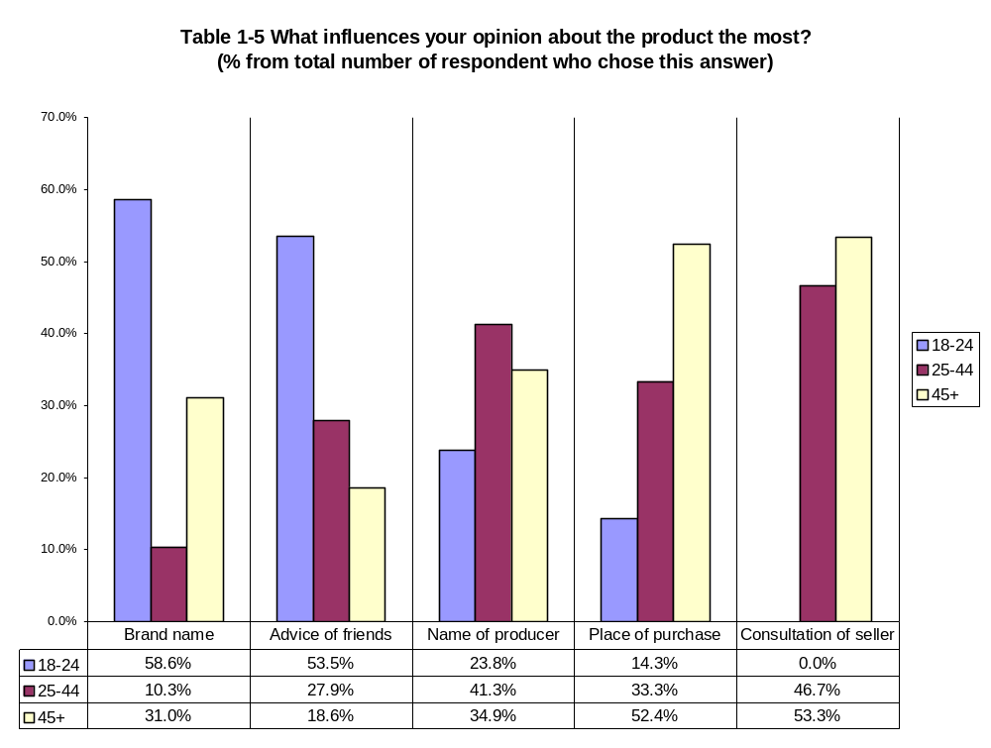
This table (1-4) presents the data clustered by chosen answers. Total number of respondents who chose one answer makes 100%. Color coded columns show what percentage of respondents who chose this answer belong to each of the three age groups.
The difference of importance of PLACE OF PURCHASE and CONSULTATION OF SELLER is more vivid when presented in this format. Thus, PLACE OF PURCHASE witnesses almost linear arithmetical progression: the younger the respondent the less likely she would choose this factor. Respondents older than 25 account for 86% of the cases when PLACE OF PURCHASE was chosen as the factor that influences the opinion about products the most.
If we come back to the original assumption that each generation of consumers developed its thinking patterns and consumer behaviors under the influence of certain socio-economic conditions present during the time of formation of these generations, we see that with the advances of changes in the economical, cultural, and political environments in Ukraine the immediate place of purchase lessens in importance in the formation of consumer’s opinion about the product. Although it over reaches the data to assert brand advertising was the cause of such trend, it does seem sound to assume so, because the role of the immediate place of purchase in Ukraine begins resembling the one in a society with the long history of practicing brand advertising.
Consider current American market environment. Because of a disproportionate emphasis is made on creating, positioning, and sustaining brand names, the attention of the consumer is inadvertently drawn to the product itself, its name, and image, and not on other factors that accompany and influence purchasing behavior. For example, no matter which supermarket is chosen by a customer, he or she expects to find a favorite brand of toothpaste. With rare exceptions, the most popular brands are present in every distributive channel. Thus, when a customer thinks about Crest, then she thinks of it in terms of qualities or benefits attached to it by its brand positioning and advertising, rather than as of a toothpaste that is sold in Wal-Mart, or Kroger, or Bi-Lo. Identification of products by the place of purchase is very limited in use in a market environment that makes heavy use of brand advertising.
Similar reasoning explains the differences among the age groups in rating the importance of CONSULTATION OF SELLER in formation of opinions about products. From Table 1-4 we see that the 18-24 group does not ascribe to this factor any importance whatsoever. All respondents who chose this answer on the survey belonged to the 25-44 or 45+ group. In the system of gosstandarts, if the manufacturer was unfamiliar to the customer and/or for some reason did not provide much information about the product, people would turn to the seller as a more informed party and incorporate the seller’s opinion into their own. In a brand saturated market environment, however, there are information sources besides the seller that can provide such information. Brand advertising, in this way, also lessens the importance of the seller’s consultation in the purchasing process. It makes sense. The buyer does not care what Kroger cashier thinks about Doritos he or she bought there.
When formulating the hypotheses to test by this research, I had a general expectation that with the advent of western brand advertising to Ukraine the purchasing process formed by the new advertising system would become a competitor to traditional sources of information about the product, such as consultation of sellers, place of purchase, or advice of friends. Because the use of these traditional sources implied at least some interpersonal communication I hypothesized that brands would lessen people’s necessity to involve in social interaction (such as talking to a seller, or asking friends what they know about a manufacturer, ect) thus promoting individualism.
However, the data for ADVICE OF FRIENDS factor produces contrary implication. The 18-24 group places much more importance in this factor that any other group. Nearly 40% from this age group identify it as the most important factor in formation of their opinion about products, making it the leader in this age group. Groups 25-44 and 45+ allocate 22% and 14% respectively of their answers for this factor. From all the respondents who chose ADVICE OF FRIENDS as an answer almost 60% were from the18-24 group. This partially refutes the hypothesis, however, it must be remembered that this particular age group is much more prone to peer pressure than older age groups. In fact, studies in social psychology show that peer pressure influence decreases with age, which is just what the data reflect.

Question II. Can the same products differ in quality depending on the place where they are sold?
One of the most important functions of a brand is one of standardization. Brand serves as an anchor of customers’ beliefs and attitudes. Brand assigns to the product a constant that does not vary by other elements of the marketing system, or at least is not supposed to vary. Thus, for example, Heinz brand of ketchup through positioning and advertising came to produce certain expectations in consumers, whether it is taste, thickness, design of the bottle, color, etc. If these expectations do not come true every time a customer buys Heinz ketchup, that is if with every other purchase the customer would get a slightly different products, marked under the same brand, he or she would have to find an alternative differential scale to define products they prefer. This makes sense; if I know what I want, I would find a way to classify and identify products in a way that would enable me to be certain that the product I buy is exactly what I want.
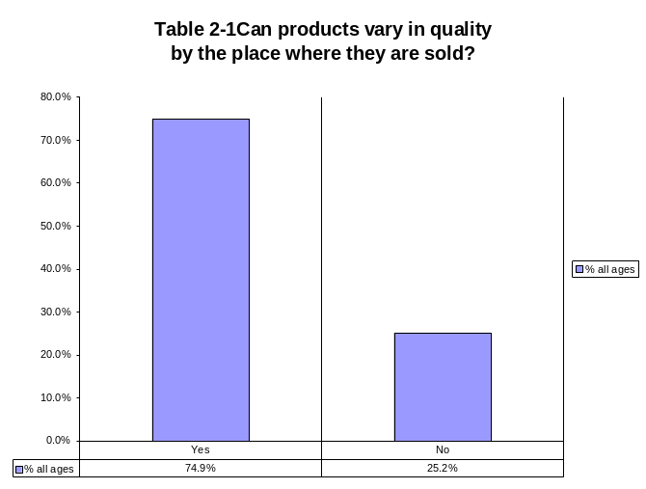
Brand is a constant in the multivariable equation of purchase. If this constant wavers, some other variable must be assigned fixed to solve the equation. The greatest potential for becoming an alternative constant I see in the place of purchase. I assume that if system of branding was not at place, customers would make shops and stores anchors of customers’ cognitions about products. In fact, such system existed in America before the second industrial revolution. Even after the distribution networks were well-established and media attained the capacity for national brand promotion in late 1800’s early 1900’s, local stores keepers “almost never featured illustrations of brand names in their ads. For the most part , small-town advertising by local merchants served the intended purpose of providing information about the variety of selection, low prices ,and availability of goods” (Norris, 13). The purpose of advertising in such a system was not to persuade the customer in the superiority of a given product or make it appear unique and different from the rest, but by the list of products attract the customer to a specific store and cultivate their loyalty to that specific place of purchase. The emphasis was, in contrast to the brand system, not on the product itself, but on the merchant or shop that carried it.
Therefore, the marketing system with little or no brand advertising history would place greater importance on the immediate seller of the product. Ukraine, where brand advertising is a relatively young phenomenon, should follow this trend. The research data supports such an assumption (Table 2-1).
The respondents were asked whether the quality of products depended on where this product is sold. The question was intended to address the perceptions of the respondents rather than to describe their actual experience. Thus by asking “ Can products vary” instead of “Do products vary” an attempt was made to limit the answer to perception. The question was also designed to be deliberately vague, without mention of specific products, or even categories of products. In this way the respondents would think of a product or a group of products that are most accessible because of awareness and, consequently, predominant in formation of their general consumer’s thinking pattern.
Seventy five percent of respondents agreed that products can vary in quality depending on the place where they are sold. It shows that the majority of customers in Ukraine still run off the presumption that the shop or the merchant matters more in cultivating customer loyalty than brand names, and influences the perception of product’s quality to a greater degree than brand names.
However, because the question did not specify the kind or group of products, we cannot know whether the respondents had in mind products with high brand awareness or non-brand or low-brand generic products. Thus, we must be careful drawing conclusions from these results, for we cannot make any valid assumption as to what kind of product the respondent had in mind.
If they all had high-brand products in mind, we could have concluded the place of purchase is more important to the customer in determining the quality of the product that the place of purchase. Such a result would be counterintuitive and would set off the whole theory behind brands. On the other hand, if all respondents had generic products in mind, the conclusion could have been that brand products and brand advertising did not penetrate the market enough to influence the thinking pattern of consumers, which would contradict the known information about the presence of high-brand products in the Ukrainian market (see section II).
It is precisely because the question was vague in this regard that we can assume that it measures what portion of products the respondents consider defined by brands as compared to those for which quality is best defined, described, and predicted by the place of purchase. It measures whether they tend to think about products as brands. It measures their promptness to trust a brand instead of the shop when it comes to making a purchase. But most of all it measures to what degree they incorporate the concept of brands in their mind.
To think of it, really, how can the same things differ? Is not that an oxymoron? It depends on how one defines sameness. If you tend to think of products in terms of brands then they cannot differ. Heinz ketchup would be the same Heinz ketchup in Wal-Mart, Kroger, Food Lion, private shop, online store, anywhere. On the other hand, if a brand is not differentiating the products, then ketchup in one store would differ from the ketchup in another store. It still would be ketchup, and in this regard it would be the same thing. But the measure of sameness would not embrace the characteristics’ profile of the product.
The results of the survey show that “brand thinking” among the Ukrainian customers accounts only for 24% of the cases with age not factored in. It means that for the majority of Ukrainian customers, the association of products with a specific shop or store is more prevalent than with a brand name.
Different age group are consistent in this trend. Table 2-2 shows the distribution of answers by the age group.
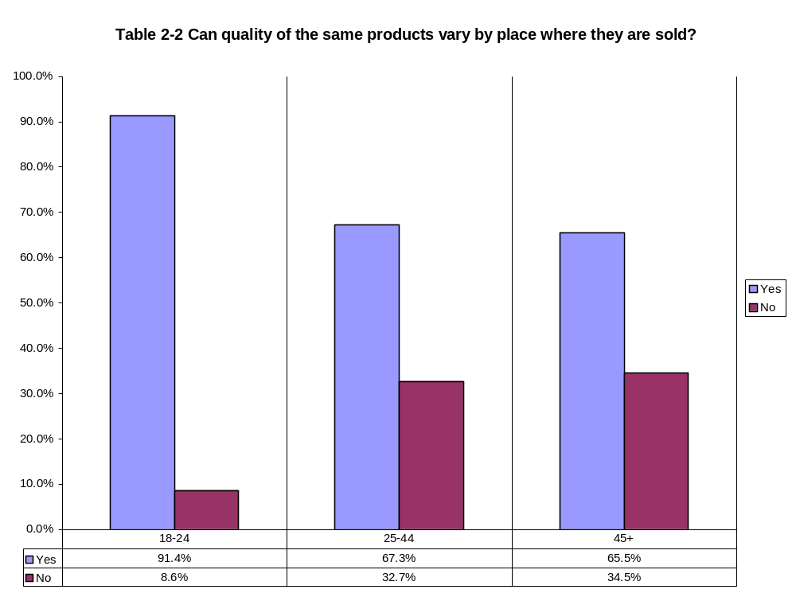
Every age group favored YES significantly more. Answers of two older groups fully support the hypothesis by showing that “brand thinking” is less prevalent than the non-brand thinking in older generations of Ukrainian consumers. This also goes along with the result found in the first question of the survey, where older groups assign less importance to BRAND NAME as opposed to the place of purchase (table 1-3) in formation of their opinion about the product.
While 25-44 and 45+ age groups are almost identical in their answers, and consistent with the answers to the first question, the 18-24 group differs by the disproportionate support of YES to the second question, and contradicts its answers to the first question. They say that brand names are more important (by 25%) in what they think about a product than the place of purchase, but at the same time say that the place of purchase determines the quality of this product. How can this be so?
This is seemingly counterintuitive to the overall hypothesis, by which the younger generation should exhibit greater infiltration of brand concepts into their consumer thinking pattern. In other words, if brand advertising does influence one’s thinking about products, the young, whose mindset was defined by brand advertising to a greater degree than the one of older generations, must exercise the thinking pattern indigenous to brand system in a greater measure. Following this assumption, it was expected that the distribution of answers in the 18-24 group would be exactly the reverse, and that the young generation of consumers would define sameness of products in terms of brands. However, with further analysis, we find that contradiction is superfluous, and when taken in the context of certain aspects of Ukrainian society and market environment, support each other and reinforce the hypothesis.
For cultural and economic reasons, a majority of young people in Ukraine live with their parents. In many cases three generations can share the same apartment, simply because the living space is limited and loan programs are practically non-existent. Only in recent years, after the economic situation in the country somewhat stabilized, has there been an effort made to develop a system of house loans, which is still a foreign concept for Ukrainians. This issue was addressed differently in the Soviet Union. Very few people actually bought their apartments; the living space was provided by the government and distributed according to demographic quotas.
In addition to this, the disposable income of young people, particularly university students, is abysmally low, because the Ukrainian educational system places substantial time requirements on pupils. It is not unusual for a freshman to have up to 40 academic hours of classes to attend during a week, not counting out-of-class study. In fact, it is very much the standard. Together with little time to spare, the availability of jobs, and especially part-time jobs, leaves much to be desired. With highly educated professionals struggling to find any job, the chance for a student to find a part-time job with a flexible schedule to fit the university demands is very low.
These conditions place certain restrictions on what consumers in the18-24 age group buy. Food is usually provided by the parents and home purchases are done by them as well. With little buying power, young consumers usually enjoy buying only recreational products, such as clothes, electronics, music, snacks, various gadgets and peer fad paraphernalia.
Street markets in Ukraine are well known for selling goods that fake the famous brand names. Coming from various countries, Taiwan, China, Indonesia, Turkey, Poland, and many local manufacturers, such product pretend to represent brands such as Nike, Adidas, Puma, but frequently unsuccessfully. For example, setting your mind on getting a pair of New Balance training sneakers, one might wander the rows of a street market marveling at the variety of spellings. It is quite difficult sometimes to decide from among Nue Ballance, Nu Balanse, New Balans, Neu Bollanse and New Balance. Such honest or, sometimes, deliberate misspellings cultivate the mistrust for brand names.
The youth is constricted by peer pressure –for which this age group exhibits high susceptibility - to the desire to get the “real thing.” Young people cannot count on street markets to providing them. Specialized stores, on the other hand, in which real brands can be found (as opposed to the street markets - the predominant form of selling in Ukraine), are capable of catering to such needs. Prices, of course, are higher, but ensure the young that they are getting what they expect to get.
This supports why the 18-24 age group agreed so strongly with the statement that the same products can vary by place of purchase. It is because they value a brand name more than the older generation of consumers and are more sensitive to it that they differentiate between products bought in street markets and those bought in boutiques and specialized stores. This view is supported by the result from Question I, where BRAND NAME is given overwhelmingly greater importance in formation of opinion about the product than PLACE OF PURCHASE.

Questions III- IV. What is guaranty of quality for low-brand and high-brand products?
Questions III and IV on the questionnaire read, “You want to buy a kilogram of sugar. What would serve you as a guarantee of quality for this product?” The same question was asked about a bar of chocolate. The purpose of naming these two products specifically was to see what the difference in customers’ perceptions is when purchasing decisions involve low-brand and high-brand products.
Low-brand products are those that do not have much brand presence in the market or brand recognition with the consumers. Examples of such products would be flour, salt, sugar, grain, bread and milk. These products, by their nature, are not prone to brand advertising, because it is very difficult to associate them with a psychological benefit that can be derived from them. Consumption of such goods is defined more by necessity and habit than by other drives such as status aspiration, emotional association, peer pressure, fashion, or psychological needs.
High-brand products, on the other hand, are goods for which customers have little if any genuine need. These products are the fruit and incarnation of Karl Marx’s commodification concept. His economic analysis argued that in the capitalistic system, objects are being commodified by acquiring an exchange value, which takes the place of the intrinsic value (Thussu, 69). In other words, instead of paying what the product is worth, people pay what they are willing to pay for this product, with a supply-demand equilibrium affecting the price. Promotion, namely brand advertising, in this system is allotted the role of increasing this exchange value. Products such as soft drinks, beer, electronics, specialty equipment, and such belong to this category of high-brand products.
The difference in thinking about low-brand and high-brand products for general population of Ukrainian consumers is illustrated in the table 3-1
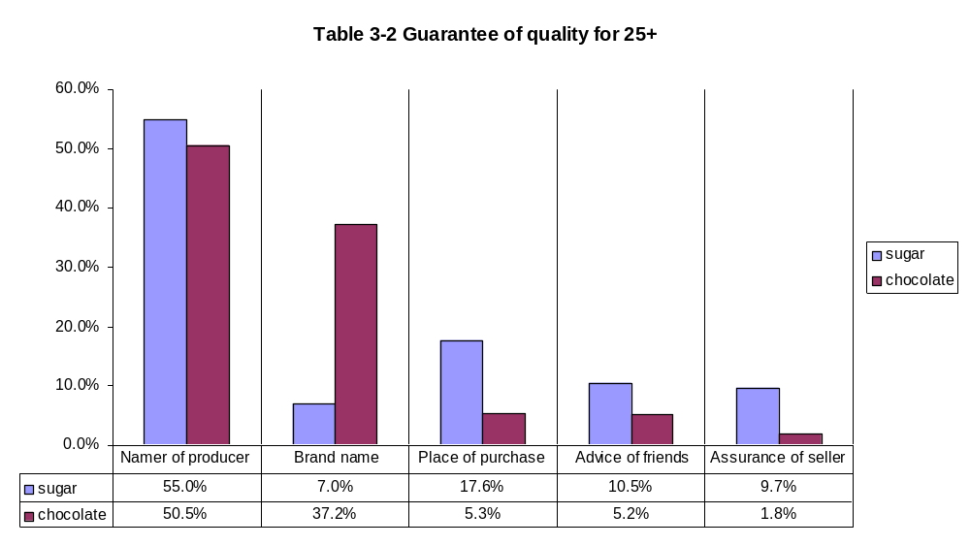
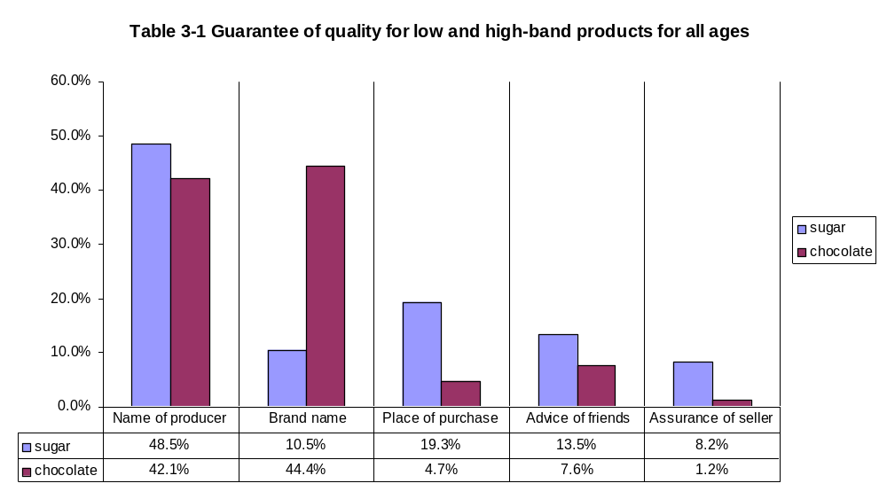
When consumers must decide on chocolate, a high-brand product, BRAND NAME serves as a much more reliable and accurate indicator of product’s quality than any other factors. In reverse, when deciding on sugar (low-brand product) BRAND NAME is last but one. For sugar, on the other hand, the most reliable indicator of quality is NAME OF PRODUCER, which is followed by PLACE OF PURCHASE. No surprises here.
Because age groups 25-44 and 45+ were so similar in their responses they were combined into one group 25+. The answers of this age group are displayed in the table 3-2.
The importance of name of the producer and the immediate place of purchase for the consumers in the Soviet Union has been presented, thus making it easier to understand why NAME OF PRODUCER got more percentage of answers for chocolate (high-brand – HB) for this age group. While the new marketing concepts penetrates into the minds of older consumers (BRAND NAME for chocolate HB is the second most popular answer – 37%) the inertia of thinking from the Soviet times still resident. In fact, even 18-24 age consumers rank NAME OF PRODUCER the second most popular answer (table 3-3) for LB products.
In the economy of the Soviet Union, most products were low-brand, including chocolate, beer, soft drinks, and many others, which American consumers would classify as high-brand. It means that if this survey were to be conducted 15 years ago, answers for sugar and chocolate would not be very different.
In the 25+ group, BRAND NAME accounts for the least percentage of responses (7%) for low-brand product. When compared to 17% in 18-24 group it reinforces the existing opinions from the Soviet era. NAME OF PRODUCER, as predicted by the hypothesis, is the most popular (55%) answer for LB products, with PLACE OF PURCHASE (17%) in second position. This supports the research assumption; in a society with weak brand presence, shops and stores possess greater importance for the consumer.
For the new generation of consumers the picture is different.
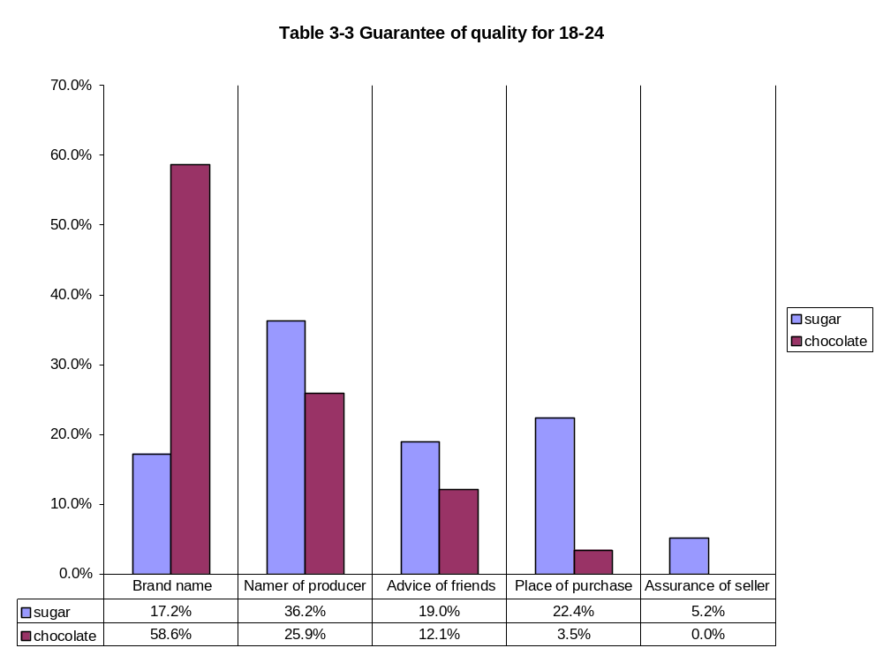
While NAME OF PRODUCER is still a popular response for this age group, BRAND NAME changes the distribution. For LB product in 18-24 age group, BRAND NAME accounts for 17% , which is 10% more than for the 25+ group. PLACE OF PURCHASE is very strong, getting more percent of the answers than in 25+ group (18%), but falling down to 3.5% for chocolate. In fact, PLACE OF PURCHASE drops 19% in popularity with 18-24 group, while this number for 25+ group is only 12%, from which contributes to the assumption that younger people are more affected by the system of brands than the older generation of Ukrainian consumers. ADVICE OF FRIEND is almost as twice as popular for low-brand products in 18-24 group (19%) than in 25+ group (10.5%). It might be argued that without much information about the LB product, the young would instinctively turn to those whom they hold in high regard (friends), rather than actually those who have the information (seller).
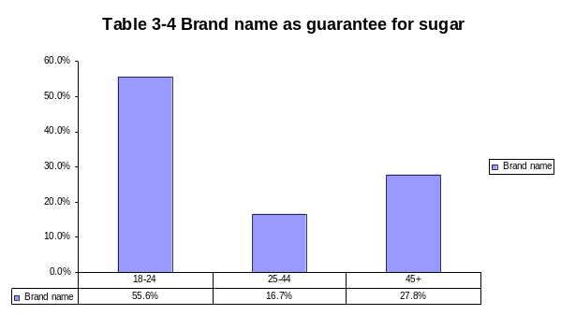
I would like, however, to focus on the role of brand name as a guarantee for low-brand products in the 18-24 age group. Here the influence of “brand thinking” is the most recognizable. Young people generally do not buy sugar, because most of them live with their parents and the latter do food shopping. In addition to this, it is very hard to think of a brand of sugar in Ukrainian market. Sugar is usually sold loose, not in prepackaged bags that would carry the brand name. Young people do not usually buy it, they do not know the name of brands (because such virtually do not exist), they do not even know very well how it is sold, and yet from all respondents, who said that brand name serves a guarantee of quality when they buy sugar 57% were in the 18-24 group (table 3-4). This shows that the system of brand advertising brings the “brand thinking” into the mindset of consumer even if his or her actual experience does not prompt to do so. Not only does a consumer think brands for high-brand products, such thinking gets applied for other products as well.
Concurrent to the hypothesis, young people are also more prone to use a brand name to serve as a guarantee for HB products. Fifty nine percent of them marked this answer for chocolate, while only 37% in the 25+ group did so.
It is also worth mentioning that such guarantees as PLACE OF PURCHASE and ADVICE OF FRIENDS are more popular for low-brand products in both of the age groups. When asked about a high-brand product, the popularity of the guarantor drops drastically in both groups, giving favor to BRAND NAME. But what implications do this data have?
People use different information to be sure in the quality of LB and HB products. If the market contained only LB products and such information source as brand name would be inaccessible, the information it supposed to provide would have to be compensated by other sources. It means that in the market with no brands people would have to listen to sellers more, know more about the local shops and stores, communicate with their friends and families more in order to learn this information. On the other hand, in the market with heavy presence of HB products, brand name makes these traditional sources of information less needed and, consequently, less used.
If chocolate was still a low-brand product (just as it was in the Soviet Union), information that serves as a guarantee of quality for low-brand products would be used for it as well. But Table 3-2 presents a slightly different point. If chocolate was a low-brand product PLACE OF PURCHASE would account for 18% of times customers chose it as a guarantor of quality. But because today it is a high-brand product, this rate goes down to 5%. ADVICE OF FRIENDS goes down from 11% to 5%. ASSURANCE OF SELLER goes downs from 10% to 2%.
If most of the products in the Soviet Union could be classified as low-brand products, then consumers would use guarantees of quality 25+ group listed for sugar. The pseudo-information they get from brand advertising would have to compensate by the information from other sources. The customer would still have a need to possess knowledge about the product in order to make a satisfying purchase, but the way the information is gathered would differ. If consumers needed the advice of friends more, they would have to talk to them to in order to receive such advice. If they need the consultation of sellers more, they would have to communicate with them. Placing more emphasis on the place of purchase leads to better knowledge of people who work in this shop, sellers, owners, and of local community.
Although I cannot ascertain to what degree the need to find product information spurred social interaction in the Soviet Union, it is clear that such interaction was much more needed and practiced than in the system of branded products. People would not stop talking to each other if the market is flooded with brands. But they will do it less. They would need each other less. They would be more independent in their search of product information, because the brand name would be the medium of the information and the information itself: effortless accessible, enjoyable, entertaining.
If chocolate remained a low-brand product, as it used to be before the appearance of western corporations in Ukrainian markets, 10% of consumers would talk to a seller before buying some (25+ group for sugar) Today, none would(18-24 group for chocolate). If chocolate remained a low-brand product, 18% would associate it with their local shop and not with a distant corporation. Today, 4 % would. While the degree to which the brand system of selling encourages individualistic thinking and detachment form the local community is an open question (it certainly cannot be determined from this study). The structure of a brand system is such that it has the potential of doing so. The exercise of such potential is already in action and clearly seen from the result of this research.

Question V. How often do you follow the seller’s advice?
According to the results presented in table 3-2, in the market dominated by low-brand products the advice of seller (9.7%) is almost as important in assuring the quality of products as the advice of friends (10.5%). We are able to make such assumption because the way sugar was sold in the in the Soviet Union does not differ much from the way it is sold in Ukraine today. No brands of sugar appeared on the market, and the actual selling takes place almost in identical way. We assume that the guarantees the consumers (the 25+ group) used for sugar in Soviet Union are pretty much the same and sustain the same relative distribution among themselves for these consumers today.
The role of the seller for the youth of Ukraine deteriorated drastically. It’s correlation with ADVICE OF FRIENDS is also different (19% to 5.2% for low-brand products, and 12.1% to 0% for high-brand). For low-brand products young consumers are four times more likely to use their friends’ advice than the advice of seller, while for the older generation this percentage is almost the same (about 10%). Because of peer pressure and peer sensitivity influences these answers greatly, and it is impossible to estimate the absolute change of importance of seller in the purchasing process of the young and older consumers. The next question on the questionnaire (and Question VII, at which we will look later) was designed to address this issue directly.
The question asked “how often do you follow the seller’s advice.” The options included NEVER, RARELY, FROM TIME TO TIME, FREQUENLY, ALWAYS. None of the respondent from any age group answered ALWAYS; this option does not appear in the analysis. This question was flawed because the options were inadequate; they hinder its analysis. More specific answers should have been provided, which respondents could not have interpreted arbitrarily. The picture derived from this analysis would be a rough shot, but hopefully, if not to scrutinize the trend, it would be able to give us a clue about its vector.
Table 5-1 gives as a look at distribution of answers among age groups.
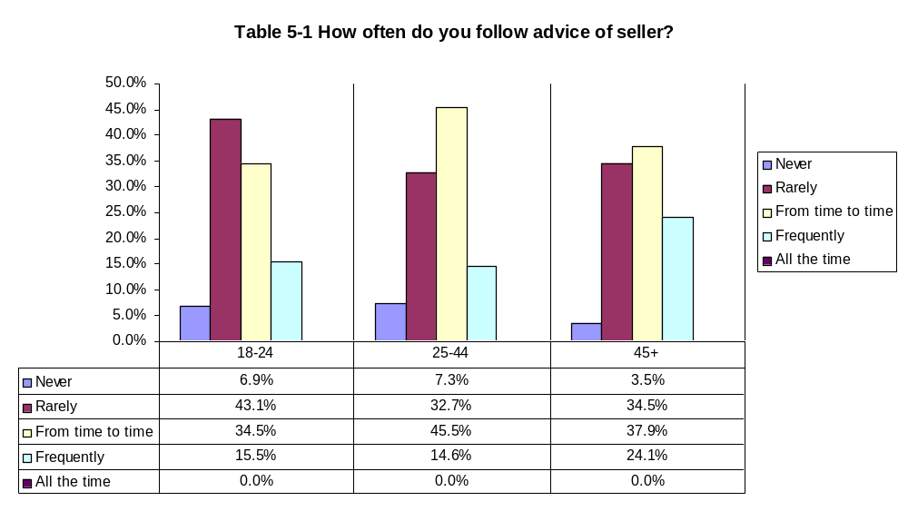
The 18-24 group in the majority answer in RARELY(43.1%), while in 25-44 and 45+ groups FROM TIME TO TIME is the leader with 45.5% and 37.9% respectively. The graphic representation of the results show the trend: the older the consumer, the more likely he or she is to listen to the advice of seller. If we combine NEVER and RARELY into one option, and do the same with FROM TIME TO TIME and FREQUENLY we would see that it supports such view(Table 5-2).
The oldest group of consumers showed the greatest proneness to engage the seller into the formation of their opinion about the product in Question I(13.8%) and reinforce this trend by results from Question V.
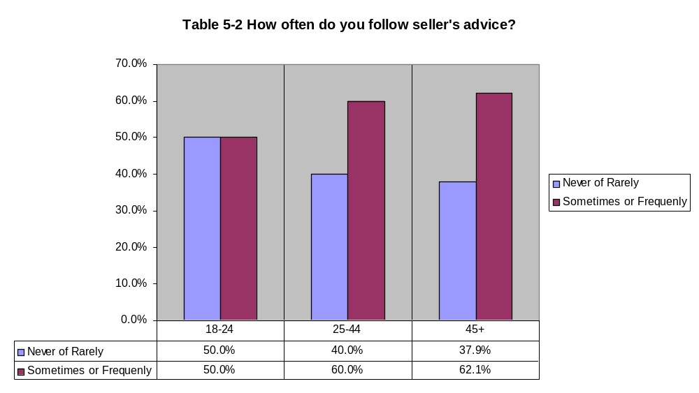
It is safe to say that NEVER and RARELY imply relative unwillingness to listen to the advice of seller, while other two answers signify that consumers are generally willing to do so. From this chart we see that 18-24 is equally divided on this issue, while 25-44 and 45+ group show greater preference to FROM TIME TO TIME and FREQUENTLY.
Analysis of responses to this question, together with the analysis of answers to questions III (tables 3-1,3-2,and 3-3) supports the hypothesis that the role of the immediate seller deteriorated with the introduction of branded products. This means the system of brand products discourages interaction of consumers and sellers, making the market place a more individualized and placed, where the parties communicate less with each other.

Question VI. What feature/quality of a shop is the most important to you?
The options of answers to this question included CONVENIENT LOCATION, VASTSELCTIONOF PRODUCTS, LOW PRICES, TRUSTWORTHY SELLERS, and FAST SERVICE. Distribution of answers by the age group is shown in table 6-1.
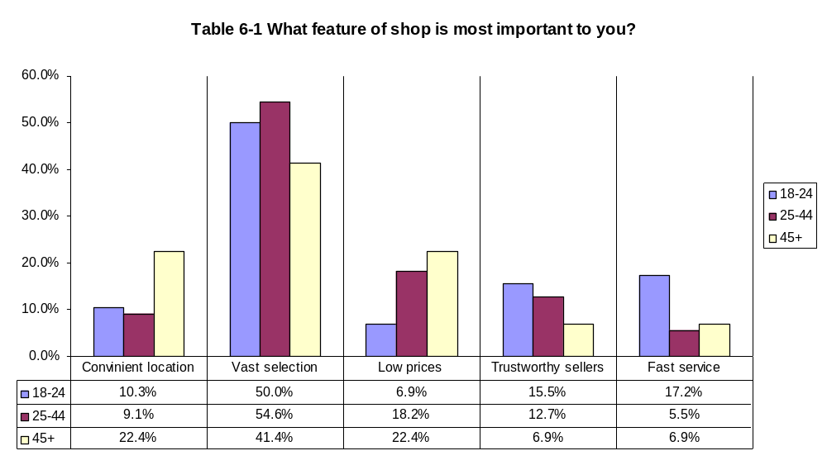
Distribution of answers in CONVENIET LOCATION and LOW PRICES follow the common sense, that tells us that older people would be more sensitive to the location of a store, because they have to walk the distance to it. Car ownership is very low in Ukraine, but the system of public transportation is very well developed. Nevertheless, most everyday purchases are done in walking distance from home or work.
Older customers would also be more sensitive to price factors, because they manage family budgets and determine spending. The elderly, retired people have extremely limited financial resources, even smaller than those of college students, who get family support.
The TRUSTWORTHY SELLER choice, however, is more interesting. Through the first five questions of the survey, the 18-24 group has consistently shown the role of seller in formation of opinion about the product and importance of the seller in purchasing process is the lowest among the listed options. However, more respondents from the 18-24 group listed TRUSTWORTHY SELLERS as the most important feature of a store more, than any other age group. In fact 15.5% of the 18-24 group listed it as their answer, which is more than CONVIENIENT LOCATION and LOW PRICE received.
This might be explained by the relative inexperience of the young consumers, as compared to the older groups, in evaluating and purchasing products. While older consumers have a life experience to draw from, members of 18-24 group are much less protected in this regard against making a unwise or unsuccessful purchase. What happens is that even though the 18-24 group exhibits the greatest need in the advice of sellers, they are the least likely to ask for it.
This group has also the greatest percentage of FAST SERVICE response than any other group. While only 5.5% and 6.9% of respondents from 25-44 and 45+ groups respectively mark FAST SERVICE as the most important feature of a store, this number for the 18-24 group reaches 17.2%. Fast service, should be mentioned, is one most distinguishable features of a highly individualized market environment.

Question VII. Among the shops you visit most frequently, do you know any seller’s name or could recognize him/her in face?
This question was included in order to estimate the degree to which younger consumers participate in communication in the marketplace, as compared to the older consumers. Options for this question included “yes, I could recognize the seller in face” (YES, IN FACE), “yes, I know the seller by name” (YES, BY NAME), and “no I don’t know the seller’s name and would be able to recognize her in face” (DON’T KNOW). It should be safe to assume that knowledge of seller’s name would imply a greater degree of interaction between the seller and the consumer than the ability to recognize the seller in face. Distribution of answers is shown in table 7-1.
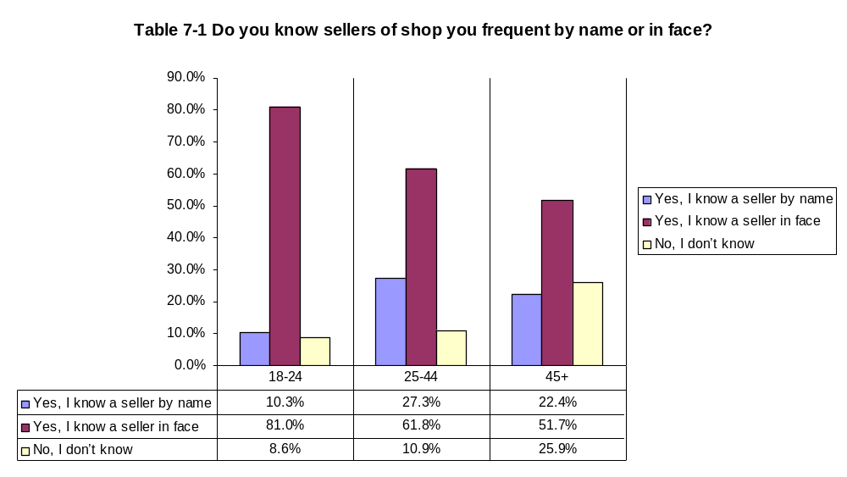
A very interesting tendency could be derived from these results. The older the consumers are the less likely they are to be familiar with the seller. In the 18-24 group only 8.6% say they do not know either the seller’s name or could recognize her in face; this number increases to 10.9% and 25.9% in 25-44 and 45+ groups respectively.
On the other hand, the older groups are more likely to know the sellers on the personal basis and know them by name. Only 10.3% of respondent from 18-24 group said they know the sellers name. The groups 25-44 and 45+ exhibited much greater tendency to know seller’s name; 27.3% and 22.4% of respondents in corresponding age groups said they the seller’s name.
Although it is very difficult to estimate what role brand advertising plays in consumers familiarity with the persona of the seller, one of the assumption of this thesis is that thinking patterns and consumer behaviours of 18-24 group were mainly formed by the market environment with heavy presence of branded products in it, then the system of branded products decreases the level of intense interaction with the seller, which results in smaller percentage of YES, BY NAME response in the 18-24 group.
The fact that 1) young consumer are more likely to be able to recognize the seller in face and that 2)the older generation of Ukrainian consumers are more likely not know either name or be able to recognize face of the seller might be explained by the following condition.
The predominant share of employees in shops and stores in Ukraine are young people. Pay for this job is very low, and older people who have to support families have to look for a greater source of income. Higher paid jobs have greater competition, thus decreasing the chances of inexperienced youth getting it. In light of this fact, it would be safe to assume that young customers would be more prone to related to sellers of the same age, remember better how they look. The reverse could be said about the older consumers.

Question VIII. How often do you meet your friends while shopping?
This particular question was design specifically to address of the hypotheses that stated that strong presence of branded products in the market makes the intensity of social interaction in the market place less prevalent. The design of this question suffers the same criticism that was addressed at Question 5. The distribution of answers among all the respondents to this question forms almost a perfect bell curve (Table 8-1).
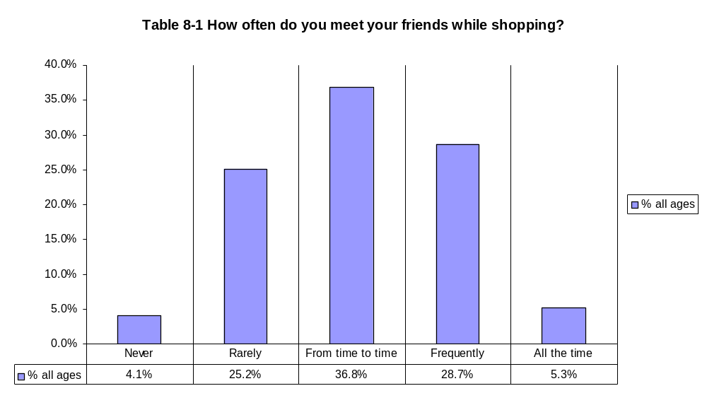
When broken down by age category the picture is slightly different.
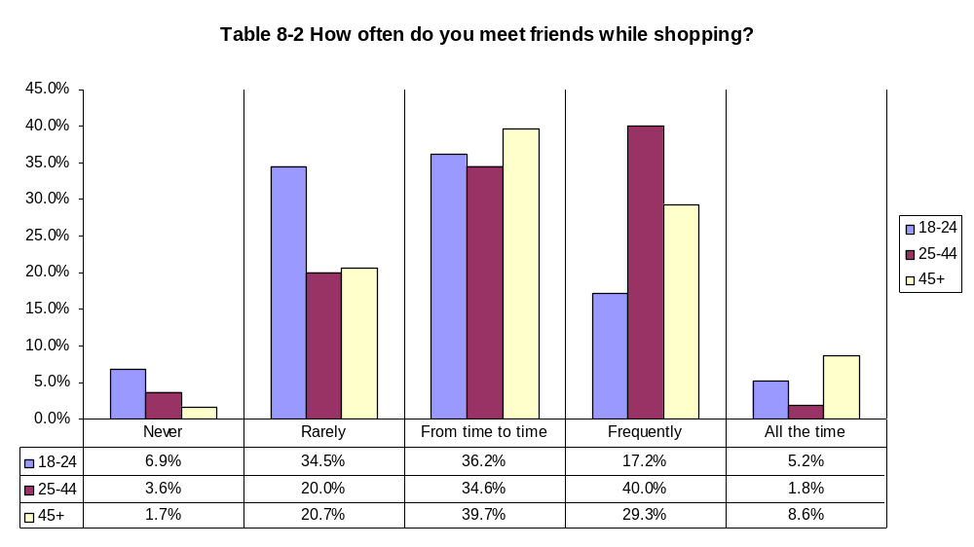
Respondents in 25-44 and 45+ are considerably more likely to meet friends while shopping. FROM TIME TO TIME answer hold very much the same share of responses for all the age groups. The oldest groups of consumers are more likely than any other group to meet friend ALL THE TIME.
In general the older generation of Ukrainian consumers tends to socialize during shopping more than 18-24 group. However, due to many other social and cultural variables we cannot assert that such difference is a result of introduction of branded products into the Ukrainian market. More research needs to be done to verify this hypothesis.

Chapter 11. Conclusion
The survey achieved the goal to test the hypotheses.
Hypothesis 1. Products are differentiated from one another:
- in the older generation: by seller (specific place of purchase), or by producer
- in the younger generation: mostly by brand names, sometimes by the seller or producer
This data fully support the hypothesis.
The older generation does place greater importance on the name of the producer in forming opinions about the products than any other factor (table 1-3). This remains true for low- and high-brand products alike (Table 3-2).
The young generation of Ukrainian consumers incorporated a great deal of “brand thinking” into their consumers behavior. Brands are a very important factor in their experience in the market, second only to the peer culture (Table 1-3). They are twice as likely to think of products in terms of brands than 45+ group and 6 times as 25-44 group (table 1-4). Not only do they use brand names more than any other factor in formation of their opinions about high-brand products, but they also intuitively exercise such thinking when deal with low-brand products (table 3-4).
Hypothesis 2. A guarantee of quality of products and successful purchase is
- in the older generation: the persona of the seller, word of mouth, place of purchase
- in the young generation: the brand name
The data partially supports this hypothesis.
The major predictor of quality for the older generation is the name of producer for both low-brand and high-brand products (table 3-2). While the persona of the seller, word of mouth (advice of friends) and place of purchase are slightly more important to older generation, this holds true only for high-brand products. The importance of these factors to the young generation is lower for high-brand products, but equal or higher for low-brand products (table 3-3). However, brand name is the most influential factor the young consumers in estimating the quality of high-brand product(Table 3-3), and a significant contributor of such for low-brand products(table 3-4).
Most importantly, I have ascertained that sources of information about a product’s quality would differ greatly for both generation. Consequently the processes of gathering such information would differ as well. This supports the overall thesis statement, that proliferation of branded products alters the thinking pattern and behaviors of consumer in a way that make social activities in the market environment less needed and less exercised.
Hypothesis 3. The role of the immediate seller is
- in the older generation: provider of information about the product, guarantor of quality
- in the young generation: predominantly functional ( money-goods exchange)
The data fully support this hypothesis.
The younger generation assigned the least amount of importance specifically to this factor and did so consistently in almost all questions. The older generation does ascribe more significance to the persona of the seller than the young generation, and does so mostly for low-brand products. Young consumers are the least likely to have intense social interaction with sellers (table7-1) and less likely to follow the seller’s advice (table 5-1), but exhibited a better general familiarity with the persona of the seller than older generations (table 7-1)
Hypothesis 4. Role of a market in society:
- in older generation: encourages social interaction among people
- in young generation: utilitarian

This hypothesis includes and derives from the first three. Those questions are “Are people as sociable in the new market environment as they were in the old? Does the structure of the new market environment affect the level of social interaction?”
It is clearly seen from the data that people treat low- and high-brand products differently. They engage different methods of gathering information about them, different terms to think about them, and employ different behaviors as the result.
When considering high-brand products, such factors as the place where the product is sold, opinion of friends, the persona of the seller become much less important and active to consumers than for the low-brand products. If is obvious that if the largest share of the products in a market becomes high-brand products, this would lead to changes in consumer’s thinking patterns and behaviors.
Those factors important in considering low-brand products imply intense social interaction. With the decrease of their importance in the system of high-brand products such interaction decreases as well.
The young generation of Ukrainian consumer, formed in the system of branded products, shows considerable change from the previous generations. They have incorporated the concept of brands into their consumer thinking and this affects how they think even about low-brand products.
I think it would be fair to conclude that the system of branded products and brand advertising that creates and sustains it does change the nature of social interaction. This research, however, does not estimate the degree of such change. But it does define the general outlines of this change. Social interaction in Ukraine with the advent of branded product becomes inhibited by the structure of the new market environment
Further studies with a greater and more representative sample of participants might reveal the details of this trend.

Bibliography

Boorstin, David. Americans: the national experience. New York, Random House, 1965
Cialdini Robert B. Influence : science and practice. New York: Harper Collins College Publishers
Csikszentmihalyi, Mihaly. Flow : the psychology of optimal experience. New York: Harper & Row, c1990.
Darwin, Charles. The origin of species by means of natural selection. Chicago, Encyclopaedia Britannica [1955, c1952]
Dawkins, Richard. The selfish gene Oxford ; New York : Oxford University Press, 1989
Depew, Chauncey M. 1795-1895: One hundred years of American commerce. A history of American commerce by one hundred Americans. New York, Greenwood Press, 1968
Festinger, Leon. A theory of social comparison processes. Human Relations, 7, 1954. pp. 117-140.
Golivkina, N., Sangwan S. Advertising in emerging markets: Consumer attitudes in Ukraine. On-line paper. 2000.
Goffman.E. The presentation of self in everyday life. New York: Anchor Books. 1959
Haberstroh, Jack. Ice cube sex : the truth about subliminal advertising. Notre Dame, Ind., U.S.A.: Cross Cultural Publications, c1994.
Hanson, Philip. Advertising and socialism. London, The MacMillan Press Limited, 1974
Heider, Fritz. The psychology of interpersonal relations. Oxford, England: John Wiley, 1958.
Høyer, S. 1998b. Constructing Epochs in the History of the Press. Nordicom Review No. 2/1998
Kilbourne, Jean. Can't buy my love : how advertising changes the way we think and fee. New York : Simon & Schuster, 2000, c1999.
Lebedev-Lubimov A. The Psychology of Advertising. Sankt-Pitersburg: Piter. 2003
Marchand, Roland. Advertising the American dream : making way for modernity, 1920-1940. Berkeley : University of California Press, c1985
Martineau, Pierre. Motivation in advertising; motives that make people buy. New York, McGraw-Hill, 1957
Nicolaisen W.F.H. Narrating names - Presidential Address Given To The Folklore Society March 2001 - Transcript Folklore, April, 2002
Norris, James D. Advertising and the transformation of American society, 1865-1920 James D. Norris. New York : Greenwood Press, 1990
Ostlund, Lyman (1973) “Russian Advertising: a new concept”, Journal of Advertising Research, 13 (1), 11-17
Packard, Vance Oakley, The hidden persuaders. New York : Pocket Books, 1958, c1957
Putnam, Robert D. Bowling alone: the collapse and revival of American community New York : Simon & Schuster, c2000.
Presbrey, Frank. The history and development of advertising. With more than three hundred and fifty illustrations. New York, Greenwood Press, 1968 [c1929]
Reis A. & Trout J. Positioning: The Battle for Your Mind. New York : McGraw-Hill 1986
Riesman, David, 1961, The Lonely Crowd Yale University Press, 1961 McGraw-Hill, 1957.
Riesman, David. Individualism reconsidered, and other essays. Glencoe, Ill., Free Press [1954]
Sampson, Henry. A history of advertising from the earliest times. Detroit, Gale Research Co 1976
Swann, William B. Griffin, John J.; Predmore, Steven C.; The cognitive-affective crossfire: When self-consistency confronts self-enhancement. Journal of Personality & Social Psychology, Vol. 52(5), May 1987. pp. 881-889.
Thussu, Daya Kishan. International communication : continuity and change London : Arnold ; New York : Co-published in the United States of America by Oxford University Press, 2000.
Twitchell, James B. Adcult USA: the triumph of advertising in American culture. New York : Columbia University Press, 1996.
Uchenova V.V., The History of Advertising. Sankt-Piterburg: Piter 2002
Underhill, Paco. Why We Buy: the Science of Shopping. New York : Simon & Schuster, c1999.
Veblen, Thorstein. The theory of the leisure class. New York, A. M. Kelley 1899

Appendix.

The questionnaire used in data collection.

I. What influences your opinion about the product the most?
- Place where the product is sold (shop, kiosk, tent)
- Name of manufacturer (plant, fabric, centre)
- Brand Name
- Consultation of the seller
- Advice of friends

II. Do you agree with the following sentence “The same products can differ in quality depending on the place where they are sold”?
- Yes
- NO

III. You want to buy a kilogram of sugar. What would serve you as a guarantee of quality for this product?
- Name of manufacturer (plant, fabric, centre)
- Assurance of seller
- Advice of friends
- Brand name
- Place where the product is sold (shop, kiosk, tent)

IV. You want to buy a bar of chocolate. What would serve you as a guarantee of quality for this product?
  - Name of manufacturer (plant, fabric, centre)
  - Assurance of seller
  - Advice of friends
  - Brand name
  - Place where the product is sold (shop, kiosk, tent)

V. How often do you follow the seller’s advice?
- Never
- Rarely
- From time to time
- Frequently
- All the time

VI. What feature/quality of a shop is the most important to you?
- Convenient location (proximity)
- Vast selection of products
- Low prices
- Sellers that can be trusted
- Fast service

VII. Among the shops you visit most frequently, do you know any seller’s name or could you recognize him/her in face?
- Yes, I know a seller by name
- Yes, I know a seller in face
- NO, I don’t

VIII. How often do you meet your friends while shopping?
1. Never
2. Rarely
3. From time to time
4. Frequently
5. All the time

IX. Sex 1. М 2. F X. Age ________

