Appendix C: Review Variables

# Environment

# Attach these packages so their functions don't need to be qualified: http://r-pkgs.had.co.nz/namespace.html#search-path  
library(magrittr) # enables piping : %>%   
library(ggplot2)  
# Verify these packages are available on the machine, but their functions need to be qualified: http://r-pkgs.had.co.nz/namespace.html#search-path  
requireNamespace("ggplot2") # graphing  
requireNamespace("readr") # data input  
requireNamespace("tidyr") # data manipulation  
requireNamespace("dplyr") # Avoid attaching dplyr, b/c its function names conflict with a lot of packages (esp base, stats, and plyr).  
requireNamespace("testit") # For asserting conditions meet expected patterns.  
requireNamespace("corrplot") # For asserting conditions meet expected patterns.  
# requireNamespace("car") # For it's `recode()` function.

# Call `base::source()` on any repo file that defines functions needed below. Ideally, no real operations are performed.  
source("./scripts/common-functions.R") # used in multiple reports  
source("./scripts/graph-presets.R") # fonts, colors, themes

#Put code in here. It doesn't call a chunk in the codebehind file.

# Data

# the production of the dto object is now complete  
# we verify its structure and content:  
dto <- readRDS("./data/unshared/derived/dto.rds")  
names(dto)

[1] "unitData" "metaData" "analytic"

# 1st element - dto[["unitData"]] - unit(person) level data; all original variables  
# 2nd element - dto[["metaData"]] - meta data, info about variables  
meta <- dto[["metaData"]]  
# 3rd element - dto[["analytic"]] - small, groomed data to be used for analysis  
ds <- dto[["analytic"]]

# Variables

#### Demographic variables

|  |  |
| --- | --- |
| Variable name | Label |
| id | person identifier |
| pregnant | Are you pregnant? |
| marital | What is your marital status? |
| education | How far did you go in school? |
| weeks_pregnant | Duration of pregnancy (weeks) |
| haskids | Do you have children? |

|  |  |
| --- | --- |
| Proposed Factor | Number of items |
| embarrassment | 6 |
| pain | 5 |
| meds | 5 |
| delivery.mode | 6 |
| safe.baby | 6 |
| safe.mom | 5 |
| body.change | 5 |
| sex.function | 4 |
| interventions | 7 |

#### Fear of Childbirth factor: embarrassment

|  |  |  |  |
| --- | --- | --- | --- |
| Factor | Code name | Short Name | Label |
| embarrassment | foc_01 | rude | 1 - Losing emotional control in front of other people (being rude, yelling) during labour/birth? |
| embarrassment | foc_02 | urine | 2 - Having other people see me urinate during labour/birth? |
| embarrassment | foc_03 | bowel | 3 - Other people seeing me have a bowel movement during labour/birth? |
| embarrassment | foc_04 | naked | 4 - Other people seeing me naked during labour/birth? |
| embarrassment | foc_05 | weak | 5 - Not living up to expectations to be strong? |
| embarrassment | foc_06 | watched | 6 - Being watched by strangers during labour/birth? |

#### Fear of Childbirth factor: pain

|  |  |  |  |
| --- | --- | --- | --- |
| Factor | Code name | Short Name | Label |
| pain | foc_07 | contractions | 7 - Experiencing pain during contractions? |
| pain | foc_08 | vaginal | 8 - Experiencing pain during a vaginal birth? |
| pain | foc_09 | cesarean | 9 - Experiencing pain during a cesarean birth? |
| pain | foc_10 | labour | 10 - Experiencing pain during labour? |
| pain | foc_11 | pushing | 11 - Experiencing pain while pushing the baby out? |

#### Fear of Childbirth factor: meds

|  |  |  |  |
| --- | --- | --- | --- |
| Factor | Code name | Short Name | Label |
| meds | foc_12 | no.meds | 12 - Not getting the pain medication I need? |
| meds | foc_13 | no.epidural | 13 - Not being able to have an epidural during labour if I want/need one? |
| meds | foc_14 | unwanted | 14 - Receiving unwanted pain medication during labour/birth? |
| meds | foc_15 | pres.pain | 15 - Feeling pressure to receive pain medication during labour/birth even though I may not want to? |
| meds | foc_16 | pres.natur | 16 - Feeling pressure from others to have a natural (unmedicated) childbirth, even though this is not really what I want? |

#### Fear of Childbirth factor: delivery.mode

|  |  |  |  |
| --- | --- | --- | --- |
| Factor | Code name | Short Name | Label |
| delivery.mode | foc_17 | no.choice | 17 - Not being able to have the kind of birth I want (i.e., either vaginal or cesarean)? |
| delivery.mode | foc_18 | no.cesarean | 18 - Not being able to have a cesarean birth, even though this is what I would prefer? |
| delivery.mode | foc_19 | no.vaginal | 19 - Not being able to have a vaginal birth, even though this is what I would prefer? |
| delivery.mode | foc_20 | vaginal? | 20 - Having a vaginal birth? |
| delivery.mode | foc_21 | ceasarean? | 21 - Having a cesarean birth? |
| delivery.mode | foc_49 | vomit | 49 - Vomiting during labour/birth? |

#### Fear of Childbirth factor: safe.baby

|  |  |  |  |
| --- | --- | --- | --- |
| Factor | Code name | Short Name | Label |
| safe.baby | foc_22 | harmed | 22 - The baby being harmed during labour/birth? |
| safe.baby | foc_23 | die | 23 - The baby dying during labour/birth? |
| safe.baby | foc_24 | handicapped | 24 - The baby being damaged/handicapped as a consequence of labour/birth? |
| safe.baby | foc_25 | illness | 25 - The baby contracting an illness during labour/birth (e.g., Herpes, HIV)? |
| safe.baby | foc_26 | suffocate | 26 - The baby suffocating during labour/birth? |
| safe.baby | foc_27 | hurt.in.labor | 27 - The baby being hurt by a medical intervention that takes place during labour/birth (e.g., vacuum, anesthetics)? |

#### Fear of Childbirth factor: safe.mom

|  |  |  |  |
| --- | --- | --- | --- |
| Factor | Code name | Short Name | Label |
| safe.mom | foc_28 | bleed | 28 - Bleeding too much during labour/birth? |
| safe.mom | foc_29 | incompetent | 29 - Being harmed because of incompetent medical care? |
| safe.mom | foc_30 | die | 30 - Dying during labour/birth? |
| safe.mom | foc_31 | tear.vaginal | 31 - Vaginal tearing during labour/birth? |
| safe.mom | foc_32 | tear.rectal | 32 - Rectal tearing/damage as a consequence of labour/birth? |

#### Fear of Childbirth factor: body.change

|  |  |  |  |
| --- | --- | --- | --- |
| Factor | Code name | Short Name | Label |
| body.change | foc_33 | scars.vaginal | 33 - Being left with scars from a vaginal birth? |
| body.change | foc_34 | scars.cesarean | 34 - Being left with scars from a cesarean birth? |
| body.change | foc_35 | stretch.vaginal | 35 - Stretching of my vagina from giving birth vaginally? |
| body.change | foc_36 | less.attractive | 36 - My body looking less attractive following the birth? |
| body.change | foc_37 | less.attr.vagina | 37 - My vagina looking less attractive following a vaginal childbirth? |

#### Fear of Childbirth factor: sex.function

|  |  |  |  |
| --- | --- | --- | --- |
| Factor | Code name | Short Name | Label |
| sex.function | foc_38 | enjoy | 38 - Enjoying sexual intercourse less because of stretching from a vaginal birth? |
| sex.function | foc_39 | partner | 39 - My partner enjoying sexual intercourse less because of stretching of my vagina from having a vaginal birth? |
| sex.function | foc_47 | sex.discomfort | 47 - Enjoying sexual intercourse less because of pain or discomfort from the birth? |
| sex.function | foc_48 | epidural | 48 - Being administered an epidural? |

#### Fear of Childbirth factor: interventions

|  |  |  |  |
| --- | --- | --- | --- |
| Factor | Code name | Short Name | Label |
| interventions | foc_40 | episiotomy | 40 - Having an episiotomy? |
| interventions | foc_41 | vacuum | 41 - Requiring vacuum or forceps? |
| interventions | foc_42 | injection | 42 - Being administered injections? |
| interventions | foc_43 | catheter | 43 - Having a catheter inserted (a tube inserted into the urethra to collect urine)? |
| interventions | foc_44 | gen.anesthetic | 44 - Having general anesthetic? |
| interventions | foc_45 | no.healing | 45 - Having scars or wounds that do not heal properly? |
| interventions | foc_46 | stitches | 46 - Needing to have stitches after the birth? |

#### Interference Scale

|  |  |  |
| --- | --- | --- |
| Code name | Short Name | Label |
| itf_1 | relations-spouse | Interference 1 - My relationship with my partner/spouse. |
| itf_2 | relations-family | Interference 2 - My relationships with family members |
| itf_3 | relations-other | Interference 3 - Other relationships in my life |
| itf_4 | relations-parents | Interference 4 - My relationships with my prenatal caregivers |
| itf_5 | work-life | Interference 5 - My work life |
| itf_6 | leisure | Interference 6 - My leisure activities |
| itf_7 | baby-ready | Interference 7 - Getting ready for the new baby |

# EMBARRASSMENT

Correlation of items in the proposed factor:

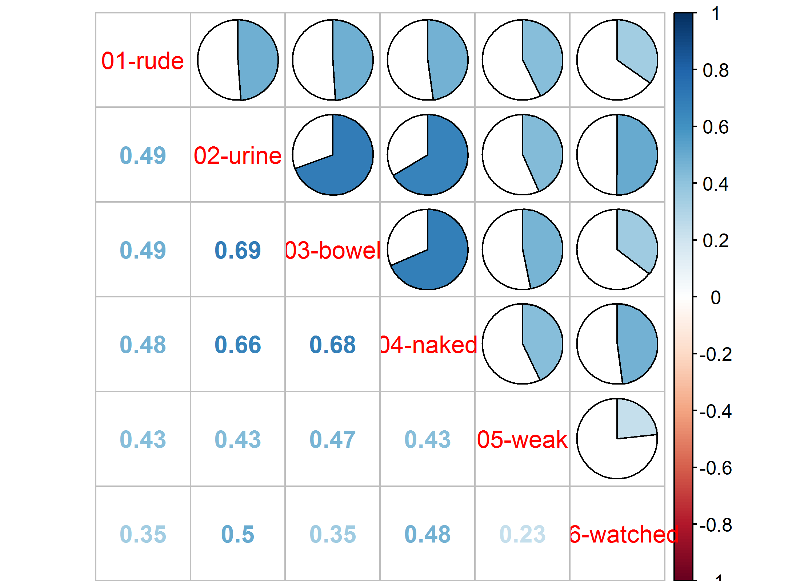NULL

## 01 - rude

1 - Losing emotional control in front of other people (being rude, yelling) during labour/birth?

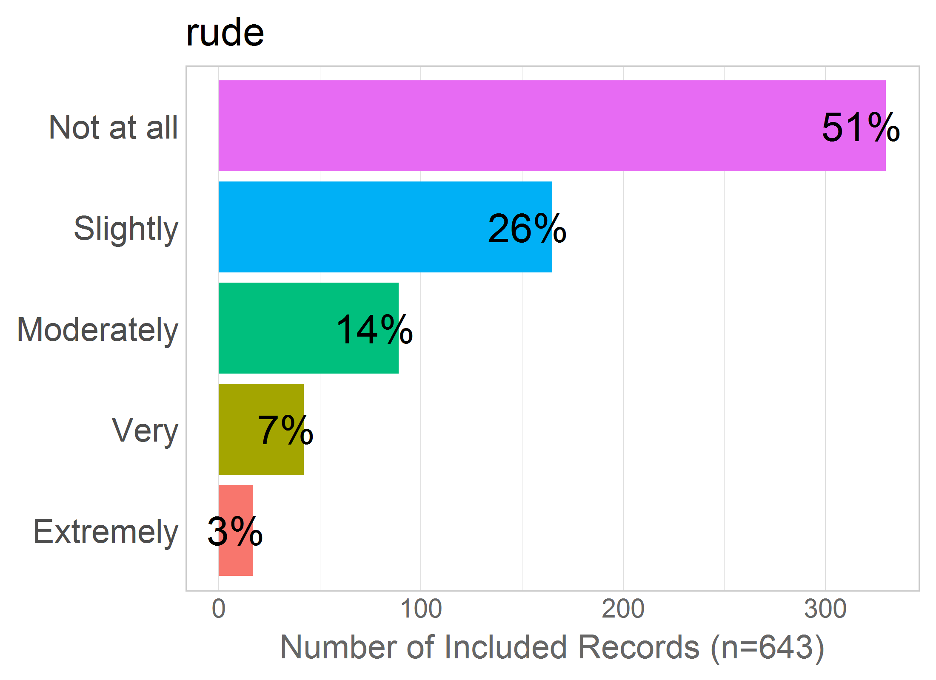

Mean: 1.84

SD: 1.06

Missing: 0

## 02 - urine

2 - Having other people see me urinate during labour/birth?

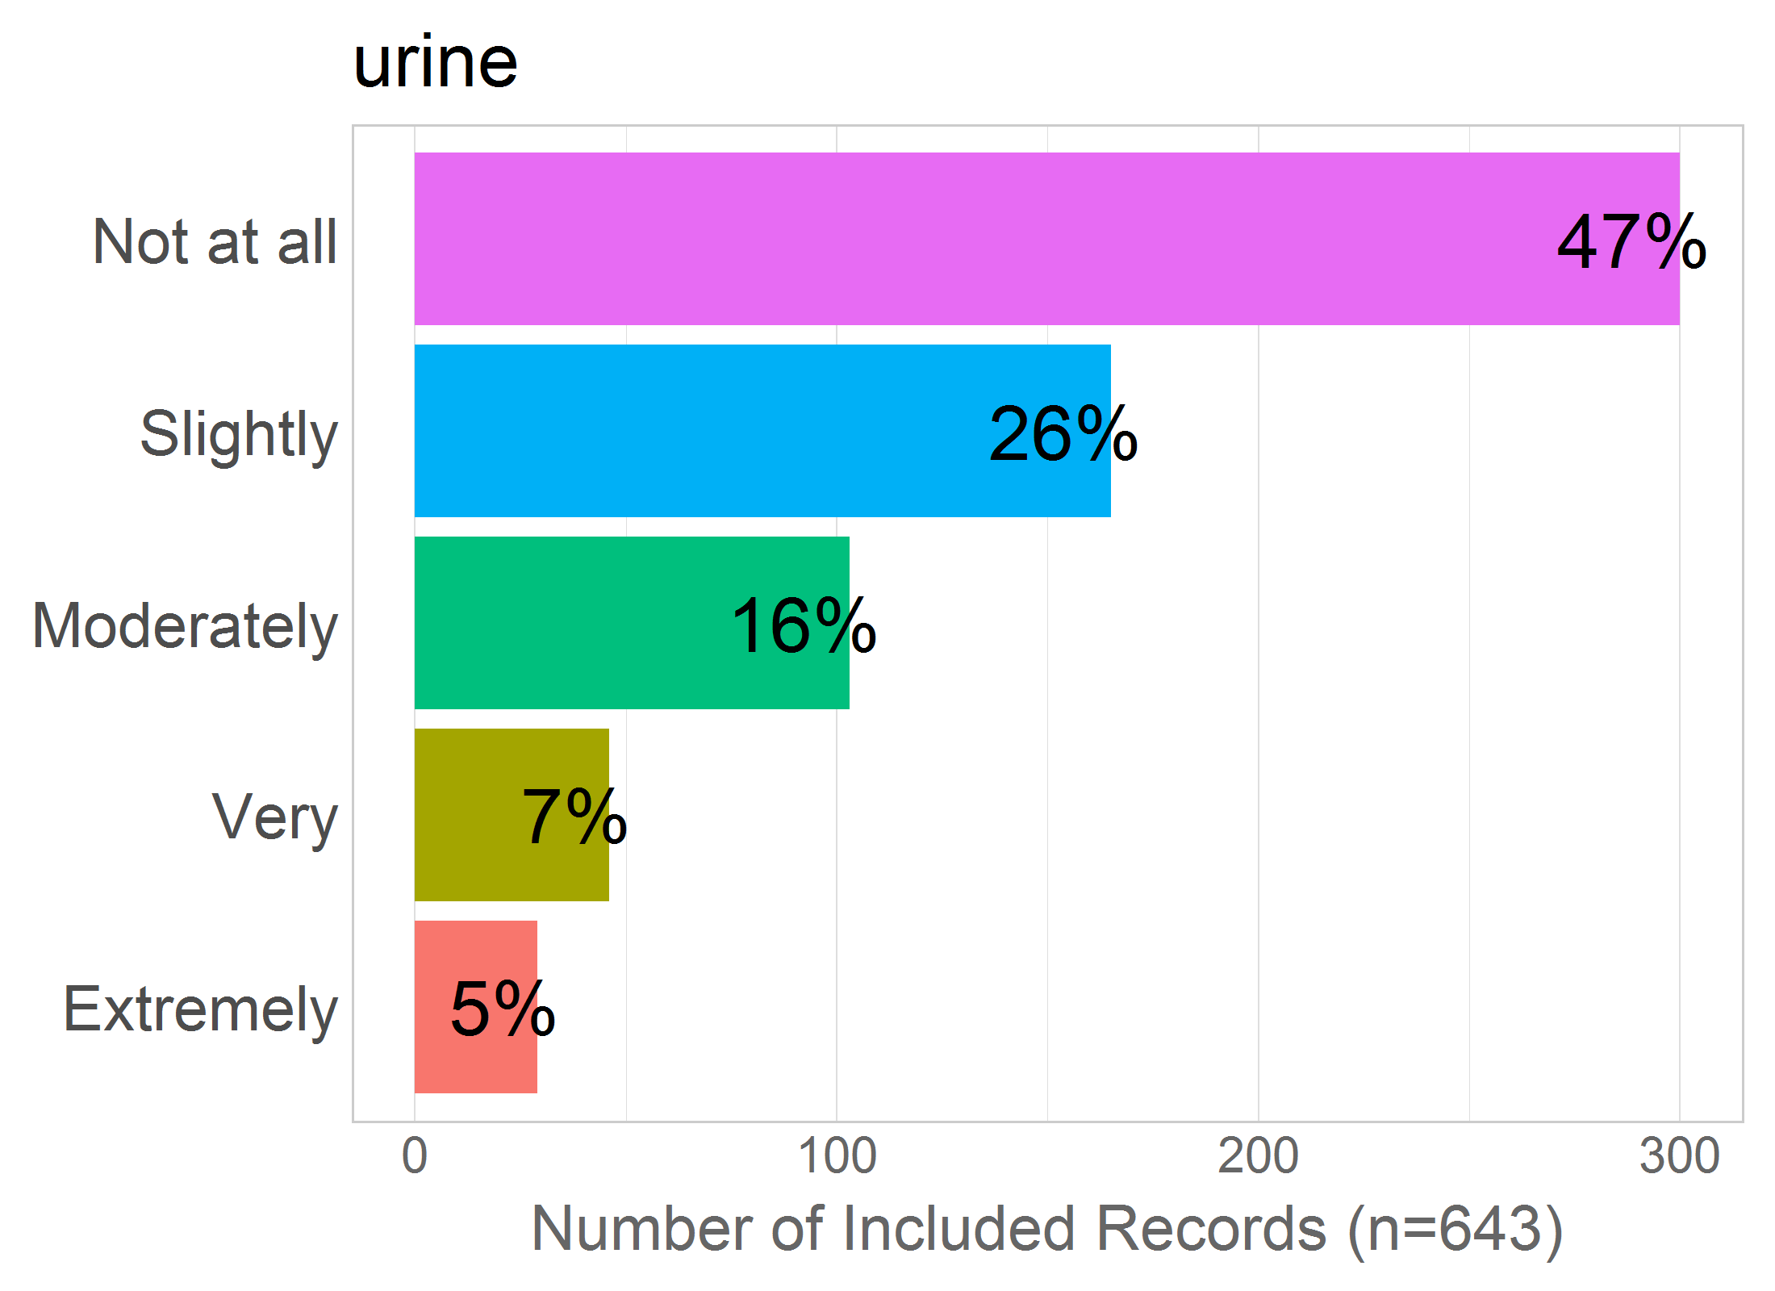

Mean: 1.97

SD: 1.15

Missing: 0

## 03 - bowel

3 - Other people seeing me have a bowel movement during labour/birth?

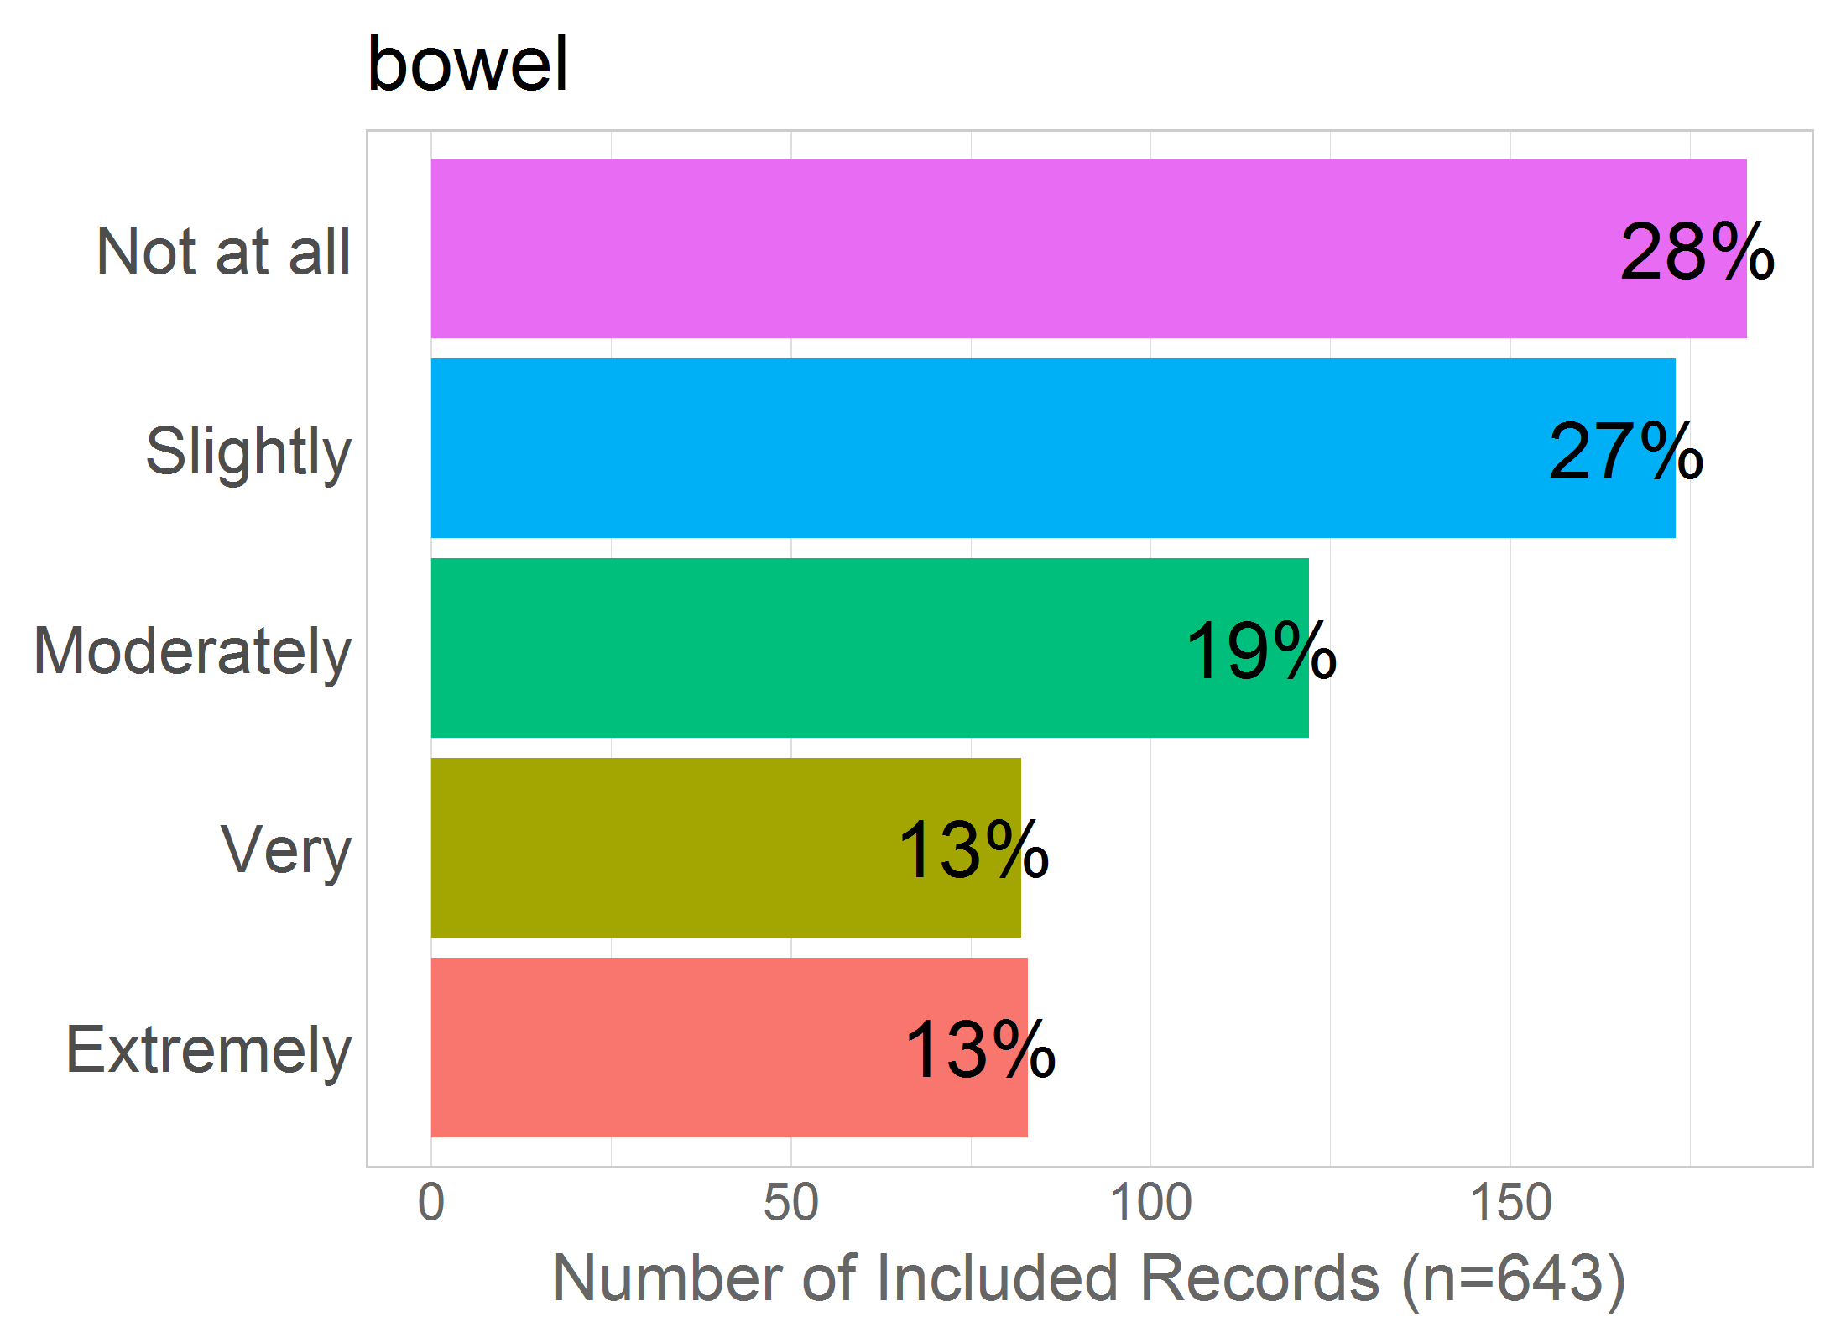

Mean: 2.55

SD: 1.36

Missing: 0

## 04 - naked

4 - Other people seeing me naked during labour/birth?

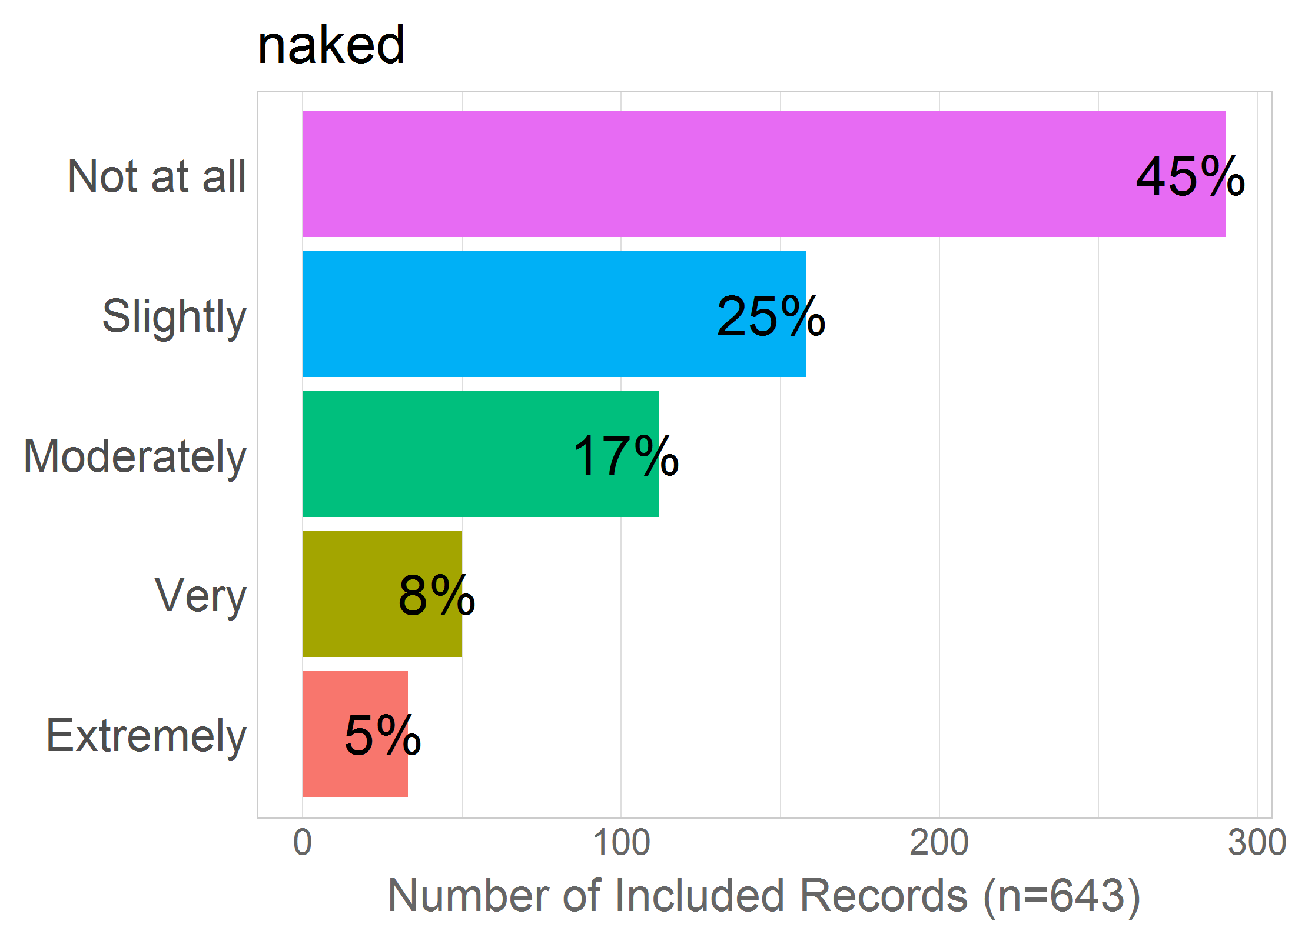

Mean: 2.03

SD: 1.18

Missing: 0

## 05 - weak

5 - Not living up to expectations to be strong?

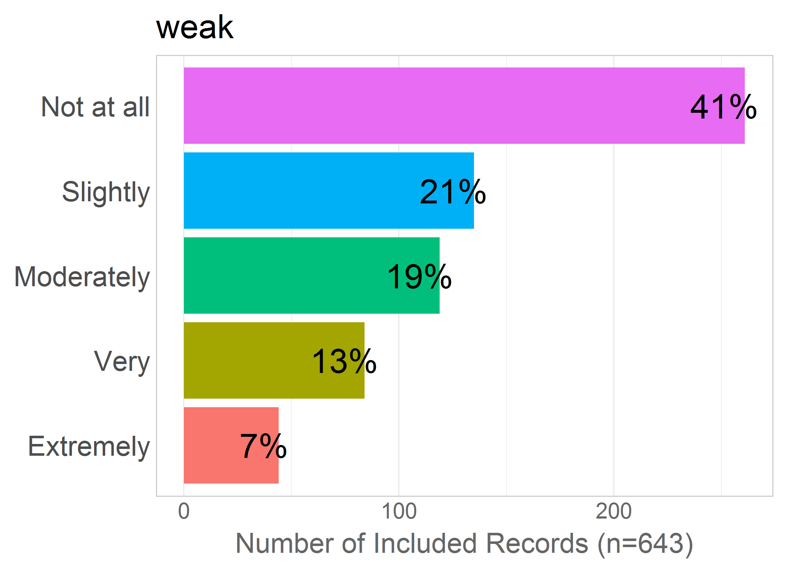

Mean: 2.25

SD: 1.29

Missing: 0

## 06 - watched

6 - Being watched by strangers during labour/birth?

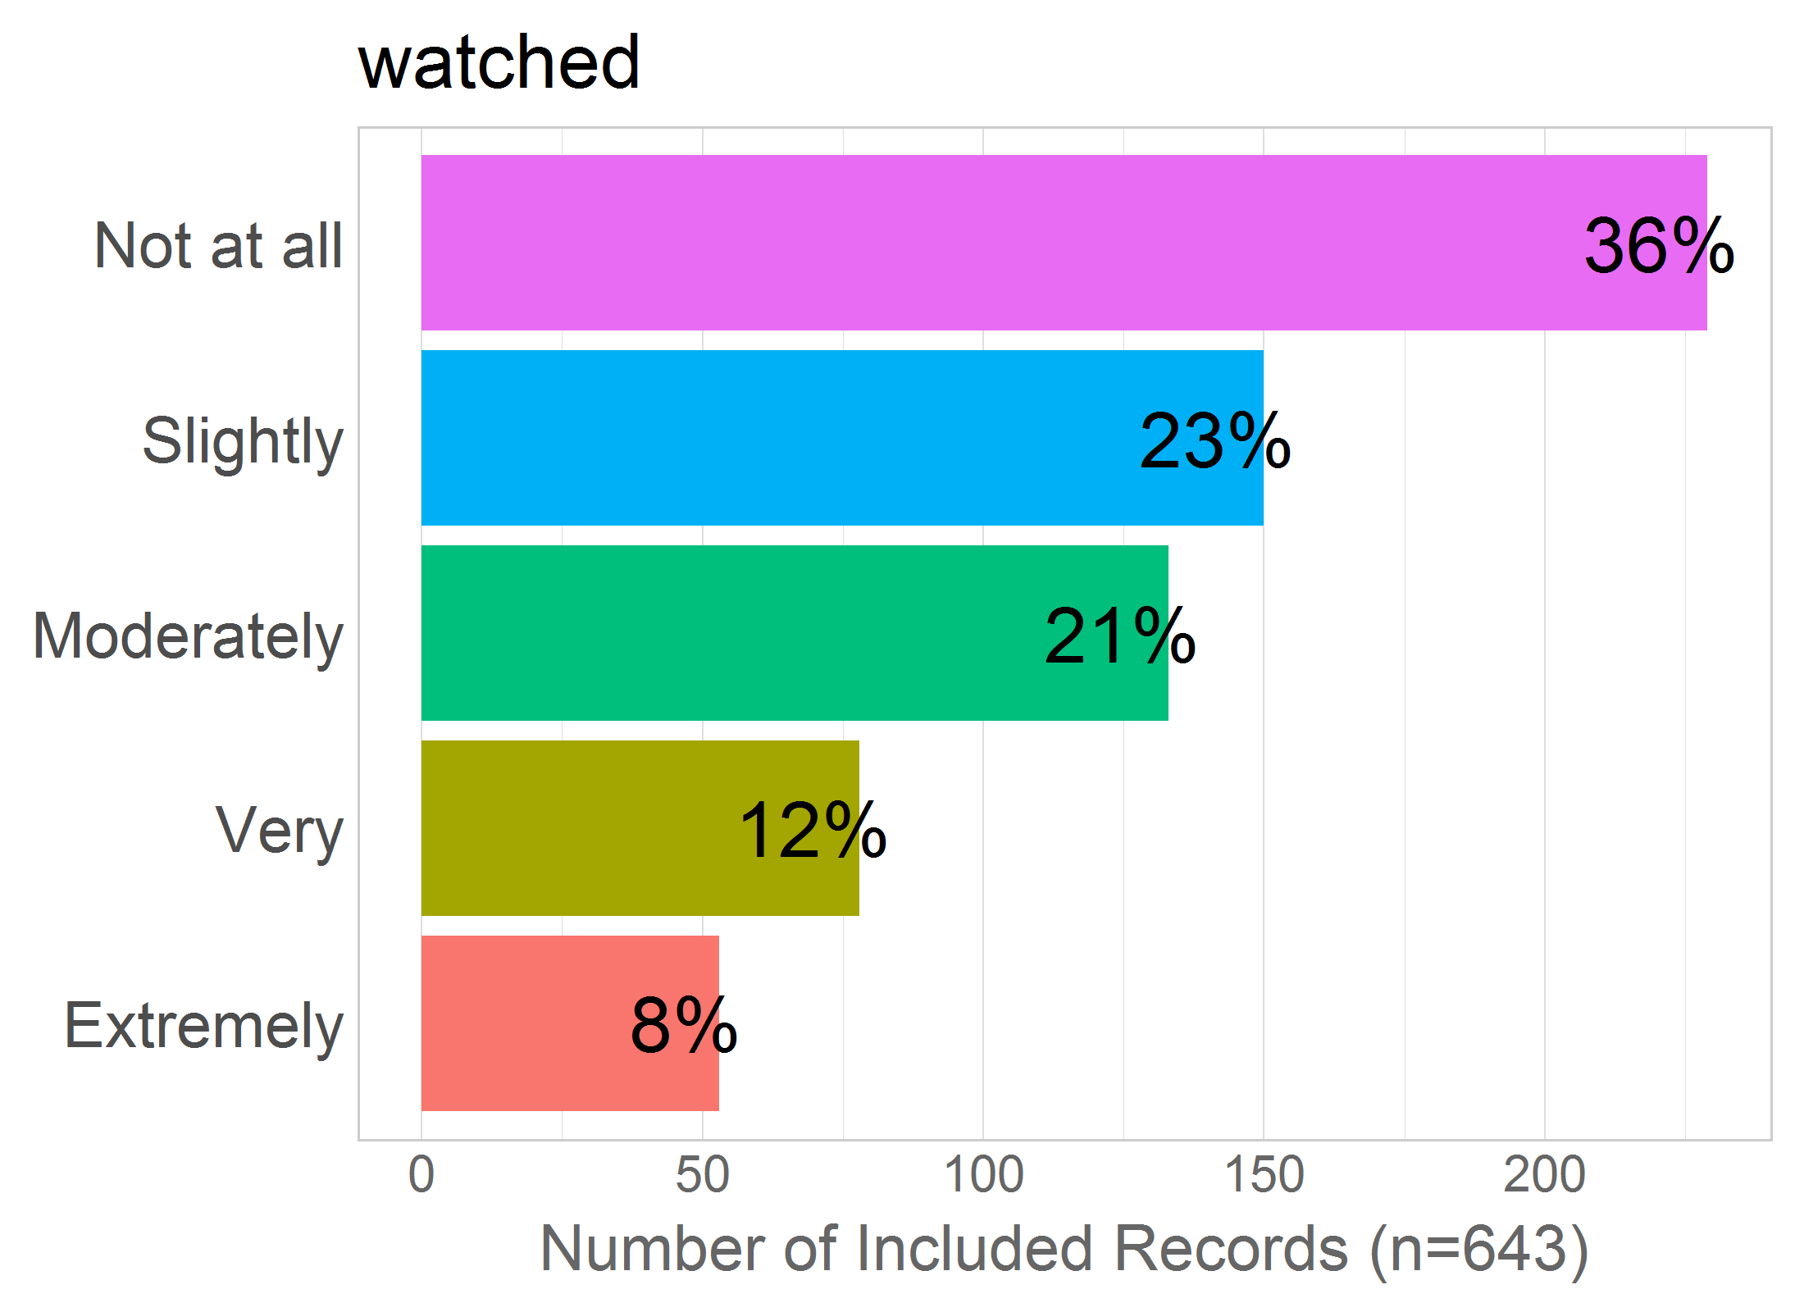

Mean: 2.34

SD: 1.29

Missing: 0

# PAIN

Correlation of items in the proposed factor:

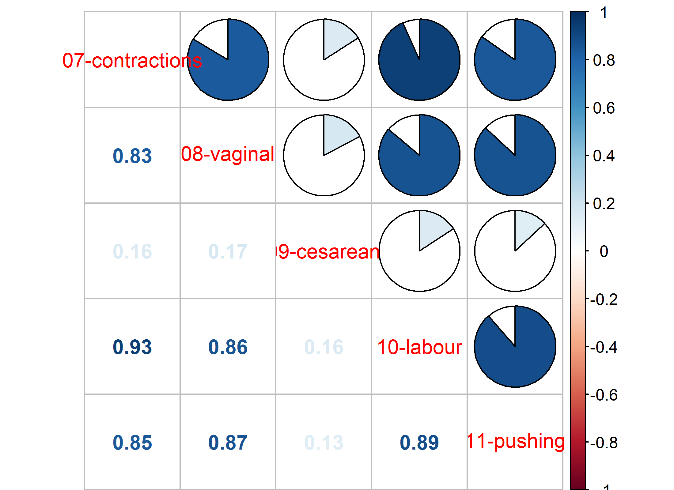NULL

## 07 - contractions

7 - Experiencing pain during contractions?

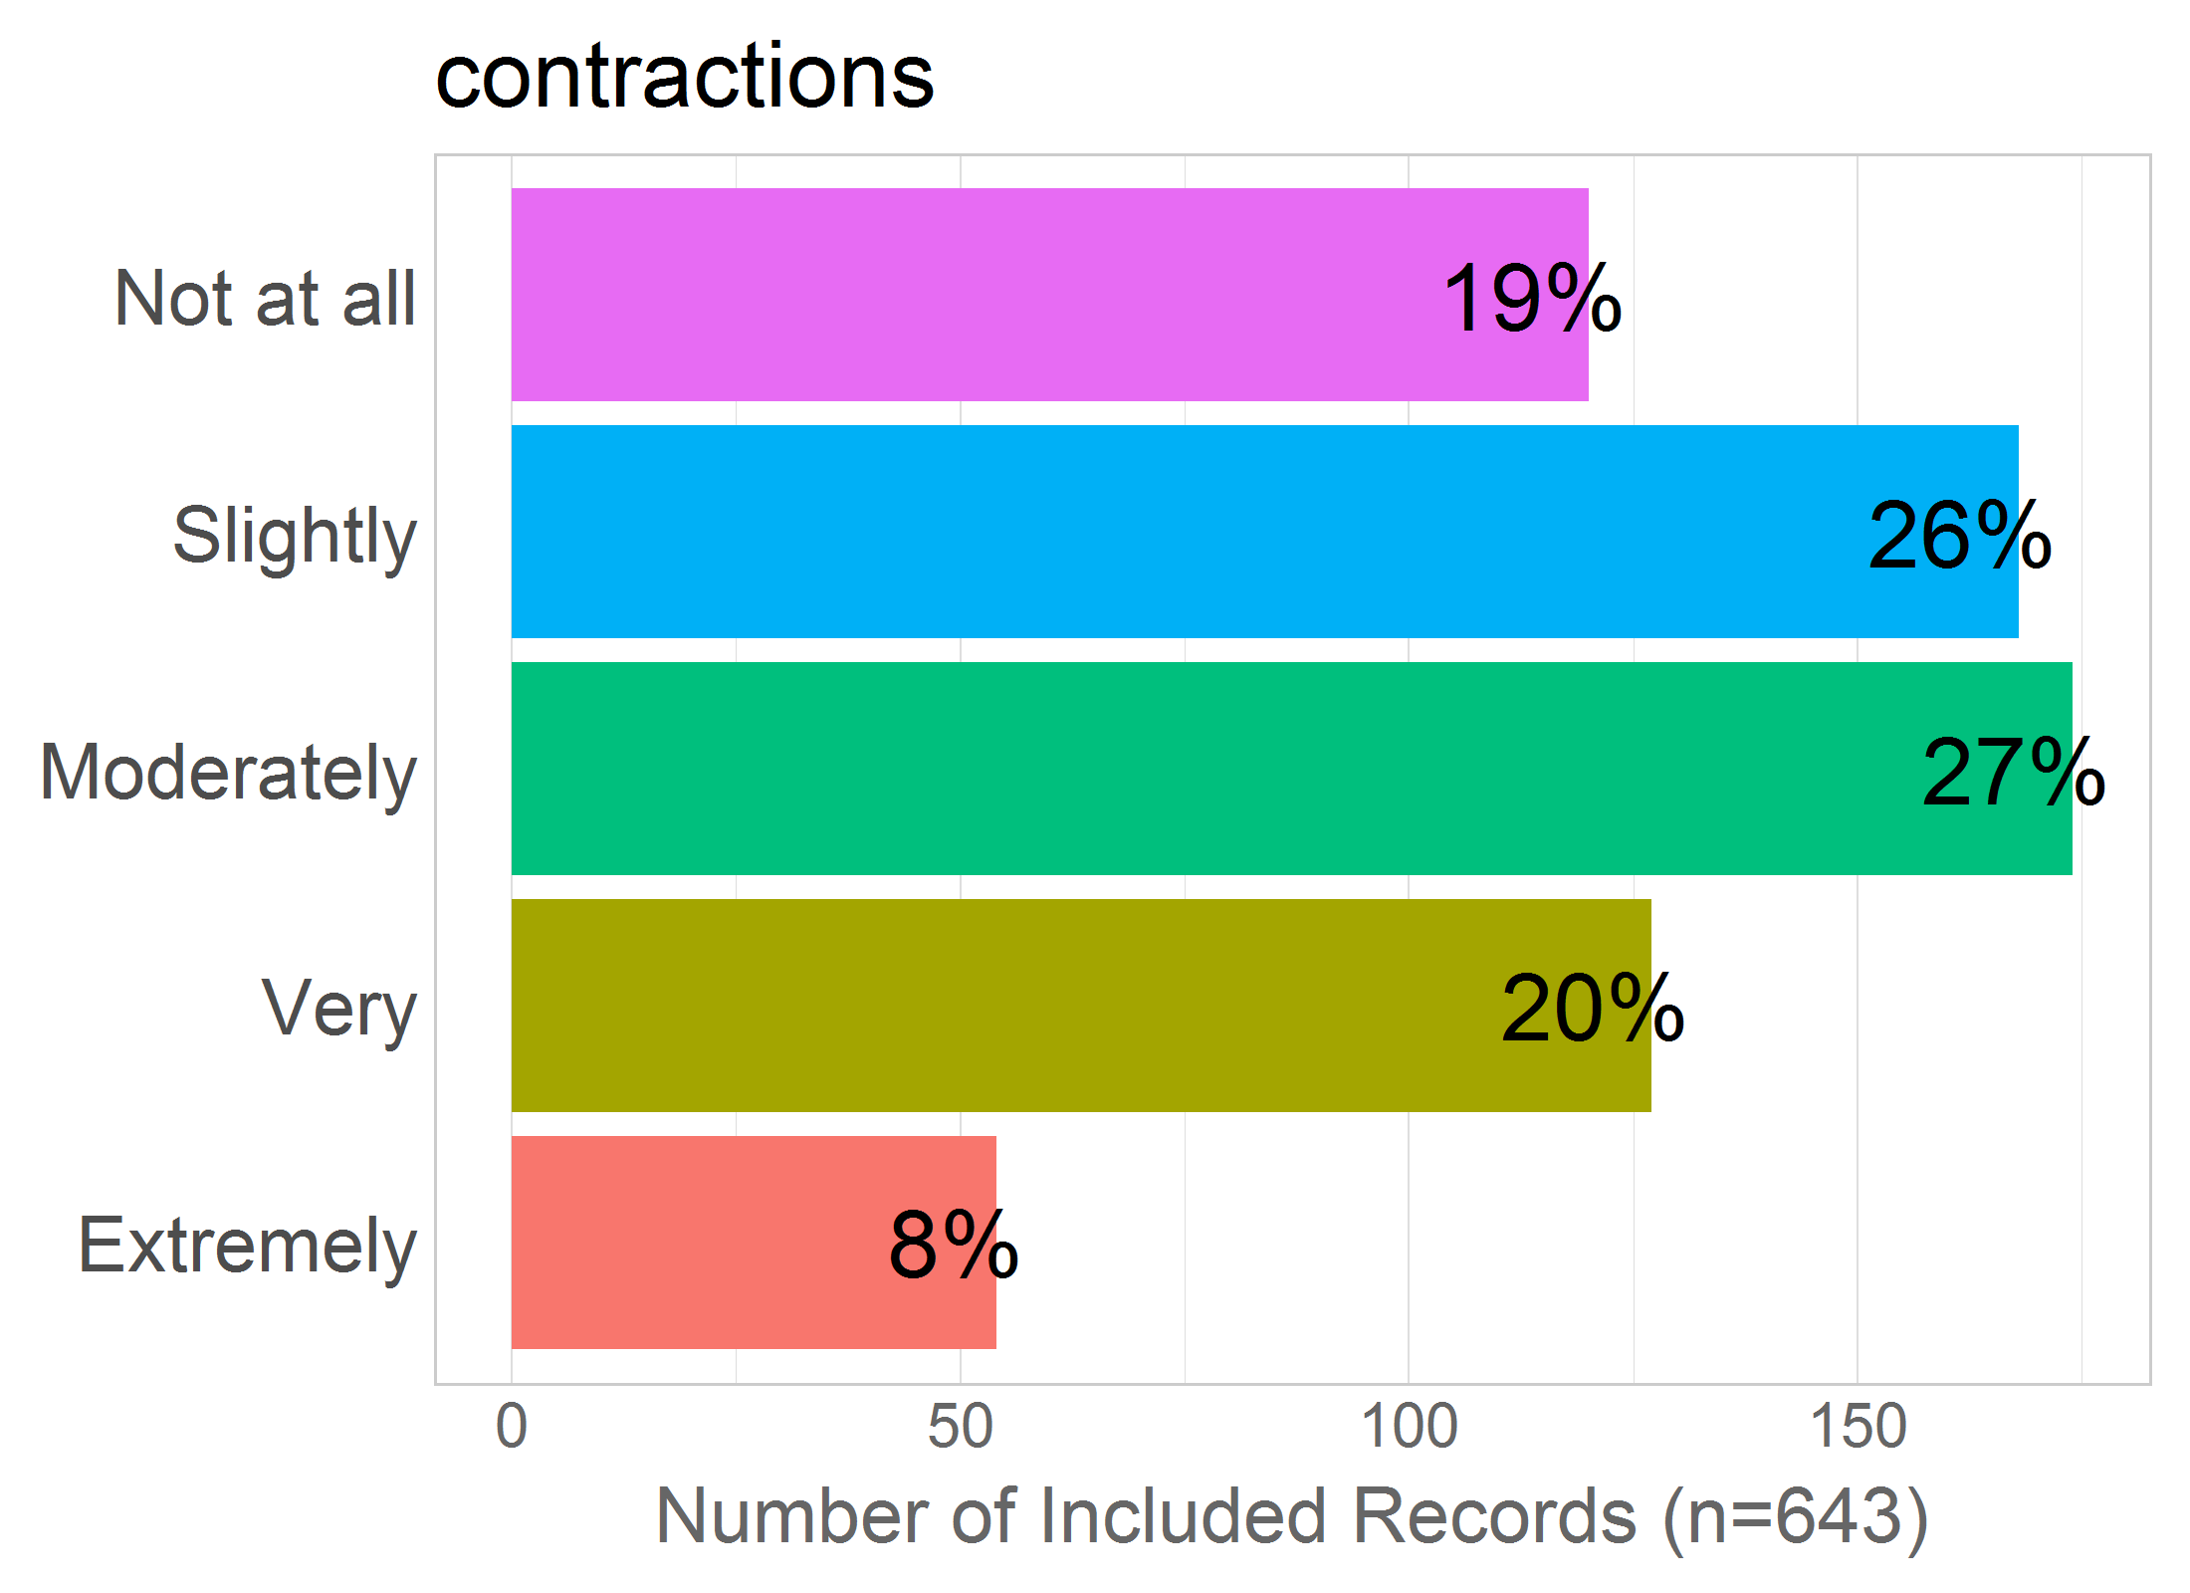

Mean: 2.73

SD: 1.21

Missing: 0

## 08 - vaginal

8 - Experiencing pain during a vaginal birth?

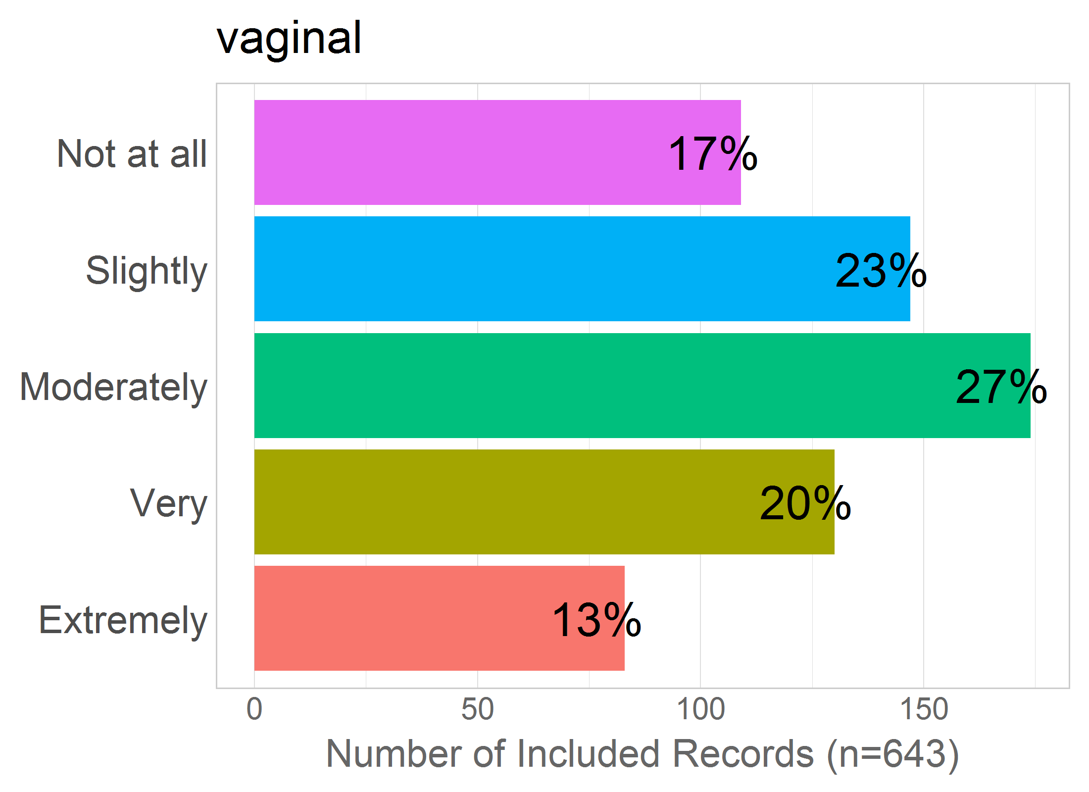

Mean: 2.89

SD: 1.27

Missing: 0

## 09 - cesarean

9 - Experiencing pain during a cesarean birth?

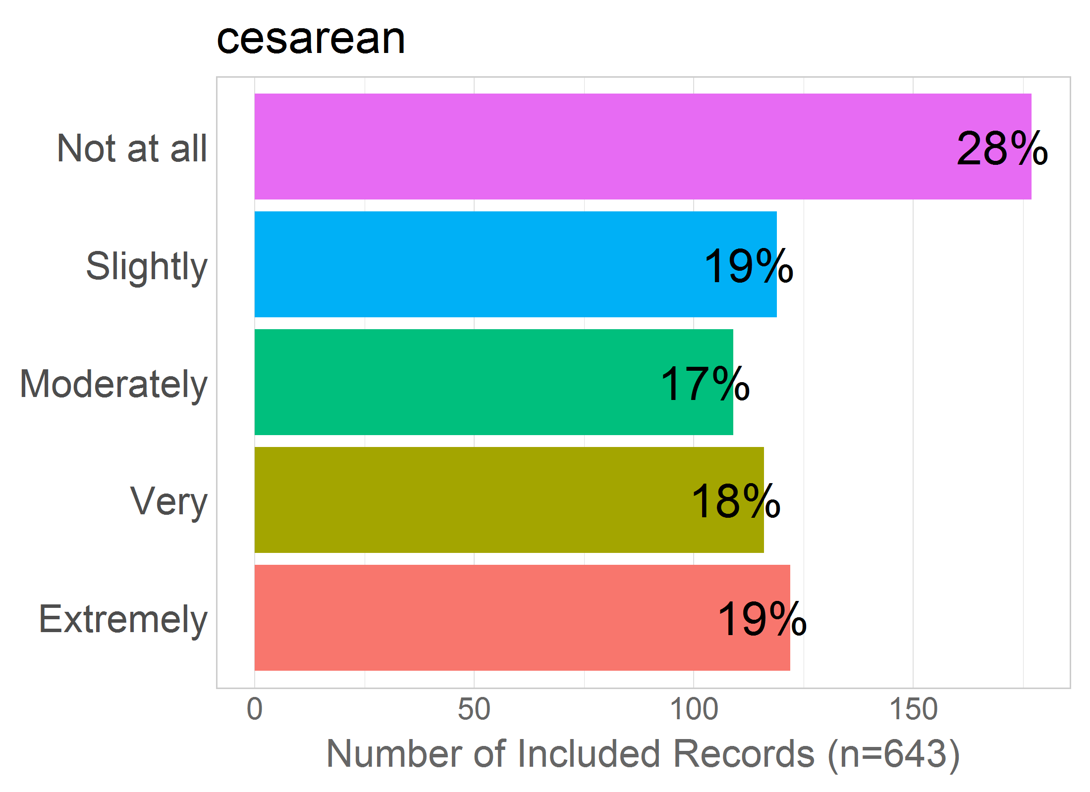

Mean: 2.82

SD: 1.48

Missing: 0

## 10 - labour

10 - Experiencing pain during labour?

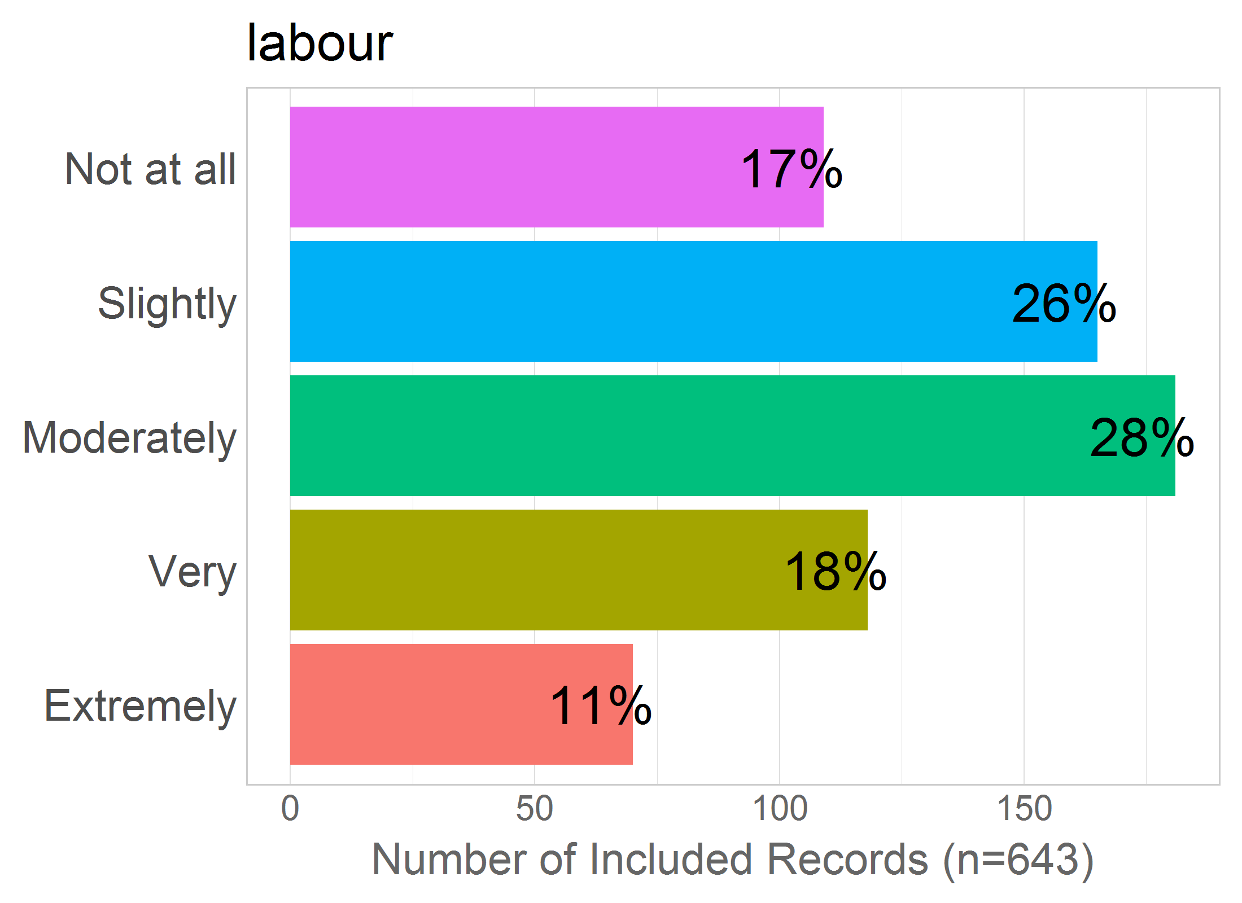

Mean: 2.81

SD: 1.23

Missing: 0

## 11 - pushing

11 - Experiencing pain while pushing the baby out?

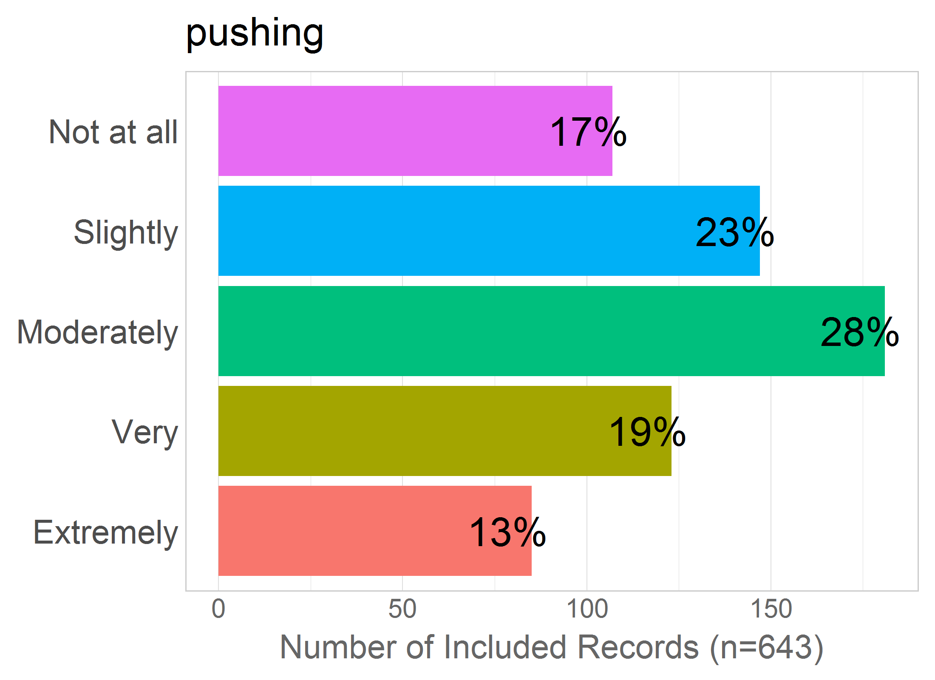

Mean: 2.89

SD: 1.27

Missing: 0

# MEDS

Correlation of items in the proposed factor:

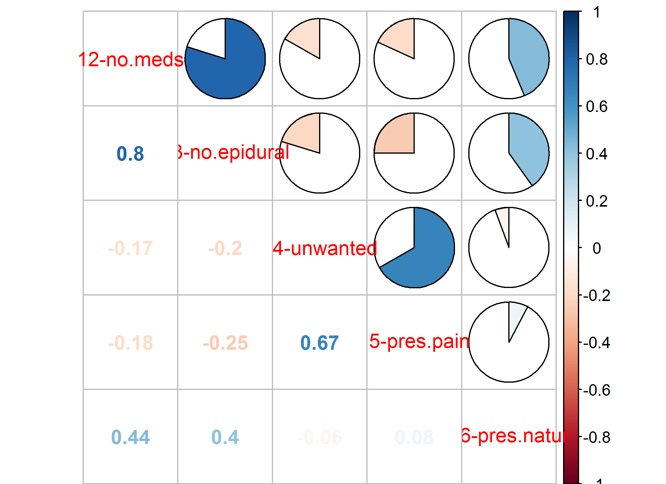NULL

## 12 - no.meds

12 - Not getting the pain medication I need?

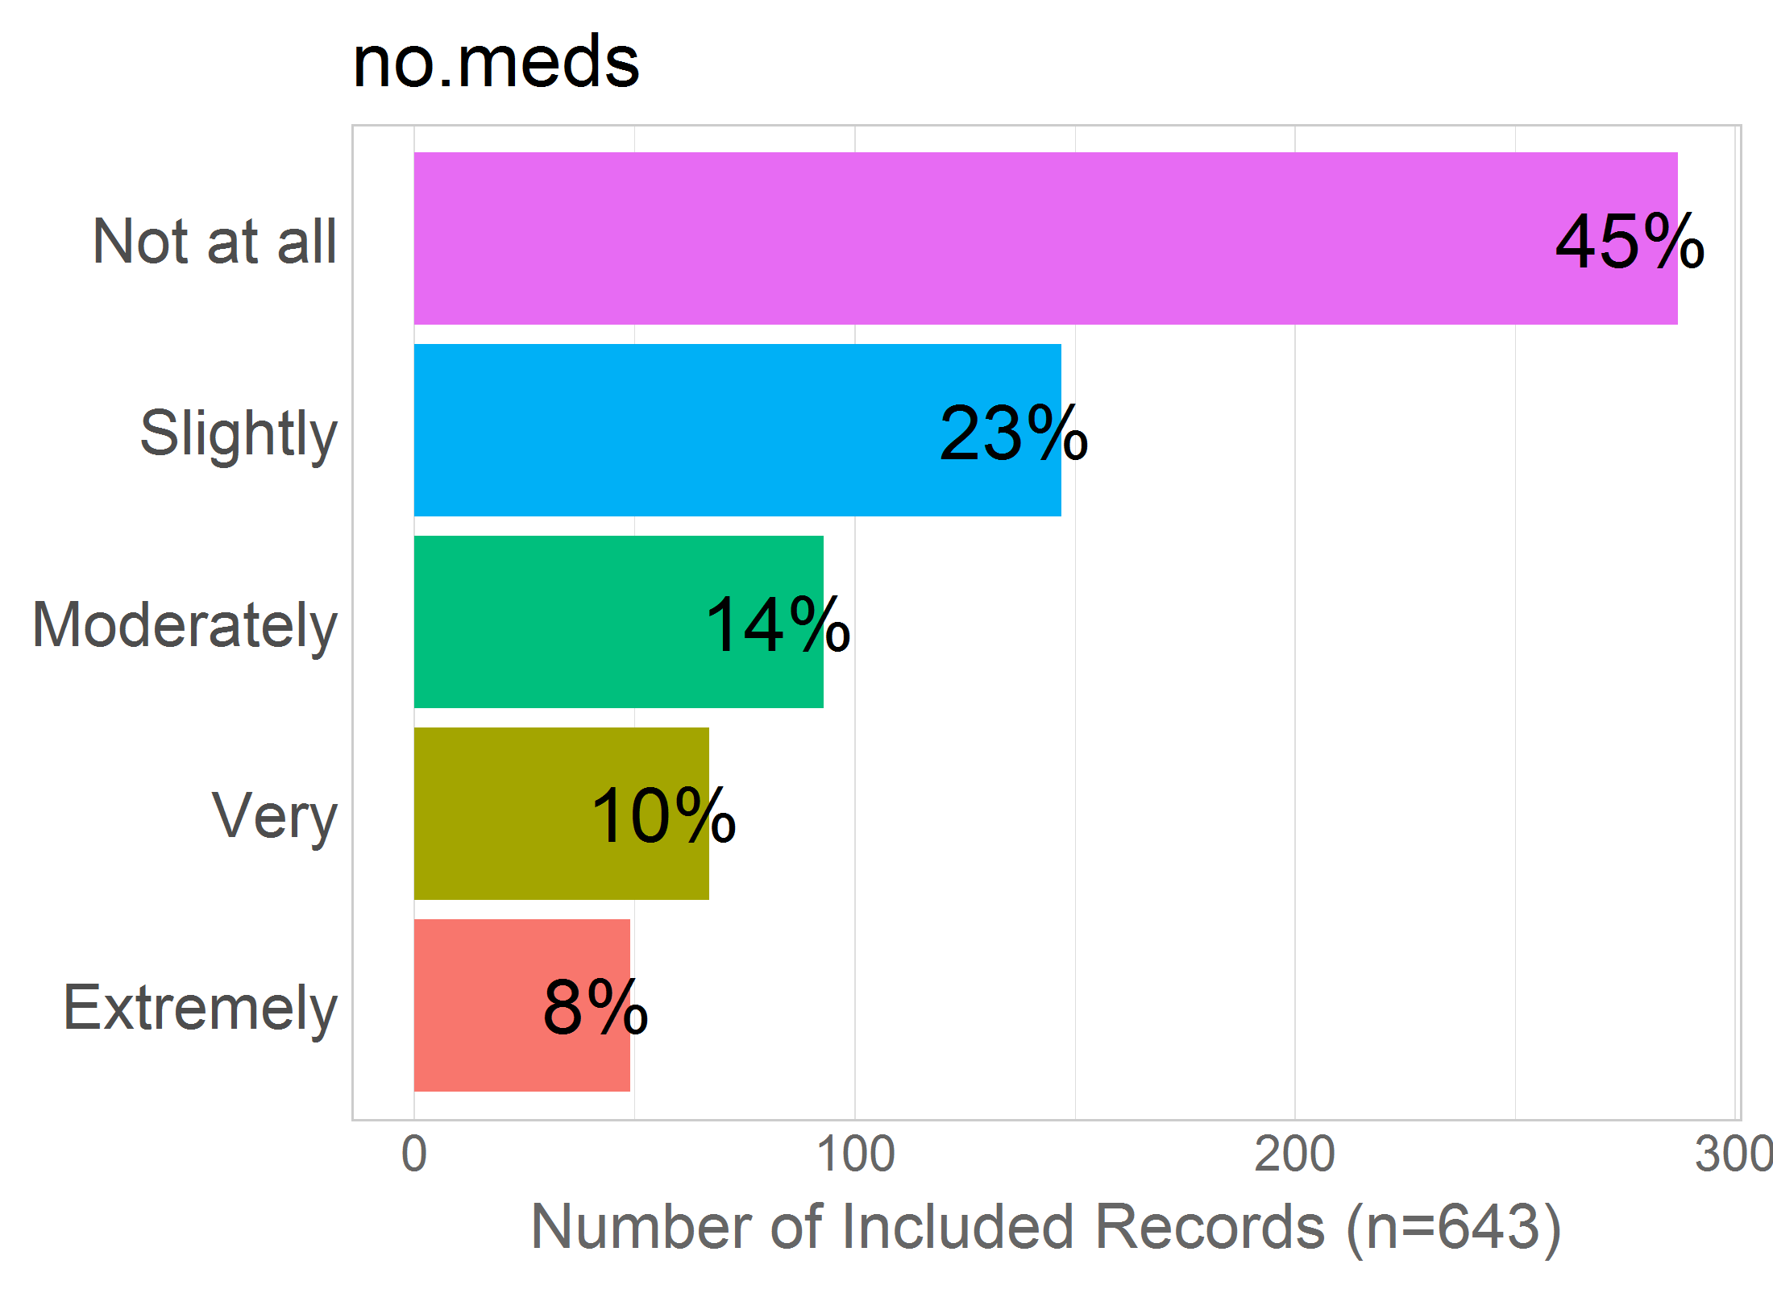

Mean: 2.14

SD: 1.3

Missing: 0

## 13 - no.epidural

13 - Not being able to have an epidural during labour if I want/need one?

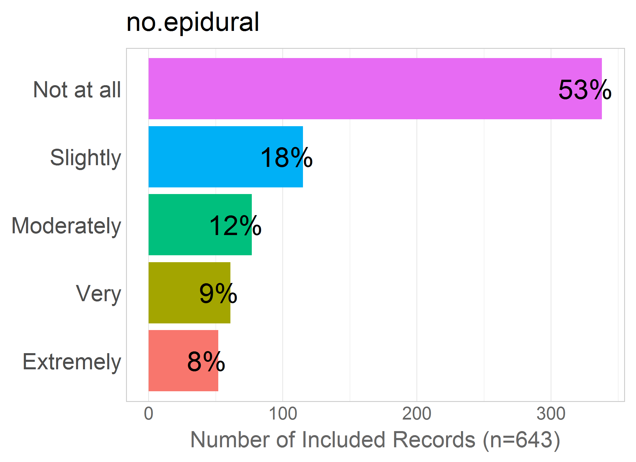

Mean: 2.03

SD: 1.32

Missing: 0

## 14 - unwanted

14 - Receiving unwanted pain medication during labour/birth?

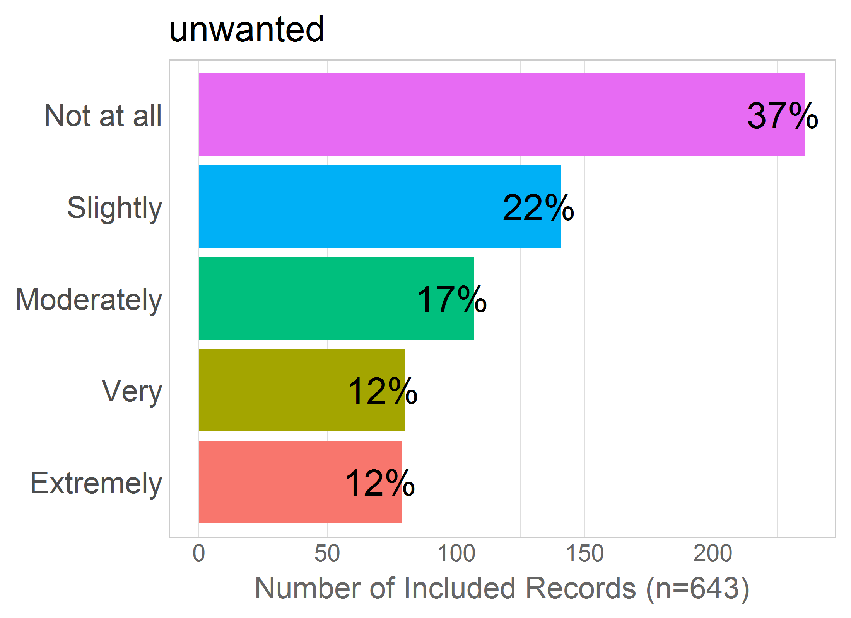

Mean: 2.42

SD: 1.4

Missing: 0

## 15 - pres.pain

15 - Feeling pressure to receive pain medication during labour/birth even though I may not want to?

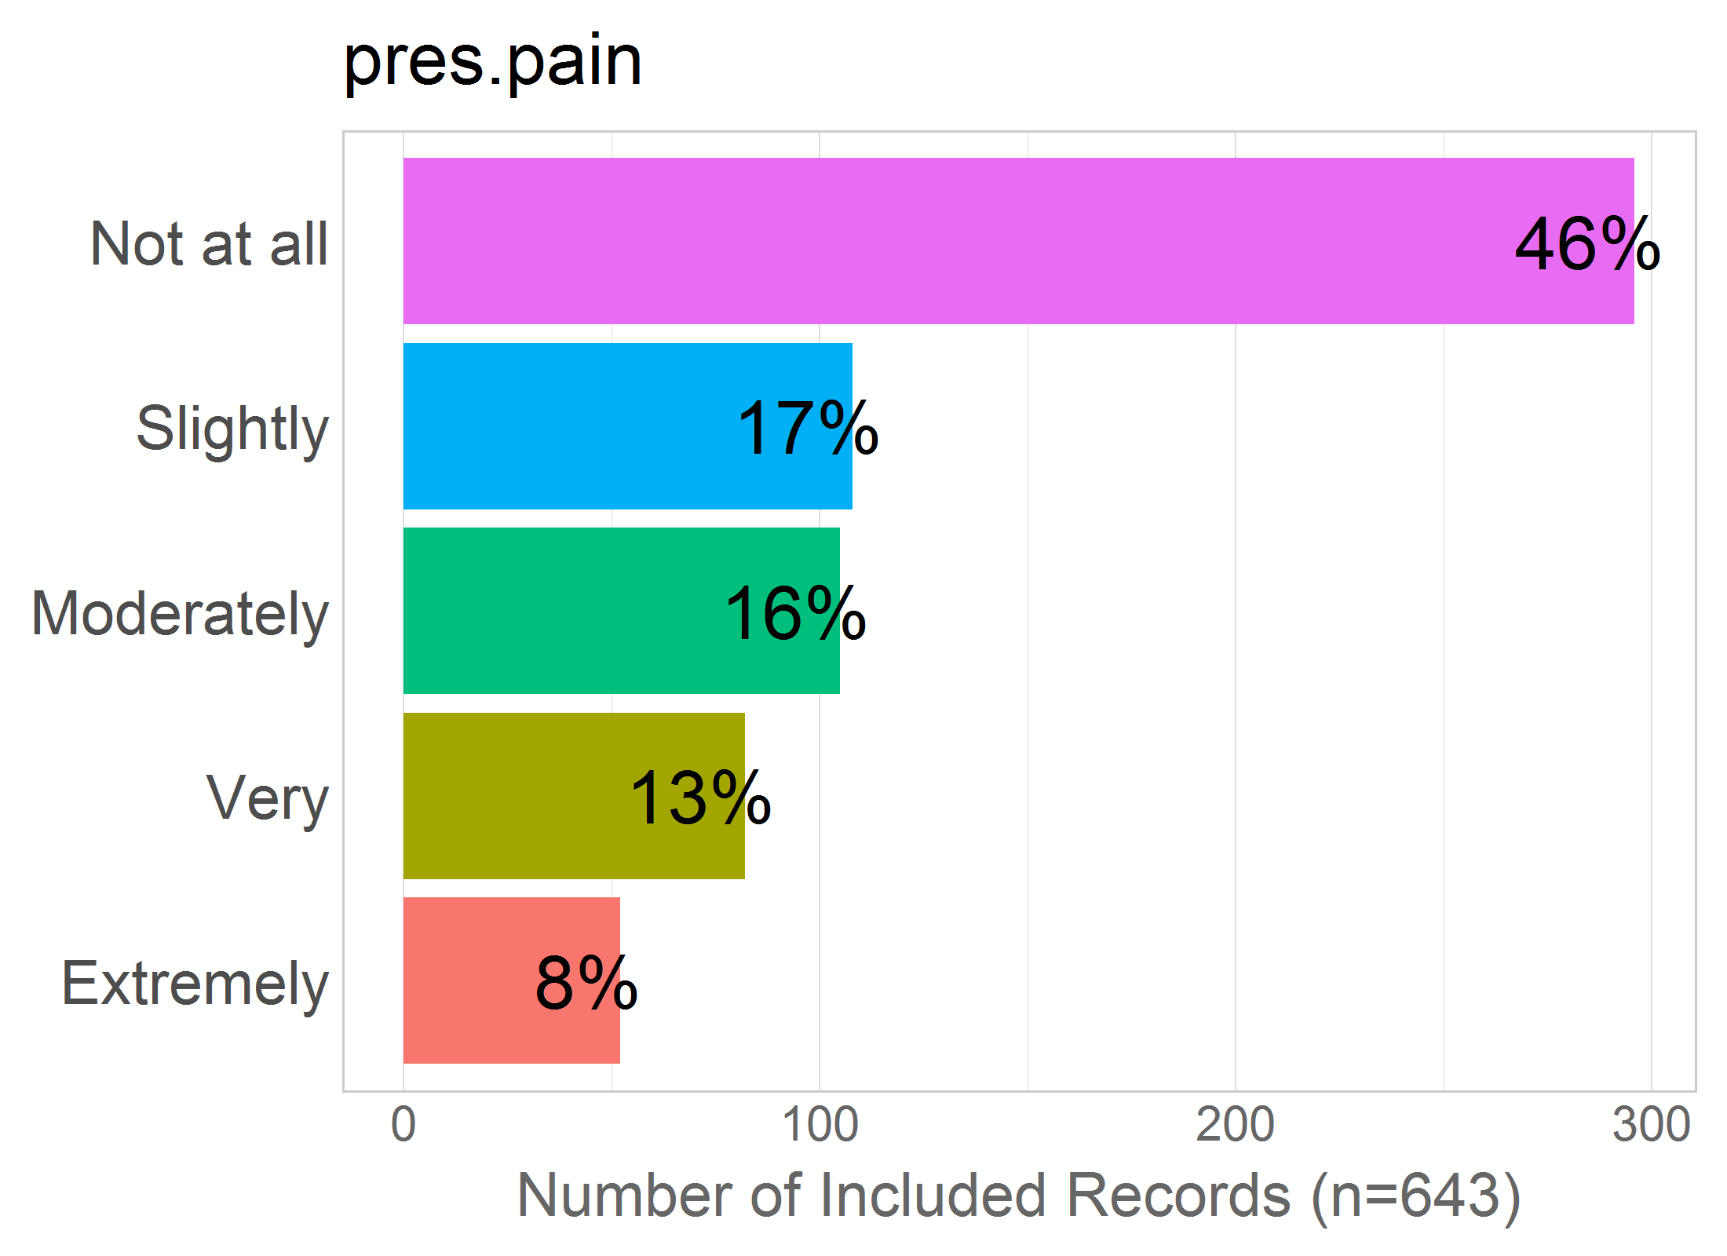

Mean: 2.2

SD: 1.35

Missing: 0

## 16 - pres.natur

16 - Feeling pressure from others to have a natural (unmedicated) childbirth, even though this is not really what I want?

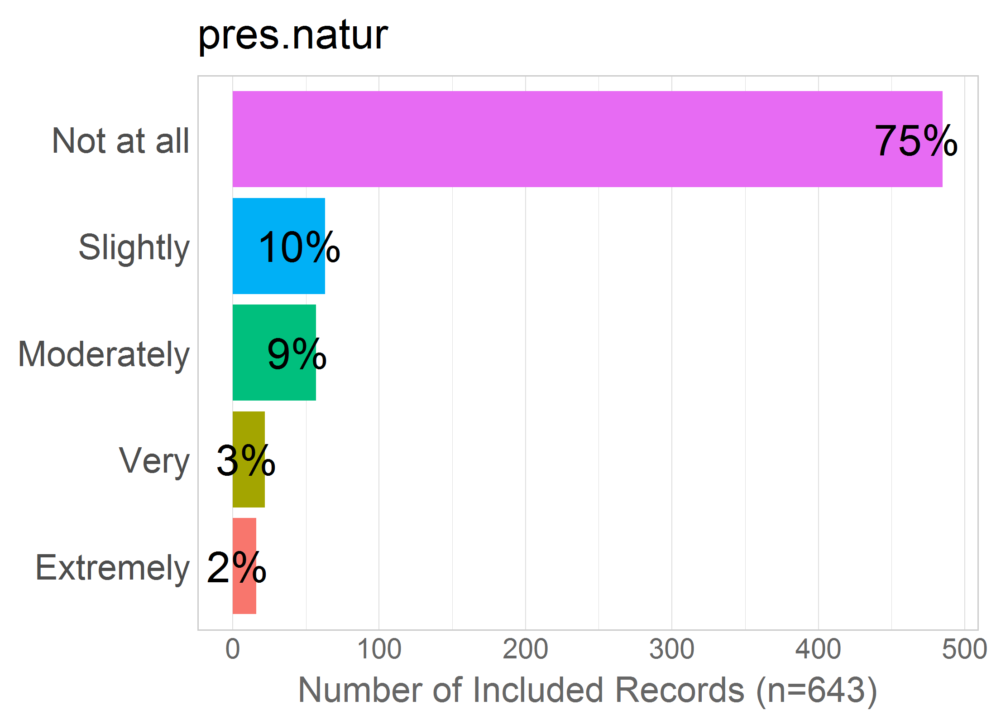

Mean: 1.48

SD: 0.97

Missing: 0

# DELIVERY.MODE

Correlation of items in the proposed factor:

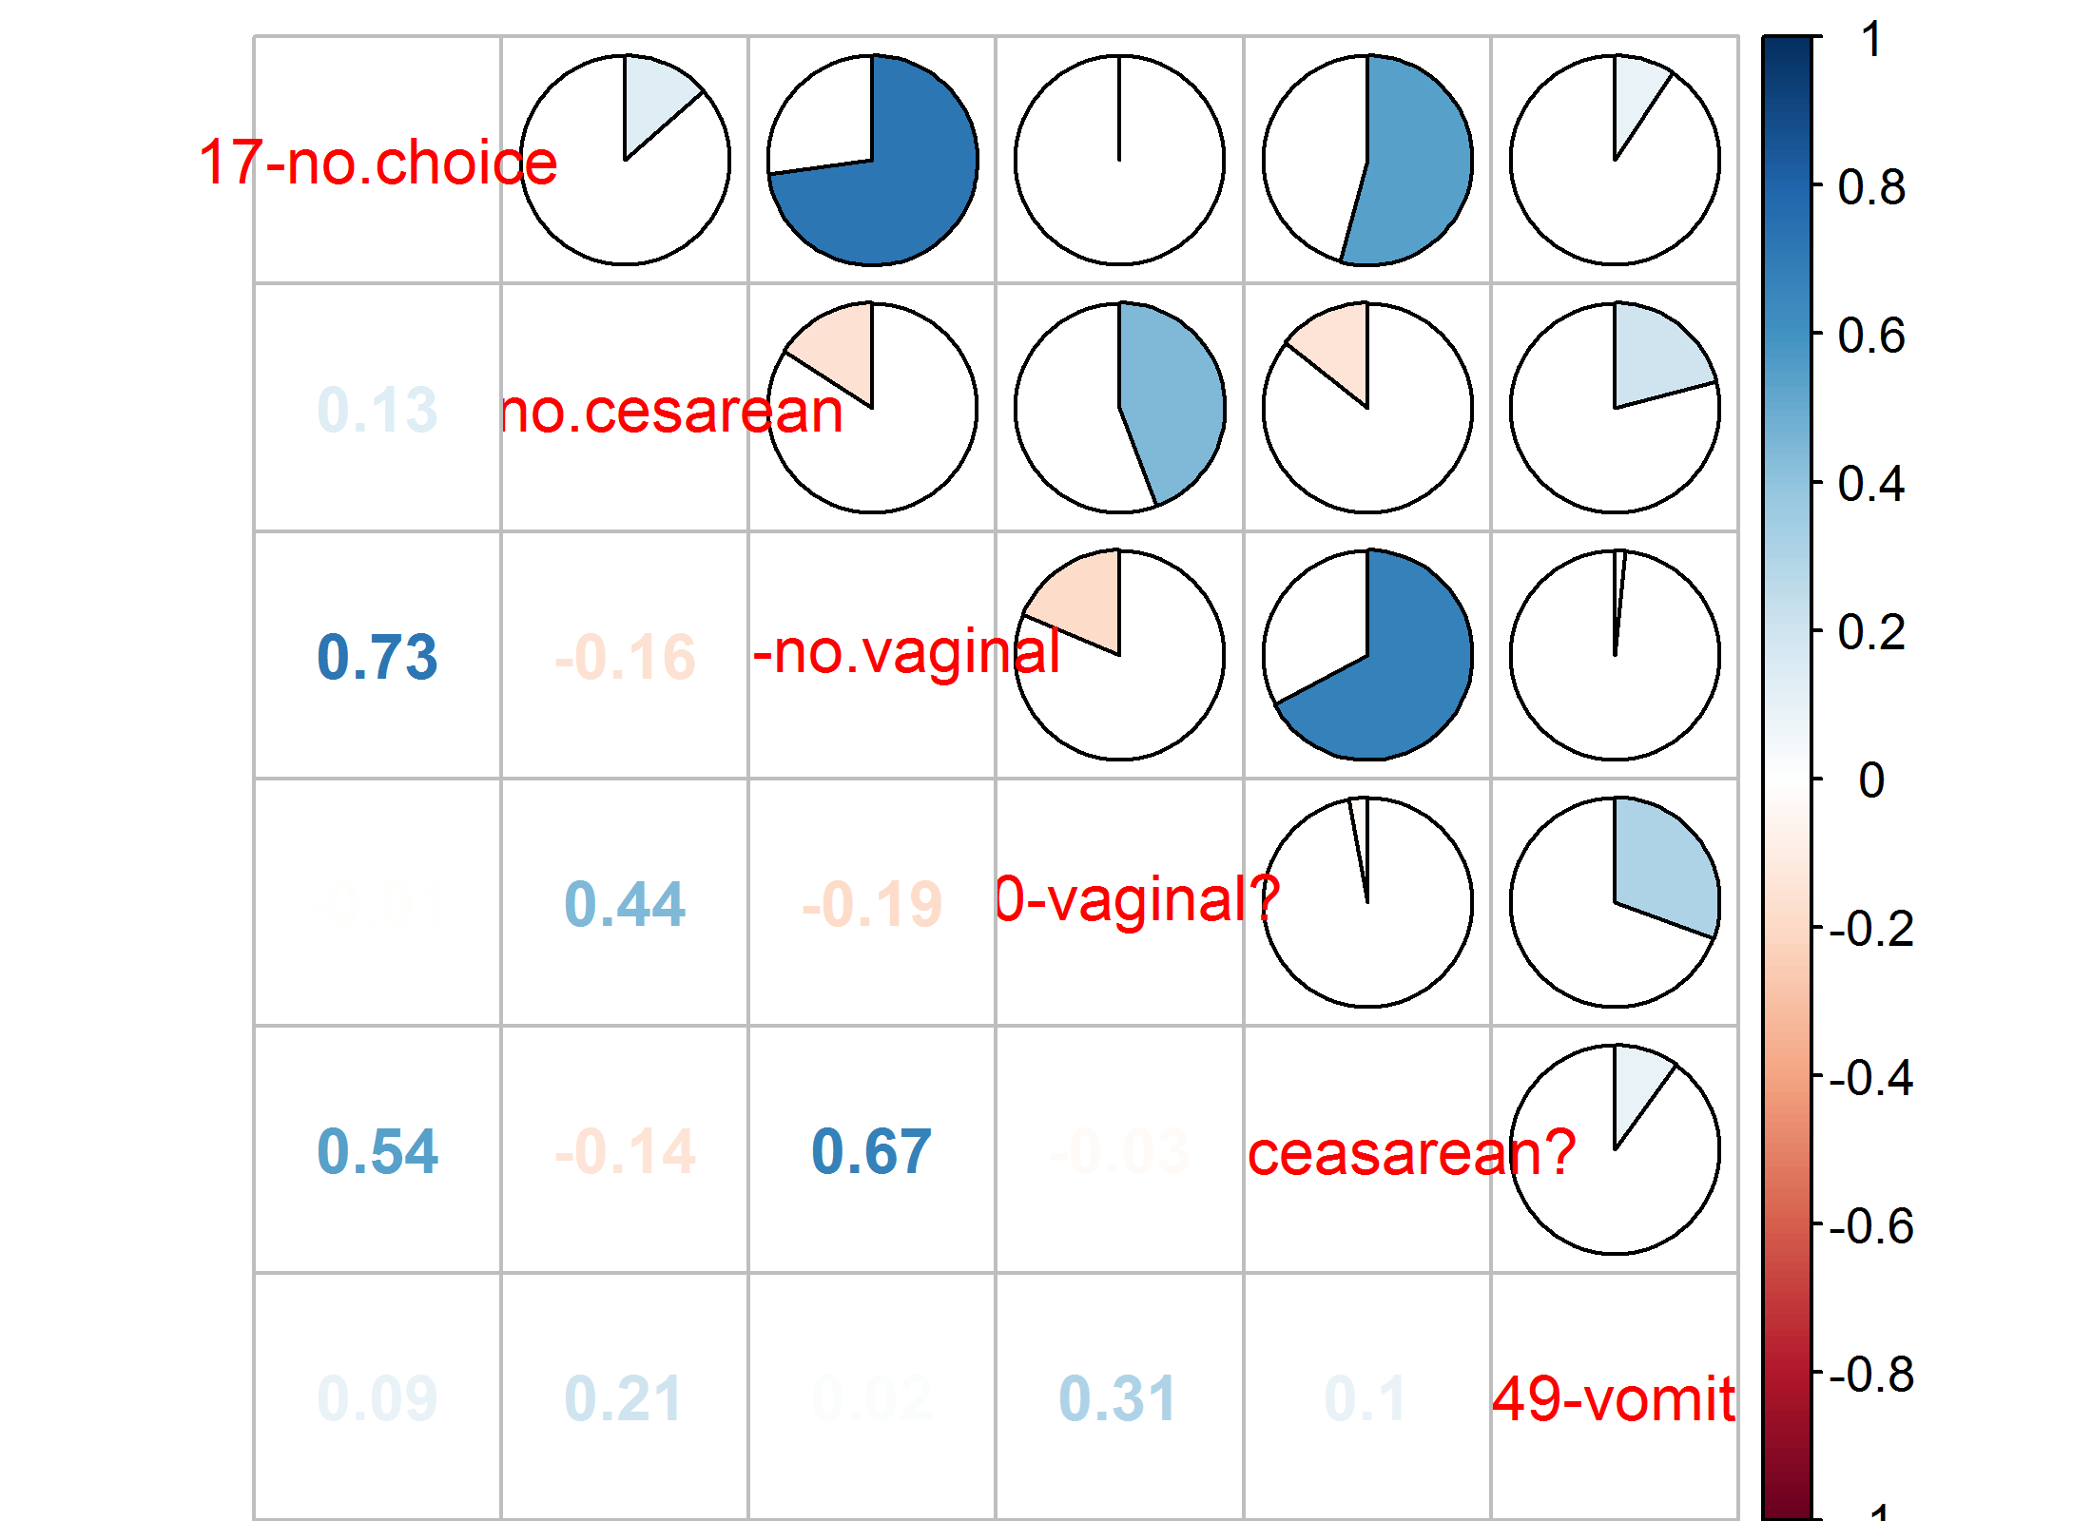NULL

## 17 - no.choice

17 - Not being able to have the kind of birth I want (i.e., either vaginal or cesarean)?

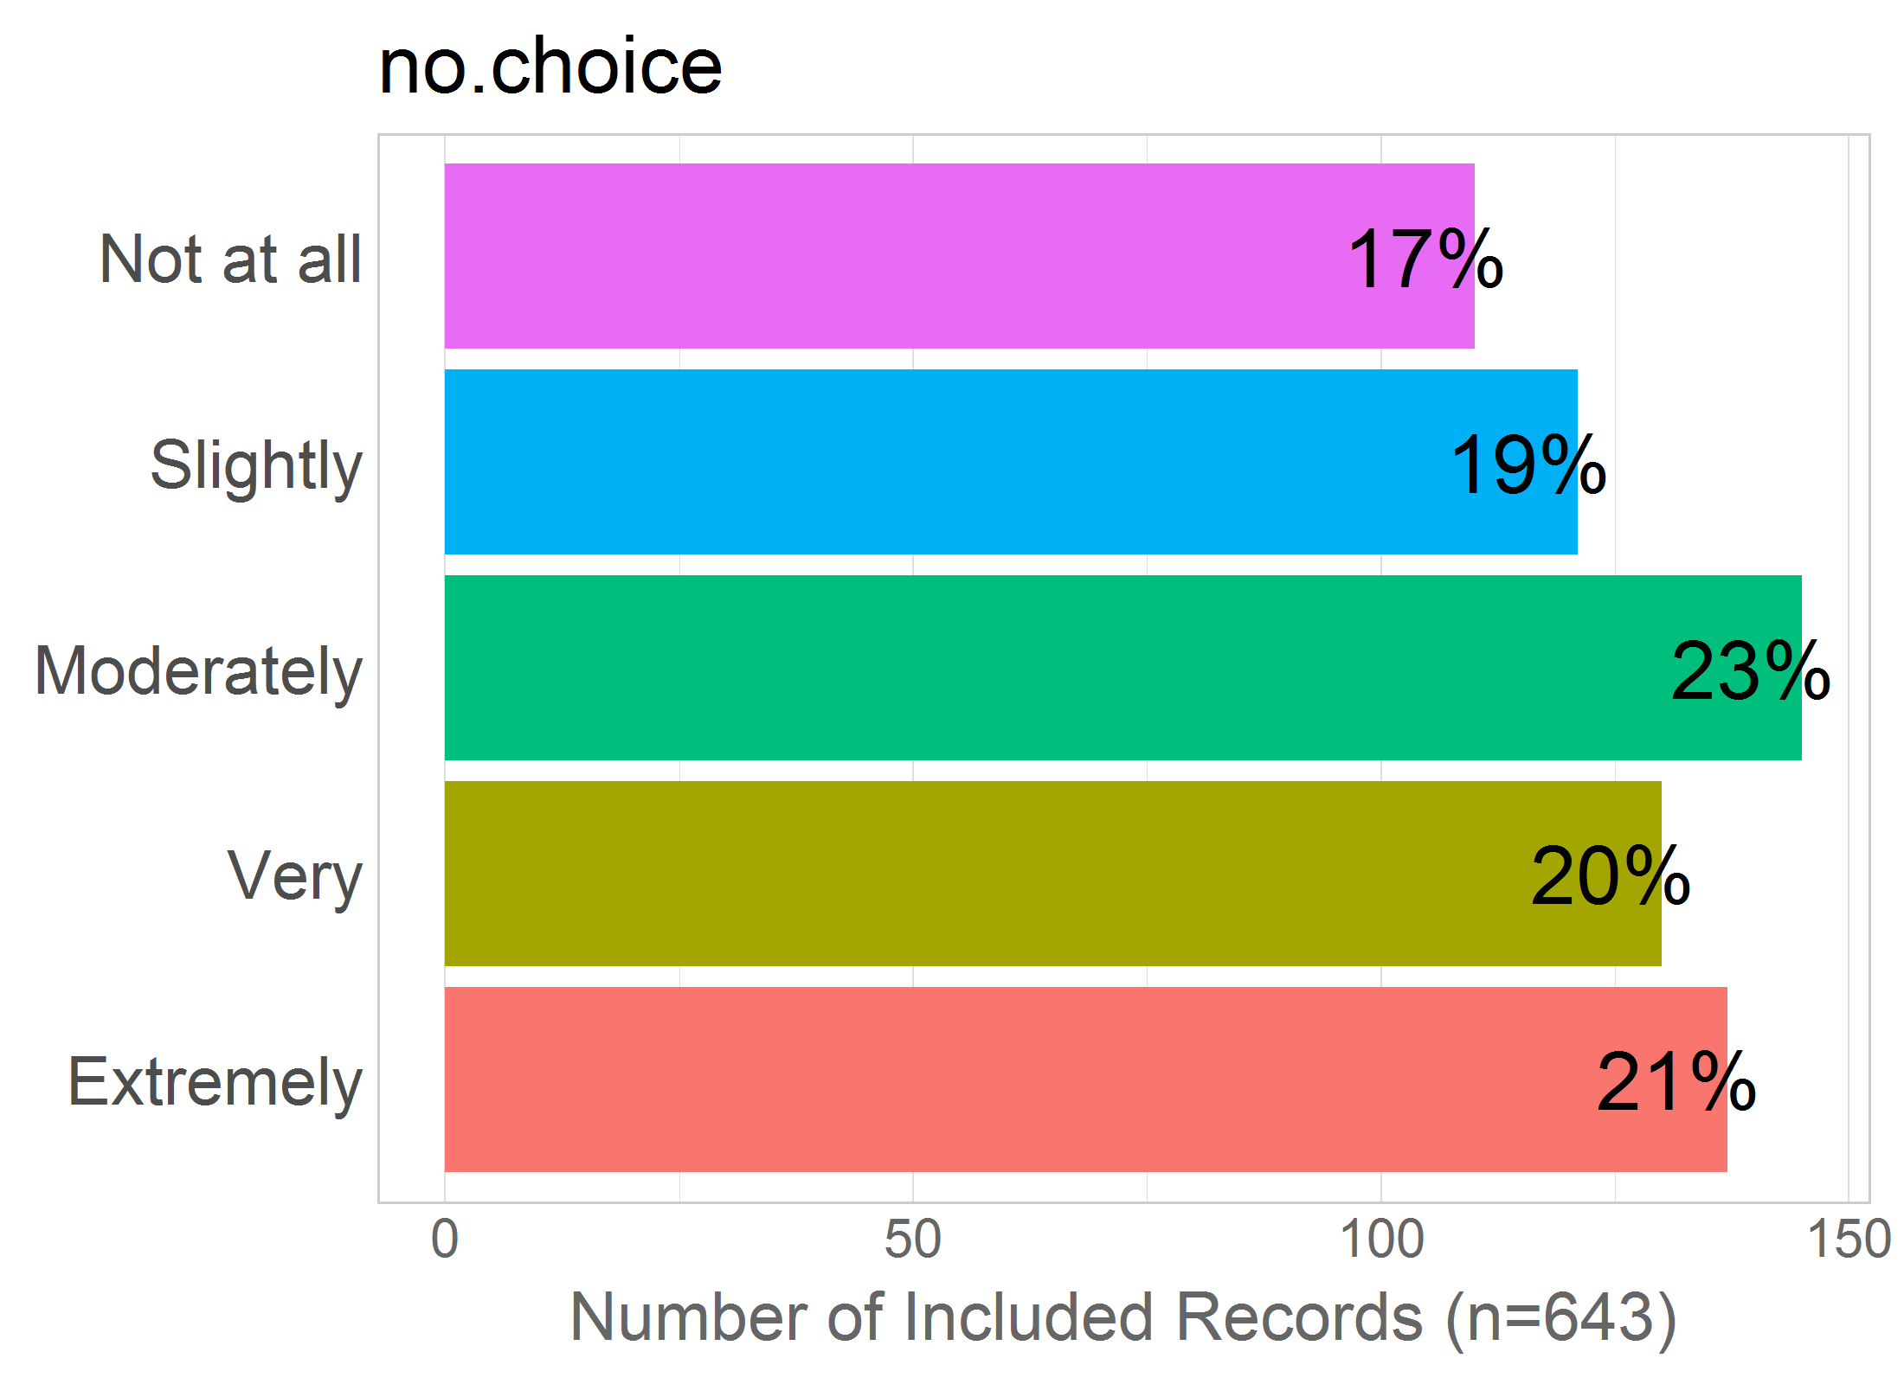

Mean: 3.1

SD: 1.39

Missing: 0

## 18 - no.cesarean

18 - Not being able to have a cesarean birth, even though this is what I would prefer?

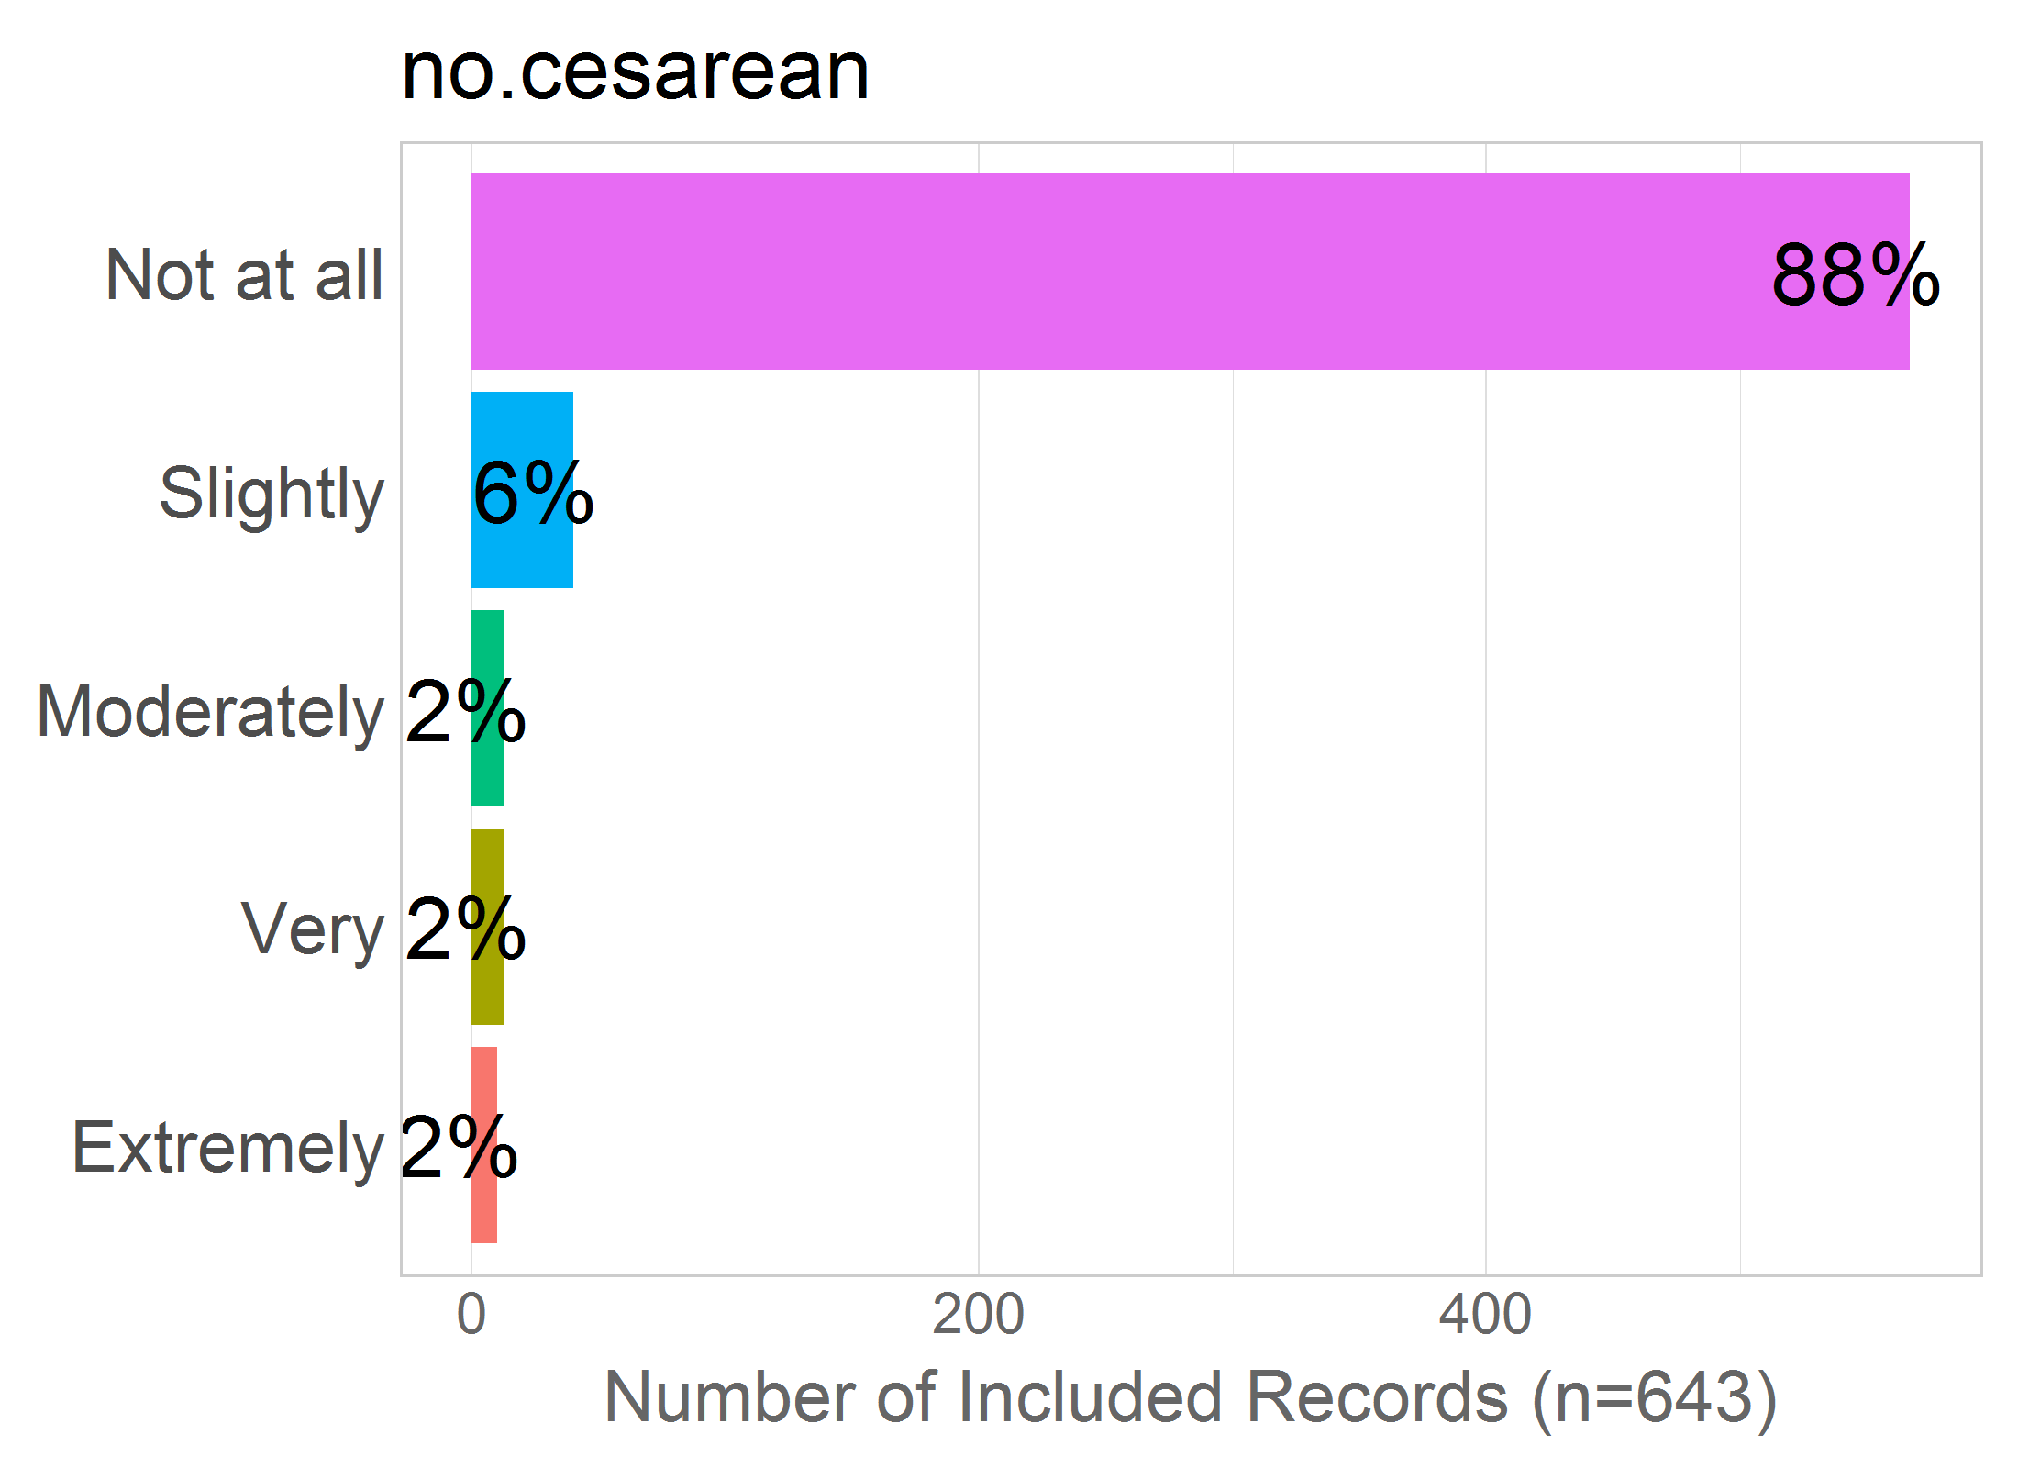

Mean: 1.23

SD: 0.72

Missing: 0

## 19 - no.vaginal

19 - Not being able to have a vaginal birth, even though this is what I would prefer?

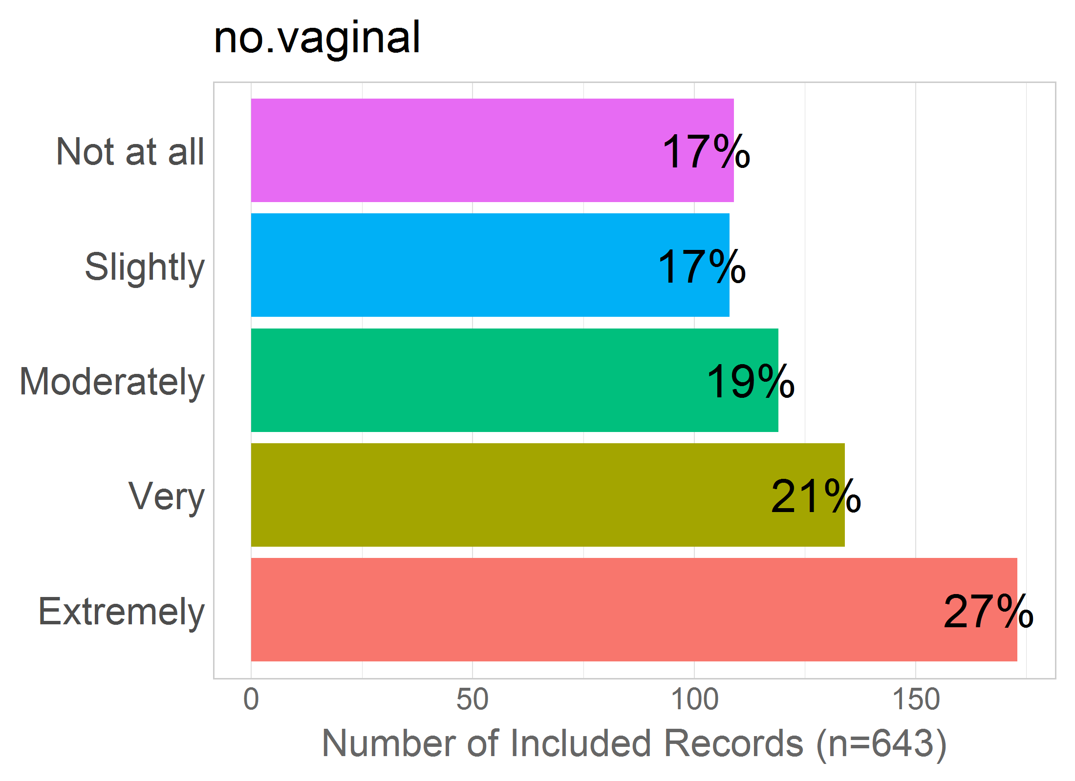

Mean: 3.24

SD: 1.44

Missing: 0

## 20 - vaginal?

20 - Having a vaginal birth?

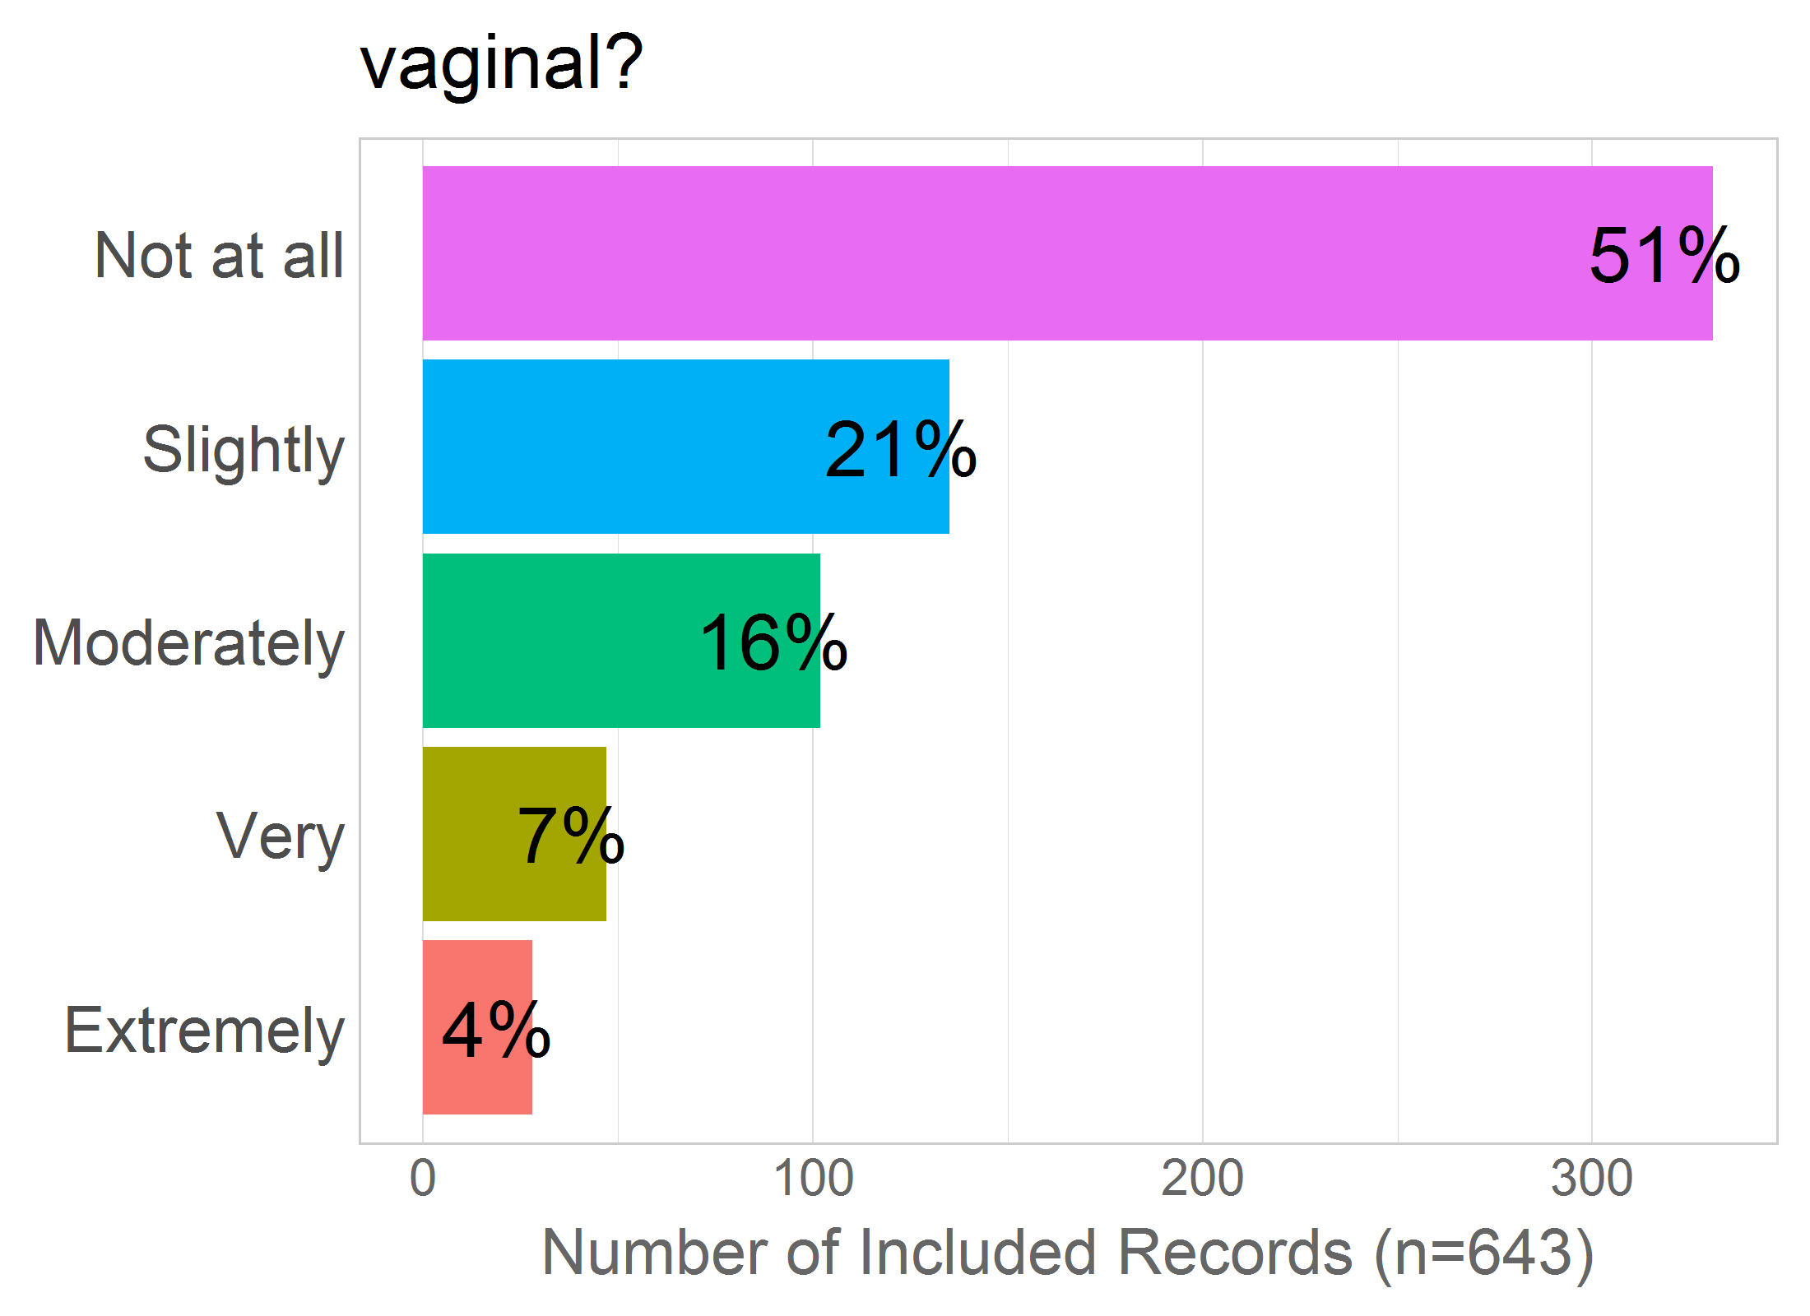

Mean: 1.92

SD: 1.16

Missing: 0

## 21 - ceasarean?

21 - Having a cesarean birth?

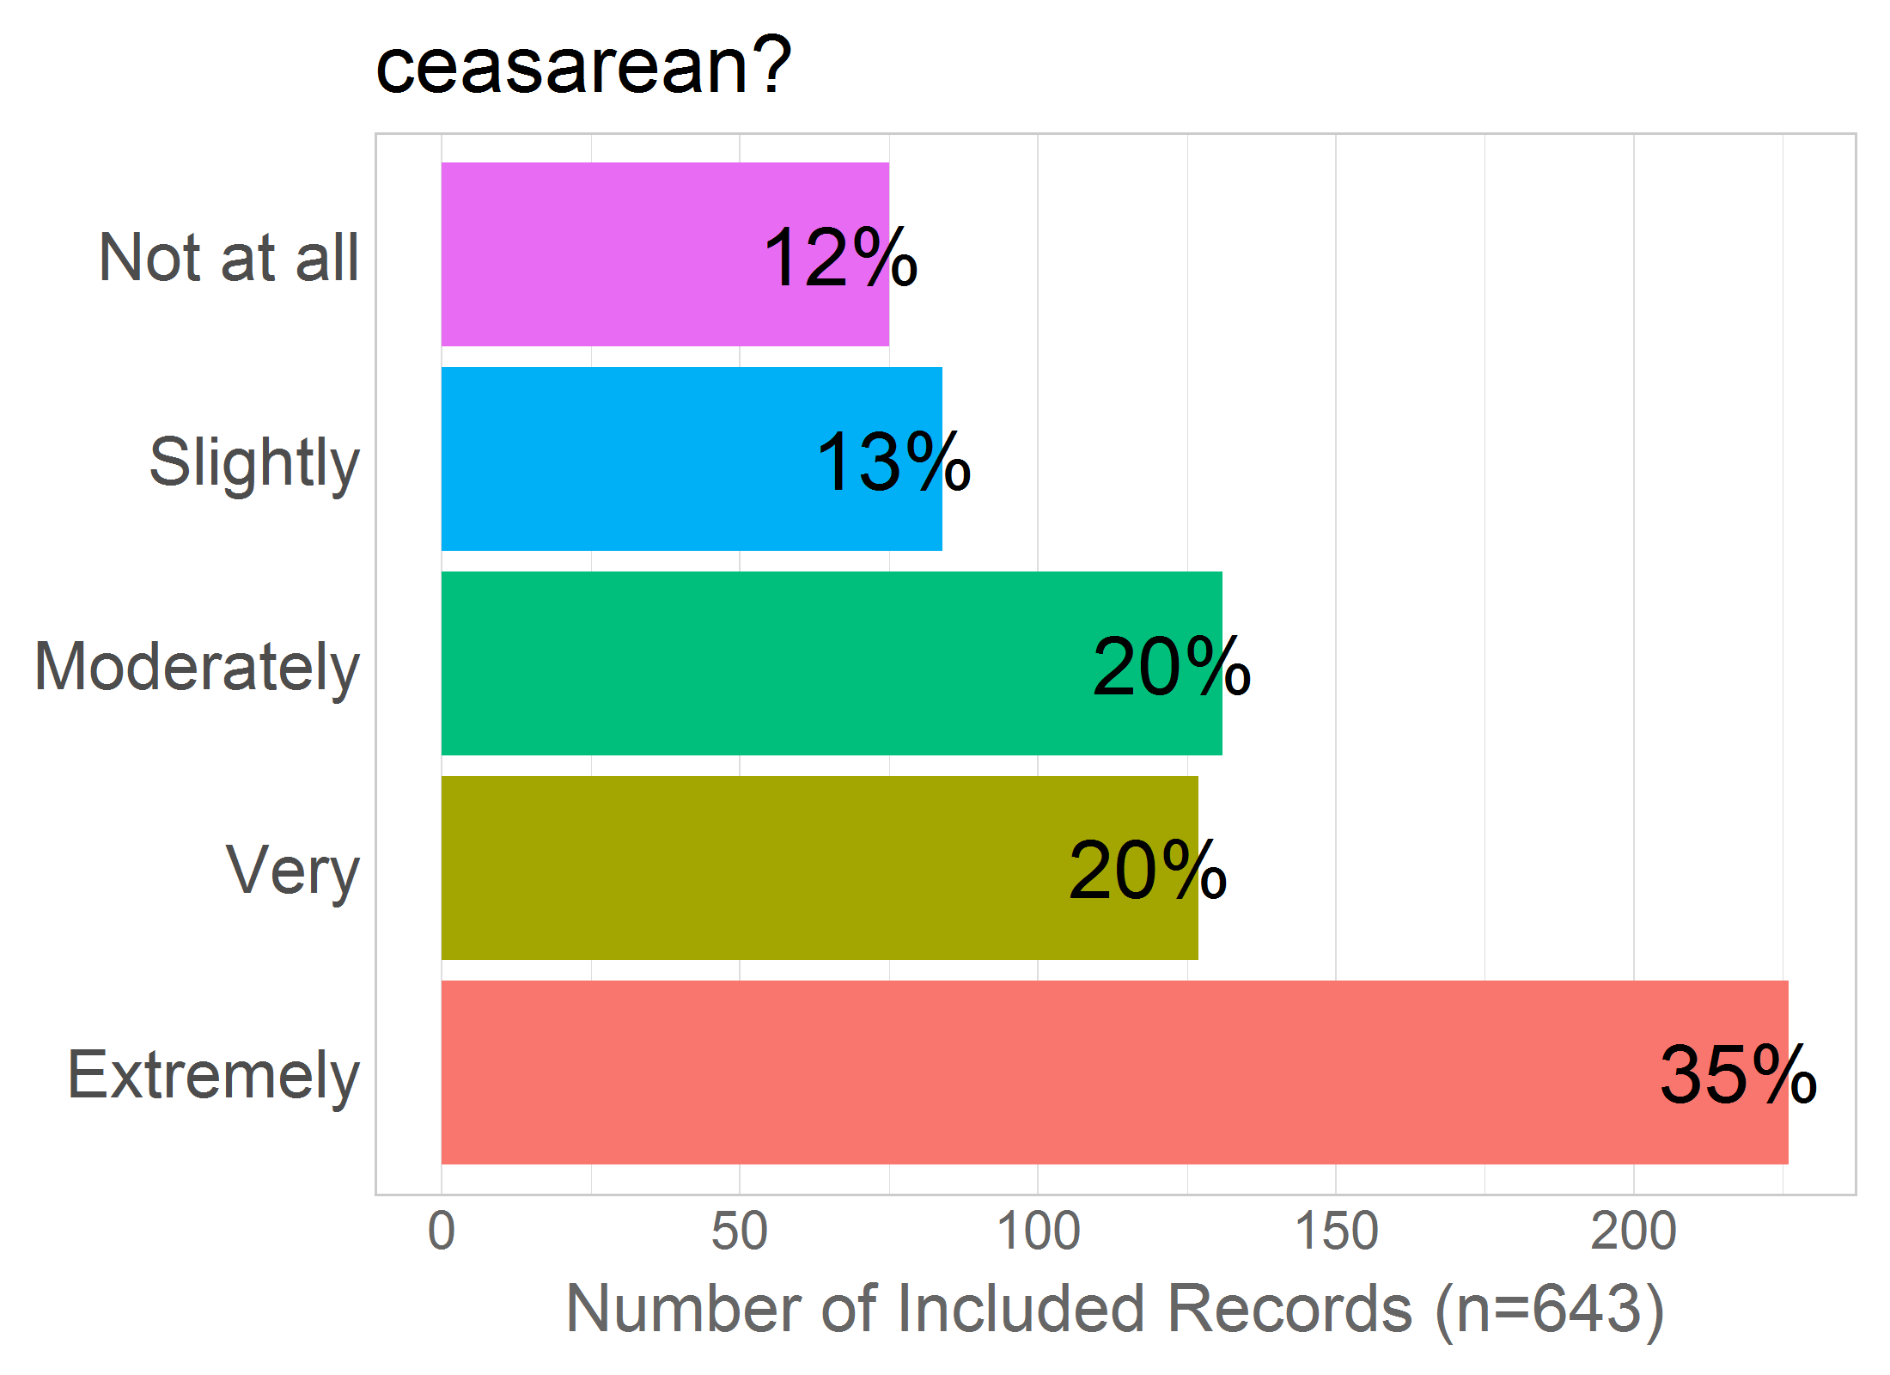

Mean: 3.54

SD: 1.38

Missing: 0

## 49 - vomit

49 - Vomiting during labour/birth?

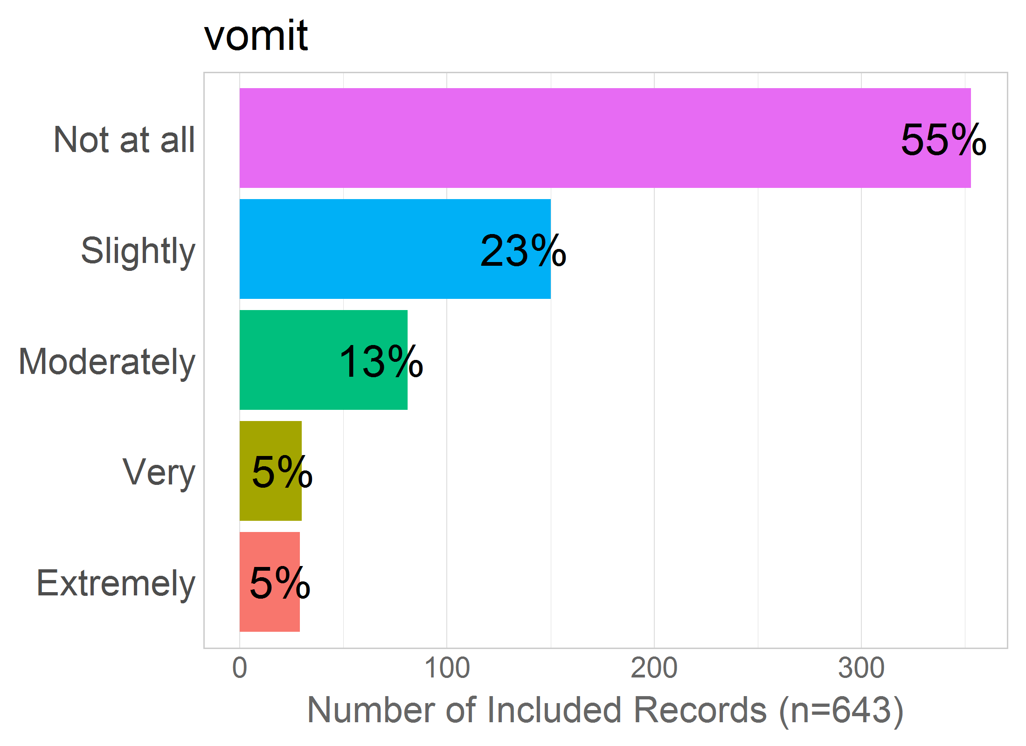

Mean: 1.81

SD: 1.11

Missing: 0

# SAFE.BABY

Correlation of items in the proposed factor:

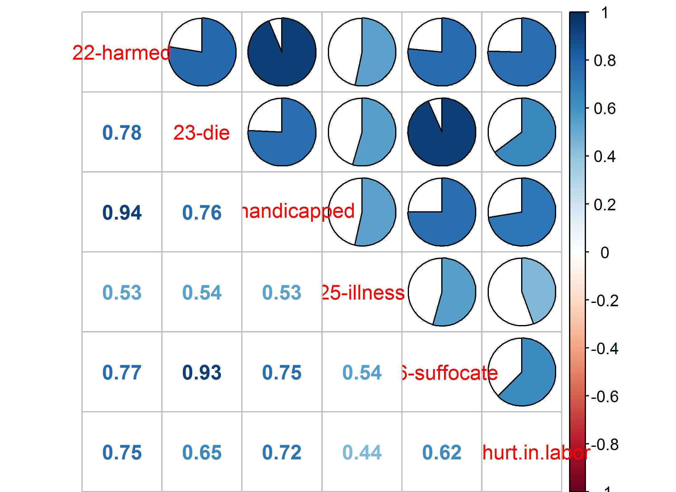NULL

## 22 - harmed

22 - The baby being harmed during labour/birth?

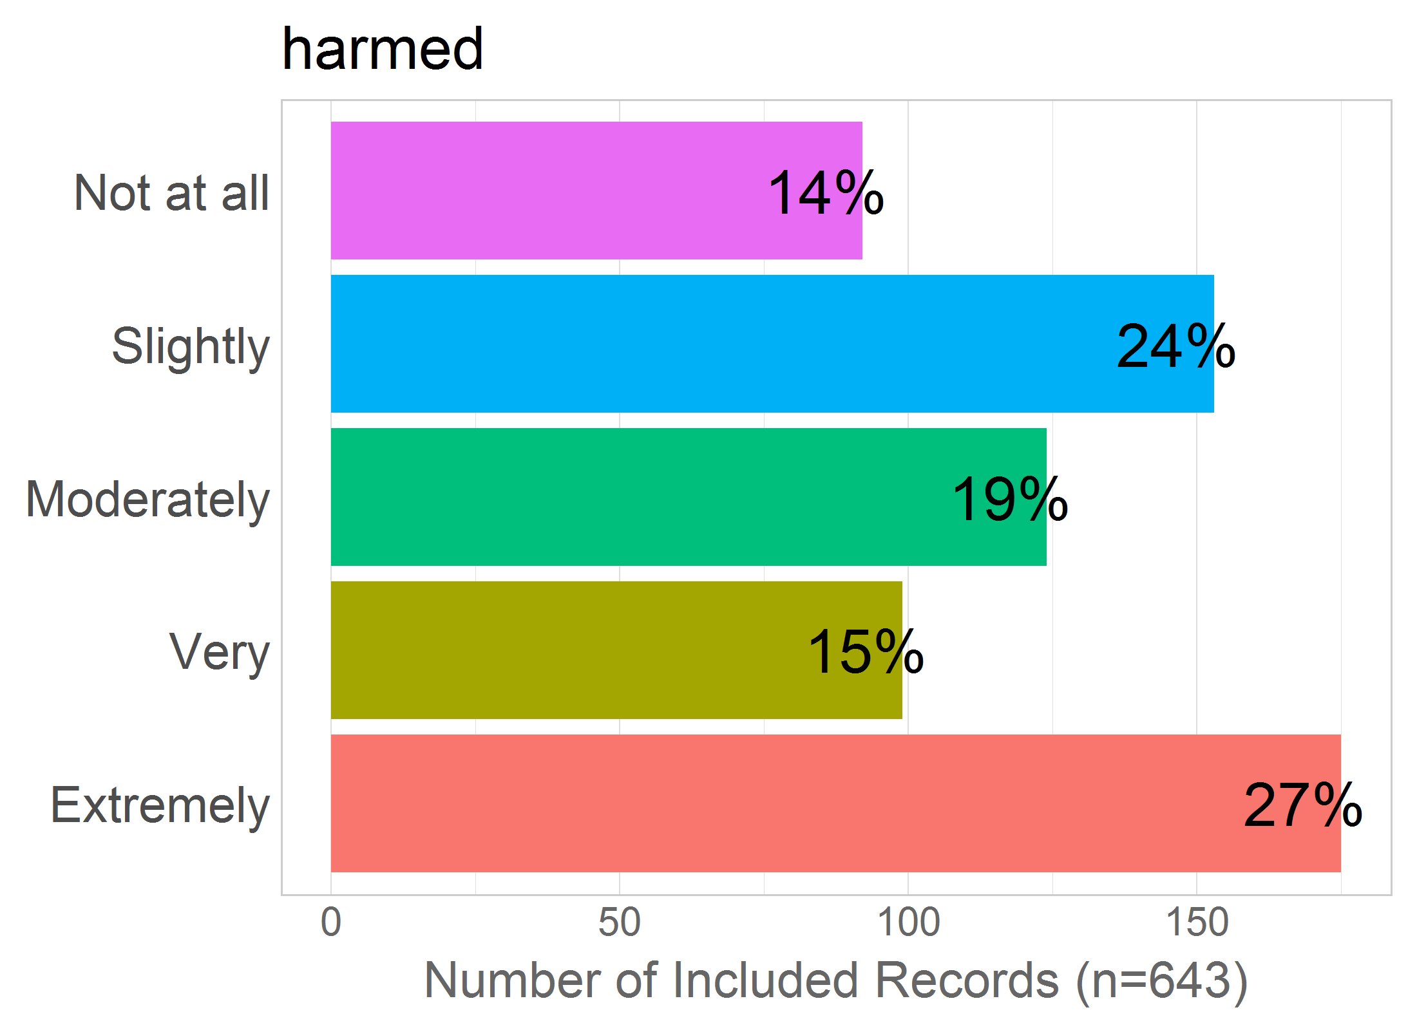

Mean: 3.17

SD: 1.42

Missing: 0

## 23 - die

23 - The baby dying during labour/birth?

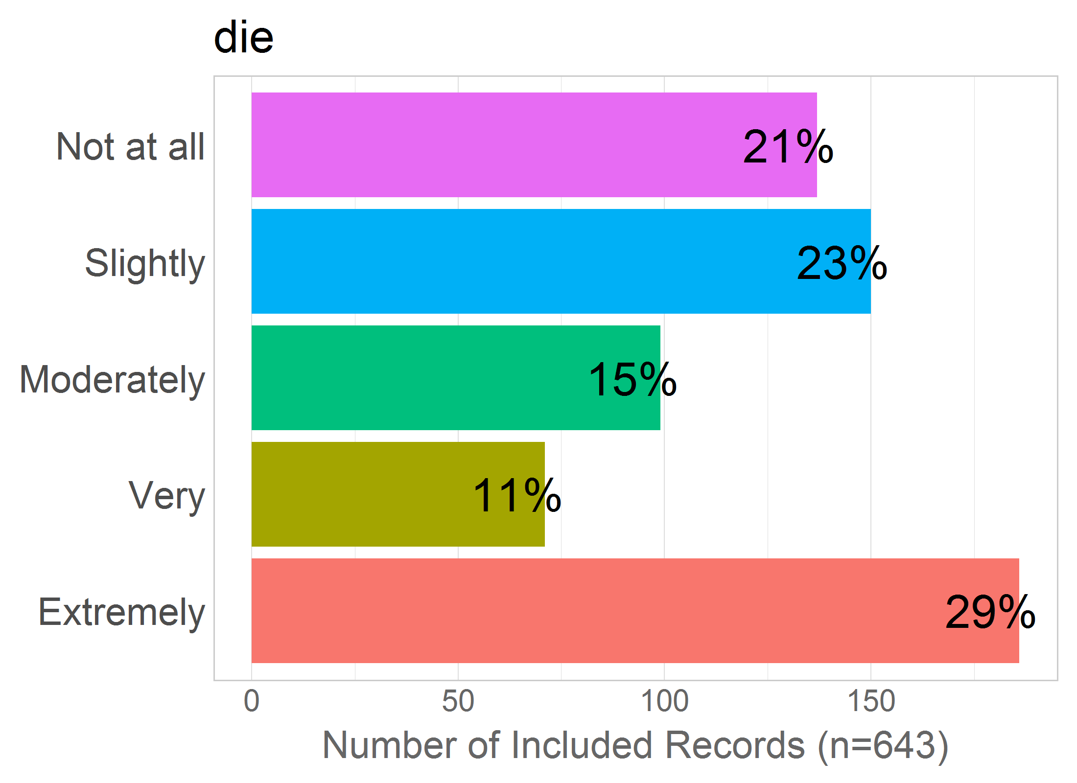

Mean: 3.03

SD: 1.53

Missing: 0

## 24 - handicapped

24 - The baby being damaged/handicapped as a consequence of labour/birth?

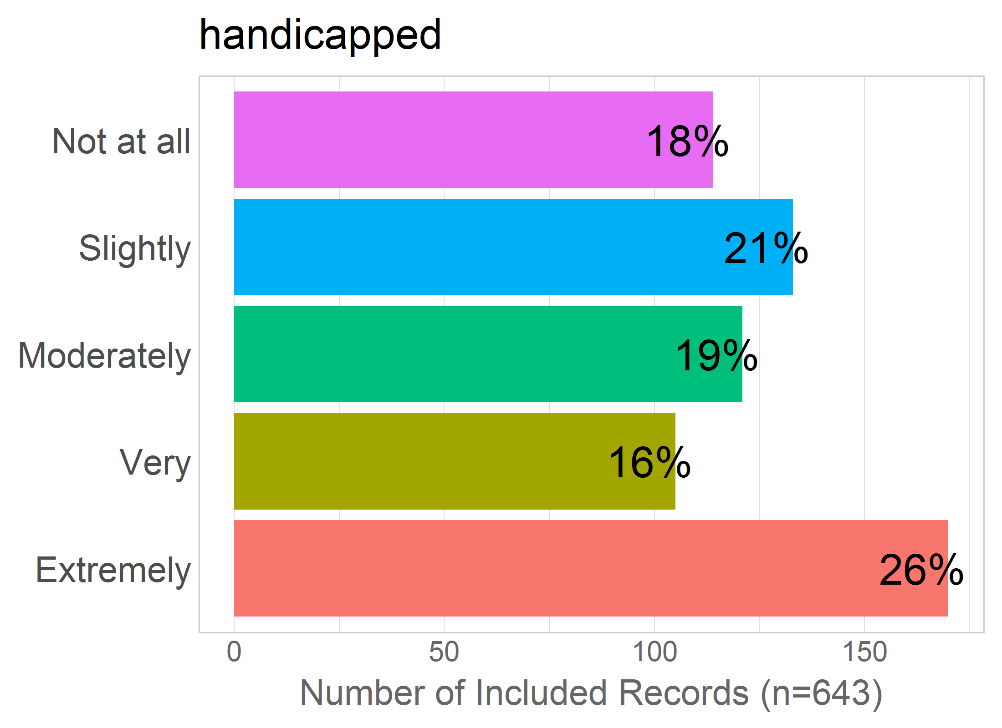

Mean: 3.13

SD: 1.46

Missing: 0

## 25 - illness

25 - The baby contracting an illness during labour/birth (e.g., Herpes, HIV)?

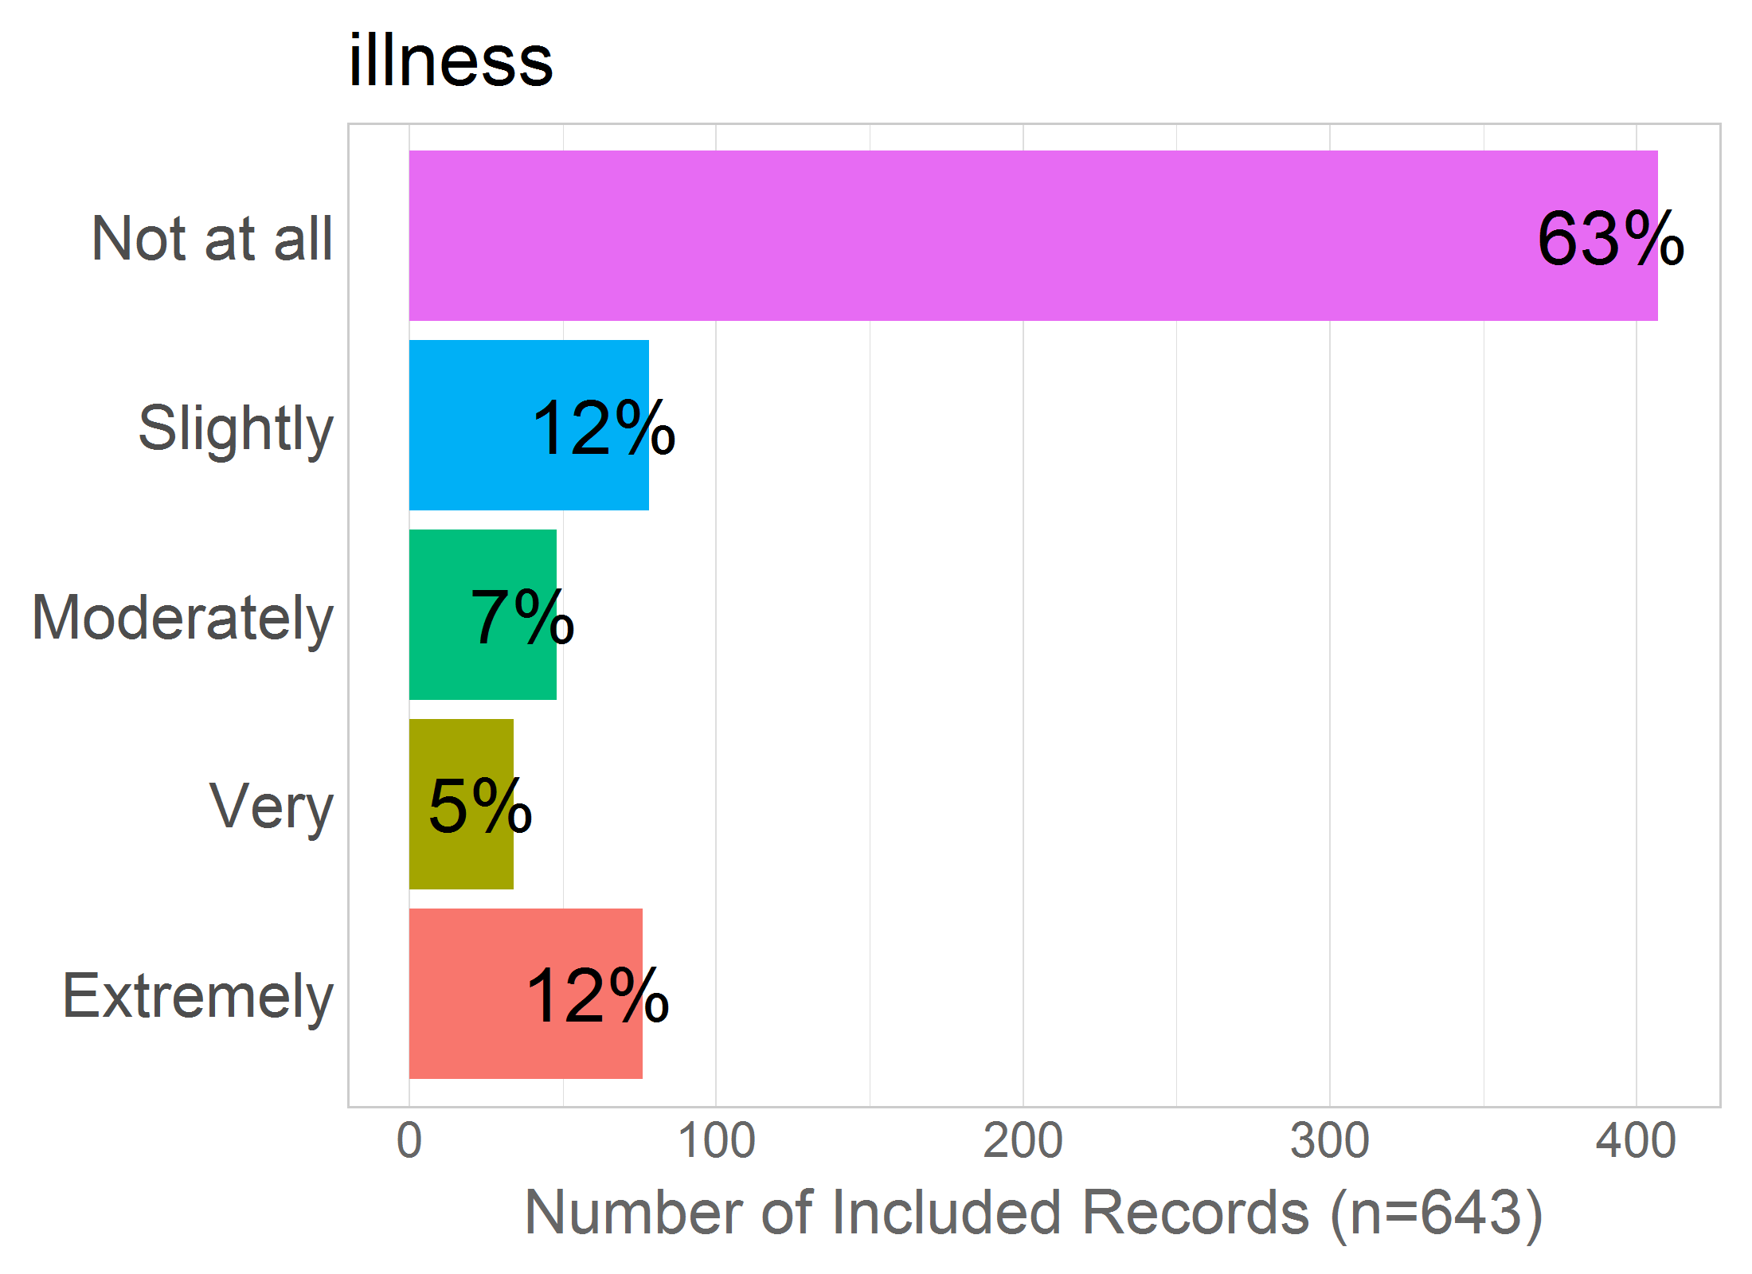

Mean: 1.9

SD: 1.41

Missing: 0

## 26 - suffocate

26 - The baby suffocating during labour/birth?

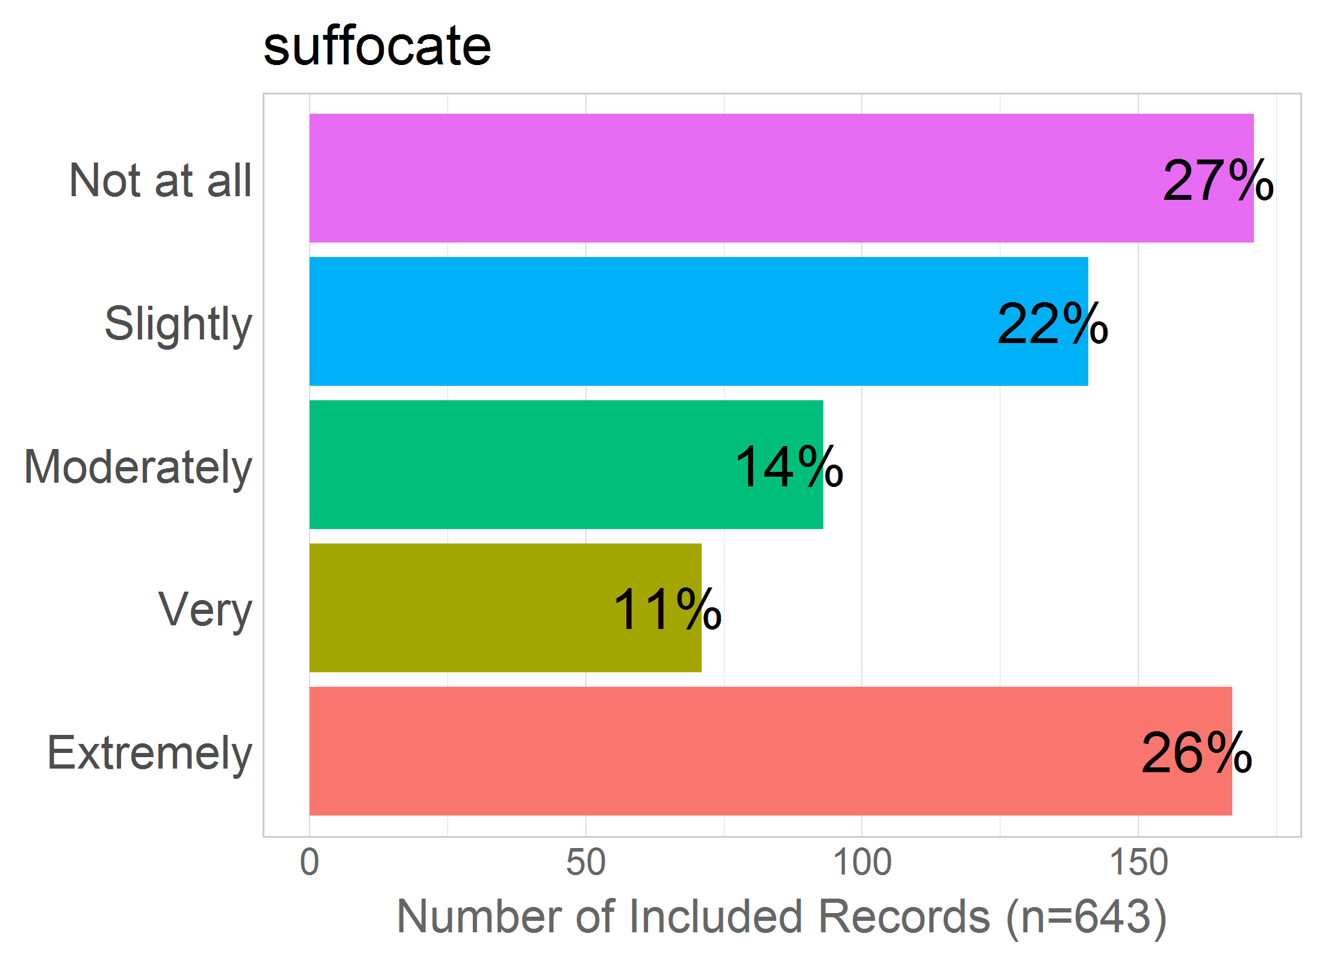

Mean: 2.88

SD: 1.56

Missing: 0

## 27 - hurt.in.labor

27 - The baby being hurt by a medical intervention that takes place during labour/birth (e.g., vacuum, anesthetics)?

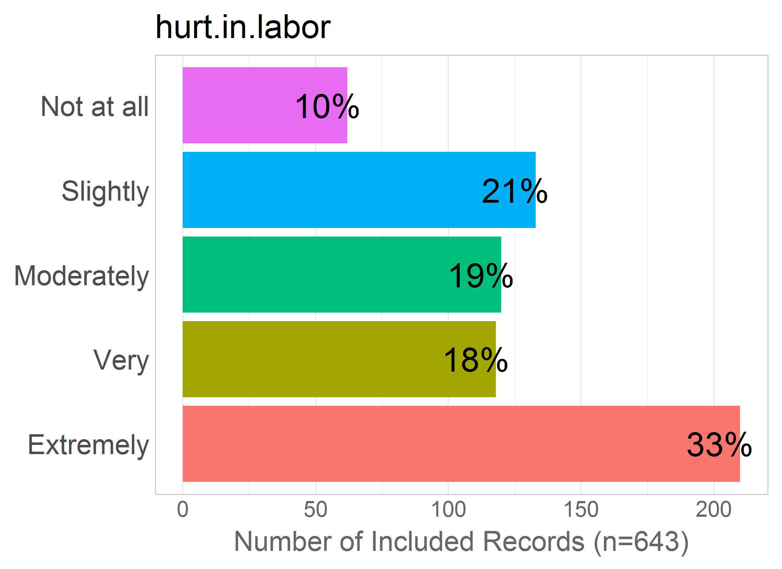

Mean: 3.44

SD: 1.38

Missing: 0

# SAFE.MOM

Correlation of items in the proposed factor:

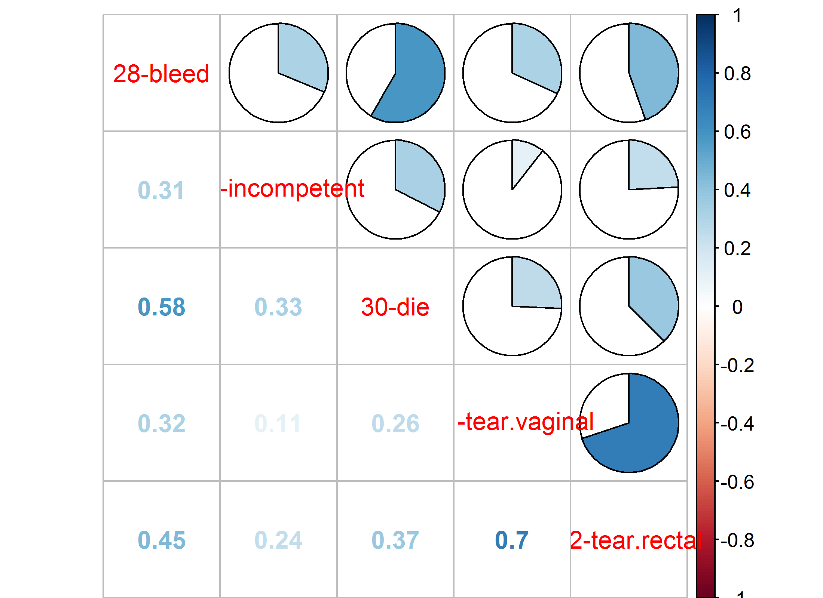NULL

## 28 - bleed

28 - Bleeding too much during labour/birth?

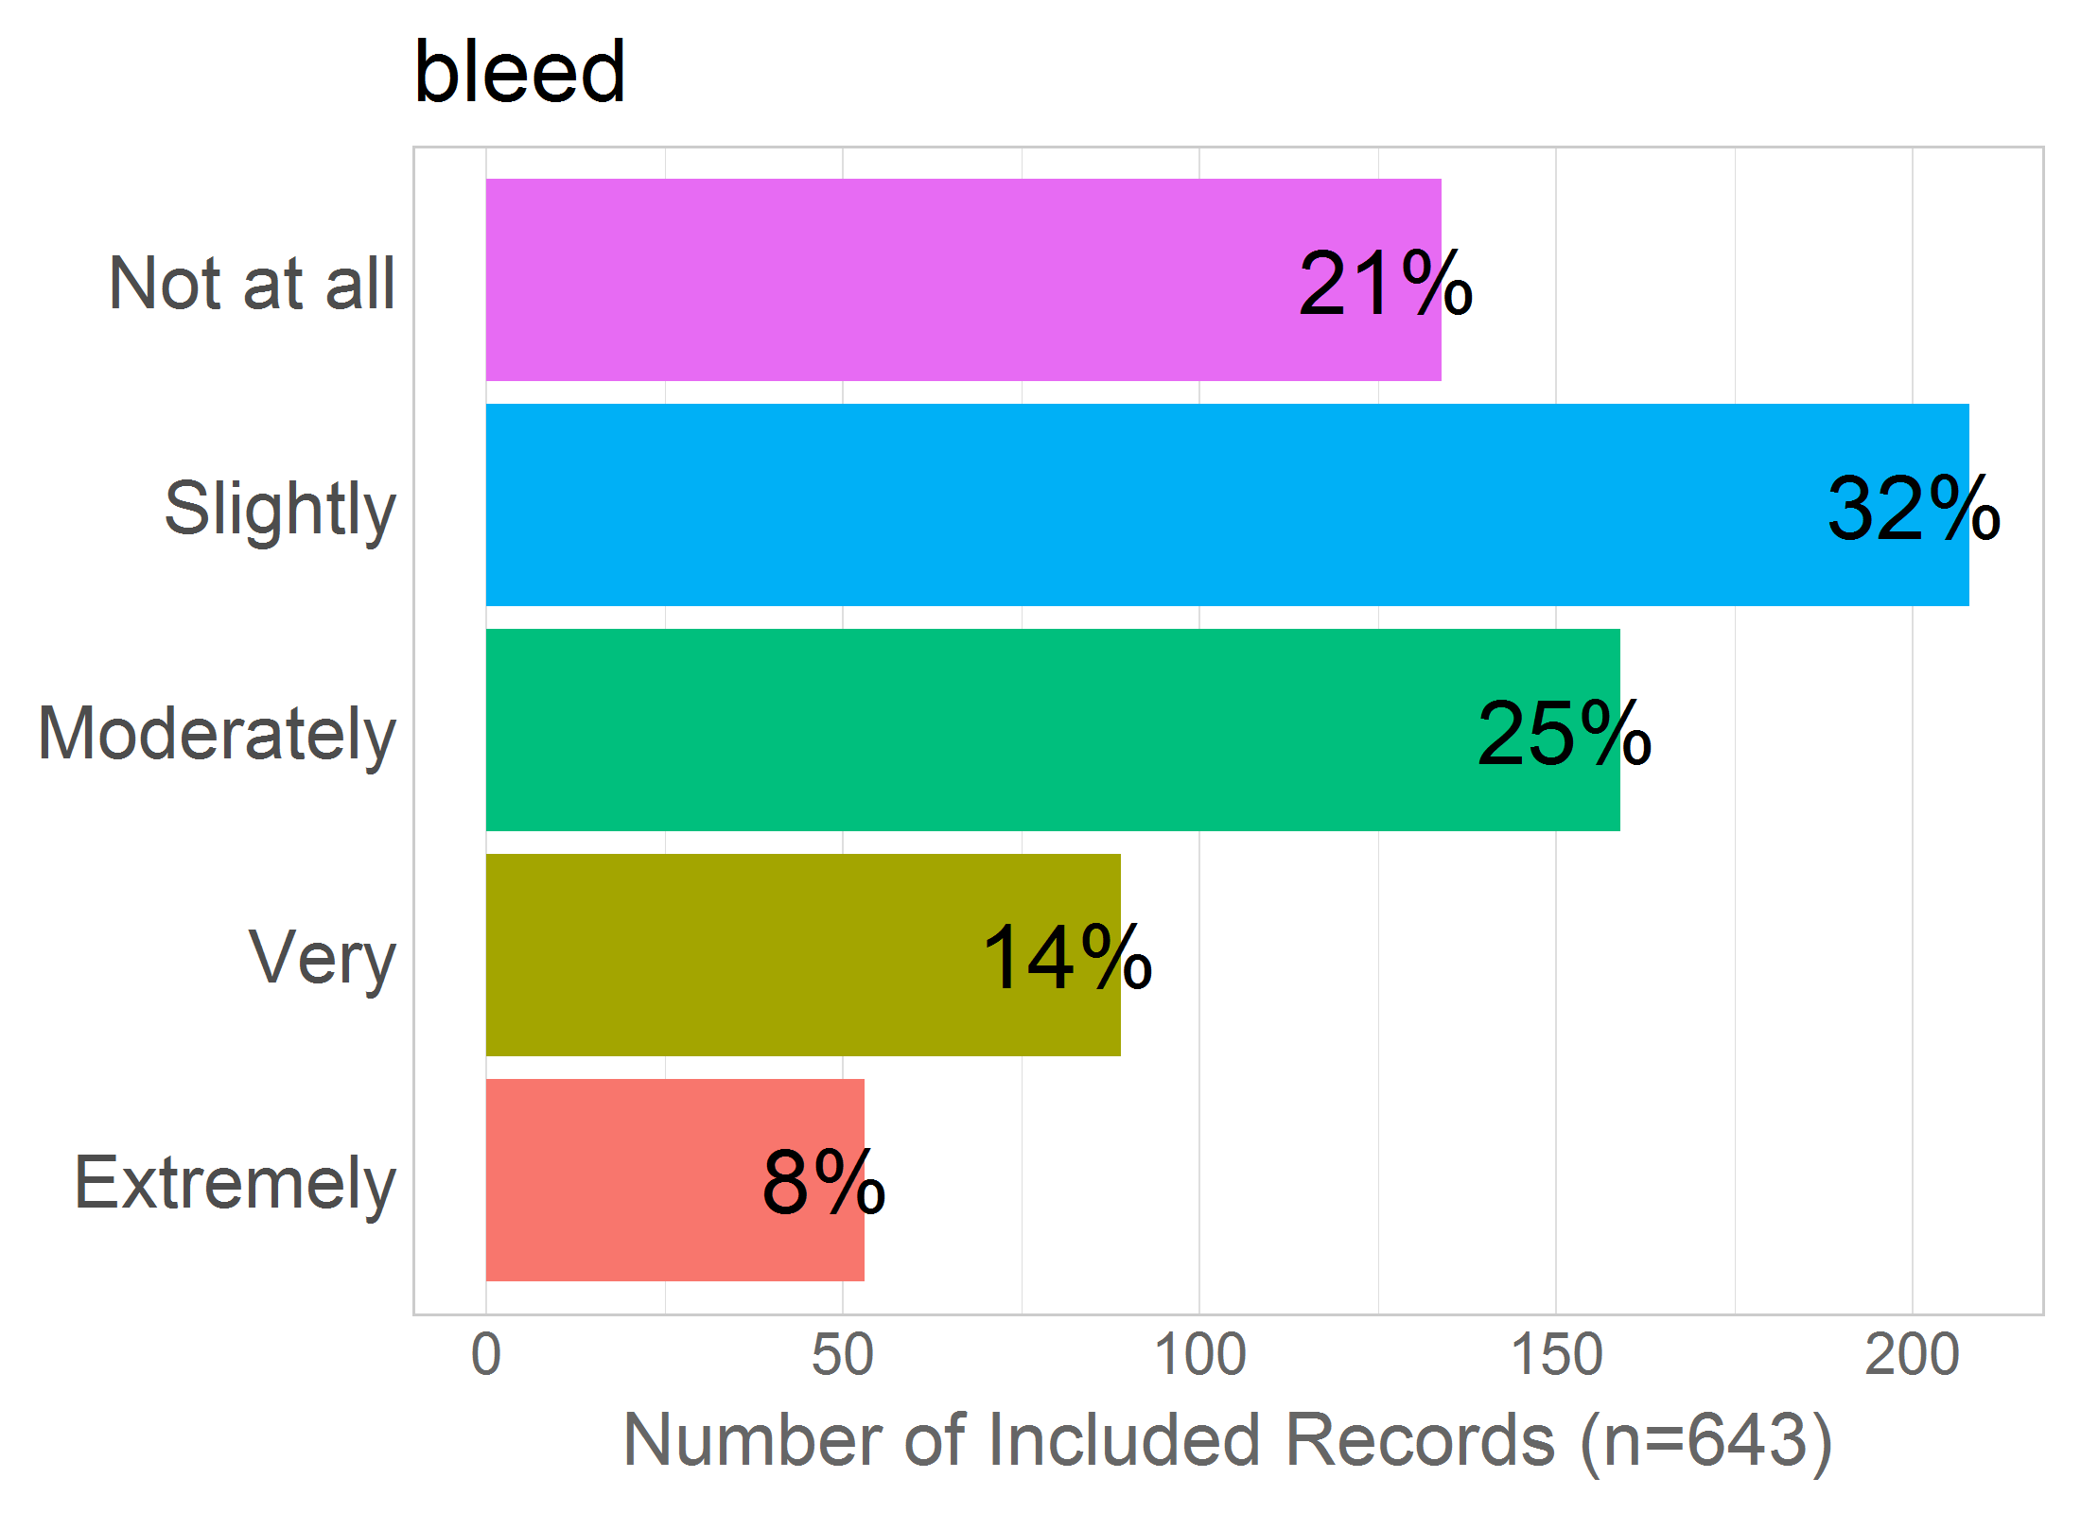

Mean: 2.56

SD: 1.2

Missing: 0

## 29 - incompetent

29 - Being harmed because of incompetent medical care?

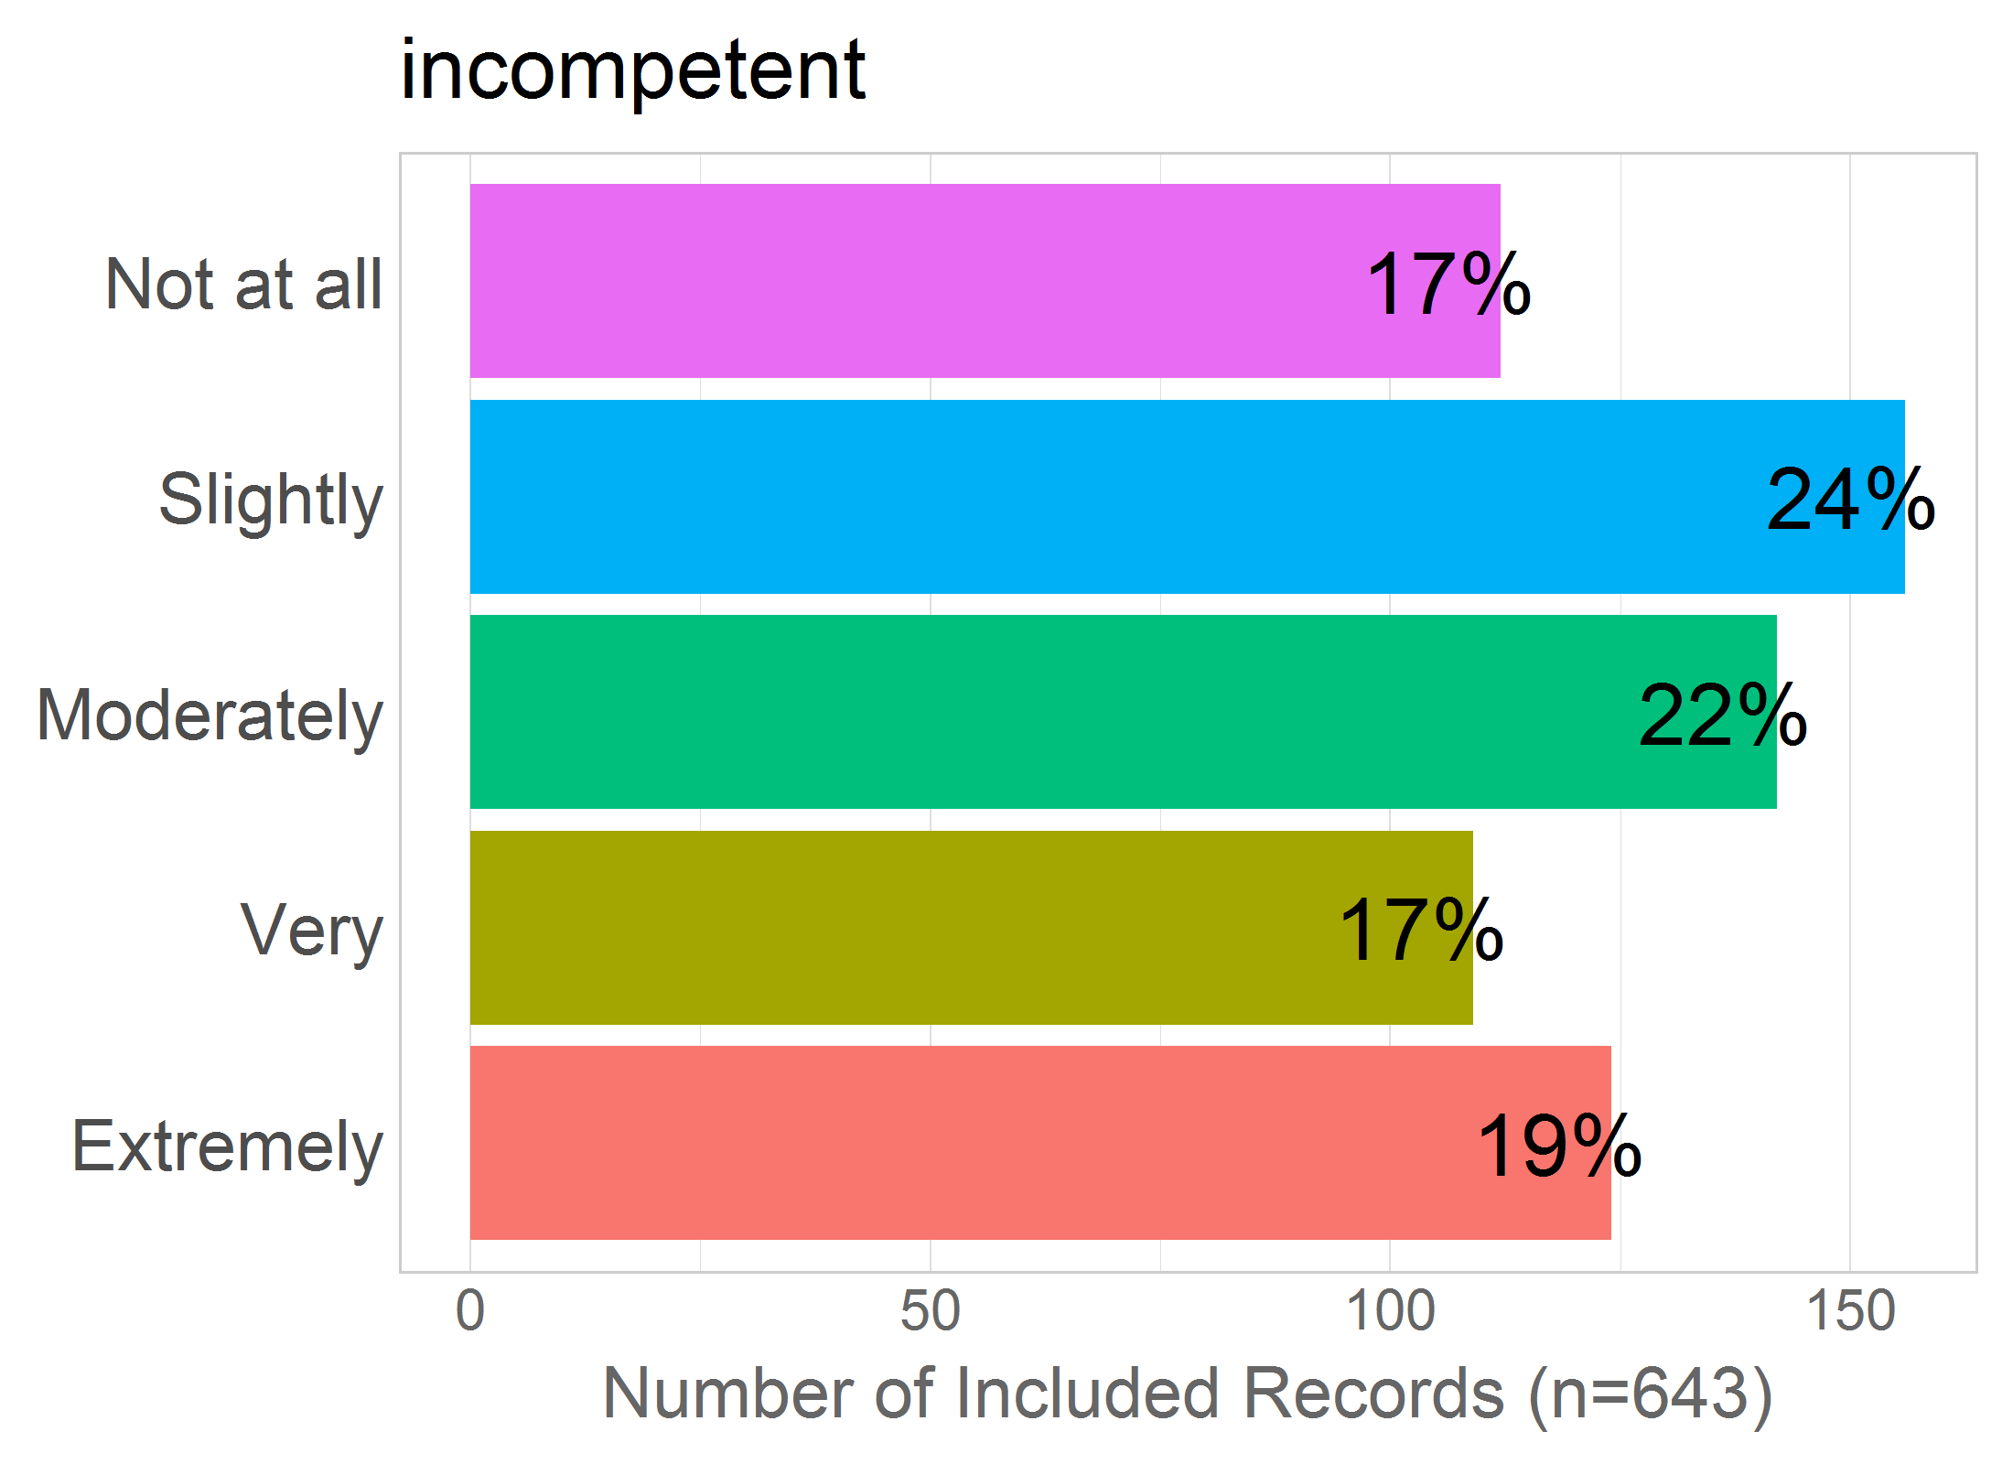

Mean: 2.96

SD: 1.37

Missing: 0

## 30 - die

30 - Dying during labour/birth?

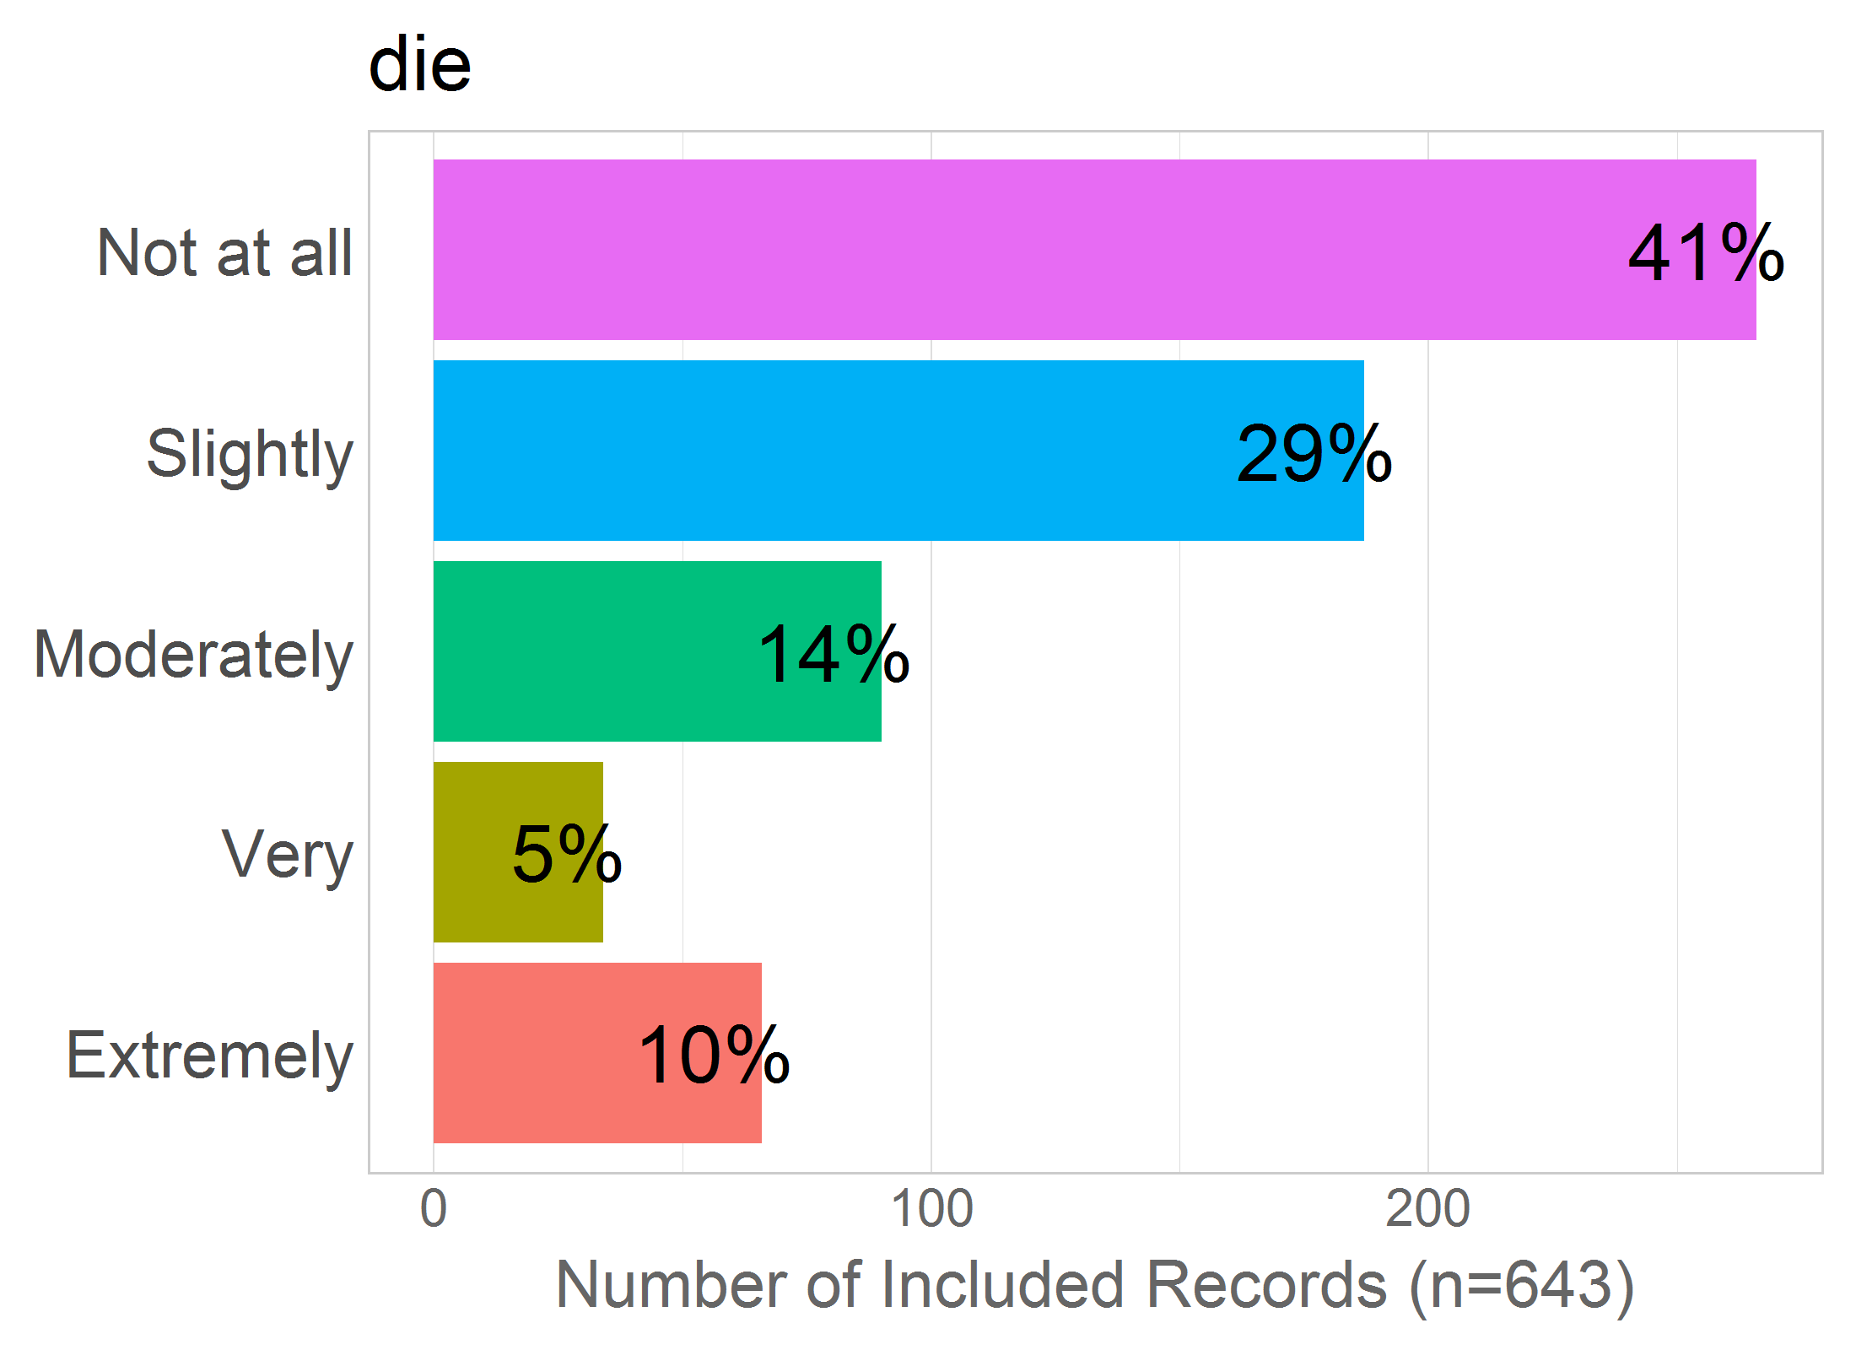

Mean: 2.14

SD: 1.29

Missing: 0

## 31 - tear.vaginal

31 - Vaginal tearing during labour/birth?

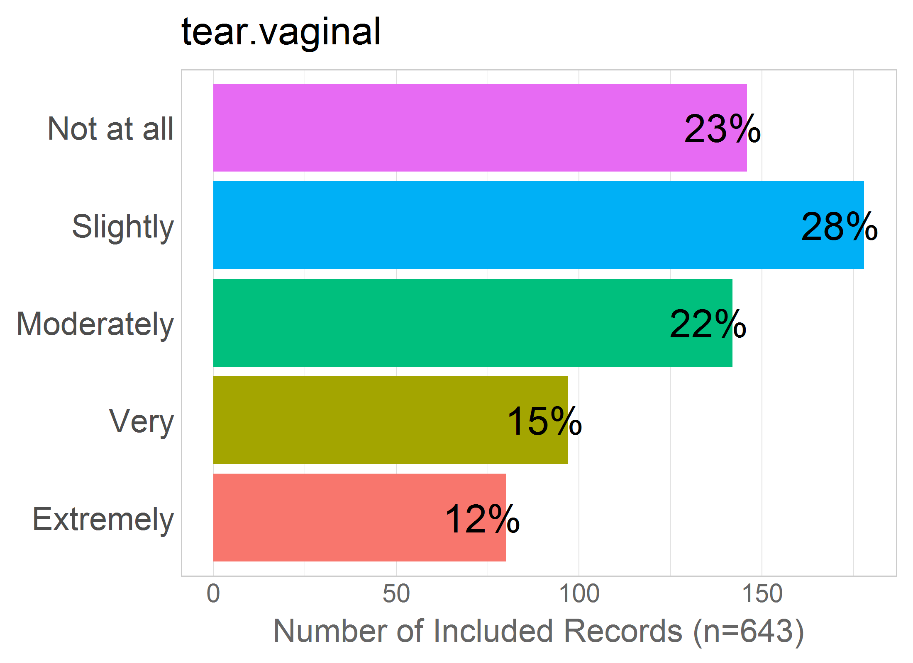

Mean: 2.67

SD: 1.31

Missing: 0

## 32 - tear.rectal

32 - Rectal tearing/damage as a consequence of labour/birth?

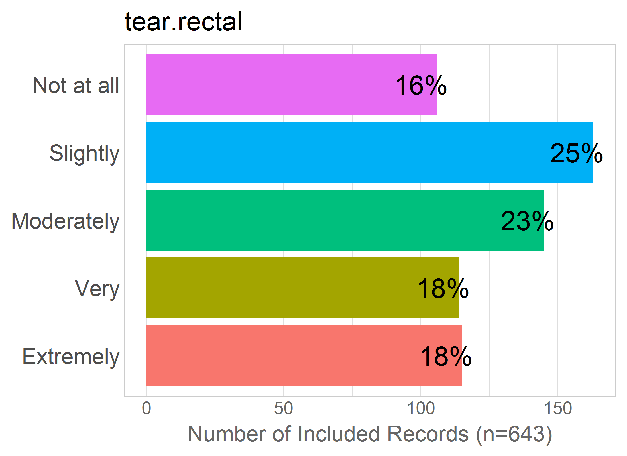

Mean: 2.95

SD: 1.34

Missing: 0

# BODY.CHANGE

Correlation of items in the proposed factor:

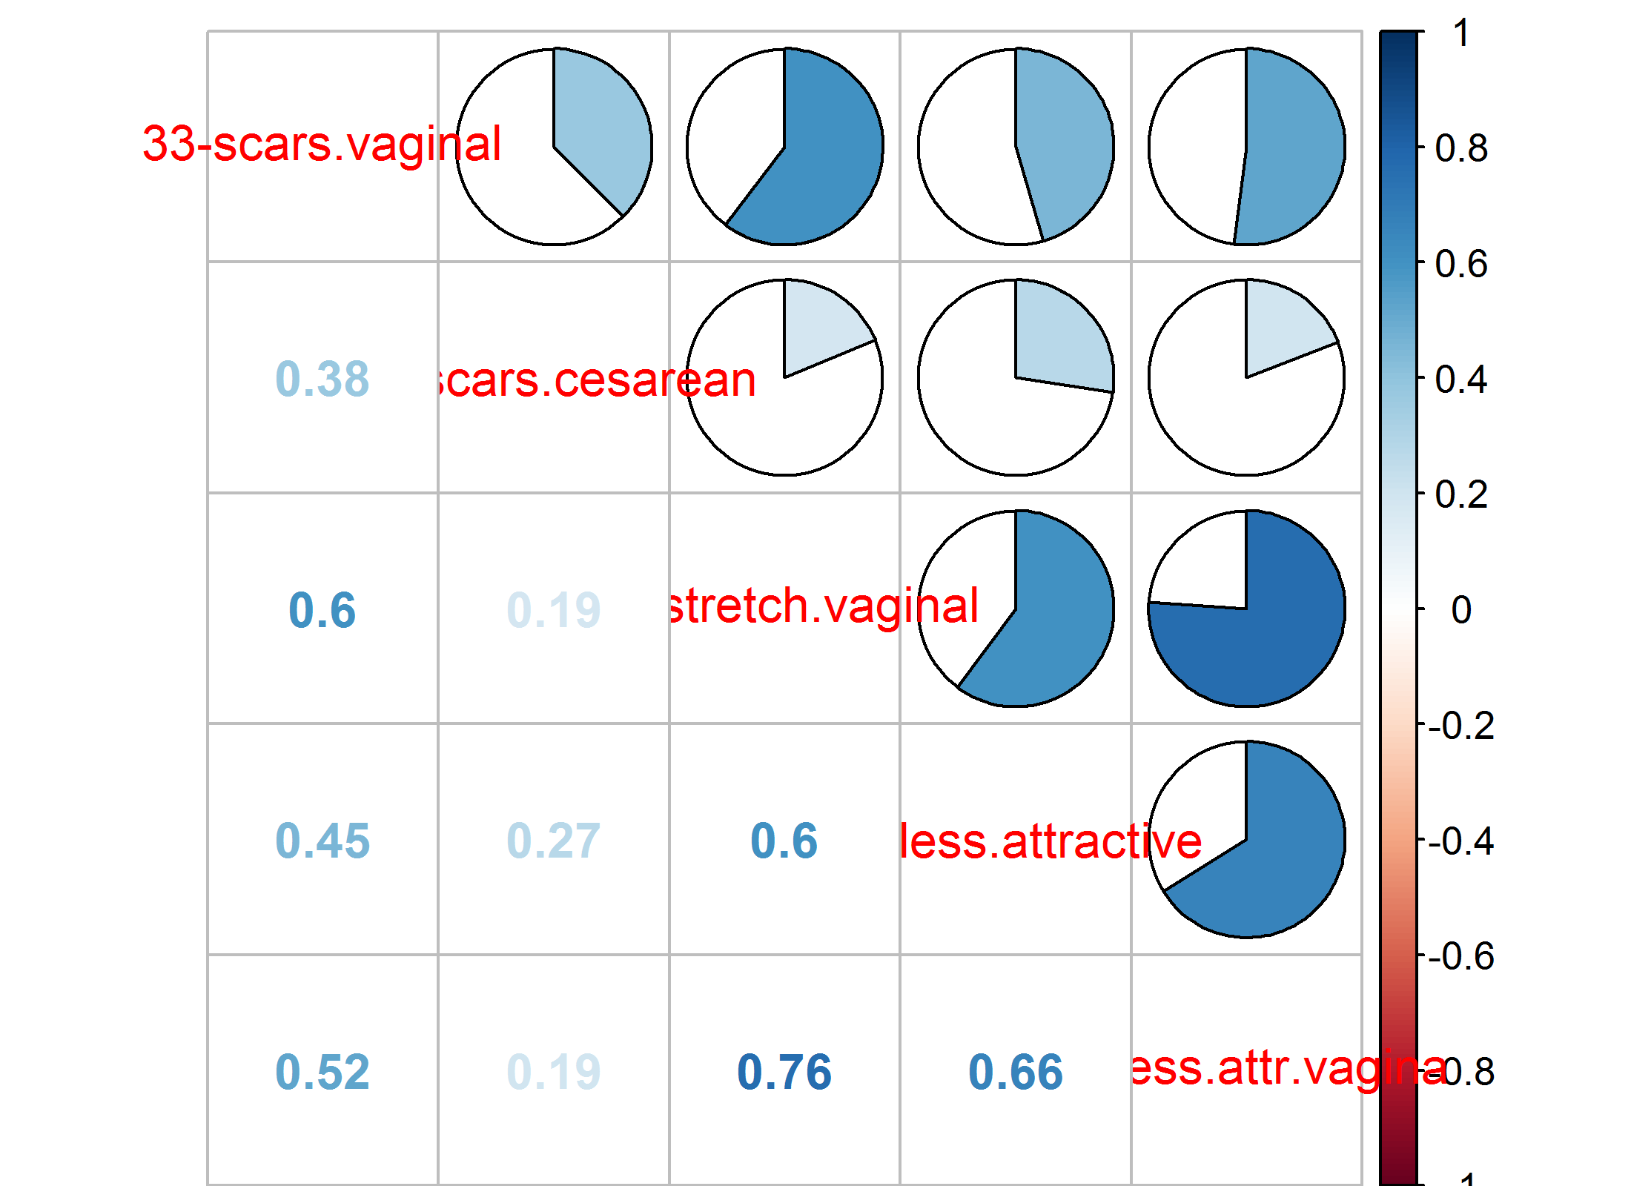NULL

## 33 - scars.vaginal

33 - Being left with scars from a vaginal birth?

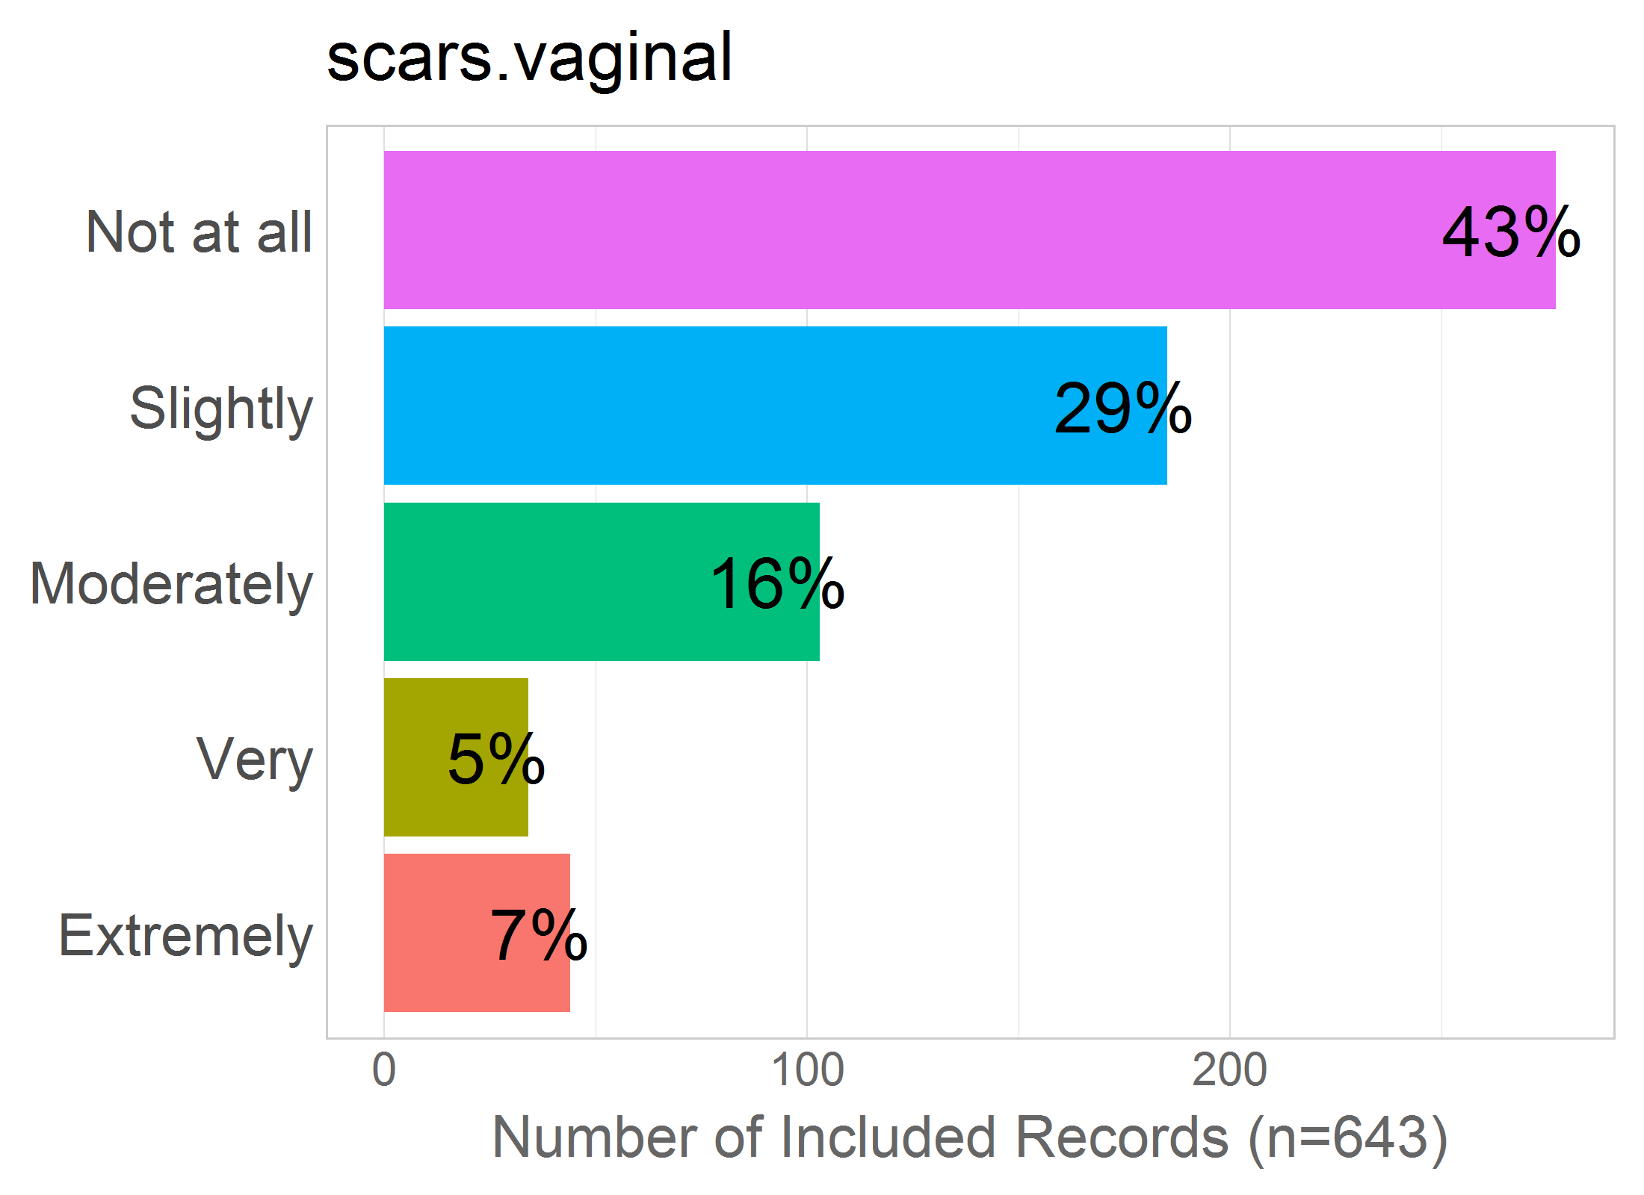

Mean: 2.04

SD: 1.19

Missing: 0

## 34 - scars.cesarean

34 - Being left with scars from a cesarean birth?

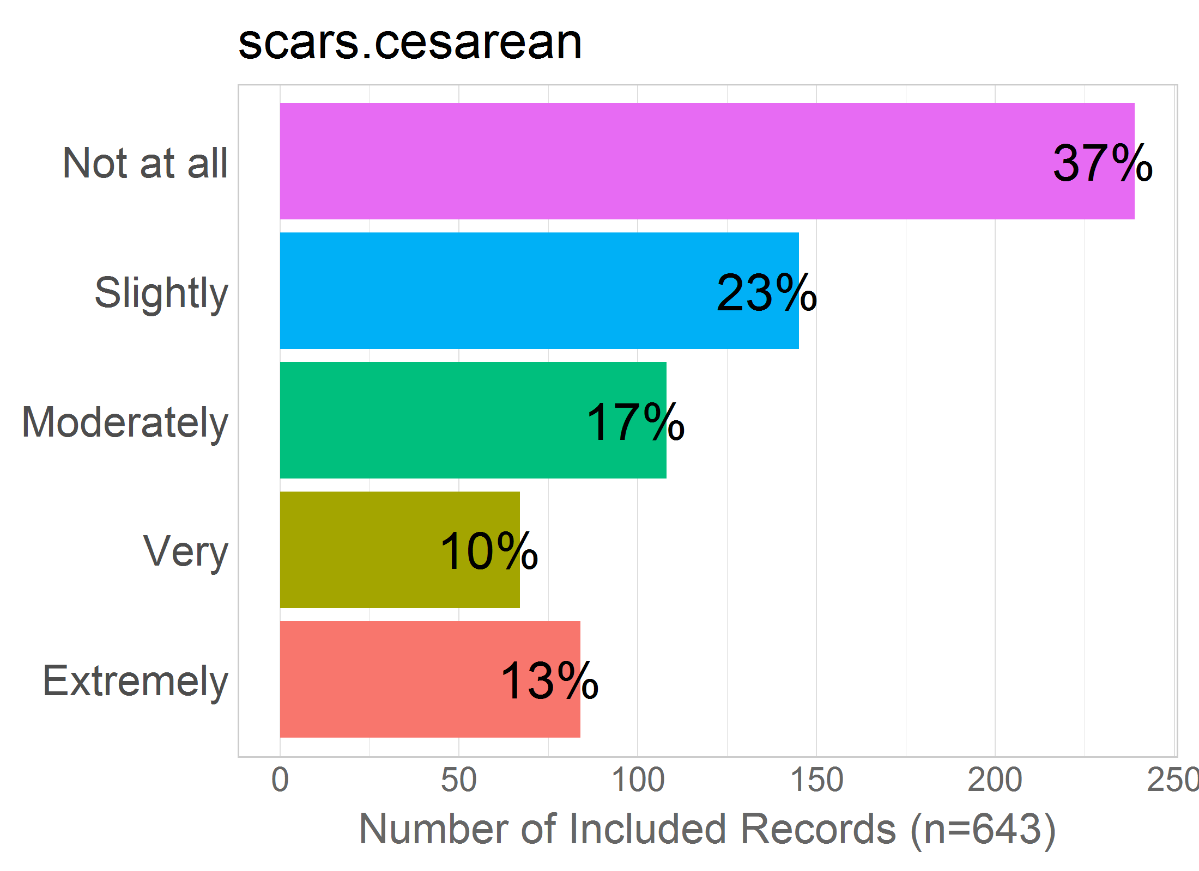

Mean: 2.4

SD: 1.41

Missing: 0

## 35 - stretch.vaginal

35 - Stretching of my vagina from giving birth vaginally?

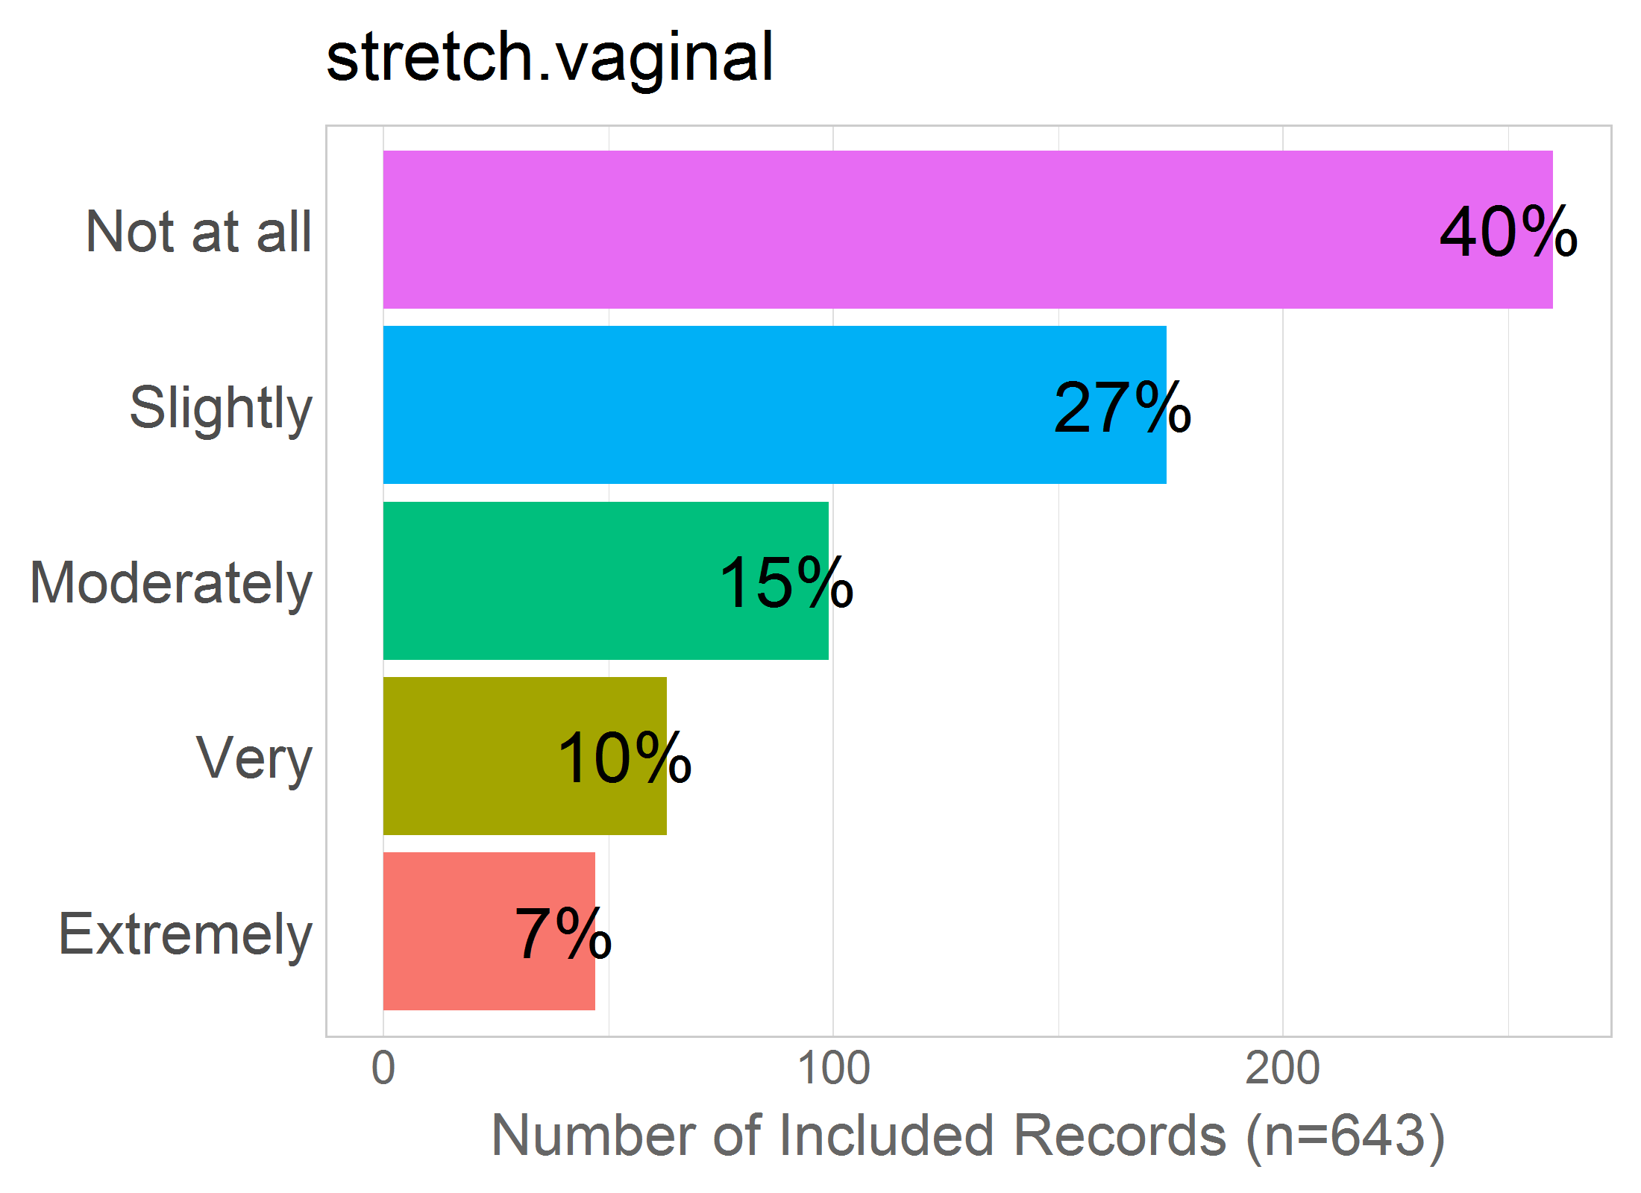

Mean: 2.16

SD: 1.26

Missing: 0

## 36 - less.attractive

36 - My body looking less attractive following the birth?

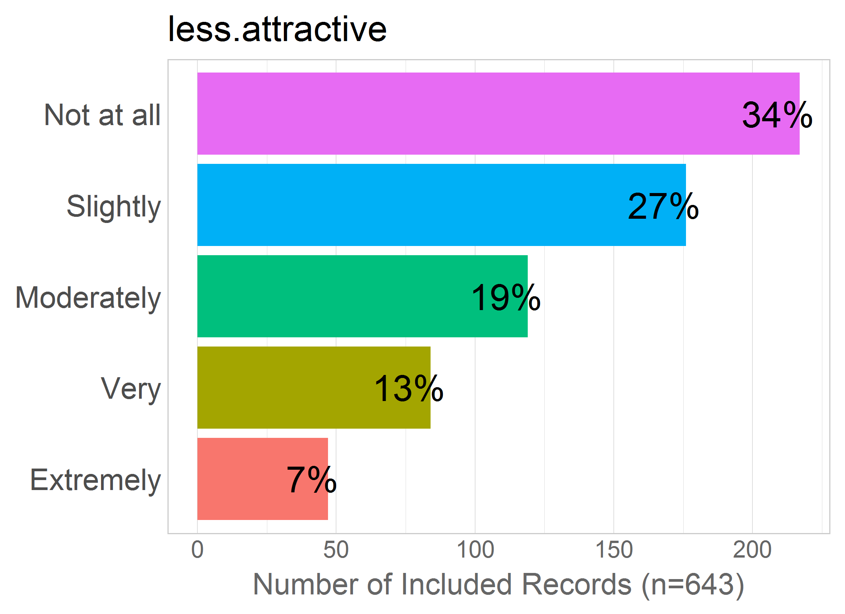

Mean: 2.33

SD: 1.26

Missing: 0

## 37 - less.attr.vagina

37 - My vagina looking less attractive following a vaginal childbirth?

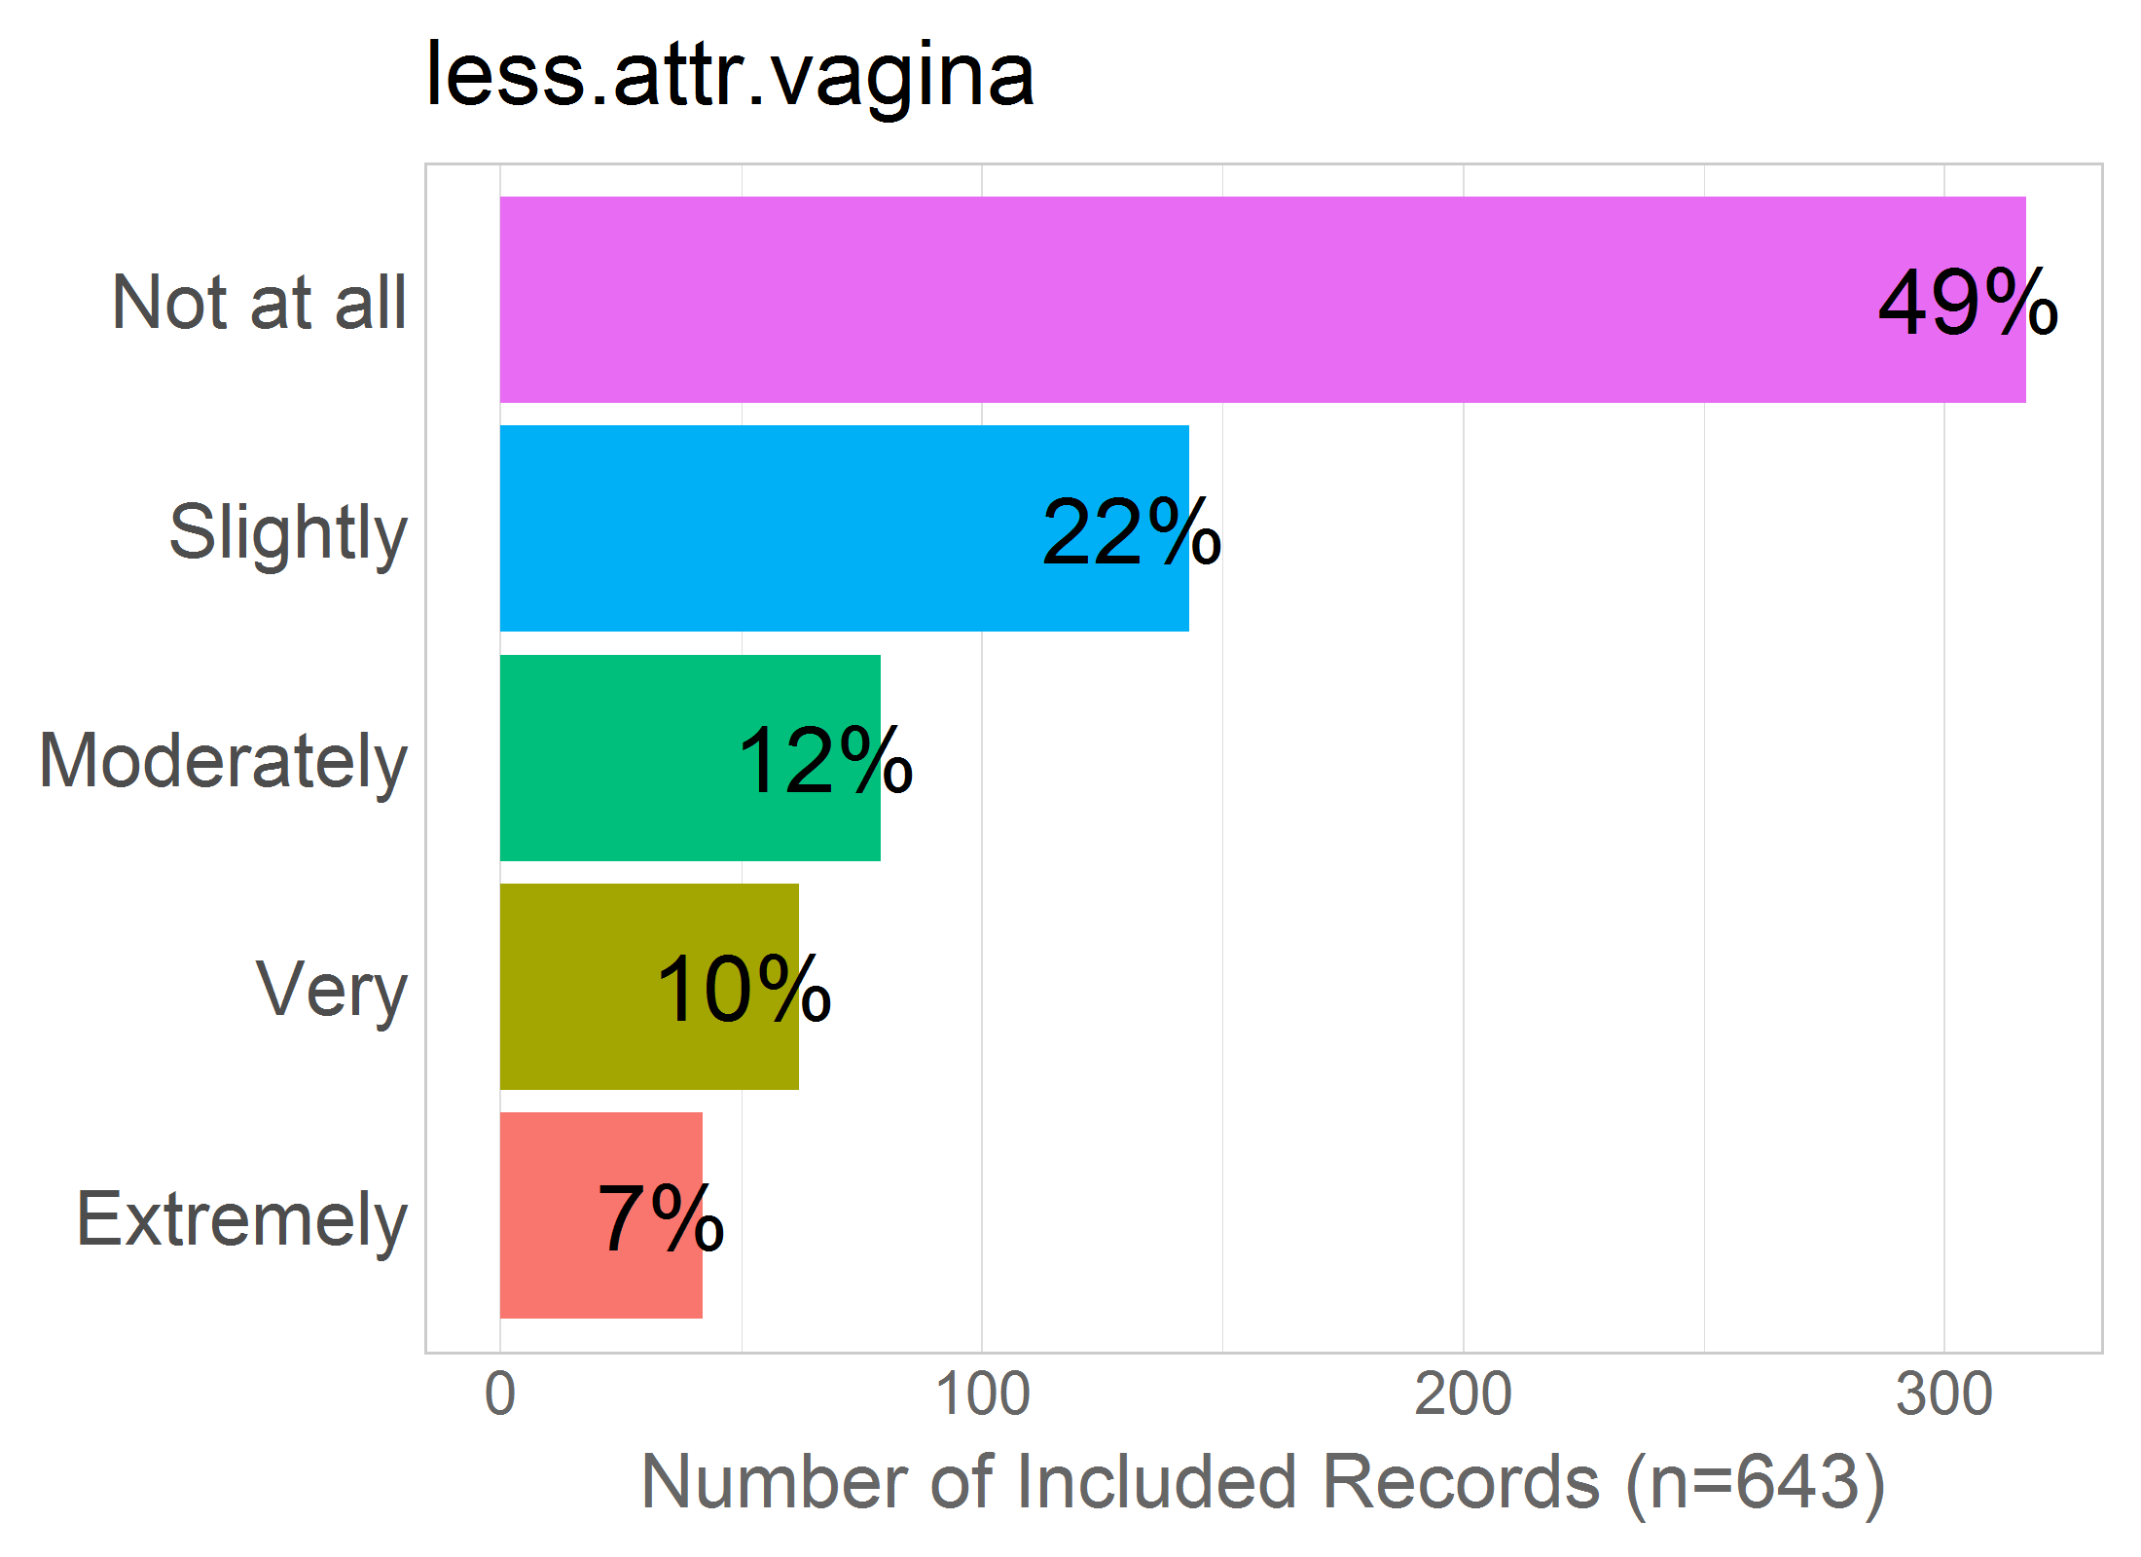

Mean: 2.02

SD: 1.26

Missing: 0

# SEX.FUNCTION

Correlation of items in the proposed factor:

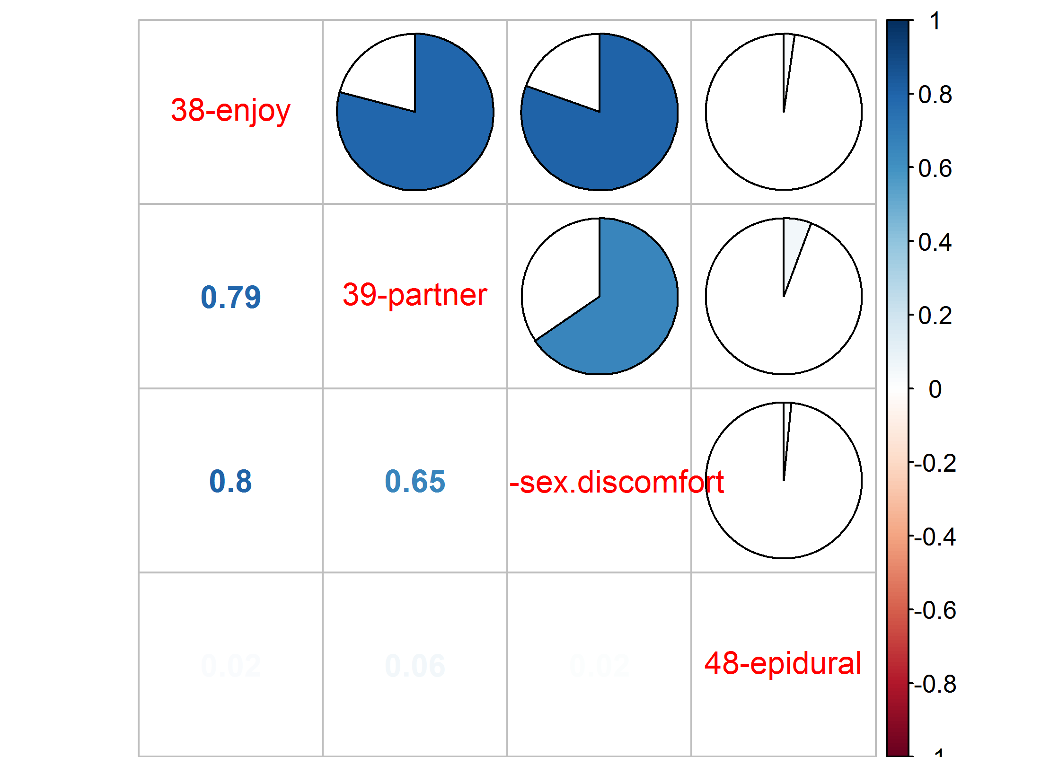NULL

## 38 - enjoy

38 - Enjoying sexual intercourse less because of stretching from a vaginal birth?

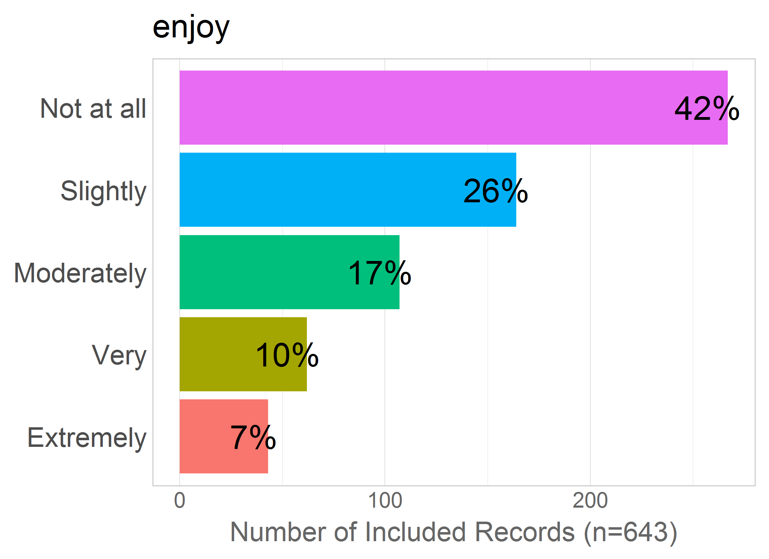

Mean: 2.14

SD: 1.25

Missing: 0

## 39 - partner

39 - My partner enjoying sexual intercourse less because of stretching of my vagina from having a vaginal birth?

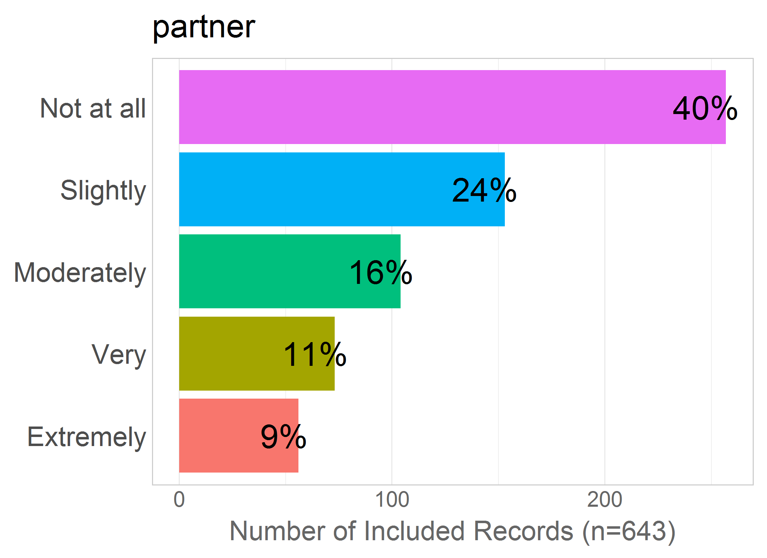

Mean: 2.25

SD: 1.32

Missing: 0

## 47 - sex.discomfort

47 - Enjoying sexual intercourse less because of pain or discomfort from the birth?

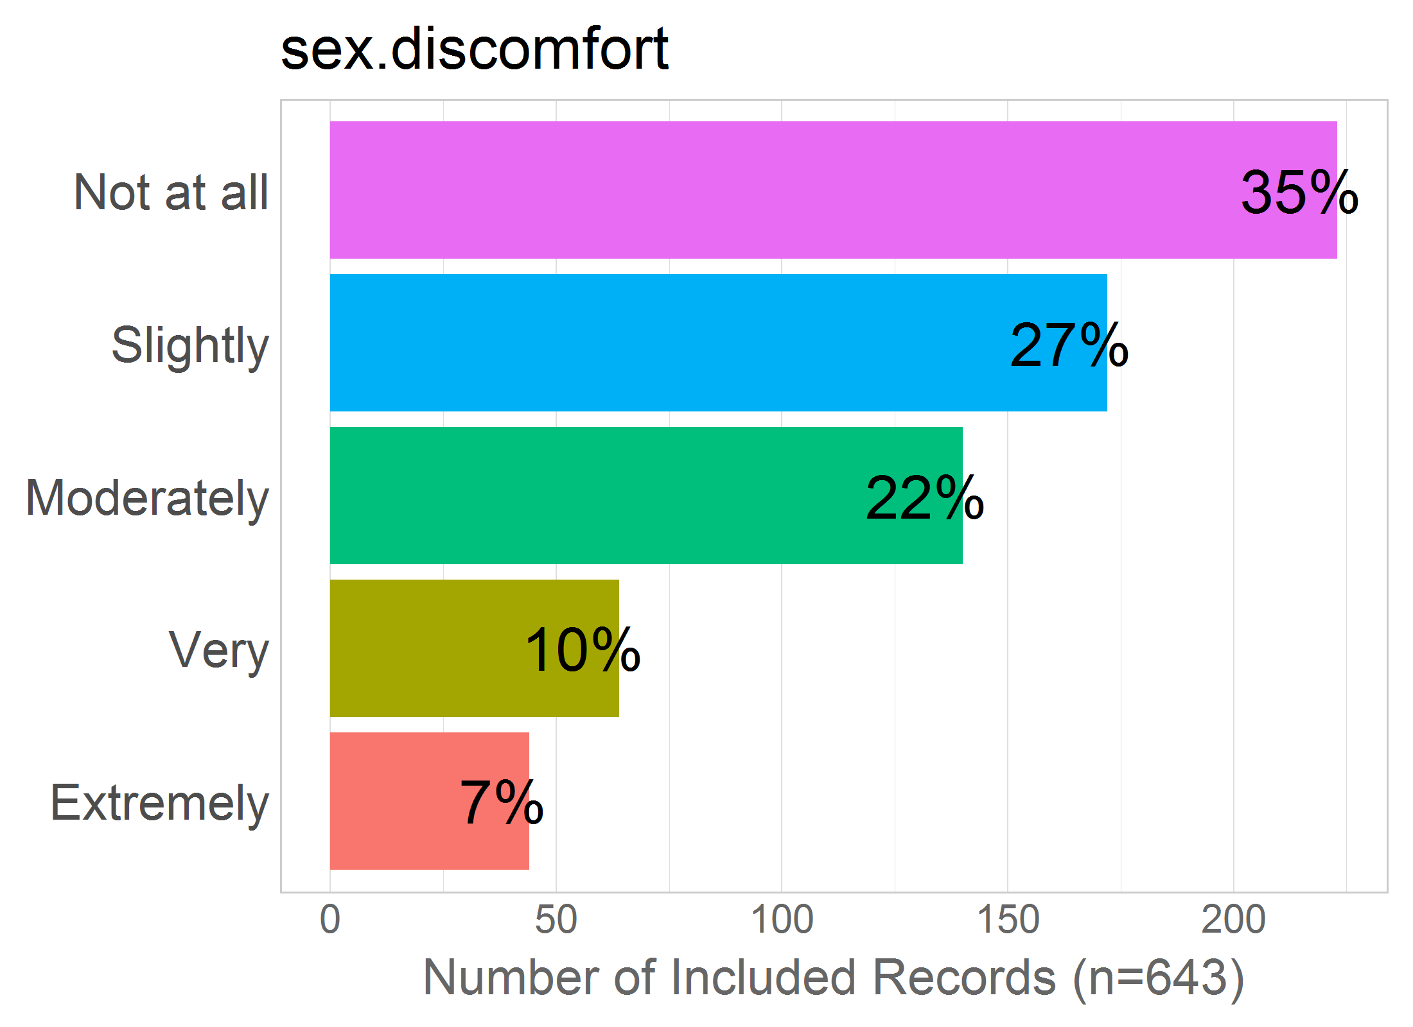

Mean: 2.28

SD: 1.23

Missing: 0

## 48 - epidural

48 - Being administered an epidural?

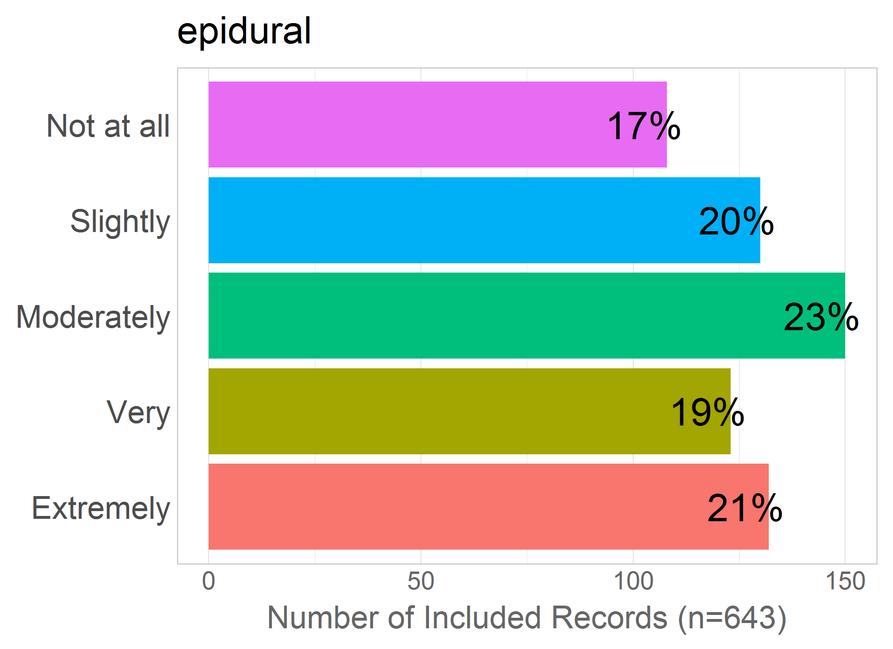

Mean: 3.06

SD: 1.37

Missing: 0

# INTERVENTIONS

Correlation of items in the proposed factor:

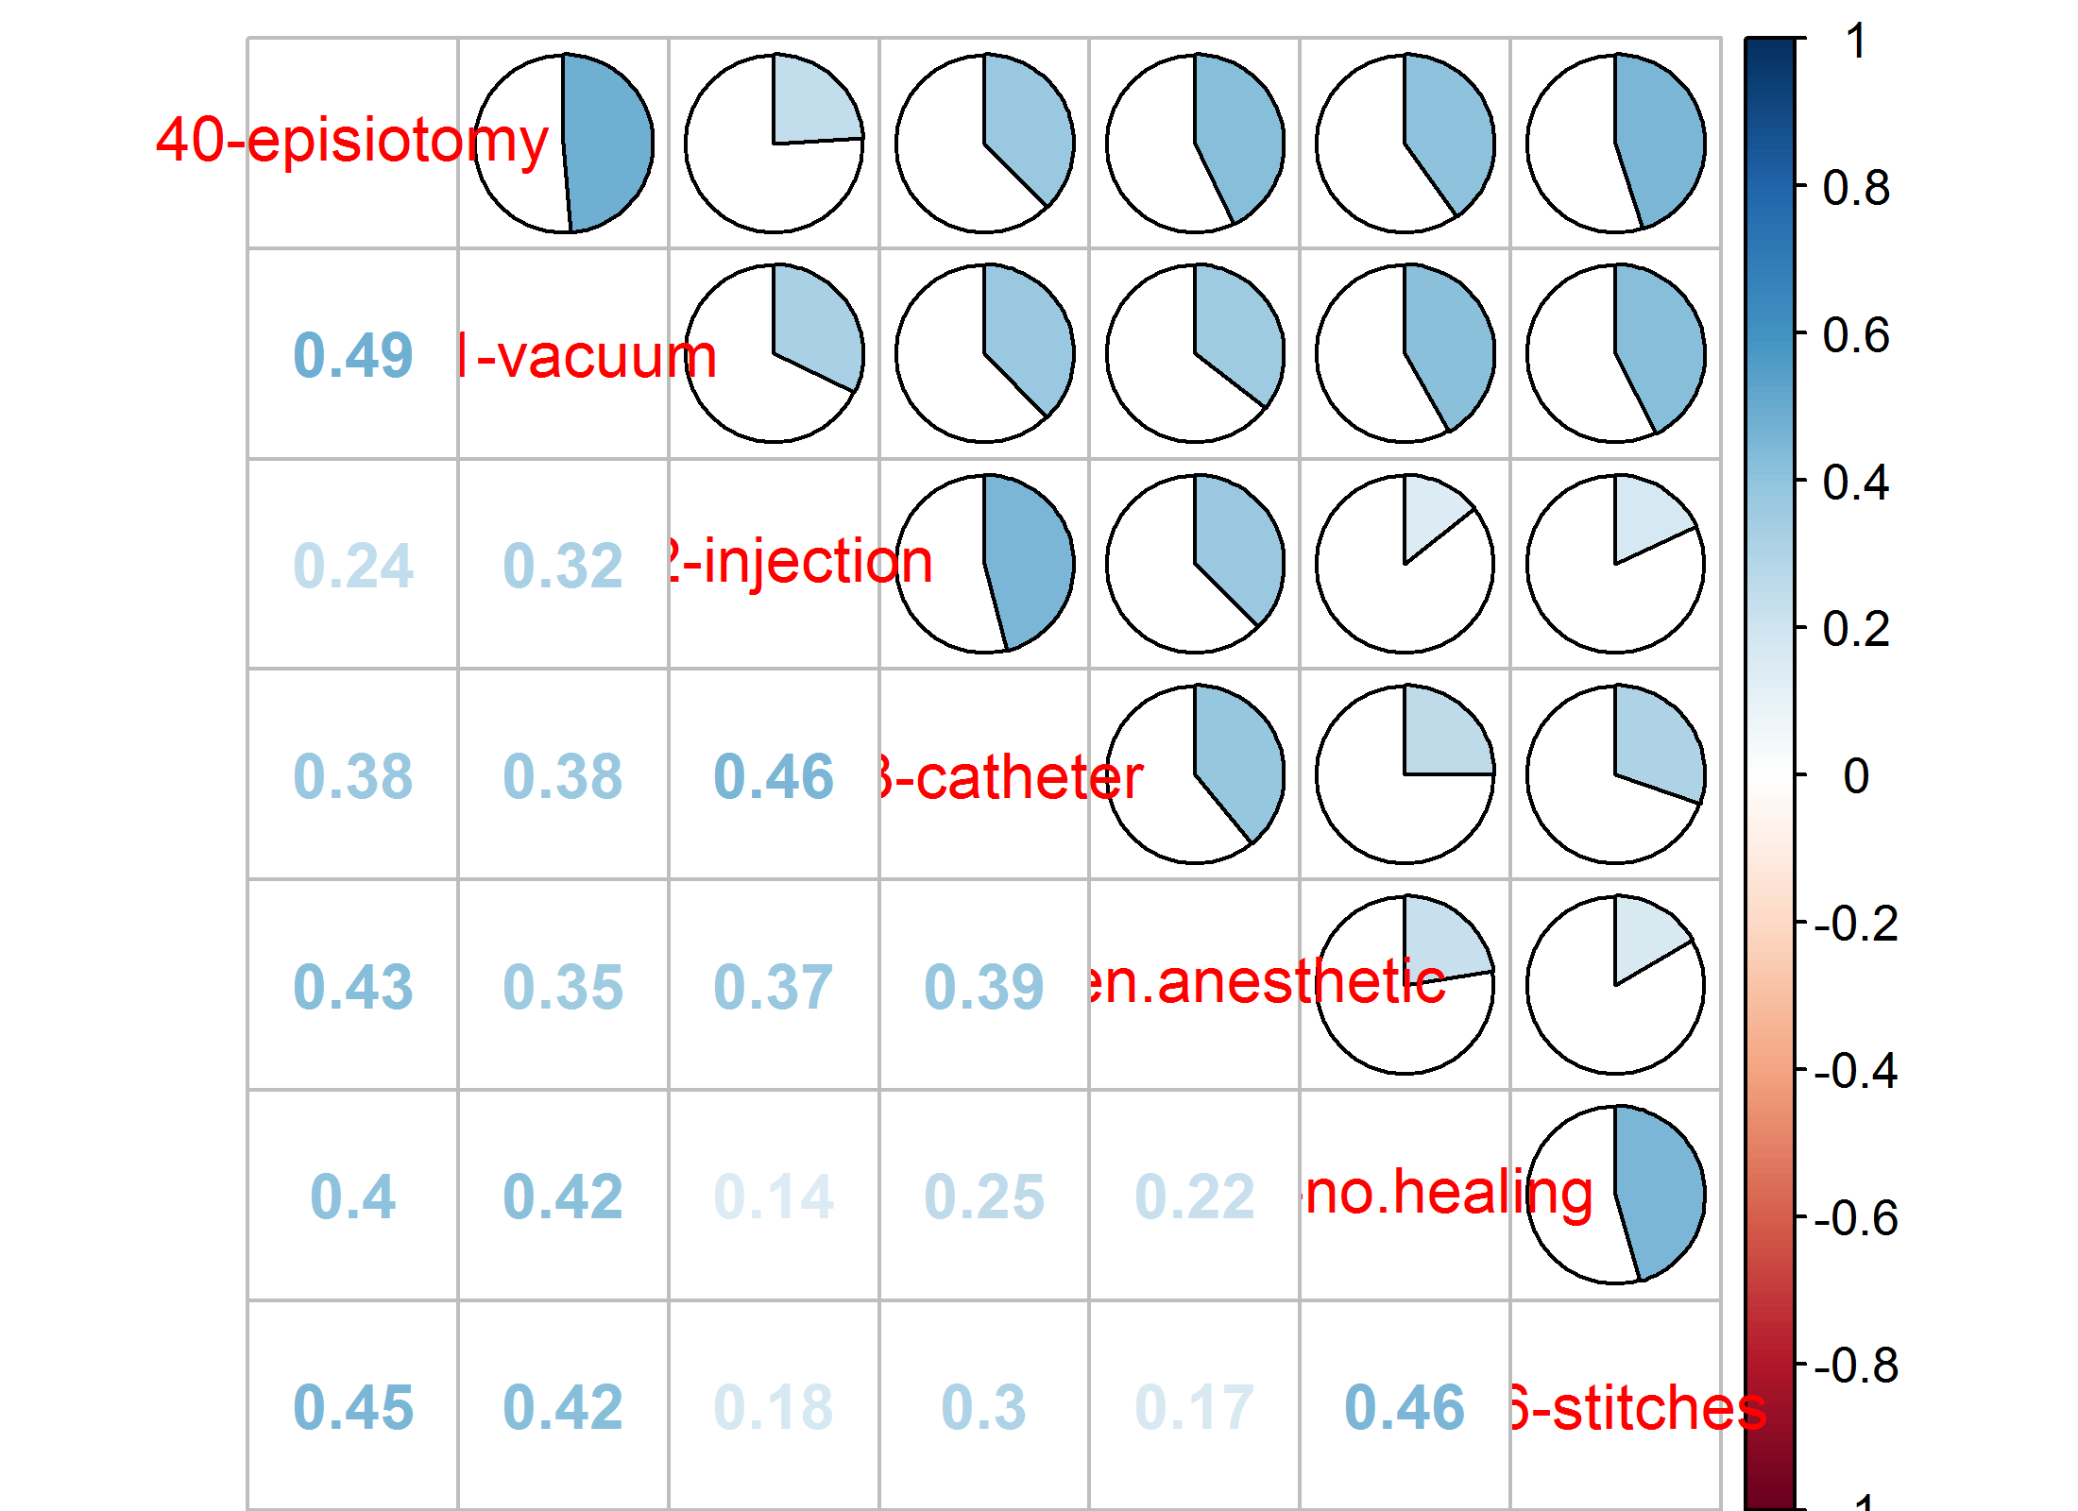NULL

## 40 - episiotomy

40 - Having an episiotomy?

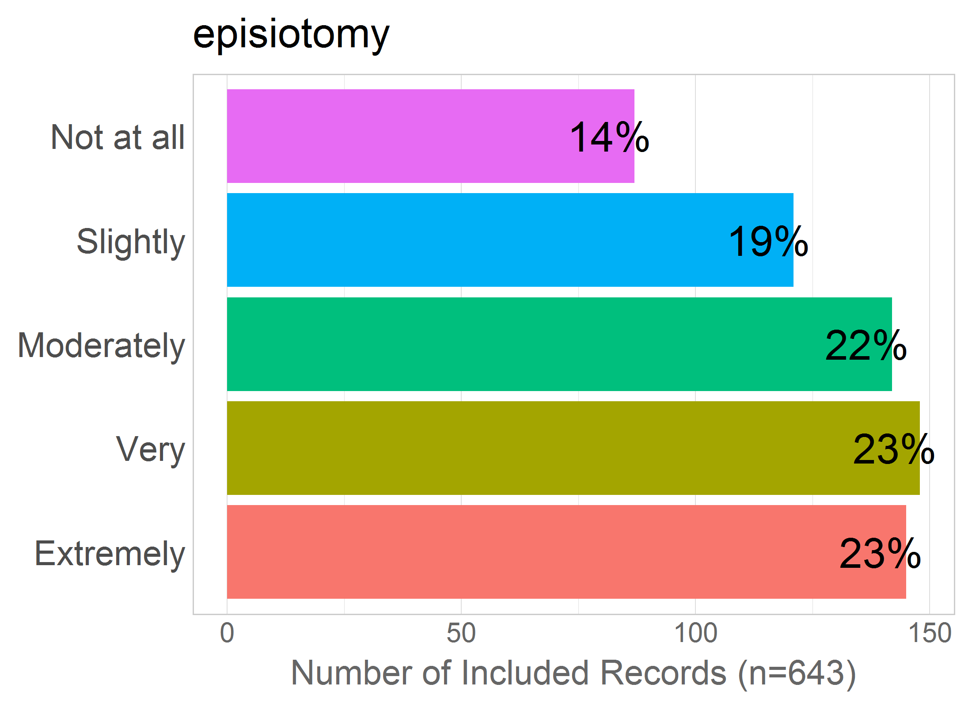

Mean: 3.22

SD: 1.35

Missing: 0

## 41 - vacuum

41 - Requiring vacuum or forceps?

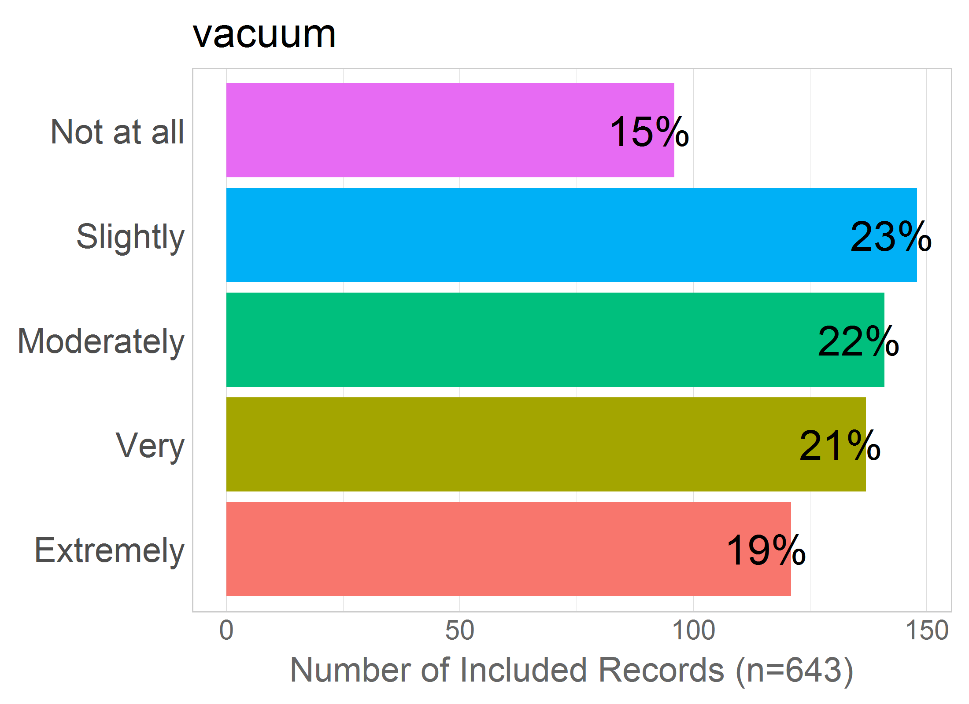

Mean: 3.06

SD: 1.34

Missing: 0

## 42 - injection

42 - Being administered injections?

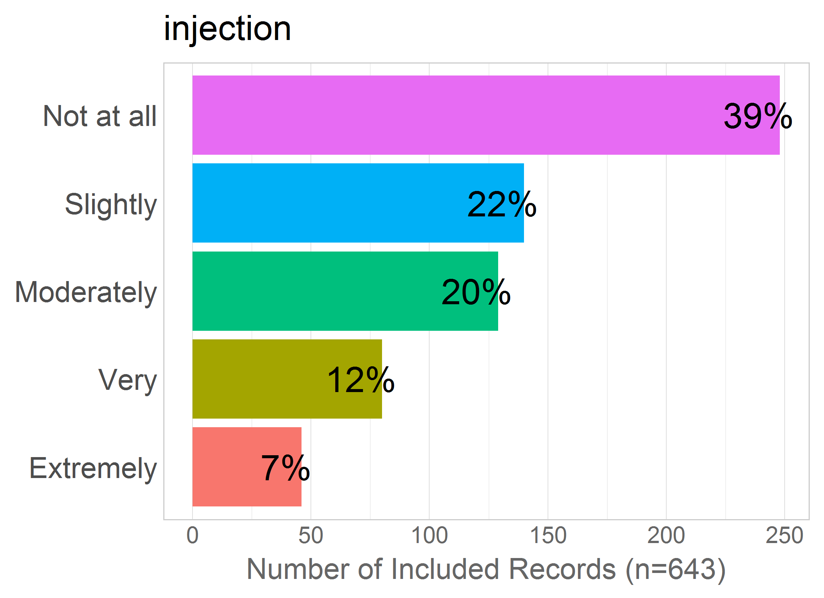

Mean: 2.28

SD: 1.29

Missing: 0

## 43 - catheter

43 - Having a catheter inserted (a tube inserted into the urethra to collect urine)?

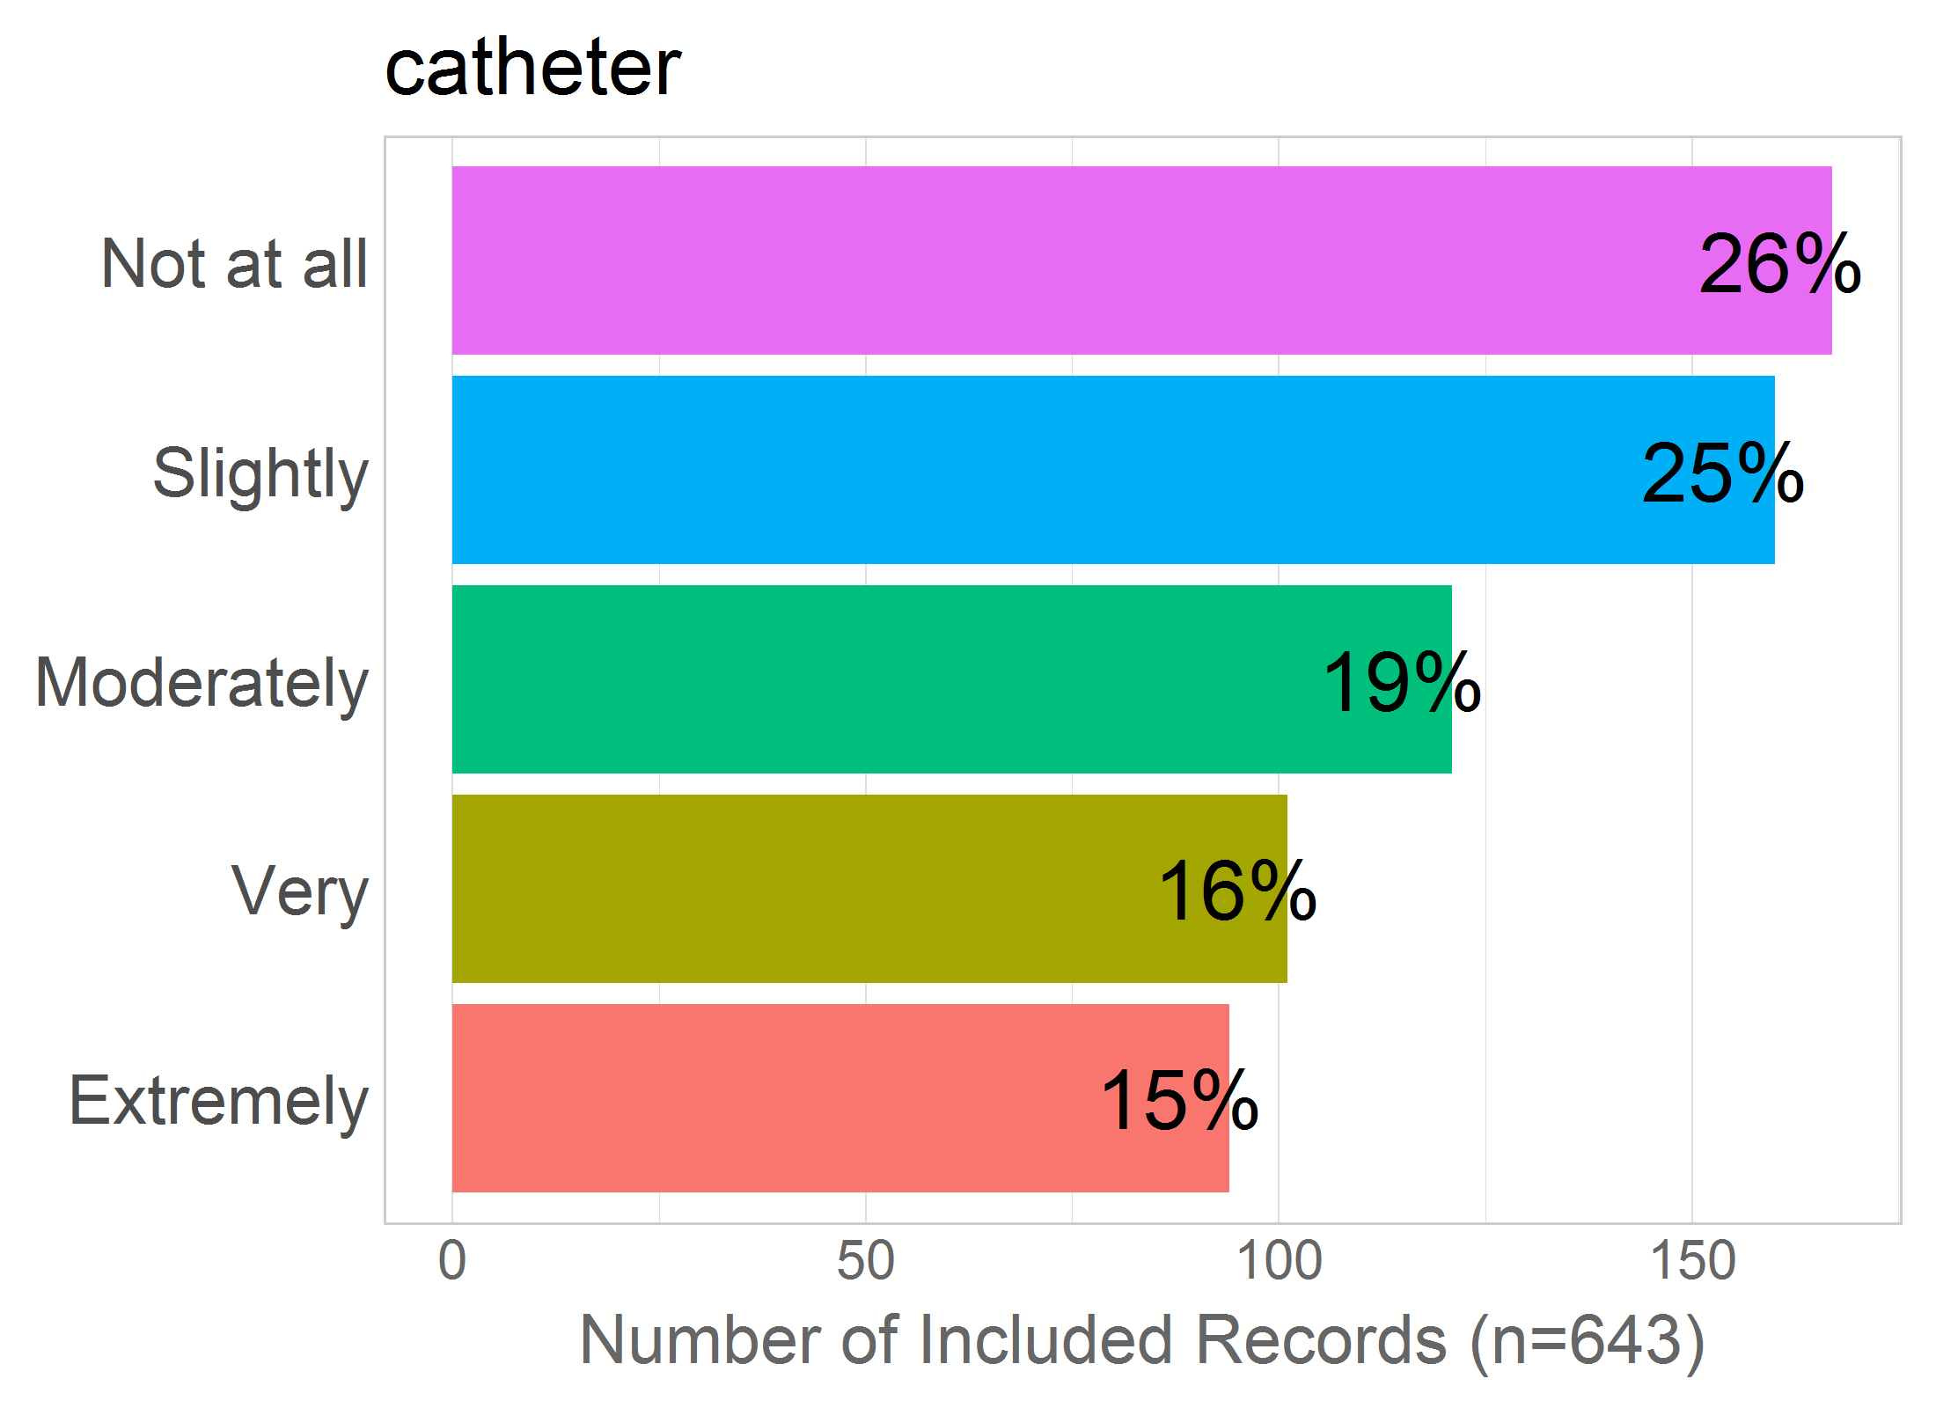

Mean: 2.68

SD: 1.39

Missing: 0

## 44 - gen.anesthetic

44 - Having general anesthetic?

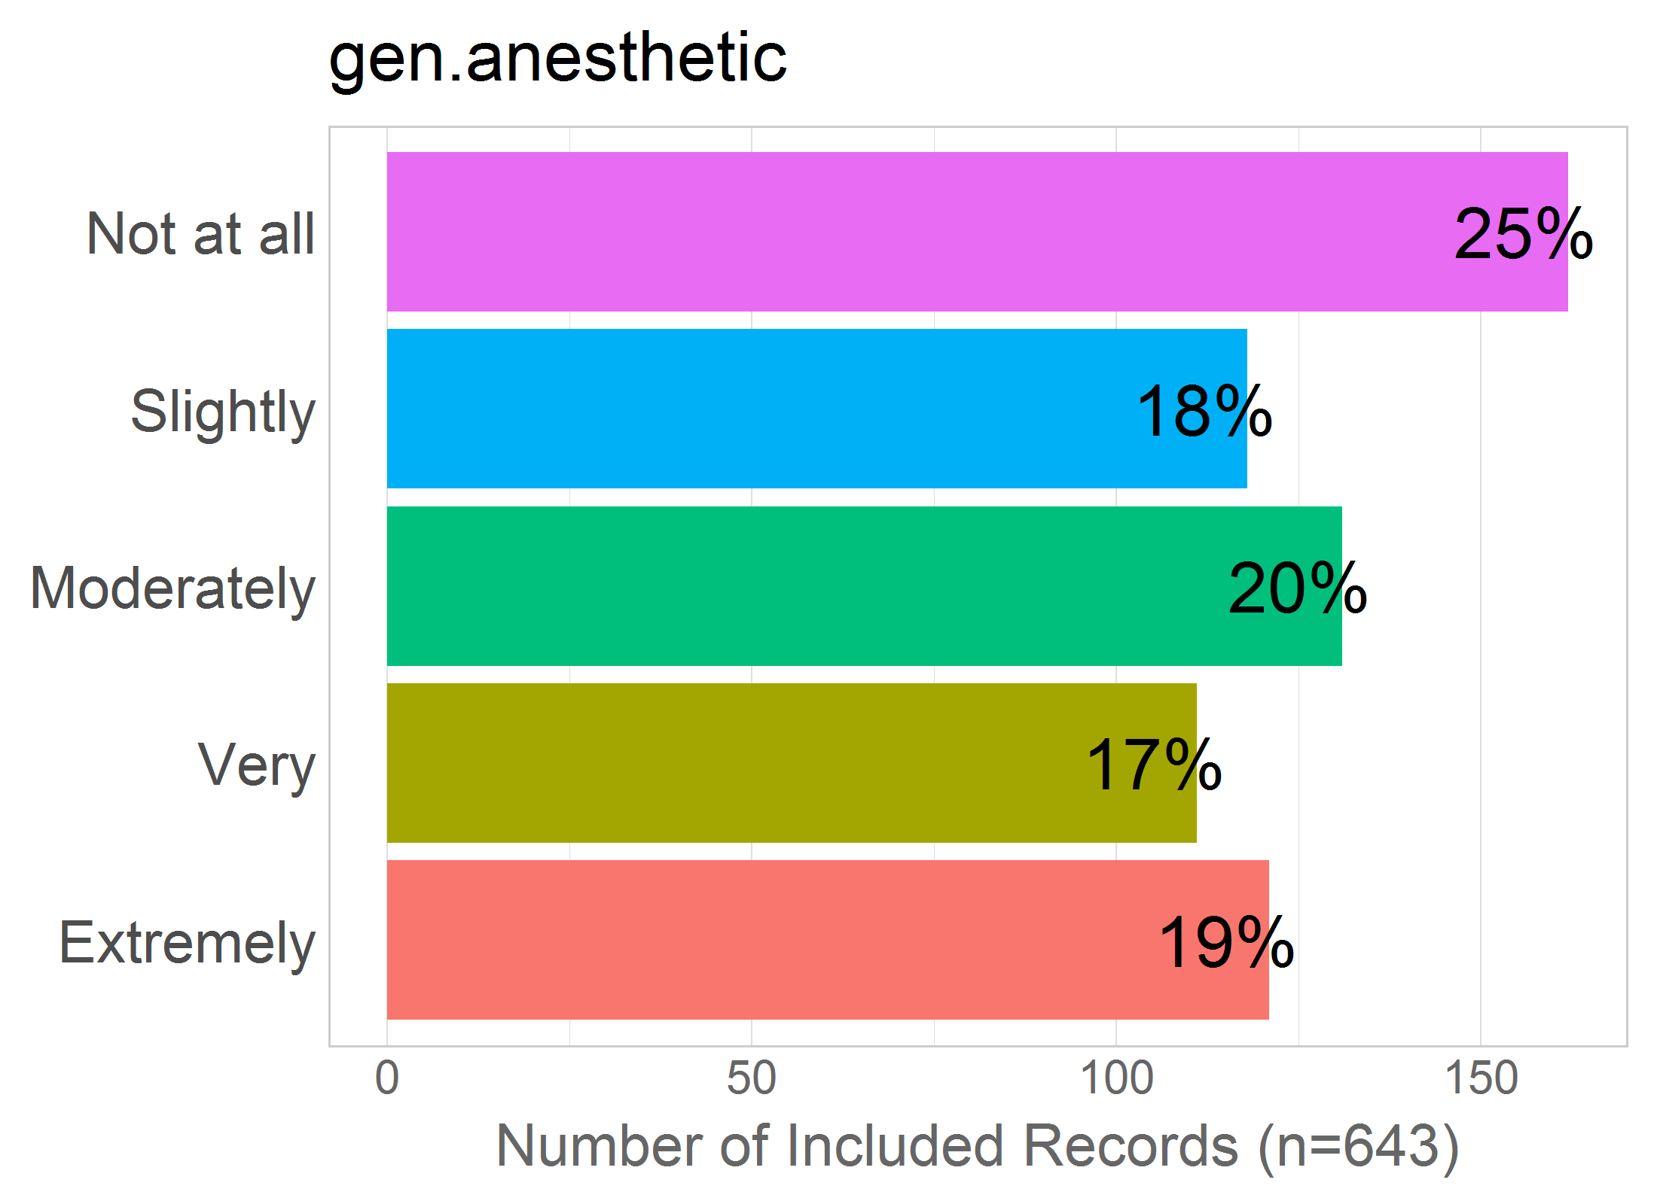

Mean: 2.86

SD: 1.45

Missing: 0

## 45 - no.healing

45 - Having scars or wounds that do not heal properly?

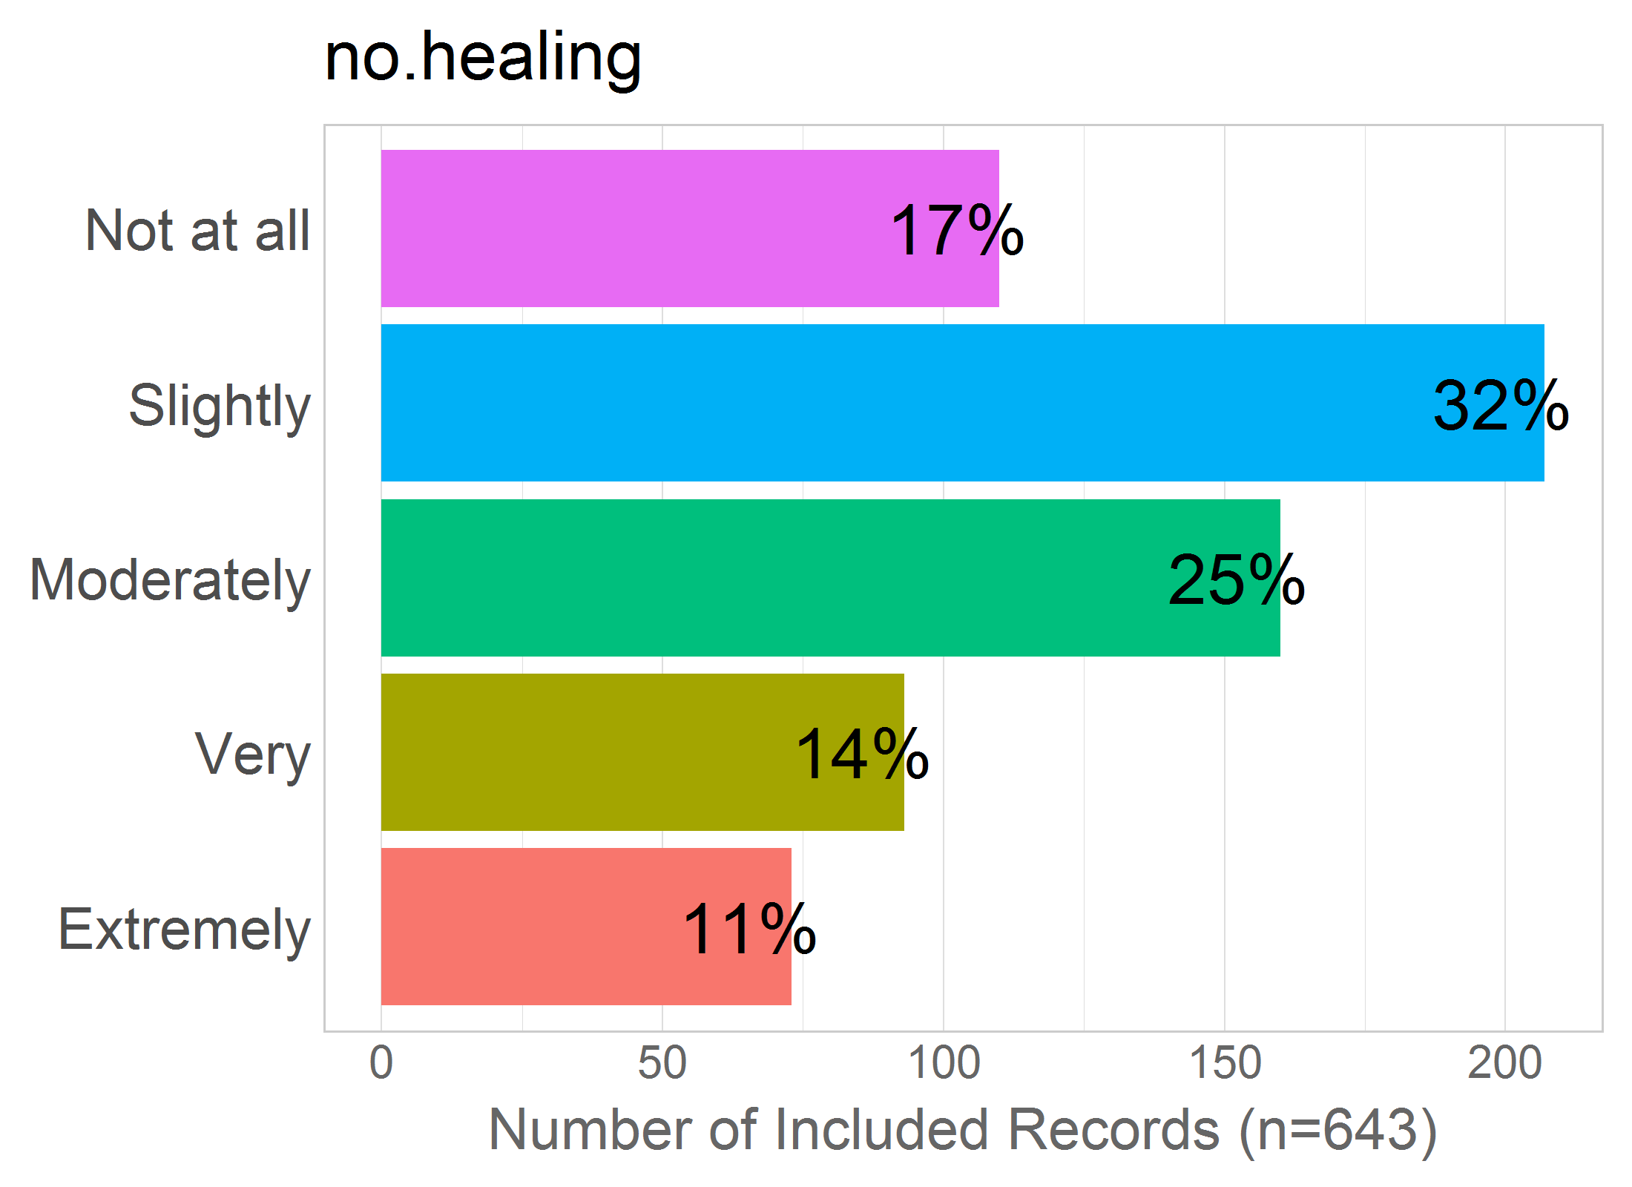

Mean: 2.71

SD: 1.23

Missing: 0

## 46 - stitches

46 - Needing to have stitches after the birth?

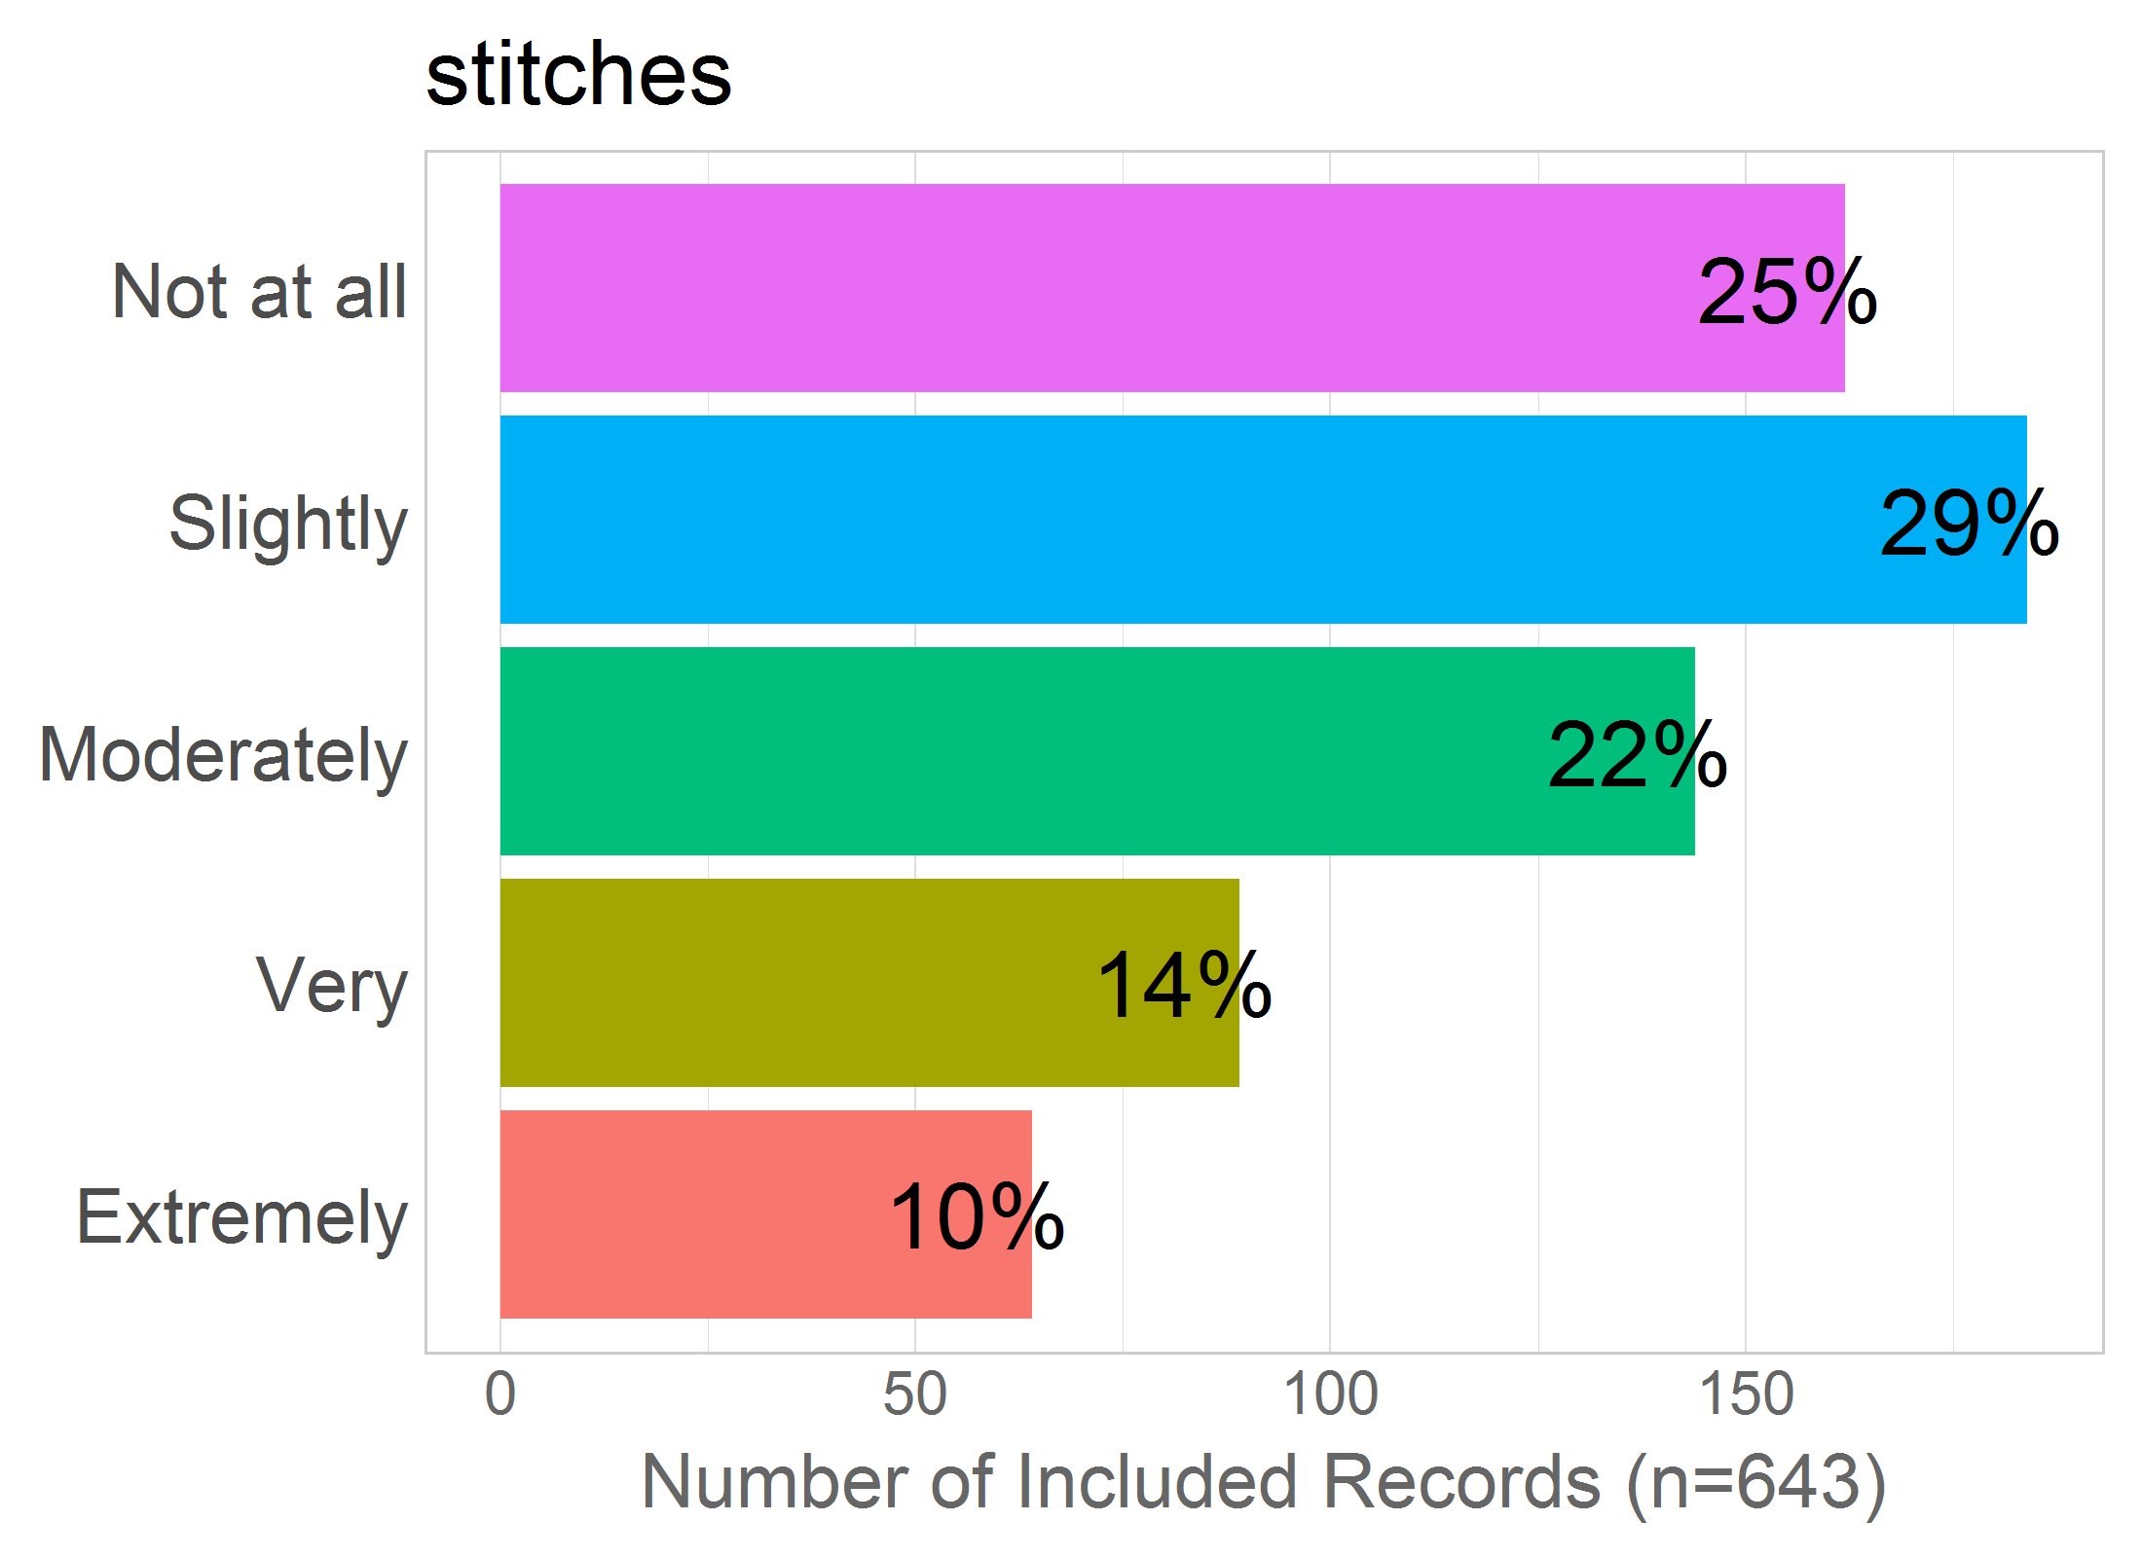

Mean: 2.55

SD: 1.28

Missing: 0

# INTERVENTIONS

Correlation of items in the proposed factor:

NULL

## 40 - episiotomy

40 - Having an episiotomy?



Mean: 3.22

SD: 1.35

Missing: 0

## 41 - vacuum

41 - Requiring vacuum or forceps?



Mean: 3.06

SD: 1.34

Missing: 0

## 42 - injection

42 - Being administered injections?



Mean: 2.28

SD: 1.29

Missing: 0

## 43 - catheter

43 - Having a catheter inserted (a tube inserted into the urethra to collect urine)?



Mean: 2.68

SD: 1.39

Missing: 0

## 44 - gen.anesthetic

44 - Having general anesthetic?



Mean: 2.86

SD: 1.45

Missing: 0

## 45 - no.healing

45 - Having scars or wounds that do not heal properly?



Mean: 2.71

SD: 1.23

Missing: 0

## 46 - stitches

46 - Needing to have stitches after the birth?



Mean: 2.55

SD: 1.28

Missing: 0

# prepare variables as factors  
foc_levels <- c(0,1,2,3,4)  
foc_labels <- c("Not at all",  
 "Slightly",  
 "Moderately",  
 "Very",  
 "Extremely")  
# (varlist <- c(paste0("foc_0",1:9),paste0("foc_",10:49)))  
#   
#   
# for( i in varlist){  
# ds[,i] <- as.numeric(ds[,i])-1  
# ds[,i] <- factor(ds[,i], levels = foc_levels, labels = foc_labels)  
# }