2 | 3 pcs  Resistor 10k 1% | 3 | 1 pc  Resistor 68k 1% | 4 | 1 pc  Resistor 680R 1%
 |  |  |  | 
5 | 3 pcs  Button | 6 | 1 pc  DIL-8 Socket | 7 | 1 pc  CR3202 Battery Holder
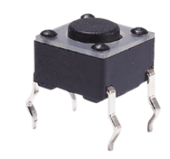 |  | 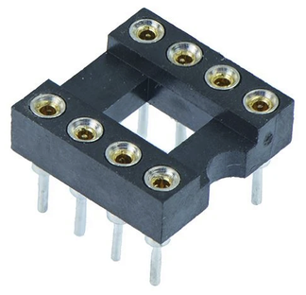 |  | 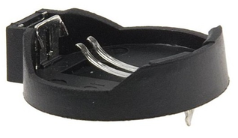  MOUNT ON BOTTOM SIDE!
8 | 1 pc  SSD1306 I²C OLED 0.96“ | 9 | 1 pc  LED 2mA | 10 | 1 pc  Slider Switch SS12F23
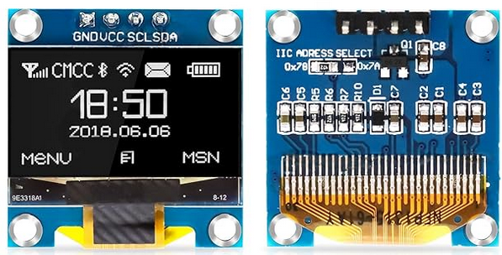 |  | 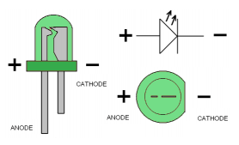 |  | 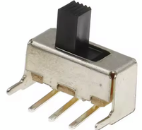
11 | 1 pc  ATTINY85 | TOOL  Programmer USBasp |  | 12 | 1 pc  3V Battery C2032
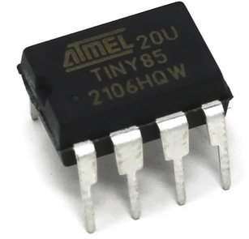 |  | 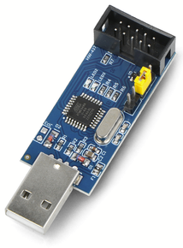 |  | 
13 | 1 pc  Passive Buzzer | Material  Solder |  | 1 | 1 pc  Tiny Arc Buddy PCB
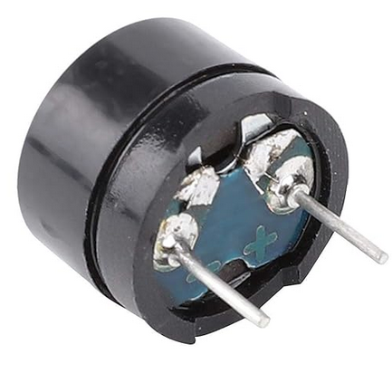  MOUNT AFTER PROGRAMMING! |  | 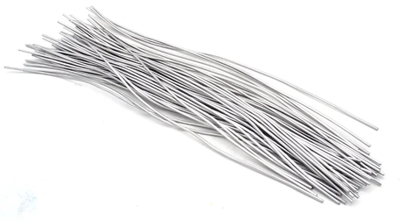 |  | 