K-Comp V2 Assembly Guide

Schematics
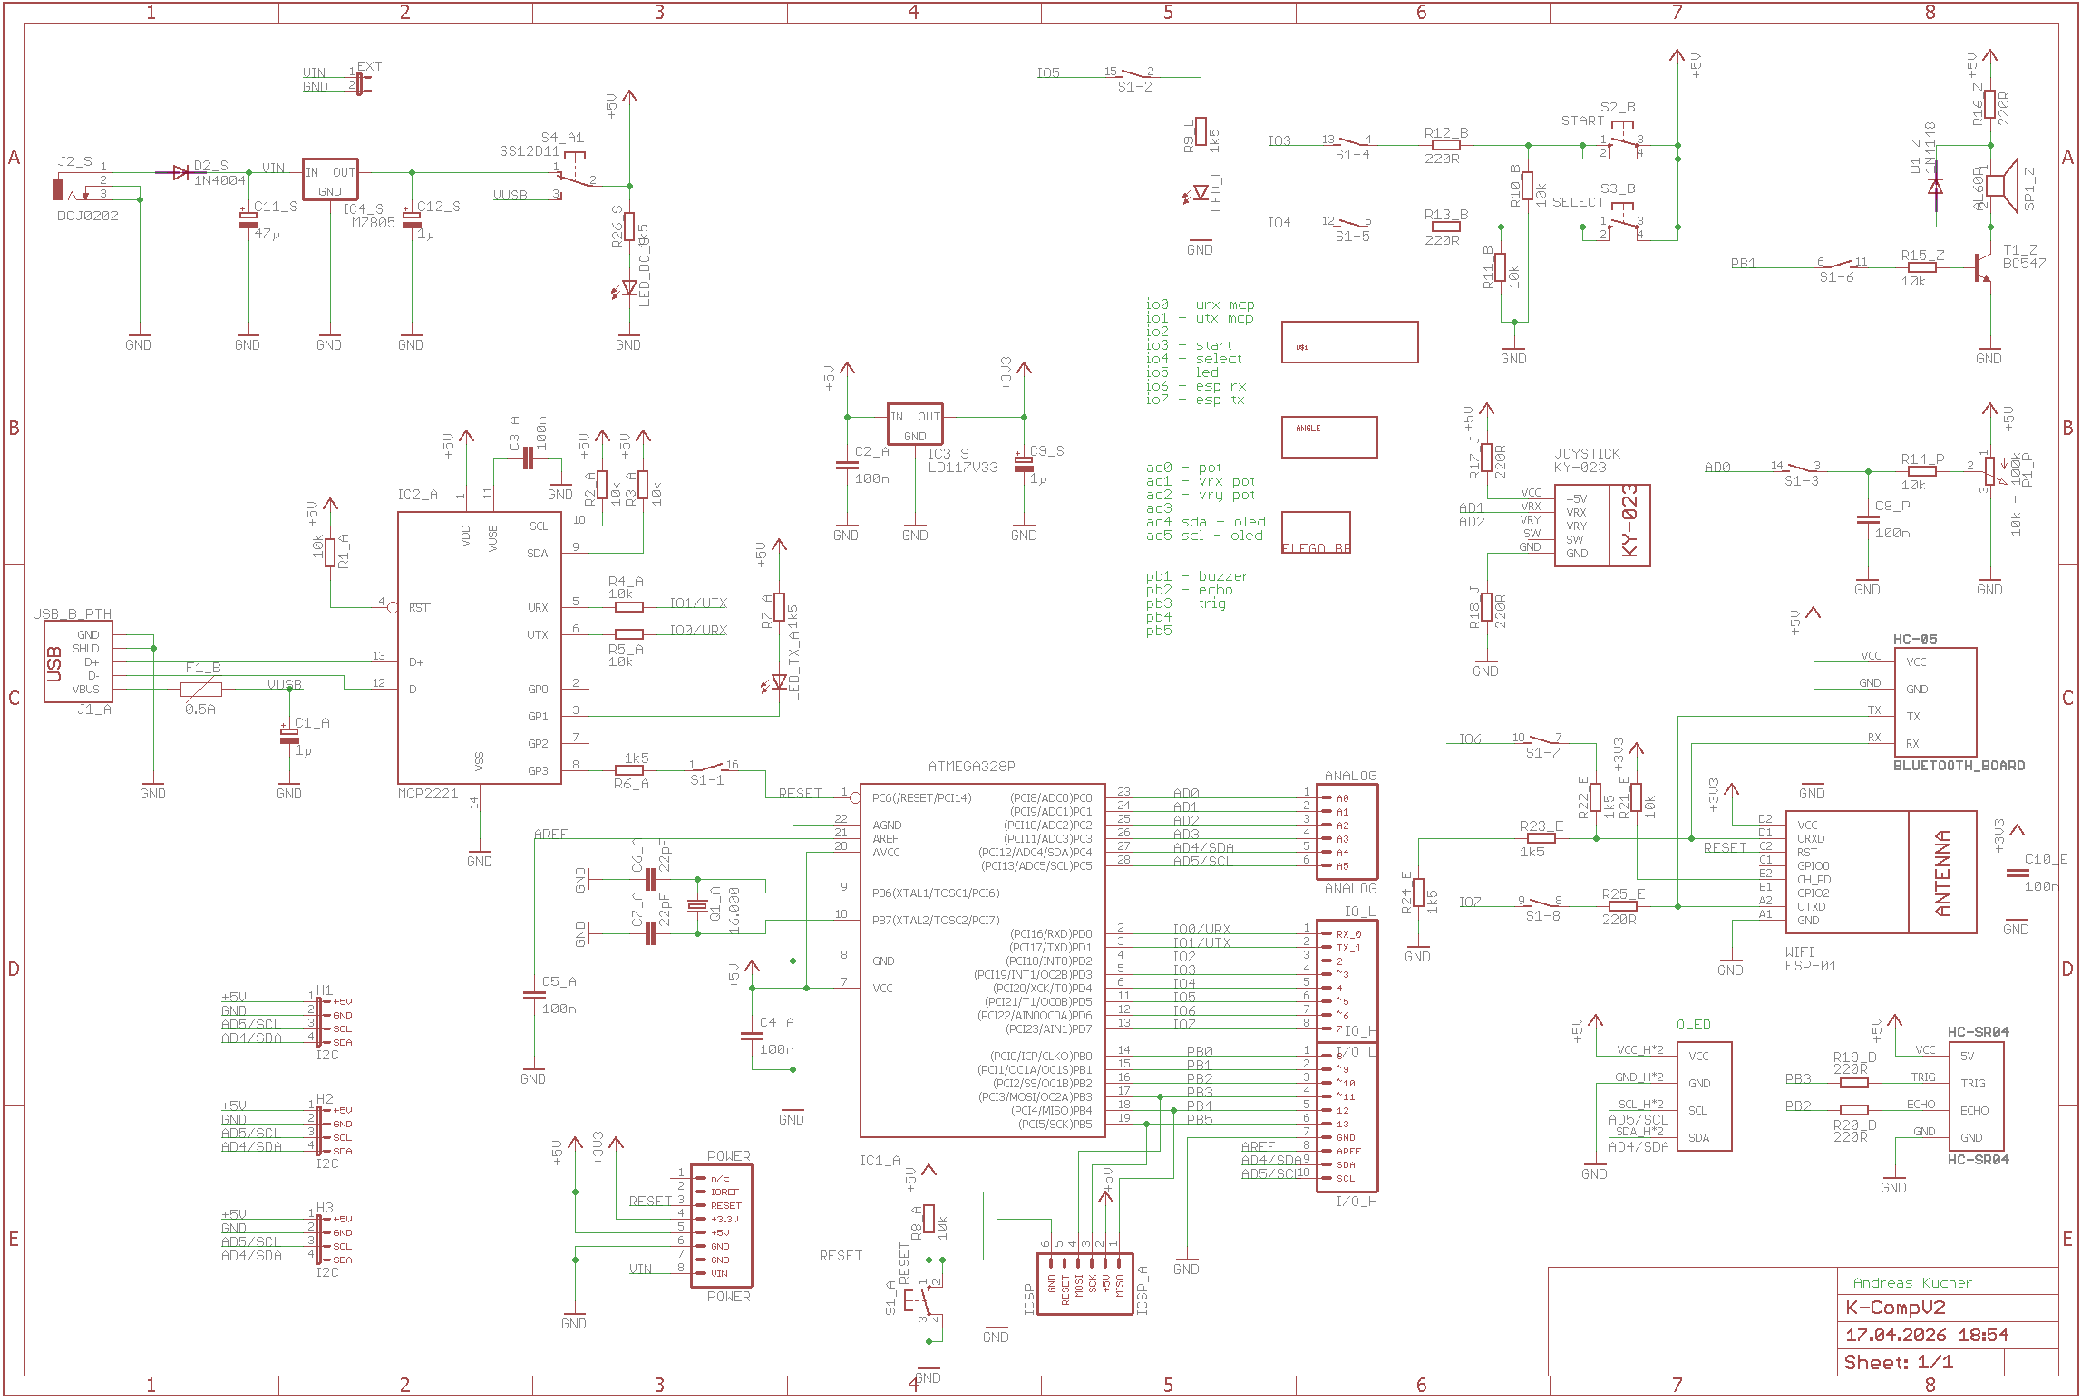

Assembly Guide
Welcome to the step-by-step assembly guide for your Single Board Computer K-Comp! This guide helps you solder and assemble each component from the assortment box to the printed circuit board (PCB). Follow the steps in order and use the images as visual checkpoints.

Legend (Letter at the end of each part number on the PCB):

- A: Base Module
- B: Buttons
- L: LED
- E: ESP WiFi Module / HC-05 BT Module
- J: Joystick

- Z: Buzzer
- P: Potentiometer
- O: OLED Display
- D: Distance Sensor
- S: External Power Supply

Numbers in parentheses (e.g. 3 pcs) = Number of components for the section.

Tools Required

- Soldering iron & solder
- Small pliers & cutters
- Multimeter (optional)
- Screwdrivers

Step-by-Step Assembly
Use the image below and the demo board to check for position and polarity of the components!

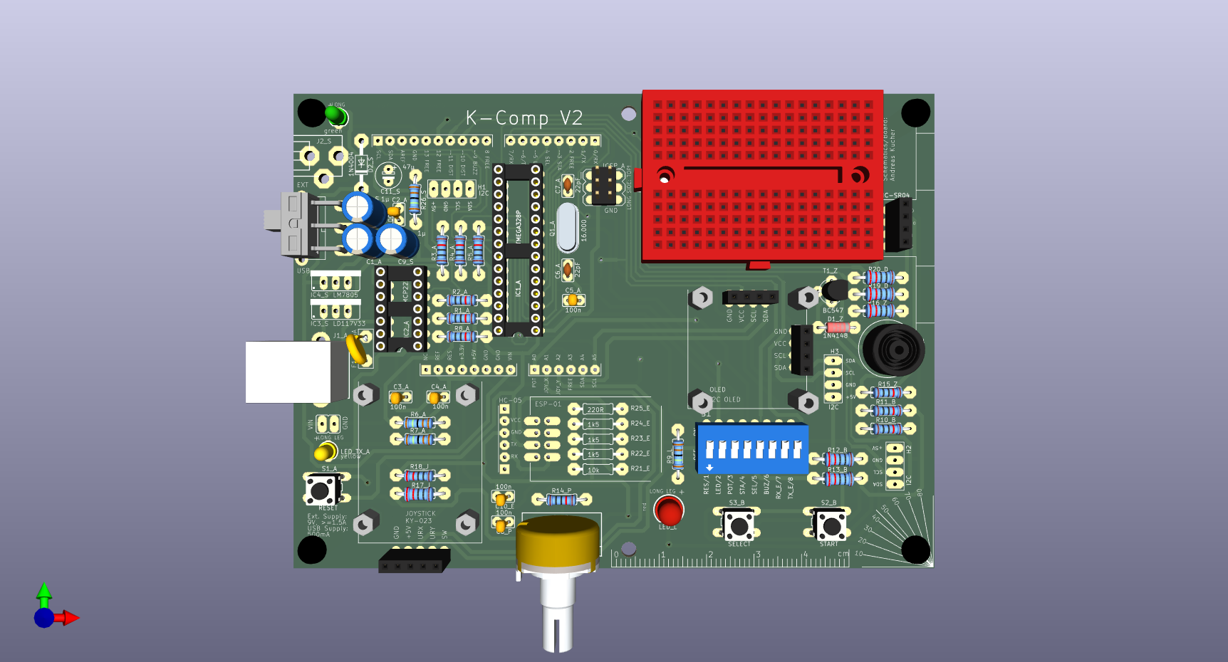

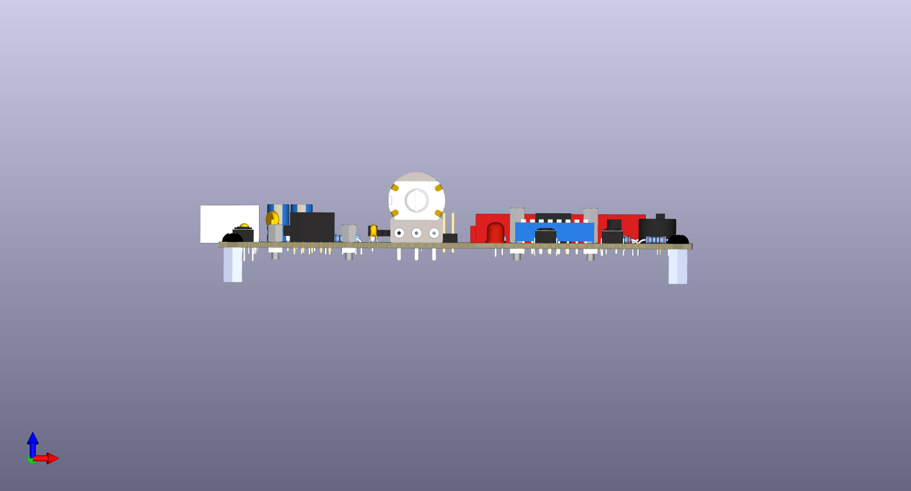

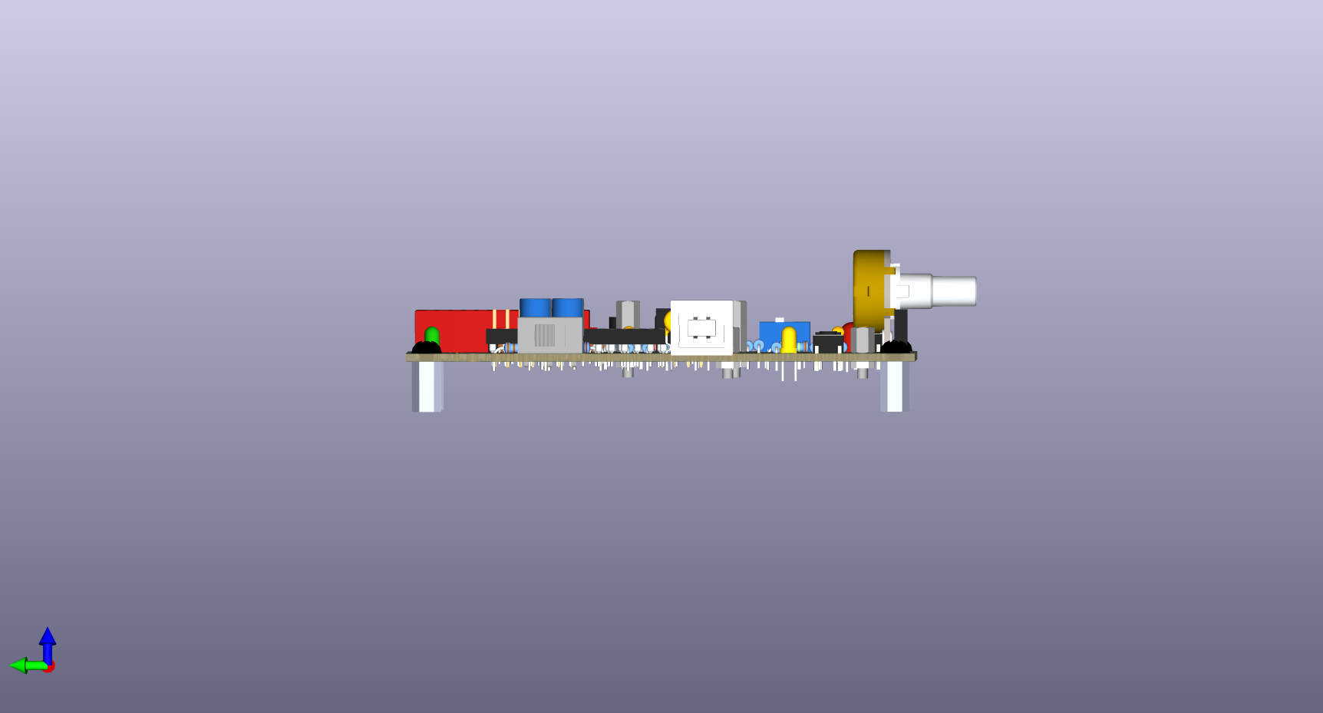
Step 1 – Resistors 10k or 1k2 (10 pcs)
Step 2 – Resistors 1k5k (4 pcs)
Step 3 – Resistor 220R (7 pcs)
Step 4 – Diode 1N4148 (1 pc)
Place with correct polarity (black ring matches mark on PCB).
Step 5 – Quartz 16MHz (1 pc)
Step 6 – Ceramic Capacitors 100nF (6 pcs)
Step 7 – DIL-14 Socket (1 pc) - Also align notch correctly.
Step 8 – DIL-28 Socket (1 pc) - Also align notch correctly.
Step 9 – Buttons (3 pcs)
Step 10 – Geen LED (1 pc) / Yellow LED (1 pc) - Place with correct polarity!
Step 11 – Ceramic Capacitors 22pF (2 pcs)
Step 12 – Transistor BC847 (1 pc) - Place with correct orientation!
Step 13 – 8 Positions DIP Switch (1 pc) - Place with correct orientation!
Step 14 – SS12D11 Toggle Switch (1 pc)
Step 15 – Red LED 5mm (1 pc) - Place with correct polarity!
Step 16 – Passive Buzzer (1 pc) - Place with correct polarity!
 | Step 17 – Pin Header Male 3x2 (1 pc) – Cut them of 3x2 using the cutter!  Step 18 – Pin Header Female 1x4 (3 pcs)  Step 19 – Pin Header Female 1x5 (1 pcs) | Long side on the top part of the PCB!
 | Step 20 – USB-B Connector (A(1))  Step 21 – Resettable Fuse 500mA (A(1))  Step 22 – Electrolyte Capacitor 1uF (3 pcs) - Place with correct polarity!  Step 23 – Potentiometer 10k-100k (1 pc) – Solder on top as well!  Step 24 – Potentiometer Cap (1 pcs) - Align the cap correctly! | At least Step 24 must be completed after the first unit!
Step 25 – Flash the ICs, test USB and do a first test!
(Go to your teacher with your board. Your teacher will check your PCB assembly, mount the MCP2221A USB-UART chip / Atmega328P Microcontroller and configure/program them.)
Step 26 – Nylon Screws M3x6mm (4 pcs)
Step 27 – Hex Spacer f/f M3x5mm (4 pcs)
Step 28 – Hex Spacer m/f M2x5mm (4 pcs) – for the Joystick
Step 29 – Spacer m/f M2x10mm (4 pcs) – for the OLED Display
Step 30 – Hex Nut M2 (8 pcs) – Use a M2 Nut Wrench for mounting!
Step 31 – KY-023 Joystick (1 pcs)
Step 32 – Nylon Screws M2x6mm (4 pcs) – For the Joystick Only!
Step 33 – SSD1306 OLED Display (1 pc)
Step 34 – Breadboard 170 Tie Points (1 pc)
Step 35 – HC-SR04 Distance Sensor (1 pc)
Step 36 – Final test – Run test codes!

For Teachers: Configuring MCP2221A and Burning the Bootloader on ATmega328P
        - Software Required
MCP2221A Uitility
- Install and the MCP2221A Utility (https://www.microchip.com/en-us/product/mcp2221a#Tools%20And%20Software)
USBasp Driver
- Download and install Zadig (https://zadig.akeo.ie).
- Connect USBasp via USB.
- Select USBasp and libusbK (vx.x.x.x).
- Select Reinstall WICD Driver. (This may take some time.)

        - Configuring MCP2221A and Burning the Bootloader
MCP2221A Configuration
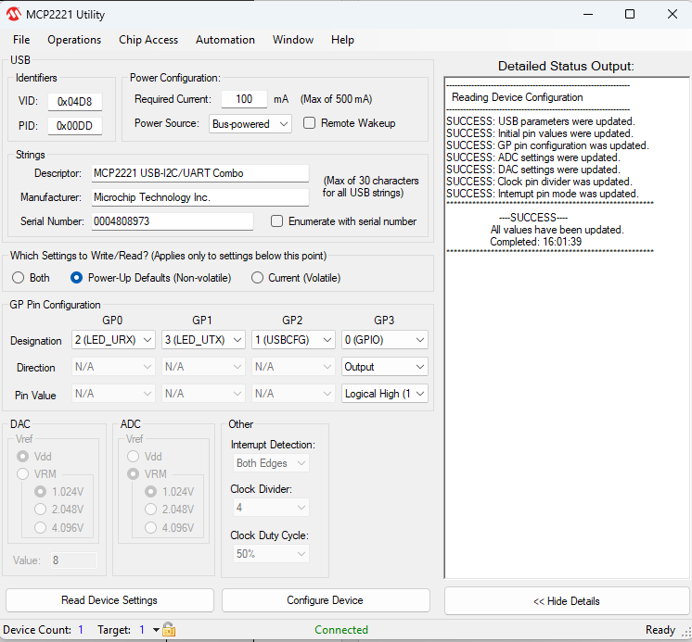
      - Start the MCP2221A Utility and connect K-Comp via USB.
      - Set GP3 to 0(GPIO), Output and Logical High (1).
      - Press Configure Device.

Burning the Bootloader on ATmega328P
- Connect USBasp to the ICSP Pin Headers on the K-Comp Board (make sure GND is connected to GND).
- Open the Arduino IDE and ensure that K-Comp V1 is the device selected.
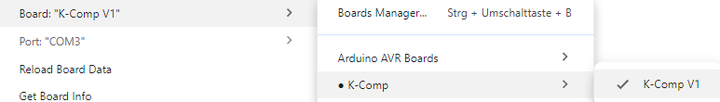
- Set the programmer in Tools | Programmer to USBasp.
- Click on Tools | Burn Bootloader.
- (Note: in case everything is connected properly etc. and burning the bootloader still fails, close JP3 on the USBasp and try again. Closing JP3 enables the “slow programming mode”.)

