K-Comp V2 – a brief overview

The K-Comp V2 is a custom-designed single board computer (SBC) tailored for learners of the C programming language working on interactive hardware projects. It is based on the ATmega328P microcontroller, the same chip used on Arduino Uno boards, but it extends the functionality with pre-connected components, custom made libraries and is fully supported in the Arduino IDE. It should be suitable for learning to develop embedded systems and sensor applications in C with minimal wiring and setup.

Hardware Specifications of the ATmega328P

Feature | Value | Explanation
Controller | ATmega328P | The main processor that runs your code and controls all components.
Clock Speed | 16 MHz | Determines how fast the microcontroller can execute instructions (e.g. ADD, LOAD, JMP, …) 16 million cycles per second).
Data Width | 8 bit | The processor works with 8 bits at a time – for example, it adds or stores data in 8-bit chunks.
Flash Memory | 32 KB | Stores your program permanently, even when power is off.
SRAM | 2 KB | Temporary memory used to store variables while the program is running.
EEPROM | 1 KB | A type of memory where you can save data permanently from within your code (e.g., settings).
USB Interface | MCP2221A | Converts USB signals from the PC to serial data the microcontroller can understand.
Power Supply | USB (or opt. 5V external) | The board can be powered directly via USB (or optionally from a separate 5V power source).
Digital I/O Pins | 14 | Used to read digital sensors or control devices like LEDs, buzzers, or relays.
Analog Inputs | 6 | For reading continuous signals (e.g., from a potentiometer or joystick).

Main Components (All Prewired):

(only gives the basic idea!)

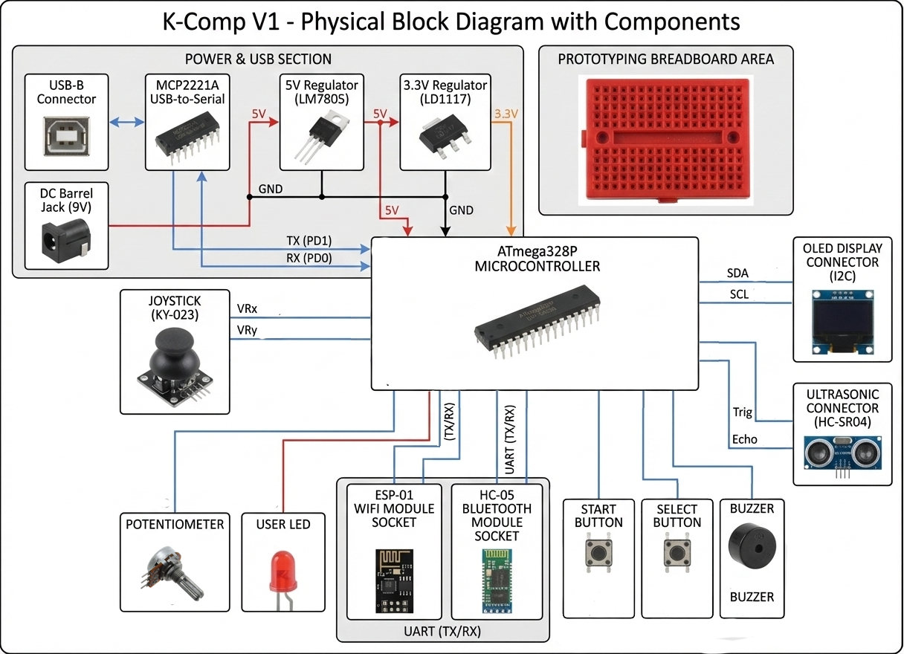

🧠 Main Processor – ATmega328P  - This is the heart of the system — it runs your Code  - Digital pins (D0–D13) for controlling LEDs, buzzers, buttons, etc.  - Analog inputs (A0–A5) for reading from sensors like the potentiometer or joystick.  - It gets programmed via the MCP2221A.  - A 16 MHz crystal oscillator provides the timing. | 🔄 USB Communication – MCP2221A  - The MCP2221A (IC2) is a USB-to-serial chip. It connects the board to your PC via USB and takes care of:  - Uploading code to the ATmega328P  - Serial communication between the PC and the microcontroller  - It connects to the TX (D1) and RX (D0) lines of the ATmega328P.
🔴 Red LED  - For feedback, indicators, or status signals.  - Connected to D3. | 🔘 2 Push Buttons  - For user input, program control, or state switching.  - Connected to D7 (START) and D8 (SELECT).
🎚️ Potentiometer  - Analog input for user-adjustable values (e.g., brightness, delay, volume).  - Connected to A0 for analog input. | 🔊 Passive Buzzer  - Can generate tones for alarms or sound output.  - Connected to D5.
🎮 Joystick (KY-023)  - Two analog axes (X, Y).  - For navigation, menus, or control inputs.  - X and Y axes go to A1 and A2, so they’re read as analog values. | 📟 0.96" OLED Display (SSD1306, I²C)  - 128×64 pixels.  - Display text, values, or simple graphics.  - Controlled via I2C lines: SCL (PC5) and SDA (PC4) on the ATmega328P.
📏 HC-SR04 Ultrasonic Distance Sensor  - Measures distances between 2 cm and 400 cm.  - Trigger pin to D12, echo pin to D11. | 📡 ESP-01 WiFi Header (Optional)  - Lets you add an ESP-01 WiFi module for wireless communication.
🔌 Pin Headers and Jumpers  - You can use jumpers (JP_RESET, JP_SEL, JP_STA, etc.) to enable or disable parts of the circuit, or for debugging. | 📡 HC-05 Header (Optional)  - Lets you add an HC-04 Bluetooth module for wireless communication.

Software and Development Environment
- Fully supported in the Arduino IDE, Visual Studio Code (PlatformIO) and MBlock 5.
- Comes with a custom board package, libraries, and ready-to-run examples
- Libraries abstract away complex hardware access — focus on logic, not details

- Using K-Comp in the Arduino IDE
This section shows how to add K-Comp V2 to your Arduino IDE and to compile and upload sample programs.

- Install Arduino IDE (https://www.arduino.cc/en/software) and start it.
Open File | Preferences and add https://raw.githubusercontent.com/andkuc/k-comp/refs/heads/main/kcompV1_1_0_0_package_index.json to Additional Boards Manager URLs.
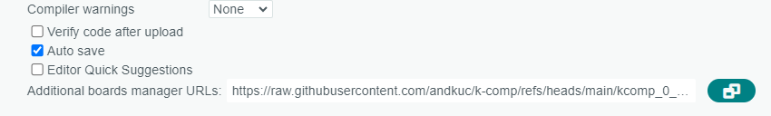

Open the Boards Manager on the left side of the Arduino IDE and install K-Comp. Do not forget to install the driver for MCP2221A!
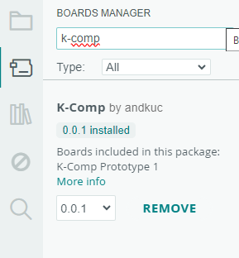
- Select K-Comp V1 under Tools | Board.
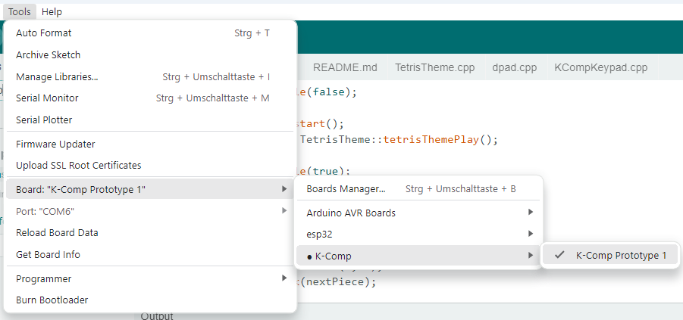
- Select the COM port if K-Comp is connected!
- Try out some of the sample programs:
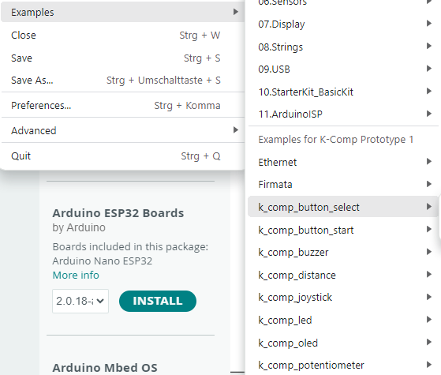
In order to upload the sample programs, you select Sketch | Upload
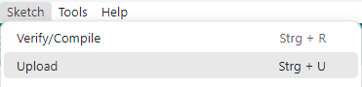

Note: If you run Linux, make sure to add the latter udev rule for MCP2221A if you want to make use of auto-reset before upload!
#!/bin/bash
# K-Comp Board Rule Installer
# Run this once with sudo: sudo ./install_linux_rules.sh

echo "Installing udev rules for K-Comp (MCP2221A)..."

# 1. Create the rule file
echo 'SUBSYSTEM=="usb", ATTRS{idVendor}=="04d8", MODE="0666", GROUP="plugdev"' | sudo tee /etc/udev/rules.d/99-kcomp.rules > /dev/null

# 2. Reload rules
sudo udevadm control --reload-rules
sudo udevadm trigger

echo "Success! Please unplug and replug your K-Comp board."

- Using K-Comp in Visual Studio Code
- Make sure to have git installed (https://git-scm.com/install).
- Install the latest version of Visual Studio Code (https://code.visualstudio.com).
- Install the PlatformIO Extension for Visual Studio Code:
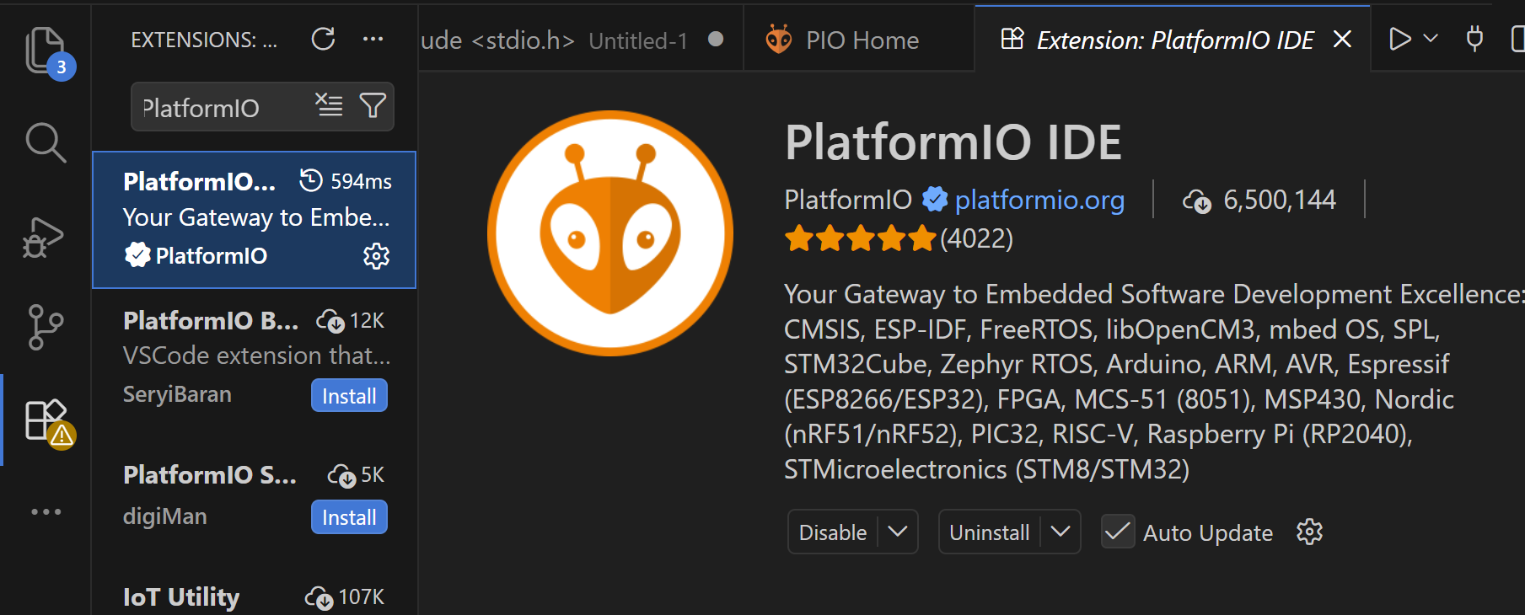
- Open the PlatformIO Extension and navigate to Platforms and select Advanced Installation . Enter https://github.com/andkuc/k-comp-v1-pio.git and install the K-Comp platform.
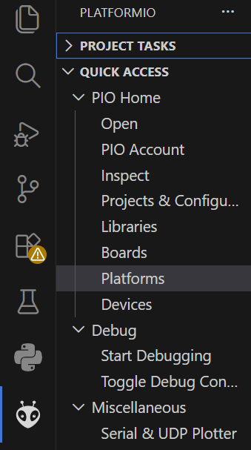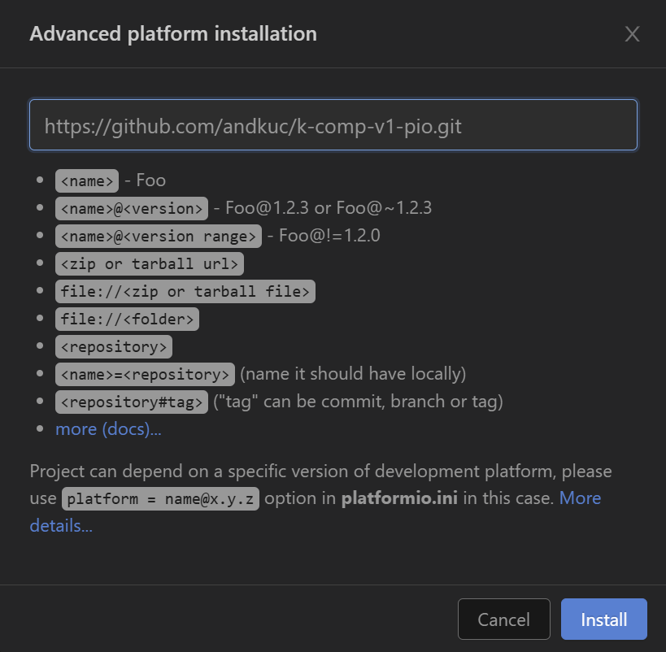
- Navigate to PIO Home and select Open Project Examples. Pick a K-Comp example project of your choice and import it.
- Navigate to main.cpp. You can build and upload the example project like in the screenshot:
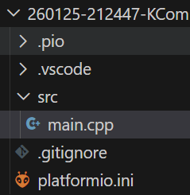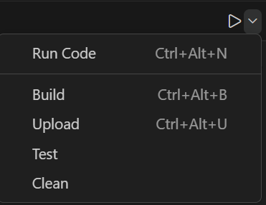
- You can open the Serial Montor by clicking on the  symbol.

- Using K-Comp in Mblock 5
- Download and install Mblock 5 (https://mblock.cc/pages/downloads).
- Run Mblock 5 and delete all devices.
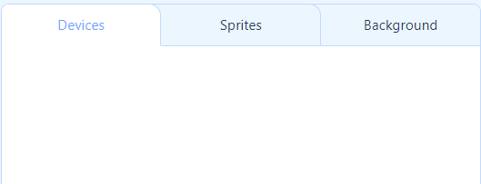
- Download k_comp_v1.mext from the K-Comp Mblock repository (https://github.com/andkuc/k-comp-mblock5).
- Drag k_comp_v1.mext into the Mblock 5 IDE.
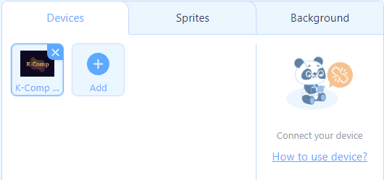
- Connect to K-Comp. Make sure you have Show all connectable devices selected.
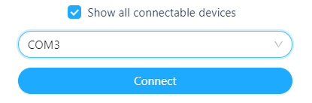
- You now can program K-Comp by arranging blocks! See the example below:
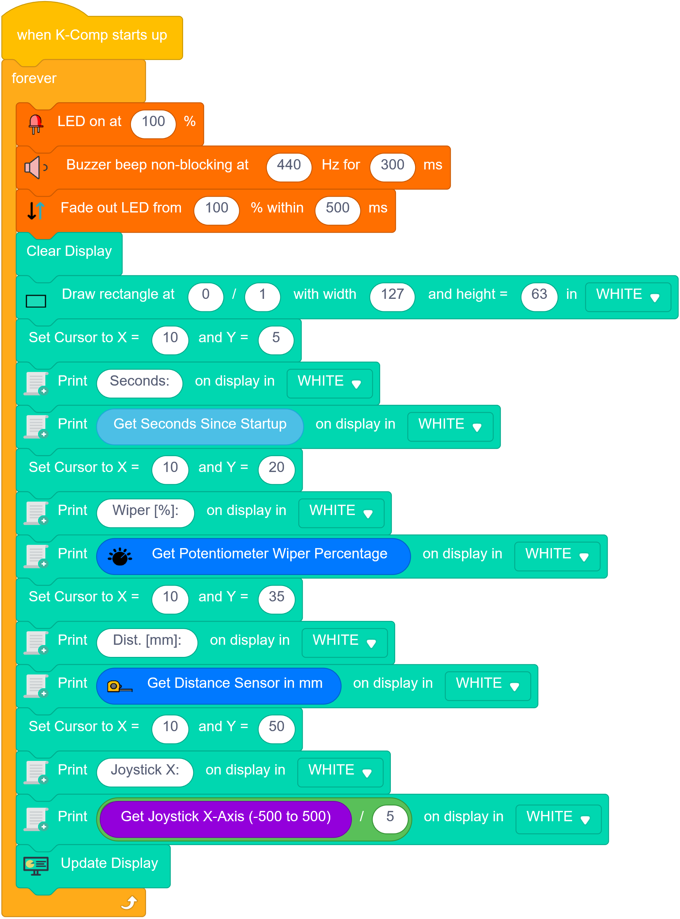
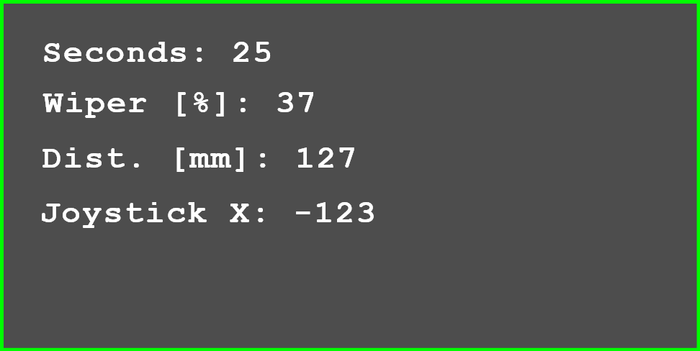
- Press Upload code and upload the program. Press and release the Reset-button on the K-Comp board as soon as start uploading…... shows up in the Upload progress dialog!

