Identify Fraud from Enron Email
By Andre Luis Borges

Introduction

The Enron scandal, publicized in October 2001, eventually led to the bankruptcy of the Enron Corporation, an American energy company based in Houston, Texas, and the de facto dissolution of Arthur Andersen, which was one of the five largest audit and accountancy partnerships in the world. In addition to being the largest bankruptcy reorganization in American history at that time, Enron was cited as the biggest audit failure. [1]
In the resulting Federal investigation, a significant amount of typically confidential information entered into the public record, including tens of thousands of emails and detailed financial data for top executives. [2]
Who are the persons of interest in the fraud case? Based financial data available, we are going to build an identifier to find out the persons of interest.

Data analysis
- Summarize for us the goal of this project and how machine learning is useful in trying to accomplish it. As part of your answer, give some background on the dataset and how it can be used to answer the project question. Were there any outliers in the data when you got it, and how did you handle those? [relevant rubric items: “data exploration”, “outlier investigation”]
My goal in this project is to build an identifier to find out the persons of interest. The dataset has 146 observations and the numbers of Persons of interest identified is 20, which means the allocation across classes is 0.14.
An outlier is an observation that lies an abnormal distance from other values in a random sample from a population. In a sense, this definition leaves it up to the analyst (or a consensus process) to decide what will be considered abnormal. Before abnormal observations can be singled out, it is necessary to characterize normal observations [4].
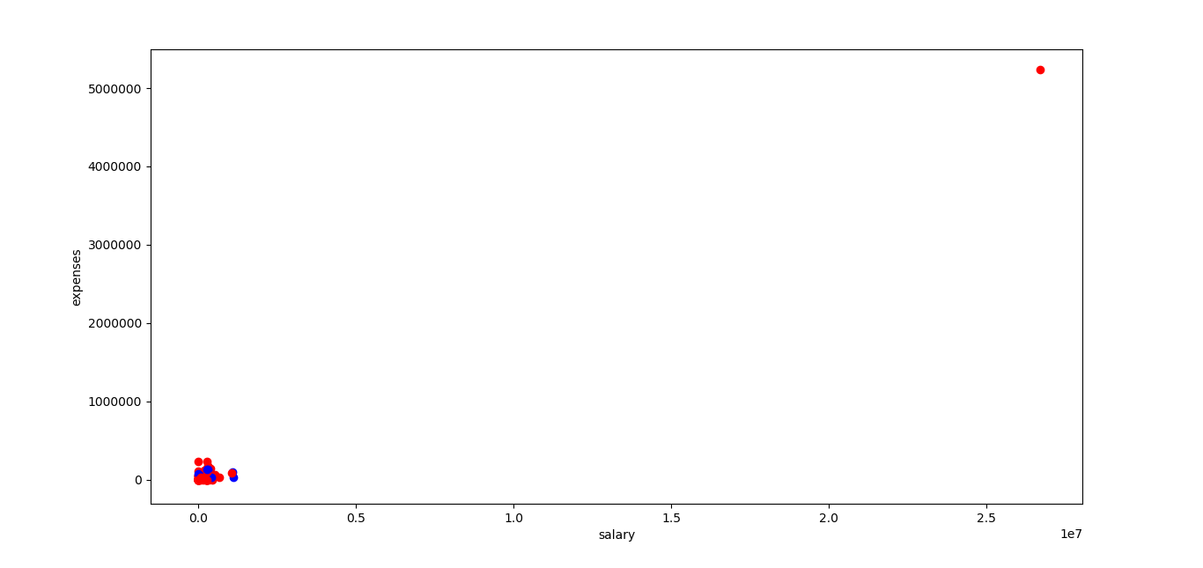
After plot the salary vs expense, I figured out an outlier value.
A commonly used rule says that a data point is an outlier if it is more than 1.5 * IQR above the third quartile or below the first quartile.[6]
IQR = Q3 – Q1, where Q3 = median of the n largest entries and Q1 = median of the n smallest entries.[7]
I count how many outliers there were for each data entry and print the top 14.
Name | Number of outliers
TOTAL | 14
FREVERT MARK A | 10
BELDEN TIMOTHY N | 10
LAY KENNETH L | 10
WHALLEY LAWRENCE G | 8
LAVORATO JOHN J | 8
SKILLING JEFFREY K | 8
ALLEN PHILLIP K | 6
BAXTER JOHN C | 6
RICE KENNETH D | 6
KITCHEN LOUISE | 6
DELAINEY DAVID W | 6
DERRICK JR. JAMES V | 6
SHAPIRO RICHARD S | 5

The first one is the TOTAL. According the official pdf documentation [8], Total is the sum of the columns and we can drop it from the dataset.
However, there are 3 person with 10 outlier feature. They are FREVERT MARK A, BELDEN TIMOTHY N and LAY KENNETH L. According the dataset, FREVERT MARK A is not a POI, and BELDEN TIMOTHY N and LAY KENNETH L both are. I don’t think we should remove them from the dataset because they are important for our analyses.
Next plot is going to show the salary vs expense without the TOTAL row.
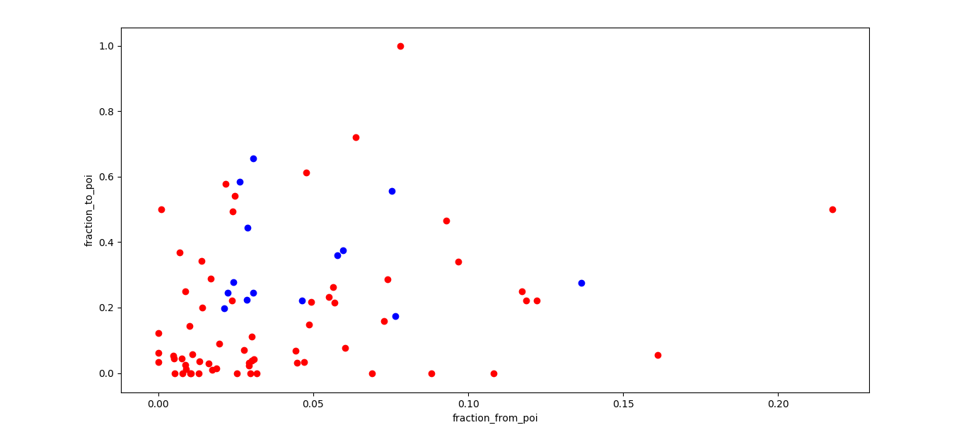

There is payments were made by Enron employees of business-related travel to ‘THE TRAVEL AGENCY IN THE PARK’ [8]. The data in the dataset is about Enrom employees and this company will be dropped from the dataset.

- What features did you end up using in your POI identifier, and what selection process did you use to pick them? Did you have to do any scaling? Why or why not? As part of the assignment, you should attempt to engineer your own feature that does not come ready-made in the dataset -- explain what feature you tried to make, and the rationale behind it. (You do not necessarily have to use it in the final analysis, only engineer and test it.) In your feature selection step, if you used an algorithm like a decision tree, please also give the feature importances of the features that you use, and if you used an automated feature selection function like SelectKBest, please report the feature scores and reasons for your choice of parameter values. [relevant rubric items: “create new features”, “intelligently select features”, “properly scale features”]

Feature scaling is a method used to standardize the range of independent variables or features of data[15]. For example, in the dataset, the HANNON KEVIN P have salary of 243,293.00 and the total stock value is 6,391,065.00. In order to use the features to identify the POI, I scale all the value from my feature list.
I create the Fraction to poi and Fraction from poi new features to verify if the number of e-mails send and received from POI could help us to identify a POI. Fraction to poi is the number emails sent to a POI divided by the total of email sent. Fraction from poi is the number of emails received from a POI divided by the total of e-mail received.
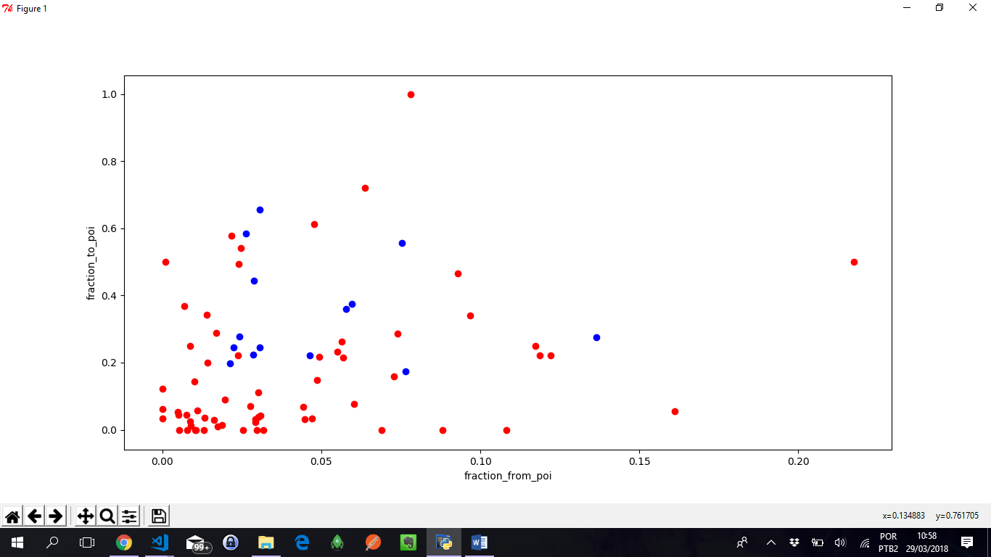

In the last chart, blue are the POI and red is the no POI. I think these new features are important. They will have a positive impact on precision metric because the most part of the POI are concentrated between 0.2 and 0.6 fraction_to_poi feature value and 0.03 and 0.08 fraction from POI and the most part of no POI are out of this zone what make it good for an classifier algorithm identify a POI. Therefore, I added these features to my feature list.

Feature selection is the process of selecting a subset of relevant features (variables, predictors) for use in model construction. Feature selection techniques are used for four reasons: simplification of models to make them easier to interpret, shorter training times, to avoid the curse of dimensionality, enhanced generalization by reducing overfitting[5]. There are 20 features in the dataset and I put away the features with missing value features higher than 50%, what reduce the amount of features to 10, plus 2 features I have created.

Feature | Number | Percent of missing value
salary | 51 | 34.93 %
to_messages | 60 | 41.10 %
deferral_payments | 107 | 73.29 %
total_payments | 21 | 14.38 %
exercised_stock_options | 44 | 30.14 %
bonus | 64 | 43.84 %
restricted_stock | 36 | 24.66 %
restricted_stock_deferred | 128 | 87.67 %
total_stock_value | 20 | 13.70 %
director_fees | 129 | 88.36 %
from_poi_to_this_person | 60 | 41.10 %
loan_advances | 142 | 97.26 %
from_messages | 60 | 41.10 %
other | 53 | 36.30 %
expenses | 51 | 34.93 %
from_this_person_to_poi | 60 | 41.10 %
deferred_income | 97 | 66.44 %
shared_receipt_with_poi | 60 | 41.10 %
email_address | 35 | 23.97 %
long_term_incentive | 80 | 54.79 %
The last table showed the percent of missing value by feature.

In order to continue reducing the number of feature, I applied the SelectKBest and PCA algorithms with 2, 4, 7 and 9 features. SelectKBest selects the features according to the k highest score [9]. PCA is linear dimensionality reduction using Singular Value Decomposition of the data to project it to a lower dimensional space [12].
After apply the PCA and SelectKBest algorithm, I compared the precision metrics from Guassian Naïve Bayes, decision tree, SVM and k nearest neighbor algorithm to find out the best one to identify the POI. SelectKBest showed a better performance than the PCA algorithm as you can see in the next chart.
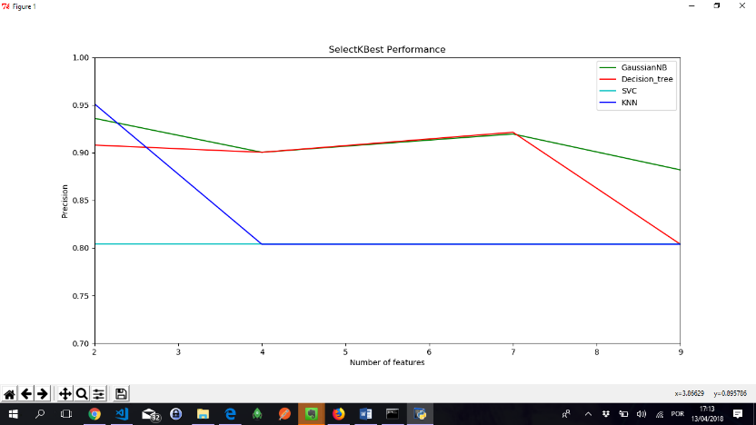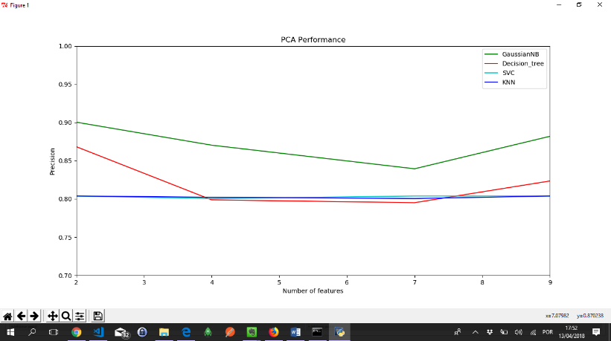
Therefore, I’ve chosen the SelectKBest method because it had a better performance to find out the POI.
SelectKBest showed its best performance to find out the POI with two features bonus and fraction_to_poi. The fraction_to_poi was created during this analysis. The process to reduce the number of feature is important because the smaller is the number of features, faster is the process to train and predict.
- What algorithm did you end up using? What other one(s) did you try? How did model performance differ between algorithms? [relevant rubric item: “pick an algorithm”]

I tried the Guassian Naïve Bayes, decision tree, SVM and K Nearest Neighbor algorithm.
In order to find out the best performance, I based my analysis on precision metric, however I collected data from accuracy, precision, recall and f1 score metrics. The next chart show the performance from the metrics by models.
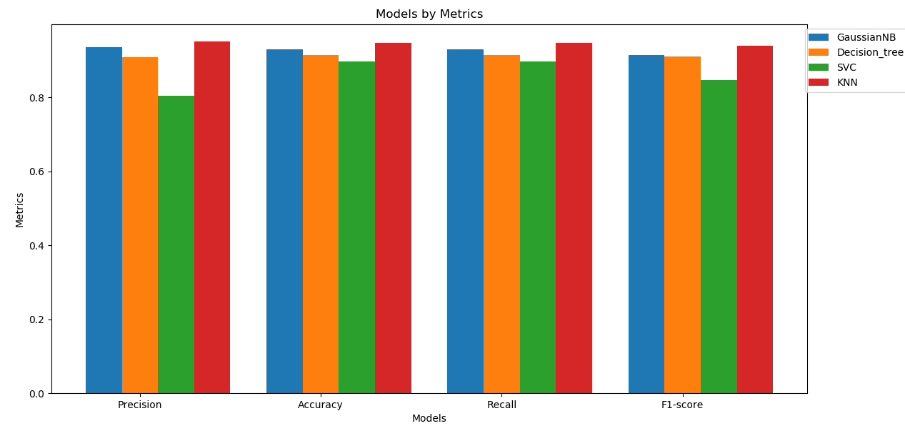
All this algorithms were tuned. For precision metric, the result was very close for K Nearest Neighbor (KNN) and Gaussian Naïve Bayes and SVC showed the worst result. For accuracy and recall the results are very close for all models, with slight highlight for KNN model.
This analysis make me believe I should use the K Nearest Neighbor (KNN) algorithm because its results.
- What does it mean to tune the parameters of an algorithm, and what can happen if you don’t do this well? How did you tune the parameters of your particular algorithm? What parameters did you tune? (Some algorithms do not have parameters that you need to tune -- if this is the case for the one you picked, identify and briefly explain how you would have done it for the model that was not your final choice or a different model that does utilize parameter tuning, e.g. a decision tree classifier). [relevant rubric items: “discuss parameter tuning”, “tune the algorithm”]
In Machine Learning, tuning is the problem of choosing a set of optimal parameters values for a learning algorithm. [14]
Tuning the parameter value is important because an optimized parameters value can improve the algorithm to better predict or classify a data when you set it correctly, on the other hand, making the wrong setting, the prediction can get worse.
For example, the K Neighbors Classifier with bonus and fraction_to_poi features had a better performance. The accuracy metric varied from 0.91 to 0.95 after tuning.
Due the difficulties to figure out the best parameters values, I used the GridSearchCV automation to make exhaustive search over specified parameters values to find the best estimator [11]. GridSearchCV was used in decision tree, SVC and KNeighborsClassifier algorithm. I tried to search the best parameters values for Decision Tree (min_samples_split and criterion), SVC (kernel, C, gamma), KNeighborsClassifier (n_neighbors, weights). Gaussian Naïve Bayes was not possible to tune because it does not have parameter to set.
During my tests, I figured out when I tuned the model, there was few improvement and the time spent to train the data is slower. For example, the time average spent for a decision tree model to be trained are 0.00088, and after I added the GridSearchCV, the average time rose to 0.1472, what means 167 time slower. Working with decision tree, after 9 training and prediction test with different number of features, just once there was improvement from default to the tuned algorithm.
- What is validation, and what’s a classic mistake you can make if you do it wrong? How did you validate your analysis? [relevant rubric items: “discuss validation”, “validation strategy”]
Validation is the process of deciding whether the numerical results quantifying hypothesized relationships between variables, are acceptable as descriptions of the data [16]. The main mistake we can make is to use the same data for training and testing because you will overfitting the data.
In my case, I use 40% for testing and 60% for training. There is a better way to train your data if I used the k-fold cross-validation. In the k-fold cross-validation, the original sample is randomly partitioned into k equal sized subsamples. Of the k subsamples, a single subsample is retained as the validation data for testing the model, and the remaining k − 1 subsamples are used as training data. The cross-validation process is then repeated k times (the folds), with each of the k subsamples used exactly once as the validation data. The k results from the folds can then be averaged to produce a single estimation. The advantage of this method over repeated random sub-sampling is that all observations are used for both training and validation, and each observation is used for validation exactly once[13].
- Give at least 2 evaluation metrics and your average performance for each of them. Explain an interpretation of your metrics that says something human-understandable about your algorithm’s performance. [relevant rubric item: “usage of evaluation metrics”]
These are the formula for all metrics I showed during the project
Accuracy is the number of items in a class labeled correctly divided by all the items in the class[2].
Precision is the number of true positive divided by the number of true positive plus false positive. (True positive / true positive + false positive) [2]
Recall is the number of true positive divided by the number of true positive plus false negative. (True positive / true positive + false negative) [2]
F1-score can be interpreted as a weighted average of the precision and recall, where an F1 score reaches its best value at 1 and worst score at 0. F1 = 2 * (precision * recall) / (precision + recall)[10]
The 2 evaluation metrics I used were the precision and the recall. Precision is the fraction of the relevant POI successfully identified. Recall is the fraction of the POI identification that are relevant for the query. During the analysis, I figured out the precision metric was the best metric to identify the POI because the fewer amount of the POI and when they are identified is relevant for the average metric.
This chart clarify the difference for each one. KNN highlighted for all the metrics, however SVC (green bar) has a very bad precision result while accuracy and recall metrics the results for all algorithms was very close. Looking close to SVC algorithm, it didn’t hit the prediction of any POI, however it successfully hit the prediction of the most part of the no POI. The others models hit the prediction of the POI with 50% or higher. Even tough, accuracy and recall showed a very close performance metric for all models while the precision, for SVC highlighted the bad performance.
For our analyze, is better to say that a person is POI when they are not, false positive, because in the next phase of investigation will confirm if they really are a POI. Because of this, I think the accuracy had the best results, it considered in its formula the positive and false positive, what make it better for our analysis.

Reflection
During this project, I learned how to deal with imperfect dataset, validate a machine learning result using test data, evaluate the result using quantitative metrics, compare the performance of different algorithms, tune the algorithm to get the maximum performance and communicate the result.
I struggled when I was trying to understand pipeline and use it to reduce the number of features. My knowledge about this improved after I read a book and watch again the last 3 module from the Machine Learning.
I figured out after I tune an algorithm, I got better performance to predict however. Because of this, I tried to tune all the algorithms I was working using GridSearchCV and this make my code slower. Working with this dataset, the code worked, however with a dataset larger than that, probably my code will take hours to be executed. I think, the best approach is to tune the algorithm after find the number of features and the best algorithm.
It is not easy to find the best numbers of features to work with. After I learn how to work with PCA and SelectKBest I figured out the importance of this function. When I use all the features I choose, the result was horrible, however after I reduce the number of features the result improved. I was surprised that two features was enough for my identifier.
I think it was amazing to work in this project and I learned a lot.

References

[1] - https://en.wikipedia.org/wiki/Enron_scandal
[2] - https://classroom.udacity.com/nanodegrees/nd115/
[4] - https://www.itl.nist.gov/div8988/handbook/prc/section1/prc16.htm
[5] - https://en.wikipedia.org/wiki/Feature_selection
[6] - https://www.khanacademy.org/math/statistics-probability/summarizing-quantitative-data/box-whisker-plots/a/identifying-outliers-iqr-rule
[7] - https://en.wikipedia.org/wiki/Interquartile_range
[8] - https://github.com/udacity/ud120-projects/blob/master/final_project/enron61702insiderpay.pdf
[9] - http://scikit-learn.org/stable/modules/generated/sklearn.feature_selection.SelectKBest.html#sklearn.feature_selection.SelectKBest
[10] - http://scikit-learn.org/stable/modules/generated/sklearn.metrics.f1_score.html
[11] - http://scikit-learn.org/stable/modules/generated/sklearn.model_selection.GridSearchCV.html
[12] - http://scikit-learn.org/stable/modules/generated/sklearn.decomposition.PCA.html
[13] - https://en.wikipedia.org/wiki/Cross-validation_(statistics)#k-fold_cross-validation
[14] - https://en.wikipedia.org/wiki/Hyperparameter_optimization
[15] - https://en.wikipedia.org/wiki/Feature_scaling
[16] - https://towardsdatascience.com/cross-validation-in-machine-learning-72924a69872f

