Program description: The program prompts the user to enter the credentials. When they enter the correct credentials, they are allowed into the program and are given controls to perform such as viewing the tickets and creating a ticket.

Username: admin

Password: admin1

1. Insert at least 10 tickets into the table

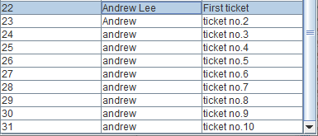

2. Update your record by changing your ticket description

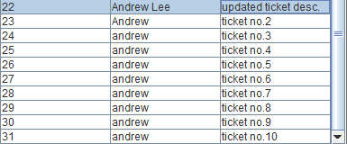

3. Show a view of your updated ticket



4. Delete your ticket from the database

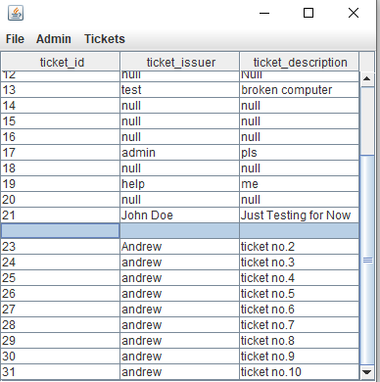

5. Close any two existing tickets

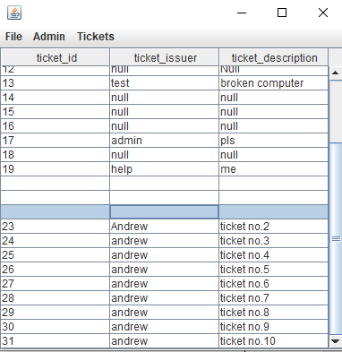

6. Lastly show a table view of all your tickets

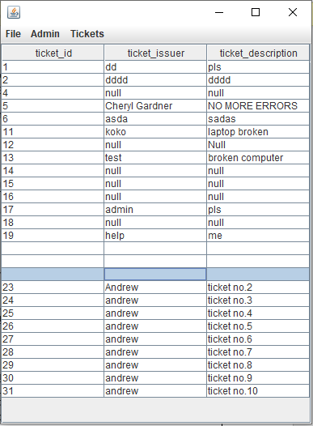

Extra Credit: Github

