Class Structure

# Before Class

1. Familiarize yourself with static fields and methods. What is the difference between static and instance fields. When to use static methods.

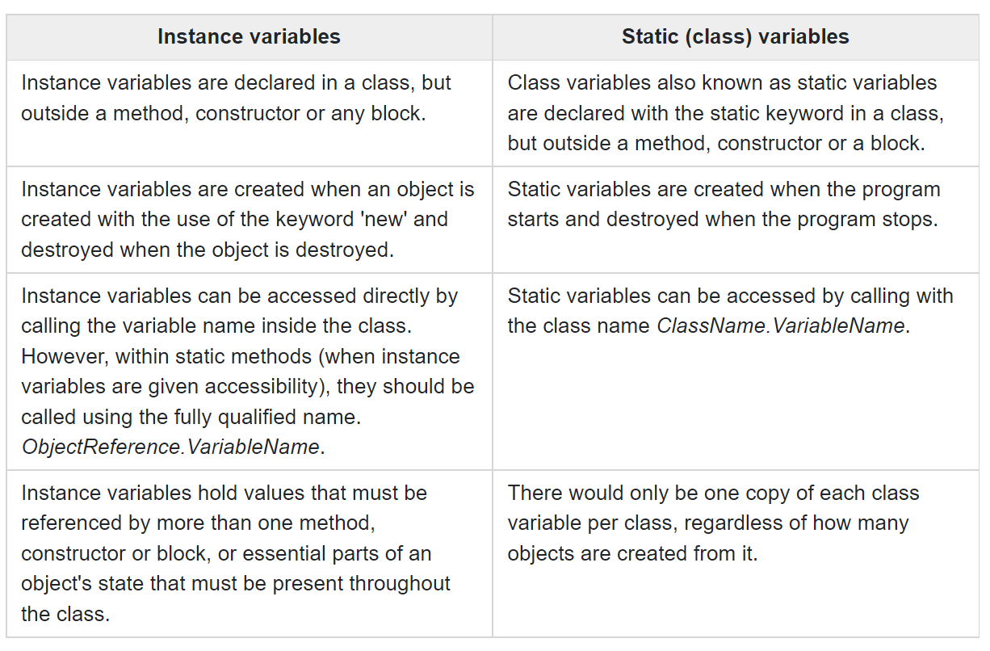

1. Find out, from which statement a Java program starts. Where is that statement located.

**The main method** is where program execution starts and stops. Even though the main method can ask other classes, objects, methods or parts of the java language to help, the overall execution of your program begins and ends in the main method

1. What is the role of constructor in object-oriented programming.

In class-based, object-oriented programming, a constructor (abbreviation: ctor) is **a special type of subroutine called to create an object**. It prepares the new object for use, often accepting arguments that the constructor uses to set required member variables

1. Array is a data structure consisting of a collection of elements. How to declare and use arrays in Java.

String[] cars = {"Volvo", "BMW", "Ford", "Mazda"};

System.out.println(cars[0]);

1. Familiarize yourself with the use of iterative and conditional statements in Java.

if (boolean condition) {} else {}, For-each, for, while, do-while

1. Explain the concept “method overloading”.

If a [class](https://www.javatpoint.com/object-and-class-in-java) has multiple methods having same name but different in parameters, it is known as **Method Overloading**.

# During Class

## Static class members

1. Define a class CinemaTicket to describe cinema tickets. The ticket attributes are: cinema name, film title, row, seat, and price. Since the name of cinema is the same for all tickets, use a static field. Then define a method to display ticket data. Try to create two tickets and display ticket details.
2. Define a class SurfaceArea that contains static methods to calculate the surface area for: circle, rectangle and triangle. Validate the created methods.

## Application entry point

1. Define a Motto class. Then, create a program that displays the following text: "Do what you love". Put the method below in the defined class.

public static void main(String[] args) {  
 System.out.println("Do what you love");  
}

After that, compile and run a program.

1. Using a class describing cinema tickets, write a program that creates two tickets. Print the created tickets.
2. Using the class to calculate the area of geometric figures, write a program that creates the calculation and displays:
   1. area of a rectangle with sides 4 and 5
   2. area of a circle with a radius of 3
   3. area of a triangle with base 3 and height 4

## Constructor

1. Modify the class describing cinema tickets. Add a constructor that creates a ticket for the specified movie, with row and seat numbers. Assume that in the first two rows the ticket price is PLN 10, and in the remaining rows, PLN 25. Then write a program that, in the Morning Star Cinema, creates two tickets for the movie “Gladiator”, the first one is in row 2 and the second one in row 7. Print the created tickets.
2. Define a class Person for person’s record. The class should contain the attributes: name, weight (kg) and height (cm). Add constructors:
   1. Person(name)
   2. Person(name,weight,height)

Then add methods that represents the object's behaviors:

* 1. setWeightAndHeight(weight,height)
  2. calculateBMI() – calculates Body Mass Index
  3. displayRecord() – displays full info (name, weight, height, and BMI)

The correct BMI value is 18.5 to 24.9. When displaying a person’s record, if the BMI is too low, display the message: "BMI too low". When the index is too high, display the message: "BMI too high". Write a program, create three persons and display their records.

# After Class

1. Create a library of methods for converting temperatures between Celsius, Kelvin, and Fahrenheit. You can name the methods e.g. CelsiusToKelvin(), KelvinToCelsius(), ect. Then create a program that calculates and displays the temperature:
   1. 25 degrees Celsius in Kelvin and Fahrenheit
   2. 100 degrees Fahrenheit in Kelvin and Celsius
   3. 0 degrees Kelvin in Celsius and Fahrenheit
2. Create a library of methods for the calculation of basic statistics:
   1. Number of items within the specified range <x,y>
   2. Sum of numbers in the given range <x,y>
   3. Arithmetic mean of the numbers in the given range <x,y>

Then create a program that calculates and displays the basic statistics for integers in the range <5,10>

1. There are many devices that can use the Internet: a personal computer, laptop, tablet, smartphone, internet radio or TV. Define an InternetDevice class to describe such devices. The class should contain attributes: name (device name), connected (whether a device is connected to the Internet), and connectedDevices (the number of connected devices - static field). Add a constructor InternetDevice(name) and methods for device manipulation: connect(), disconnect(), isConnected(), displayStatus(), displayConnections() (static method). Then write a program that creates five different internet devices, three of which are connected to the Internet. Display the status of each device and information about the number of devices connected to the Internet.
2. The following definition of the StudentGrades class allows the storage of a student's grades.

public class StudentGrades {  
  
 String studentName;  
 double[] grades;  
  
 StudentGrades(String name, double[] grades) {  
 this.studentName = name;  
 this.grades = grades;  
 }  
}

Complete the class with methods that:

* 1. calculates of the lowest grade
  2. calculates of the highest grade
  3. calculates of the number of grades
  4. calculates of the grade point average
  5. displays student’s record with student’s name, a list of the student's grades, number of grades, lowest grade, highest grade, and grade point average

Then, write a program that creates grades for two students:

* 1. Amanda: 3.5, 4.5, 4.0, 2.0, 5.0, 3.5, 3.5
  2. James: 2.0, 3.0, 2.0, 4.5, 4.5

Tip: pass student's grades to the constructor, as an array, in curly brackets, e.g. StudentGrades({5.0, 3.5}).

1. Add the constructor StudentGrades(String name, int numberOfGrades) to the StudentGrade class, which allows you to randomly create the given number of student grades. Tip: use the random number generator, which is available in the Random class. See the manual for more information.
2. Add the constructor StudentGrades(String name) that allows you to enter student’s grades from the keyboard. Tip: use the Scanner class. See the manual for more information.
3. Define a class Clock that represents a digital clock. It has two attributes: hour and minute. The hour value ranges from 0 to 23. The minute value ranges from 0 to 59. Next, define the following constructors:
   1. Clock() – initialises clock to 00:00
   2. Clock(hour,minute) – initialises clock to hour:minute

Then, define methods:

* 1. setClock(hour,minute)
  2. setClock() - reset clock to 00:00
  3. displayTime()
  4. addOneMinute()

After that, write a program that:

* 1. creates a clock with starting time 12:47
  2. displays time
  3. sets a clock to 18:14
  4. displays time
  5. sets a clock to 09:03
  6. displays time
  7. sets a clock to 23:58
  8. displays time
  9. adds one minute
  10. displays time
  11. adds one minute
  12. displays time

1. Add an alarm function to the clock. Complete the class definition with the attributes: alarmHour, alarmMinute. Add methods: setAlarm(hour, minute) and runAlarm(), which displays the "beep-beep-beep-beep !!" alarm sound. Turn on the alarm when the alarm time is the same as the clock time(compare times in the addOneMinute() method).
2. Define a class Room that represents a hotel room. The class should contain the attributes: number, beds, occupied, and guestName. Add constructors: Room(number) (creates a room with two beds) and Room(number,beds). Next, define methods for room manipulation: checkin(guestName), checkout(), isOccupied(), and displayStatus(). Then write a program in which create three rooms with two beds, two rooms with three beds and one room with one bed. Store all room objects in an array:

Room[] rooms = new Room[6];

Then follow the steps below:

* 1. Display status of a single room (room number, number of beds, occupied, guest name). Display data in a single row.
  2. Display a report with a list of rooms (room number, number of beds, occupied, guest name)
  3. Display a report with a list of rooms, limited to rooms with the specified number of beds
  4. Display a report on how many rooms are vacant and how many are occupied
  5. Display a report on how many vacant beds are available

Create a separate static method for each report. Pass a list of rooms (an array) to the defined static methods.

1. Modify the Room class. Define toString() method that returns information about the room status. Replace the displayStatus() method with the defined toString() method. Tip: find out in the manual how to define and use the toString() method.