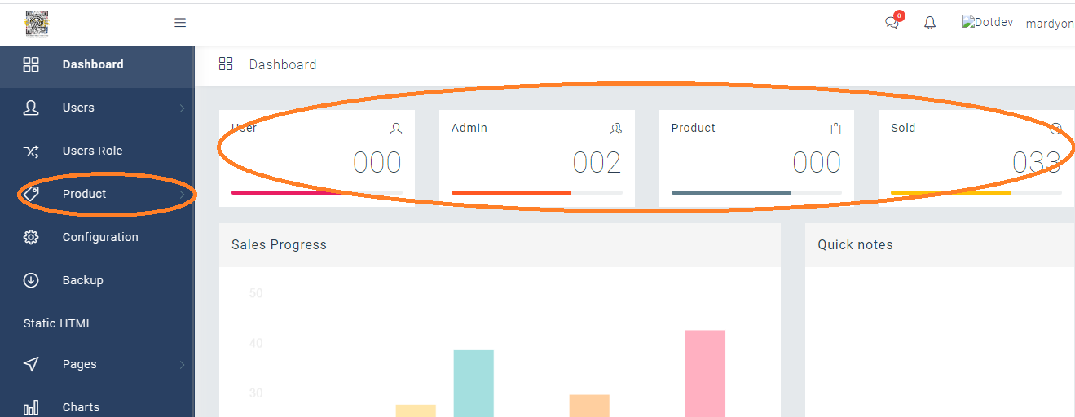

Apply the COUNT in existing PSAPRO ASSET and Change the **Product** to the Asset Menu (on existing)

Yun Product na may Bilog sa taas itong apaplit mo ASSET. Na menu,



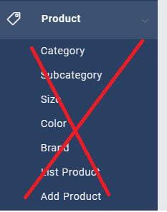

Pagka click ng ASSET (PRODUCT NA PAPALITAN) ITO YUN VIEW sa Product –> List Product

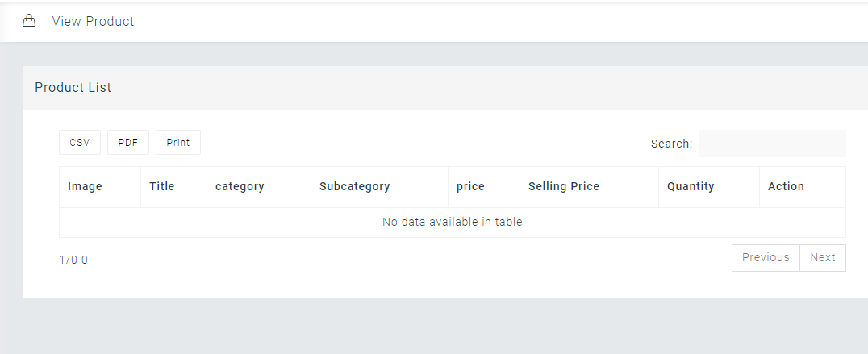

Itong View na ito ang gagamitin sa front end nito

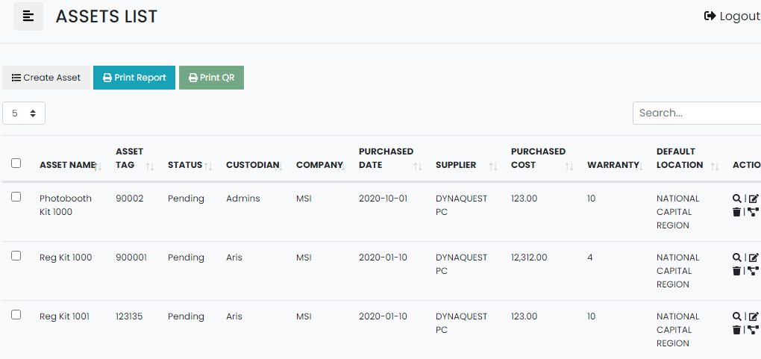

*put the Buttons here and fields checkboxes to the new FRONT END ABOVE for the Asset / Product List.

*FOR THE CREATE ASSET – apply the Add Product Design,

