**1. Repair Approval Bug**

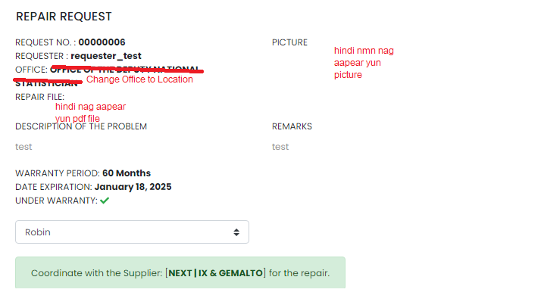

**2. Approval Bug:**

Scenario: After mag Approve, hindi nmn napunta sa Approved tab., ganun din sa approve tab.

Expected: Once Approved the record of pending record a while ago will move to **Approved** Tab. Same with **Dissparoved** Tab sa mga na disapprove

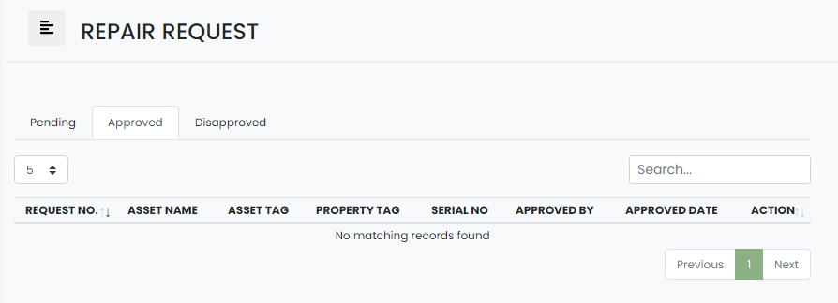

**3. error when clicking the other Repair Pending Request**

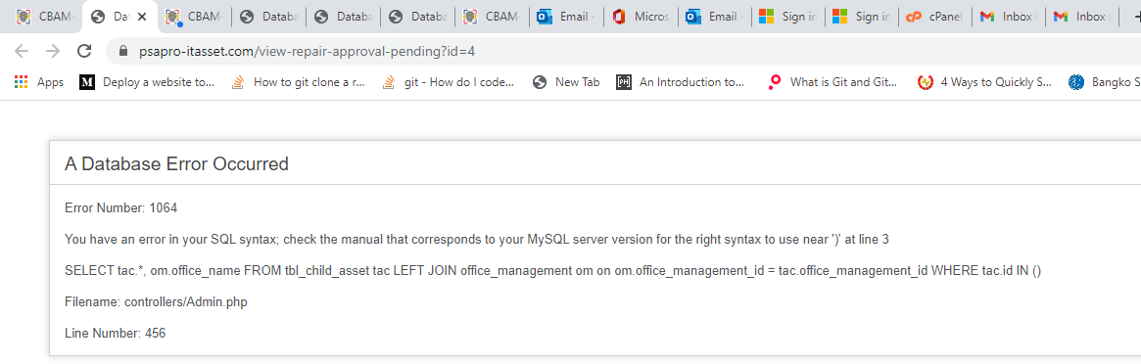

**4. Lagpas nmn at hindi maayos yun data table. yun View Repair Request, ito yun sinsasabi ko dapat nasa loob ng pinkaa UI nya.**

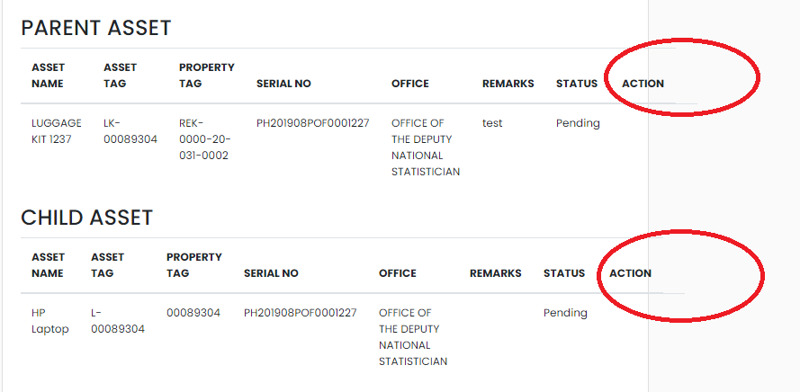

**5. After mag Click ng Approve Button, parang wala nman ngyayari**

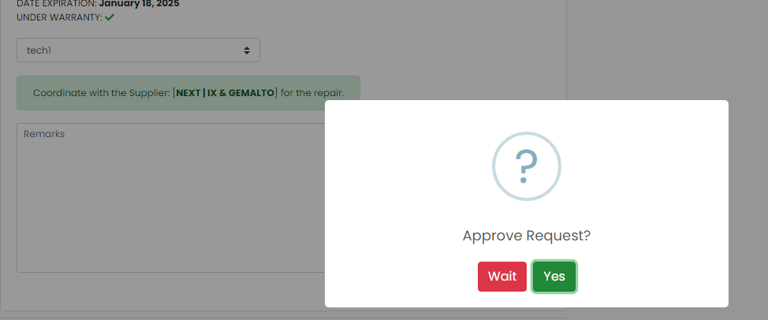

After submitting the yes button. Wala nmn ngyari

Expected Result, once clicking the yes button to approve, it should be redirecting to Approved Tab with the record details, and the ticket for repair is now tagged as Approved

Dito na dapat mag redirect , kaso walang laman, as mentioned in item **# 2 above**