1. In **Settings**

Add new Menu for “**ASSET CATEGORY”**

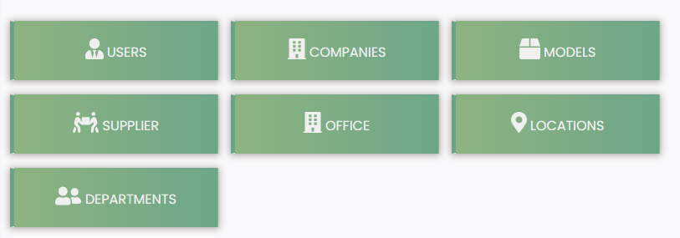

**Category Code| Category Name**

**1. 10000 Laptop**

**2. 20000 Projector**

**2.** 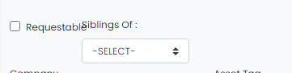

**Paki ayos ito, magulo ito. Sa Create Asset, at sa Create Child Asset.**

**3. Tapos yun Company, yun Asset Category na ang ipapalit. (for Mother Asset , add,edit, at du nsa child asset, add, edit)**