Repair Bugs ( Approver Data table)

1. Request by : data not displaying for Request by.

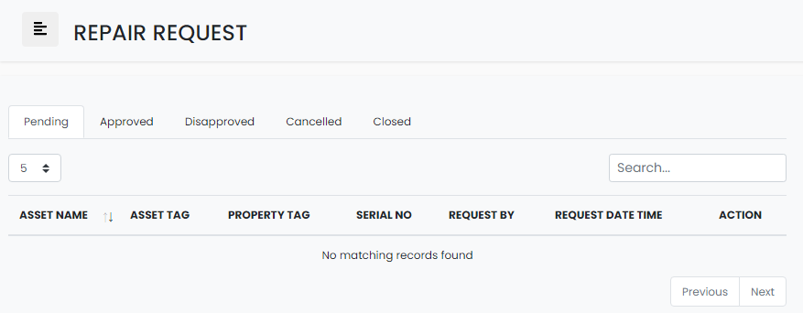

Change to

**Pending - Tab**

**REQ # | ASSET NAME | CATEGORY | ASSET TAG | SERIAL NO | LOCATION | REQ BY| REQ DATE TIME | ACTION**

**Approved – Tab**

**Yun Approved BY: bakit 1 nakadisplay.?**

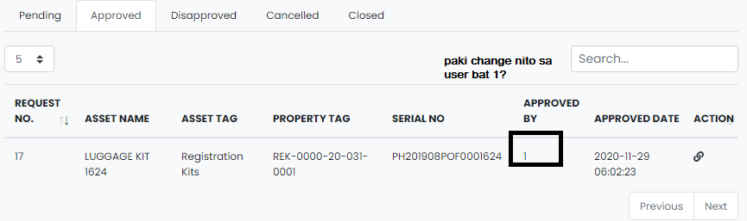

Change to

**REQ # | ASSET NAME | CATEGORY | ASSET TAG | SERIAL NO | LOCATION | APPROVED BY | APPROVED DATE TIME | ACTION**

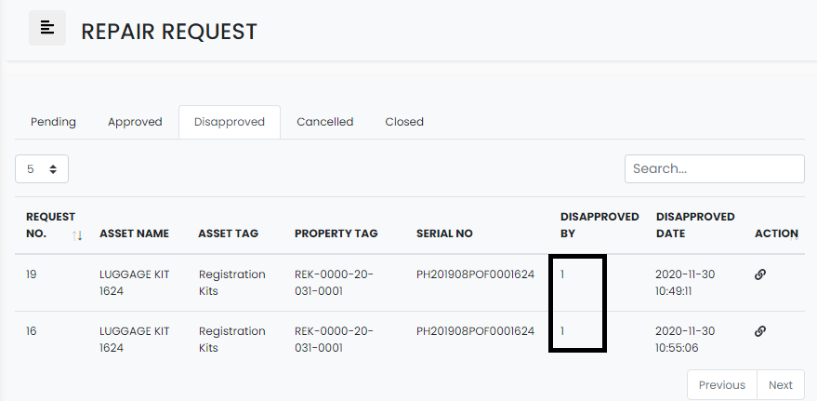

Same bug, disapproved by naka 1 cya, ndi mismong user nag ddisplay.

Change to

**REQ # | ASSET NAME | CATEGORY | ASSET TAG | SERIAL NO | LOCATION | DISAPPROVED BY | DISAPPROVED DATE TIME | ACTION**

4. Cancelled and Close tab (not working sa approver side)



5. Action Link in Approved , Disapproved not working properly and not encrypted

