**APPROVER – BUGS**

**See the screenshot below:**

**1. paki widen yun view ditto sa Approver /Admin tulad ng sa Requester sa ilalim**

**2. paayos nun data sa data table hindi magkakatapat sa column yun data, at wala pang display yun “Dispatch To” na data.**

**3. sa Requester sa ilalim, wala yun Incidident Report Tab, palagay,**

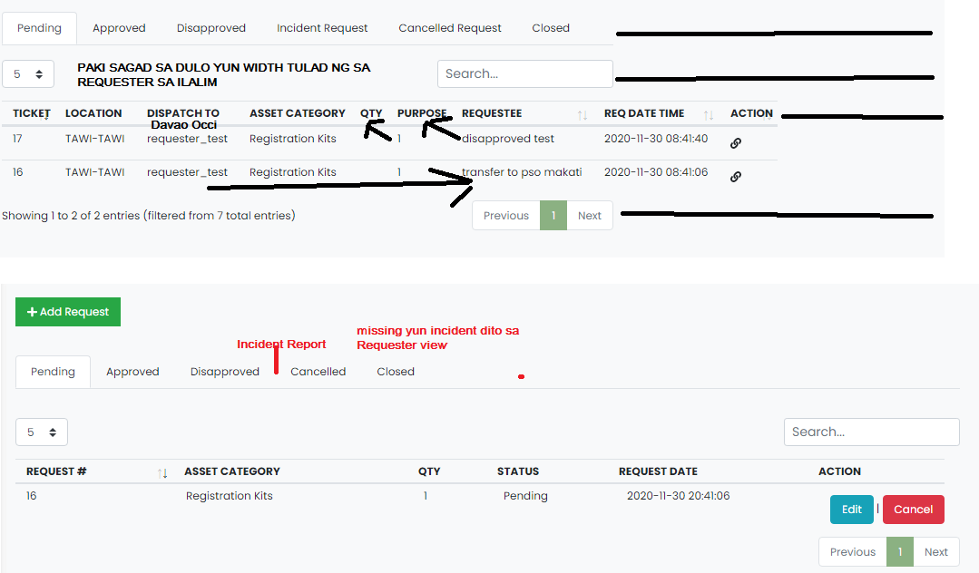

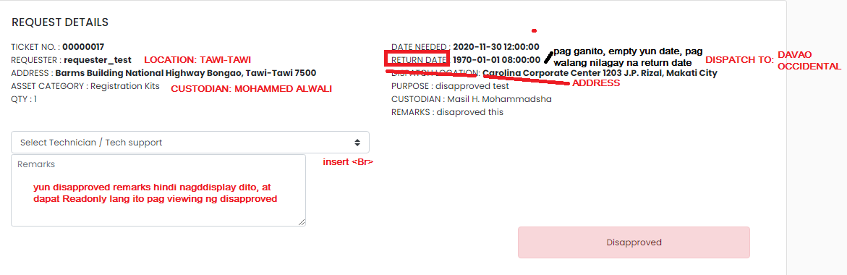**2. See screenshot below**

**Sa left side**

**1. INSERT LOCATION: below REQUESTER.**

**2. yun Address Pa <Break sa two lines>**

**3. INSERT CUSTODIAN below Address**

**Sa Right Side**

**1. Pag empty yun date need at date return, “PA BLANK na lng” instead na invalid date yun nagddisplay.**

**2. Insert DISPATCH TO below Return Date**

**3. change dispatch address to “ADDRESS”**

**4. Disapproved Remarks, should be read only.**

**5. insert break new line between select tech support dropdown and Disapprove Remarks textarea.**

**\*Paki apply itong view sa lahat (pending, approved, disapproved, incident, at closed, yun changes sa taas.)**

**Sa view ng Approved Na**

**Bugs**

**1. yun caption ng button, bakit repair.**

**2. yun remarks sa approved hindi nagddisplay, at yun sa dropdown ng select tech support, hindi naka display yun sinelect ko nun nag approve ako knina.**

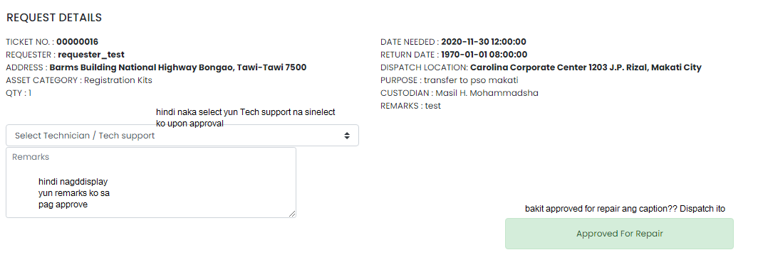

**Tapos yun data table.**

**Filtered out na magddisplay ditto kung ano lang yun sinelect ko knina sa Pending, or yun Status ay = 2 Ready to Deploy na.**

