Reimbursement Approval

Pending | Approved | Disapproved | Cancelled | Closed

**Pending**

REQ # | PR No. | Filed Date | Type | Description | Amount | REQ By | REQ DATE TIME | ACTION

1 1234 11/30/2Travel Expense Travel to Tawi 200 MYONGSON 11/30/2020 11:00: 00 am chain link icon

2 1234 11/30/2Travel Expense Travel to Tawi 200 MYONGSON 11/30/2020 11:00: 00 am chain link icon

**Approved**

**Yun REQ LINK <ito yun request no. na ni link na request no. sa dispatch or repair or approval**

REQ # | PR No. | Filed Date | Type | Description | Amount | Approved by | Approved DATE TIME | REQ LINK | ACTION

1 1234 11/30/2Travel Expense Travel to Tawi 200 MYONGSON 11/30/2020 11:00: 00 am none chain link

2 1234 11/30/2Travel Expense Travel to Tawi 200 MYONGSON 11/30/2020 11:00: 00 am 1234 chain link

**Disapproved**

REQ # | PR No. | Filed Date | Type | DESC | Amount | Disapproved by | Disapproved DateTime | Remarks | ACTION

1 1234 11/30/2Travel Expense Travel to Tawi 200 MYONGSON 11/30/2020 11:00: 00 am not valid link link

2 1234 11/30/2Travel Expense Travel to Tawi 200 MYONGSON 11/30/2020 11:00: 00 am notvalid link link

**CANCELLED**

REQ # | PR No. | Filed Date | Type | DESC | Amount | Cancelled by | Canceleld DateTime | Remarks | ACTION

1 1234 11/30/2Travel Expense Travel to Tawi 200 MYONGSON 11/30/2020 11:00: 00 am not valid link link

2 1234 11/30/2Travel Expense Travel to Tawi 200 MYONGSON 11/30/2020 11:00: 00 am notvalid link link

**CLOSED**

**Yun REQ LINK <ito yun request no. na ni link na request no. sa dispatch or repair or approval**

REQ # | PR No. | Filed Date | Type | DESC | Amount | Closed by | Closed DateTime | REQ LINK| ACTION

1 1234 11/30/2Travel Expense Travel to Tawi 200 MYONGSON 11/30/2020 11:00: 00 am none link link

2 1234 11/30/2Travel Expense Travel to Tawi 200 MYONGSON 11/30/2020 11:00: 00 am 12345 link link

**See approval new window on the next page, when Action Chain Link is click**



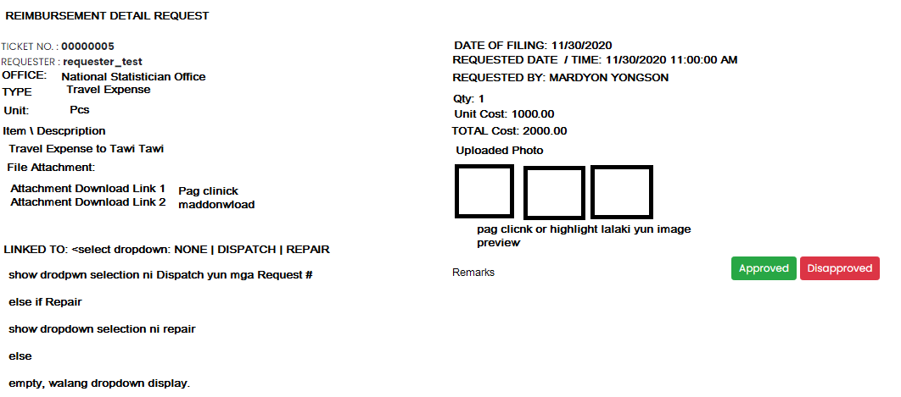

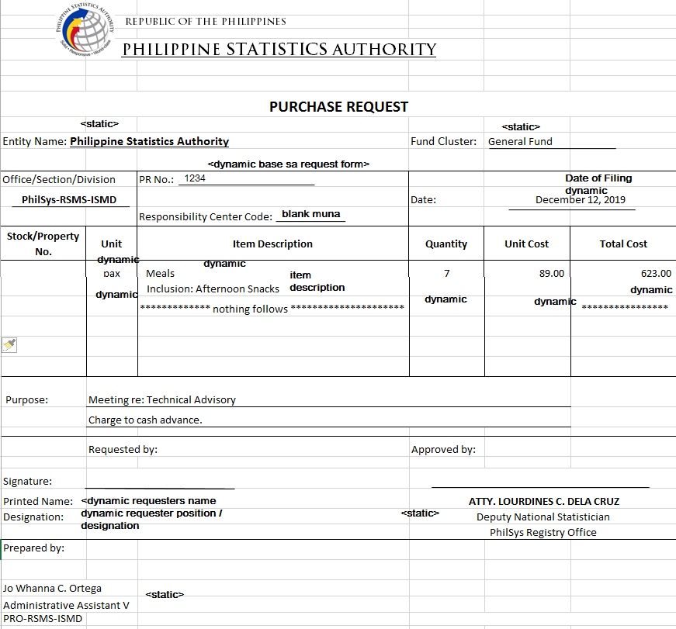

Ssa **Approved** Action link.

May Print Button na pwedeng Print ito as pdf

