AUSPIFY TECHNOLOGIES
DATA SCIENCE INTERNSHIP
TASK 1 – DATA CLEANING & PREPROCESSING

Netflix Dataset
Name: Anand Kumar
Internship: Data Science
Task: 1
Tools: Python, Pandas, NumPy
Objective:
The objective of this task is to prepare the Netflix dataset for further analysis by cleaning, transforming, and organizing the raw data.

Software:
• Python
• Visual Studio Code

Libraries:
• Pandas
• NumPy

1.Dataset
The dataset used for this task is the Netflix titles dataset provided for the internship. The dataset was imported into Python using the Pandas library.
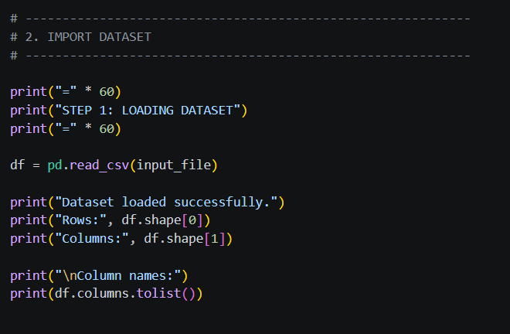
Figure 1: Importing and inspecting the Netflix dataset
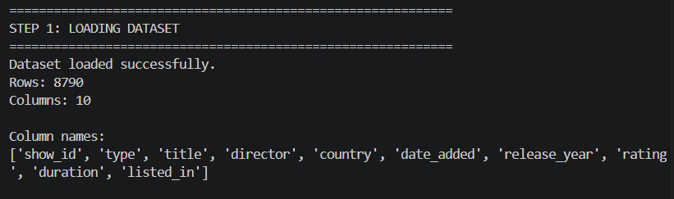
2.Missing Value Analysis
Missing values were checked for each column using Pandas. This step was performed to identify incomplete records before further preprocessing.
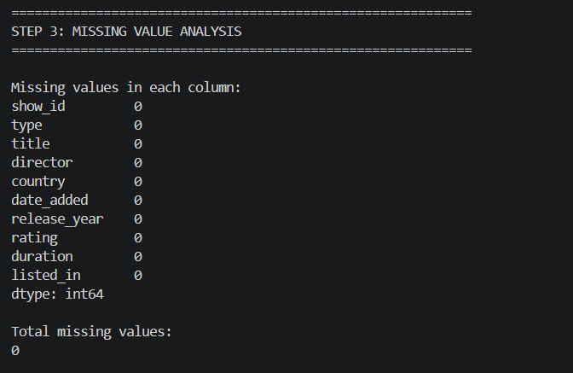

Figure 2: Missing value analysis
3.Duplicate Analysis
Duplicate records were checked using the Pandas duplicated() function. Duplicate rows, if present, were removed using drop_duplicates().
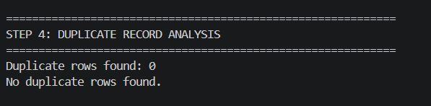
Figure 3: Duplicate record analysis
4.Data Cleaning
Text columns were cleaned by removing unnecessary leading and trailing spaces. Missing values in selected categorical and text columns were handled appropriately.
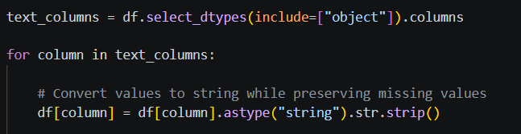
Figure 4: Text data cleaning code
5.Date Transformation
The date_added column was converted into datetime format. Additional date-related features were created, including year, month, and month name.
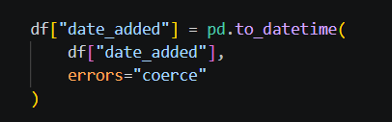
Figure 5: Date transformation and feature creation
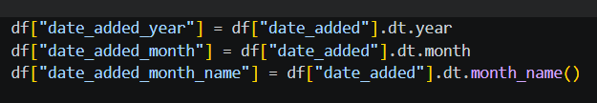
6.Duration Transformation
The duration column was transformed into two separate columns: duration_value and duration_unit. This makes the duration information easier to analyze.
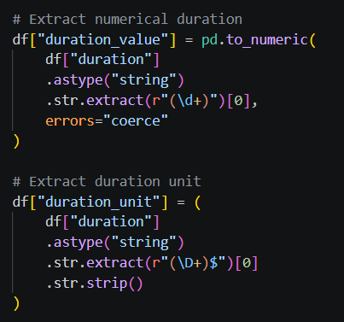
Figure 6: Duration transformation
7.Final Data Quality Check
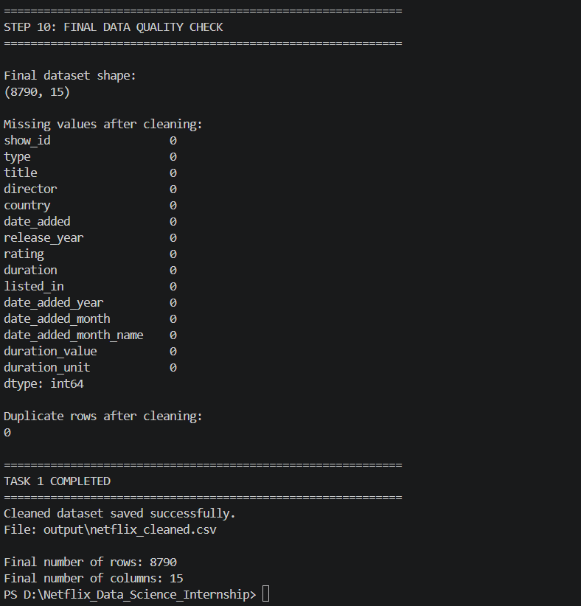
Figure 7: Final data quality check
After preprocessing, the dataset was checked again for missing values and duplicate records to verify the cleaning process.
8.Cleaned Dataset
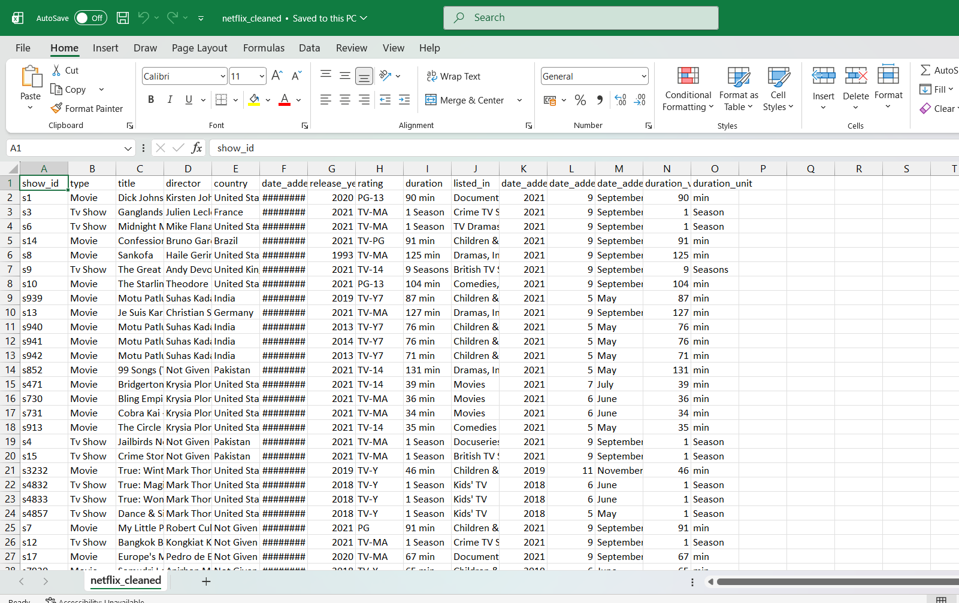
Figure 8: Final cleaned Netflix dataset

Conclusion
The Netflix dataset was successfully cleaned and preprocessed using Python and Pandas. The dataset was inspected for missing and duplicate records, text data was cleaned, date information was transformed, and duration information was separated into useful components. The resulting cleaned dataset is ready for further analysis and visualization.

