AUSPIFY TECHNOLOGIES
DATA SCIENCE INTERNSHIP

TASK 2 – EXPLORATORY DATA ANALYSIS
Netflix Dataset
Name: Anand Kumar
- Objective
The objective of this task is to explore the Netflix dataset to uncover trends, patterns, and insights. The analysis focuses on content distribution, countries, categories, release years, and ratings, supported by visualizations.
- Tools and Libraries
- Python
- Pandas
- NumPy
- Matplotlib
- Seaborn
- VS Code
- Dataset Overview
Total titles: 8790
Movies: 6126
TV Shows: 2664
Unique countries: India,Japan,Pakistan,
Unique ratings: TV-MA,TV14,R,PG-13
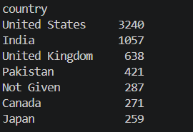
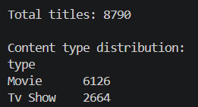
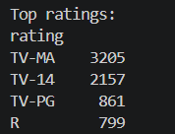
Figure 1: Dataset overview and statistical analysis

- Content Distribution
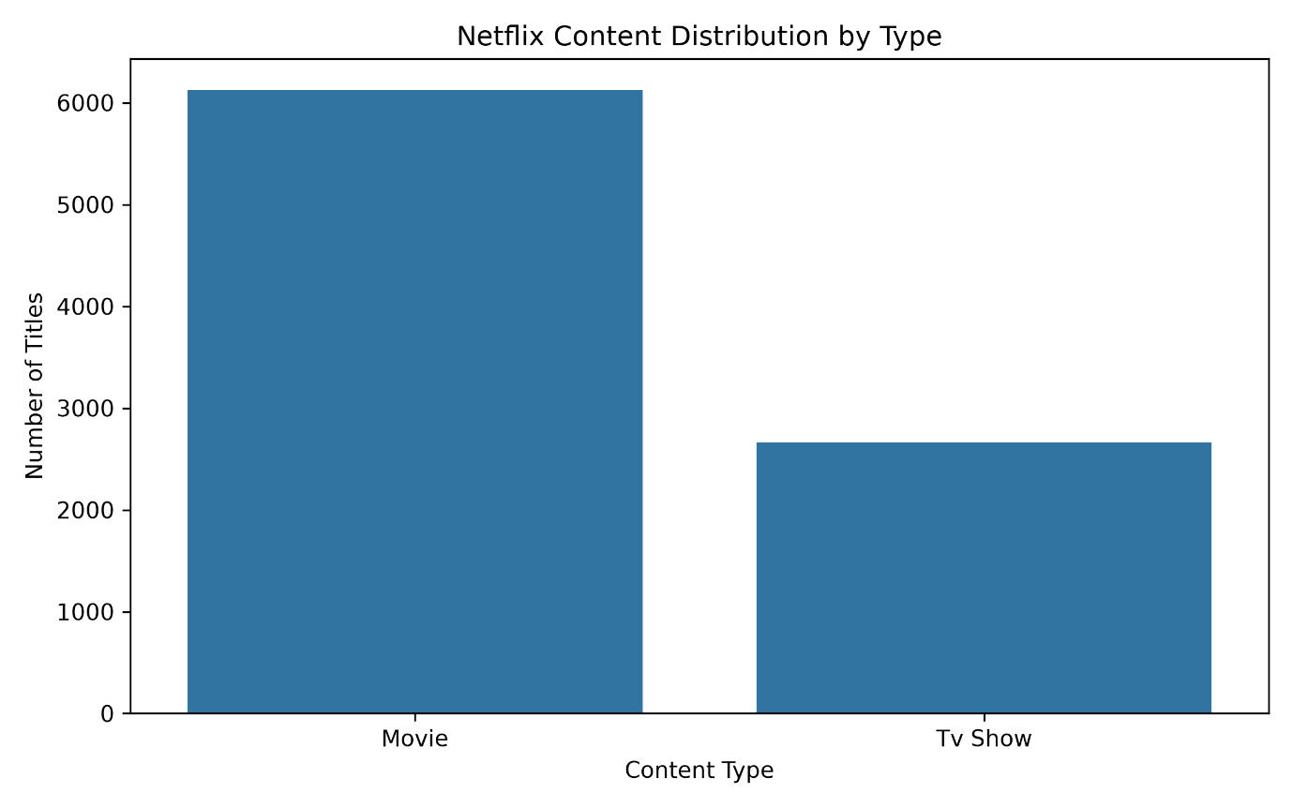
The distribution of Netflix content was analyzed based on the type column to compare Movies and TV Shows.

Figure 2: Netflix content distribution by type
The visualization shows the relative distribution of Movies and TV Shows in the dataset. The larger category represents the type with the greater number of titles.
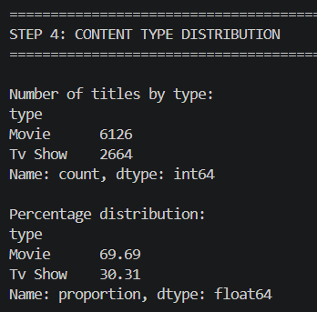

- Release Year Analysis
The release year of Netflix titles was analyzed to identify changes in content production and the overall trend across years.
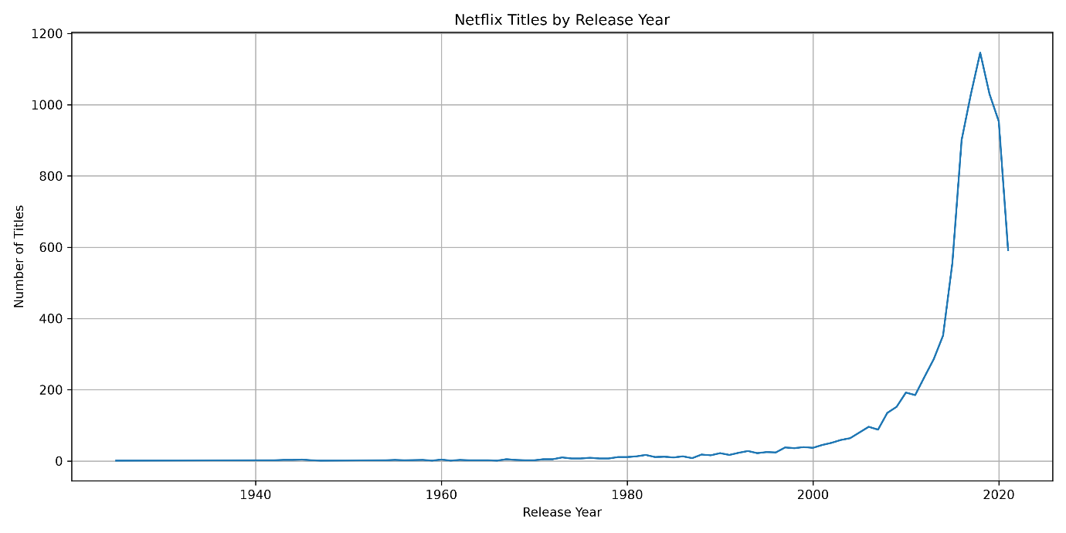Figure 3: Netflix titles by release year
The graph indicates that the number of titles varies considerably across release years, with substantially more titles concentrated in recent years.
- Top Countries
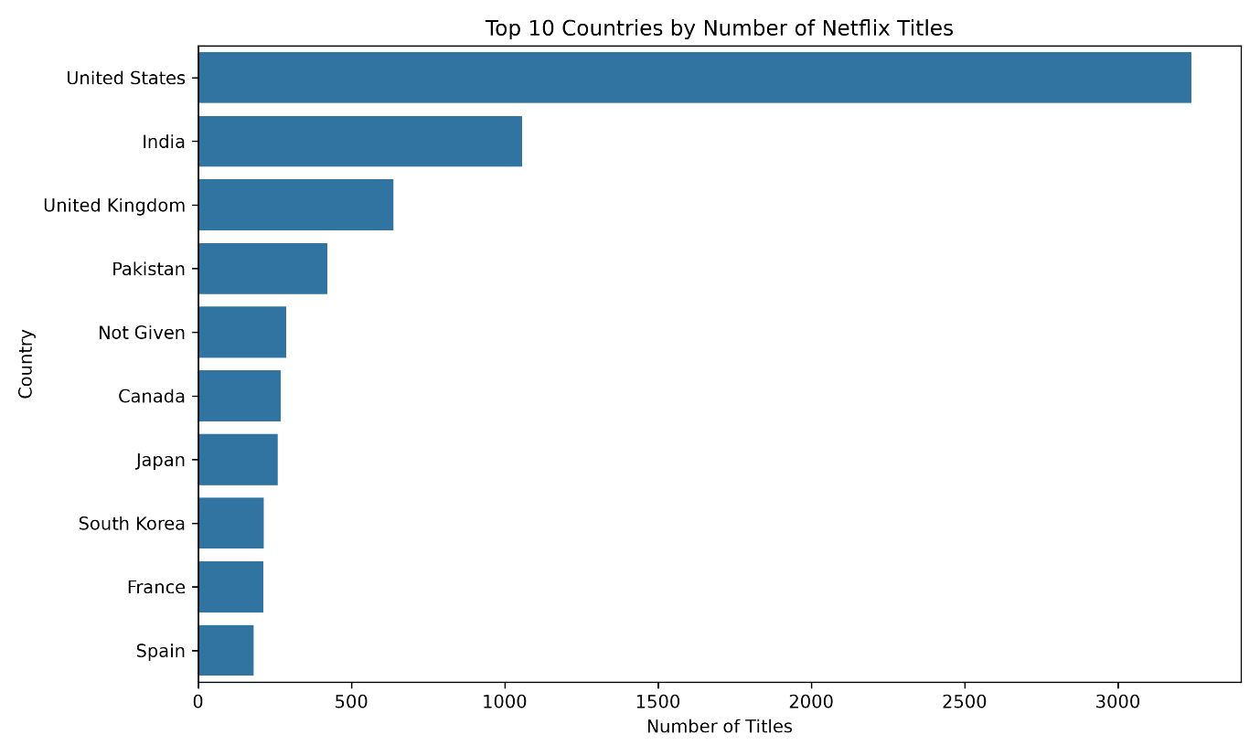Figure 4: Top 10 countries by number of Netflix titles
- Top Categories
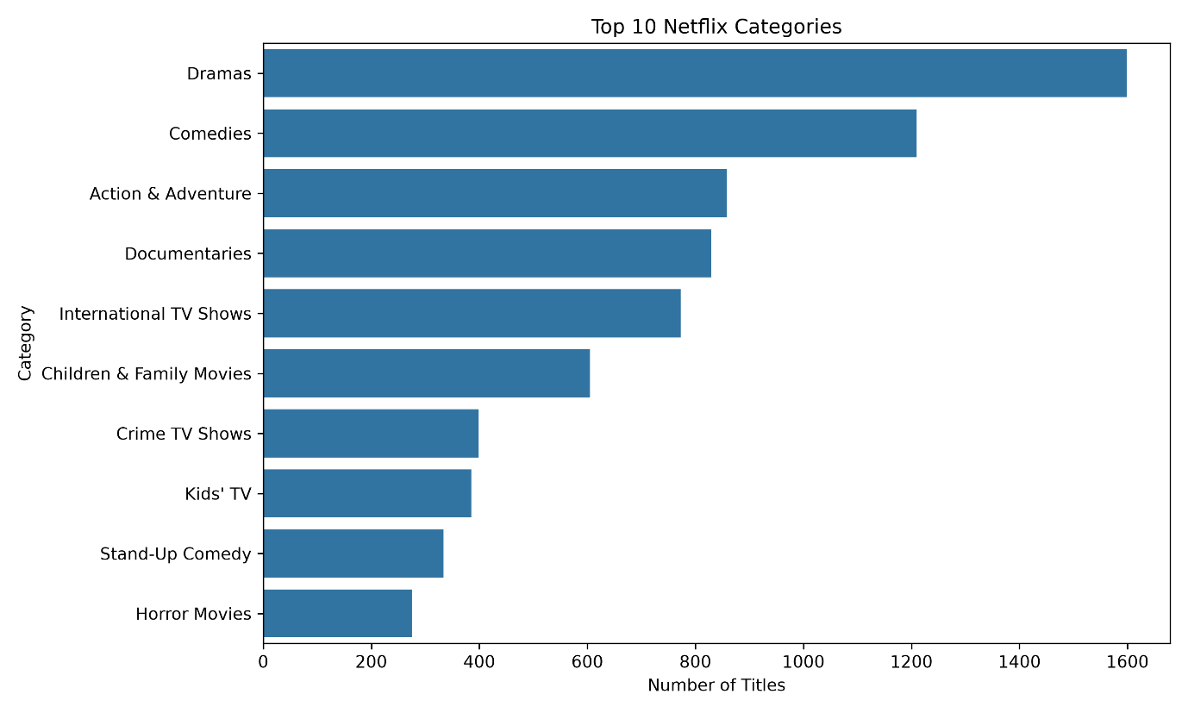Figure 5: Top 10 Netflix categories
- Ratings Analysis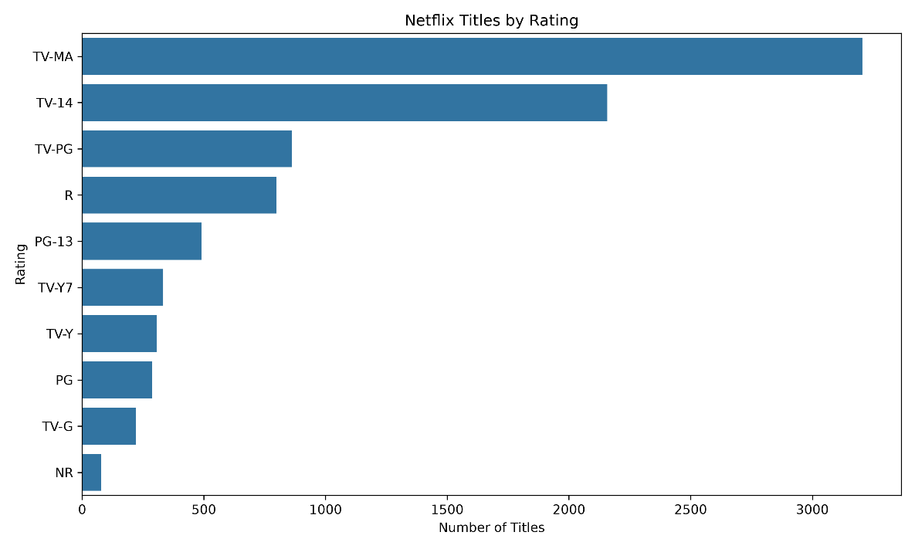
Figure 6: Netflix titles by rating

- Movie vs TV Show Trend

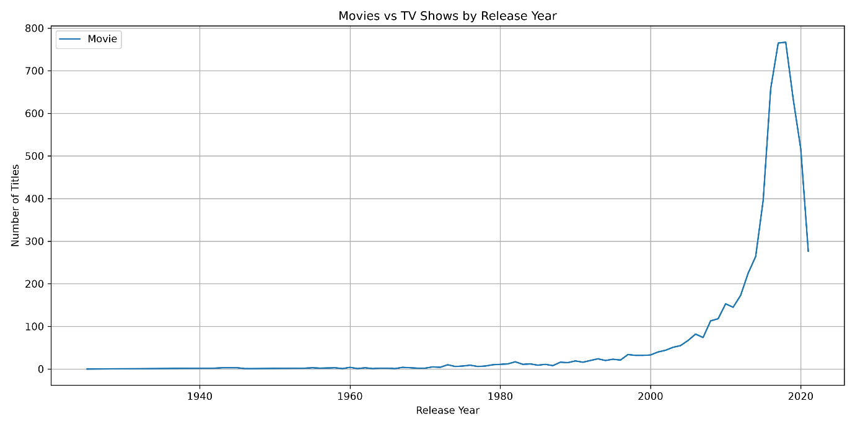
Figure 7: Movies vs TV Shows by release year
10.Key Findings
1. The dataset contains 8790 Netflix titles.
2. Movies account for 6126 titles, while TV Shows account
for 2664 titles.
3. The country with the highest number of titles is United States.
4. The most common category is Drama.
5. The most common rating is TV-MA.
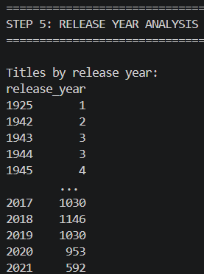
6. The release-year analysis shows.

11.Conclusion
Exploratory data analysis was successfully performed on the Netflix dataset. The analysis examined the structure and statistical characteristics of the data, content type distribution, release-year trends, top countries, categories, and ratings. Visualizations were created to make the patterns easier to understand. The results provide useful insights into the composition and characteristics of Netflix content.

