AUSPIFY TECHNOLOGIES
DATA SCIENCE INTERNSHIP

TASK 3
RECOMMENDATION SYSTEM ANALYSIS

Netflix Content Recommendation System

Name: Anand Kumar
Internship: Data Science
Tools:
Python | Pandas | NumPy | Scikit-Learn
Objective
The objective of this task is to develop a basic content recommendation system based on Netflix titles and categories. The system uses relevant content features, performs text preprocessing, calculates content similarity, and generates recommendations for selected titles.
Dataset
The Netflix dataset provided for the internship was used for developing the recommendation system. The dataset contains information about Netflix titles, including title, type, director, cast, country, rating, categories, and description.
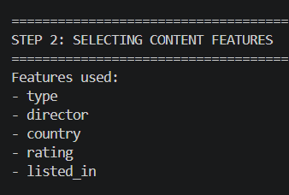
Figure 1: Netflix dataset used for recommendation analysis

Feature Selection
[Type, director, cast, country, rating, listed in, description] Relevant content-related features were selected to represent the characteristics of each Netflix title. These features provide information about the type, people involved, country, rating, category, and description of the content.
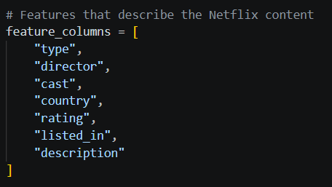
Figure 2: Selection of content features
Text Preprocessing
The selected text features were combined into a single content feature. Missing values were handled and the text was converted to lowercase. Unnecessary special characters and extra spaces were removed before feature extraction.
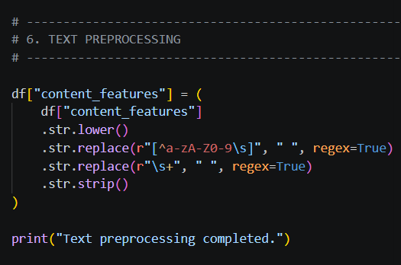
Figure 3: Text preprocessing

TF-IDF Feature Extraction
TF-IDF (Term Frequency–Inverse Document Frequency) was used to convert the textual content features into numerical vectors. These vectors allow the recommendation system to compare Netflix titles based on their textual characteristics.
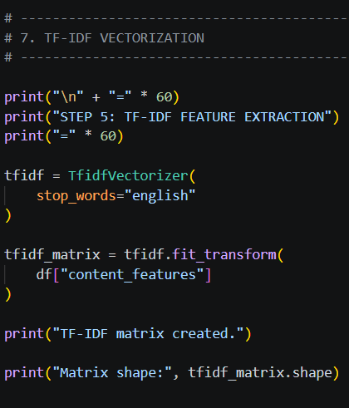
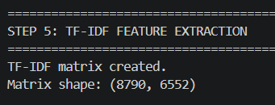
Figure 4: TF-IDF feature extraction and matrix creation
Content Similarity Calculation
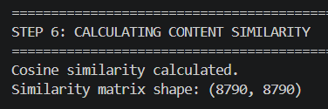
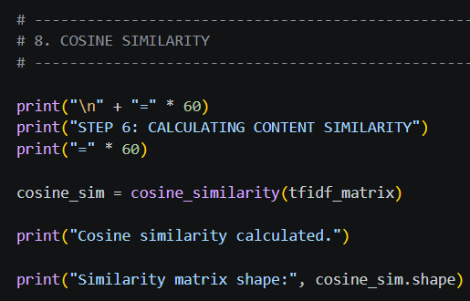
Cosine similarity was used to calculate the similarity between Netflix titles. Each title was compared with the other titles based on their TF-IDF vectors.
Figure 5: Cosine similarity calculation

Recommendation Method
A recommendation function was created that accepts a Netflix title as input. The system finds the selected title in the dataset, obtains its similarity scores, sorts the titles according to similarity, removes the selected title itself, and returns the top recommendations.
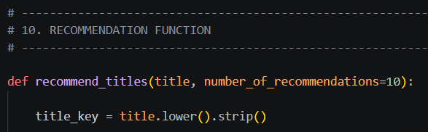
Figure 6: Recommendation function
Recommendation Results
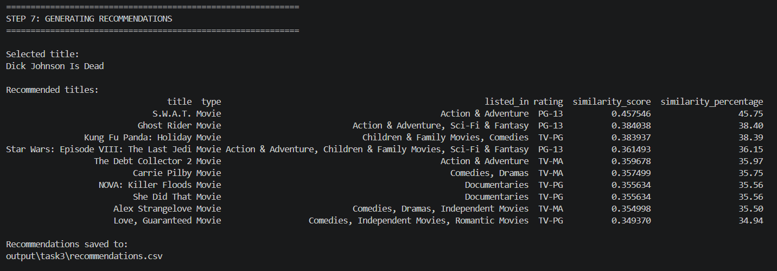
Figure 7: Generated Netflix recommendations
Recommendation Quality Analysis
The similarity scores provide an indication of how closely the recommended titles match the selected title based on the content features used by the model.
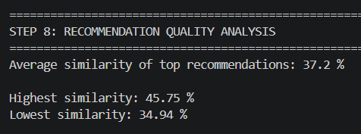
Figure 8: Recommendation quality analysis

Results and Discussion
The recommendation system successfully generated similar Netflix titles for the selected input title. The recommendations were produced using content-based similarity calculated from the TF-IDF representation of the selected features. The resulting titles can be examined based on their categories, ratings, type, and similarity scores.
Selected title:
- S.W.A.T. Movie
- Ghost Rider Movie
- Kung Fu Panda: Holiday Movie
- Carrie Pilby Movie
- NOVA: Killer Floods
Number of recommendations: 10
Average similarity:37.3%
Conclusion
A basic Netflix content recommendation system was successfully developed using Python and Scikit-Learn. Relevant Netflix content features were extracted and combined, text preprocessing was performed, TF-IDF was used for feature extraction, and cosine similarity was used to identify similar titles. The system successfully generated recommendations for selected Netflix titles.

