AUSPIFY TECHNOLOGIES
DATA SCIENCE INTERNSHIP

TASK 4
TREND PREDICTION ANALYSIS

Netflix Content Trend Prediction
Name: Anand Kumar
Internship: Data Science
Tools:
Python | Pandas | NumPy | Matplotlib |
Seaborn | Scikit-Learn
Objective
The objective of this task is to analyze historical Netflix content trends and forecast future content growth using release-year data. The analysis includes preparation of release-year data, yearly trend analysis, forecasting model development, visualization of future predictions, and interpretation of the results.
Dataset Preparation
The cleaned Netflix dataset from Task 1 was used for trend analysis. The release_year column was converted into numeric format and records without a valid release year were excluded. The number of Netflix titles was then aggregated for each release year.
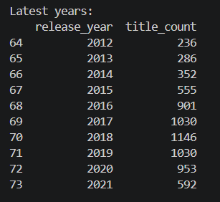
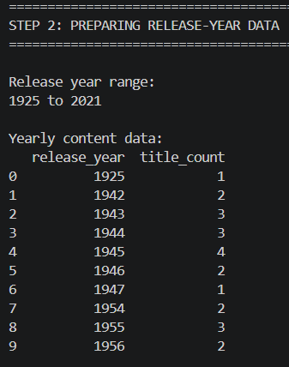
Figure 1: Preparation of release-year data

Historical Trend Analysis
The number of Netflix titles was grouped by release year to identify historical changes in content volume.
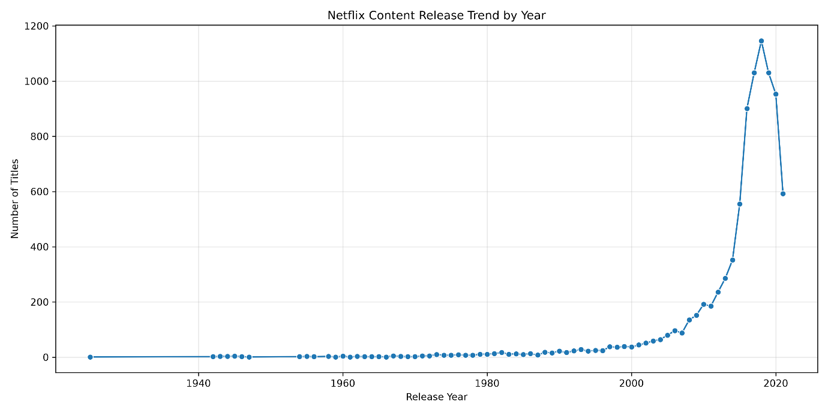
Figure 2: Historical Netflix content release trend
The historical data shows an overall [upward/downward/mixed] pattern in the number of titles across the observed period.
Forecasting Method
Linear Regression was used as the forecasting model. The release year was used as the independent variable and the number of titles released during that year was used as the dependent variable.
Training data = first 80% of chronological observations
Testing data = remaining 20%
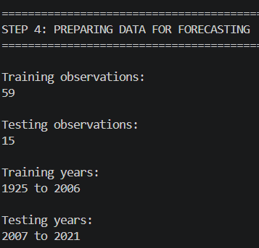
Figure 3: Forecasting model training
Model Evaluation
Metric | Value
MAE | 475.14
RMSE | 603.2
R² Score | -1.593

The model was evaluated using Mean Absolute Error (MAE), Root Mean Squared Error (RMSE), and R² Score. These metrics were calculated using the chronological test portion of the dataset.
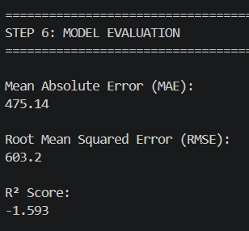
Figure 4: Forecasting model evaluation
Future Forecast
After training the model, predictions were generated for the five years following the latest release year available in the dataset.
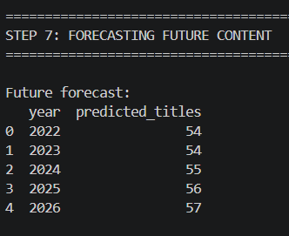
Figure 5: Future Netflix content forecast
Forecast Visualization
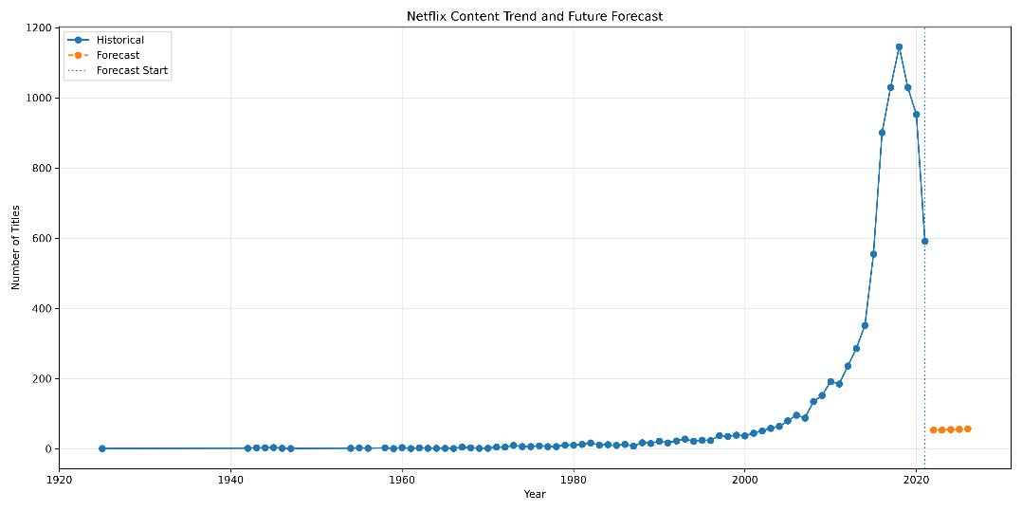
Figure 6: Historical Netflix trend and future forecast
The graph presents the historical number of Netflix titles by release year together with the future values predicted by the Linear Regression model. The historical portion represents the observed data available in the dataset, while the forecast portion represents model-generated estimates for the years following the latest available release year. The forecast should be interpreted as a projection based on the historical relationship between release year and the number of titles.
Actual vs Predicted Results
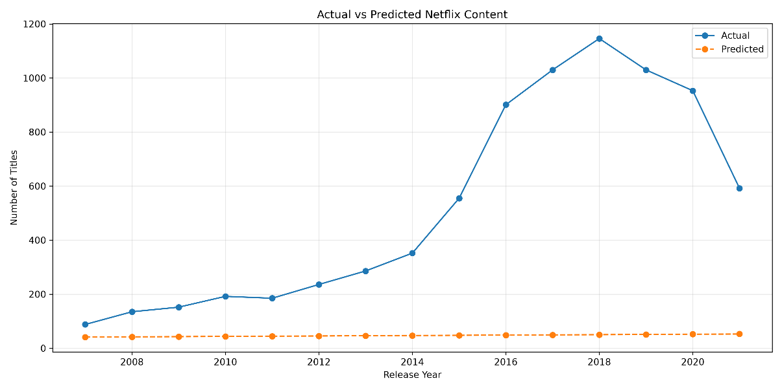
Figure 7: Actual versus predicted Netflix content
The graph compares the actual number of Netflix titles with the values predicted by the Linear Regression model for the test period. If the predicted line follows the general movement of the actual line, the model is capturing part of the underlying trend. Differences between the two lines represent prediction errors.
Trend Interpretation
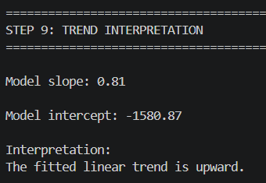
Figure 8 : Shows Trend Interpretation
Key Findings
1. The dataset covers release years from 1925 to 2021.
2. The forecasting model used was Linear Regression.
3. MAE = 475.14.
4. RMSE = 603.2.
5. R² Score = -1.593.
6. The forecast covers 1925 to 2006.
Limitations
The forecasting model uses only release year and historical title counts. It does not include external factors such as Netflix business strategy, licensing decisions, market conditions, regional demand, production budgets, or future changes in the dataset. Therefore, the forecast should be interpreted as a model-based projection of the historical trend rather than a guaranteed prediction of future Netflix content.

Conclusion
Historical Netflix content trends were analyzed using release-year data. A Linear Regression forecasting model was developed using chronological training and testing data. Model performance was evaluated using MAE, RMSE, and R² Score, and future content counts were estimated for the next five years after the latest year in the dataset. The resulting visualizations and forecasts provide a data-driven view of the historical trend and its model-based future projection.

