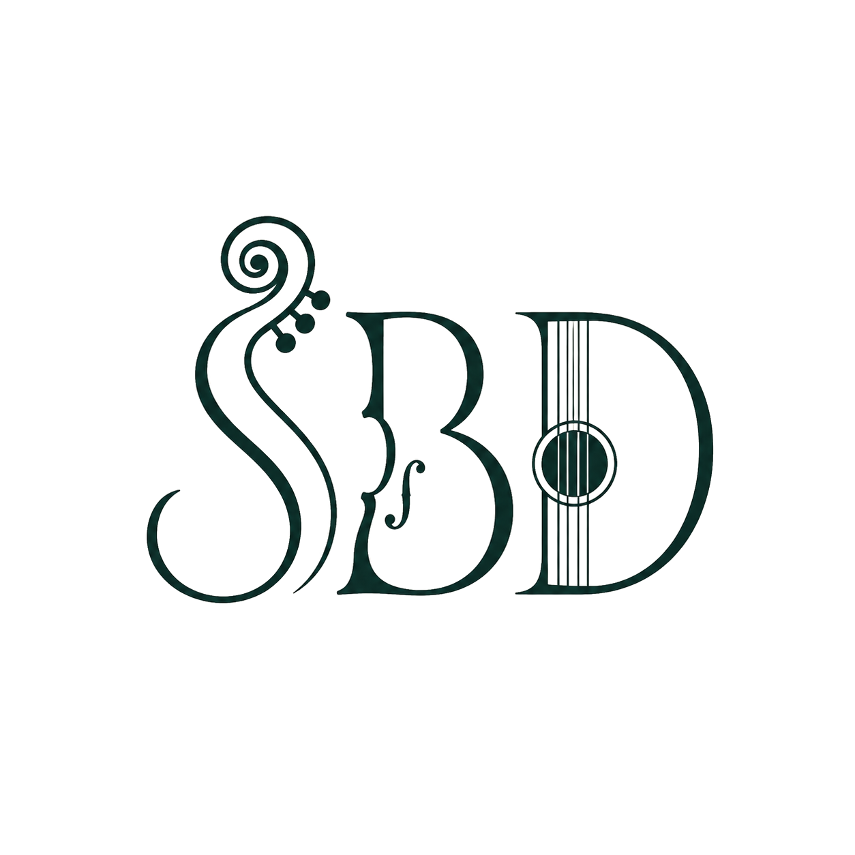
STAGE 2 — YEARS 3–4

Bush Dance Explorers: The Heel & Toe Polka in Colonial Australia
DURATION  60 minutes | YEAR LEVEL  Year 3–4 | GROUP SIZE  Whole class / cohort | LOCATION  Hall / gymnasium / flat outdoor area

Learning intentions
- We are learning that bush dances tell us about the people, journeys and community life of colonial Australia.
- We are learning to perform simple set-dance formations with control, timing and expression.
- We are learning to share our own opinion about what a dance communicates.

Success criteria — students can:
- Perform basic locomotor and non-locomotor bush dance steps in time with the music and a partner or group.
- Name at least one reason bush dances developed among colonists, convicts and free settlers in early Australia.
- Describe, in my own words, a feeling or idea a dance communicated to me.

Curriculum outcomes targeted
Outcomes below are drawn from syllabuses currently in force for Stage 2 (History K–10 (2012); Creative Arts K–6 (2006); PDHPE K–10 (2018)). Equivalent outcomes exist in the new K–6 syllabuses (Creative Arts 2024, PDHPE 2024, HSIE 2024) being phased in for 2027 — update codes when your school transitions.

Code | Outcome (paraphrased) | Learning area | Syllabus
HT2-3 | Describes people, events and actions related to world exploration/migration and its effects — bush dances arriving with settler groups. | History | K–10 (2012)
HT2-4 | Describes and explains effects of British colonisation in Australia, including new social and cultural practices. | History | K–10 (2012)
HT2-5 | Applies skills of historical inquiry and communication. | History | K–10 (2012)
DAS2.1 | Performs dances from a range of contexts, demonstrating movement skills, expressive qualities and understanding of dance elements. | Creative Arts (Dance) | K–6 (2006)
DAS2.2 | Explores, selects and combines movement using the elements of dance to communicate ideas, feelings or moods. | Creative Arts (Dance) | K–6 (2006)
DAS2.3 | Gives personal opinions about the use of elements and meaning in their own and others' dances. | Creative Arts (Dance) | K–6 (2006)
MOS2.4 | Displays a focus on quality of movement in applying movement skills to familiar and new situations. | PDHPE | K–10 (2018)
ALS2.6 | Discusses the benefits of participation in a range of physical activities. | PDHPE | K–10 (2018)

Equipment & preparation
- Cleared hall/flat space, roughly 1.5m x 1.5m per student
- Live music: violin (presenter) and guitar (accompanist) — no speaker/playlist required
- Presenter calls the dance live throughout — no separate caller track needed
- Optional: 2–3 large images of colonial-era bush dances or First Fleet arrival (for the history talk)
- Name tags or coloured wristbands if allocating dance partners/sets

Lesson sequence (60 minutes)
Time | Segment | Teaching & learning activity | Curriculum outcomes targeted
0–10 min | Settle & warm-up | Welcome the class, settle students into a large circle, set expectations for a shared music-and-movement space. Gentle warm-up: walk, skip, gallop and clap in time with a short live tune to build locomotor control and group focus. | MOS2.4
10–18 min | History yarn | Short interactive talk with images: Who came to the colony on the First Fleet and afterwards? Where did their dances come from (Irish, Scottish, English folk traditions)? Why did communities dance together in the bush? | HT2-3, HT2-4
18–53 min | Teach, live music & perform: Heel & Toe Polka | Presenter teaches the Heel & Toe Polka step-by-step (walk-through, then heel-and-toe pattern, then polka step), calling each stage live while the guitarist joins in. Build from slow tempo to full performance tempo with live violin and guitar, repeating and refining formations and partner work. | DAS2.1, DAS2.2, MOS2.4, ALS2.6
53–58 min | Reflect & share | Turn-and-talk then 3–4 volunteers share: 'What story do you think the Heel & Toe Polka was telling? How did dancing to live music make you feel?' | DAS2.3, HT2-5
58–60 min | Cool down | Slow stretch and thank-you circle; preview follow-up classroom task. | MOS2.4

Assessment
- Teacher observation checklist against DAS2.1/MOS2.4 (movement quality) during the Teach, Live Music & Perform segment.
- Anecdotal notes on 3–4 student responses during Reflect & Share, coded against DAS2.3 and HT2-5.
- Exit ticket (1 sentence): 'One thing I learned about colonial Australia from the Heel & Toe Polka was…' — evidence for HT2-4.

Differentiation
- Pair students needing extra support with a confident peer 'dance buddy' for formations.
- Offer a seated/adapted version of steps (arm and upper-body patterns) for students with mobility needs.
- Provide picture cue cards for formation vocabulary for EAL/D learners.
- Extend capable dancers with a 'caller's assistant' role, helping cue peers alongside the presenter.

Key vocabulary
colony • settler • convict • heel & toe • polka step • promenade • folk dance • live music

Extending the learning back in the classroom
Use these follow-up tasks to deepen curriculum coverage after the incursion:
- English/History: write a first-person diary entry as a child attending a bush dance in the 1820s colony (extends HT2-5).
- History: sort a set of picture cards into 'before the First Fleet' and 'after colonisation' (extends HT2-3/HT2-4).
- Creative Arts: in small groups, invent a new 4-step variation on the Heel & Toe Polka and explain the 'story' it tells (extends DAS2.2/DAS2.3).
- PDHPE: keep a one-week physical activity log, including how the Heel & Toe Polka compared to other activities (extends ALS2.6).

Prepared for booking schools by Sydney Bush Dances • sydneybushdances.com • Outcomes referenced from current NSW Education Standards Authority (NESA) syllabuses.

