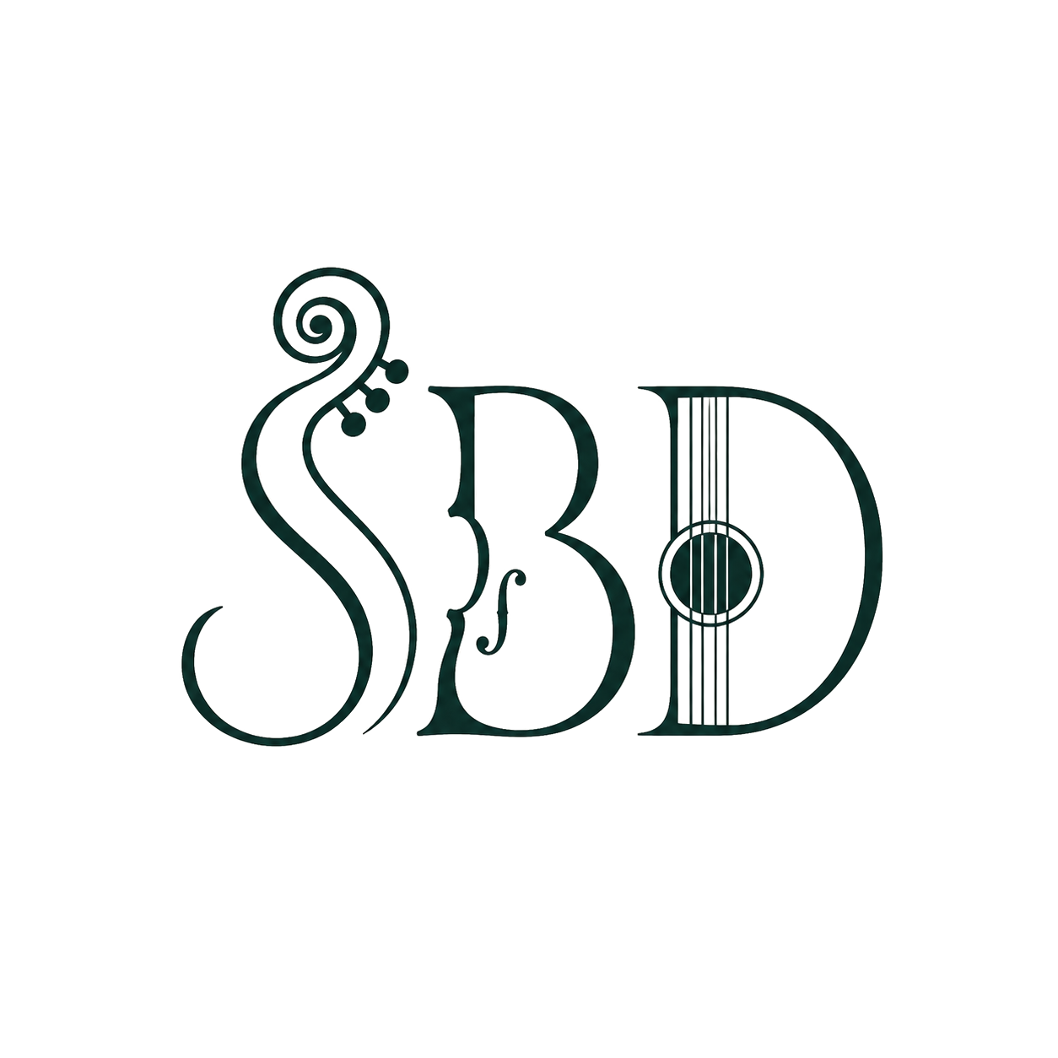
STAGE 3 — YEARS 5–6

Colonial Communities on the Dance Floor: The Heel & Toe Polka
DURATION  60 minutes | YEAR LEVEL  Year 5–6 | GROUP SIZE  Whole class / cohort | LOCATION  Hall / gymnasium / flat outdoor area

Learning intentions
- We are learning how bush dances reflect the different experiences of people living in colonial Australia.
- We are learning to perform and interpret set dances with technical control and creative refinement.
- We are learning to discuss how context and meaning connect in a dance performance.

Success criteria — students can:
- Perform a set of bush dance sequences with increasing technical control and timing.
- Explain how the same historical period (colonial Australia) was experienced differently by settlers, convicts and Aboriginal Peoples.
- Discuss how a dance's formations, tempo or style relate to its historical or cultural context.

Curriculum outcomes targeted
Outcomes below are drawn from syllabuses currently in force for Stage 3 (History K–10 (2012); Creative Arts K–6 (2006); PDHPE K–10 (2018)). Equivalent outcomes exist in the new K–6 syllabuses (Creative Arts 2024, PDHPE 2024, HSIE 2024) being phased in for 2027.

Code | Outcome (paraphrased) | Learning area | Syllabus
HT3-1 | Describes and explains the significance of people, groups, places and events to the development of Australia. | History | K–10 (2012)
HT3-2 | Describes and explains different experiences of people living in Australia over time — settlers, convicts, Aboriginal Peoples. | History | K–10 (2012)
HT3-5 | Applies a variety of skills of historical inquiry and communication. | History | K–10 (2012)
DAS3.1 | Performs and interprets dances from particular contexts, using a wide range of movement skills and expressive qualities. | Creative Arts (Dance) | K–6 (2006)
DAS3.2 | Explores, selects, organises and refines movement using the elements of dance to communicate intent. | Creative Arts (Dance) | K–6 (2006)
DAS3.3 | Discusses and interprets the relationship between content, meaning and context in their own and others' dances. | Creative Arts (Dance) | K–6 (2006)
MOS3.4 | Refines and applies movement skills creatively to a variety of challenging situations. | PDHPE | K–10 (2018)
ALS3.6 | Discusses the role of physical activity in maintaining a balanced, healthy lifestyle. | PDHPE | K–10 (2018)

Equipment & preparation
- Cleared hall/flat space with room for a longways set / large circle
- Live music: violin (presenter) and guitar (accompanist) — no speaker/playlist required
- Presenter calls the dance live throughout — no separate caller track needed
- 2–3 primary-source style images or short paraphrased extracts about colonial social gatherings (for source discussion)
- Whiteboard/butcher's paper for quick brainstorm of 'whose stories are missing?'

Lesson sequence (60 minutes)
Time | Segment | Teaching & learning activity | Curriculum outcomes targeted
0–10 min | Settle & warm-up | Settle the class into a large circle, set expectations for a shared music-and-movement space. Dynamic warm-up (jog, side-step, turn) in time with a short live tune while recapping prior knowledge of colonial Australia from classroom units. | MOS3.4
10–18 min | Source discussion | Guided look at images/paraphrased accounts of colonial social gatherings. Discuss: whose experiences are shown (settlers, officials) and whose are often missing (convicts, women, Aboriginal Peoples)? | HT3-1, HT3-2
18–53 min | Teach, live music & perform: Heel & Toe Polka | Presenter teaches the Heel & Toe Polka's formation and etiquette (bowing/curtseying, changing partners respectfully), then the step pattern, calling live while the guitarist accompanies. Build from slow walk-through to full tempo, coaching refinement of timing, spacing and expression before a full performance. | DAS3.1, DAS3.2, MOS3.4
53–58 min | Perform & peer-feedback | Small groups perform the polka for each other; peers give one piece of feedback linking a movement choice to the historical context discussed earlier. | DAS3.3, HT3-2
58–60 min | Reflection exit ticket | Written exit ticket: 'What does the Heel & Toe Polka suggest about community life in colonial Australia?' | HT3-5

Assessment
- Teacher observation checklist against DAS3.1/MOS3.4 during the Teach, Live Music & Perform segment.
- Peer-feedback notes collected during Perform & Peer-Feedback, coded against DAS3.3.
- Written exit tickets assessed against HT3-2/HT3-5 for depth of historical reasoning.

Differentiation
- Provide a simplified 4-count version of the polka for students needing more processing time.
- Group mixed-confidence students so peer coaching supports skill refinement (supports MOS3.4).
- Offer sentence starters for the source discussion and exit ticket for students needing writing support.
- Extend confident students by asking them to choreograph one new transition or variation on the polka (extends DAS3.2).

Key vocabulary
colonial • convict • free settler • heel & toe • polka step • etiquette • context • interpretation

Extending the learning back in the classroom
Use these follow-up tasks to deepen curriculum coverage after the incursion:
- History: research one named figure or group from colonial NSW (bushranger, convict, settler, Aboriginal leader) and present findings (extends HT3-1/HT3-5).
- History: compare two accounts of the same colonial event from different perspectives (extends HT3-2).
- Creative Arts: choreograph and notate an eight-count original variation on the Heel & Toe Polka inspired by a colonial theme (extends DAS3.2/DAS3.3).
- PDHPE: design a class fitness circuit and explain its health benefits, linking back to the polka as physical activity (extends ALS3.6).

Prepared for booking schools by Sydney Bush Dances • sydneybushdances.com • Outcomes referenced from current NSW Education Standards Authority (NESA) syllabuses.

