

**Spylight Data Entry Guidelines**

Prepared for our Fashion Consultants on June 22, 2014

Please read through this packet carefully, as some of the entry requirements may have changed.

**INTRODUCTION**

Welcome to Spylight! Spylight is a web and mobile platform dedicated to making entertainment content shoppable. Our services would not be possible without a highly capable and successful data team – that’s you! Data is arguably one of our most valuable assets, and the more accurate, visually compelling, and detailed data we have, the more valuable our company becomes.

**REGISTER & LOG IN**

1. Go to <spylight.com/admin>
2. Click “Register” and enter your information in the form that appears.
3. You will be redirected to the main page – simply go back to <spylight.com/admin> and log in with your new account and password. If you are redirected to the main page, simply go back to <spylight.com/admin>.

**HOW OUR DATABASE IS STRUCTURED**

The following is the basic hierarchy of information for Spylight:

NETWORK > SHOW > EPISODE > SCENE > OUTFITS > PRODUCTS

In other words, networks have shows, shows have many episodes, episodes have many scenes, and scenes have many outfits, which have many products.

**THE ROLE OF FASHION CONSULTANTS**

Our fashion consultants have three interconnected yet distinct tasks:

1. ***work on set*** of TV shows and movies with stylists to collect data on what stars are wearing
2. ***research* online** (through blogs, websites, and popular retail sites) to find what stars are wearing, from head to toe
3. ***timestamp* episodes** to prepare our data for audio sync and create scenes based on those timestamps

**RETROACTIVE TIMESTAMPING (audio-sync data entry)**

Up to this point, we have only had FCs complete tasks 1 and/or 2. Therefore, most of the episodes in our database are not time-stamped, so each of those episodes only has one scene. We need time-stamping fashion consultants to go back to existing episodes in our database and 1) create scenes with start and end times and 2) assign the episode’s outfits (which have already been created) to their relevant scenes. FCs who are asked to retroactively create scenes for episodes will need to:

1. Watch episodes and mark the start and end times for scenes
2. Observe which outfits are in each scene and find them in our database
3. Create the scenes in our database and associate the existing outfits with the newly created scenes.

The instructions for this will be included in the general instructions for Fashion Consultant Data Entry below.

**THE ROLE OF FASHION CONSULTANTS MOVING FORWARD**

Moving forward, for those episodes and shows not yet entered into our database, we would like to *combine tasks 2 and 3* into one process. Fashion Consultants will therefore be asked to:

1. Watch an episode and mark the start and end times for scenes
2. Create the episode (name, tagline, air date, episode image, etc)
3. Enter the scenes into the database (start and end times; individual scene images)
4. Find EXACT or SIMILAR matches for the products in the outfits that you see on the characters. Also find at least ONE CHEAPER alternative (see “Product Sets” on page 5). For episodes that have aired in the last 12 months, 25% or more of the products entered must be exact matches.
5. Create those outfits in our database by entering all product details.
6. Match these newly created outfits with the scenes in which they appear.

**THINGS YOU NEED TO KNOW BEFORE YOU BEGIN**

* Before entering outfit information, check to see if the show that you have been assigned is in our database by clicking on “Shows” on the top navigation bar.   
  If it is not, you must create a new show (see “Entering a New Show and Characters”).   
  If the show already exists in our database, your data entry guidelines begin with “Completing an Episode Step-by-Step” on page 3.
* Watching Episodes: We would like to have the highest quality possible for all images in our database. Please download episodes or use DVDs whenever possible whenever you are taking screenshots of episodes. If downloading is not an option for you, we will purchase HD episodes for you on our Amazon account – username: [aly@spylight.com](mailto:aly@spylight.com). Ask us for the password!   
  *Please do not purchase episodes before asking Spylight for confirmation.*
* There are various levels of verification in our data entry process. After you create any item in our database (whether it be shows, characters, episodes, outfits, etc), verification occurs automatically, using a series of built-in checks. Those checks are listed under “Verification” on page 8.
* After an item is “verified,” a check will appear under the “verified” column on various index pages, and the item will be ready for approval by data managers (eg Mychal, Aly, April). Therefore, you should **never** touch the “approved” option in any of the forms on the /admin site.
* The quality of images is very important to Spylight:
  + For all images, there are either specific dimensions or rules to abide by that are mentioned in these guidelines. *An image will not be verified unless its dimensions are correct.*
  + Screenshots of TV shows can sometimes appear too dark. Please make sure that images are not too dark before you upload them in our database.
  + Low-resolution photos will not be approved.
  + We recommend either Photoshop or Picmonkey.com for editing photos (cropping or brightening them). Pic Monkey is completely free and does not require a download. Also, if you open up an image in Preview, you can alter the brightness and size of the image. Here is a tutorial for editing images in preview: http://www.macworld.com/article/2045136/editing-and-annotating-images-with-preview.html

**ENTERING A NEW SHOW AND CHARACTERS**

1. On the top navigation bar, click on “Shows.”
2. Click on “New Show” at the top right of the page.
3. Enter the name of the show.
4. Add at least one show image. See “Show Image Requirements.”
5. To enter the show’s characters, click “Add new characters.”
6. When the New Character form appears, fill out all fields.

* NAME: Please spell check.
* SHOW: Select show.
* DESCRIPTION: Keep this description short, just one sentence. Please make the description a grammatically correct sentence (punctuation etc). Ex: Jess from New Girl – “New Girl's main character Jess is a quirky and bubbly young schoolteacher living with three guys.” DO NOT COPY AND PASTE FROM IMDB, THIS MUST BE ORIGINAL.
* ACTOR: The actor’s name (eg “Zooey Deschanel”)
* GENDER: Male or Female
* IMPORTANCE: Please rank all of the main characters in order of importance in the show, 1 being the most important. \*Please note that you will not be able to save the character without ranking the character, but you can go back and change the character’s importance later.
* IMAGES: See “Character Image Requirements”
* Click ‘Create Character.’

1. Click “Create Show.” If your submission is successful, you are now ready to create episodes.  
     
     
   IMPORTANT NOTE:  
   You can enter guest stars into our database by simply checking “Guest” when creating a new character.

**COMPLETING AN EPISODE STEP-BY-STEP**

The following details the process that an FC will repeat with every episode. We measure work on an episode-by-episode basis.

Every episode starts at 0; all times are in SECONDS *not* MINUTES. E.G. 1:27 would be 87 seconds, so you would input 87 seconds. **Make sure scenes don’t overlap in time; for example, if a scene ends at 10 seconds, the next scene must being at 11 seconds.**

1. *ADD A NEW EPISODE IN THE “EPISODES” TAB*

* Check to see if your episode is already listed on the left. (Use the filter on the far right to view all episodes for your specific show – or search for a specific episode number – more quickly.) If your episode has already been created, please move on to #2.
* If the episode has not yet been created, create “New Episode.” Please fill out every field in the “New Episode” form as completely as possible. Do not check “approved.”
* For the ‘tagline’ field, please enter an appropriate one-sentence summary of the episode. *Please double-check for spelling and grammar.*   
  EX for New Girl “Double Date”: “Schmidt’s relationship house of cards comes tumbling down during a double date.”
* Add *one* episode image. Please check the “Episode Image Requirements” on page 3 to make sure the episode image is usable.

1. *WATCH THE EPISODE AND TAKE NOTES.*

See “**Where should I stream episodes?**” on page 4 and “**What counts as a scene?**” on page 5.  
  
We strongly recommend that you follow these steps:  
  
If outfits have already been entered for the episode:

* 1. Use paper and pen.
  2. Write the Season and Episode #s at the top of the paper.
  3. In a separate window, open <spylight.com/admin/outfits> and filter by the episode you are working on.
  4. Play the episode. When there is a scene change, pause the episode and write down the time at which the scene changed. For example, you might write: “1) 00s – 10s” to note that the first scene started at 00s and ended at 10s.
  5. Take a screenshot still of the scene. (Please see “Scene Image Requirements”)
  6. Go to the /admin/outfits window and check to see if any of the episode’s outfits in the database were in the scene you just watched. If so, write down the Outfit ID # next to the scene timestamps, eg:  
     1) 00s – 10s #25, #101, #52
  7. Continue this process until you are done with the episode.

If outfits have not yet been entered for the episode, and you are using a continuity booklet or on set of a show:

* 1. Use paper and pen.
  2. Write the Season and Episode #s at the top of the paper.
  3. Keep your continuity book in front of you.
  4. Play the episode. When there is a scene change, pause the episode and write down the time at which the scene changed. For example, you might write: “1) 00s – 10s” to note that the first scene started at 00s and ended at 10s.
  5. Take a screenshot still of the scene. (Please see “Scene Image Requirements”)
  6. While the episode is still paused, look through the continuity booklet for the same outfits in the scene and write down the change numbers on paper. You might want to also take a still of the outfit at this point (please see “Outfit Image Requirements”).
  7. Continue this process (d-f) until you are done with the episode.

If outfits have not yet been entered for the episode, and you are NOT using a continuity book:

1. Use paper and pen.
2. Write the Season and Episode Numbers at the top of the paper.
3. Play the episode. When there is a scene change, pause the episode and write down the time at which the scene changed. For example, you might write: “1) 00s -10s” to note that the first scene started at 00s and ended at 10s.
4. Take a screenshot still of the scene. (Please see “Scene Image Requirements”)
5. Continue this process (c, d) until you are done with the episode.
6. *CREATE SCENES FOR THE EPISODE AND ENTER SCENE INFORMATION.*

If outfits have already been entered for the episode:

* 1. Go to the episode that you (or someone else) have already created. Click “Edit” (it is an option on the right).
  2. Click “Add New Scene.”
  3. Enter all fields, using the information you wrote down on paper.
  4. Enter the IDs of the outfits that belong to the scene.
  5. Upload the scene image.
  6. You can add as many 5 scenes at a time before clicking “Update Episode.” For now, you should not upload more than 5 scenes at once, as you might overload the server.
  7. Delete the dummy scene (the one with duration 0-1s). This was created as a technical workaround.
  8. You are done with this episode! You can skip all subsequent steps.

If outfits have not yet been entered for the episode:

1. Go to the episode that you (or someone else) have already created. Click “Edit” (it is an option on the right).
2. Click “Add New Scene.”
3. Enter all fields, using the information you wrote down on paper.
4. Please add all scenes, regardless of whether you plan to enter outfits into those scenes.
5. Skip the Outfits field.
6. Upload the scene image.
7. You can add as many 5 scenes at a time before clicking “Update Episode.” For now, you should not upload more than 5 scenes at once, as you might overload the server.
8. Remember to include the opening sequence as a separate scene. Check “intro” when entering the opening sequence.
9. Move on to Step #4.
10. *ADD OUTFITS TO THE EPISODE.*
    1. You should enter new products only through the New Outfit form. *Please do not use the “Products” tab on the main navigation, unless you want to* edit *the information for the individual product.*
    2. Enter all fields in the ‘New Outfit’ form. Do not check ‘approved.’ If you are not working from an official set continuity booklet, ‘change’ is not applicable to you, so **leave it blank**. If you are copying information from a continuity booklet, please copy the ‘change number’ for the outfit into this field.
    3. Add at least **one outfit image** (see “Outfit Image Requirements”). You may have to go back and take a still from the episode, or you may have taken one while watching the show.
    4. Now you are ready to add products to this outfit.
11. *ADD THE PRODUCTS TO THE OUTFIT (‘ADD NEW OUTFIT PRODUCT’)*
    1. If this new outfit re-uses an item that was used in another outfit, search for the product in the ‘existing product’ field. Products will be labeled with an ID number, so you can identify the exact product.
    2. If you are entering a new product, select ‘Add New Outfit Product.’ Fill out all fields. Please see the product verification checklist at the end of the document.
       * If your brand/store does not appear in their respective fields, first click ‘Create Outfit’ at the very bottom of the form, open the ‘Brands’ or ‘Stores’ tab on the top navigation bar, create the brand and/or store, and then go back to the outfit you were working on. Make sure the page is refreshed. You can now add the brand or store.

* Please do not touch the 'status' option when you are creating a product source.
  + - **Enter one existing Product Category**. Attached to these guidelines is a list of product categories – please make sure to select the most specific category for your item. *Do not create new product categories. If you have a suggestion for a new category, please email developers@spylight.com.*
  1. Enter at least one product image for every product. Instructions on how to retrieve these images are attached (see ‘How to save raw product images from retailer sites’). Please **do not** use screenshots of images, even if saving screenshots is more efficient.
  2. If multiple product images are entered into the database, please determine which image is the main one and mark it (using the checkbox) as “primary.”
  3. Do not check ‘approved.’
  4. Click ‘Create Outfit’ or ‘Update Outfit.’

*YOU’RE DONE! YOU CAN NOW CREATE PRODUCT SETS.*Make sure to check “Fashion Consultant Completed” and “Audio Sync Completed” so that we know your episode is ready for review.

**What counts as a scene?**

* If there’s an ad prepended to the episode (even if the ad is for the show), skip the ad and pretend like the beginning of the episode (after the ad) is at 0:00.
* Continuous action in one place (a continuous conversation)
* Generally contains the same characters
* Even if characters are wearing the same outfits for several scenes, please distinguish those scenes in the database.
* Flashbacks: If there are many flashbacks in quick succession, you can consider those flashbacks to be part of one scene. If the flashback lasts for longer than 15 seconds, then you can consider it to be a separate scene.
* Opening sequences (e.g. “Who’s that girl…It’s Jess!” for New Girl or “Baa ba ba ba baaa” in How I Met Your Mother) are considered to be unique scenes. Please check “intro” next to these opening sequences when you are entering these special scenes AND number them.
* Recaps: Please group recaps at the beginning of an episode into one scene that is *included* in the episode.
* In mockumentaries like *The Office, Parks and Rec,* or *Modern Family*, include the interview snippets as part of the scene before or after – you can use your judgment for where the ‘interview snippet’ belongs.

**PRODUCT SETS: EXACT MATCHES, SIMILAR, & CHEAPER ITEMS**

There are three types of products you can enter into our database: **exact match**, similar, and cheaper. Of those three types, only “exact match” is an explicit label that would be attached to an outfit product.

We ask for alternatives to exact matches for a few reasons:

* Sometimes the exact match is no longer available to buy (not in stock or was never available online)
* Sometimes we cannot identify the exact match
* Sometimes the exact match is too expensive and users would like to see cheaper options.

Therefore, we define the three types of items in the following ways:

1. Exact match – The item that the character is wearing on the show – we know that it is an exact match either from continuity books provided by the studio or if the item is distinct and unique enough.
2. Similar – an item that is IN STOCK and available to buy, and very close to the exact match in style, regardless of price. A similar item may be of comparable price to the exact match. Only look for similar items when the *exact match* is unavailable (unidentifiable or unpurchaseable).
3. Cheaper – The alternative item is 50%+ cheaper than the exact match. **We ask that you find a cheaper alternative to most of the items you enter into the database. If an item is less than $50, however, you do not need to worry about finding alternatives.**

When creating outfits, you should indicate whether a product is an exact match. If you find similar or cheaper alternatives to an item, do not include those in the outfit (they will not be outfit products). You should create Product Sets for those alternatives.

How To Create A Product Set

1. Go to “Product Set” on the top navigation bar.
2. Click “New Product Set”
3. **Do not enter anything in the first field.**
4. Add products to the second field by searching by ID.

NOTES: You do not need to mark items as “cheaper,” “similar,” or “exact matches” when creating product sets. Also, if you add a product that is already in a separate product set, its entire set will be combined with this one.

THE FIVE-MINUTE RULE

Please do not spend more than 5 minutes on finding alternatives.

EX: 1. Go to polyvore.com and look up “pink flared dress.” No luck, go to

2. Google Images: “pink flared dress.”

3. Quickly select an image that is similar in shape, pattern, and/or color.

*Do not worry about uploading an item that is not similar enough. Data managers will go through uploaded alternatives and accept/reject items.*

LIST OF USEFUL SITES

(feel free to email us with additions to this list)

Worn On TV – <wornontv.net>

GetThis - <getthis.tv>

Pradux - <pradux.com>

whataretheywearing.com/tag/tv

Magazine features like Vulture’s for Scandal

**Where to look for similar items**

Lyst.com

ModCloth.com

ShopStyle.com

ThisNext.com

Polyvore

Google Reverse Image Search (images.google.com)

Say that you are looking for a cheaper alternative to this Movado watch:

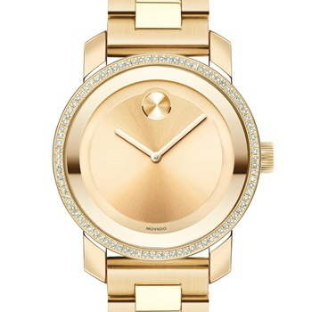

You can use Google Images Reverse Search to look for similar matches. Right click on the image, click "Copy Image URL," and then go to [images.google.com](http://images.google.com/" \t "_blank). Click on the camera icon in the search field, and it will prompt you for an image URL. Enter that URL, and then search! You will see that it locates your image in different places around the web and then offers you "visually similar images."

Sometimes you will get really lucky (like the results for this Movado watch were great), and sometimes reverse image search will be completely off. It just depends on the image that you feed it.

Google Reverse Image Search is also very helpful for finding higher-quality scene/episode/outfit stills.

**Resources of Specific Shows: Check out the FC Resources Goggle doc at: https://docs.google.com/document/d/1z\_S0qDlpRjF4Xx9gH-4o7W32yzvLt9j7UVCATlf6nHM/edit?usp=sharing**

**Sites that can help you format images (if you don’t use Photoshop)**

picmonkey.com

http://www.orbling.org/squareit/ - this is a square image generator. It will be most useful for product images for jewelry, shoes, hates, and pants.

CHECKLIST FOR PRODUCT VERIFICATIONS

Please make sure that each product entry contains all of the following:

1. All fields must be filled in. All “look-alike” items must be in stock with every field filled in. Exact matches may be missing price, source, or link. Please do your best to fill in as much as possible for exact matches.
   1. Brand
   2. Product Name (should NOT be in all caps)
   3. Description
   4. Colors (Please only try to add one color for an item if possible. Only use “multi” if a product has equal parts of 5 or more colors)  
      eg: If a shirt is blue with small white pin stripes, only enter blue as a color. It will not make sense if users search ‘white shirt’ and a blue shirt comes up. Only enter more than one color if half of the item or more is that color.
   5. Categories  
      Each product should only have one category. The categories work as branches so an item listed under ‘Female: cocktail dress’ will automatically be under ‘female:dress.” Do not enter both. Be as specific as possible.
   6. Image (do not leave blank!)
   7. Source (if price is unknown put 0.01) and status (in stock)
2. Image must be clear and undistorted.
3. Image must be centered, easily seen in a thumbnail view.
4. Images cannot contain borders.
5. Product may not be sourced from a second-hand or rental website. Etsy can only be used if thousands of those products are in stock. No Ebay please! Do not use our competitors as links in product sources (ie “get This TV” and “Pradux”)

**IMAGE QUALITY & SIZE REQUIREMENTS**

In parentheses is the number of (unique) photos you must upload to our database.

**SHOW & MOVIE IMAGES (2)**

First Image (Cover)

\_\_\_ Image is an official promotional picture

\_\_\_ Image can have the official show title/logo (not required)

\_\_\_ DIMENSIONS: 350x200

\_\_\_ RESOLUTION: 350px x 200px or higher, but **the larger the resolution, the better.**

Second Image (Poster)

\_\_\_ DIMENSIONS: 300x440

\_\_\_ Must be an official poster of the show (as appears on Netflix for example)

**CHARACTER IMAGES (2)**

First Image (Cover)

\_\_\_ DIMENSIONS: at least 1000px wide and at least 375px tall. Preferably of higher resolution.

\_\_\_ The ideal character photo starts at the tip of the character’s head and cuts off just below the shoulders.

\_\_\_ The photo is an official promotional picture from the show. Sometimes this is not available; then you should find a high-quality still containing JUST that character (no one else).

\_\_\_ Check ‘cover.’

Second Image (Thumbnail)

\_\_\_ DIMENSIONS: A perfect square.

\_\_\_ RESOLUTION: at least 500px x 500px resolution.

\_\_\_ The photo is an official promotional picture (a photoshoot photo)

\_\_\_ The photo contains just the head, neck, and top of the shoulder of the character (a headshot).

**EPISODE IMAGES (1)**

\_\_\_ Just one image is necessary

\_\_\_ PROPORTIONS: 650 x 350

\_\_\_ RESOLUTIONS: at least 800 x 430px. The higher the better, as long as the proportions are 65:35.

\_\_\_ Check ‘primary’ (very important).

\_\_\_ Image contains multiple characters

\_\_\_ Image serves as a good identifying representation for that episode

**OUTFIT IMAGES (1)**

\_\_\_ RESOLUTION: The higher the pixel resolution, the better. At least 400px wide and 400px tall.

\_\_\_ PROPORTIONS: A square with the character in the middle of the square. However, it is more important that the ***outfit image is taller than it is wide.***

\_\_\_ The image does not contain any words.

\_\_\_ Stills that show the whole outfit (ie full body) are preferred.

\_\_\_ The image shows more than just the actor’s face and shoulders.

\_\_\_ The image is not so dark that it is difficult to see the character and/or clothes in the image.

\_\_\_ The image is in JPG format.

\*\*Important Note: If you find an image on Google Search that is very rectangular (taller than it is wide), do NOT crop it into a square if it means losing part of the outfit. Simply upload the rectangular image into the database and allow our system to automatically generate a square crop of the image.

**SCENE IMAGES (1)**

\_\_\_ DIMENSIONS: 640 x 330

\_\_\_ RESOLUTION: at least 1000px wide.

\_\_\_ Has maximum number of characters possible

\_\_\_ Not blurry!

EXAMPLES OF UNAPPROVED IMAGES

*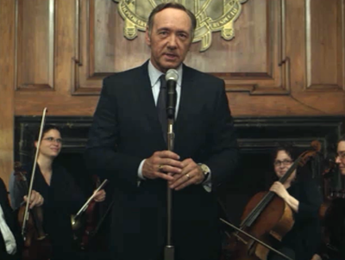*

THIS IMAGE IS WIDER THAN IT IS TALL.

*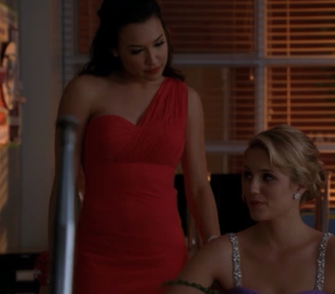*

THIS IMAGE IS TOO DARK.

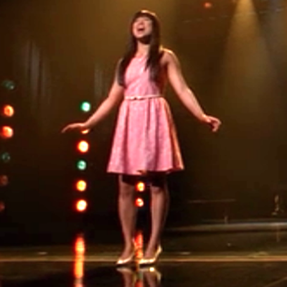

This image’s resolution is too low.

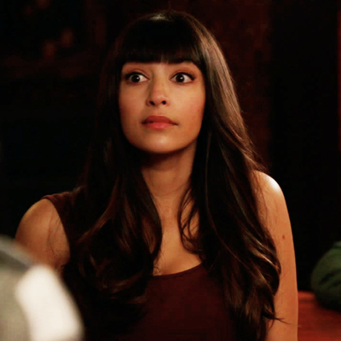

Not enough of the outfit is shown in this image.

**

*This image is watermarked. Though these dimensions are considered too rectangular, we do NOT want you to crop the image (cut off the bottom half of the outfit, for example) in order to make it a square. We would prefer if a) you checked to see if you could obtain an outfit image that is cropped closer to a square and includes just as much of the outfit OR b) you simply uploaded this image to the database without cropping. Though our code will automatically crop the image into a square, we will still have the raw image with the full outfit available for our use.*

Also, a shoe that is cropped like:

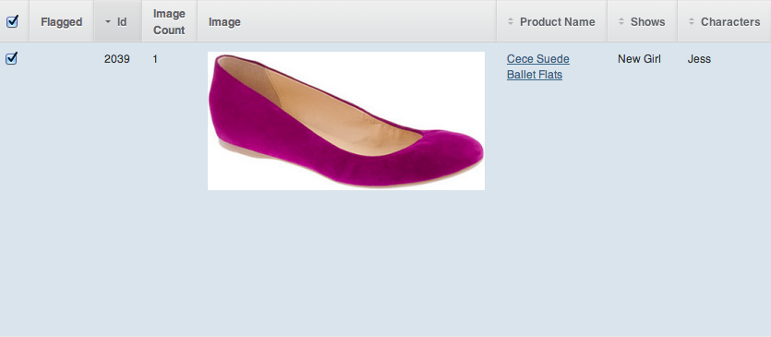

will show up like:

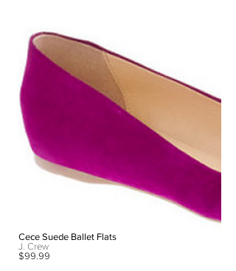

on the site. Please make sure your image is close to a square are you crop it!

**VERIFICATION**

If a check does not appear automatically under “Verified” for the item you enter, your entry is missing one of the following conditions needed for verification.

**Verified Episodes**

\_\_ Has a PRIMARY episode image

\_\_ Season

\_\_ Show

\_\_ Episode Number

\_\_ Name

\_\_ Has at least three approved outfits

**Verified Outfits**

\_\_ Has at least one *active* product

\_\_ Belongs to an episode

\_\_ Has a character

\_\_ Has at least one outfit image

**Verified Products**

\_\_ Name

\_\_ Product Image

\_\_ Brand

\_\_ Description

\_\_ Product Source (with valid store and a price that is not $0.00)

\_\_ Product Category

**Active Products**

\_\_ Verified

\_\_ Approved (by data manager)

**Verified Guest Characters**

\_\_ “Guest” is checked

\_\_ Character has a cover image

**Verified Main Characters**

\_\_ Has verified outfits

\_\_ Has a primary character image

\_\_ Name

\_\_ Has a PRIMARY character image (make sure for one of the images, primary is checked)

\_\_ Description is between 60 and 600 characters

\_\_ Show

**Verified Shows**

\_\_ Verified main characters

\_\_ Approved episodes

**THE APPROVAL PROCESS**

1. Data managers will approve/flag **ONLY VERIFIED ITEMS (ie verified outfits, verified products, verified characters)**. If your outfit is not verified, then the data manager will not approve the outfit. Data managers can approve/flag items in episodes that are not yet completed by the FC.
2. Once you have completed entering outfits for an episode, check if the episode is “verified,” and then mark “Fashion Consultant Completed.”
3. Once you have completed entering scenes with outfits, check if the episode is “verified,” and mark “Audio Sync Completed.”
4. The data manager will flag items and comment on them with the modification required. When one of your items is flagged, you will receive an email notification.
5. After you make a change, add a comment to the item: “FIXED.” A data manager will receive a notification that you have added a comment to the item. If the item has been successfully changed, the data manager will approve the item and remove the flag.
6. After the data manager approves your episode, Spylight will be responsible for delivering your payment based on the waged agreed upon. Once you are paid, the data manager will check “paid.”

**RECOMMENDATIONS FOR OBTAINING OUTFIT IMAGES**

1. Scan Google first for outfit images. Oftentimes the show’s official website (e.g. abc.go.com/shows/scandal/photos) will have very high quality episode stills.  
   TIP for Google Image Search: Use the SEARCH TOOLS > SIZE > LARGER THAN \_\_.

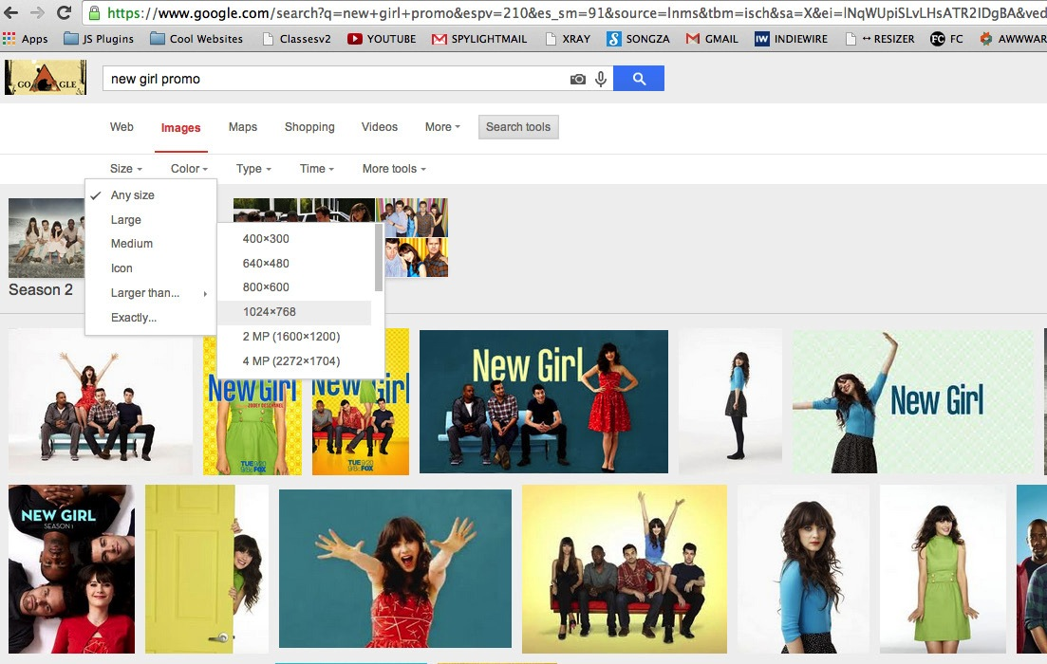

1. Fill in the gaps with screenshots (link to how-to here) from downloaded or streamed episodes.
   1. Downloading episodes is the preferred method of making stills. Keep in mind that screen captures do not work in iTunes downloaded content, so iTunes downloading is not an option. Downloaded content can be opened through the VLC player software (<http://www.videolan.org/vlc/>) or through Quicktime.
   2. Hulu + Netflix + Amazon HD are good streaming options.  
      HULU: When you pause, a transparent black overlay lies on top of the streaming show, so use (for Macs) CMD + SHIFT + 3 to capture the whole screen while the show is streaming and then crop the image down to the appropriate size (ideally 500 x 500 px).  
      NETFLIX + AMAZON HD: You should pause the episode, check to make sure the actor’s eyes aren’t closed and that the screencap will capture most of the outfit, and then use CMD + SHIFT + 4 to select just the character wearing the outfit (500x500px).
   3. This [link](http://sweeney32.blogspot.com/2012/02/how-to-make-screencaps-mac-pc.html) (http://sweeney32.blogspot.com/2012/02/how-to-make-screencaps-mac-pc.html) provides a full explanation for grabbing and editing screencaps. Please look over the resource thoroughly; it provides good advice (e.g. for editing photos that are too dark; for PC users)
2. ­­­If you are having a difficult time finding high quality outfit images, please make specific requests to [developers@spylight.com](mailto:developers@spylight.com) -- we may be able to secure some official studio stills for you.

**HOW TO SAVE RAW PRODUCT IMAGES FROM RETAILER SITES**

1. Use the Chrome browser. If you do not have it downloaded, please download it [here](https://www.google.com/intl/en/chrome/browser/).
2. Let’s take a Nordstrom example. You’ve arrived [here](http://shop.nordstrom.com/s/vince-camuto-windetta-boot/3516196?origin=category-personalizedsort&contextualcategoryid=0&fashionColor=Black&resultback=0&cm_sp=personalizedsort-_-browseresults-_-1_1_B). First, check the image size that you see. If it is smaller than about 500 x 500 px, go to step 3. If it is larger than about 500x500px, check if “Save Image As” appears as an option when you right click it. If the option appears, save the image, and you are done. If the option does not appear, go to step 3.
3. On Chrome’s navigation bar, click VIEW > DEVELOPER > DEVELOPER TOOLS (or the shortcut, alt/option + cmd + I). Click on the RESOURCES tab in the small window that appears. Click the folder FRAMES, and keep opening up the folder until the folder IMAGES appears. Browse through the images until you find the largest image of the boot available. Click on the URL that is provided underneath the product (see below for an example), right click on the image in the new page, and click “Save Image As.” You are done! ­

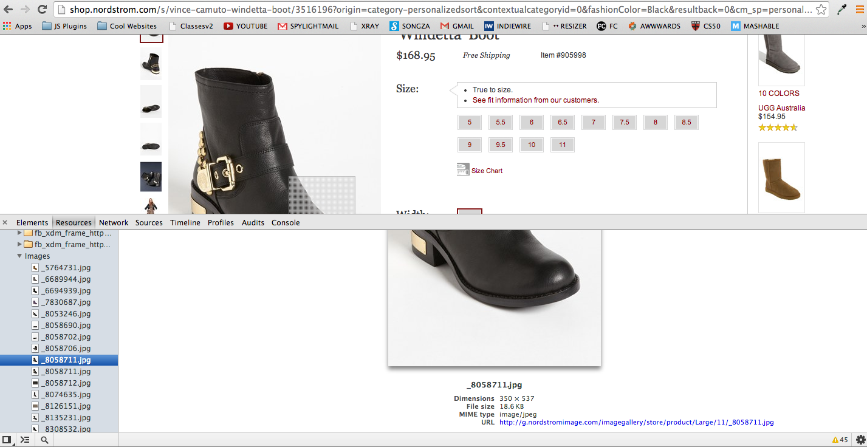

**** List of Product Categories

*All categories below are “Product Categories,” so you can assign any (even the ones in bold) to a product. Please be as specific as possible with your categorization of products. Product categories are sometimes displayed twice, under different groupings.*

Men

**~~Tie~~**

*Necktie*

*Bow Tie*

*Pocket Square*

*Tie Bar*

***Bag***

*Computer Bag*

*Briefcase*

*Messenger Bag*

*Backpack*

Duffel Bag

***Wallet***

*Card Case*

*Money Clip*

*Key Chain*

***Belt***

***Suspenders***

***Watch***

***Hat***

**Glove**

**Scarf**

***Cufflinks***

***Jewelry***

***Shoe***

*Boots*

*Dress Shoe*

*Loafers*

*Drivers*

*Oxfords*

*Slippers*

*Sneakers*

***Coat***

***Jacket***

*Vest*

*Rainwear*

*Leather Jacket*

*Puffer*

***Denim***

­

***Polo***

***Shirt***

***Sport Shirt***

***Dress Shirt***

***Pants***

*Active & Lounge Pants*

*Cargo Pants*

*Khaki Pants*

*Chino Pants*

*Corduroy Pants*

*Dress Pants*

***Shorts***

*Swim Shorts*

***Suit***

*Sport Coat*

***Sweater***

*Hoodie*

*Cardigan*

*Crewneck*

*Half Zip*

*Shawl Collar*

*Turtleneck*

*Vest*

*V-Neck*

***Tee***

***Sweatshirt***

*Long-Sleeve Tee*

*Short-Sleeve Tee*

*Tank Top*

***Underwear***

*Boxer*

*Boxer Brief*

*Brief*

*Jock Strap*

*Robe*

*Sleepwear*

*Undershirt*

***Socks***

***Glasses***

*Sunglasses*

Neutral

*Diaper Bag*

Women

***Blazer***

***Jacket***

*Jean Jacket*

*Leather Jacket*

*Vest*

***Coat***

*Rainwear*

*Puffer*

*Trench Coat*

***Denim***

*Skinny Jeans*

*Bootcut Jeans*

*Straight Jeans*

*Denim Shorts*

*Denim Skirts*

*Denim Jacket*

*Denim Vest*

*Flare Jeans*

***Dress***

*Day Dress*

*Evening Dress*

*Cocktail Dress*

***Lingerie***

***Bra***

*Panties*

*Shapewear*

*Camisole*

*Slip*

*Chemise*

***Activewear***

*Sports Bra*

*Tee*

*Active Jacket*

*Sports Pants*

*Sports Leggings*

*Sweatshirt*

***Suit***

***Pants***

*Sports Pants*

*Sports Leggings*

*Skinny Pants*

*Bootcut Pants*

*Corduroy Pants*

*Flare Pants*

*Straight Pants*

*Capris*

*Shorts*

***Leggings***

***Skirt***

*Miniskirt*

***Shorts***

***Capris***

***Sleepwear***

*Chemise*

*Pajamas*

*Nightgown*

***Robe***

***Sweater***

*Cardigan*

*Crewneck sweater*

*Turtleneck sweater*

*V-Neck*

***Swimsuit***

*One-piece Swimsuit*

*Bikini*

*Tankini*

***Cover Up***

***Tights***

***Socks***

***Hosiery***

***Tops***

*Tee*

*Tank Top*

Long-Sleeve Tee

*Short-Sleeve Tee*

*Sweatshirt*

***Shoe***

[*Boots*](http://www1.bloomingdales.com/catalog/index.ognc?CategoryID=19212&cm_sp=NAVIGATION-_-TOP_NAV-_-16961-SHOES-Boots)

[*Booties*](http://www1.bloomingdales.com/catalog/index.ognc?CategoryID=1000692&cm_sp=NAVIGATION-_-TOP_NAV-_-16961-SHOES-Booties)

[*Cold Weather & Rain Boots*](http://www1.bloomingdales.com/catalog/index.ognc?CategoryID=1000693&cm_sp=NAVIGATION-_-TOP_NAV-_-16961-SHOES-Cold-Weather-%26-Rain-Boots)

[*Flats*](http://www1.bloomingdales.com/catalog/index.ognc?CategoryID=16963&cm_sp=NAVIGATION-_-TOP_NAV-_-16961-SHOES-Flats)

[*Pumps*](http://www1.bloomingdales.com/catalog/index.ognc?CategoryID=17397&cm_sp=NAVIGATION-_-TOP_NAV-_-16961-SHOES-Pumps)

[*Sandals*](http://www1.bloomingdales.com/catalog/index.ognc?CategoryID=17398&cm_sp=NAVIGATION-_-TOP_NAV-_-16961-SHOES-Sandals)

[*Slippers*](http://www1.bloomingdales.com/catalog/index.ognc?CategoryID=17399&cm_sp=NAVIGATION-_-TOP_NAV-_-16961-SHOES-Slippers)

[*Sneakers*](http://www1.bloomingdales.com/catalog/index.ognc?CategoryID=17400&cm_sp=NAVIGATION-_-TOP_NAV-_-16961-SHOES-Sneakers)

*[Wedges](http://www1.bloomingdales.com/catalog/index.ognc?CategoryID=17402&cm_sp=NAVIGATION-_-TOP_NAV-_-16961-SHOES-Wedges-%26-Espadrilles)*

*[Espadrilles](http://www1.bloomingdales.com/catalog/index.ognc?CategoryID=17402&cm_sp=NAVIGATION-_-TOP_NAV-_-16961-SHOES-Wedges-%26-Espadrilles)*

***Bags***

[*Clutches*](http://www1.bloomingdales.com/catalog/index.ognc?CategoryID=17309&cm_sp=NAVIGATION-_-TOP_NAV-_-16958-HANDBAGS-Clutches)

*Crossbody Bag*

*Mini Bag*

[*Hobos*](http://www1.bloomingdales.com/catalog/index.ognc?CategoryID=17311&cm_sp=NAVIGATION-_-TOP_NAV-_-16958-HANDBAGS-Hobos)

*Satchel*

*Shoulder Bag*

*Tote Bag*

[*Travel*](http://www1.bloomingdales.com/catalog/index.ognc?CategoryID=1000369&cm_sp=NAVIGATION-_-TOP_NAV-_-16958-HANDBAGS-Travel) *Bag*

***Accessories***

*Watch*

***Jewelry***

*Bracelet*

*Earring*

*Necklace*

*Ring*

*Charm*

*Diamond*

***Glasses***

*Sunglasses*

*Scarf*

*Tights*

*Socks*

*Hosiery*

*Hat*