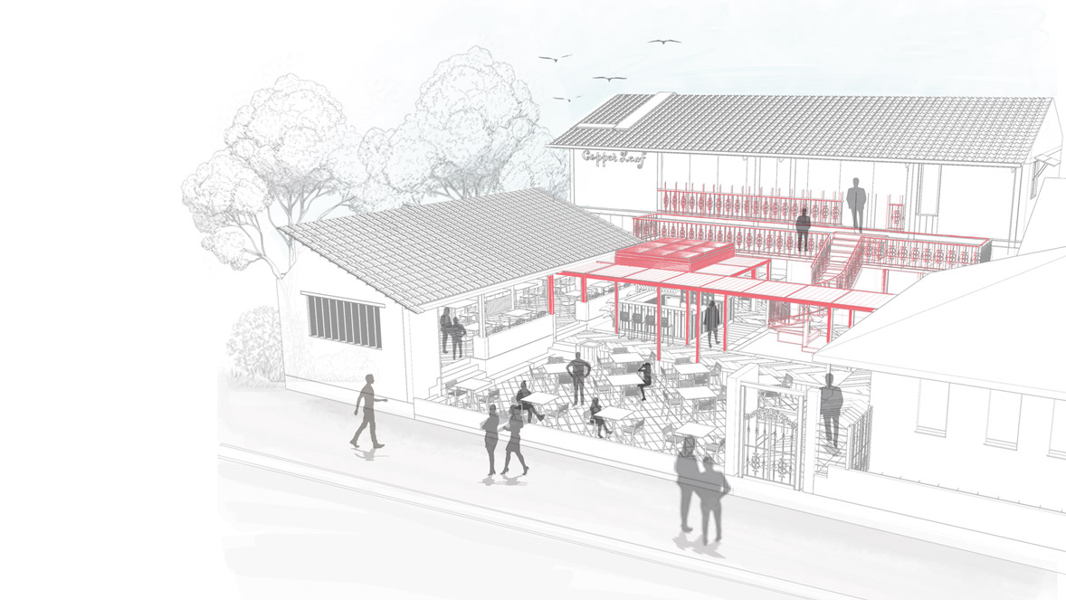

**THE BACKYARD REVIVAL**

A MULTICUISINE RESTAURANT

PROJECT TYPE: LIVE PROJECT

MENTOR: MADHURI GULABANI

DATE: SPRING 2024

LOCATION: INDIA

TEAM MEMBERS: AISHWARYA, SIMRAN

The restaurant has been revitalized through a thoughtful renovation that transforms its once-neglected backyard into the focal point of space. This area now features an open-air courtyard with outdoor seating, framed by multiple fine dining zones—including dedicated family seating, a smoking area, a bar counter, and a striking spiral staircase. A pergola with integrated glass elements provides a cohesive connection between these spaces. The spiral staircase leads to the first floor, which is exclusively designed for family dining.

