BaDCaT wifi modem


Brief Documentation

Ensure your computer is OFF before inserting the cartridge!

1. Introduction

BaDCaT, is a WiFi modem to connect our MSX computers to the Internet. The main goal was to reduce Z80 CPU load as much as possible with the addition of external hardware in the same cartridge for TCP/IP processing. On the other hand to be able to work on MSX1 computers even with low RAM. All this process is carried out by an ESP8266 integrated circuit, specifically the ESP12 version with 4MB of flash memory.
The cartridge consists of an UART 16C550C which implements an RS232 port as interface between ESP12 and the MSX bus. It also provides an standard serial port to the MSX. In short, we could say that this cartridge features two working modes:
- MSX1: both the TCP/IP stack and telnet client run on the cartridge. The computer would only run a terminal program.
- MSX2 and higher: the TCP/IP stack runs on cartridge and telnet client on the MSX. To do this, the ducasp's telnet version has been modified in order to offer the same functionality with the WiFi modem and UNAPI interfaces. This telnet version is already available on ducasp's Github.
Technical specifications:
- MSX1/MSX2 (and higher) compatible.
- Serial port up to 115200 bps.
- RTS/CTS flow control.
- Fossil driver compatible (without any modification).
- ESP12 modem based on zimodem, effective speed of 57600 bps.
- ducasp's telnet compatible and with all its functionalities (fast ANSI decoding, files download...)
- Possibility of running telnet client on the cartridge itself.
- Upgradable firmware.

2. Initial Set-up

Configure your wifi network

1. With your BadCAT inserted in the slot, ensure that the wifi switch is turned on as indicated in Figure 1 (to the left).
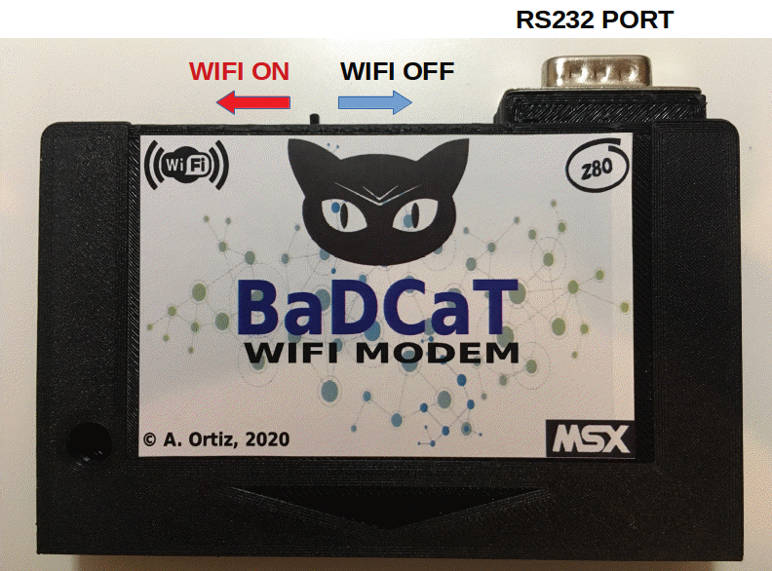

Figure 1. BaDCaT cartridge

2. Load the terminal program
a) In MSX1, bload the bdterm.bin program.
b) In MSX2 and higher, load the Fossil Driver and then the Ducasp Telnet without any parameter:
a> driver
a> telnet

3. With the terminal program running, type atz. The BaDCaT should respond “OK” indicating that it is working and ready to receive commands (command mode).

4. Configure your wifi network by the config menu:
· Type at+config and press ENTER
· The configuration menu will appear. Then, type wifi and press ENTER
· Wait for a while until the received wifi networks appear
· Chose a wifi network
· Type the password of the wifi network and press ENTER
· Press ENTER again and say “yes” to store the changes. After a while, this will exit the config mode and return to command mode

5. In command mode, you can see your wifi network and the assigned IP by typing ATI and pressing ENTER.

6. Alternatively, you can type help and press ENTER to see a help text

3. Connect to a BBS

In this example we will connect to sotanomsxbbs.org using a telnet

1. In command mode, use:

a) MSX1. From BDTERM, type ATDT “sotanomsxbbs.org:23”. Then chose the appropiate BBS profile. Remember that ANSI is not supported in MSX1.
b) MSX2. From the ducasp telnet, type ATD “sotanomsxbbs.org:23”. Then chose the appropiate BBS profile (ANSI, MSDOS character set). Alternatively, you can run the ducasp telnet directly with the url of the bbs (remember… Fossil driver has to be previously loaded!. Otherwise the telnet will advert you and exit)

a> telnet sotanomsxbbs.org 23

4. Filesystem management (from v1.3)

BaDCaT provides some basic commands to manage the local filesystem in the ESP’s flash. These commands are:

a) lfiles. Show the files in the storage system and the current free space.
b) delete <filename> . Remove a file from the local storage.
c) dload <file> . Downloads a file from the internet repository to the local storage.

4.1. Configuration of the local repository

1. From the command line, type ATZ and press ENTER to ensure the BaDCaT is ready. “OK” should appear.
2. Type at+config and press ENTER
3. Type repo and press enter
4. Enter the repository’s url and press ENTER. Only http (not https) is supported.
5. Press ENTER again and accept to store changes.

5. OTA updates (from v1.3)

It is possible to upgrade BaDCaT directly from the Internet.

1. In command mode, type at&u
2. The version of the latest available firmware will appear
3. To upgrade, type at&u=<version> and press ENTER (eg. at&u=1.3)
4. This will take some time. After that, the BaDCaT will reboot and show the upgraded firmware (you can check it with the ATI command)

*** Downgrading below v1.3 will disable OTA updates!

6. Load ROMs up to 32 KB (experimental)

This functionality is present from v.1.3 and only works using the DBTERM client.

These commands can be used to load roms from the local storage or from Internet.
1. lfiles. Show the files in the local storage
2. load <file> . Load a ROM (don’t forget the full path! i.e. load /your_rom.rom)
3. rfiles. Show the files in the internet repository. You can use your own repository!. Be sure that a file called “filelist.txt” is in the repository’s root folder. This filename will contain the files in the repository as well as their length in the following format:

file_1.rom<TAB><TAB> size
file_2.rom<TAB><TAB> size
·
·
file_n.rom<TAB><TAB> size

4. dload <file> . Download a file to the local storage
5. rload <file> load a ROM directly from the Internet repository

7. RS232 Port

BaDCaT provides a standard RS232 port, mapped at 0x80 IO port to provide compatibility with standard software such as Eric Maas Fossil driver.
To use the RS232 port, the wifi switch MUST BE IN THE OFF POSITION!!

Hereafter, standard software can be used. Eric Maas ERIX terminal, is recommended, which works with his Fossil driver.

Note that this command will read the filelist.txt text file from the repository

