Right whale recognition using convolutional neural networks

Andrei Polzounov, Ilmira Terpugova, Deividas Skiparis, Andrei Mihai

{andrei.polzounov, ilmira.terpugova, deividas.skiparis, andrei.mihai}@est.fib.upc.edu

Facultat d'Informàtica de Barcelona, Universitat Politècnica de Catalunya

# Abstract

We studied the feasibility of recognizing individual right whales (Eubalaena glacialis) using convolutional neural networks. Prior studies have shown that CNNs can be used in wide range of classification and categorization tasks such as automated human face recognition. To test applicability of deep learning to whale recognition we have developed several models based on best practices from literature. Here, we describe the performance of the models. We conclude that machine recognition of whales is feasible and comment on the difficulty of the problem.

Keywords: Eubalaena glacialis, convolutional neural networks, deep learning, whale recognition

# Introduction

There are fewer than 500 North Atlantic right whales (Eubalaena glacialis) remaining in the world (Fujiwara and Caswell [9]). The species is highly endangered and is considered as such by the U.S. and Canadian governments. Recognizing individual whale specimens is important if we are to help the species recover to sustainability. Recognizing individual specimens from shipborne or helicopter imagery is a tedious task for marine biologists. Convolutional neural networks are quickly becoming the tool of choice for automated image recognition and classification [1, 2, 3, 4, 5, 6].To the best of our knowledge automated “face” recognition techniques have not previously been proposed for recognizing right whales. In this report we summarize our analysis of using convolutional neural networks to recognize individual North Atlantic right whales.

# Convolutional Neural Networks

In the last few years deep convolutional neural networks (CNN) have been seeing an explosion in literature and on the internet. They differ from traditional networks by making the explicit assumption that the input data is an image. This allows convolutional networks draw another inspiration from nature – receptive fields of vision. The deep network can focus on specific parts of the image using a convolution.

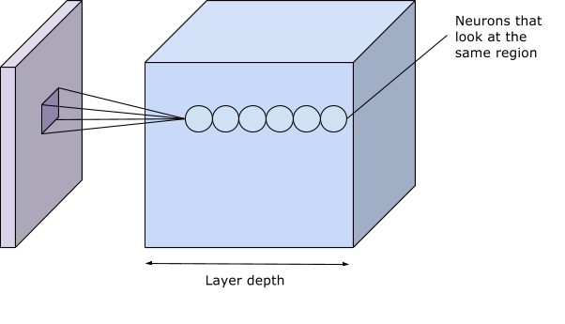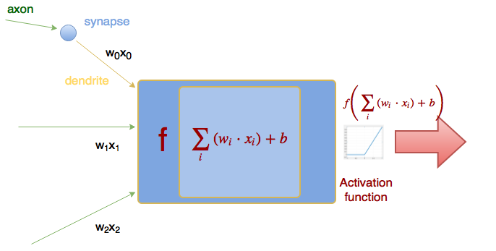

Figure 1: Receptive field of the neurons in CNN (l**eft**) combined with the traditional neuron activation mechanism (r**ight**).

CNNs consist of convolutional layers – which act as receptive fields, followed by pooling layers – which decrease the amount of features and pixels the next convolutional and pooling layers can focus on. These convolutional and pooling layers are stacked many times until finally connected to a classical neural network (named fully connected in deep learning literature) with some hidden layers and then finally the output layer as the classifier.

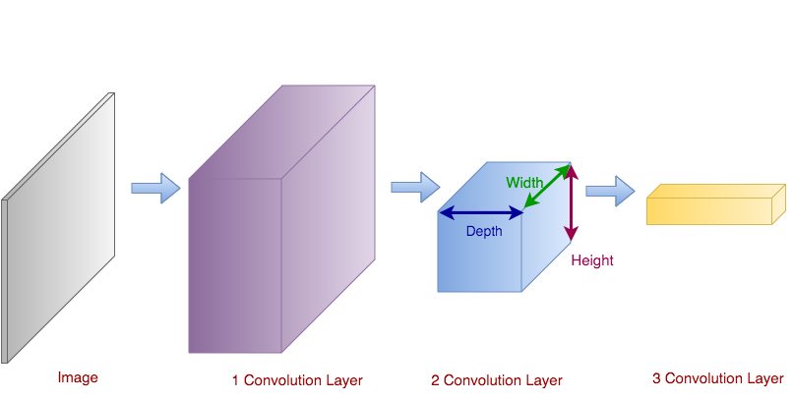

Figure : CNNs arrange the neurons in 3 Dimensions (width, height and depth)

Theoretically recognizable features should be close to each other – this allows to create CNN receptive fields using fully-connected neural network in which the first neuron layer is connected to every single pixel of the image. This will potentially result in a higher descriptive ability of the network at the cost of greatly increased complexity. Also the neural network will not exploit the fact that pixels very far from each other are not likely to be part of the same feature. See Appendix A for more CNN theory.

## *Successful Applications of Deep Networks*

Deep networks have been very successful in classifying many different kinds of objects. Some of the best networks are able to classify as many as 22000 different categories learned from a set of 15 million images (Krizhevsky et al [1] and Russakovsky et al [6]). Despite highly optimized code and 3 high performance video cards – the ImageNet network takes about 5 days to train according to the authors [1].

Another very successful network is outlined in a paper from Google – the GoogLeNet [2]. It employs many classical computer vision techniques along with the raw computational power of CNN. Some of the novel techniques utilized in the architecture from Google are using stacks of very small convolutional kernels instead of larger kernels. Smaller kernels are easier to train individually and when stacked they can provide the same discrimination of features as larger filter. These small kernels are further popularized by the work of Simonyan and Zisserman [4] and are in fact what the winners of this Kaggle challenge used [18] to classify the right whales.

# Preprocessing of imagery

## *Expected features for detecting individual whales*

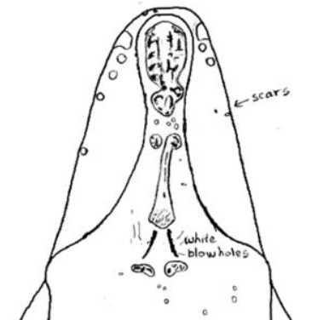

Figure : Unique callosity pattern of an individual whale specimen (NOAA Fisheries Whale Catalog, 1997 [8])

The feature that we are most interested is called the callosity pattern which includes the facial markings on top of the head of the whale and the white markings above the blowholes. These features are unique to each whale. Some of the features that we decided to ignore were the shape of the tail, dorsal fins and side flippers which may also have been useful, but would have increased the complexity of the detection.

# The dataset

From the original dataset [8] of 11469 images only 4542 images were labeled; the labels included 427 unique individuals. Some of the labels only included a single image of the whale. To limit training time we extracted a new dataset – α-whales from the labeled data. Taking only specimens which have 20 or more labeled images, this gave us a set of 924 images of 38 unique whales, which is what we based our classifier on.

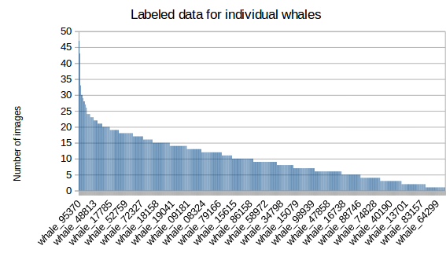

Figure : Histogram of label distribution in original Kaggle data

## *Dataset Preprocessing*

The raw images from the dataset were a very large resolution. Operating on such images would require massive processing power. In addition much of the visible area of each image was taken up by the water. A large amount of noise with respect to the ROI (region of interest) was added by the waves and splashes around the whale.

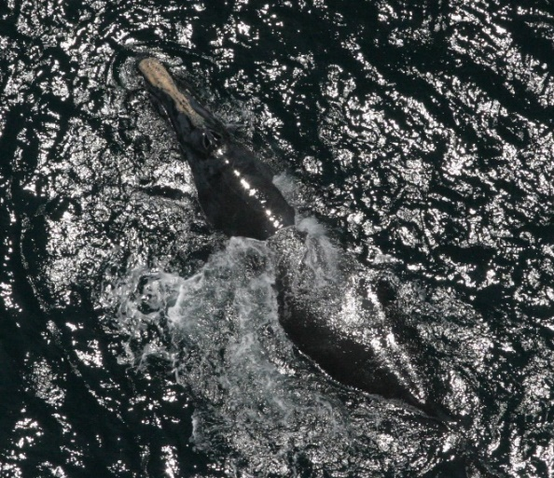

Figure : Example of noise from waves and splashes

To preprocess the data we had tried to segment the ROI of the whale from the water. We managed to discard the majority of the water pixels by segmenting on the histogram of the saturation channel of the image.

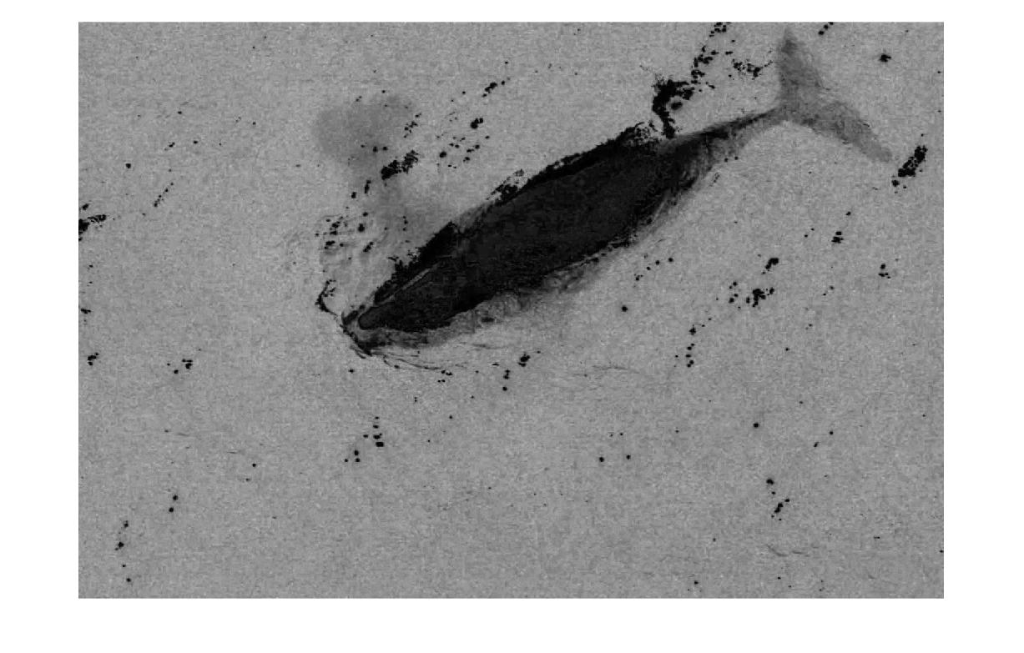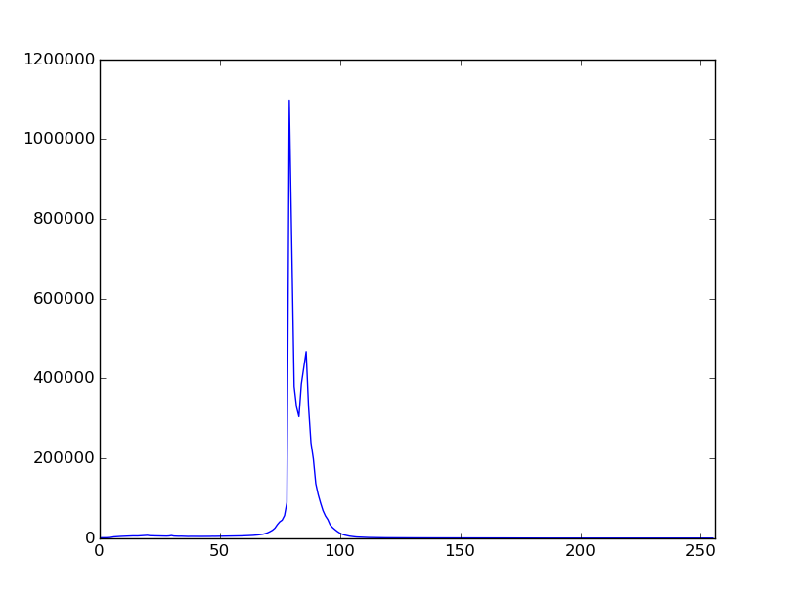

Figure : Saturation from HSV and histogram of saturation channel

Ideally the saturation histogram should have two visible peaks (as above). We can threshold the image using the minima that can be found between the two local maxima points – which leaves us with the pixels corresponding to the whale and the surrounding noisy pixels of waves/splashes.

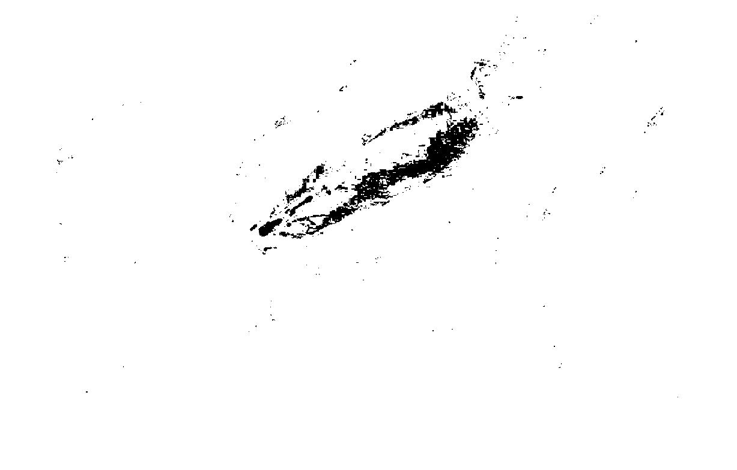

Figure : Extracted mask of ROI from thresholding the saturation channel

Using this ROI polygon we can detect the direction of whale inscribing an ellipse into ROI polygon. Knowing the angle of rotation from major axis of polygon we can use an affine transformation to rotate the image.

The entire process works well about 80% of the time. But even in the successful runs of the preprocessor we were left with the problem of not knowing whether the whale was facing up or down – which mean that we could not further crop out the remainder of the whales body since the face is the most interesting feature.

Since we were not able to reliably preprocess the raw images using conventional CV (computer vision) techniques we turned to manual preprocessing of what we desired the output to be:

* Rotate the image to have the whale facing right.
* Cut out a square area with the whale dead center.
* Resize image to 256x256

These steps ensured that we obtained the “passport” photos of that the CV preprocessor should have made.

# Experiments with CNN models

As part of the project we have evaluated many different CNN models. The biggest constraint of trying new models and tuning the associated hyper-parameters were training time, processing power and lack of sufficient computer memory. Due to design of Google TensorFlow a large chunk of memory is pre-allocated to be used in its computation graph [20]. None of our models could fit into 2 GB GPU memory that was available, which could have provided a huge speedup over training on CPU.

Model topology diagrams can be found in Appendix B.

1. DumbNet – our first model (retroactively named DumbNet) was completely of our own design. It consisted of 5 convolutions each followed by a pooling layer. The model relied too much on pooling (after every convolution) and many of the neurons died out from over-saturation. We concluded that the model was not complex enough as it failed to converge while training.
2. AlexNet (Krizhevsky et al [1]) – the network was difficult to work with due to the non-standard convolution and pooling layers which changed the size of the output image in a way very different from other networks. This network did not converge either.
3. VGGNet (Simonyan and Zisserman [4]) –the net operates on the use of small stacked convolutions with fewer pooling layers in between. The authors argue that a stack of three 3x3 convolutions activated by ReLU (rectified linear unit) [ref: relu] activations can be more discriminative than a single 7x7 convolution. The problem we experienced with our interpretation of the VGG network was of the massive computational cost of running it. The network consists of 13 convolutional layers, 5 pooling layers and 2 wide fully connected layers before finally coming to the classifier neuron layer. Our computers were not able to reasonably run the network.
4. DeepSenseNet – this network was inspired by the winner of this Kaggle competition [19]. The authors must have themselves drawn inspiration from VGG as the network seems to be a simpler version of that one. We were able to obtain adequate results from our interpretation of this topology after about 12 hours of training. We used an exponentially decaying learning rate and local-response normalization [1] of the activation levels of every convolutional layer. The results were over-fit to the training data with about 80% classification accuracy on the training set and 15% on the validation set. However the result was enough to prove statistical significance of the classifier.

# Results

To set the baseline for neural networks, k – nearest neighbor (kNN) [12] classifier with cropped images has been used. The cropped and rotates containing only the nose of the whale were used (image size 256 x 256. See dataset preprocessing section for details).

Firstly kNN classification was applied to raw feature vectors i.e. vector of unrolled image pixel values. A number of different k values have been used, namely k=1, 3 and 5. Euclidean distance was used as a measure of similarity. The same train + validation data split as for CNN has been used with the kNN classifier to ensure that the results would be comparable.

The accuracy achieved with this setup was relatively poor – the best accuracy was for k=1. Full table below.

In order to improve accuracy of the naïve kNN classifier we have also implemented PCA (principal component analysis) (Jolliffe [13]) and LDA (linear discriminant analysis) algorithms [14, 15] to reduce feature size before comparison. Lastly we changed the distance metric from Euclidean to Chebyshev distance to obtain better kNN results. See Appendix A for in depth analysis of PCA, LDA and kNN.

Below is the full table of kNN classification results:

|  |  |  |  |  |
| --- | --- | --- | --- | --- |
|  | | | | |
| **k** | **RAW** | **PCA** | **PCA+LDA** | **PCA+LDA (Chebyshev)** |
| k=1 | 0.2097 | 0.2419 | 0.5726 | 0.5968 |
| k=3 | 0.1290 | 0.1371 | 0.5484 | 0.6048 |
| k=5 | 0.1290 | 0.1452 | 0.5242 | 0.6129 |

Figure : kNN classification results. #Runs = 20 per k

TODO: results of CNN

|  |  |  |  |  |  |  |
| --- | --- | --- | --- | --- | --- | --- |
| Network | Learning rate (starting) | Dropout | Batch size | Norm | Min cross-entropy | Validation acc |
| DumbNet | 10-3 | 0 | 20 | LRN | 621.7 | not converge |
|  | 10-4 | 0 | 20 | LRN | 621.7 | not converge |
|  | 10-5 | 0 | 20 | LRN |  | not converge |
|  | 10-4 | 0 | 10 | L2 | 214.3 | not converge |
|  | 10-4 | 0 | 10 | LRN | 310.8 | not converge |
| DumbNetSimple | 10-4 | 0 | 10 | LRN | 28.5 | 7.3% |
| AlexNet | 10-4 | 0 | 10 | LRN | 230.3 | not converge |
|  | 10-5 | 0 | 10 | LRN | 207.2 | not converge |
| VggNet | 10-4 | 0.5 | 10 | - | - | out of memory |
| VggLikeNet | 10-4 | 0 | 20 | LRN | 656.2 | not converge |
| DeepSenseNet | 10-4 | 0 | 20 | L2 |  |  |
|  | 10-4 | 0.5 | 20 | LRN |  |  |
|  | 10-4 | 0.5 | 20 | L2 |  |  |
|  | 10-4 | 0 | 20 | LRN | 138.9 | 15.3% |

# Analysis

## *Successes*

We can demonstrate that for simple problems such as the MNIST handwritten digit recognition (Le Cun et al [5]) (see Appendix E for our results applied to the MNIST problem), we can easily outperform the naive kNN approach using a CNN. Even though we have failed to demonstrate better performance classifying our α-whales dataset using a CNN vs the kNN we can still produce statistically significant results of about 0.15 classification accuracy on the validation set. This is much greater than a random guess of 1/38 = 0.0263, but not as high as the 0.2 value from kNN.

We have been able to show that many of the filters that we trained with our convolutional layers are in fact detecting the callosity patterns of the whales with different levels of activations (close to zero or closer to one) and with different types of filters. Some of the filters act as high pass filters – which act edge detectors and some as low pass smoothing filters.

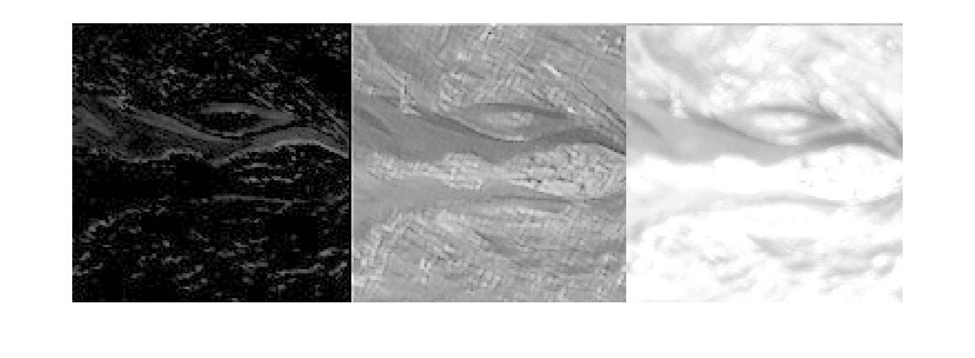

Figure : Output of a sample neuron layer.

1. High pass filter. Low activation levels overall (close to zero mean) does not show the callosity pattern at all and the activated patterns are mostly noise from the waves. Perhaps the outline of the whale could be useful to deeper layers.
2. Low pass filter. Average activation levels (as seen by the gray levels), very clear callosity pattern and the features from the waves have been smoothed.
3. Low pass filter. Very high overall activation. Similar features to (b) with a good callosity pattern but with slightly more noise – this filter is probably still useful.

Another success of the project is to note that we have qualitatively verified that stacks of small convolutions such as the ones proposed by (Szegedy et al [2], Simonyan and Zisserman [4]) are easier to work with and converge much faster than networks with large convolution kernels. We suspect that many successful projects in the short term will adopt a similar approach, in fact the winner of the Kaggle competition – Deep Sense used a simplified VGG net [19].

## *Shortcomings*

Our DeepSenseNet was overfit to the training data, this can be easily interpreted from the high classification accuracy on the training set and low accuracy on validation data. Another major problem is the arbitrary validation set, we did not use k fold cross-validation as it would have required multiplying the already long training time by a factor of k. Furthermore, we have observed saturation in some of the convolutional layers even after normalizing each one of them.

Each one of the squares in the above image corresponds to a feature detected by a feature in the conv net. Many of the squares are completely black meaning the neurons are dead and cannot be brought back even with very strong multipliers. This is because of a known property of the ReLU activation function of multiplying negative result by zero (Nair and Hinton [11]). Other activation functions have other downsides that were also considered during the design phase of this project. For further discussion of training convolutional filters see Appendix C.



Figure : Saliency maps of two distinct images

To analyze the features that our network was learning from, we drew a saliency map of a sample image. The map can be interpreted as a heat map with cold (blue) pixels contributing less to feature classification than the hot (red) pixels. The results were disappointing as the hot areas of the saliency maps were showing that noisy areas were contributing more to classification than the desired features. For a further discussion on saliency maps see Appendix C.

# Possible Improvements

## *Preprocessing*

We were unable to perfect our preprocessing algorithms using conventional computer vision techniques. A solution to utilize computational intelligence to the whale detector. We could take the full set of 11000 images and manually tag the location of the whales head on some of them. Using this supervised data a “whale-head-detector” can be trained. This algorithm combined with our working rotation algorithm will result in a whale that is roughly aligned to the horizontal axis. At this point the whale will be facing either left or right and another classifier can be trained to flip the images to their correct orientation.

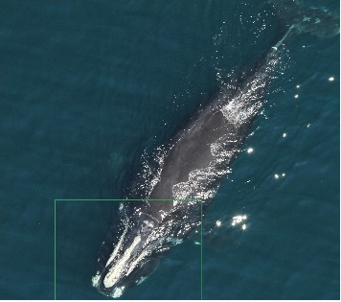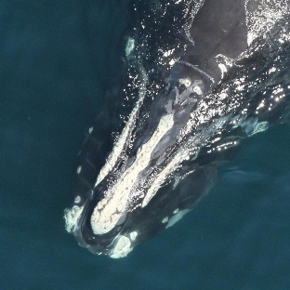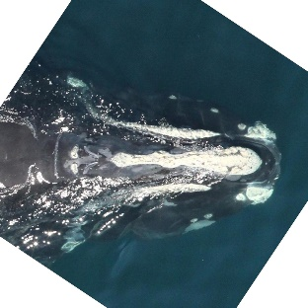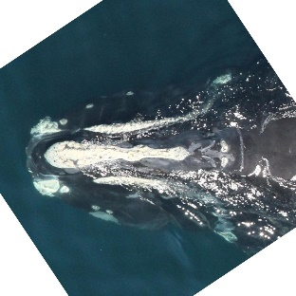

Figure : Proposed whale image preprocessing system

This working preprocessor can then be run on the full set of data – labeled and unlabeled. Ideally this larger dataset should be more trainable without overfitting the data then our α-whales dataset.

## Augmenting the training data

After obtaining the full training data we would be left with 4500 labeled images of 427 whales – still not enough data to detect some of the whales. We can expand the labeled images set using some augmentation techniques. For every image we would run it through some filters which are meant to signify the variance between the images of the set and then use filter outputs as additional training data. Some of the filters we would use: low pass filter (smoothing), high pass filter (edge detection or sharpening) and various affine transforms such as rotation about the horizontal axis, scaling and pixel-wise shift.

## Improved hardware

A huge weakness of our project was the lack of cross validation and the constraints imposed on us not being able to train more complex networks in a reasonable amount of time. Training on a video card with a large amount of memory or on the cloud would enable us to iterate through hypothesis much faster.

# Conclusion

We have confirmed that CNNs classify images that pose significant difficulty to untrained humans. While the results were less than ideal they were sufficient to show the feasibility of the solution. We conclude that the problem is too computationally intensive to solve using unprocessed imagery. Therefore we propose a way of chaining machine learning driven preprocessing system. We have compared many different neural topologies and we concur with the trend in literature of using small kerneled stacked convolutions. Ultimately we must note that the heavy computational requirements remain a limiting factor for the usefulness of deep learning techniques in image recognition.

# References

1. Krizhevsky, A., Sutskever, I., & Hinton, G. E. (2012). Imagenet classification with deep convolutional neural networks. In *Advances in neural information processing systems* (pp. 1097-1105).
2. Szegedy, C., Liu, W., Jia, Y., Sermanet, P., Reed, S., Anguelov, D., & Rabinovich, A. (2014). Going deeper with convolutions. *arXiv preprint arXiv:1409.4842*.
3. Mahendran, A., & Vedaldi, A. (2014). Understanding deep image representations by inverting them. *arXiv preprint arXiv:1412.0035*.
4. Simonyan, K., & Zisserman, A. (2014). Very deep convolutional networks for large-scale image recognition. *arXiv preprint arXiv:1409.1556*.
5. Le Cun, B. B., Denker, J. S., Henderson, D., Howard, R. E., Hubbard, W., & Jackel, L. D. (1990). Handwritten digit recognition with a back-propagation network. In *Advances in neural information processing systems*.
6. Russakovsky, O., Deng, J., Su, H., Krause, J., Satheesh, S., Ma, S., ... & Berg, A. C. (2014). Imagenet large scale visual recognition challenge. *International Journal of Computer Vision*, 1-42.
7. Lindeberg, T. (2013). A computational theory of visual receptive fields. *Biological cybernetics*, *107*(6), 589-635.
8. North Atlantic Right Whale Catalog. (1997). Retrieved December 27, 2015, from http://rwcatalog.neaq.org

Piccardi, Massimo. "Background subtraction techniques: a review." *Systems, man and cybernetics, 2004 IEEE international conference on*. Vol. 4. IEEE, 2004.

1. Fujiwara, M., & Caswell, H. (2001). Demography of the endangered North Atlantic right whale. *Nature*, *414*(6863), 537-541.
2. Srivastava, N., Hinton, G., Krizhevsky, A., Sutskever, I., & Salakhutdinov, R. (2014). Dropout: A simple way to prevent neural networks from overfitting. *The Journal of Machine Learning Research*, *15*(1), 1929-1958.
3. Nair, V., & Hinton, G. E. (2010). Rectified linear units improve restricted boltzmann machines. In Proceedings of the 27th International Conference on Machine Learning (ICML-10) (pp. 807-814).
4. Coomans, D., & Massart, D. L. (1982). Alternative k-nearest neighbour rules in supervised pattern recognition: Part 1. k-Nearest neighbour classification by using alternative voting rules. Analytica Chimica Acta, 136, 15-27.
5. Jolliffe, I. (2002). Principal component analysis. John Wiley & Sons, Ltd.
6. Ji, S., & Ye, J. (2008). Generalized linear discriminant analysis: a unified framework and efficient model selection. Neural Networks, IEEE Transactions on, 19(10), 1768-1782.
7. Martínez, A. M., & Kak, A. C. (2001). Pca versus lda. Pattern Analysis and Machine Intelligence, IEEE Transactions on, 23(2), 228-233.
8. Mitchell, T. (1997). *Machine Learning*. New York: McGraw-Hill.
9. Kingma, D., & Ba, J. (2014). Adam: A method for stochastic optimization. *arXiv preprint arXiv:1412.6980*.
10. Bogucki, R. (2016, January 16). Which whale is it, anyway? Face recognition for right whales using deep learning | deepsense.io. Retrieved January 18, 2016, from http://deepsense.io/deep-learning-right-whale-recognition-kaggle/
11. Lau, F. (2016, January 6). Recognizing and Localizing Endangered Right Whales with Extremely Deep Neural Networks. Retrieved January 18, 2016, from http://felixlaumon.github.io/2015/01/08/kaggle-right-whale.html
12. Google. (n.d.). TensorFlow API Documentation. Retrieved January 21, 2016, from <https://www.tensorflow.org/versions/master/api_docs/index.html>