

**Android Project – WorldMap App**

**Project made by:**

**Alecu Andrada**

**CONTENT**

0. TABLE OF FIGURES 3

1. INTRODUCTION 4

1.1 Overview 4

1.2 Goals and objectives 4

1.3 General framework 4

2.DESCRIPTION OF THE SOLUTION 5

2.1 Description of scenario usage. 5

2.2 Description of functionalities 5

2.1.1 Login 5

2.2.2 Main Activities 5

3. SYSTEM IMPLEMENTATION 7

General technical requirements implemented: 7

3.1 User login 7

3.2 Shared Preferences 8

3.3 Passing an object with an intent 8

9

3.4 Processing images 9

3.5 Asynchronous tasks 9

3.5 Google maps API 10

4. CONCLUSIONS 11

5. BIBLIOGRAPHY 12

# 0. TABLE OF FIGURES

WorldMap Fragment 0‑1 5

Countries and Capitals 0‑2 5

Graph 0‑4 5

View Country 0‑3 5

Find out more Page 0‑6 6

Visited Countries 0‑5 6

SignIn Page 1‑0‑1 7

Register Page 1‑0‑2 7

Shared Preference Code 1‑0‑3 8

Passing Object Through Intent 1‑0‑4 8

Procced Image 1‑0‑5 9

Image Processing 1‑0‑6 9

GoogleMaps Activty 1‑7 10

# 1. INTRODUCTION

## 1.1 Overview

The ‘WorldMap” is a mobile application available to smartphone Android users. The application will allow users to accumulate more information about countries and capitals.

This document provides information on the requirements for the ‘WorldMap software application. Project goals, scope and definitions are given in the introduction. Design constraints and application environment are described in the following sections. Non-functional requirements are given to show the system features and expected user interaction.

The technical implementation of this project can be found at the end of the document. This document is designed to be beneficial for users, creators and for the final grade of the project. The development team was able to use it while developing the software system to ensure that the user receives the expected product.

## 1.2 Goals and objectives

‘WorldMap’ goals are:

* Develop a database in a format that is maintainable and updatable by the administrators
* Provide a quick and reliable login process
* Develop a user interface that allow users to navigate through the app and find useful information about countries and their capitals.

## 1.3 General framework

The ‘WorldMap’ application can be used in any environment by any user at any time from any continent.

# 2.DESCRIPTION OF THE SOLUTION

## 2.1 Description of scenario usage.

● This application allows a user to expand it’s knowledge about our world in terms of country positioning and knowing more insights about it. Moreover, the application can be an useful tool for passionate travelers by retaining useful information about their holidays or city breaks. This app can store a list of visited countries where the user can personalize his experience by adding his thoughts, feelings and the memorable moments lived there. Also, he can find some curiosities about some continents and countries.

.

## 2.2 Description of functionalities

### 2.1.1 Login

● The application starts with a login form where you can create a new account or register if you are not a user already. In case you don’t have an account yet you can click on the ‘Sign up’ button and will get you in a new page where you can register your email and password.

### 2.2.2 Main Activities

WorldMap Fragment 0‑1

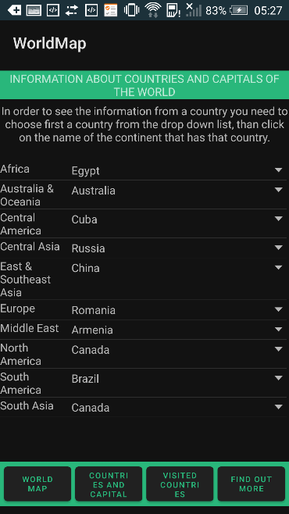 ● The main app is based on a menu where you can find many functionalities. Each button takes you in a new fragment where you can find different information about different topics. The ‘WORLD MAP’ button opens up a fragment where you can upload a photo and also change the photo that is taken from the internet, so the application makes the connection with the internet and retrieves from it the specified image.

The other button ‘COUNTRIES AND CAPITALS’ displays a list view with the continents. Inline with each continent there is a spinner with the countries from that continent. If the user wants to see more information about the country and the capital he have to choose first a country form the spinner and after that he have to click on the continent in order to be shown another page with the information the user requested.

Countries and Capitals 0‑2

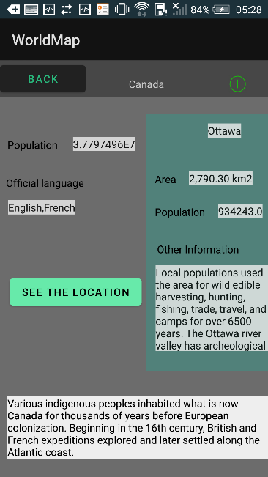

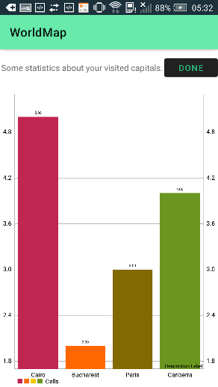Thus, another activity is created where users can view the information about the specified country. On the left hand side of the page you can find some statistics about the country and on the right hand side about the capital. Also, you can click the button ‘SEE THE LOCATION’ that opens up another activity with the location of the country on the map. In the upper part there is an image button, when is clicked the respective country is added on your list of visited countries**.**

Moving on to the next fragment by clicking ‘VISITED COUNTRIES’ users can see their list of visited countries and some more other things. At the top of the page there is an image button that can export the information form the list and in the bottom part is another button ‘CLICK TO SEE HOW MANY CAPITALS YOU HAVE IN YOUR LIST’ that opens a new activity with a graph that shows some statistics about the user visited capitals, showing how many times he visited it.

Graph 0‑4

View Country 0‑3

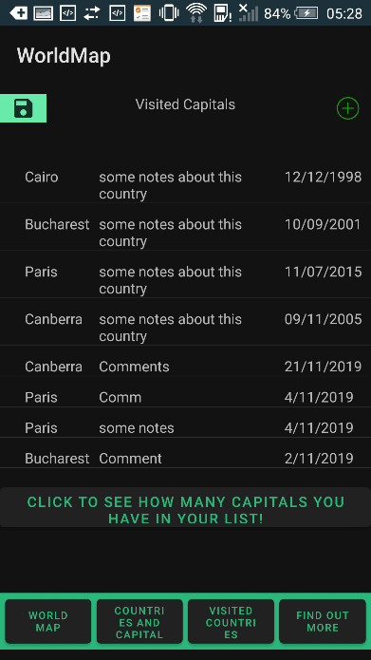Coming back to our page with the list of the visited countries another image button is placed in the right of the title that opens up an activity where you can add a visited country. First there is a spinner with all the countries that are taken for the local database, an edit view where the user can type some notes about his experience in that capital, and the date in which he was there.

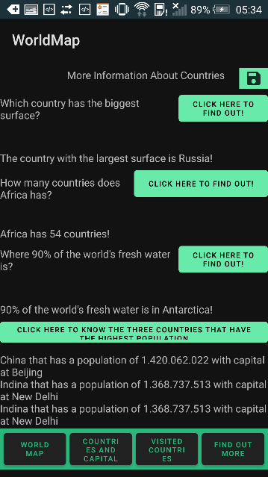

Find out more Page 0‑6

In the last fragment that is displayed by clicking ‘FIND OUT MORE’ users can learn new curiosities about our world. By clicking on the buttons from the page the information that will be shown is retrieved from database. On the last button the information is retrieved from a json file.

All this information can be exported in a file with a simple click on the image button form the top of the page. The information that is exported is showed in a new activity.

Visited Countries 0‑5

# 3. SYSTEM IMPLEMENTATION

## General technical requirements implemented:

## 3.1 User login

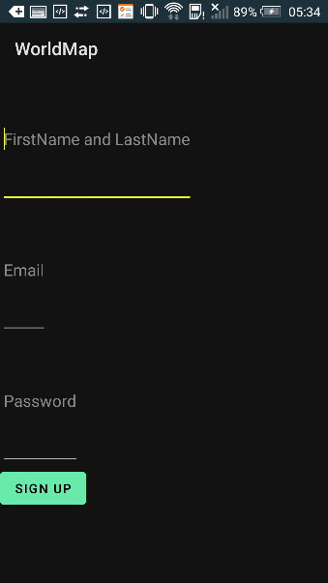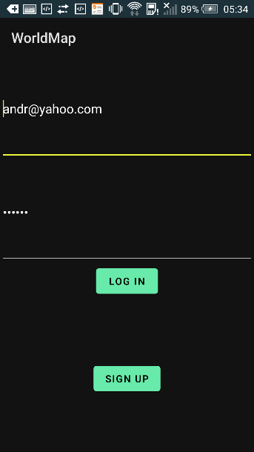 After a user passes the validation for the textboxes when he wants to login, the string which the user introduced in the email and password edit view is validated and looks for it in the database. After it is found, it also checks if the password matches with the one from the database. If we have a password match, the user is able to enter in the application. This was done by using Firebase.

SignIn Page 1‑0‑1

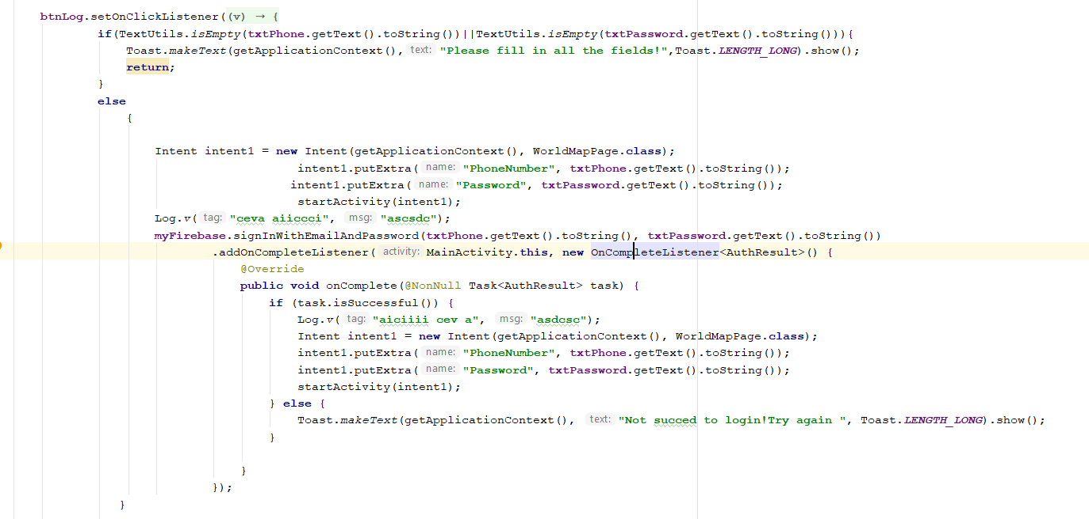

Register Page 1‑0‑2

## 3.2 Shared Preferences

Shared Preferences allows activities and applications to keep preferences, in the form of key-value pairs similar to a Map that will persist even when the user closes the application. Android stores Shared Preferences settings as XML file. Is our application the email and password of a user is remembered so that not to introduce each time is logging in the data.

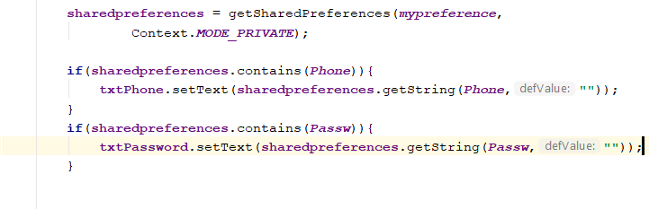

Shared Preference Code 1‑0‑3

## 3.3 Passing an object with an intent

I fund it really useful in my application passing an object through an intent that can be send only if it is serializable. From the main list of capitals , after you choose one the activity should display its information so I had to pass the clicked country through the intents that opens up the ‘View Country’ activity.

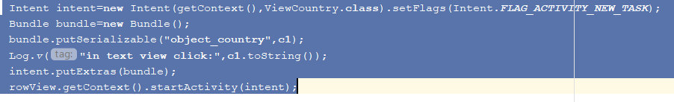

Passing Object Through Intent 1‑0‑4

## 

## 3.4 Processing images

When the user chooses an image from it’s phone, it is applied a grayscale filter on it. The display of the image and the filter was made with Picasso Library.

Procced Image 1‑0‑5

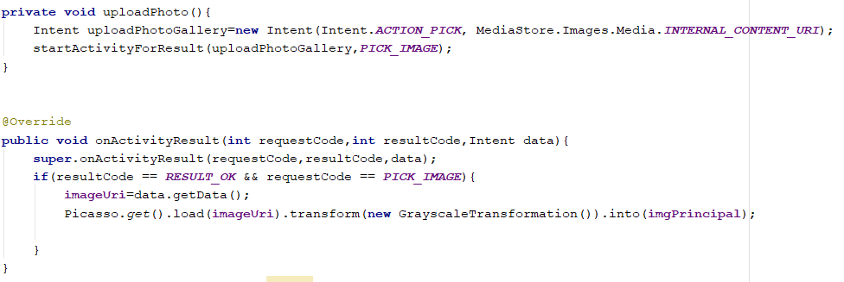

Image Processing 1‑0‑6

## 3.5 Asynchronous tasks

When the user click the button the page with the graph is displayed while in the background another thread is counting the visited countries from the list. After the user closes the ‘Graph’ page the information is already displayed on the screen.

## 3.5 Google maps API

The map is displayed when ‘See the location’ is clicked. Also I have implemented a menu of different types of maps.

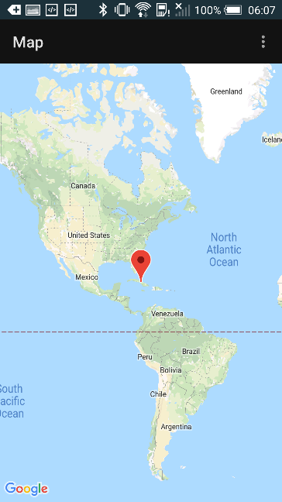

GoogleMaps Activty 1‑7

Unexpectedly, I have found a lot of advantages of Android while we were working on this project. I wes glad that we can find a lot of support online for all the questions that I had, courses and videos which helped me in making this application. The complexity of Android Studio amazed me and also the fact that you can put into practice all your thoughts in making an interesting application.

# 4. CONCLUSIONS

In conclusion, building this application helped me understand some key things and insights that should be known when building an application. One of the main things is designing the application so that should have a database in order for the data to be stored, not to be lost in the process. Another important thing that an application should have is a user friendly interface in order for the user to find quickly what he searches for.

Also, the colors and styles from the user interface are really important taking into consideration the fact that first thing you are looking at is how that application looks like. Moreover, asynchronous task is the thing that should not be forgotten. This implementation can make users life easier because you can run more tasks in the background while he can still access the application, especially when a task takes longer to be finished.

# 5. BIBLIOGRAPHY

(GoalKier, 2000)

(S, 2018)

(Muhammad Usama bin Aftab, 2014)

(Horton, 2018)

(Tech, 2019)

(Android Basics: Networking-Course, n.d.)

(Understanding Android Application Basics, n.d.)

(How to Pick an Image from the Gallery with Android Studio, 2015)

(Displaying Images with the Picasso Library, n.d.)

(Firebase Authentication, n.d.)

(Android AsyncTask Example Tutorial, n.d.)

( Simple Text Files, n.d.)