CSS
TUGAS 2 : SISTEM INFORMASI OPERASIONAL TERPADU PADA MYHINK TRAVEL
Nama /Nim | : | Andra Syailendra Perdana / 2318901
Kelas | : | A
Pengajar | : | BUDI PRIYONGGO (2518026)

Tujuan
- Praktikan dapat mentranslasikan desain prototipe antarmuka Figma (Index, Login, Register, Dasbor) ke dalam sintaks HTML dan CSS murni (native) tanpa framework.
- Praktikan dapat merancang struktur tata letak halaman Dasbor Admin yang memuat dua menu data CRUD (Paket Wisata dan Rental Armada).
- Praktikan dapat menerapkan teknik Responsive Web Design menggunakan fitur Media Query agar antarmuka menyesuaikan ukuran layar mobile.

Alat dan Bahan
- Laptop/pc
- Modul Praktikum Web 2026
- TextEditor (Visual Studio Code / Sublime Text)

Langkah-langkah
- Buat file style.css pada direktori css/ untuk mengatur tata letak terpusat, warna tema, serta aturan Responsive Web Design menggunakan Media Query.
Source Code :
@import url('https://fonts.googleapis.com/css2?family=Poppins:wght@300;400;500;600;700&display=swap');

* { margin: 0; padding: 0; box-sizing: border-box; font-family: 'Poppins', sans-serif; }
body { background-color: #f8fafc; color: #334155; }
nav { display: flex; justify-content: space-between; align-items: center; padding: 20px 8%; background-color: #ffffff; box-shadow: 0 2px 10px rgba(0, 0, 0, 0.05); position: sticky; top: 0; z-index: 100; }
.logo { font-size: 24px; font-weight: 700; color: #0ea5e9; text-decoration: none; }
nav ul { display: flex; list-style: none; gap: 30px; }
nav ul li a { text-decoration: none; color: #64748b; font-weight: 500; transition: color 0.3s; }
nav ul li a:hover { color: #0ea5e9; }
.btn-primary { background-color: #0ea5e9; color: #ffffff !important; padding: 10px 24px; border-radius: 8px; border: none; font-weight: 600; cursor: pointer; transition: 0.3s; text-decoration: none; display: inline-block; }
.btn-primary:hover { background-color: #0284c7; }
.hero { display: flex; align-items: center; justify-content: space-between; padding: 60px 8%; background-color: #e0f2fe; min-height: 70vh; }
.hero-text { flex: 1; padding-right: 40px; }
.hero-text h1 { font-size: 46px; color: #0f172a; line-height: 1.2; margin-bottom: 20px; }
.hero-text p { font-size: 16px; color: #475569; margin-bottom: 30px; line-height: 1.6; }
.hero-image { flex: 1; display: flex; justify-content: center; }
.hero-image div { width: 100%; height: 350px; background-color: #bae6fd; border-radius: 20px; }
.auth-container { display: flex; justify-content: center; align-items: center; min-height: 100vh; background-color: #f1f5f9; }
.auth-card { background: #ffffff; width: 400px; padding: 40px; border-radius: 16px; box-shadow: 0 10px 25px rgba(0, 0, 0, 0.05); text-align: center; }
.auth-card h2 { color: #0f172a; margin-bottom: 30px; font-size: 28px; }
.input-group { width: 100%; padding: 14px 16px; margin-bottom: 20px; border: 1px solid #cbd5e1; border-radius: 8px; font-size: 14px; outline: none; transition: 0.3s; }
.input-group:focus { border-color: #0ea5e9; box-shadow: 0 0 0 3px rgba(14, 165, 233, 0.15); }
.auth-card p { margin-top: 20px; font-size: 14px; color: #64748b; }
.auth-card a { color: #0ea5e9; text-decoration: none; font-weight: 600; }
.dashboard-layout { display: flex; min-height: 100vh; }
.sidebar { width: 260px; background-color: #ffffff; border-right: 1px solid #e2e8f0; padding: 30px 20px; position: fixed; height: 100%; }
.sidebar .logo { display: block; margin-bottom: 40px; text-align: center; }
.sidebar-menu { list-style: none; }
.sidebar-menu li { margin-bottom: 10px; }
.sidebar-menu a { display: block; padding: 12px 16px; color: #64748b; text-decoration: none; border-radius: 8px; font-weight: 500; transition: 0.3s; }
.sidebar-menu a.active, .sidebar-menu a:hover { background-color: #e0f2fe; color: #0ea5e9; }
.main-content { flex: 1; margin-left: 260px; padding: 40px; }
.dashboard-header { display: flex; justify-content: space-between; align-items: center; margin-bottom: 40px; }
.stat-cards { display: flex; gap: 20px; margin-bottom: 40px; }
.stat-card { background: #ffffff; flex: 1; padding: 24px; border-radius: 16px; box-shadow: 0 4px 15px rgba(0, 0, 0, 0.03); border: 1px solid #f1f5f9; }
.stat-card h4 { color: #64748b; font-size: 14px; margin-bottom: 10px; }
.stat-card h2 { color: #0f172a; font-size: 28px; }
.data-table-container { background: white; padding: 24px; border-radius: 16px; border: 1px solid #f1f5f9; }
@media (max-width: 768px) {
nav ul { display: none; }
.hero { flex-direction: column; text-align: center; padding: 40px 5%; }
.hero-text { padding-right: 0; margin-bottom: 40px; }
.dashboard-layout { flex-direction: column; }
.sidebar { width: 100%; position: relative; height: auto; padding: 20px; }
.main-content { margin-left: 0; padding: 20px; }
.stat-cards { flex-direction: column; }
.auth-card { width: 90%; }
}
- Ubah file index.html dan tambahkan struktur untuk merender Landing Page.
Source Code :
<!DOCTYPE html>
<html lang="id">
<head>
<meta charset="UTF-8">
<meta name="viewport" content="width=device-width, initial-scale=1.0">
<title>Myhink Travel</title>
<link rel="stylesheet" href="css/style.css">
</head>
<body>
<nav>
<a href="index.html" class="logo">Myhink Travel</a>
<ul>
<li><a href="index.html">Beranda</a></li>
<li><a href="#">Paket Wisata</a></li>
<li><a href="#">Armada</a></li>
<li><a href="login.html" class="btn-primary">Masuk</a></li>
</ul>
</nav>
<section class="hero">
<div class="hero-text">
<h1>Jelajahi Dunia Tanpa Batas Bersama Kami</h1>
<p>Sistem reservasi wisata, penyewaan armada, dan kasir terpadu. Nikmati kemudahan bertransaksi dengan Myhink Travel.</p>
<a href="register.html" class="btn-primary" style="padding: 14px 30px; font-size: 16px;">Mulai Sekarang</a>
</div>
<div class="hero-image">
<div></div>
</div>
</section>
</body>
</html>

Hasil Tampilan :
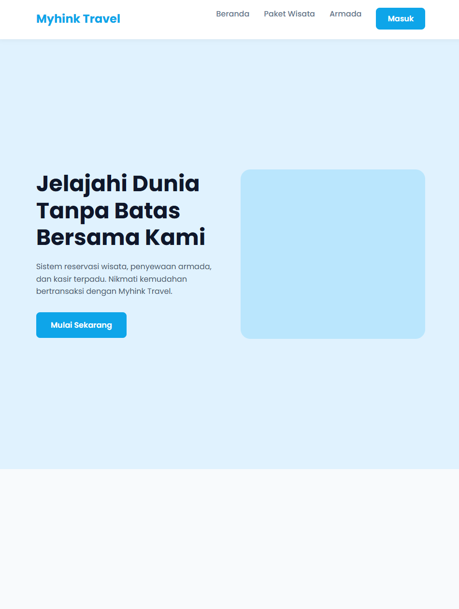

Gambar 1.1 Tampilan Frontpage
- Buat file login.html dan register.html untuk mengatur antarmuka Autentikasi.
Source Code (Login):
<!DOCTYPE html>
<html lang="id">
<head>
<meta charset="UTF-8">
<meta name="viewport" content="width=device-width, initial-scale=1.0">
<title>Login - Myhink Travel</title>
<link rel="stylesheet" href="css/style.css">
</head>
<body>
<div class="auth-container">
<div class="auth-card">
<h2>Selamat Datang</h2>
<form action="dashboard.html">
<input type="email" class="input-group" placeholder="Email Address" required>
<input type="password" class="input-group" placeholder="Password" required>
<button type="submit" class="btn-primary" style="width: 100%;">Log In</button>
</form>
<p>Belum punya akun? <a href="register.html">Daftar sekarang</a></p>
</div>
</div>
</body>
</html>
Source Code (Login):
<!DOCTYPE html>
<html lang="id">
<head>
<meta charset="UTF-8">
<meta name="viewport" content="width=device-width, initial-scale=1.0">
<title>Register - Myhink Travel</title>
<link rel="stylesheet" href="css/style.css">
</head>
<body>
<div class="auth-container">
<div class="auth-card">
<h2>Buat Akun Baru</h2>
<form action="login.html">
<input type="text" class="input-group" placeholder="Nama Lengkap" required>
<input type="email" class="input-group" placeholder="Email Address" required>
<input type="password" class="input-group" placeholder="Password" required>
<button type="submit" class="btn-primary" style="width: 100%;">Daftar</button>
</form>
<p>Sudah punya akun? <a href="login.html">Masuk di sini</a></p>
</div>
</div>
</body>
</html>
Hasil Tampilan:
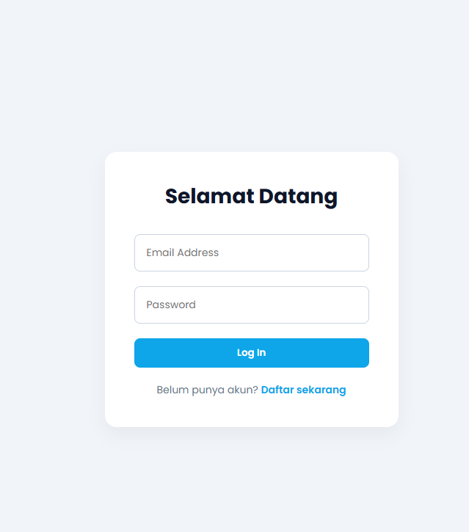Gambar 1.2 Login
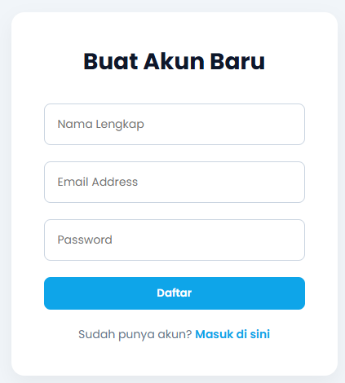

Gambar 1.3 Register
- Buat File dashboard.html untuk memvisualisasikan sistem administrasi terpadu beserta 2 entitas menu CRUD (Wisata dan Armada).
Source Code:
<!DOCTYPE html>
<html lang="id">
<head>
<meta charset="UTF-8">
<meta name="viewport" content="width=device-width, initial-scale=1.0">
<title>Dashboard - Myhink Travel</title>
<link rel="stylesheet" href="css/style.css">
</head>
<body>
<div class="dashboard-layout">
<aside class="sidebar">
<a href="index.html" class="logo">Myhink Admin</a>
<ul class="sidebar-menu">
<li><a href="dashboard.html" class="active">Dashboard Utama</a></li>
<li><a href="#">CRUD Paket Wisata</a></li>
<li><a href="#">CRUD Rental Armada</a></li>
<li style="margin-top: 50px;"><a href="login.html" style="color: #ef4444;">Logout</a></li>
</ul>
</aside>

<main class="main-content">
<div class="dashboard-header">
<h2>Overview Sistem</h2>
<div style="display: flex; gap: 15px; align-items: center;">
<span style="font-weight: 500;">Andra Syailendra</span>
<div style="width: 40px; height: 40px; background: #0ea5e9; border-radius: 50%;"></div>
</div>
</div>

<div class="stat-cards">
<div class="stat-card">
<h4>Total Pendapatan (POS)</h4>
<h2>Rp 4.500.000</h2>
</div>
<div class="stat-card">
<h4>Reservasi Wisata Aktif</h4>
<h2>12 Booking</h2>
</div>
<div class="stat-card">
<h4>Status Sewa Armada</h4>
<h2>3 Kendaraan Jalan</h2>
</div>
</div>

<div class="data-table-container">
<h3 style="margin-bottom: 20px; color: #0f172a;">Transaksi Terkini</h3>
<p style="color: #64748b;">(Tabel riwayat booking Open Trip, Kasir POS, dan Rental Armada dirender di sini)</p>
</div>
</main>
</div>
</body>
</html>
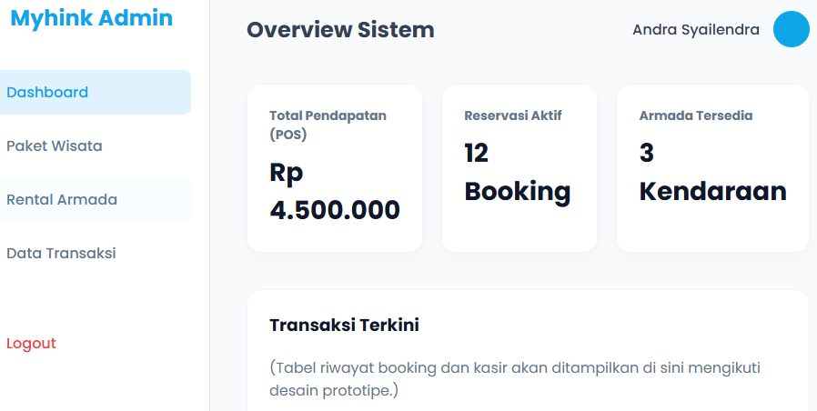
Gambar 1.4 Register
Analisa:
Berdasarkan pengerjaan tugas implementasi UI/UX ini, dapat dianalisa bahwa merancang tata letak website secara murni (native CSS) membutuhkan pengelolaan Flexible Box Model (display: flex) yang cermat, khususnya saat menyusun komponen struktural kompleks seperti Sidebar Navigation dan kartu statistik berderet pada dashboard.html. Karena penggunaan framework seperti Tailwind dilarang, setiap kelas harus didefinisikan secara eksplisit di dalam style.css. Untuk mematuhi prasyarat Responsive Web Design, blok Media Query (@media (max-width: 768px)) diinjeksikan guna memaksa susunan horizontal (misalnya pada area hero section dan stat-cards) patah menjadi tumpukan vertikal berdimensi 100%, sehingga seluruh antarmuka Myhink Travel terhindar dari distorsi tampilan ketika diakses melalui perangkat beresolusi layar kecil.

