You are to work together in groups of 2 or 3 students.

Design and code a GUI-based program that displays a Monopoly game. Add labels for the four train stations. Add buttons for all the Chance cells and set the text of these to a question mark. When the user clicks on one of the buttons, set its text to a message of your choice, chosen randomly from four messages. Create the necessary variables to keep track of money for each player. There should be the capability for 2 to 4 players. You can design the board and properties as you choose. There must be a way for players to own property and to collect money from those properties. We will not use houses or hotels. It does not have to follow the Monopoly game exactly, as long as you meet the criteria mentioned and every space has a purpose.

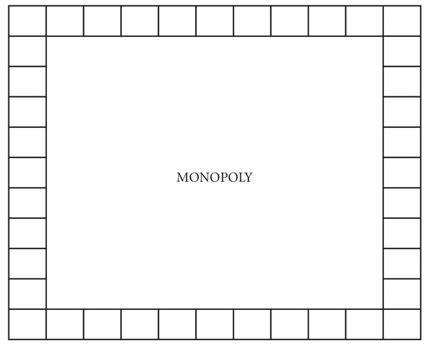

Upon completion of the project, you will write an instruction guide, explaining how to use your game. It would be expected that your game work exactly as you describe. There will be 100 points for this project. You will be given time in class to work on it Oct. 12, Oct. 17, and Oct 19. If you need more time, you will need to arrange time outside of class. This assignment will be due Nov. 7

Requirements:

1. Gameboard
2. Chance spaces with random “cards” drawn.
3. Spaces that players can own.
4. Ability to manage money for each player.
5. Ability to move around the board and click on buttons.

Try to have fun with this.