1. **UML**

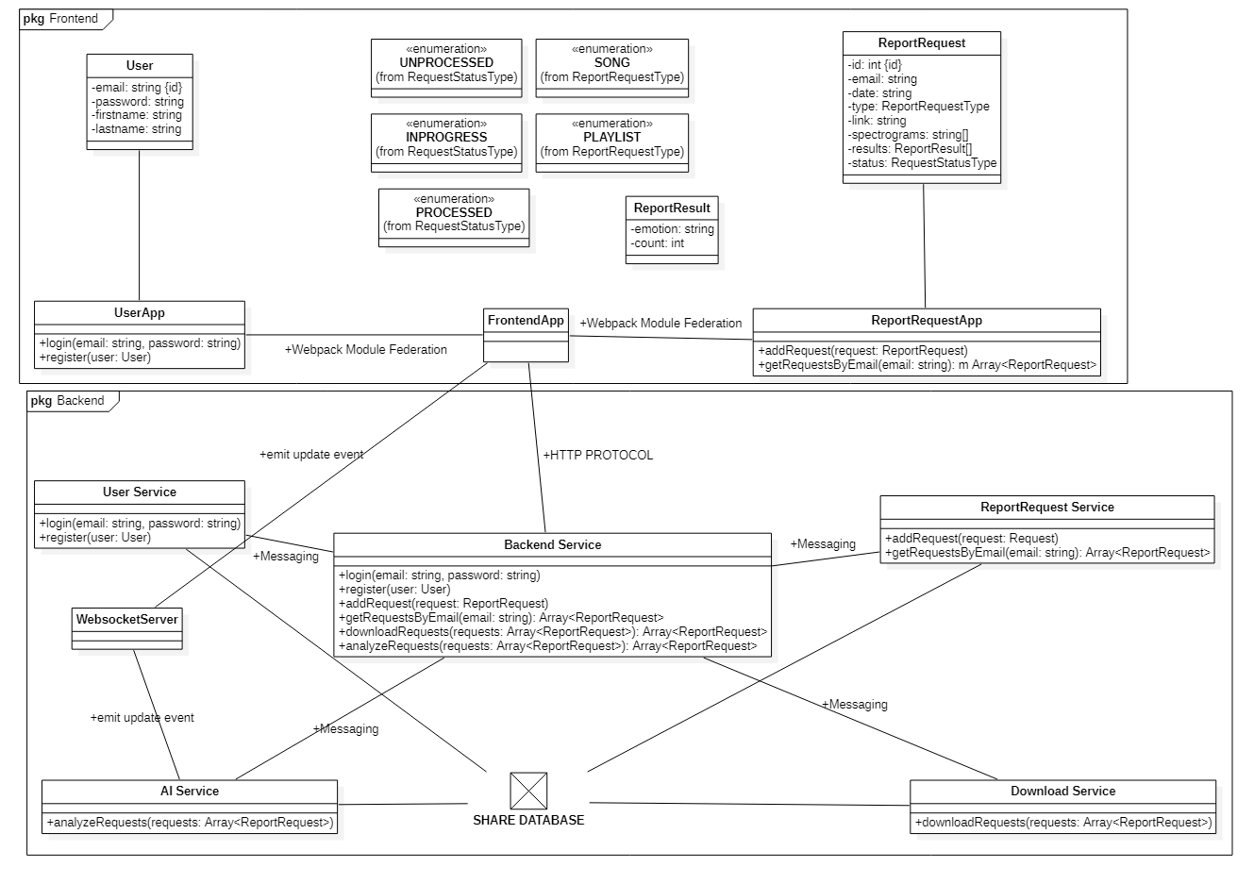

1. **SOA patterns used into the solution**

***Application architecture patterns***

* Microservice architecture

***Decomposition***

* Decompose by subdomain
  + Frontend
    - Main Application
    - User Application
    - Report Request Application
  + Backend
    - Backend Service
    - User Service
    - Report Request Service
    - Download Service
    - AI Service

***Data management***

* Shared database : MongoDB
* Domain event: WebsocketServer

***Communication patterns***

* Backend: Messaging
* Frontend: Webpack Module Federation

***Service discovery***

* Client-side discovery
* Server-side discovery

***Security***

* Access Token

***UI patterns***

* Client-side UI composition
  + Main Application
  + User Application – user subdomain components
  + Report Request Application – report request subdomain components