**CICD using git lab, Jenkins, ansible**

Step 1: First, we need to install and configure Jenkins master.

Step 2: Now, we launch the Jenkins node.

Step 2.1:

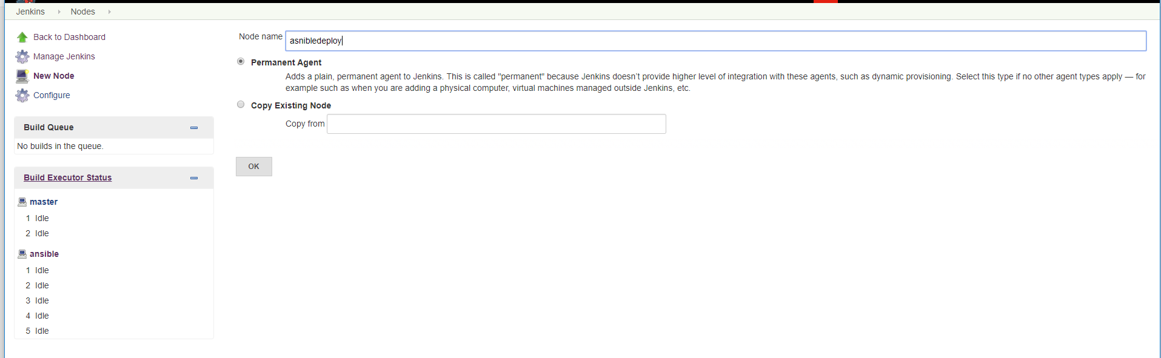

Step 2.2:

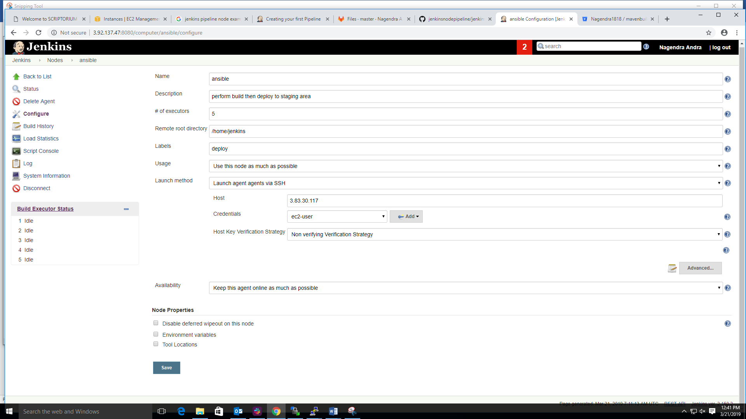

Step 3: Now, we need to install the ansible and git on Jenkins node machine

>> yum install –y ansible

>> yum install –y git

>> vi /etc/ansible/hosts

[stage] #(group-name)

Ip of stage machine

:wq!

Step 4: Now, we need to create repository on git lab and create the API token

Step 5: we need to install the git lab plugin on Jenkins master and configure git lab connection and test connection screen shot.

Click on manage Jenkins 🡪 click on configure system 🡪 go to the git lab section

Connection name: customize name

Gitlab host url: <https://gitlab.com>

Credentials: Gitlab API token

Click on test connection (it will display success message)

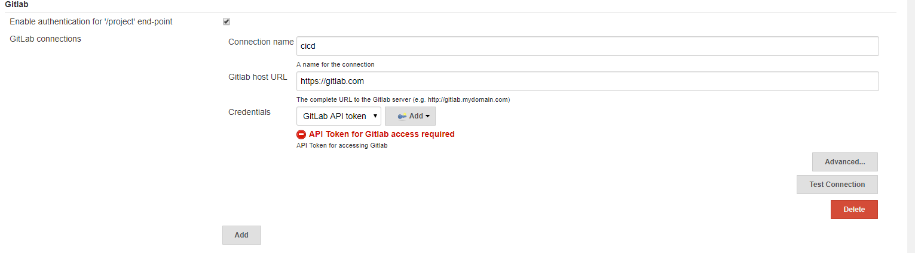

Step 6: Now, we create the pipeline job in Jenkins follow the below steps.

Step 6.1: Now, we create the pipe line job, **click on new item** 🡪 Enter the job name 🡪 select the type job(pipe line) 🡪 click on ok

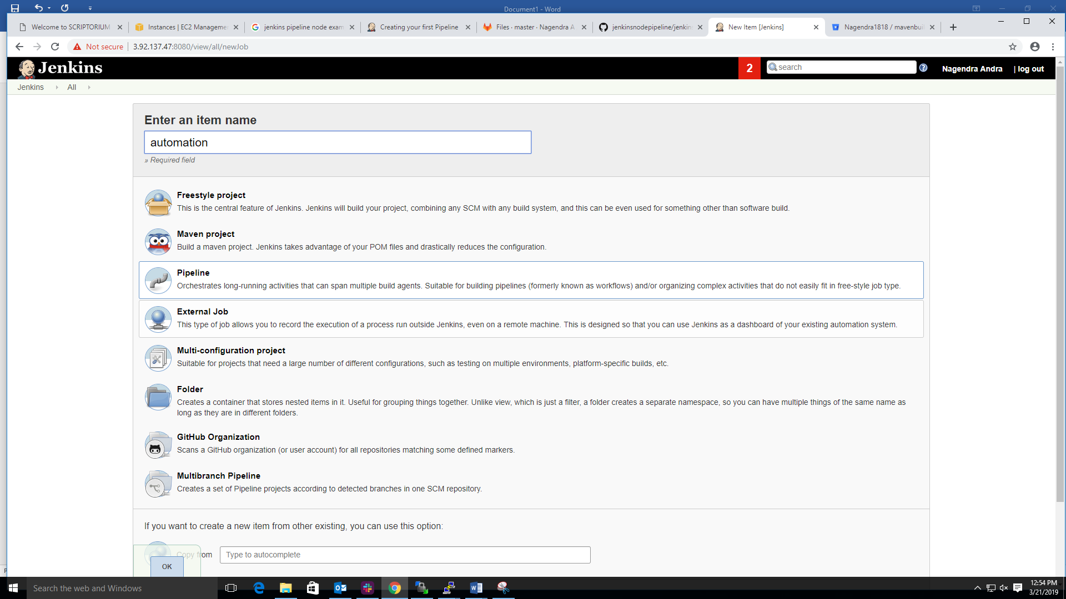

Step 6.2: Once click ok above step, we will get the below screen, here Git lab section add the project url.

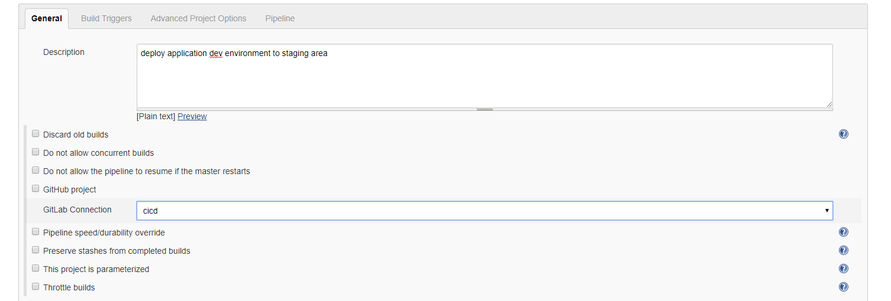

Step 6.3: Now, we go to the build trigger section choose the option build when a change is pushed to git lab, GitLab web hook. As shown in below screen shot.

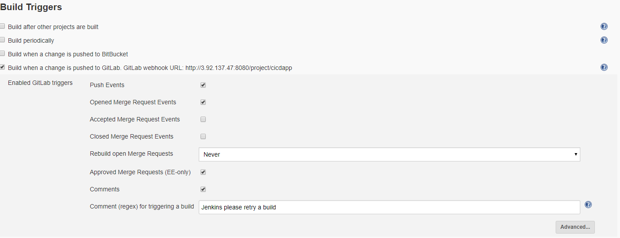

Step 6.4: we will go to Pipe line section select Jenkins file from scm option.

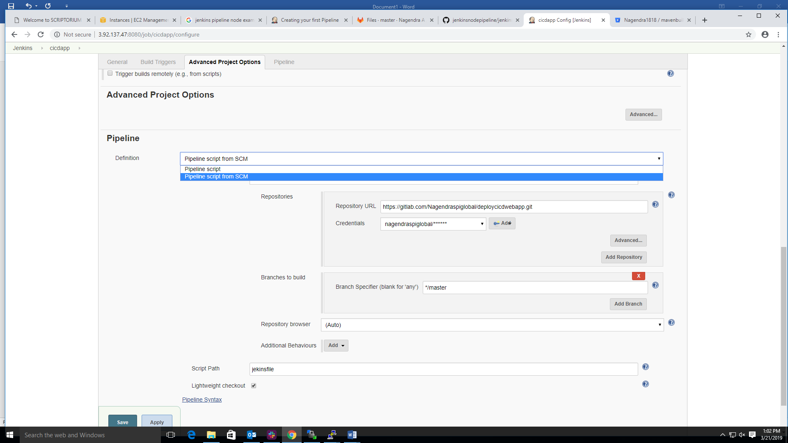

Step 6.4: Here, choose the git and add the repository url and user credential then enter Jenkins file path at script path section. Click on apply and save

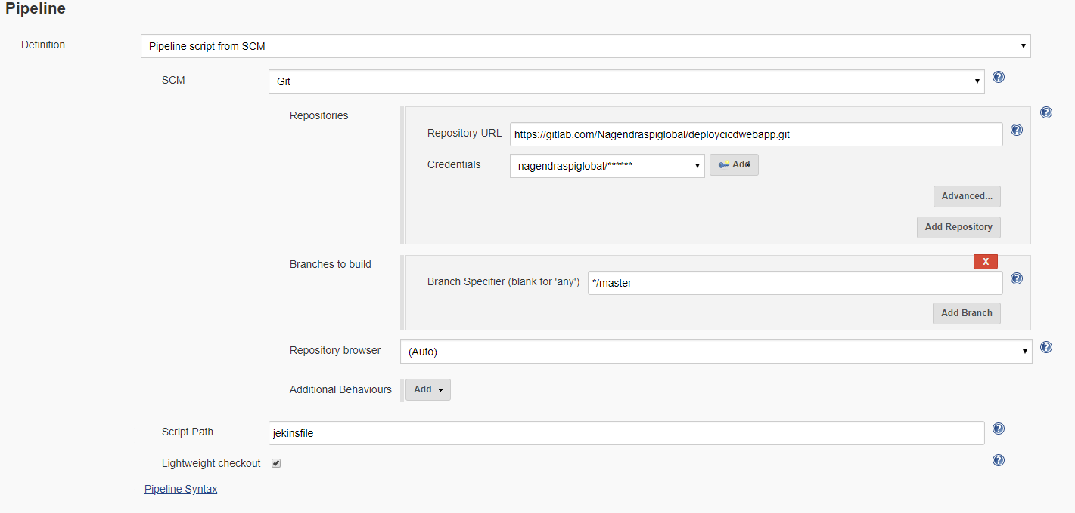

Step 7: Now we need to configure the git lab web hooks on git lab repository side, we need to follow Jenkins integrate with git lab web hooks document.

Jenkins file:

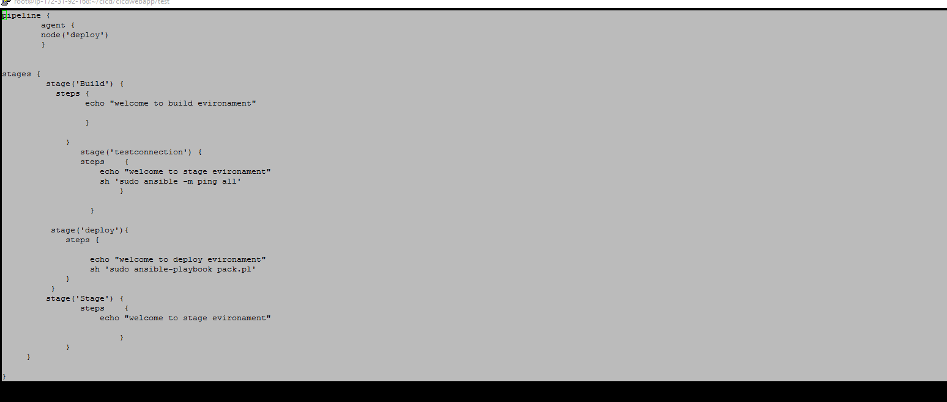

Ansible playbook:

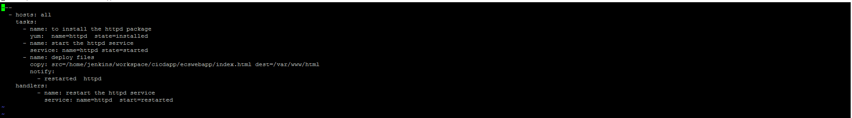

Step 8: now we create the Jenkins file and ansible playbook, then upload the remote repository then build automatically trigger.