Webhook :

Here, we go to settings and double click.

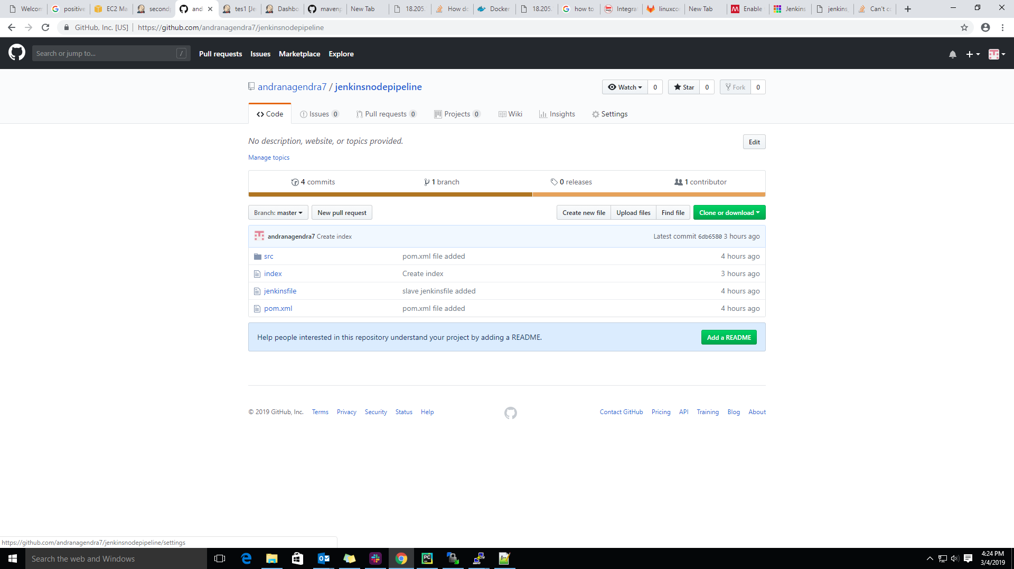

Step 2: After, double click we will get the below window as shown in below screen shot.

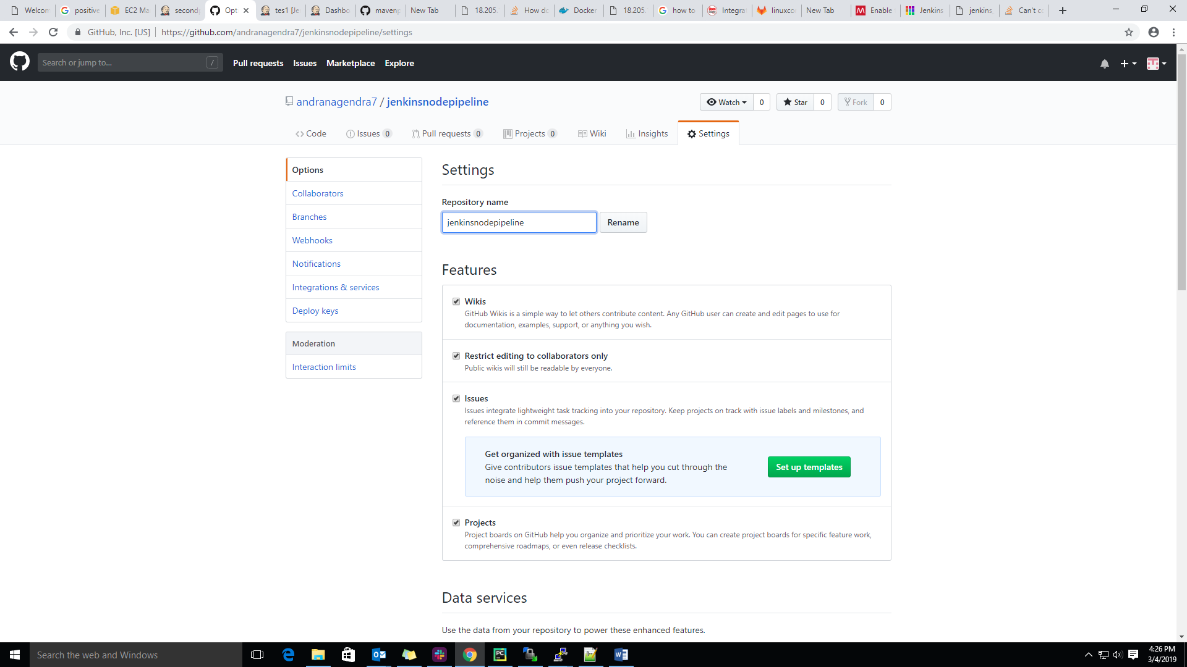

Step 3: Now, we double click on the web-hooks option, then double click on Add webhook.

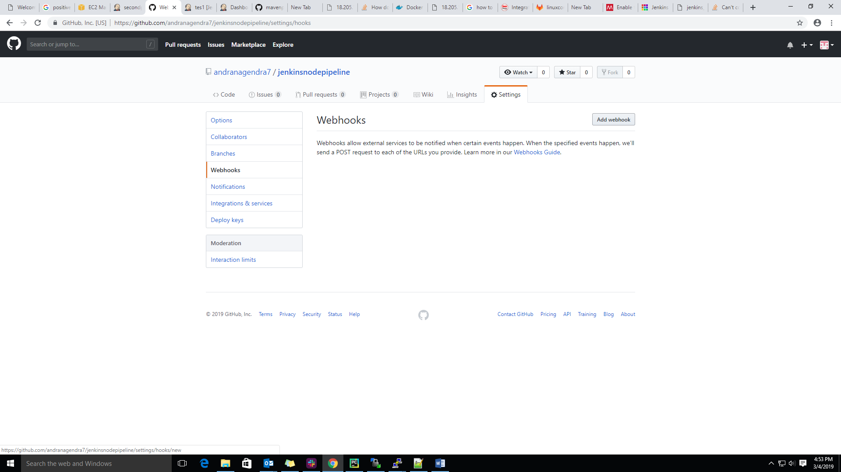

Step 4: Now we will enter the payload url like(Jenkins server url).

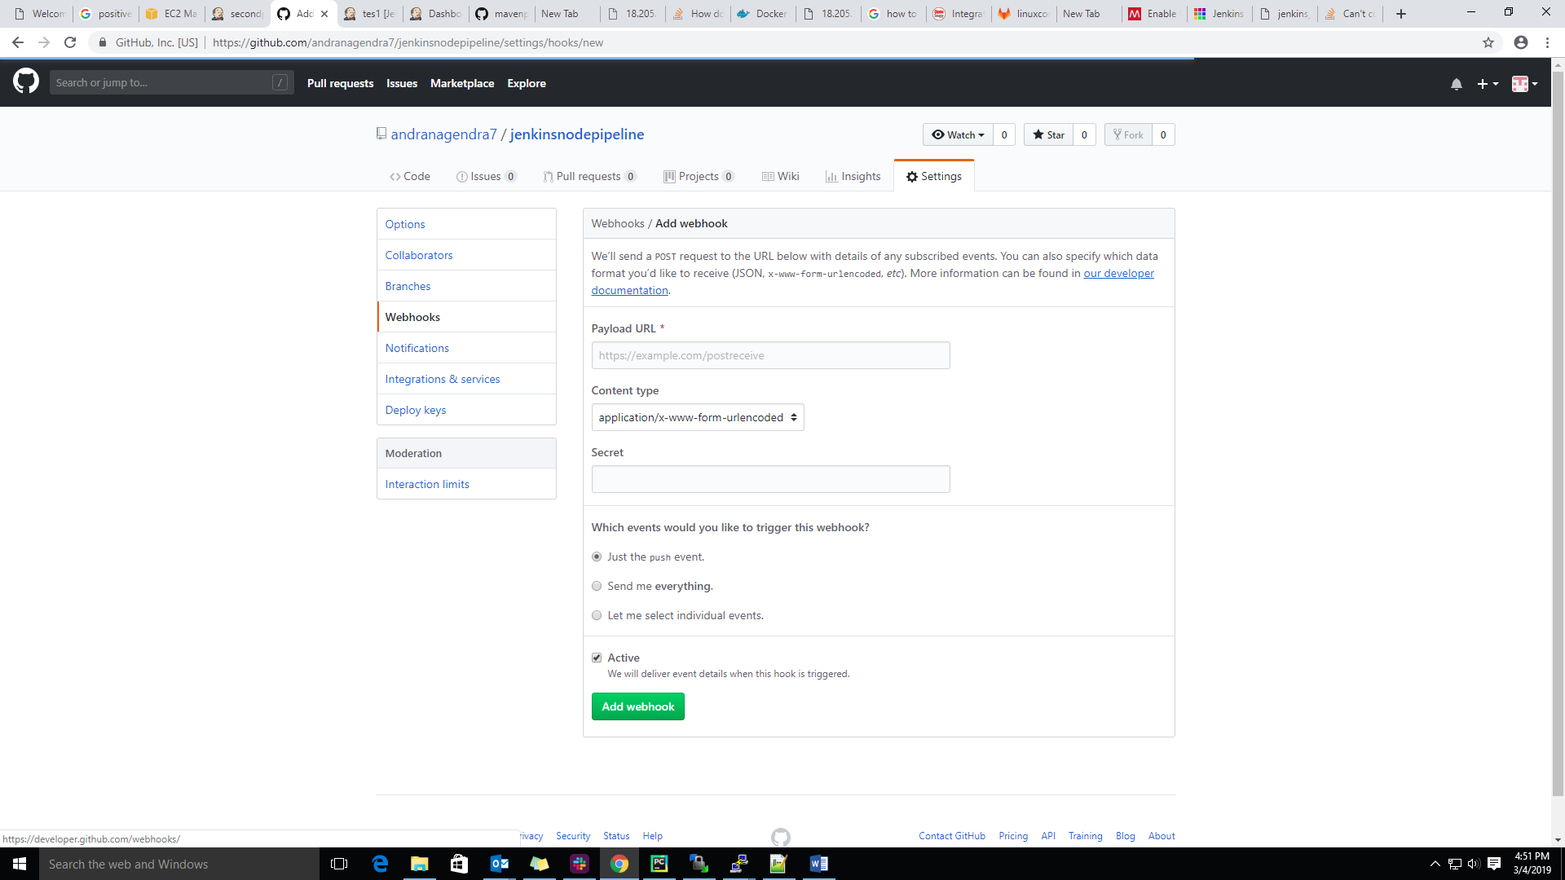

Step 5: we need to the add ($Jenkins url)/github-webhook/ then click on add webhook as show below screen shot.

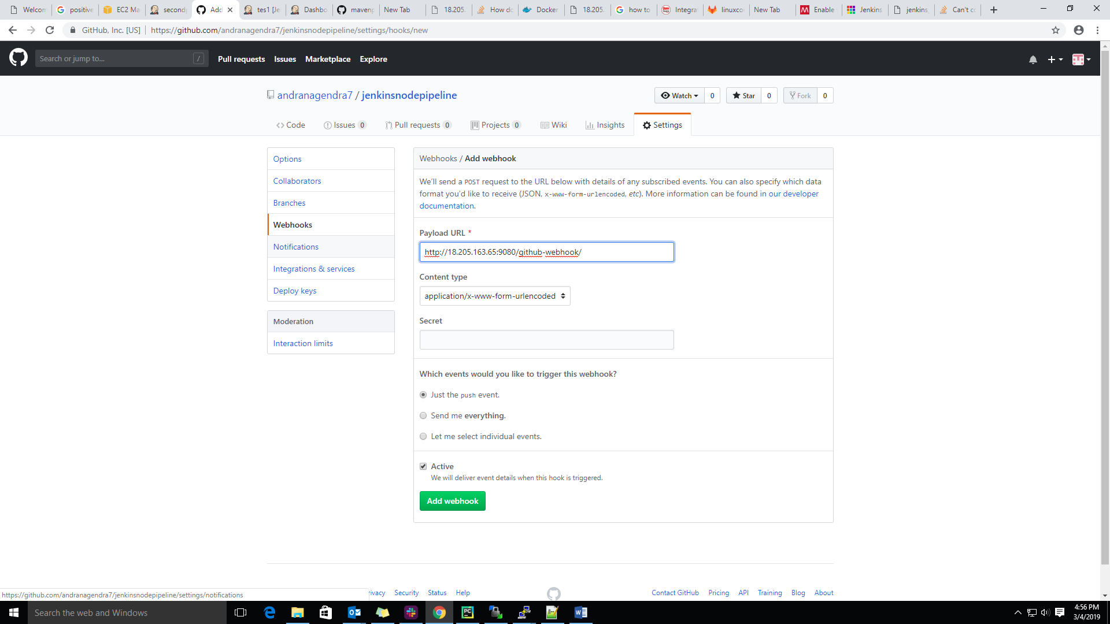

Step 6: we will get the below window , here if we get the green color right mark connection establish successfully.

