To launch windows node

Node side requirements:

Step 1: Java install and setup environmental variables:

1. We need to Install the java and set the environmental variables of java and.
2. Set the JAVA_Home path and JRE_ Home path.
3. Now we will install Git and set environmental variable.

|  |  |
| --- | --- |
|  |  |

Now we setup the windows agent on Jenkins master:

Step 1: log into the Jenkins dash board 🡪 go to manage Jenkins 🡪 click on Global configure Security 🡪 move the agents part 🡪

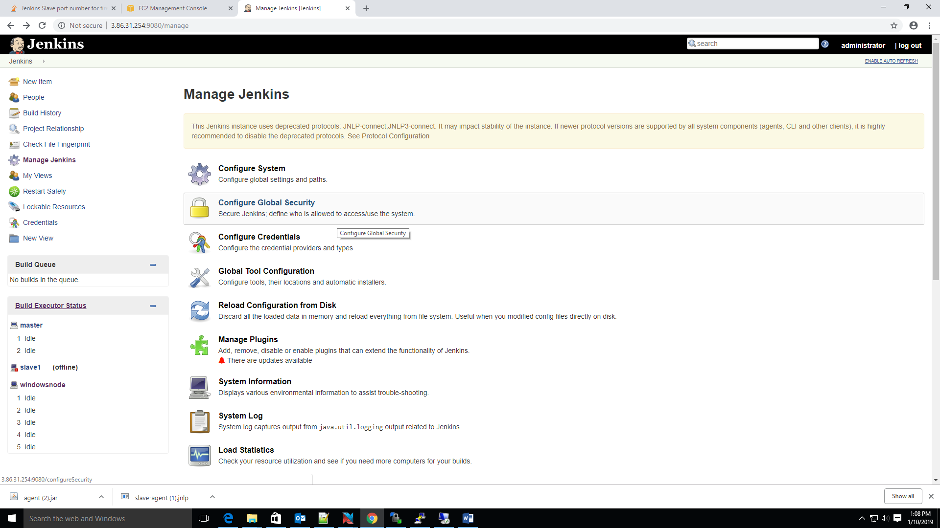

move the agents part 🡪 we will see the below window



Now we select the fixed button and enter the port number(customize)



Next we select the agent type of protocol

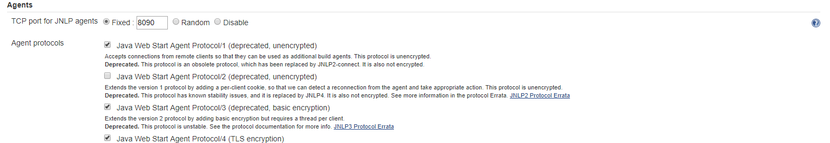

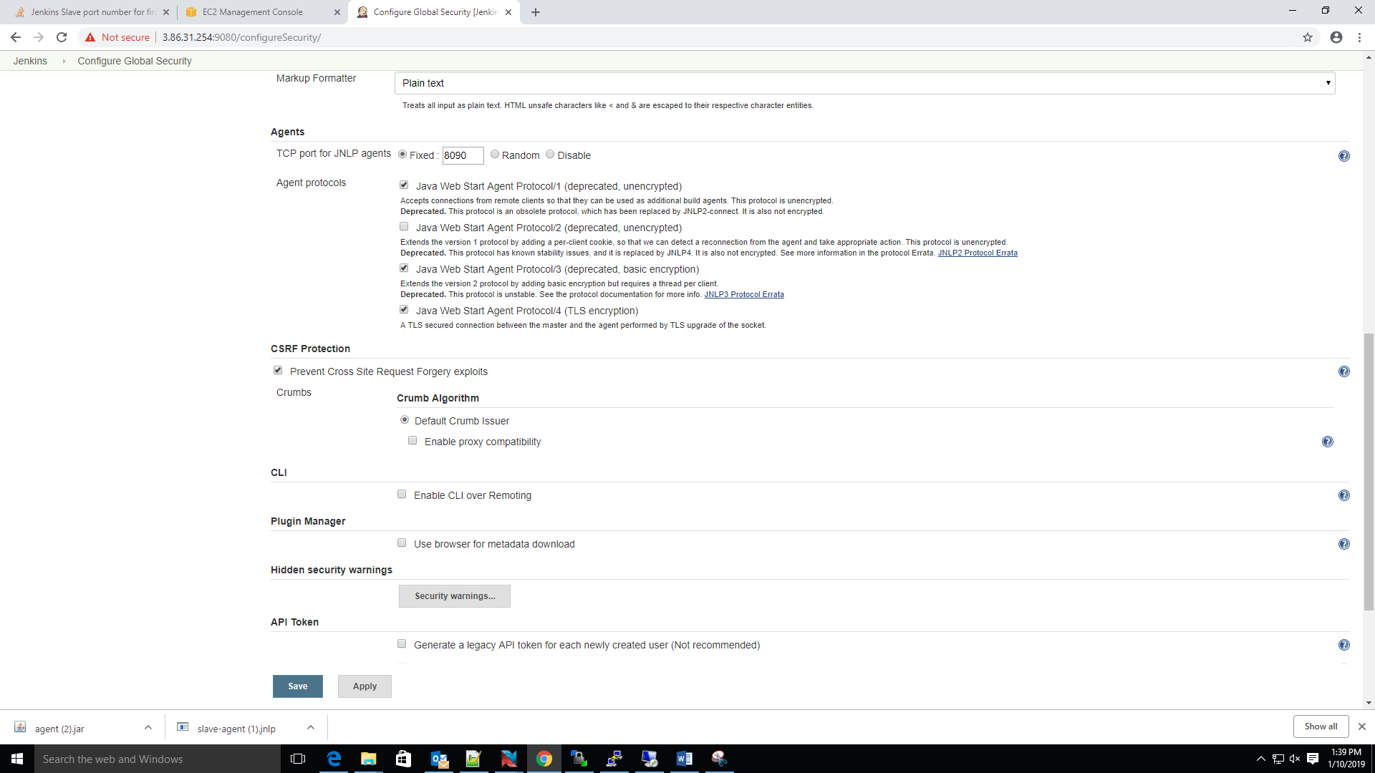

Now we click on apply and save

Now we will setup the node part:

Click on manage_jenkins 🡪 go to manage-nodes and click on

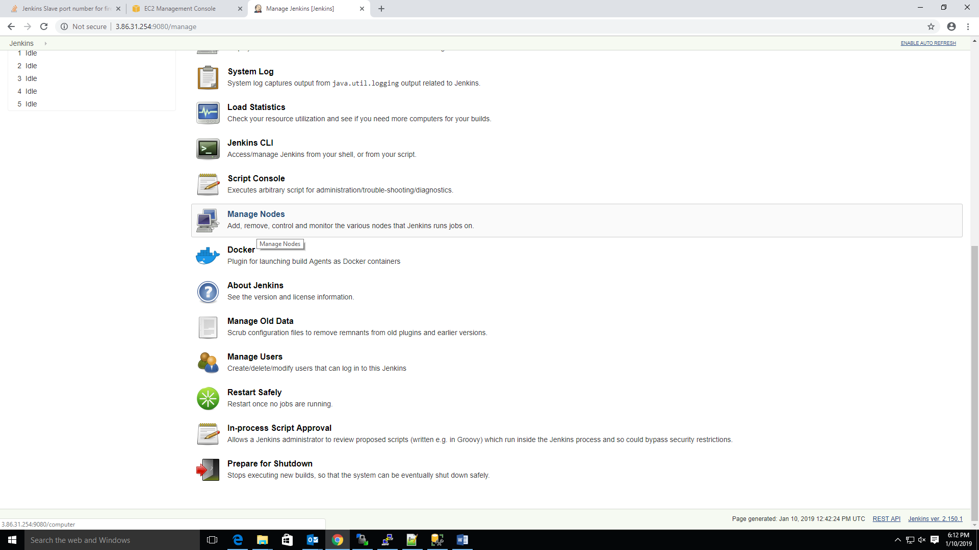

Step 1: We go to the manage Jenkins 🡪 click on the manage nodes 🡪 click on new node 🡪select the agent as permanent 🡪 Enter the node name

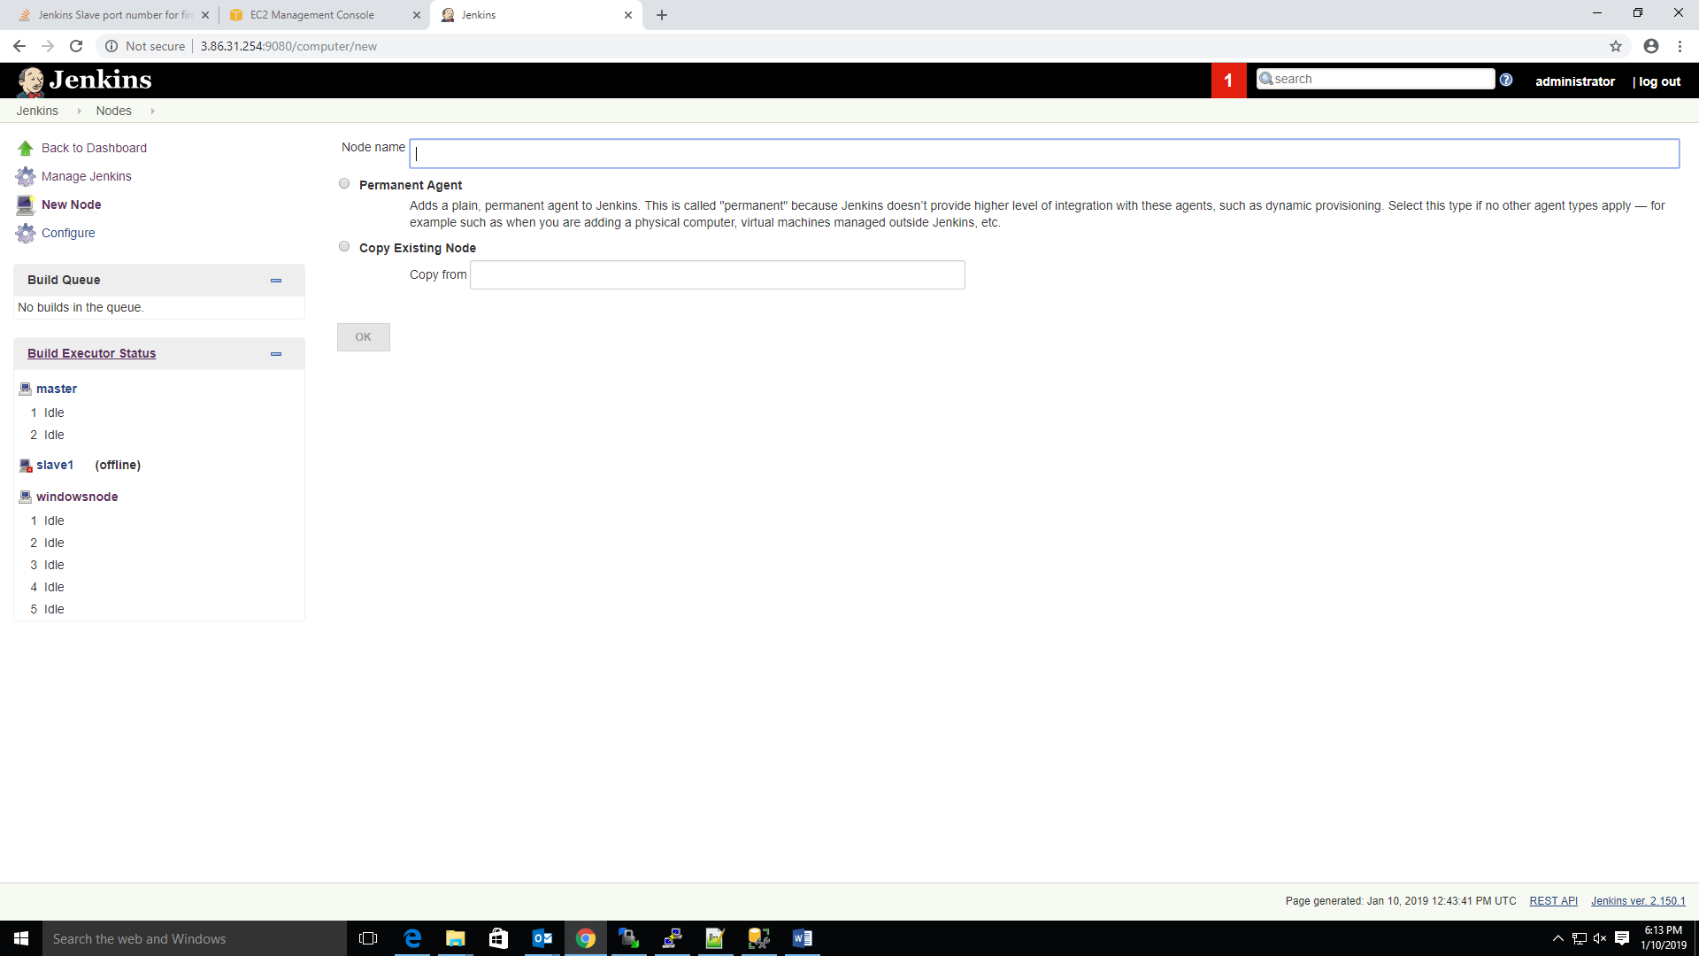

Step 2: Now we here enter the node name and enter the description

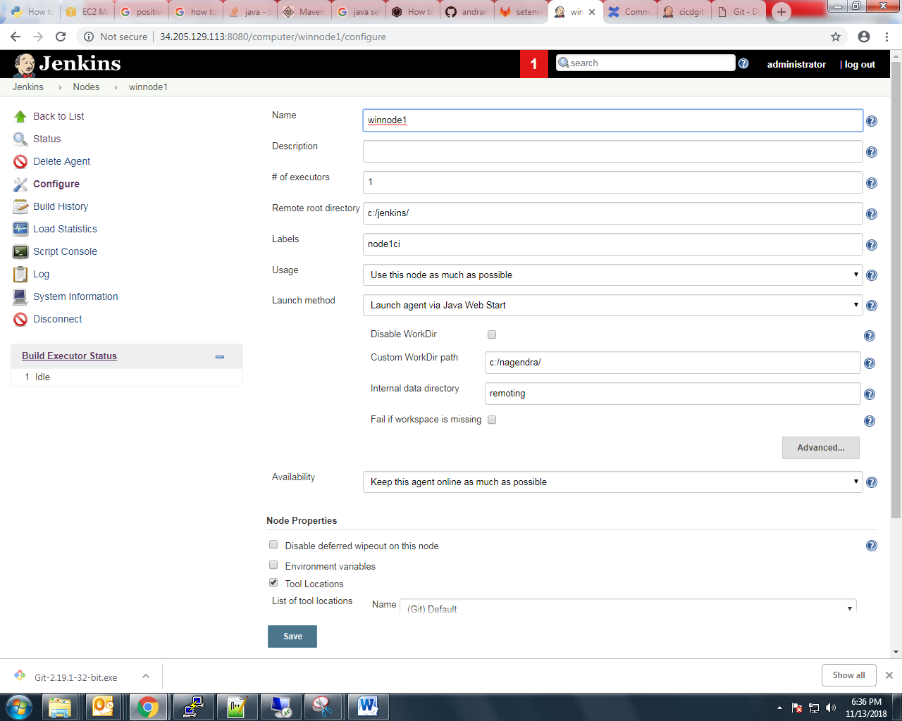

Step 3: Now, we are giving to no of builds run in this node(executors)

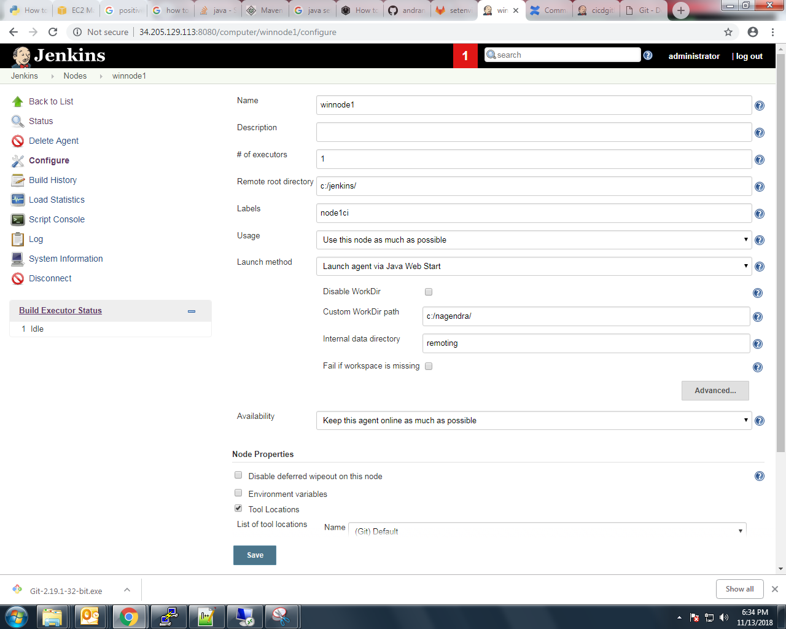

Step 4: Now here we are Entering to slave.jar file root directory on node side. if don’t have that directory we need to create this directory.

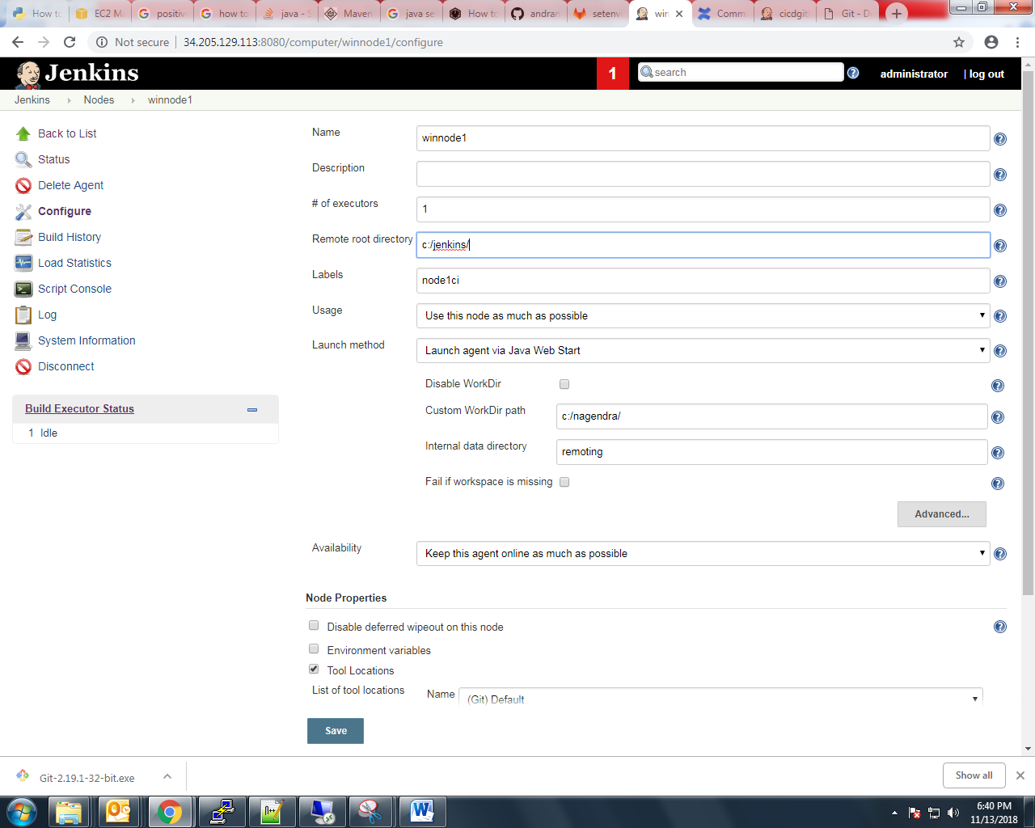

Step 5: Now, we are entering the slave label name.

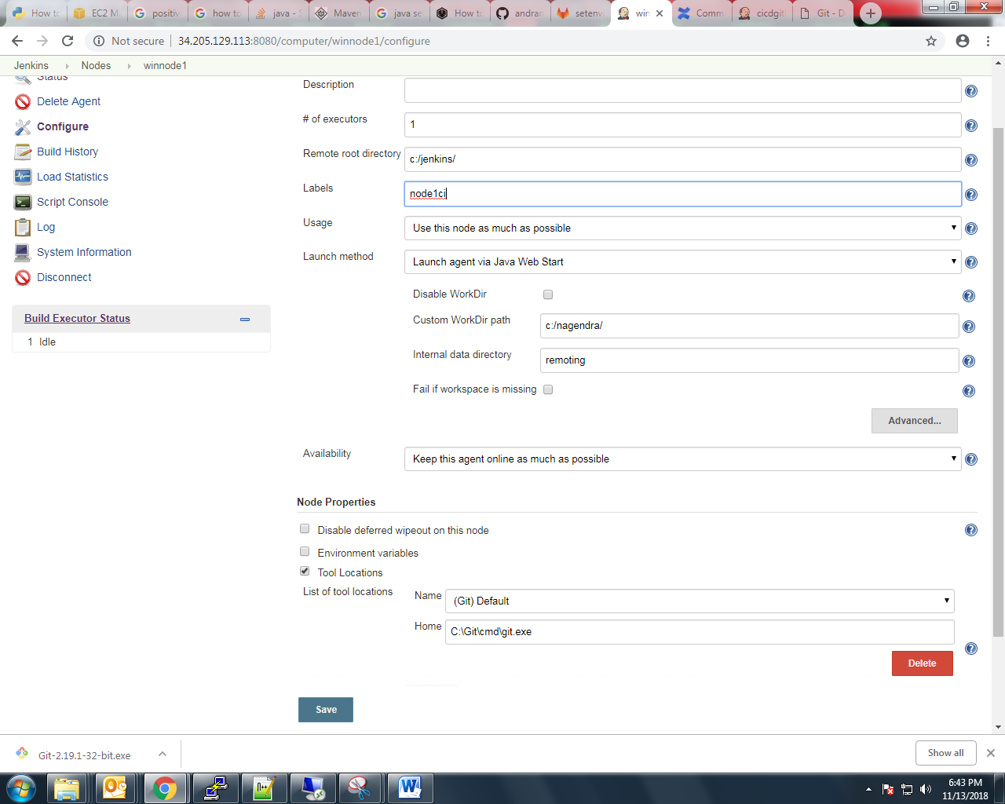

Step 6: now select this option “**Use this node as much as possible” node status**

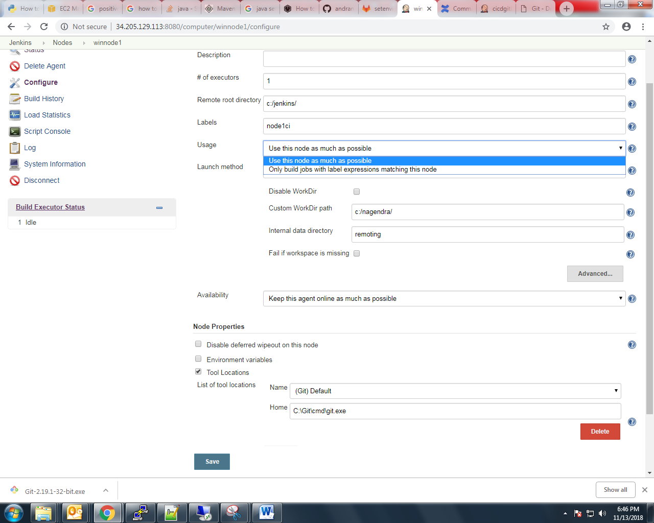

Step 7: now we are specifying node launch method. Here we selected the ”**Launch agent via Java Web Start” because this node is windows**

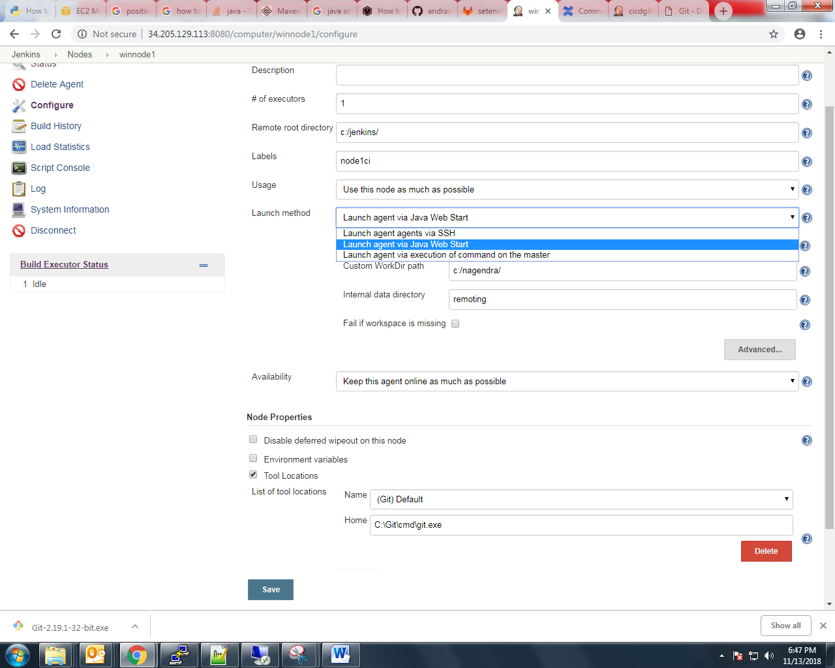

Step 8: Now we are specifying the log path and remoting path.

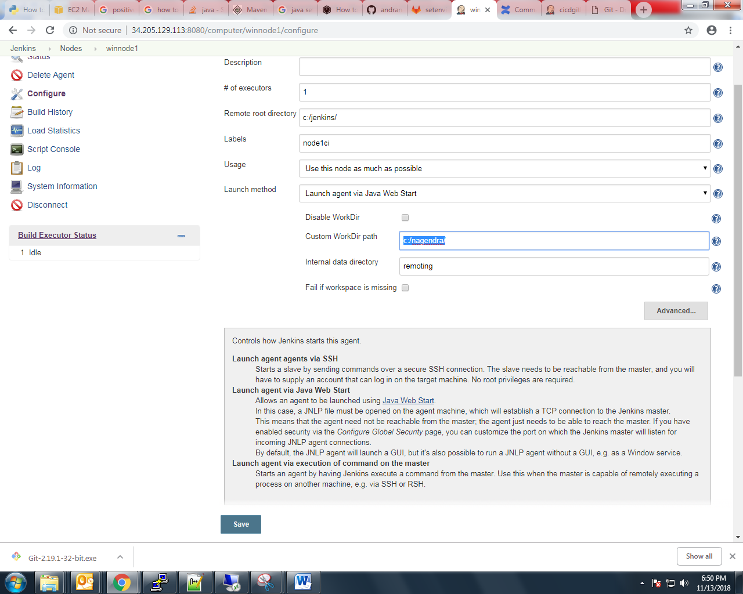

Step 9: now we are specifying the node status

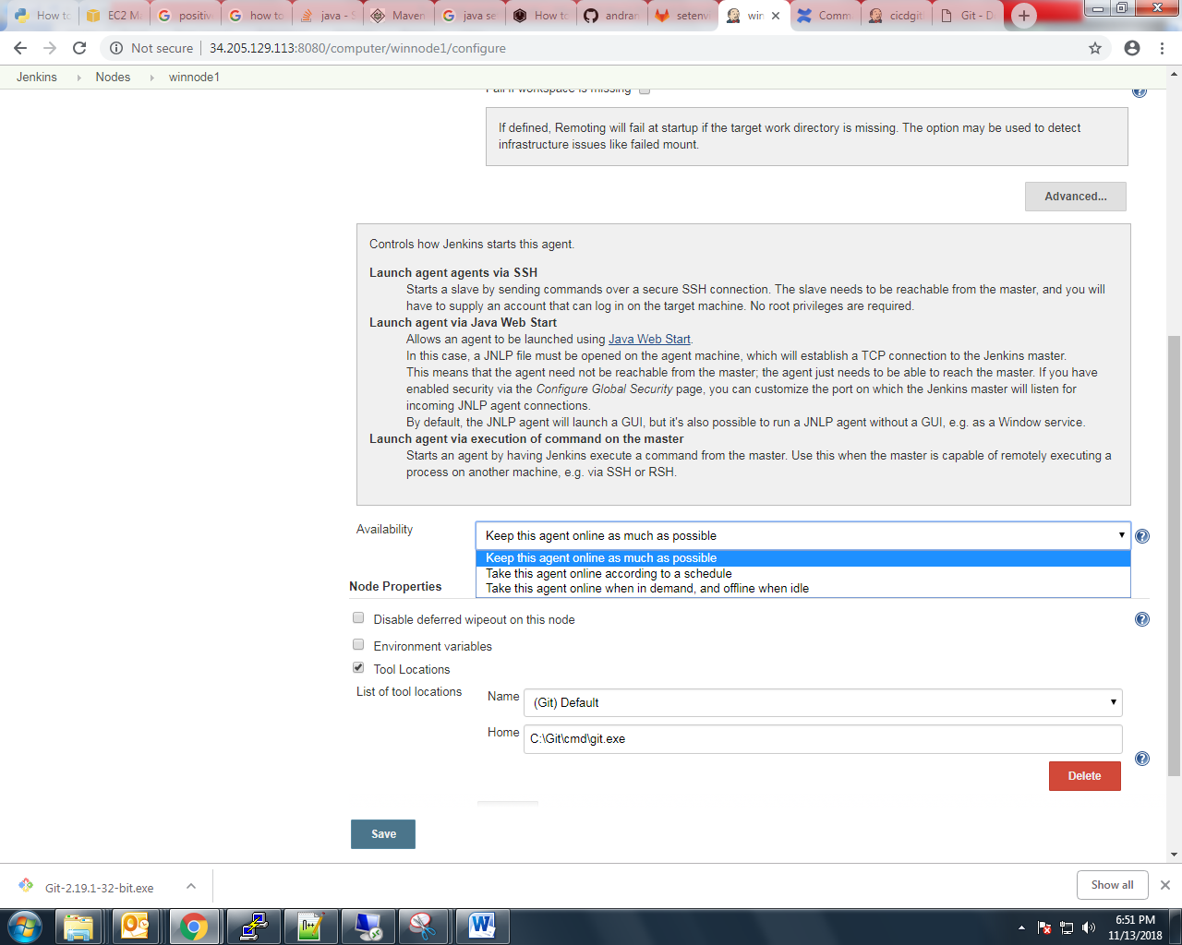

Step 10: we are giving git.exe path and java_home at node properties. Click save button

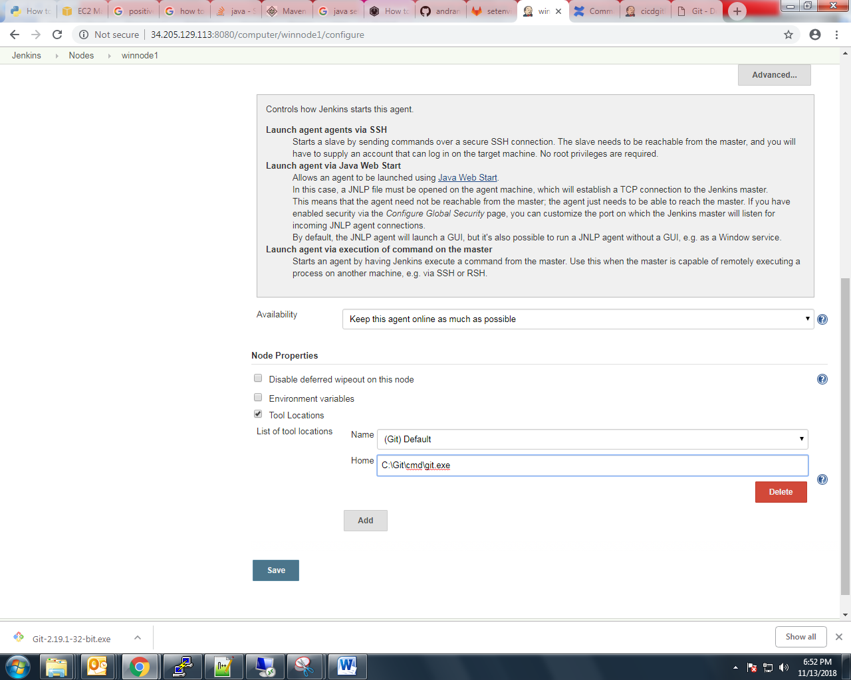

Next we will go to Jenkins node dash board and click on nodes, we get the new pop up window

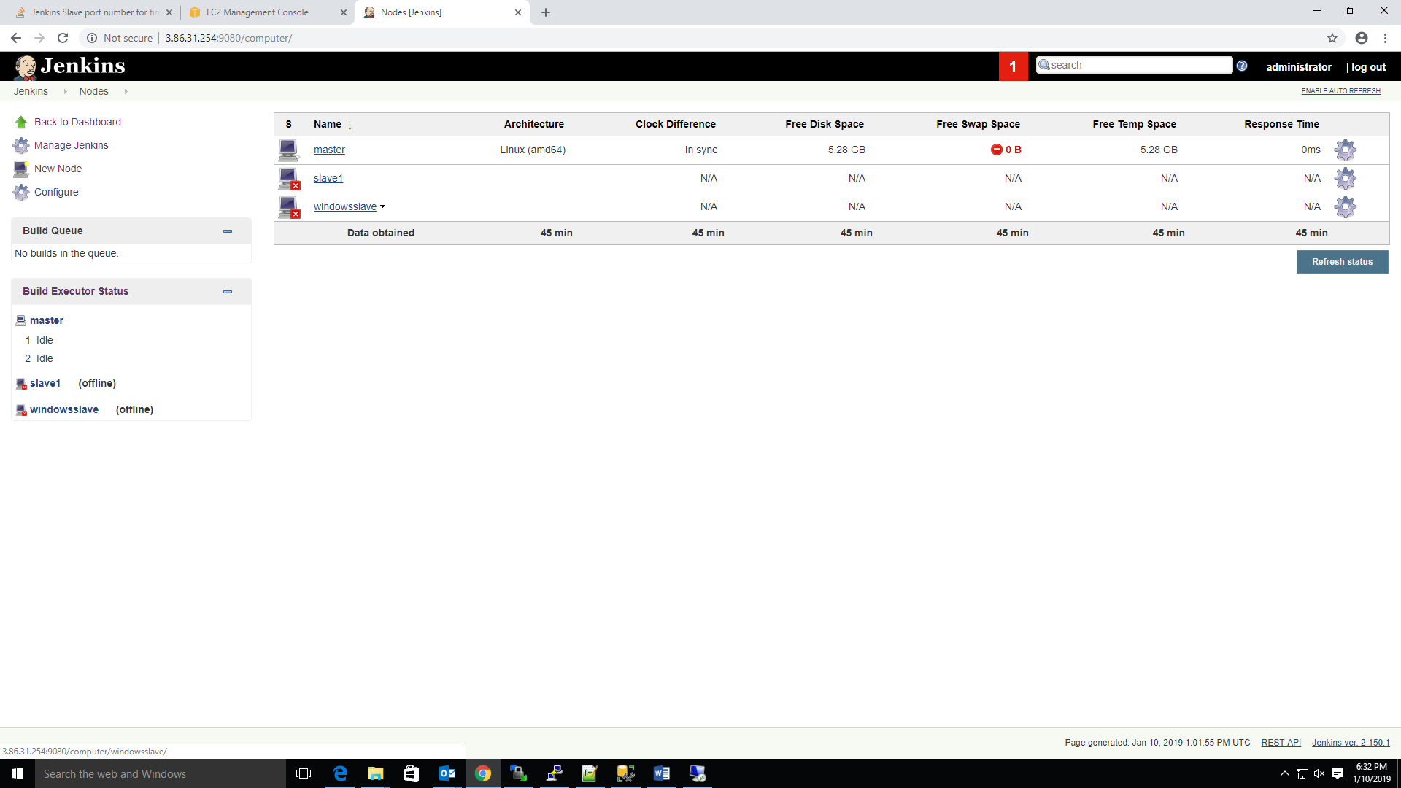

Click on launch, this time slave. Jar file will download .

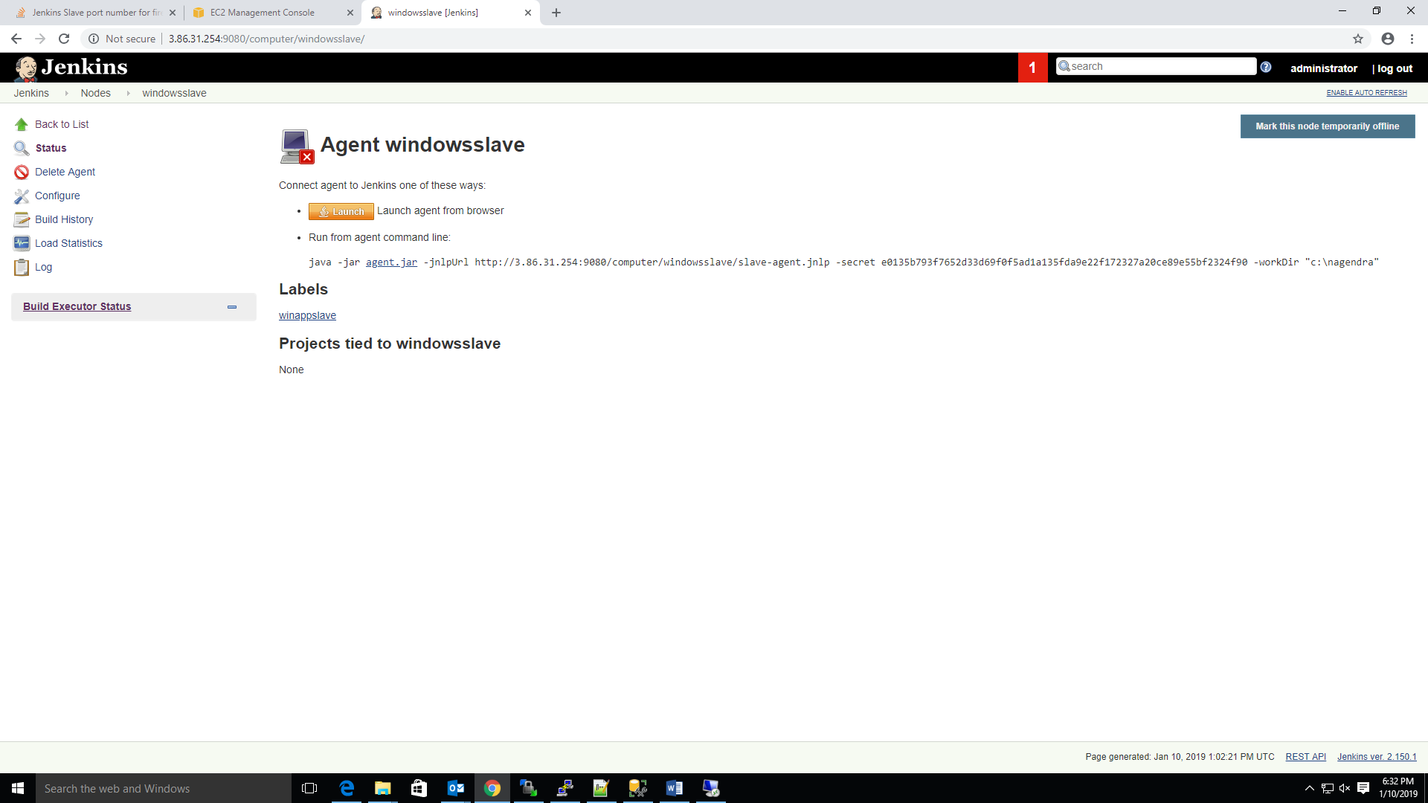

we have to move the download file to windows slave machine and once double click on jar file node launch process will start. We gets the below window click on run

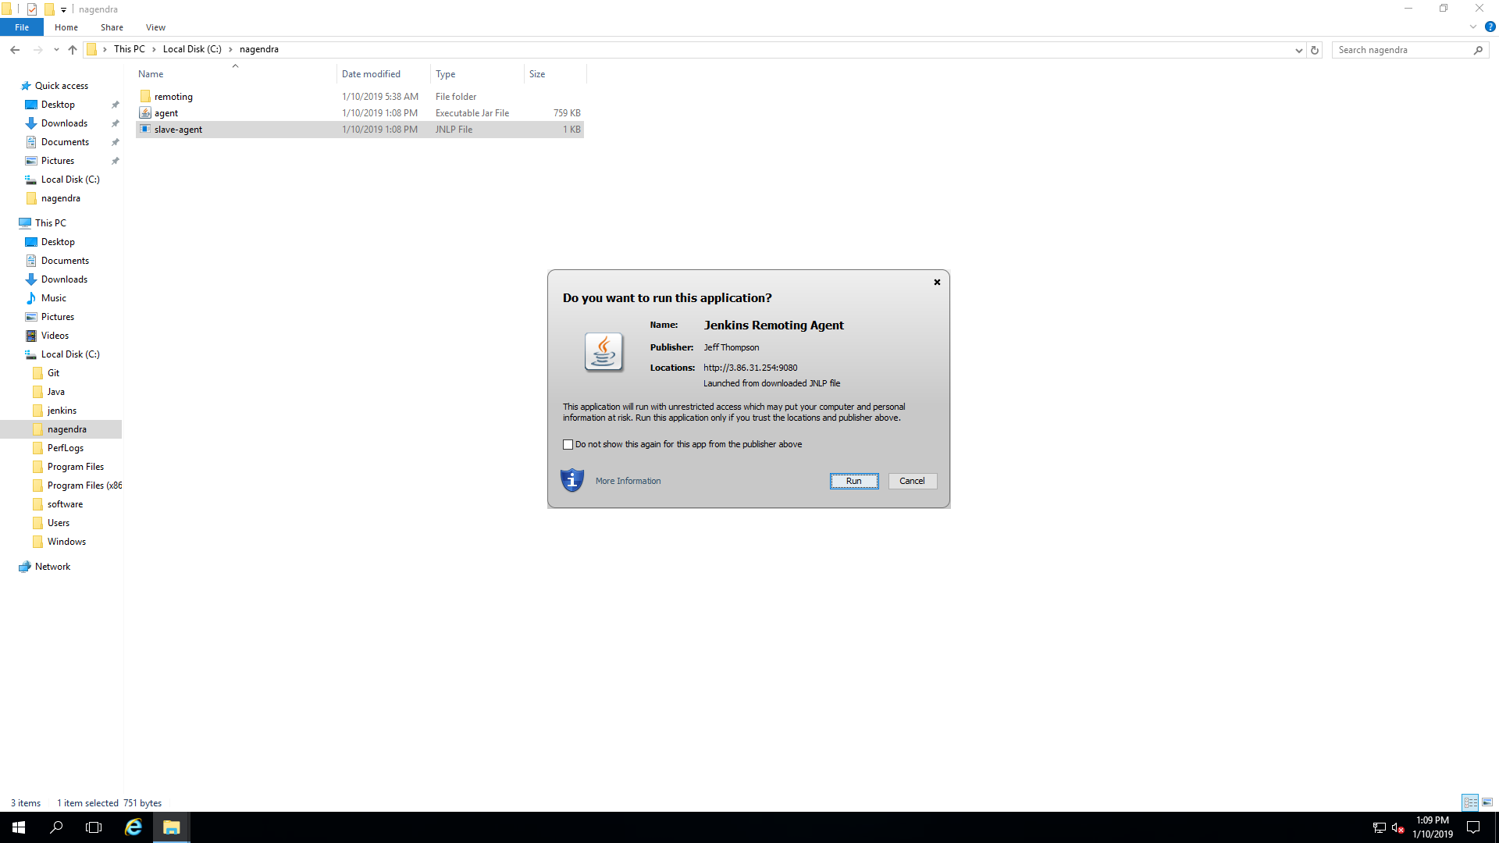

After the successful launch the windows slave we will get below output:

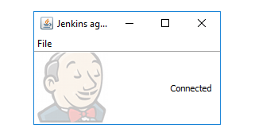

Note:- If we want to launch window machine we enable the tcp ports for jnlp agents select flexible enter the port number and one thing remember we need to enable jnlp agents port on node machine and Jenkins master.

After the windows slave launched , we can see the below figure shown output.

