**Steps to Install PHP manually on Windows 2016 server**

In this blog, we will show the steps to install PHP manually on Windows 2016 server.

**REQUIREMENTS**

* Virtual Machine
* IIS Web Server
* WinCache Extension for PHP
* PHP Binary Files
* VC++ Compiler

**INSTALLING IIS**

* Open the Windows PowerShell and type the below command to install IIS service with CGI extension.

**Install-WindowsFeature -name web-server,web-cgi –IncludeManagementTools**

[Install PHP manually on Windows 2016 server](https://www.assistanz.com/wp-content/uploads/2017/09/image-16.png)

* It will take few minutes to complete the installation.

[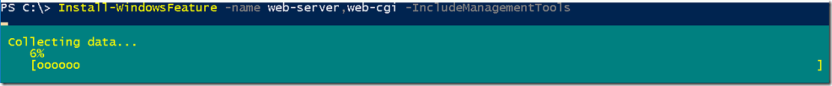](https://www.assistanz.com/wp-content/uploads/2017/09/image-17.png)

[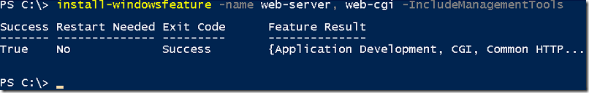](https://www.assistanz.com/wp-content/uploads/2017/09/image-18.png)

* Once the installation is completed, verify the CGI feature was installed in the server using the below command.

**Get-WindowsFeature web-cgi**

[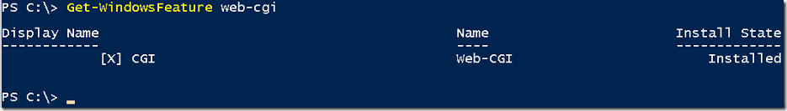](https://www.assistanz.com/wp-content/uploads/2017/09/image-19.png)

**INSTALLING PHP**

* Go to the below URL to download the PHP 7.1 version.

<http://windows.php.net/download/>

[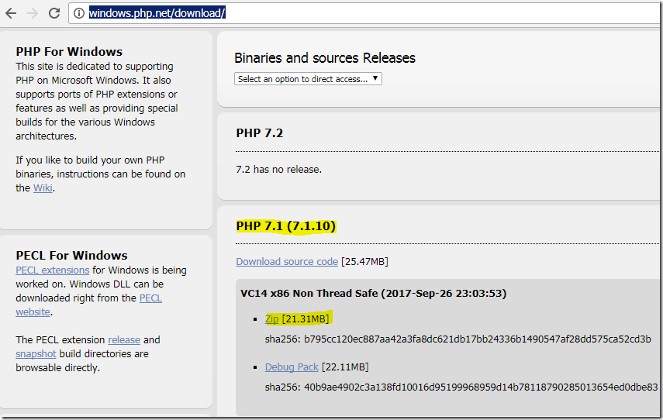](https://www.assistanz.com/wp-content/uploads/2017/09/image-20.png)

* Extract the ZIP file to **C:\program files** folder.

[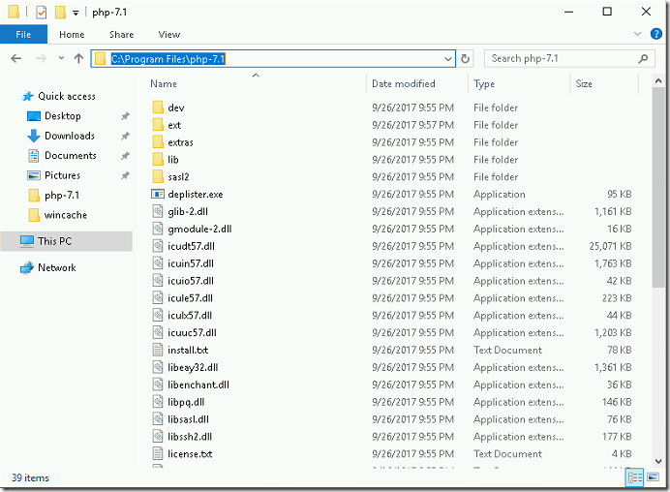](https://www.assistanz.com/wp-content/uploads/2017/09/image-21.png)

* There will be two PHP.ini files are available in that folder. Rename the **php-.ini-development** to **php.ini.**

[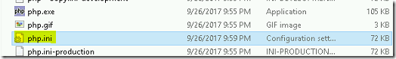](https://www.assistanz.com/wp-content/uploads/2017/09/image-22.png)

* Open the **php.ini** file Add the following line at the end of the file.

**extension=php_wincache.dll**

[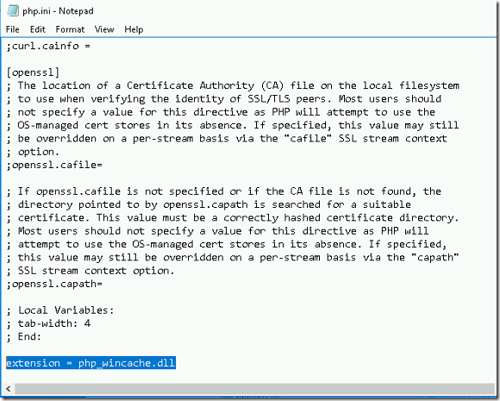](https://www.assistanz.com/wp-content/uploads/2017/09/image-23.png)

* Save and close the php.ini file.

* Right-click on the windows start menu and click on system.

[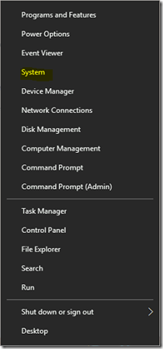](https://www.assistanz.com/wp-content/uploads/2017/09/image-24.png)

* Click on Advanced system settings.

[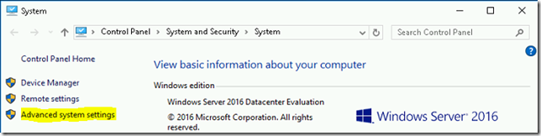](https://www.assistanz.com/wp-content/uploads/2017/09/image-25.png)

* Click on Environment Variables.

[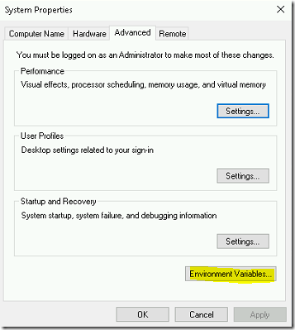](https://www.assistanz.com/wp-content/uploads/2017/09/image-26.png)

* Under System Variables, select path variable and click on Edit.

[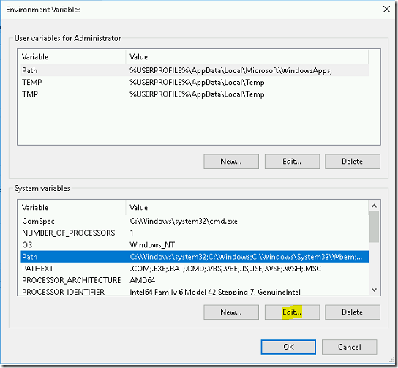](https://www.assistanz.com/wp-content/uploads/2017/09/image-27.png)

* Click on New button and add the PHP binary path.

[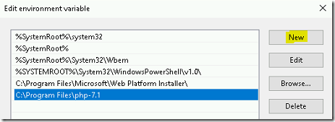](https://www.assistanz.com/wp-content/uploads/2017/09/image-28.png)

* Click **OK** thrice to close the system properties window.

**INSTALL WINCACHE EXTENSION**

* Browse the below URL to download the Wincache extension for PHP.

<https://www.iis.net/downloads/microsoft/wincache-extension>

[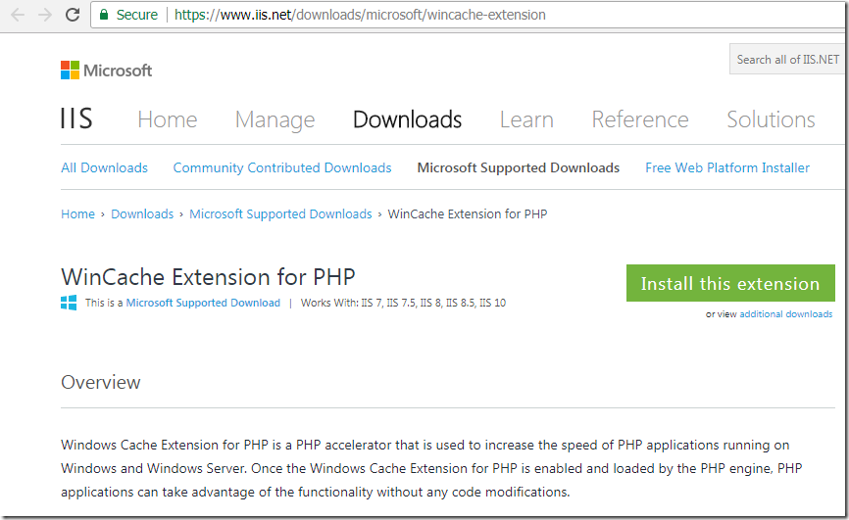](https://www.assistanz.com/wp-content/uploads/2017/09/image-29.png)

* Scroll down and download **WinCache 2.0 for PHP 7.1** under download section.

[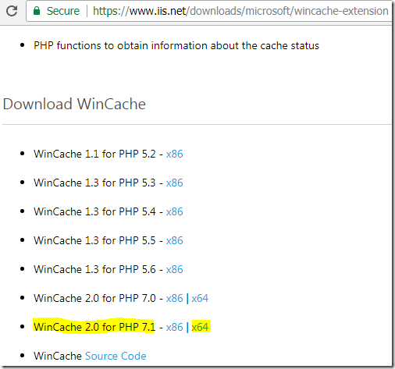](https://www.assistanz.com/wp-content/uploads/2017/09/image-30.png)

***Note : In this demo, we are installing PHP 7.1, so we are downloading corresponding wincache version***

* Once you download, double-click on the **wincache-2.0.0.8-dev-7.1-nts-vc14-x64.exe** file and extract the files to a folder.

[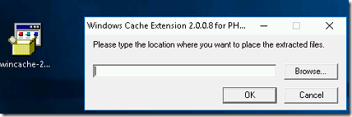](https://www.assistanz.com/wp-content/uploads/2017/09/image-31.png)

[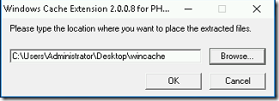](https://www.assistanz.com/wp-content/uploads/2017/09/image-32.png)

[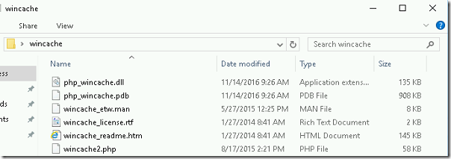](https://www.assistanz.com/wp-content/uploads/2017/09/image-33.png)

* Copy the **php.wincache.dll** file to **C:\Program Files\php-7.1\ext** folder.

[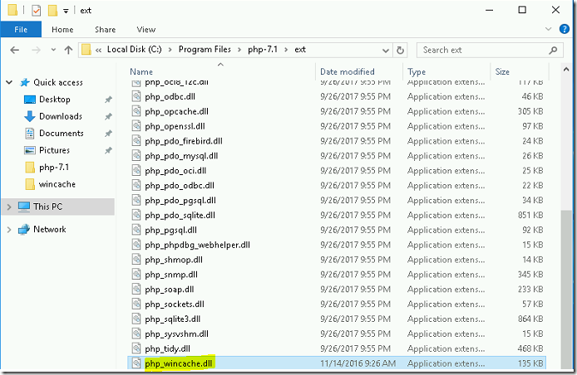](https://www.assistanz.com/wp-content/uploads/2017/09/image-34.png)

**CONFIGURE PHP IN IIS**

* Open IIS snap-in and click on the server name.

[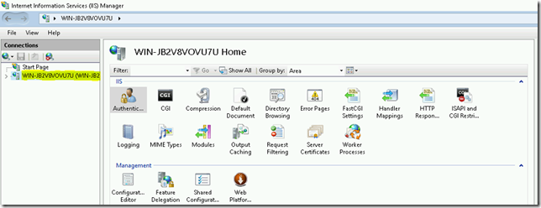](https://www.assistanz.com/wp-content/uploads/2017/09/image-35.png)

* Double click on **Handler Mappings** icon.

[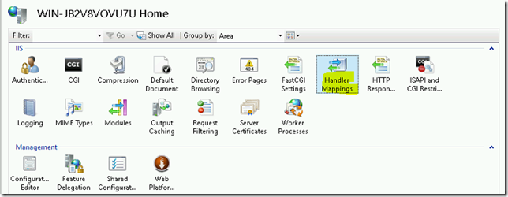](https://www.assistanz.com/wp-content/uploads/2017/09/image-36.png)

* Click on **Add Module Mapping…** under actions menu.

[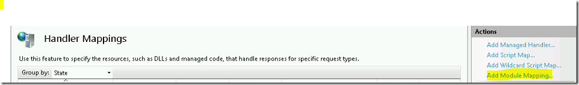](https://www.assistanz.com/wp-content/uploads/2017/09/image-37.png)

* Provide the below information as shown below. And click on Request Restrictions, under Mapping make sure you have select the **File or Folder** button.

[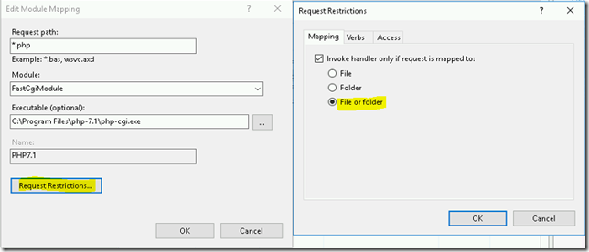](https://www.assistanz.com/wp-content/uploads/2017/09/image-38.png)

* Click OK twice to close configuration window. Now the PHP will be listed under Handler Mappings List.

[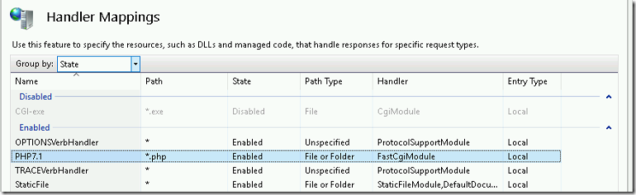](https://www.assistanz.com/wp-content/uploads/2017/09/image-39.png)

**INSTALLING VC++**

* Browse the below URL and download the Microsoft Visual C++ 2015 Redistributable Update 3 RC package.

<https://www.microsoft.com/en-us/download/details.aspx?id=52685>

[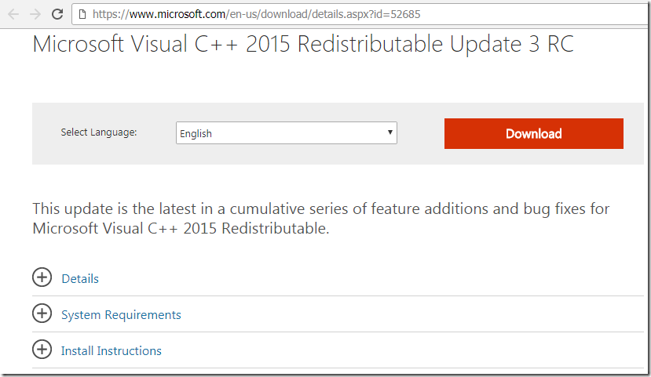](https://www.assistanz.com/wp-content/uploads/2017/09/image-43.png)

* Click on Download and select **vc_redist.x86.exe** and click Next.

[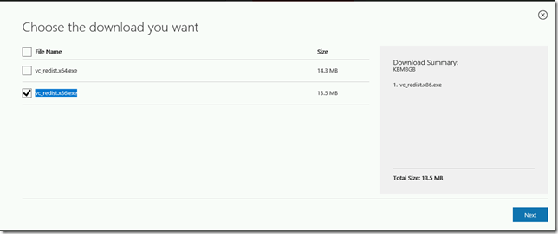](https://www.assistanz.com/wp-content/uploads/2017/09/image-44.png)

* Once the download is complete, double-click on the **vc_redist.x86.exe** file. Accept the License Agreement and click on Install button.

[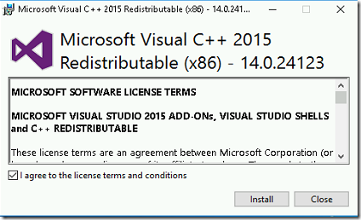](https://www.assistanz.com/wp-content/uploads/2017/09/image-45.png)

* Once the installation is successful click on close button.

**VERIFYING PHP**

* To Verify the PHP extension, place a file named phpinfo.php in your root folder of IIS website and add the below lines in that file.

**<?php  
phpinfo();  
?>**

[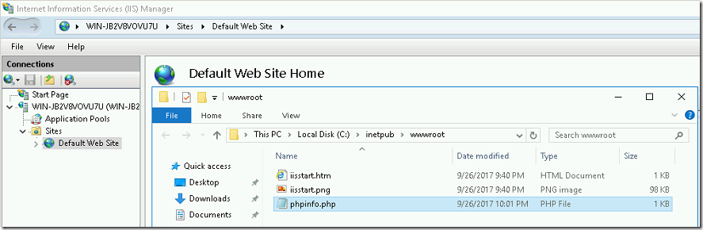](https://www.assistanz.com/wp-content/uploads/2017/09/image-40.png)

[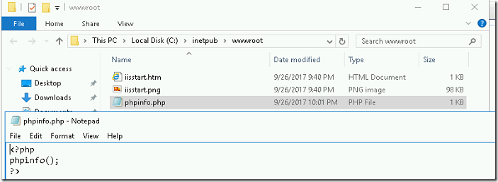](https://www.assistanz.com/wp-content/uploads/2017/09/image-41.png)

* Open the web browser and access the URL <http://localhost/phpinfo.php> and able to see the PHP configuration information.

[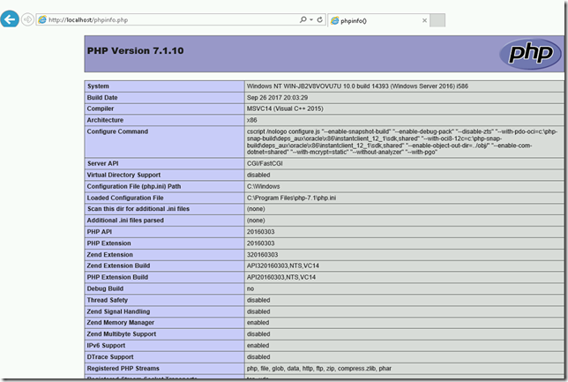](https://www.assistanz.com/wp-content/uploads/2017/09/image-42.png)