* One morning, when Gregor Samsa woke from troubled dreams, he found himself transformed in his bed a horrible vermin. He lay on his ar-mour-like back, and if he lifted his head a little he could see his brown belly, slightly domed and divided by arches into stiff sections.
* WHO&WHY

The gentlemen who rented the room would sometimes take their evening meal at home in the living room that was used by everyone, and so the door to this room was often kept in the evening. But Gregor found it easy to give up having the door open, he had, after all, often failed to make use of it when it was open and, without the family having noticed it, lain in his room in its darkest corner. One time, though, the charwoman left the door.

* An Wow Feature. The gentlemen who rented the room would sometimes take their evening meal at home in the living.
* A Beautiful Feature. The gentlemen who rented the room would sometimes take their evening meal at home in the living.
* An Amazing Feature. The gentlemen who rented the room would sometimes take their evening meal at home in the living.
* Featured Articles. The gentlemen who rented the room would sometimes take their evening meal at home in the living room that was used by everyone, and so the door to this room was often kept closed in the.
* Comic. A million ways to die in the wild wild wild west
* Lifestyle. The most comfortable chair comes with no backpain
* Travel. Journey to the center of the earth with Jefferson
* Portfolio & Screenshots

The gentlemen who rented the room would sometimes take their evening meal at home in the living room that was used by everyone, and so the door to this room was often kept in the

* “ Happiness cannot be traveled to, owned, earned, or worn. It is the spiritual experience of living every minute with love, grace & gratitude.
* A new product is coming

The office assistant was the boss’s man, spineless, and with no understanding. What about if he reported sick? But that would be extremely strained and suspicious as in fifteen years of service Gregor had never.

padding: 300px 20px 182px 20px;

let num = 6 + 4;

let vcs = "Labas";

let relationship = (vcs == num);

console.log(num + ", " + vcs + ", " + typeof(vcs) + ", " + relationship);

console.log(`${num}, ${vcs}, ${typeof(vcs)}, ${relationship}`);

let firstName = "Andra";

let lastName = "Šakenė";

let introduction = firstName + " " + lastName;

console.log(introduction);

let tekstas = "Pirmas";

// tekstinės eilutės ilgis

console.log(tekstas.length);

//didžiosiomis raidėmis

console.log(tekstas.toUpperCase());

//mažosiomis raidėmis

console.log(tekstas.toLowerCase());

//išveda nurodytą tekstinės eilutės simbolį pagal eilutę

console.log(tekstas.charAt(1));

//išveda ieškomos raidės ar žodžio pradžios poziciją eilutėje

console.log(tekstas.indexOf("ma"));

tekstas ="čia gali būti jūsų reklama";

//pakeičia nurodytą eilutės dalį į naują

console.log(tekstas.replace("gali būti", "yra"));

//išveda atitinkamą eilutės dalį pagal mūsų nurodytas pozicijas

console.log(tekstas.substring(4, 14));

console.log(tekstas.substring(14));

console.log(tekstas.substr(4, 9));

// ir vienas ir kitas

let metai = 2001;

if(metai < 2010 && metai > 1990) {

console.log("tai buvo senaiai");

} else {

console.log("tai buve=o neseniai");

}

\*,

\*::before,

\*::after {

box-sizing: border-box;

}

html {

font-size: 14px;

font-family: 'Francois One', sans-serif;

}

body {

margin:0;

}

/\* HEADER \*/

.site-header {

background-image: url("../images/firstone.jpg");

background-repeat: no-repeat;

width:100%;

display:block;

}

.container {

max-width:1170px;

width:100%;

margin: 0 auto;

padding: 0 20px;

}

.flex-container {

display:flex;

}

.site-header .container {

justify-content: space-between;

align-items: center;

}

.main-nav li {

list-style: none;

}

.main-nav a {

color: #000;

text-transform:uppercase;

text-decoration: none;

font-size: 1rem;

margin:0 10px;

}

.logo {

padding: 55px 0;

}

.top-container {

text-align: right;

color:#000;

padding-top:100%;

}

section > .container {

padding:181px 165px;

}

.top-container h1 {

font-size: 3.36rem;

letter-spacing: 0.05;

text-transform:uppercase;

}

.top-container h1:after {

content:"";

display:block;

width: 90px;

border-top: 4px solid #14a58c;

margin: 22px auto;

}

padding: 0 165px;

max-width: 970px;

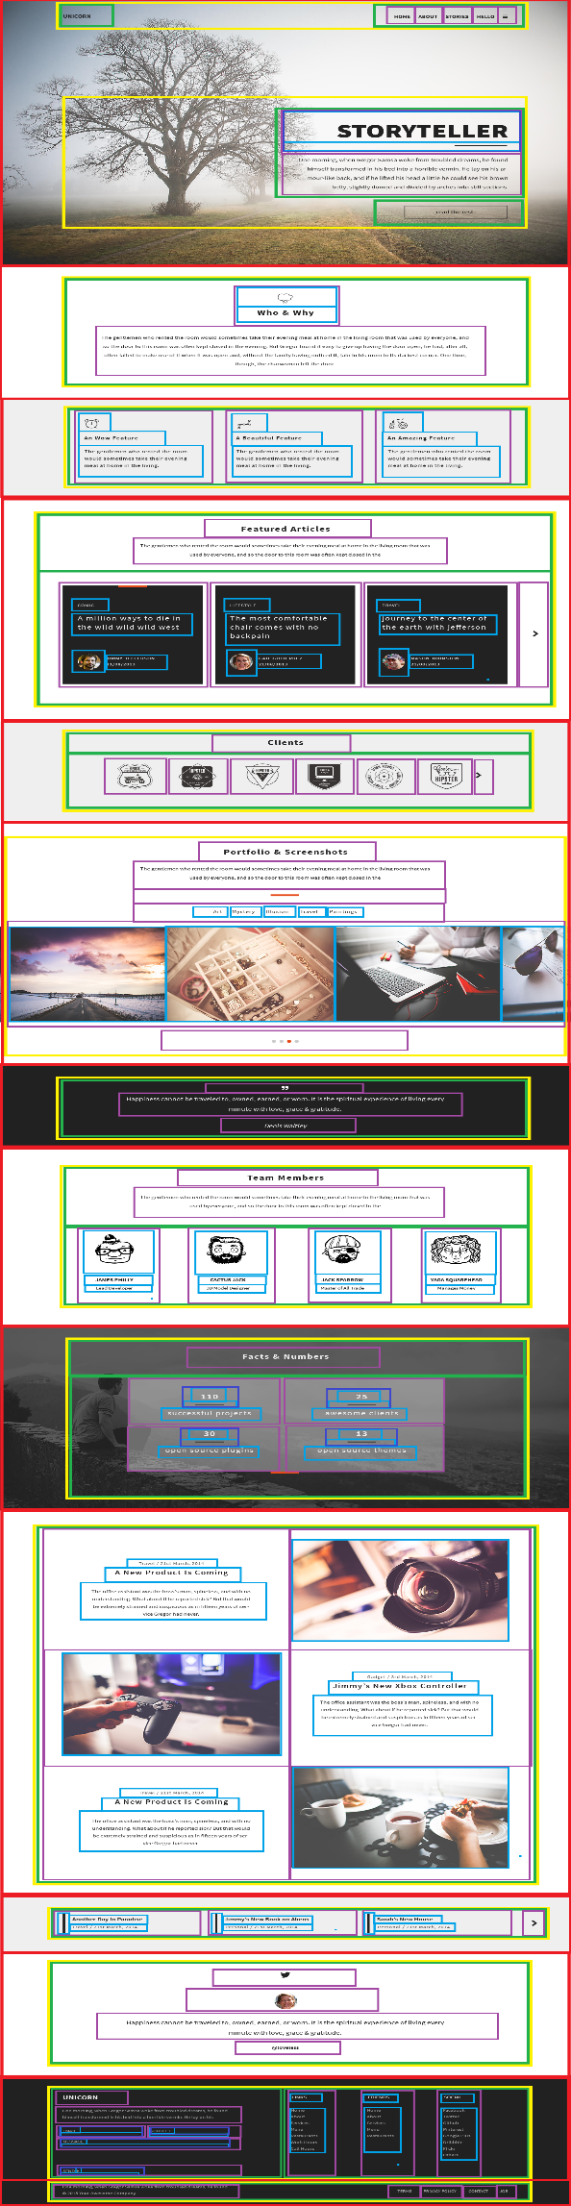žžžžžžžžžžžžžžžžžžžžžžžžžžžžžžžžžžžžžžžžžžžžžžžžžžžžžžžžžžžžžžžžžžžžžžžžžžžžžžžžžžžžžžžžžžžžžžž[[[[[[[[[[[[