**Meeting Agenda**

**Date:** *Wednesday, Dec. 15, 2021* **| Time:** *12:30 PM EST*   **| Location:** *Zoom* <https://zoom.us/j/9746683778>

We wanted to send you an agenda prior to our meeting **today at @ 12:30 PM EST** so that you have an idea of what to expect.  
  
Points that will be discussed during the meeting:

**Google Ads**  
  
***Discussion:***

* **Tracking Inconsistencies -** Why are salesforce leads lower than the number of leads generated from Google Ads?
  + Forms - Underreported - has GA Connector
  + Calls - Underreported - does not currently have GA Connector so would not be tagged correctly.
  + Potential causes:
    - UTM issues
    - Process issues (leads how they’re entered into salesforce, mainly from calls, or live chat potentially)
    - Tech issue, possible there’s a pixel issue, either overcounted, or somehow the forms aren’t being logged.
* **GA Connector + CallRail** - GA Client ID fixes - Salesforce set up, needs Josh to Link the ID now.
* **Salesforce GA Connector Fixes** - Need Josh Update - Josh to set up a call w/ GA Connector - Josh - follow up.

***Completed Tasks: (***[***search plan link***](https://docs.google.com/spreadsheets/d/1a93fM5pT_jzSZgfuEwgHe-hGon-Z9UDawYoZb-yJm4A/edit?ts=60630013#gid=1467554408)***)***

* Commercial KW Build
* New Year Copy - RES: “The new year’s the perfect opportunity to upgrade your home tiles.” | COM: “Shop Architessa’s Latest tiles for 2022.” - Delivery by EOW or early next week.
* COM campaign Launches

***Upcoming Tasks:***

* Performance Max Testing
* Budget Prep for Q1
* Search Query / Negative Optimization
* Dynamic Campaigns - DSA - Finding a good opportunity for this

**On Hold**

* Campaign Retesting
  + Look - Week 3
  + Finish - Week 4
  + Color - Week 3
    - Green & Blue tiles are strong
* Display Campaigns for Competitors
* Outdoor - Outside Expansion (lower priority)
* [Youtube Testing](https://drive.google.com/file/d/1MD7sc6_URKUrdJh1RNhvwtnbZ8gfroAr/view) - $500 Test - Separated - Dashboard Updates - Videos in September (or October) from Architessa
* [**Local Inventory Ads**](https://support.google.com/merchants/answer/7023001) + **Offline Conversions - Revisit by: Nov 1**
* Offline Conversions will require some figuring out to work with GA Connector.

[Data Studio Link](https://datastudio.google.com/u/1/reporting/e55498c9-4305-4998-929e-2298457401f1/page/qlD)

***GAD Last 7 vs Previous***

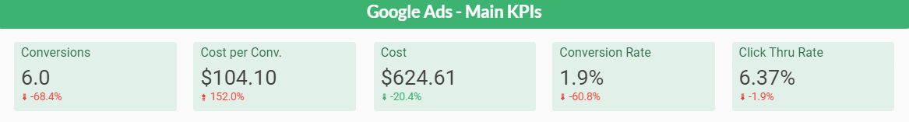***GAD Last 14 vs Previous***

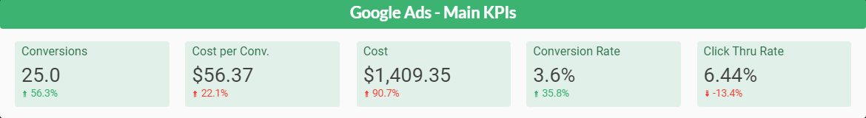

***GAD Last 30 vs Previous  
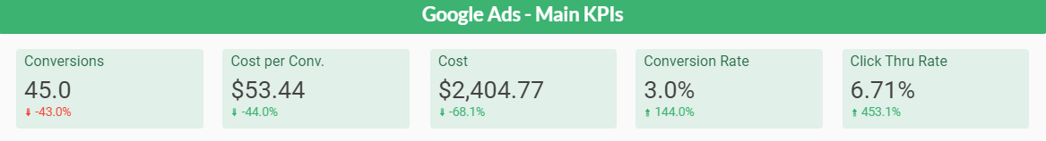***

***Top Campaigns From Launch***

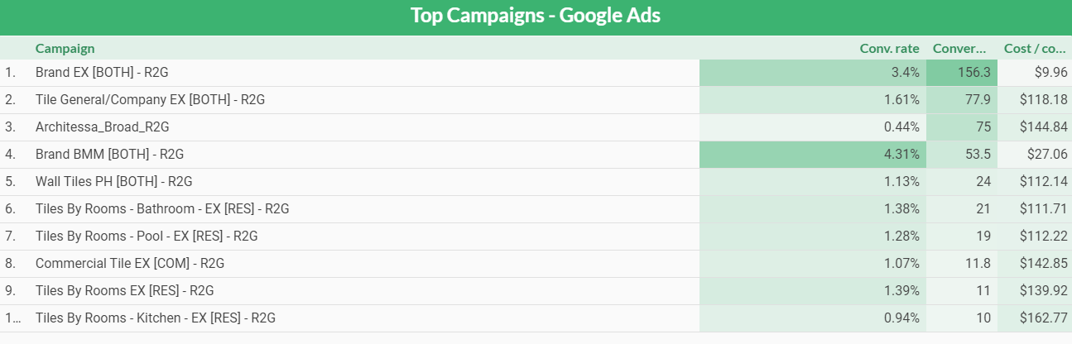

**Good News**

* General Tile terms continue to perform well, but CPA is increasing a bit.

**Bad News**

* Conversion Volume is down due to seasonality
* CPA this week has increased as we’ve lost some ground on Branded searches, and most other product level campaigns haven’t driven a conversion this week.

**Facebook Ads**

**Hi guys I tried to get something more visual to try and get an idea of where we are compared to previous weeks and months**

[**DataStudio Link**](https://datastudio.google.com/s/tq0b9WCbnkQ)

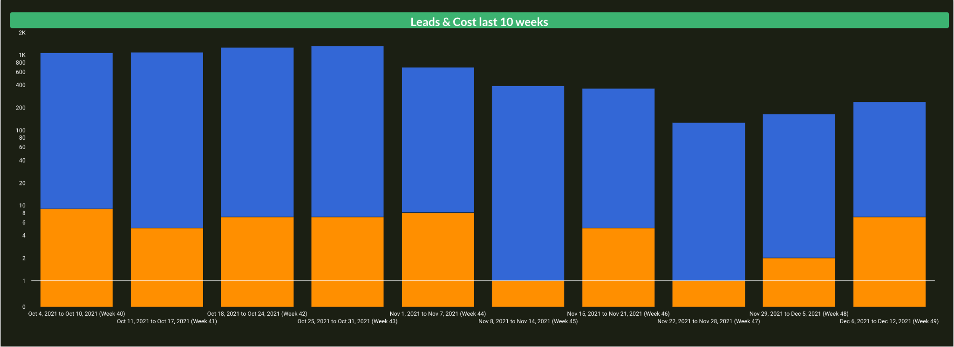

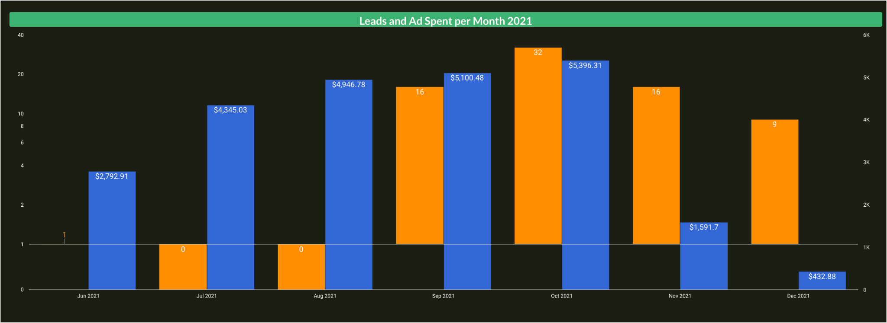

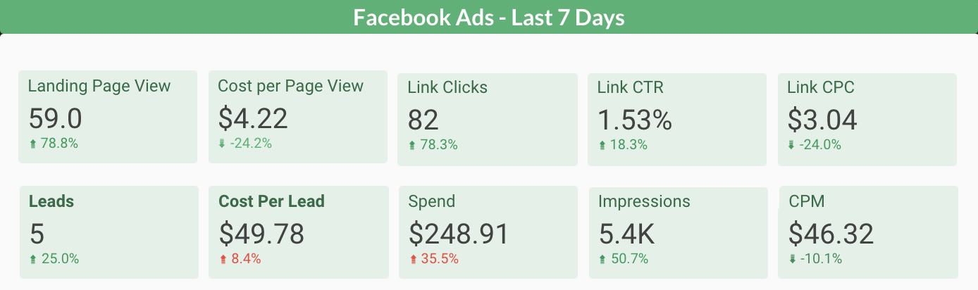

**Last 7 Days**

**Amount Spent: $248.91**

**LP Views: 59**

**Cost P LP View: $4.22**

**Leads: 5(4 in Salesforce)**

**Cost Per Lead: $49.78**

**Notes**

* We have seen 5 Leads from Facebook and 4 in Salesforce
* Leads are still coming at a very good price and quantity.
* We have launched the October Ads and already have 1 Lead from them so that is good news

**Best Performing Ads:**

**September Video Ad is the Top performer with 4 Leads the last 7 Days**



**Next Steps**

* Launch a new Interest combined with LLA to test, these have been performing very well lately
* We are still scaling back to make sure we achieve our budget goal for December
* Create new ads as soon as Nov/Dec creatives are approved

**Design Update**

**Current Projects**

* **Edits from design session with Courtney and team will be ready for review EOD 12/15 - look out for email.**
  + Do we need to send to Betty for approval? No. Could change. - via Courtney & Julie
* Following up on approved language from Elise for creatives:
  + General Ads
  + Metal Matrix - currently using “Color saturated maximalist design.”

**Weekly Summary Ad Spend**

| ***Google*** | $668.76 |
| --- | --- |
| ***Microsoft*** |  |
| ***Facebook*** | 1309$1309 1264 |
| ***Pinterest*** | $ 420.00 |
| ***TOTAL*** | $3453.02 |

Full monthly spend since April 2021: <https://docs.google.com/spreadsheets/d/1fVUesL4NFT5dJhx4-VbxJ8e4XkjqAOtwTEXJgAJl03s/edit?usp=sharing>

Video:

<https://share.vidyard.com/watch/NKcyc5cBTfwh3GAfhfR8Zr>