# HARDWARE COMPOMENTS USED

## MICROCONTROLLERS. DEFINITION. STRUCTURE.

“ A microcontroller (or MCU for microcontroller unit) is a small computer on a single integrated circuit. In modern terminology, it is similar to, but less sophisticated than, a system on a chip or SoC; an SoC may include a microcontroller as one of its components. A microcontroller contains one or more CPUs (processor cores) along with memory and programmable input/output peripherals. Program memory in the form of ferroelectric RAM, NOR flash or OTP ROM is also often included on chip, as well as a small amount of RAM. Microcontrollers are designed for embedded applications, in contrast to the microprocessors used in personal computers or other general purpose applications consisting of various discrete chips.

Microcontrollers are used in automatically controlled products and devices, such as automobile engine control systems, implantable medical devices, remote controls, office machines, appliances, power tools, toys and other embedded systems. By reducing the size and cost compared to a design that uses a separate microprocessor, memory, and input/output devices, microcontrollers make it economical to digitally control even more devices and processes. Mixed signal microcontrollers are common, integrating analog components needed to control non-digital electronic systems.

Some microcontrollers may use four-bit words and operate at frequencies as low as 4 kHz, for low power consumption (single-digit milliwatts or microwatts). They will generally have the ability to retain functionality while waiting for an event such as a button press or other interrupt; power consumption while sleeping (CPU clock and most peripherals off) may be just nanowatts, making many of them well suited for long lasting battery applications. Other microcontrollers may serve performance-critical roles, where they may need to act more like a digital signal processor (DSP), with higher clock speeds and power consumption.”[ <https://en.wikipedia.org/wiki/Microcontroller>]

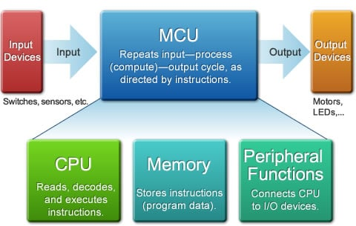

Figure Microcontroller structure

CPU: The "Thinker"

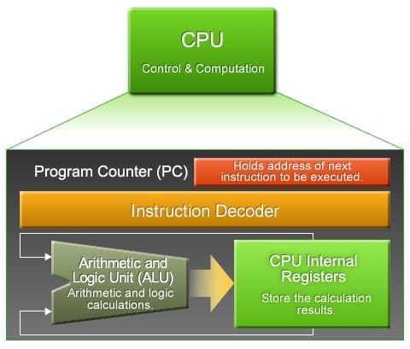

Figure Role of the CPU

* “ Program Counter (PC)

The program counter (PC) is an internal register that stores the memory address of the next instruction for the CPU to execute. By default, the PC value is automatically incremented each time an instruction executes. The PC starts at 0000, so the CPU starts program execution with the instruction at address 0000. As the instruction executes, the PC automatically advances to 0001. The CPU then executes the instruction at 0001, the PC advances again, and the process continues, moving sequentially through the program.

* Instruction Decoder

The decoder circuitry decodes each instruction read from the memory, and uses the results to drive the MCU’s arithmetic and operational circuitry. An actual decoder is a somewhat more complicated version of the decoder circuitry we studied in the session titled "Introduction to Digital Circuits-Part 2". It restores the encoded instructions to their original, unencoded form.

* Arithmetic and Logic Unit (ALU)

This circuitry carries out arithmetic and logical operations. Arithmetic operations include addition and multiplication; logic operations include AND, OR, and bit shifts. The ALU is controlled by the instruction decoder. In general, the ALU consists of a complex combination of circuits.

* CPU Internal Registers

These registers store transient information. General-purpose registers hold results of arithmetic and logical operations, whereas specialized registers store specific types of information—such as a flag register, which stores flag values (carry flag, etc.). When the ALU performs an operation, it does not operate directly on values in memory; instead, the data at the specified memory address is first copied into a general-purpose register, and the ALU uses the register content for the calculation.

Memory: The "Store"

The MCU’s memory is used to store program code and data. There are two main types of memory: ROM and RAM.

* ROM (Read-only memory)

This memory retains its content even while power is off. This memory is for reading only; it cannot be erased or overwritten. ROM is typically used to store the start-up program (executed immediately after power-on or reset), and to store constant values that may be freely accessed by running programs.

Many Renesas MCUs use flash memory in place of ROM. Like ROM, flash memory retains its content even while power is off. Unlike ROM, this content can be overwritten.

* RAM (Random-access memory)

This memory can be freely rewritten. Its disadvantage is that it loses its content when the power goes off. This memory is mainly used to store program variables.

Many single-chip MCUs (*1) use static RAM (SRAM) for their internal RAM. SRAM offers two advantages it supports faster access, and it does not require periodic refreshment. The disadvantage is that the internal circuitry is complex, making it difficult to pack large quantities on the chip’s limited space. SRAM is not suitable for implementing large memory sizes.

The alternative to SRAM is DRAM (dynamic RAM). The simple structure of DRAM allows large quantities to be mounted in small spaces; typical DRAM sizes are much bigger than typical SRAM sizes. But it is difficult to form DRAM together with high-speed logic on a single wafer. For this reason, DRAM is generally not used within single-chip MCUs. Instead, it is typically connected to the chip and treated as peripheral circuitry.

(*1) An MCU implemented on a single LSI (large scale integration) chip. The chip holds the CPU, some ROM, some RAM, oscillator circuitry, timer circuitry, serial interfacing, and other components. If the chip also includes the system’s main peripheral circuitry, it is called a "system LSI." “

[https://www.renesas.com/en-us/support/technical-resources/engineer-school/mcu-01-basic-structure-operation.html]

“ List of common microcontrollers

*  Renesas Electronics
* Atmel
* NXP Semiconductors
* Intel
* PIC “

[https://en.wikipedia.org/wiki/List_of_common_microcontrollers]

### ATmega2560 microcontroller

“The high-performance, low-power Microchip 8-bit AVR RISC-based microcontroller combines 256KB ISP flash memory, 8KB SRAM, 4KB EEPROM, 86 general purpose I/O lines, 32 general purpose working registers, real time counter, six flexible timer/counters with compare modes, PWM, 4 USARTs, byte oriented 2-wire serial interface, 16-channel 10-bit A/D converter, and a JTAG interface for on-chip debugging. The device achieves a throughput of 16 MIPS at 16 MHz and operates between 4.5-5.5 volts.

By executing powerful instructions in a single clock cycle, the device achieves a throughput approaching 1 MIPS per MHz, balancing power consumption and processing speed.

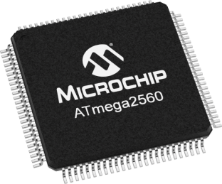

Figure ATmega2560 microcontroller

Parametrics

* Program Memory Type: Flash
* Program Memory Size (KB): 256
* CPU Speed (MIPS/DMIPS): 16
* SRAM Bytes: 8,192
* Data EEPROM/HEF (bytes): 4096
* Digital Communication Peripherals: 4-UART, 5-SPI, 1-I2C
* Capture/Compare/PWM Peripherals: 4 Input Capture, 4 CCP, 16PWM
* Timers: 2 x 8-bit, 4 x 16-bit
* Number of Comparator: 1
* Temperature Range (C): -40 to 85
* Operating Voltage Range (V): 1.8 to 5.5
* Pin Count: 100” [https://www.microchip.com/wwwproducts/en/ATmega2560]

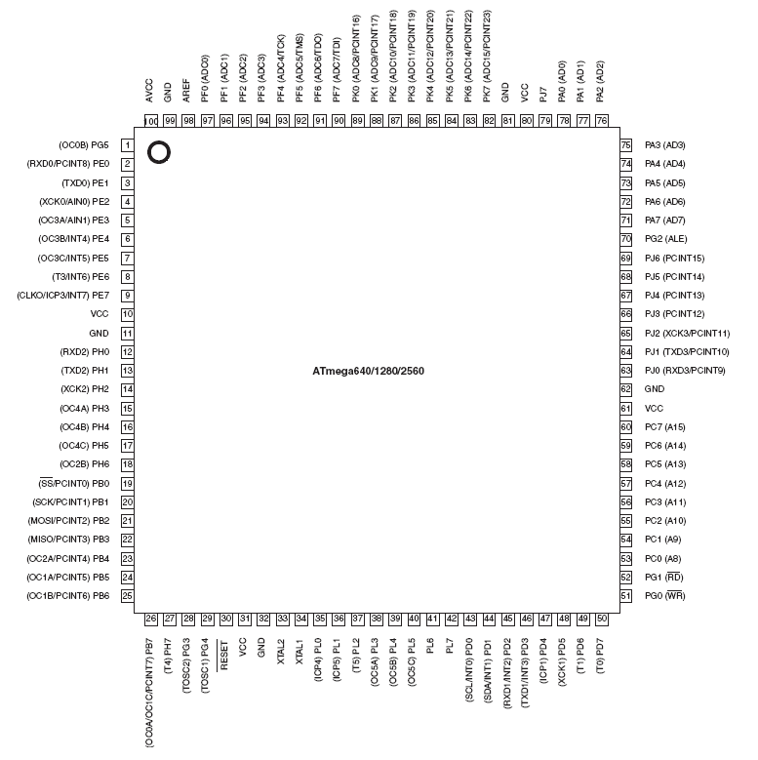

Figure ATmega2560 pin configuration

### Arduiono microcontrollers

“Arduino is an open-source electronics platform based on easy-to-use hardware and software. Arduino boards are able to read inputs - light on a sensor, a finger on a button, or a Twitter message - and turn it into an output - activating a motor, turning on an LED, publishing something online. You can tell your board what to do by sending a set of instructions to the microcontroller on the board. To do so you use the Arduino programming language (based on Wiring), and the Arduino Software (IDE), based on Processing.

Over the years Arduino has been the brain of thousands of projects, from everyday objects to complex scientific instruments. A worldwide community of makers - students, hobbyists, artists, programmers, and professionals - has gathered around this open-source platform, their contributions have added up to an incredible amount of accessible knowledge that can be of great help to novices and experts alike.

Arduino was born at the Ivrea Interaction Design Institute as an easy tool for fast prototyping, aimed at students without a background in electronics and programming. As soon as it reached a wider community, the Arduino board started changing to adapt to new needs and challenges, differentiating its offer from simple 8-bit boards to products for IoT applications, wearable, 3D printing, and embedded environments. All Arduino boards are completely open-source, empowering users to build them independently and eventually adapt them to their particular needs. The software, too, is open-source, and it is growing through the contributions of users worldwide.



Figure Arduino Logo

Arduiono boards:

*  Arduino UNO (Atmega328);
* Arduino Mega (Arduino Mega2560):
* Arduino Leonardo (Atmega32u4);
* Arduino Diecimila (Atmega168);
* Arduino Nano (Atmega328);
* Arduino Duemilavove (Atmega168); “ [https://www.arduino.cc/en/Guide/Introduction]

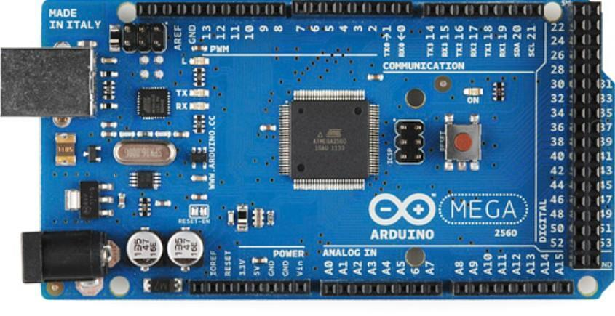

Figure Arduino Mega2560 board

## SENSORS

“In the broadest definition, a sensor is a device, module, or subsystem whose purpose is to detect events or changes in its environment and send the information to other electronics, frequently a computer processor. A sensor is always used with other electronics, whether as simple as a light or as complex as a computer.

Sensors are used in everyday objects such as touch-sensitive elevator buttons (tactile sensor) and lamps which dim or brighten by touching the base, besides innumerable applications of which most people are never aware.

With advances in micromachinery and easy-to-use microcontroller platforms, the uses of sensors have expanded beyond the traditional fields of temperature, pressure or flow measurement,[1] for example into MARG sensors. Moreover, analog sensors such as potentiometers and force-sensing resistors are still widely used. Applications include manufacturing and machinery, airplanes and aerospace, cars, medicine, robotics and many other aspects of our day-to-day life.

A sensor's sensitivity indicates how much the sensor's output changes when the input quantity being measured changes. For instance, if the mercury in a thermometer moves 1 cm when the temperature changes by 1 °C, the sensitivity is 1 cm/°C (it is basically the slope Dy/Dx assuming a linear characteristic). Some sensors can also affect what they measure; for instance, a room temperature thermometer inserted into a hot cup of liquid cools the liquid while the liquid heats the thermometer. Sensors are usually designed to have a small effect on what is measured; making the sensor smaller often improves this and may introduce other advantages.[2] Technological progress allows more and more sensors to be manufactured on a microscopic scale as microsensors using MEMS technology. In most cases, a microsensor reaches a significantly higher speed and sensitivity compared with macroscopic approaches.[3][4]”[ https://en.wikipedia.org/wiki/Sensor]

1. Bennett, S. (1993). A History of Control Engineering 1930–1955. London: Peter Peregrinus Ltd. on behalf of the Institution of Electrical Engineers. [*ISBN*](https://en.wikipedia.org/wiki/International_Standard_Book_Number) [*0-86341-280-7*](https://en.wikipedia.org/wiki/Special:BookSources/0-86341-280-7)<The source states "controls" rather than "sensors", so its applicability is assumed. Many units are derived from the basic measurements to which it refers, such as a liquid's level measured by a differential pressure sensor.>
2. [**Jump up^**](https://en.wikipedia.org/wiki/Sensor#cite_ref-2) Jihong Yan (2015). [*Machinery Prognostics and Prognosis Oriented Maintenance Management*](https://books.google.com/books?id=LbzlBQAAQBAJ&pg=PA107). Wiley & Sons Singapore Pte. Ltd. p. 107.
3. [**Jump up^**](https://en.wikipedia.org/wiki/Sensor#cite_ref-3) Jihong Yan (2015). [*Machinery Prognostics and Prognosis Oriented Maintenance Management*](https://books.google.com/books?id=LbzlBQAAQBAJ&pg=PA108). Wiley & Sons Singapore Pte. Ltd. p. 108.
4. [**Jump up^**](https://en.wikipedia.org/wiki/Sensor#cite_ref-4) Ganesh Kumar. [*Modern General Knowledge*](https://books.google.com/books?id=DbnFSqKSVb0C&pg=PA194). Upkar Prakashan. p. 194. [*ISBN*](https://en.wikipedia.org/wiki/International_Standard_Book_Number) [*81-7482-180-5*](https://en.wikipedia.org/wiki/Special:BookSources/81-7482-180-5).

“Classification of Sensors

There are several classifications of sensors made by different authors and experts. Some are very simple and some are very complex. The following classification of sensors may already be used by an expert in the subject but this is a very simple classification of sensors.

In the first classification of the sensors, they are divided in to Active and Passive. Active Sensors are those which require an external excitation signal or a power signal.

Passive Sensors, on the other hand, do not require any external power signal and directly generates output response.

The other type of classification is based on the means of detection used in the sensor. Some of the means of detection are Electric, Biological, Chemical, Radioactive etc.

The next classification is based on conversion phenomenon i.e. the input and the output. Some of the common conversion phenomena are Photoelectric, Thermoelectric, Electrochemical, Electromagnetic, Thermooptic, etc.

The final classification of the sensors are Analog and Digital Sensors. Analog Sensors produce an analog output i.e. a continuous output signal with respect to the quantity being measured.

Digital Sensors, in contrast to Analog Sensors, work with discrete or digital data. The data in digital sensors, which is used for conversion and transmission, is digital in nature.

Different Types of Sensors

The following is a list of different types of sensors that are commonly used in various applications. All these sensors are used for measuring one of the physical properties like Temperature, Resistance, Capacitance, Conduction, Heat Transfer etc.

* Temperature Sensor
* Proximity Sensor
* Accelerometer
* IR Sensor (Infrared Sensor)
* Pressure Sensor
* Light Sensor
* Ultrasonic Sensor
* Smoke, Gas and Alcohol Sensor
* Touch Sensor
* Color Sensor
* Humidity Sensor
* Tilt Sensor
* Flow and Level Sensor” [https://www.electronicshub.org/different-types-sensors/]

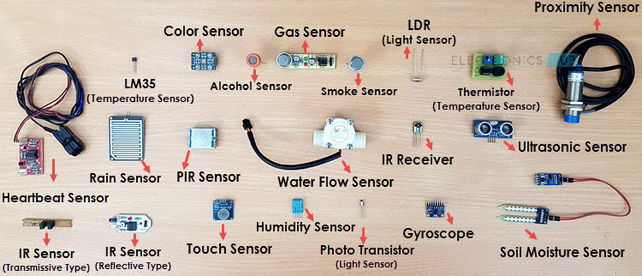

Figure Different types of sensors

### Temperature Sensor

One of the most common and most popular sensor is the Temperature Sensor. A Temperature Sensor, as the name suggests, senses the temperature i.e. it measures the changes in the temperature.

In a Temperature Sensor, the changes in the Temperature correspond to change in its physical property like resistance or voltage.

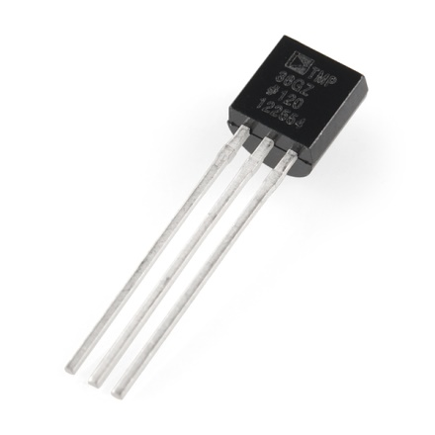There are different types of Temperature Sensors like Temperature Sensor ICs (like LM35), Thermistors, Thermocouples, RTD (Resistive Temperature Devices), etc.

Temperature Sensors are used everywhere like computers, mobile

phones, automobiles, air conditioning systems, industries etc.

Figure 8 Temperature Sensor

Humidity Sensors

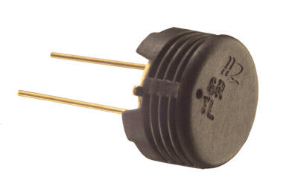“Humidity is the presence of water in air. The amount of water vapor in air can affect human comfort as well as many manufacturing processes in industries. The presence of water vapor also influences various physical, chemical, and biological processes. Humidity measurement in industries is critical because it may affect the business cost of the product and the health and safety of the personnel. Hence, **humidity sensing** is very important, especially in the control systems for industrial processes and human comfort.

F Figure 9 Humidity Sensor

Controlling or monitoring humidity is of paramount importance in many industrial & domestic applications. In semiconductor industry, humidity or moisture levels needs to be properly controlled & monitored during wafer processing. In medical applications, humidity control is required for respiratory equipment, sterilizers, incubators, pharmaceutical processing, and biological products. Humidity control is also necessary in chemical gas purification, dryers, ovens, film desiccation, paper and textile production, and food processing. In agriculture, measurement of humidity is important for plantation protection (dew prevention), soil moisture monitoring, etc. For domestic applications, humidity control is required for living environment in buildings, cooking control for microwave ovens, etc. In all such applications and many others, humidity sensors are employed to provide an indication of the moisture levels in the environment.” [https://www.engineersgarage.com/articles/humidity-sensor]