Notes

Introduction to ASP.NET Core 3.1

Now with ASP.NET Core that are 2 ways to build a web application:
- MVC application
- Razor Pages application

Basic CRUD website

Build 2 simple project:
- basic Razor project
- simple MVC project (main project)

Tools:
- Visual Studio
- .NET Core 3.1
- SQL Server 2019
- SQL Server Management Studio

Razor project

Egy masfajta megkozelites MVC-hez kepest.

Has two parts:
- Razor Page (UI/View)
- Page Model (Contains Handlers)

Oldalkozpontu megkozelites, ahol szorosan egymas mellett szerepel az oldal kodja es a PageModel

Index.cshtml – ez a Razor page/the UI of the application
Index.cshtml.cs – ez a model a fenti index razor page-nek
- ebben vannak ‘handlers’ amik olyanok mint a Controller action method-ok
- page model

Double click on the project name:
mainly it’s to reference all the NuGet packages and the target framework
this .csproj file replaces the earlier Core versions project.json and exproj files.
<targetframework> - is a node in this file. After adding more packages to the project, more nodes will be here. (if added a new Nuget package, a new package reference entry will be here)

Metapackage – it was in the earlier versions of Core included as a NuGet package, but now it’s discontinued and now it’s a part of the .NET Core Class Library

Properties folder
launchSettings.json file - it tells Visual Studio, what to do when we click the Run button
this can also be set in the Properties of the project, Debug menu option

wwwroot folder
all the static files will be placed here
this is the root folder for our website
no code files should be placed here!

Pages folder
this is the main folder inside any razor project
in Shared folder _Layout.cshtml is the default master page for the application

Routing in Razor Pages
how to match URL’s on the resources on the server?
The most straight forward answer is to map URLs to physical files on the disk - this approach was implemented for Razor pages framework
Razot pages needs a root folder
file extension should not be included in the URL path
Index.cshtml is a default document

Tag helpers
are new to ASP.NET core
it’s like Angular Directives, but the have differences
can use the regular html tag and can append a tag helper to it

HTML helpers are also for this reason, but they have not so really HTML friendly look

The Main method-ok
no global.asax anymore
startup now is determined by you. It starts with the program class file
the program.cs file contains a main method which is the entry point of the applicaton
the application initially starts as a command line application, the main method configures asp.net Core and starts it

Startup.cs
Dependency injection forms an integer part of ASP .NET Core.
ServiceCollection object is injected into the method as a parameter at public void ConfigureServices in Startup.cs
Examples of the possible services here: Entity Framework Core, Identity Services, MVC, and many more….
By default services.AddRazorPages() is added.

Public void Configure() - this method configures the HTTP request pipeline. The pipeline specifies how the application should response to HTTP request. Pipeline is composed of individual parts called middleware.
Middlewares can be Authentications, MVC, Static files… The order is important.
When the data travels to the pipeline, it gets manipulated from the individual middleware’s so as the request and the response.
Using the pipeline approach we only plug in the middlewares that we need. Everything we olug in is in a separate assembly exposed in a NuGet.
There are a few middlewares pluged in by default.
app.middlewarename is the synthax.

There are 2 webserver, one is external like IIS or APACHE or LINUX and there is also an internal webserver hosted by our application. Reqest from the external webserver are passed . Most common internal webserver is Kestrel.

Middleware in ASP.NET Core
Those pieces of code that handle the HTTP request and results the response make up the request pipeline.
We can configure this pipeline by adding middleware which are software components that are assembled into an application pipeline to handle reqest and response.
First the HTTP request which comes to the server is attached to a ‘context object’.
Every piece of pipeline checks it, and if no action needed passes to the next part. If at the end of the pipeline no response has been formed, and that will cause a 404 not found written back to whoever originated the request.
Any of the middleware pieces can form a response and send back. Not obligatory to pass forward always to the next middleware. But typically the context would go all the way to the pipeline to the end and the last piece of middleware sends a response.
The order of pipeline is important. It always gets passed from the first to the last!

AppSettings.json
All of the application settings are contained here.
Any settings to the AppSettings.json file will require restarting the “Microsoft IIS Administration” service to take effect.
Here will be ad the connection string!

Dependency Injection
ASP.NET Core support dependency injection software design pattern, which is acheieveng inversion of control between classes and their dependencies. (IOC – Inversion Of Control)
IOC container is a framework for implementing automatic dependency injection. It manages object creation and it’s lifetime and also injects dependencies to their class.
IOC container creates an object of specified class, and also injects all of the dependency objects through constructor, property, method at runtime and exposes it at appropriate time.
So we don’t have to create and manage the objects manually.
In ASP.NET Core, both framework services and application services can be injected into your classes, rather than being tightly coupled.
Dependency injection is a design pattern, in which a class or object has it’s dependent classes injected, rather than creating them directly. Dependency injection can help developers decouple the different pieces of their application.

Example:
We have 3 pages in our application and we need 3 functionalities in each page.
In classic days needed to create objects of the 3 function in all the 3 pages.

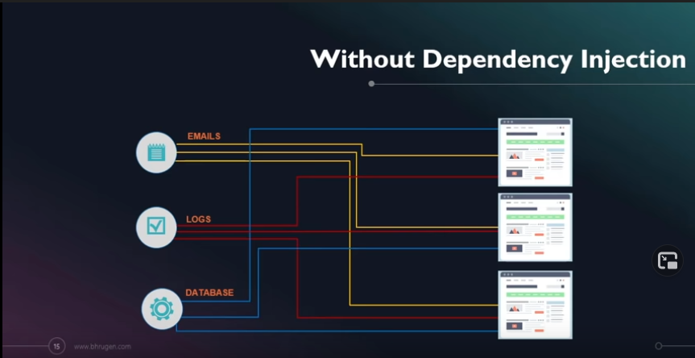
With dependeny injection, we have the dependency injection container. We will register all the 3 classes inside our container. Whenever any page will need anything we will directly extract that from the container rather then creating an object in individual pages. It’s created and registered in the container, we only have to use this. This way container deals creating, registering and exposing of the object rather then creating them in every page.
This is how efficient dependency injection is compared to the classic approach.

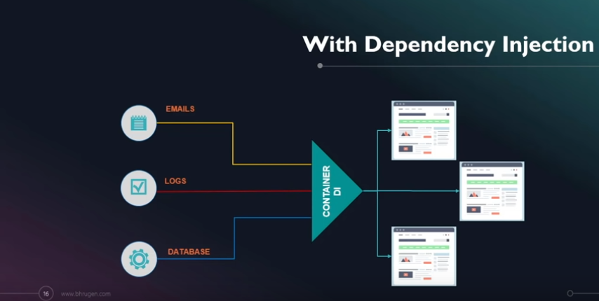

Book List Razor

First create the model and push it to the database.
After that will perform CRUD operations on book list.

Installing NuGet package
Installing the first NuGet package: to refresh website dynamically as we make the development
It’s a core package which is needed for developers.
Now auto-refresh for the view is separate package.
Microsoft.AspNetCore.MVC.Razor.RuntimeCompilation

Enable runtime compilation in an existing project
To enable runtime compilation for all environments in an existing project:
- Install the Microsoft.AspNetCore.Mvc.Razor.RuntimeCompilation NuGet package.
- Update the project's Startup.ConfigureServices method to include a call to AddRazorRuntimeCompilation. For example:
C#
public void ConfigureServices(IServiceCollection services)
{
services.AddRazorPages()
.AddRazorRuntimeCompilation();

// code omitted for brevity
}

Create first model
Models represent any table that we want in the database.
Add a new folder for Model, after that add a new class, called ‘Book’

Create database connection
Add packages:
- Microsoft.EntityFrameworkCore
- Microsoft.EntityFrameworkCore.SqlServer
- Microsoft.EntityFrameworkCore:Tools (required because we will be running migrations)

Set up connection string:
- use default server from Microsoft SQL Server Manager
- copy it into AppSetting.json file with a connection string
"ConnectionStrings": {
"DefaultConnection":
"Server=DESKTOPUPA0J1N;Database=BookListRazor;Trusted_Connection=True;MultipleActiveResultSets=True"
},

- configure configure services with entity framework (add to the pipeline)

