The bring-up of the T80 core

1. Write about building the jig
2. Pictures about the ZIF socket

The core is a mash of OLED driver and the T80 core

Trouble with the logic analyzer: needs access to blacklist file in /etc/modules.d, so either root access, or read/write access to that one specific file.

How to reset the device: second port of the FT2232H

Various Python libraries

Interaction between ports

#!/usr/bin/python

import pyftdi.serialext

port = pyftdi.serialext.serial_for_url('ftdi://ftdi:2232h/2', baudrate=300)
input("Press Enter to continue...")
print(port.write(b"\00"*10))
port.flush()
input("Press Enter to continue...")

port.close()

Doesn’t even work; probably because it interferes with port A.

This one does seem to work:

#!/usr/bin/python

from pylibftdi import BitBangDevice
import pylibftdi
from time import sleep

device_list = pylibftdi.Driver().list_devices()
for vendor, product, serial in pylibftdi.Driver().list_devices():
print(f"{vendor}:{product}:{serial}")

if len(device_list) > 1:
print("More than one FTDI device is attached. Refusing to work!")
exit(1)

with BitBangDevice(interface_select=pylibftdi.INTERFACE_B) as bb:
bb.port = 1
bb.direction = 0b0000_0001 # Set TXD to output, all others to input
bb.port = 0
sleep(0.1)
bb.port = 1
sleep(0.1)

Well, it works as in it resets the board, but it doesn’t as in it still *strangly* interferes with the LA.

Going to get a second FTDI chip…

This finally worked.

#!/usr/bin/python

from pylibftdi import BitBangDevice
import pylibftdi
from time import sleep

device_list = pylibftdi.Driver().list_devices()
for vendor, product, serial in pylibftdi.Driver().list_devices():
print(f"{vendor}:{product}:{serial}")

#if len(device_list) > 1:
# print("More than one FTDI device is attached. Refusing to work!")
# exit(1)

#with BitBangDevice(interface_select=pylibftdi.INTERFACE_B) as bb:
with BitBangDevice(device_id="FT232R USB UART") as bb:
bb.port = 1
bb.direction = 0b0000_0001 # Set TXD to output, all others to input
bb.port = 0
sleep(0.3)
bb.port = 1
sleep(0.1)

Although, to be honest, the previous one might have as well, so let’s give it another try: it might be the the plugging in of a second FTDI chip confused the LA and should have been restarted.

Nope, it’s busted with a single device (damn!)

Now to the actual investigation:

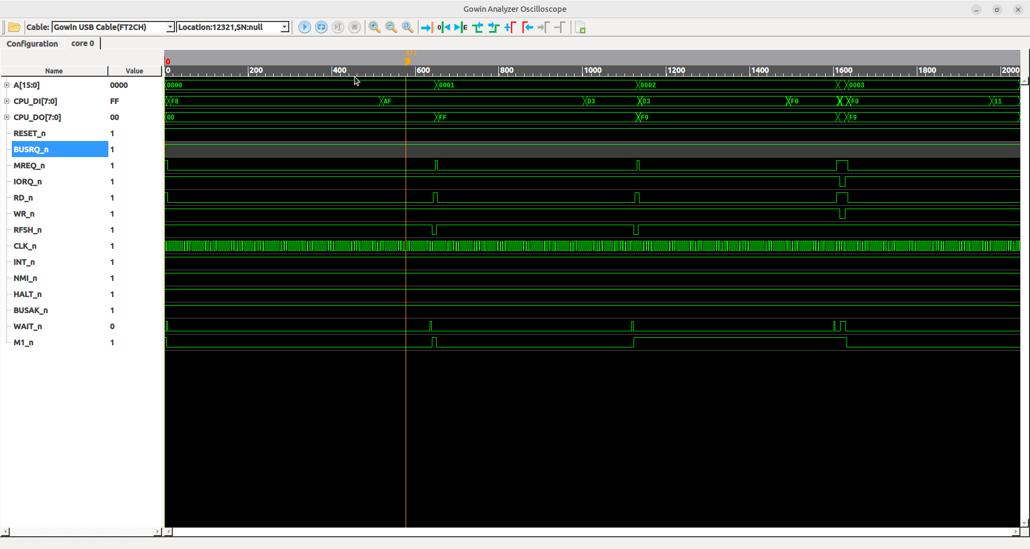

This screenshot shows a few things:

We come out of reset
We start executing
Wait-states are honored
First few instructions (provided by the 8041 printer controller) match what is expected.

http://www.chiark.greenend.org.uk/~jacobn/cpm/pcwboot.html

and

http://www.chiark.greenend.org.uk/~jacobn/cpm/pcwio.html

A later capture show us stuck in a write-loop:

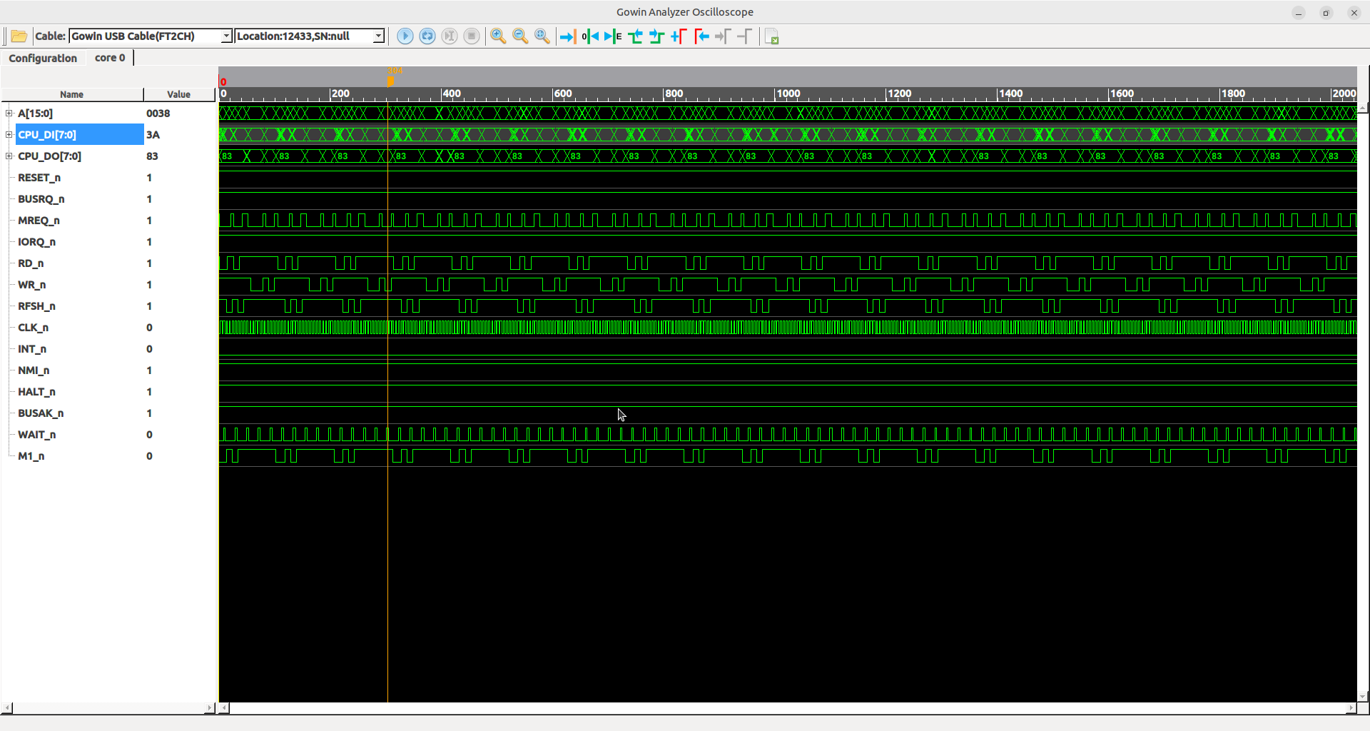

This later capture confirms that refresh is progressing.

Now I have to somehow capture more. I’m thinking, maybe I can capture all bus transactions by:

1. find the rising edge of mreq_n / iorq_n.
2. capture pin-state on the cycle *prior* to the rising edge.

This would mean that I’ll need to convince the LA to either clock from a logic signal, or to filter capturing.

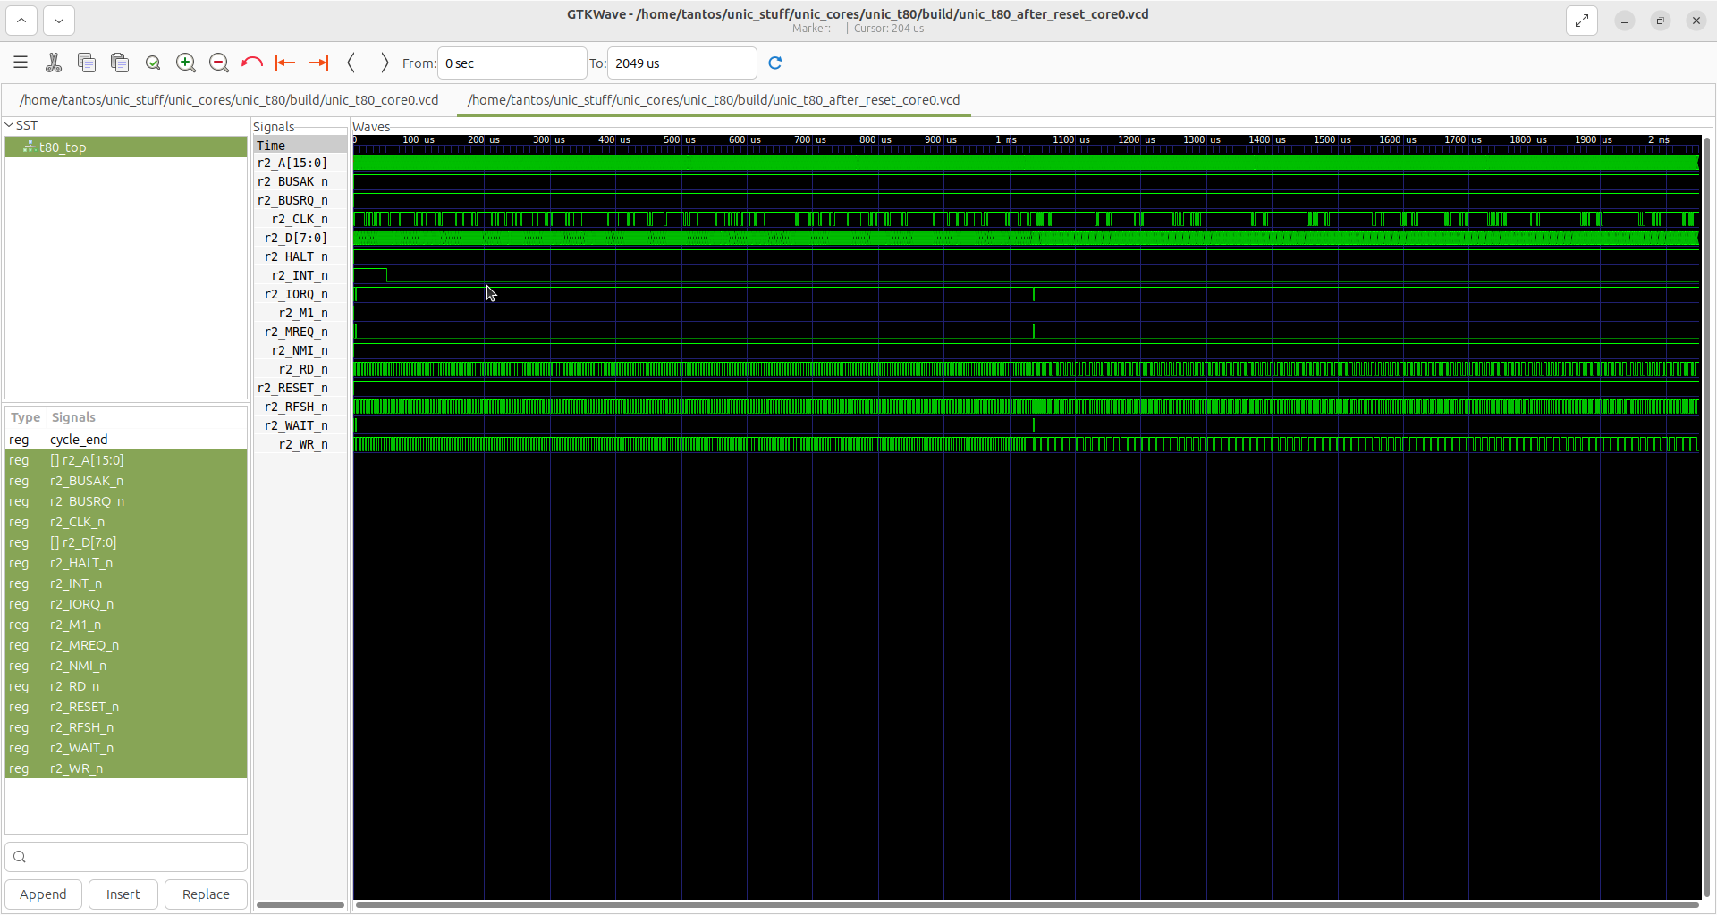

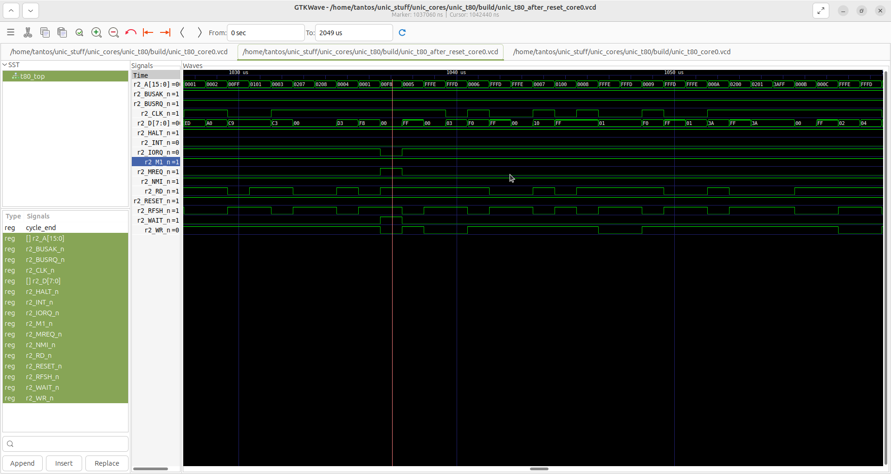This capture shows some weirdness on the address bus, something to track down. For now, I’m going to assume it’s not real and purely a capture artifact, but we shall see.

Concentrating on the data and control signals, things seem to progress as intended. The copy ‘loop’ with the many many LDI instructions seems to be progressing and the data copied matches expectations: it is the content of ‘boot ROM “proper”’. With the busted address it’s going to be difficult to find the end of this loop, except!! The end of the loop is another I/O instruction. That’s easy to find.

So, the code even up to this point seems what it should be: we do get the last LDI, then the jump to address 0, where – through some magic – we find an OUT instruction to turn off boot ROM magic.

All is well, and executed as expected.

However, after the OUT, things go down-hill FAST! The fetched instructions (or address for that matter) don’t seem to align with expectations at all. (and we’ve seen the right data being copied).

So, what should happen now is to trigger on the second I/O after a reset.

Wow, this actually worked the first time!

Looking at the signals, there’s something rather strange: the M1 cycle doesn’t terminate MREQ_n and flows straight into a refresh cycle. This probably confuses the hell out of the controller and maybe preventing DRAM refresh from working.

According to the datasheet (http://www.zilog.com/docs/z80/um0080.pdf page 23) MREQ_n should go high for half a clock-cycle between the M1 and the refresh cycle.

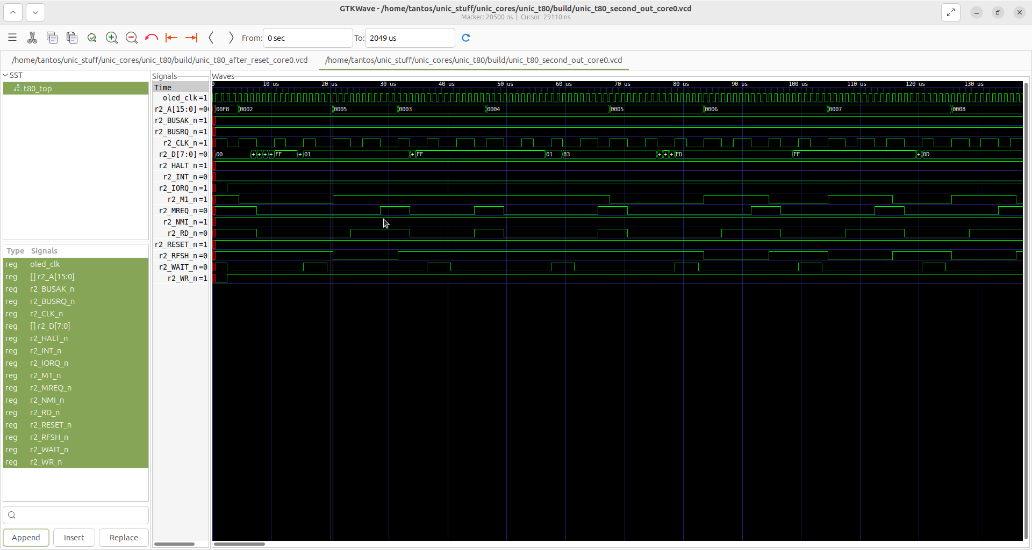

This is something I should be able to simulate…

After firing up the simulator, it seems that – without wait-states – the MREQ_n notch exists between M1 and RFSH.

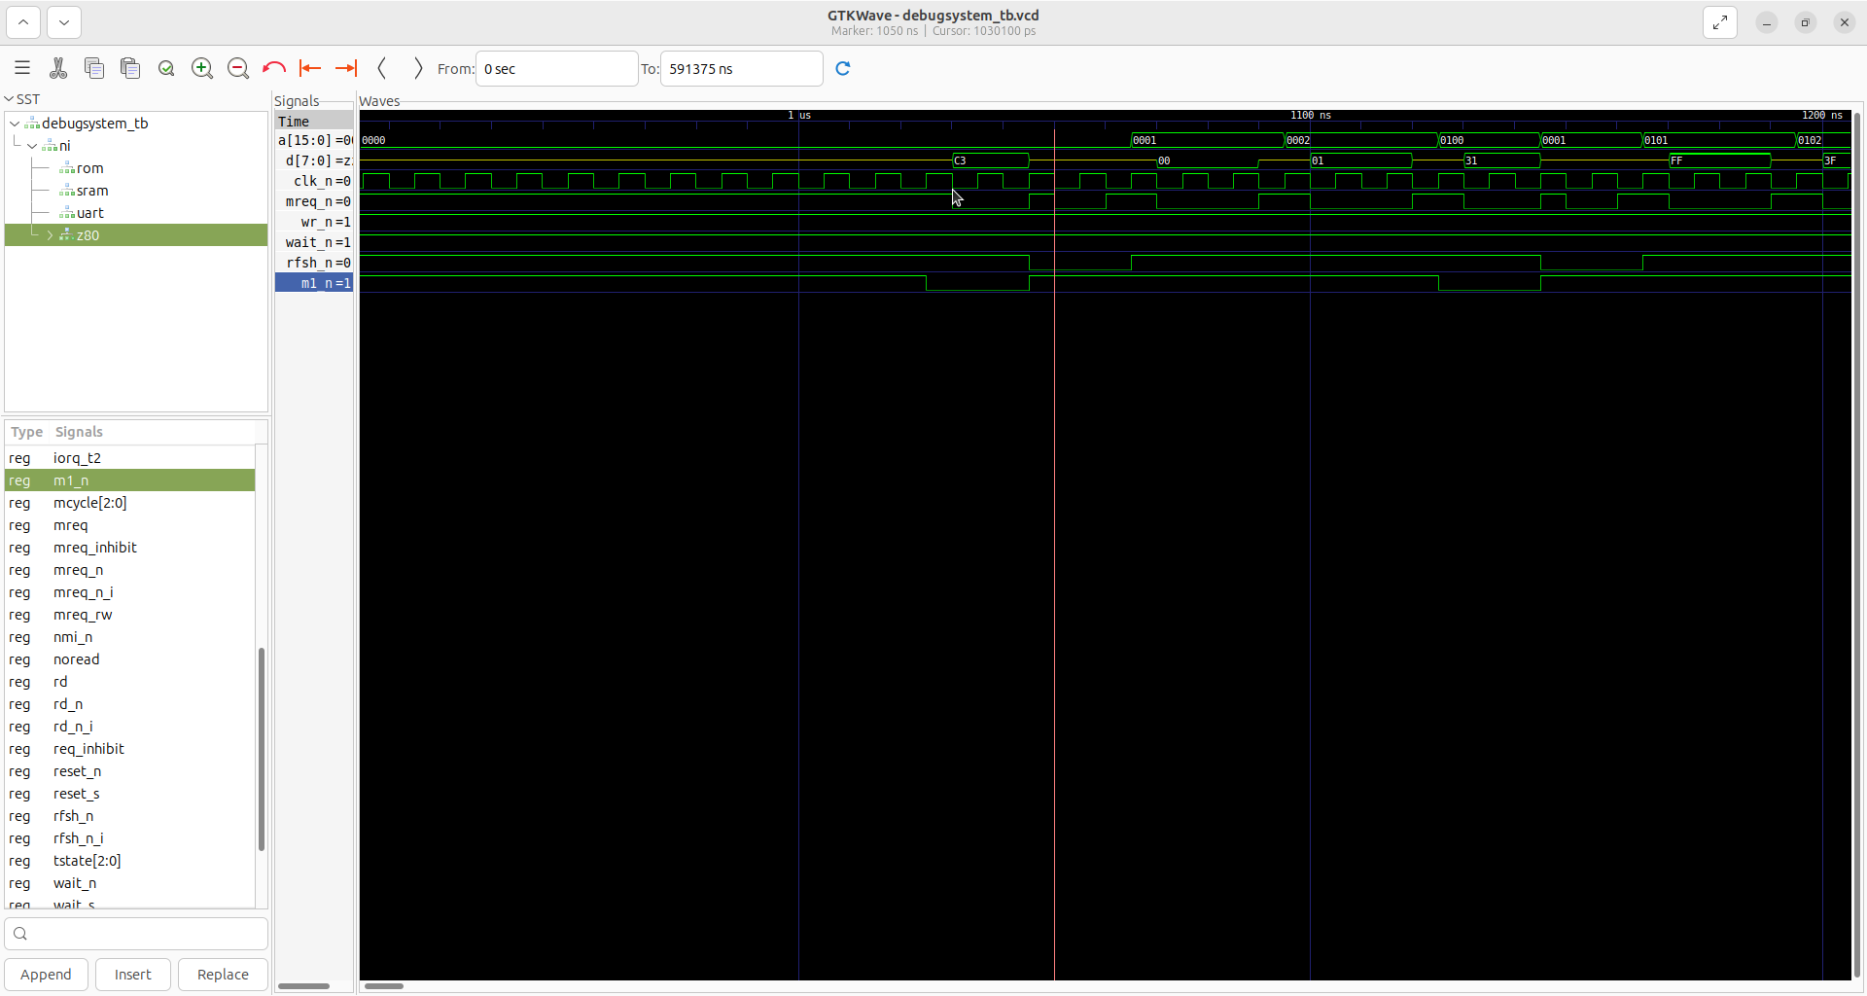

Made the appropriate simulation and the notch is still there. Strange…

One thing of note is that WAIT_n is actually just a 25% duty-cycle square wave in the real HW. Can we replicate that?

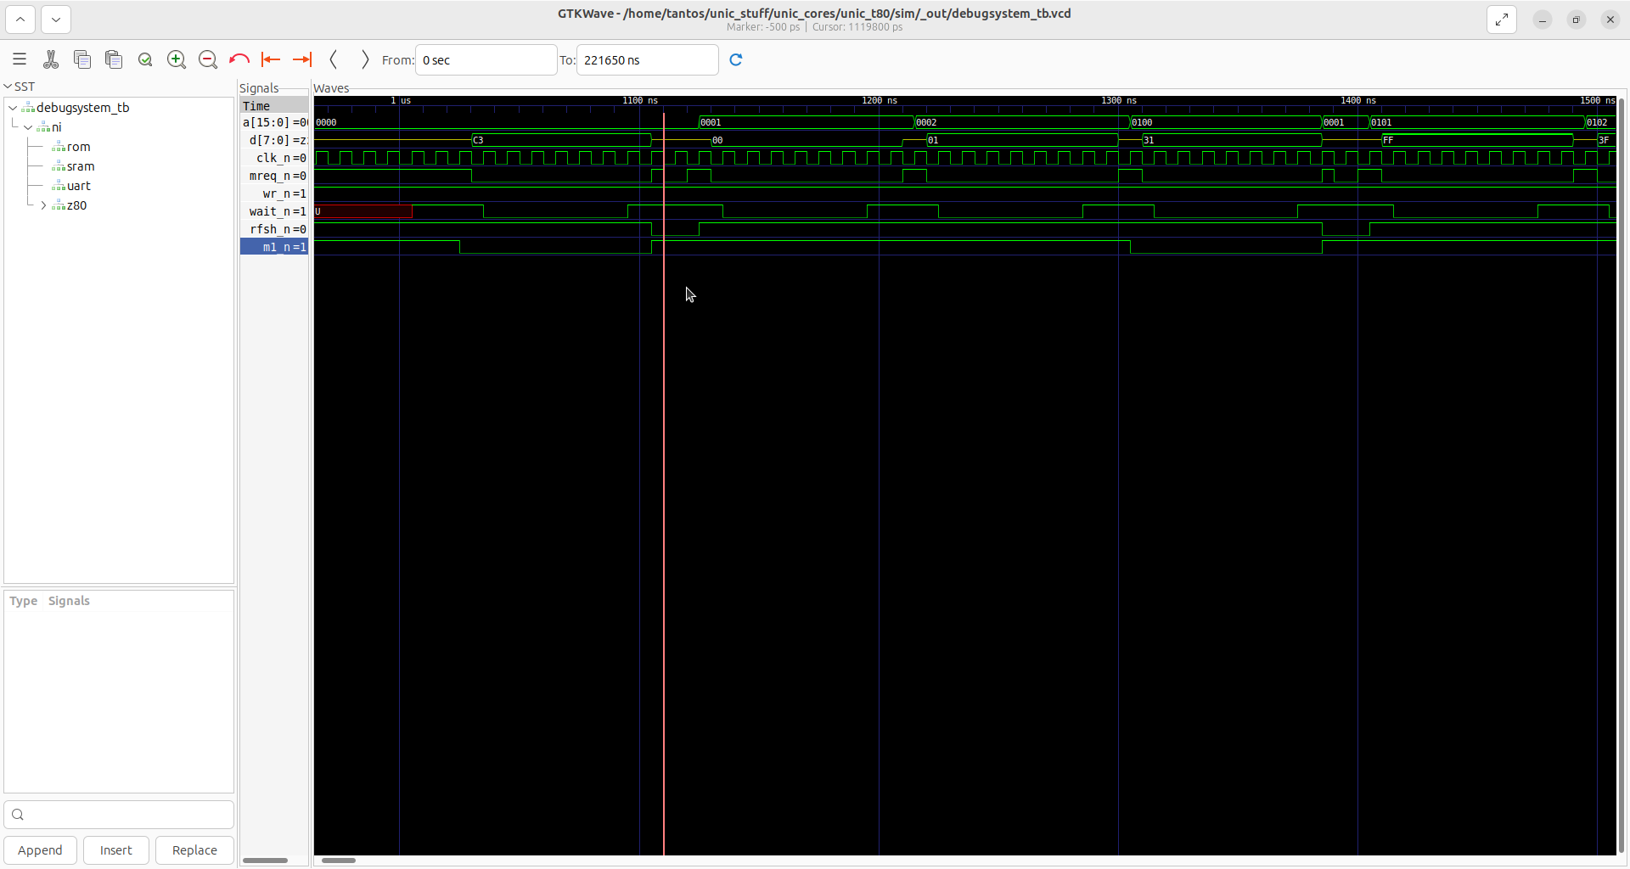

Still no repro. Even this variant dutifully inserts the half-cycle notch.

This is odd to say the least.

So, it seems that ‘MREQ’ inside the Z80 core doesn’t have the notch. That makes me wonder: do I capture (or route) the wrong trace? It doesn’t seem like it, but this is also code that’s copy-pasted between t80a_dido and t80a. Still not a good enough explanation, but here’s the idea: if the notch-insertion is busted for some reason (i.e. one of those simulation v.s. reality differences), that would explain what I’m seeing. So, let’s see if notch insertion works.

So the problem seems to be that req_inhibit isn’t engaged.

The source line is this:

MREQ_rw <= MREQ and (Req_Inhibit or MReq_Inhibit);

So both req_inhibit and mreq_inhibit needs to be low to insert the notch. If one of them is constant high, well… that would explain things.

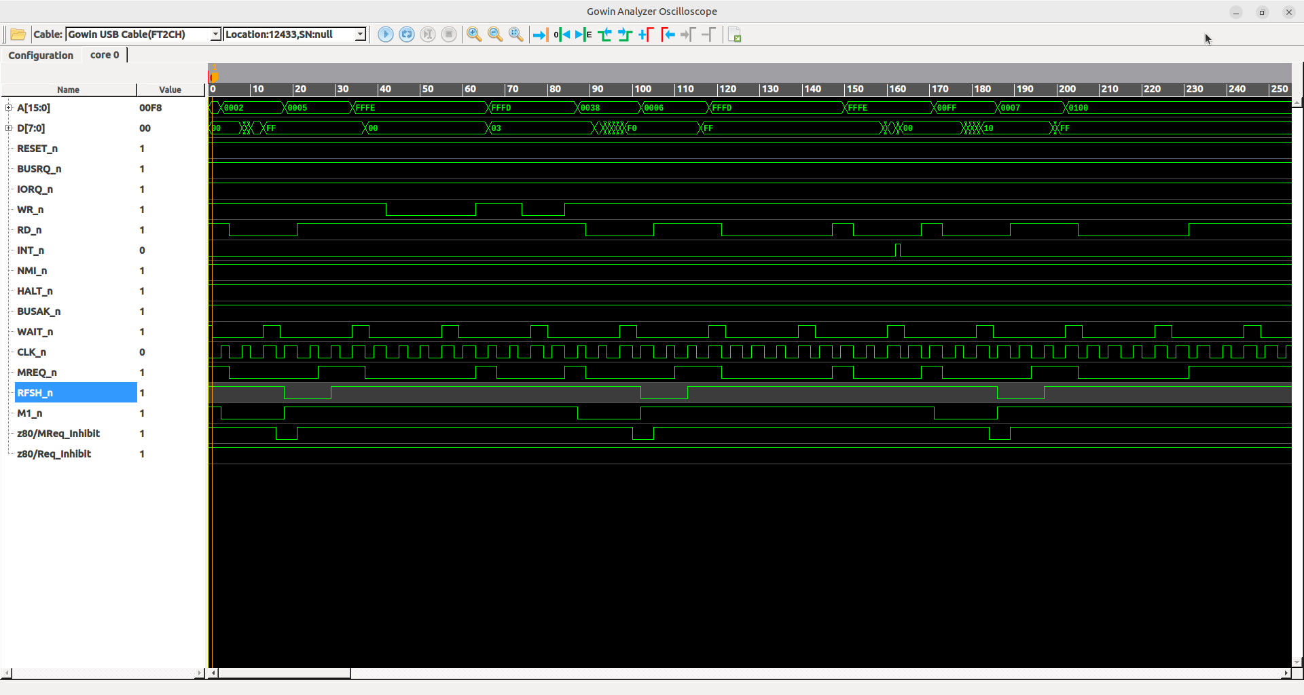

The funny thing is: mreq_inhibit is generated *exactly the same way* except for on a different clock edge!!!!

Given that though, it’s a piece of code that can be simplified.

OK, so this worked.

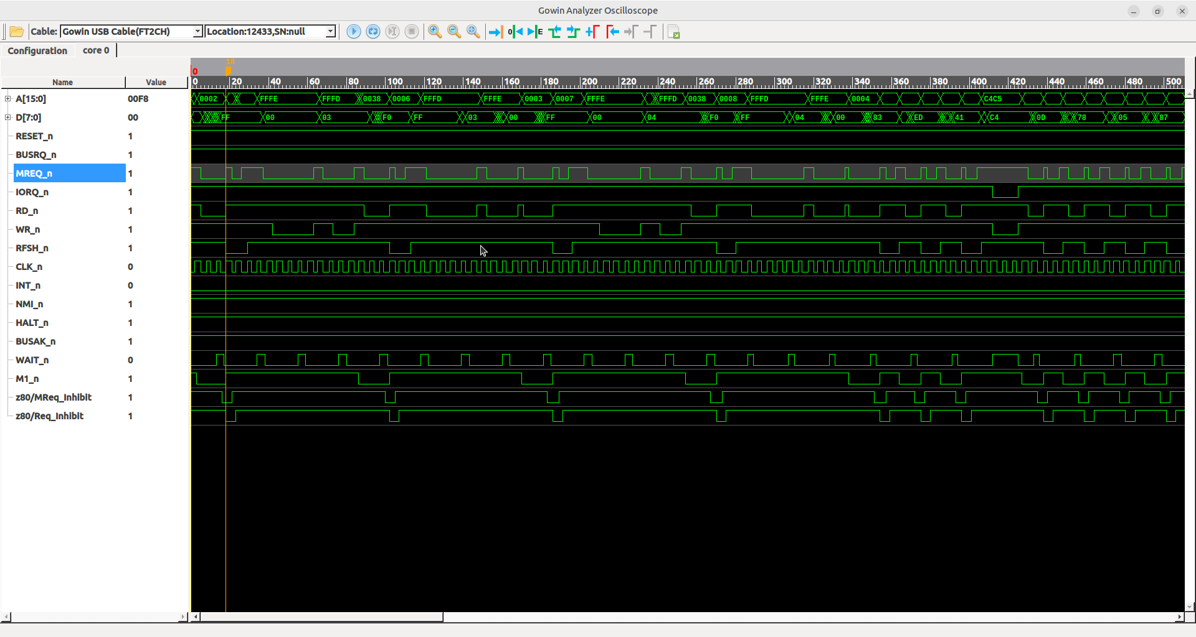

In that it inserted the notch and also, suddenly the screen turned on. This is … progress. But there are two conundrums:

1. Why didn’t the original code work?
2. What *else* doesn’t work due to similar problems?

Note: I had FPGA validation in the same device (in fact, same board!) with built-in SRAM and ROM emulation. So maybe it’s not all that far off?

Repeatedly resetting the board resulted in some strange beeps and some corrupted display being shown. Again, progress?

However, at this point I can make no sense of the data or address I see in the capture.

This is spooky. Weird. Retried the capture, and now things look better. Much better.

OK, so this trace makes more sense. At least to the point where we start the drive motor:

0012 D3 OUT (0F8h),A

OK, so this is going to be hard. I can see as far as calling ‘delay’. This is a giant loop though, so capturing all the way through it is going to be very hard. However, this is the first time we depend on high-side content of DRAM (i.e. stack) since that’s where we store the return address. I see the writes going out to DRAM, but of course I can’t see into the return.

At this point, I decided to whip out the ‘big gun’, that is, the HP1660 logic analyzer I have. The one problem with it was that I never got around getting its Ethernet port finished.

So I did that, put it back together, futzed around a lot to get X11 working (I did), then hooking up all 40 pins to probes in it, then turning everything back on and … nothing worked.

The CPU didn’t execute anything. Or executed a few instructions after which decided to go berserk; the PCW ASIC issuing incorrect wait states, feeding uninitialized memory to the CPU (instead of the boot ROM content).

I ripped off all the LA cables, same behavior. I’ve put the old (genuine Z80) processor back in, it booted (phew, at least I didn’t kill the host). Back to my T80, nothing.

After a while I realized: most of what changed was plugging and unplugging things: could it be that I have a faulty connection? Rechecking the soldering job, I quickly have found a pin that wasn’t soldered in at all. Fixing that, and I’m back where I as.

It’s soooo easy to waste hours on something trivial like this!

On the plus side, I have remote access (FTP, Telnet *and* X11) to the logic analyzer.
On the minus side, the LA has only 4k memory depth, 8k with half-channel mode (which I suppose is possible). That’s not a lot: the internal one right now has 2k samples and as soon as I get to migrate to -9 variant, it’s going to double. Maybe it’s eBay time?

So the HP LA is a complete disaster. Not only does it interfere with the signals (unstable boot even with original Z80), it has very small capture buffers, very slow response, tiny screen and horrendous UI. It also crashes a lot.

After a while, I managed to get a basic capture going, but it was impossible to make heads or tails of the data presented.

I thought, oh, well, I can at least save the data, move it over to a PC and write my own visualizations. Well, saving the data takes more than a minute. So that aint going to work either.

Plus, I had a hunch that I’m dealing with timing issues anyways. So, maybe a scope would be a better tool?

I’ve started capturing rising and falling edges of MREQ and RD/WR relative to one another.

This is how it looks on the Z80:

And this is how the same looks with my FPGA:

Ouch!! Much more noisy. Hard to say if that’s a problem, but it certainly is ugly. The amount of noise also seem to depend on the drive-strength selected (4/8/24mA as an example). The over- and under-shoot also changes a lot.

So, on the dev-board I can’t really do much about this; maybe on the form-factor board? Once I actually have an FPGA to put in one of them…
-------

Interesting find: after lowering the sample clock speed, I managed to capture a situation where the target rebooted itself. Now, this is not all that consistent (in general the way the system misbehaves is not consistent), but at least in this instance, there’s clearly something wrong and it was captured.

The trace shows the reset at the very end:

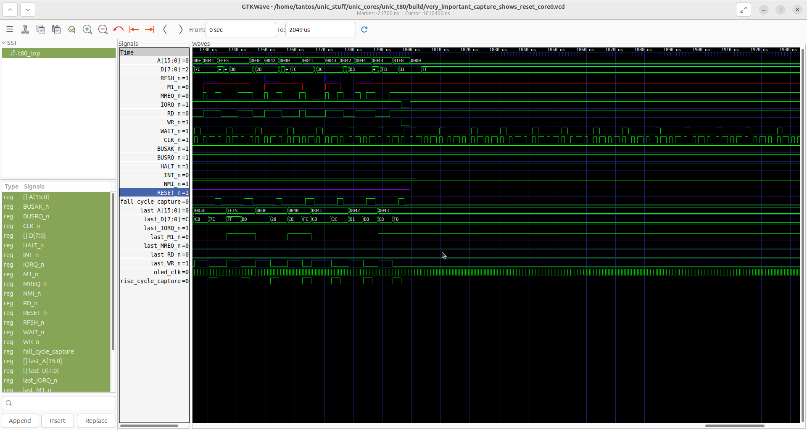
The offending instruction:

0039 21 LD HL,0FFF5h ; memory-mapped keyboard
003A F5
003B FF
003C 77 LD (HL),A ; A=10; ?
keyblp:
003D CB BIT 7,(HL) ; space bar
003E 7E
003F 28 JR Z,keyblp
0040 FC
0041 3C INC A ; A=11; bleeper?
0042 D3 OUT (0F8h),A <<<<<<==========
0043 F8
But wait, A should be 11 (0xB), instead it’s 0xB1? So, how did A end up with this value?

The disassembly above shows where A gets loaded. So let’s look up that instruction (address 0x39) in the trace:

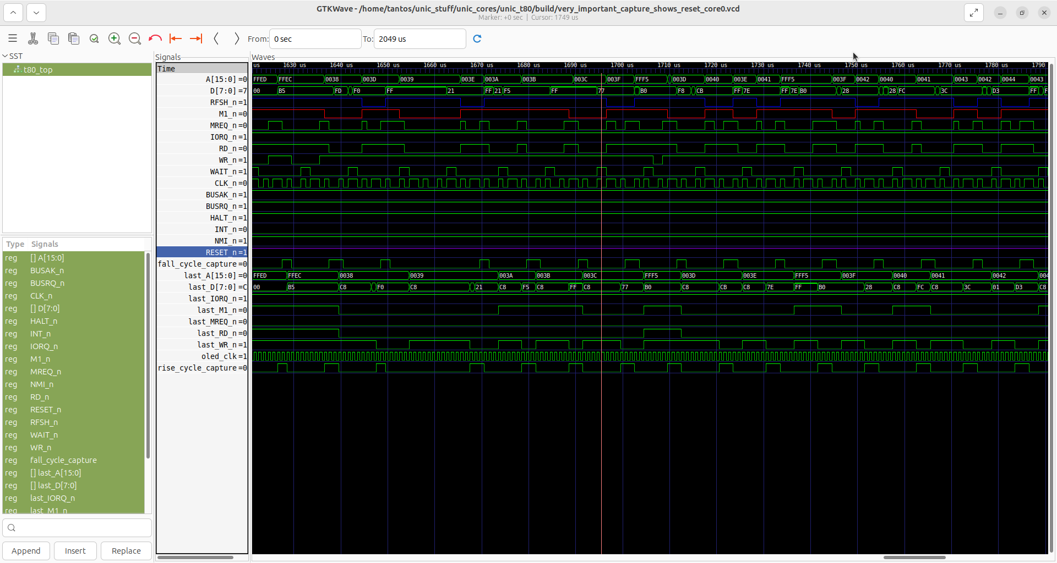

The op-code is captured as expected, but after the refresh cycle, a *WRITE* is issued, not a read!!!!

Indeed, it seems we output the value of A (0xB0) instead of loading it.

Well, to be honest, that’s exactly what the instruction should do. The comment in the disassembly is incorrect. We don’t load anything from the keyboard buffer, we’re writing to it, or something.

Why? Who knows. But not surprisingly we’re reading back what we’ve written there, determining that bit-7 is set, so exiting the loop, incrementing it and OUT-ing it out, causing the reset.

This is a bit strange and we still don’t understand two things:

1. Why does A contain the value it does
2. Why are we in this strange place in the code

The code is also strange: it only makes sense if A *doesn’t* have bit-7 set coming in. In that case it would mean: reset bit 7 in memory, then loop until it’s set, i.e. when space bar is pressed. But if A has bit-7 set to begin with… well, it makes no sense at all.

OK, so notice something interesting here:

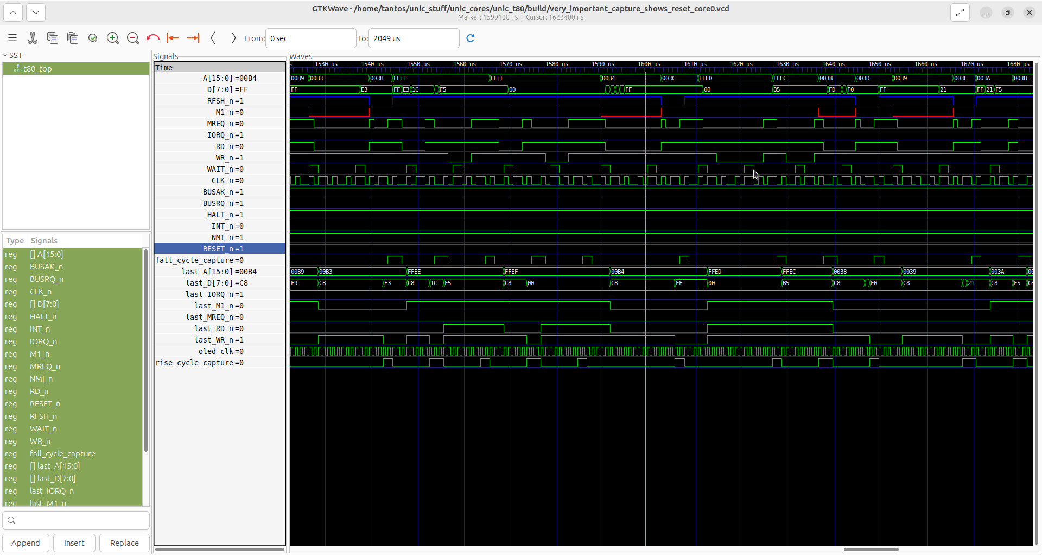
This is address 0xb4. The instruction *should* be

delaylp: ; inner loop controlled by A
00B3 E3 EX (SP),HL ; beefy NOPs?
00B4 E3 EX (SP),HL
00B5 E3 EX (SP),HL
00B6 E3 EX (SP),HL
00B7 3D DEC A
00B8 20 JR NZ,delaylp

0xe3. Instead we’re reading 0xff. Which (drum-roll please), RST 38H. So we’re jumping to address 0x38, where we end up in the middle of the key-press routine with a screwed-up A.

So, we have a culprit, but why is the read-back value 0xff???

The curious thing is that this code gets executed in a loop.

So, if we trace back, not much before, we should see another execution attempt from the same address.

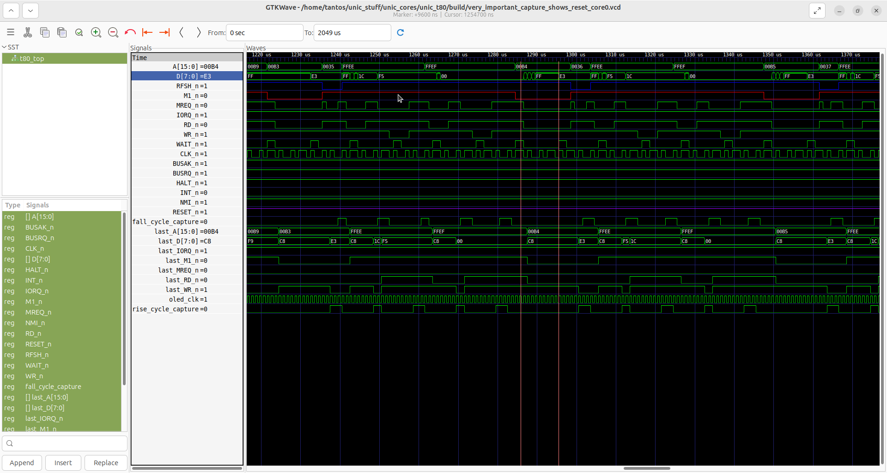

Not surprisingly that works as expected.

The clock BTW is a bit under-sampled in this capture, at higher speeds it’s clear that nWAIT transitions on the rising edge of CLK and stays low for thee cycles, high for one. (BTW: are we truly slowing the CPU down *this* much???)

At any rate, in the offending cycle, there’s no sign of the right value ever showing up on the data bus. We normally see the old value slowly decay into 0xff (probably by pull-ups) and then *bam*, the new value appearing. But not in this case. 0xff just lingers on (either for a lack of a drive or actual intention) and then all goes to hell in a hand-basket.

I’m curious about the previous cycle though: notice, how it finishes with nWAIT being low? Is that what should happen? That’s the write part of the exchange instruction. But the read part also shows similar behavior.

Yes, that seems to be kosher:

http://www.zilog.com/docs/z80/um0080.pdf page 24 shows that only T2 is extended by WS-s, so T3, where the rising edge of MREQ is can happen while WAIT is already low again. In fact, since we only allow WAIT to be high for a single cycle, that’s how it should happen for all cycles.

So, back to the mystery: why is the value read 0xff?

Option 1: noise
Option 2: lack of refresh
Option 3: ground-bounce
Option 4: ???

Option 2 can be ruled out. Even if for whatever reason refresh doesn’t work (the PCW doesn’t use the Z80 refresh mechanism), we’ve just read the same address a few cycles before. That should have refreshed it. So, that’s not it.

Noise? Possible, but what noise? There isn’t much activity on the bus at that point. The only transition is nWAIT, really.

Ground-bounce is a potentially interesting one: if our ground is going all over the place, it could move the trigger point too … low? That would be strange, but it is something that can be checked. In fact, can be checked in two ways. We can have a scope-capture of the ground and we can try to short ground to remove the influence of the diodes.

So, let’s get cranking…

OK, so I simply shorted FPGA GND and PCW GND. This was done with a simple jumper wire which is not, by any means ideal. Reset, and…

We went through the whole boot process. Bars and all:

It doesn’t get all the way to CP/M, but oh, boy, did it make a difference!

So what does it mean? It seems to validate my assumption that the problem was ground-related. Probably ground-bounce.

It also brings up the problem of whether this whole UniC idea will work. If this is not just an issue for the development board but a general problem with the idea of ‘ground-through-the-diode’, then, well, it’s not really going to work.

There is also of course the problem of not getting all the way to CPM. Which is going to be hard to diagnose with the tools, I have. Bummer.

