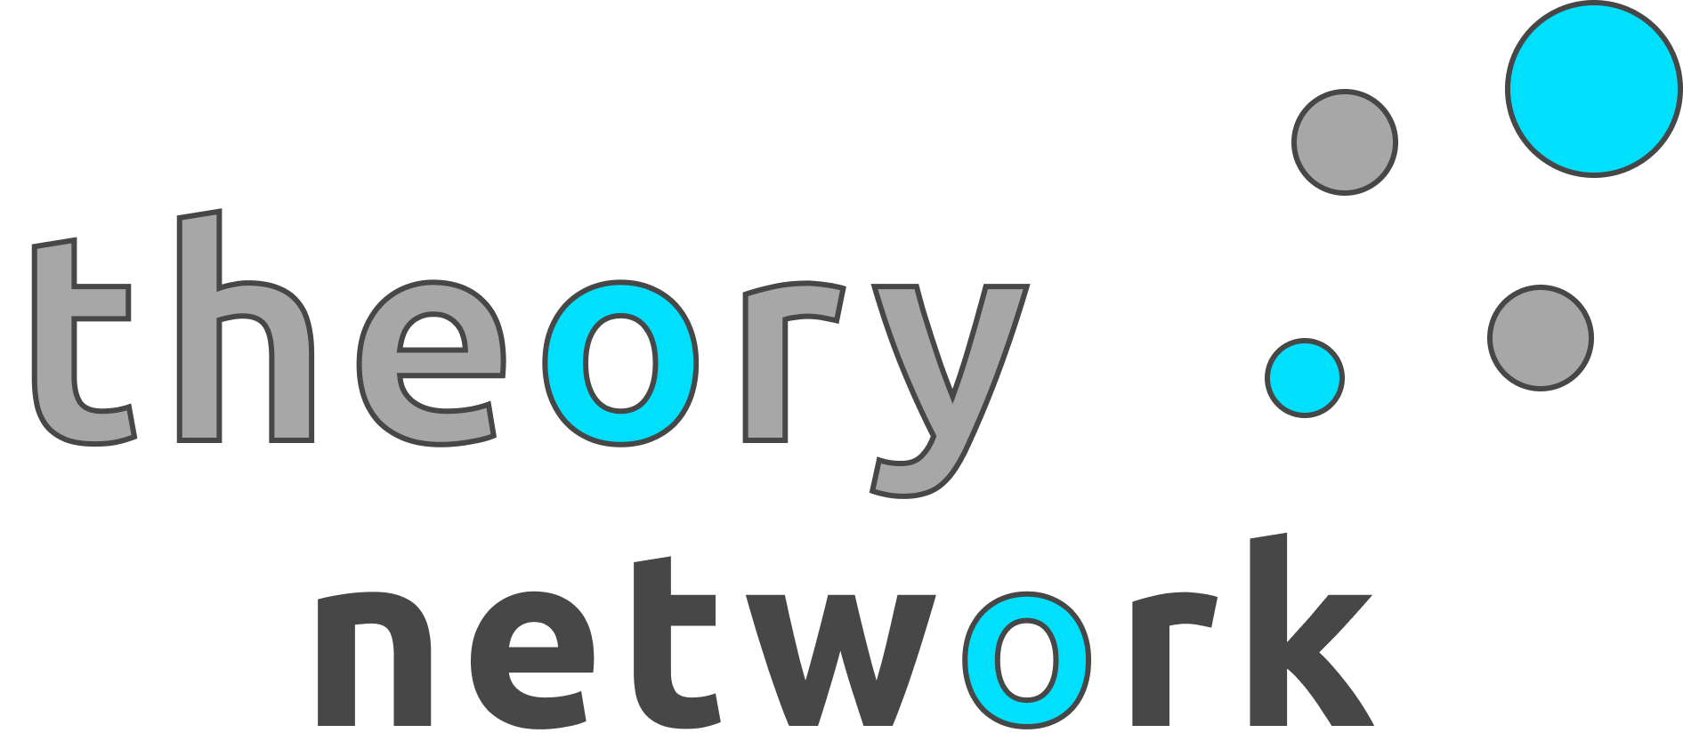
Industry:
Software
Technology:
Angular, Ionic, Firebase
Profile:
Theory Network creates mobile and web application experiences. Our first venture, Firefly, helps users find local activities and events. It can be summed up by our tagline “Life comes to you.”


Theory Network LLC
CEO’s:
David Beaton & Andre Davcev
Member Level:
Associate
Location:
Non-Resident

