ABCjs - Template
This document defines some basic macros for that allow you to write music notes with the ABC-notation. To transform this into nicely rendered music notes an to play the music online as well, this plugin uses the JavaScript library abcjs. This plugin allows you to use ABC music in two ways, only for showing and playing, or to write and interpret ABC interactively with an editor.
Try it on LiaScript:
https://liascript.github.io/course/?https://raw.githubusercontent.com/liaTemplates/ABCjs/main/README.md
See the project on Github:
https://github.com/liaTemplates/ABCjs
There are three ways to use this template. The easiest way is to use the import statement and the url of the raw text-file of the master branch or any other branch or version. But you can also copy the required functionality directly into the header of your Markdown document, see therefor the last slide. And of course, you could also clone this project and change it, as you wish.
1
- Load the macros via
import: https://raw.githubusercontent.com/liaTemplates/ABCjs/main/README.md
or use this specific version and you course will be stable:
import: https://raw.githubusercontent.com/LiaTemplates/ABCjs/0.0.2/README.md
- Copy the definitions into your Project
- Clone this repository on GitHub

@ABCJS.render
Display the ABC defined music with default options, which will render them as musical notes and add a the possibility to play the music aloud.
``` abc @ABCJS.render
X: 1
T: Shche ne Vmerla Ukrayiny ni Slava, ni volya
T: Ukrainian National Anthem
C: trad.
R: march
S: https://www.8notes.com/scores/34640.asp
Z: 2022 John Chambers <jc:trillian.mit.edu>
M: C
L: 1/8
K: F
[|\
"F"[A3F3][AF] ([AF][GE][AF])[BG] | [c3A3][BG] "A7"[A2F2][G2E2^C2] | "Dm"[F2D2][A2F2] "A"[E2^C2][A2C2] | "Dm"[D3D3][E^C] [F2D2]"C"[G2E2] |
"F"[A3F3][AF] ([AF][GE][AF])[BG] | [c3A3][BG] "A7"[A2F2][G2E2^C2] | "Dm"[F2D2][A2F2] "A"[E2^C2][A2C2] | "Dm"[D4D4] D2z2 |
"A"[E2^C2][E2C2] ([AC][GE][FD])[EC] | ("Dm"[DD3-]EF)[DD] "A"[E2^C2][E2C2] | "Dm"[F2D2][F2D2] "C"[G2E2][G2E2] | "F"[A4F4] [A2F2]z2 |
"A"[E2^C2][E2C2] ([AC][GE][FD])[EC] | ("Dm"[DD3-]EF)[DD] "A"[E2^C2][E2C2] | "Dm"[F2D2][A2F2] "A"[E2^C2][A2C2] | "Dm"[D3D3][E^C] ([FD][GE][AF])[BG] |
|:\
"F"[c3A3][=B^G] [c2A2][A2F2] | "C"[G2E2][G2E2] ([cE][BG]"^A7/C#"[AF])[GE] | "Dm"[F2D2][F2D2] "C"[G2E2][G2C2] | ("F"[A3F3][GE][A2F2])"C7"[B2G2] |
"F"[c3A3][=B^G] [c2A2][A2F2] | "C"[G2E2][G2E2] ([cE][BG]"^A7/C#"[AF])[GE] | "Dm"[F2D2][A2F2] "A"[E2^C2][A2C2] | "Dm"[D4D4] [D2D2]z2 :|
```

@ABCJS.renderWith
Use the render with option to change the default settings. A list of all possible parameters is defined in section Options. Additionally it is possible to set these parameters as comments within the ABC-code, as it is demonstrated here.
``` abc @ABCJS.renderWith(channel="10" audio="true" notes="false")
X: 1
T: Cooley's
M: 4/4
L: 1/8
K: Emin
|:D2|"Em"EBBA B2 EB|~B2 AB dBAG|"D"FDAD BDAD|FDAD dAFD|
"Em"EBBA B2 EB|B2 AB defg|"D"afe^c dBAF|"Em"DEFD E2:|
|:gf|"Em"eB B2 efge|eB B2 gedB|"D"A2 FA DAFA|A2 FA defg|
"Em"eB B2 eBgB|eB B2 defg|"D"afe^c dBAF|"Em"DEFD E2:|
```

@ABCJS.eval
Next to just showing the notes, it is also possible to directly edit music with the LiaScript editor. Alls states and versions will be preserved. Simply add the @ABCJS.eval macro to the end of the code-block. This will run eval with the default settings and print out the result within the console. The code-example contains a list of all settings that can be changed by the user, this will overwrite the default settings and gives you more control over your composition.
% audio: true% audio: true
% autoplay: false% autoplay: false
% channel: 0% channel: 0
% debug: false% debug: false
% notes: true% notes: true
% program: 60% program: 60
% responsive: true% responsive: true
% tablature: [{"instrument": "violin","tuning": ["G,", "D", "A", "e"]}]% tablature: [{"instrument": "violin","tuning": ["G,", "D", "A", "e"]}]
% voicesOff: false% voicesOff: false
% chordsOff: false% chordsOff: false
% stereo: true% stereo: true
X: 1
T: Cooley's
M: 4/4
L: 1/8
K: Emin
|:D2|"Em"EBBA B2 EB|~B2 AB dBAG|"D"FDAD BDAD|FDAD dAFD|
"Em"EBBA B2 EB|B2 AB defg|"D"afe^c dBAF|"Em"DEFD E2:|
|:gf|"Em"eB B2 efge|eB B2 gedB|"D"A2 FA DAFA|A2 FA defg|
"Em"eB B2 eBgB|eB B2 defg|"D"afe^c dBAF|"Em"DEFD E2:|

@ABCJS.evalWith
This is similar to the @ABCJS.renderWith version an allows you to configure the output more precisely. Additionally it is also possible, to overwrite these settings within the comments, as shown in the previous section.
X: 1
T: Cooley's
M: 4/4
L: 1/8
K: Emin
|:D2|"Em"EBBA B2 EB|~B2 AB dBAG|"D"FDAD BDAD|FDAD dAFD|
"Em"EBBA B2 EB|B2 AB defg|"D"afe^c dBAF|"Em"DEFD E2:|
|:gf|"Em"eB B2 efge|eB B2 gedB|"D"A2 FA DAFA|A2 FA defg|
"Em"eB B2 eBgB|eB B2 defg|"D"afe^c dBAF|"Em"DEFD E2:|

Options
option | Description
audio | Display audio settings, by default true.
autoplay | Start playing immediately when the site/abc becomes visible (by default disabled)
channel | The  “midi channel”  to use. This isn't particularly useful except that specifying channel 10 means to use the percussion sounds.
debug | Combinations of ABCJS  showDebug: ['box', 'grid']  which shows some visual debug information.
notes | Depict the notes, by default this is enabled, set it to false to hide them and to display only the  “playback”  .
program | A number for the midi program (aka  “instrument”  ) to use, if not specified in ABC string.
responsive | Used by default, if you set this to false, then there will be a scrollbar displayed on small screens.
tablature | Add tablature options as defined  here  .
voicesOff | If true, play the metronome and accompaniment; do the animation callbacks, but don't play any melody lines.
chordsOff | If true, then don't turn the guitar chord symbols into sound. (But do play the metronome if there is one.)
stereo | Use pan to mimic stereo sound (by default set to false).

ABC Tutorial
You can search https://abcnotation.com for a vast amount of songs and resources. Additionally, it might be helpful to have a look at the following videos:
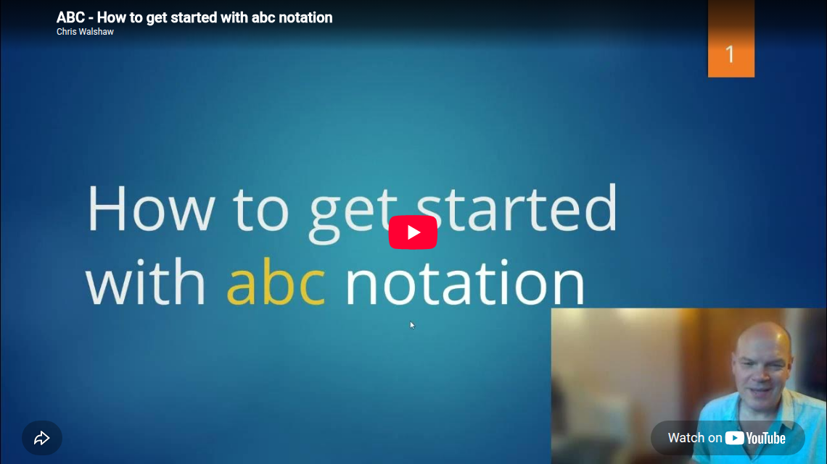
▶ Watch video: https://www.youtube.com/embed/jwzzueA5siQ?list=PLfRXRZpfgshJU-1rDD91AP1SF13VHYqbh&hl=en
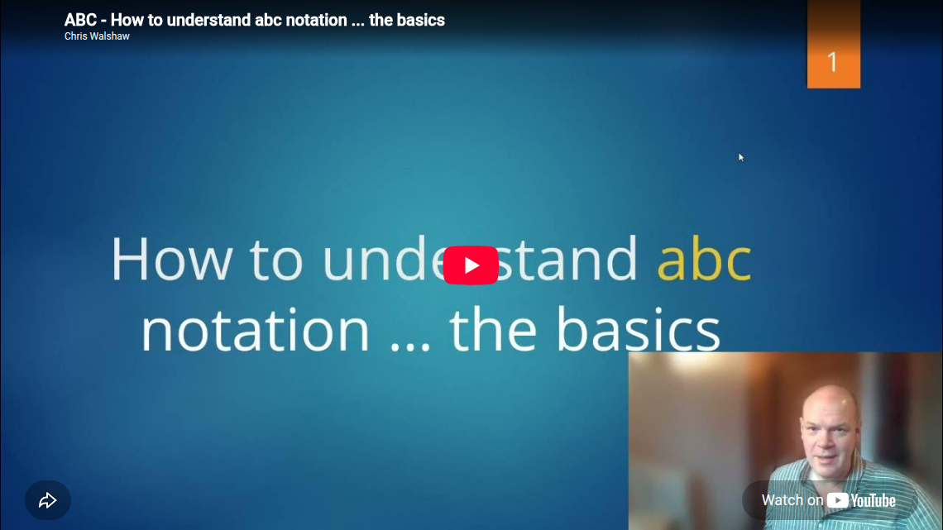
▶ Watch video: https://www.youtube.com/embed/H8hWKP5cEXE?list=PLfRXRZpfgshJU-1rDD91AP1SF13VHYqbh&hl=en
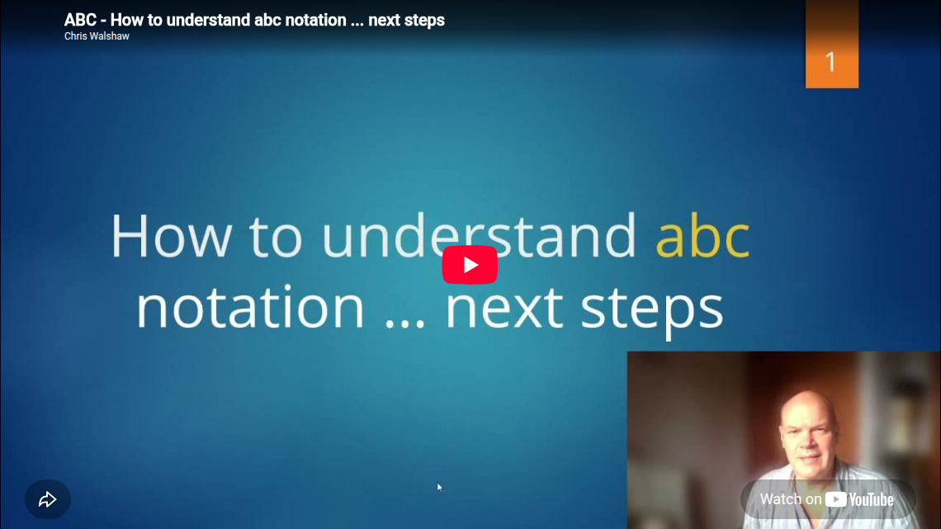
▶ Watch video: https://www.youtube.com/embed/u6_tjcKE42A?list=PLfRXRZpfgshJU-1rDD91AP1SF13VHYqbh&hl=en
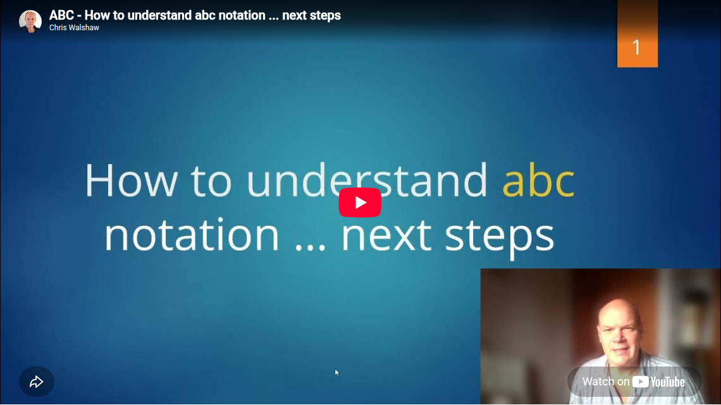
▶ Watch video: https://www.youtube.com/embed/u6_tjcKE42A?list=PLfRXRZpfgshJU-1rDD91AP1SF13VHYqbh&hl=en
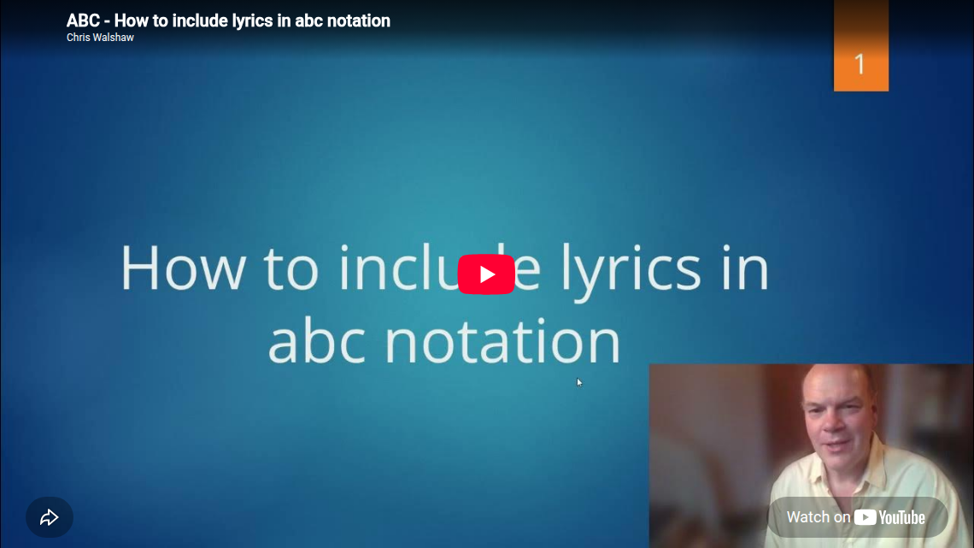
▶ Watch video: https://www.youtube.com/embed/RWNeCjid0zc?list=PLfRXRZpfgshJU-1rDD91AP1SF13VHYqbh&hl=en
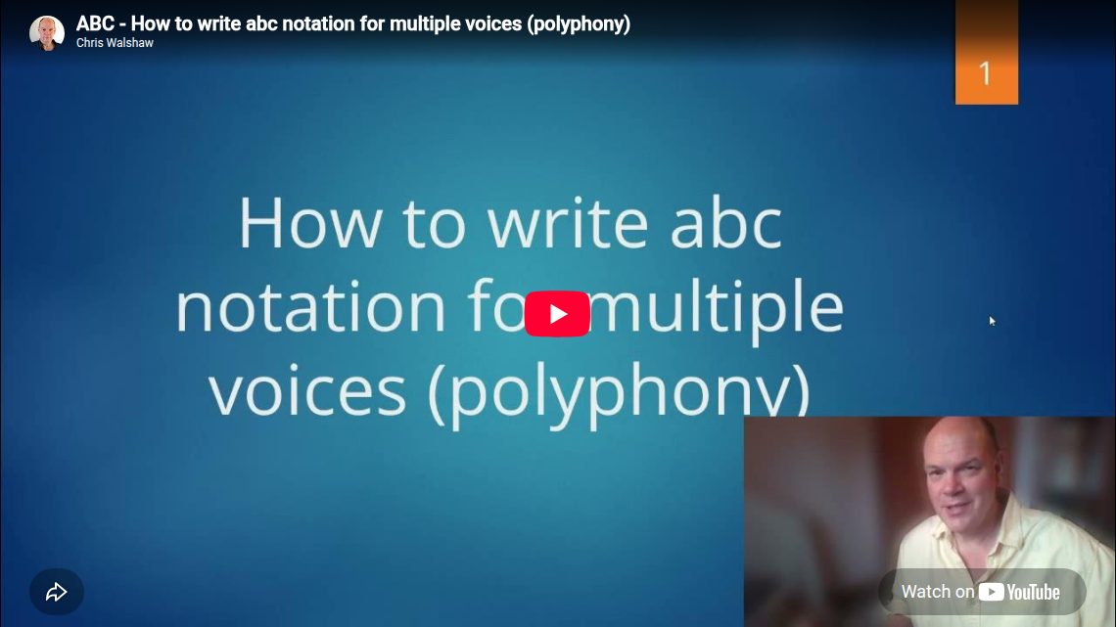
▶ Watch video: https://www.youtube.com/embed/HxLKo4HL19g?list=PLfRXRZpfgshJU-1rDD91AP1SF13VHYqbh&hl=en

Implementation
script: https://cdn.jsdelivr.net/gh/liatemplates/abcjs@0.0.2/dist/index.js

@ABCJS.render: @ABCJS.renderWith( ,```@0```)

@ABCJS.renderWith
<lia-keep>
<lia-abcjs @0>@1</lia-abcjs>
</lia-keep>
@end

@ABCJS.eval: @ABCJS.evalWith( ,@0)

@ABCJS.evalWith
<script>
console.html(`<lia-abcjs @0>@input</lia-abcjs>`)
"LIA: stop"
</script>
@end

