LinkedIn Post: Process Optimization Chapter Introduction

Diagram for Post
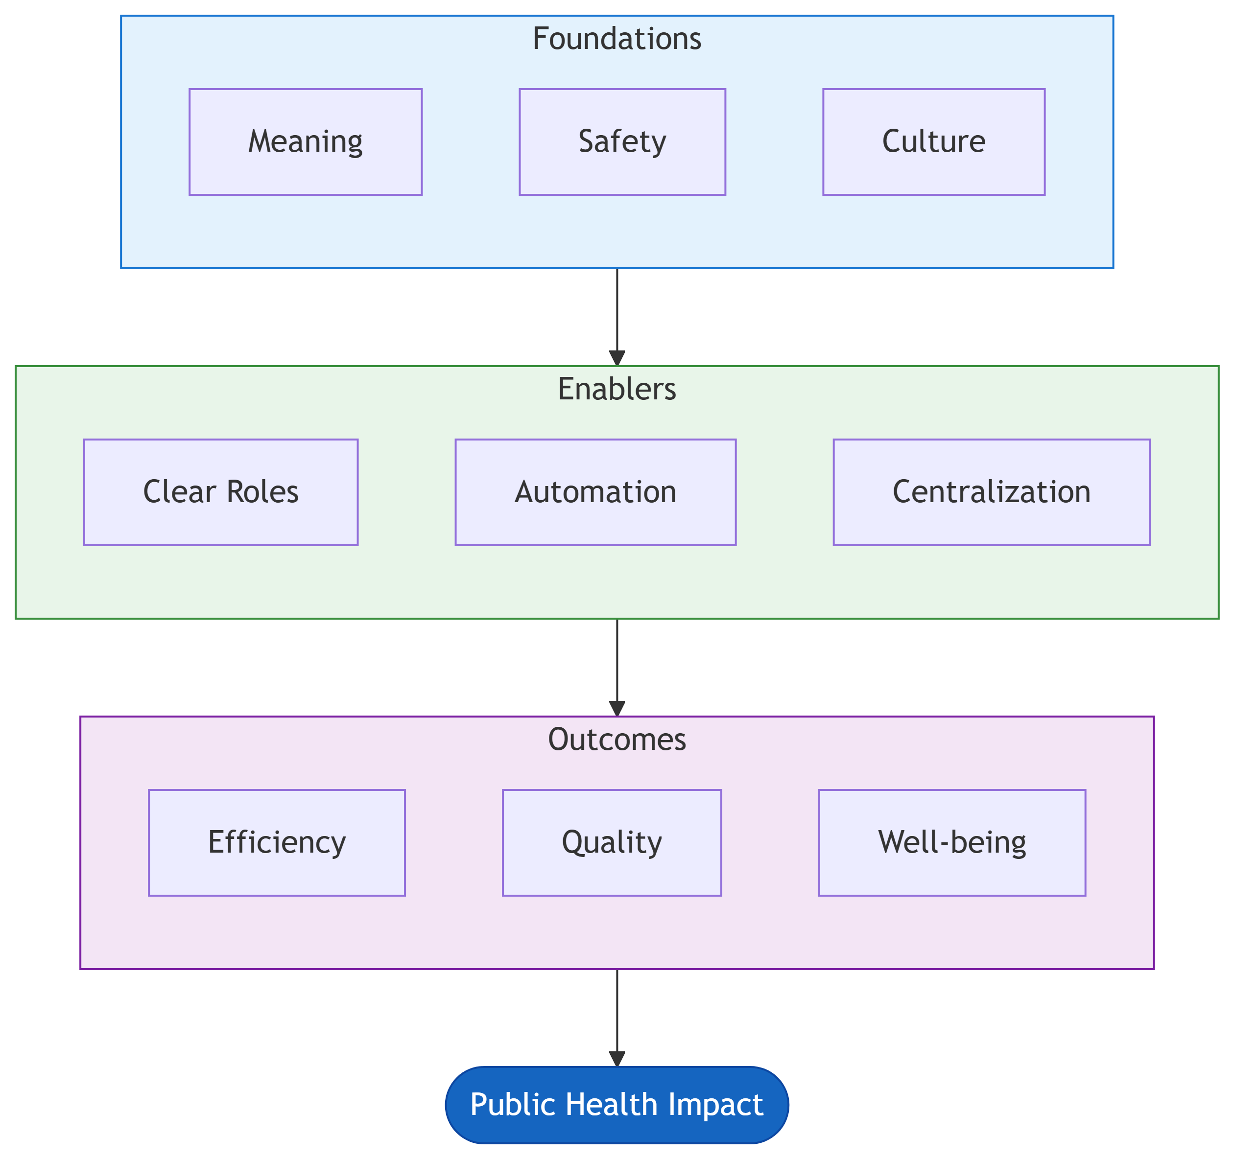
Figure 1: Process Optimization Framework
Alt text for accessibility: A flowchart showing process optimization moving from Foundations (Meaning, Safety, Culture) through Enablers (Clear Roles, Automation, Centralization) to Outcomes (Efficiency, Quality, Well-being) and ultimately to Public Health Impact.

Post Draft
Process optimization isn’t about tools. It’s about people.
I’ve spent years watching well-intentioned efficiency initiatives fail. Not because of bad technology or poor frameworks, but because they ignored something fundamental:
Processes are run by humans.
In my latest chapter on Process Optimization for the Bridgeframe Toolkit, I explore what it actually takes to improve how public health programs operate. Spoiler: it’s not another Gantt chart.

The chapter covers:
🧠 Psychological Foundations Why meaning, autonomy, and psychological safety matter more than any workflow diagram
👥 Organizational Dynamics How culture, politics, and role confusion silently sabotage even the best plans
📊 Disciplined Project Management When to use Agile vs. Waterfall vs. Hybrid (hint: the framework matters less than you think)
🤖 Automation with Accountability Why AI needs human oversight, and how to build systems that scale without breaking
🏛️ Centralization Done Right The Medallion Architecture for shared data, and when NOT to centralize
📈 Demonstrating Value The taxpayer accountability test every public health process should pass

The core insight? Efficiency for its own sake is worthless.
In public health, every optimization must connect to a tangible outcome: earlier outbreak detection, more accurate surveillance, better use of limited resources.
If you can’t explain to a taxpayer why a process exists and how it improves health, that process should be eliminated, automated, or fundamentally redesigned.

This chapter synthesizes lessons from psychology (Frankl, SDT, Edmondson), sociology (Schein, Wenger), project management, and informatics into a practical framework for analysts working at the intersection of technology and public health.
Whether you’re a business analyst entering healthcare or an epidemiologist drowning in administrative work, the goal is the same: maximize impact with the resources entrusted to us.
Link to the full chapter coming soon.
What’s the biggest barrier to efficiency you’ve encountered in your organization?
#PublicHealth #HealthInformatics #ProcessOptimization #BusinessAnalysis #DataScience #ProjectManagement #ImplementationScience #Bridgeframe

Key Themes to Highlight
- Interdisciplinary approach (psychology + sociology + informatics + PM)
- Human-centered optimization
- Taxpayer accountability in public health
- Practical frameworks, not just theory

Hashtags
- #PublicHealth
- #HealthInformatics
- #ProcessOptimization
- #BusinessAnalysis
- #DataScience
- #ProjectManagement
- #ImplementationScience
- #Bridgeframe
- #ChangeManagement
- #Leadership

