Public Health Analytics Playbook
  - Exploring Public Health Issues with Reproducible Code
André van Zyl
March 2026
Table of contents

Public Health Analytics Playbook
Exploring Public Health Issues with Reproducible Code

Welcome
The Public Health Analytics Playbook is a collection of data-driven analyses exploring real public health issues. Each chapter takes on a specific topic, pulls data from public sources, walks through the epidemiology, and provides reproducible R and Python code you can adapt for your own work.
This is equal parts curiosity project and practical reference. The analyses are grounded in published data and official statistics. The code is designed to be copied, modified, and reused.
 About This Resource
This playbook is a work in progress. New chapters are added as research is completed. Each chapter is self-contained: you can read them in any order, skip to whatever issue interests you, and pull code directly into your own projects.

What This Is
Each chapter in the playbook follows a consistent pattern:
- The issue: What is the public health problem, and why does it matter?
- The data: Where does the evidence come from, and how do we access it programmatically?
- The analysis: Reproducible code (R and/or Python) that explores the data, with narrative interpretation
- The visualizations: Charts, maps, and tables that make patterns visible
Some chapters may compare the same issue across jurisdictions (U.S. states, countries, tribal nations). Others may go deep on a single geography. The scope is flexible and issue-driven.

Who This Is For
- Epidemiologists and public health analysts looking for reproducible examples they can adapt
- Data scientists curious about public health data sources, APIs, and visualization
- Public health students seeking applied analytics beyond textbook exercises
- Anyone who wants to understand what the data actually shows about the health issues that shape our communities

Companion Projects
This playbook is part of a suite of Intersect Collaborations resources:
- Public Health Automation Clinic: Practical automation solutions for public health workflows
- Bridgeframe Toolkit: Bridging business analysis and public health terminology and practice

The U.S. Drug Overdose Crisis

The U.S. Drug Overdose Crisis
The United States stands alone among high-income nations in the scale of its overdose crisis. Drug overdoses claimed more than 100,000 lives for a third consecutive year in 2023, representing over a 50 percent increase since 2019 (Commonwealth Fund, 2025b). With an overdose rate of 324 deaths per million people (nearly 108,000 deaths in 2022), the U.S. has by far the highest overdose death rate in the world. While Scotland and Canada, the next highest-ranked countries, saw declines from 2021 to 2022, rates in the U.S. have remained persistently elevated (Commonwealth Fund, 2025b).
According to the CDC National Center for Health Statistics, the three leading causes of death in the U.S. are heart disease (680,981 deaths), cancer (613,352), and unintentional injuries (222,698), with drug poisonings dominating the latter category (National Center for Health Statistics, 2024b). Drug overdose has become a leading cause of injury mortality, with opioids driving an increasing share of these deaths since 2009 and accounting for over 70% of all overdose fatalities (National Center for Health Statistics, 2024a). The growing involvement of stimulants such as cocaine and methamphetamine alongside opioids has further complicated the crisis, transforming what began as a prescription opioid problem into a polysubstance mass-casualty event.
No peer nation experiences anything comparable. The Commonwealth Fund 2025 Scorecard on State Health System Performance documents that premature, avoidable deaths are increasing in the United States while declining in comparable high-income countries, with drug overdose a major contributor to this divergence (Commonwealth Fund, 2025a). The rate of avoidable mortality in West Virginia is more than twice the rate in Massachusetts, and wide racial disparities in premature deaths are the norm in most states (Commonwealth Fund, 2025a). While overdose deaths fell slightly between 2022 and 2023 in 37 states, the total remains above 100,000 annually, and rates spiked by 25% or more in Nevada, Oregon, Washington, and Alaska (Commonwealth Fund, 2025a).
This chapter explores what the data shows, where the crisis hits hardest, and how to access and analyze the underlying datasets and research literature programmatically.

Why This Chapter
My path to this topic stems from my educational background and professional experience. I studied psychology and counseling in South Africa, where I worked as a supportive counselor at a residential recovery center for people with substance use disorders. That experience gave me a ground-level understanding of addiction, recovery, and the human cost of substance-related harm.
When I moved to the United States, I helped with the development of COVID-19 contact tracing systems before joining a local health department as an epidemiologist, where my responsibilities included drug overdose mortality monitoring and surveillance. I worked with county-level data coming from different jurisdictions, most of which was not programmatically accessible. After working at the health department, I continued at the CDC on COVID-19 response work and then antimicrobial resistance (AMR) response, but the opioid epidemic never left my peripheral vision.
Now, with more capacity to investigate, I am returning to the overdose landscape with fresh analytical tools and a broader perspective. As the published literature documents, the scale of drug overdose mortality in the United States is without parallel among high-income nations (Commonwealth Fund, 2025a). This chapter is my attempt to understand the current state of the crisis: to see what data is available, to assess the impact and scale, to trace where funding is flowing, to examine what interventions are being tried, and to survey the research being conducted in the field.

The Scale of the Problem
Drug overdose deaths in the United States have followed a steep, accelerating trajectory over the past 25 years. Approximately 105,000 people died from drug overdose in 2023, with nearly 80,000 (76%) of those deaths involving opioids. The number of opioid overdose deaths in 2023 was nearly ten times the number in 1999, though 2023 marked the first annual decline since 2018 (Centers for Disease Control and Prevention, 2025). From 1999 to 2023, approximately 806,000 people died from an opioid overdose in the United States (Centers for Disease Control and Prevention, 2025).
The CDC describes three distinct waves of opioid overdose deaths (Centers for Disease Control and Prevention, 2025):
- Wave 1 (1990s): Increased prescribing of opioids drove a rise in overdose deaths involving prescription opioids (natural and semi-synthetic opioids and methadone) starting around 1999, though these have declined in recent years
- Wave 2 (2010): Rapid increases in overdose deaths involving heroin began in 2010, though heroin overdose deaths have also been declining in recent years
- Wave 3 (2013 onward): Substantial increases in overdose deaths involving synthetic opioids, particularly illegally manufactured fentanyls (IMFs), which have largely saturated the illegal drug supply
The third wave remains the dominant driver. IMFs are found in powder form or pressed into counterfeit pills and frequently contain other drugs, including non-opioid sedatives such as xylazine (Centers for Disease Control and Prevention, 2025). From 2022 to 2023, the rate of overdose deaths involving synthetic opioids decreased approximately 2%, heroin deaths decreased roughly 33%, and prescription opioid deaths decreased nearly 12% (Centers for Disease Control and Prevention, 2025). Despite these declines, in 2023, nearly 47% of drug overdose deaths involved both opioids and stimulants, underscoring the polysubstance nature of the current crisis (Centers for Disease Control and Prevention, 2025). Data from the SUDORS Dashboard further confirms this pattern: in 2024, 73.4% of overdose deaths involved at least one opioid and 65.1% involved at least one stimulant (Centers for Disease Control and Prevention, 2024c). Critically, 67.5% of overdose deaths had at least one potential opportunity for intervention, and in 2022, 77% of adults with substance use disorder were not receiving treatment (Commonwealth Fund, 2025a).

Data Sources
The primary datasets for analyzing drug overdose mortality in the United States are:

CDC WONDER
CDC WONDER (Wide-ranging ONline Data for Epidemiologic Research) is the premier federal system for querying mortality data from the National Vital Statistics System. It provides:
- Mortality counts, crude rates, and age-adjusted rates
- Stratification by geography (national, state, county), demographics, urbanization, and ICD-10 codes
- Multiple Cause of Death files that capture all substances listed on the death certificate
 Data Suppression
CDC WONDER suppresses counts below 10 deaths in any given cell to prevent identification. Analyses of small populations or rare drug categories at the county level will encounter this limitation.

CDC Open Data (WONDER API and Socrata)
CDC publishes several overdose-specific datasets on its open data portal at data.cdc.gov, including provisional drug overdose death counts updated monthly. These datasets are Socrata-hosted and accessible via API.

State and Local Portals
Many states and local jurisdictions maintain their own open data portals with overdose-related datasets, often including more granular geographic or toxicological detail than federal sources. These vary in format, update frequency, and accessibility, but are worth exploring for jurisdiction-specific analyses.

Accessing the Data with R

VSRR Provisional Drug Overdose Death Counts
The primary dataset used in this chapter is the VSRR Provisional Drug Overdose Death Counts (dataset ID: xkb8-kh2a), published by the National Center for Health Statistics (NCHS) as part of the Vital Statistics Rapid Release (VSRR) program. This dataset presents provisional counts of drug overdose deaths based on the current flow of mortality data in the National Vital Statistics System (NVSS). It is updated monthly, with data available within four months after the date of death.
Provisional counts may not include all deaths that occurred during a given period because drug overdose deaths often require lengthy investigation, including toxicology testing. Death certificates may initially be filed with manner of death “pending investigation” or with a preliminary cause of death. To address this undercount, NCHS developed statistical methods to generate predicted provisional counts that adjust for reporting delays based on historical completeness patterns. Drug overdose deaths are identified using ICD-10 underlying cause-of-death codes: X40–X44 (unintentional), X60–X64 (suicide), X85 (homicide), and Y10–Y14 (undetermined intent).
The dataset reports 12-month ending counts, meaning each row represents the total number of deaths occurring in the 12-month period ending in the month indicated. For example, a row for June 2024 captures deaths from July 2023 through June 2024. This rolling window smooths out seasonal variation and provides a stable trend measure. The indicator field specifies which outcome is being counted: total drug overdose deaths, or deaths involving a specific drug or drug class, identified by ICD-10 multiple cause-of-death codes:
- Heroin (T40.1)
- Natural opioid analgesics including morphine, codeine, oxycodone, hydrocodone (T40.2)
- Methadone (T40.3)
- Synthetic opioids other than methadone, including fentanyl and tramadol (T40.4)
- Cocaine (T40.5)
- Psychostimulants with abuse potential, including methamphetamine (T43.6)
Because a single death may involve multiple substances, it can appear in more than one drug category. For example, a death involving both heroin and fentanyl would be counted under both heroin and synthetic opioids other than methadone.

Dataset Columns
The dataset contains 12 fields:
Column | API Field | Type | Description
State | state | Text | Two-letter jurisdiction abbreviation (e.g., “US”, “CO”, “NM”)
Year | year | Number | Calendar year of the 12-month ending period
Month | month | Text | Month name of the 12-month ending period (e.g., “January”)
Period | period | Text | Label describing the time span (e.g., “12 Month-ending Provisional Counts”)
Indicator | indicator | Text | The specific outcome measured: “Number of Drug Overdose Deaths” or a drug-specific category such as “Heroin (T40.1)” or “Synthetic opioids, excl. methadone (T40.4)”
Data Value | data_value | Number | The reported provisional count of deaths for the indicator, jurisdiction, and period
Predicted Value | predicted_value | Number | The model-adjusted count that corrects for reporting delays and pending investigations
Percent Complete | percent_complete | Text | Percentage of expected death records received and processed for the jurisdiction and period
Percent Pending Investigation | percent_pending_investigation | Number | Percentage of death records where manner of death is listed as “pending investigation”
State Name | state_name | Text | Full jurisdiction name (e.g., “United States”, “Colorado”)
Footnote | footnote | Text | Contextual notes about data quality or suppression for the observation
Footnote Symbol | footnote_symbol | Text | Symbol corresponding to the footnote (if any)

 Interpreting Provisional Data
Provisional counts are often lower than final counts due to reporting delays. The predicted_value column provides a corrected estimate but may not fully account for unusually long delays in some jurisdictions. Comparisons of drug-specific death counts across states should be made cautiously because the percentage of death certificates with specific drugs recorded varies by jurisdiction. For definitive counts, use the final mortality data published annually through CDC WONDER.

The following code demonstrates how to pull this dataset from CDC’s Socrata-hosted open data portal.
# CDC provisional drug overdose death counts (Socrata endpoint)
# Dataset: VSRR Provisional Drug Overdose Death Counts
# Source: https://data.cdc.gov/NCHS/VSRR-Provisional-Drug-Overdose-Death-Counts/xkb8-kh2a
cdc_url <- "https://data.cdc.gov/resource/xkb8-kh2a.json"
# Query: US + all states, total drug overdose deaths only
# The Socrata API caps at 50,000 rows per request
response <- request(cdc_url) |>
req_url_query(
`$where` = "indicator = 'Number of Drug Overdose Deaths'",
`$limit` = 50000,
`$order` = "year ASC, month ASC"
) |>
req_perform()
overdose_raw <- response |>
resp_body_json(simplifyVector = TRUE)
The query returned 6966 rows covering 54 jurisdictions.
 Reproducibility
The Socrata API does not require authentication for public datasets. The dataset identifier xkb8-kh2a is stable. You can also download the full dataset as CSV from the dataset page. For full methodology, including the statistical models used to generate predicted counts and the data quality thresholds applied to each jurisdiction, see the Technical Notes.

Interactive Time Series: Drug Overdose Deaths by Jurisdiction
The plot below shows 12-month ending provisional drug overdose death counts for the United States and every reporting state. Use the legend to toggle individual jurisdictions on or off, hover over data points for exact counts, and use the range slider to zoom into specific time periods.
# Month lookup for proper date ordering
month_lookup <- c(
"January" = 1, "February" = 2, "March" = 3, "April" = 4,
"May" = 5, "June" = 6, "July" = 7, "August" = 8,
"September" = 9, "October" = 10, "November" = 11, "December" = 12
)
overdose_ts <- overdose_raw |>
mutate(
data_value = as.numeric(data_value),
predicted_value = as.numeric(predicted_value),
year_num = as.integer(year),
month_num = month_lookup[month],
date = as.Date(paste(year_num, month_num, "01", sep = "-"))
) |>
filter(!is.na(data_value)) |>
arrange(state_name, date)
# Separate United States (always visible) from states (hidden by default)
us_data <- overdose_ts |> filter(state_name == "United States")
state_data <- overdose_ts |> filter(state_name != "United States")
# Get sorted list of state names
state_names <- sort(unique(state_data$state_name))
# Build the plotly figure
p <- plot_ly() |>
# United States trend line (bold, always visible)
add_trace(
data = us_data,
x = ~date, y = ~data_value,
type = "scatter", mode = "lines",
name = "United States",
line = list(color = "#2494f7", width = 3),
hovertemplate = paste(
"<b>United States</b><br>",
"Period ending: %{x|%B %Y}<br>",
"Reported deaths: %{y:,.0f}<extra></extra>"
)
)
# Add each state as a separate trace (hidden by default via legendgroup)
for (st in state_names) {
st_df <- state_data |> filter(state_name == st)
p <- p |>
add_trace(
data = st_df,
x = ~date, y = ~data_value,
type = "scatter", mode = "lines",
name = st,
visible = "legendonly",
hovertemplate = paste0(
"<b>", st, "</b><br>",
"Period ending: %{x|%B %Y}<br>",
"Reported deaths: %{y:,.0f}<extra></extra>"
)
)
}
p <- p |>
layout(
title = list(
text = "12-Month Ending Provisional Drug Overdose Deaths by Jurisdiction",
font = list(size = 16)
),
xaxis = list(
title = "12-Month Period Ending",
rangeslider = list(visible = TRUE),
type = "date"
),
yaxis = list(
title = "Deaths (12-month ending count)",
separatethousands = TRUE
),
legend = list(
orientation = "v",
x = 1.02, y = 1,
font = list(size = 10)
),
hovermode = "x unified",
margin = list(r = 150)
) |>
config(displayModeBar = TRUE)
p
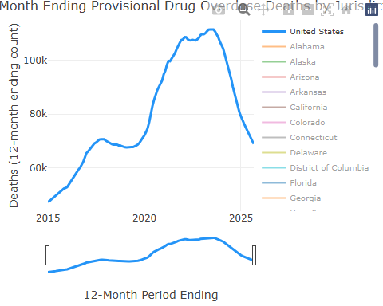

Overdose Data Detail
The table below lists the full CDC provisional overdose dataset. Use the filters to explore specific states, years, or months.
library(DT)
overdose_raw |>
mutate(
data_value = as.numeric(data_value),
predicted_value = as.numeric(predicted_value),
percent_complete = as.numeric(percent_complete)
) |>
select(
`State Name` = state_name, Year = year, Month = month,
`Reported Deaths` = data_value, `Predicted Deaths` = predicted_value,
`% Complete` = percent_complete
) |>
datatable(
caption = "CDC VSRR Provisional Drug Overdose Death Counts",
filter = "top",
options = list(
pageLength = 10,
scrollX = TRUE,
order = list(list(1, "asc"), list(2, "desc"))
),
rownames = FALSE
) |>
formatRound(c("Reported Deaths", "Predicted Deaths"), digits = 0) |>
formatRound("% Complete", digits = 1)
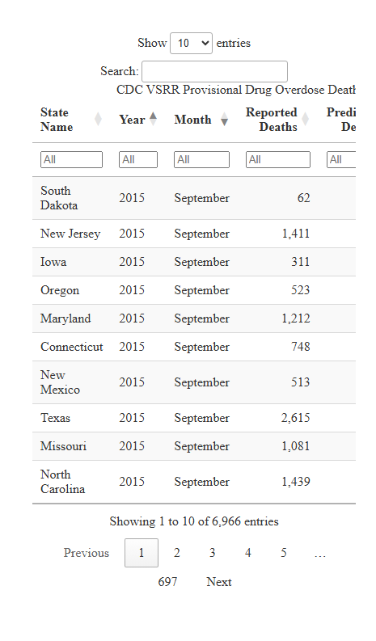

What the Interventions Look Like
Public health responses to the overdose crisis operate at multiple levels:
Harm reduction: Naloxone, a life-saving medication that can reverse opioid overdose, is now available over the counter in all 50 states (Centers for Disease Control and Prevention, 2024b). Access can be further expanded through standing orders at pharmacies, distribution by community-based organizations and law enforcement, and training for emergency medical service staff. However, only 1 naloxone prescription is dispensed for every 70 high-dose opioid prescriptions, and rural counties are nearly 3 times more likely to have low dispensing rates than metropolitan counties (Centers for Disease Control and Prevention, 2024b). Syringe services programs (SSPs) are community-based prevention programs that provide sterile syringes, testing and vaccination for infectious diseases, linkage to substance use disorder treatment, and naloxone distribution (Centers for Disease Control and Prevention, 2024d). Nearly 30 years of research shows that comprehensive SSPs are safe, effective, and cost-saving; they are associated with an estimated 50% reduction in HIV and hepatitis C incidence and do not increase illegal drug use or crime (Centers for Disease Control and Prevention, 2024d).
Treatment access: Medications for opioid use disorder (MOUD), particularly buprenorphine and methadone, substantially reduce overdose-related and overall mortality (Dowell et al., 2024). Yet in 2022, among the estimated 3.7% of U.S. adults (9.4 million people) who needed OUD treatment, only 25% received MOUD; most either did not perceive a need for treatment (43%) or received treatment that did not include medications (30%) (Dowell et al., 2024). Racial disparities persist: higher percentages of White adults received any OUD treatment compared with Black or Hispanic adults (Dowell et al., 2024). The 2022 CDC Clinical Practice Guideline provides 12 evidence-based recommendations for clinicians on prescribing opioids and managing pain, and since 2023, a waiver is no longer required to prescribe buprenorphine for OUD (Centers for Disease Control and Prevention, 2024a). Federal funding through State Opioid Response (SOR) grants ($1.48 billion in FY2025) and Tribal Opioid Response (TOR) grants (~$63 million) supports treatment, prevention, naloxone distribution, and recovery services nationwide (U.S. Department of Health and Human Services, 2025). Since the SOR program began in 2018, nearly 1.3 million people have received treatment services (including over 650,000 who received MOUD), more than 10 million opioid overdose reversal kits have been distributed, and opioid reversal medications have been used to reverse more than 550,000 overdoses (U.S. Department of Health and Human Services, 2025).
Surveillance: Enhanced death investigation through SUDORS (State Unintentional Drug Overdose Reporting System) provides toxicological detail beyond what death certificates capture, revealing which specific substances are involved (Centers for Disease Control and Prevention, 2024c).

Federal Funding
Opioid response funding flows through several federal mechanisms.

USAspending
The USAspending API enables programmatic tracking of federal grant allocations related to the opioid crisis:
# Query USAspending for opioid-related grants
# Documentation: https://api.usaspending.gov/
usa_spending_url <- "https://api.usaspending.gov/api/v2/search/spending_by_award/"
# Dynamic date window: past 5 years from today
date_end <- Sys.Date()
date_start <- as.Date(paste0(as.integer(format(date_end, "%Y")) - 5, "-01-01"))
year_end <- as.integer(format(date_end, "%Y"))
year_start <- year_end - 5
# POST request body: opioid-related keyword search for grants
request_body <- list(
filters = list(
keywords = list("opioid", "overdose", "substance abuse"),
time_period = list(
list(start_date = format(date_start, "%Y-%m-%d"),
end_date = format(date_end, "%Y-%m-%d"))
),
award_type_codes = c("02", "03", "04", "05")
),
fields = c(
"Award ID", "Recipient Name", "Award Amount",
"Awarding Agency", "Awarding Sub Agency",
"Start Date", "End Date", "Description",
"generated_internal_id"
),
limit = 100,
page = 1
)
# Paginate to collect all available awards
# USAspending API caps at 100 results per page
all_results <- list()
for (pg in 1:100) {
request_body$page <- pg
spending_response <- request(usa_spending_url) |>
req_body_json(request_body) |>
req_perform()
page_data <- spending_response |>
resp_body_json(simplifyVector = TRUE)
if (is.null(page_data$results) || nrow(page_data$results) == 0) break
all_results[[pg]] <- page_data$results
if (nrow(page_data$results) < 100) break
}
spending_data <- page_data # keep metadata from last response
spending_data$results <- bind_rows(all_results)
# Extract the results into a tidy dataframe
awards <- spending_data$results |>
as_tibble() |>
mutate(
award_amount = as.numeric(`Award Amount`),
# Build a clickable link to the award page on USAspending.gov
Award = ifelse(
!is.na(generated_internal_id) & generated_internal_id != "",
paste0("[", `Award ID`, "](https://www.usaspending.gov/award/",
generated_internal_id, ")"),
`Award ID`
)
) |>
arrange(desc(award_amount))
# Truncate descriptions to a readable length for the table
awards <- awards |>
mutate(
Description = ifelse(
nchar(Description) > 120,
paste0(substr(Description, 1, 120), "..."),
Description
)
)
# Display the top 5 awards by amount
awards |>
select(
Award, `Recipient Name`, `Award Amount`,
`Awarding Sub Agency`, Description, `Start Date`
) |>
head(5) |>
knitr::kable(
format.args = list(big.mark = ","),
caption = paste0("Top 5 Opioid-Related Federal Grant Awards by Amount (",
year_start, "-", year_end, ")")
)
Top 5 Opioid-Related Federal Grant Awards by Amount (2021-2026)
Award | Recipient Name | Award Amount | Awarding Sub Agency | Description | Start Date
B08TI010062 | HEALTH CARE SERVICES, CALIFORNIA DEPARTMENT OF | 500,650,180 | Substance Abuse and Mental Health Services Administration | SUBSTANCE ABUSE PREVENTION & TREATMENT BLOCK GRANT | 2017-10-01
B08TI010051 | DEPARTMENT OF STATE HEALTH SERVICES | 289,467,596 | Substance Abuse and Mental Health Services Administration | SUBSTANCE ABUSE PREVENTION & TREATMENT BLOCK GRANT | 2017-10-01
B08TI088093 | HEALTH CARE SERVICES, CALIFORNIA DEPARTMENT OF | 264,914,786 | Substance Abuse and Mental Health Services Administration | SUBSTANCE ABUSE PREVENTION, TREATMENT, AND RECOVERY SERVICES BLOCK GRANT - SUBSTANCE ABUSE PREVENTION, TREATMENT, AND RE… | 2024-10-01
B08TI085794 | HEALTH CARE SERVICES, CALIFORNIA DEPARTMENT OF | 262,888,524 | Substance Abuse and Mental Health Services Administration | SUBSTANCE ABUSE PREVENTION & TREATMENT BLOCK GRANT | 2022-10-01
B08TI087026 | HEALTH CARE SERVICES, CALIFORNIA DEPARTMENT OF | 260,578,442 | Substance Abuse and Mental Health Services Administration | SUBSTANCE ABUSE PREVENTION, TREATMENT, AND RECOVERY SERVICES BLOCK GRANT | 2023-10-01
The query returned 10,000 awards, with a combined value of $43,245,313,588.

What Are These Awards Funding?
The word cloud below visualizes the most frequent terms appearing in award descriptions across all 10,000 retrieved opioid-related grants. Larger words appear more often, revealing the dominant themes in federal spending.
# Use the full (untruncated) descriptions from the API response
full_descriptions <- spending_data$results$Description
# Tokenize into individual words, remove stop words and generic terms
word_counts <- tibble(text = full_descriptions) |>
filter(!is.na(text), text != "") |>
unnest_tokens(word, text) |>
anti_join(stop_words, by = "word") |>
filter(
!word %in% c("award", "grant", "funding", "program", "provide",
"project", "based", "including", "support", "services",
"funds", "federal", "national", "department", "health",
"1", "2", "3", "4", "5", "01", "02", "12",
as.character(year_start:year_end), "cfda", "fy"),
nchar(word) > 2,
!grepl("^[0-9]+$", word)
) |>
count(word, sort = TRUE)
ggplot(word_counts |> head(80), aes(label = word, size = n, color = n)) +
geom_text_wordcloud_area(family = "sans", shape = "square") +
scale_size_area(max_size = 28) +
scale_color_gradient(low = "#204d70", high = "#2494f7") +
theme_minimal() +
theme(
plot.background = element_rect(fill = "white", color = NA),
plot.margin = margin(0, 0, 0, 0)
)
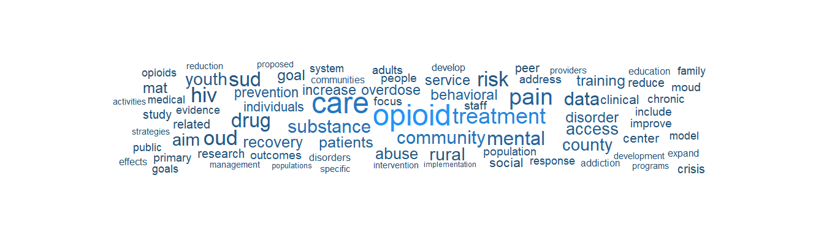

Federal Funding Over Time
The chart below plots individual grant award amounts by their start date, colored by awarding sub-agency. Hover over each point to see the recipient and award details.
# Prepare data for the timeline chart
funding_timeline <- awards |>
mutate(
start_date = as.Date(`Start Date`),
award_amount = as.numeric(`Award Amount`),
agency = `Awarding Sub Agency`,
recipient = `Recipient Name`,
hover_text = paste0(
"<b>", agency, "</b><br>",
"Recipient: ", recipient, "<br>",
"Award: $", formatC(award_amount, format = "f", digits = 0, big.mark = ",")
)
) |>
filter(!is.na(start_date), !is.na(award_amount))
# Brand-aligned color palette for agencies
agency_colors <- c(
"#2494f7", "#00a4bb", "#01272f", "#204d70",
"#e07b39", "#6b4c9a", "#d94f4f", "#2ca02c",
"#8c564b", "#17becf", "#bcbd22", "#7f7f7f"
)
funding_plot <- plot_ly(
data = funding_timeline,
x = ~start_date,
y = ~award_amount,
color = ~agency,
colors = agency_colors,
type = "scatter",
mode = "markers",
marker = list(size = 8, opacity = 0.7),
text = ~hover_text,
hoverinfo = "text"
) |>
layout(
title = list(
text = paste0("Opioid-Related Federal Grant Awards Over Time (",
year_start, "-", year_end, ")"),
font = list(size = 16)
),
xaxis = list(
title = "Award Start Date",
type = "date"
),
yaxis = list(
title = "Award Amount ($)",
separatethousands = TRUE,
type = "log"
),
legend = list(
title = list(text = "Awarding Sub Agency"),
orientation = "h",
y = -0.25,
x = 0,
font = list(size = 9)
),
hovermode = "closest",
margin = list(b = 120)
) |>
config(displayModeBar = TRUE)
funding_plot
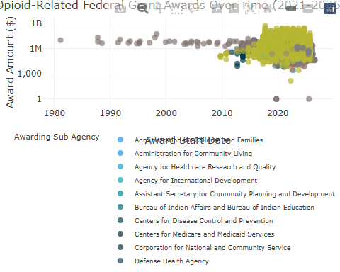

Award Detail
The table below lists all retrieved awards with full descriptions. Use the search box to filter by keyword and click column headers to sort.
library(DT)
awards |>
mutate(
`Start Date` = as.Date(`Start Date`),
`Award Amount` = as.numeric(`Award Amount`)
) |>
select(
`Awarding Sub Agency`, `Recipient Name`, `Award Amount`,
`Start Date`, Description
) |>
arrange(desc(`Award Amount`)) |>
datatable(
caption = paste0("Opioid-Related Federal Grant Awards (",
year_start, "-", year_end, ")"),
filter = "top",
options = list(
pageLength = 10,
scrollX = TRUE,
order = list(list(2, "desc")),
columnDefs = list(
list(width = "300px", targets = 4)
)
),
rownames = FALSE
) |>
formatCurrency("Award Amount", digits = 0) |>
formatDate("Start Date", method = "toLocaleDateString")
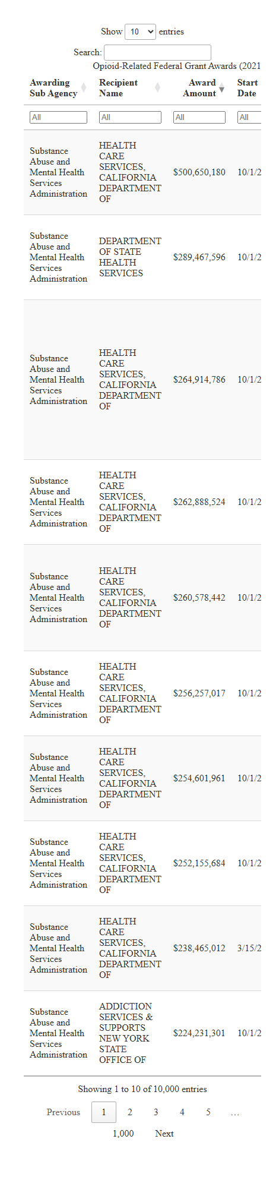
 Data Source
USAspending is the official U.S. government open data source for federal spending. HHS TAGGS provides more granular transaction-level tracking of HHS grant obligations specifically.

Research Literature and Databases
Beyond surveillance data, a large and growing body of peer-reviewed research examines the epidemiology, pharmacology, policy responses, and social determinants of the overdose crisis. Several public databases allow programmatic access to this literature and to information about funded research projects.

PubMed (NCBI E-utilities API)
PubMed indexes over 37 million biomedical citations. The NCBI E-utilities API enables programmatic search and retrieval without authentication (subject to rate limits of 3 requests per second without an API key, or 10 per second with one).
library(httr2)
library(jsonlite)
library(dplyr)
library(tidyr)
# NCBI E-utilities: search PubMed for recent opioid overdose research
# Documentation: https://www.ncbi.nlm.nih.gov/books/NBK25501/
# Step 1: Search for article IDs matching our query
esearch_url <- "https://eutils.ncbi.nlm.nih.gov/entrez/eutils/esearch.fcgi"
search_response <- request(esearch_url) |>
req_url_query(
db = "pubmed",
term = "opioid overdose fentanyl United States[Title/Abstract]",
retmax = 10000,
sort = "date",
retmode = "json",
mindate = format(date_start, "%Y/%m/%d"),
maxdate = format(date_end, "%Y/%m/%d"),
datetype = "pdat"
) |>
req_perform()
search_results <- search_response |>
resp_body_json()
# Extract PubMed IDs
pmids <- search_results$esearchresult$idlist
# Step 2: Fetch article summaries for those IDs
esummary_url <- "https://eutils.ncbi.nlm.nih.gov/entrez/eutils/esummary.fcgi"
if (length(pmids) > 0) {
summary_response <- request(esummary_url) |>
req_url_query(
db = "pubmed",
id = paste(pmids, collapse = ","),
retmode = "json"
) |>
req_perform()
summaries <- summary_response |>
resp_body_json()
# Parse into a tidy dataframe
articles <- lapply(pmids, function(id) {
article <- summaries$result[[id]]
tibble(
pmid = id,
title = article$title %||% NA_character_,
journal = article$fulljournalname %||% NA_character_,
pub_date = article$pubdate %||% NA_character_,
doi = {
doi_ids <- Filter(function(x) x$idtype == "doi", article$articleids)
if (length(doi_ids) > 0) doi_ids[[1]]$value else NA_character_
}
)
}) |>
bind_rows()
}
The search matched 317 articles. 317 were retrieved for analysis.

Publication Trends Over Time
The chart below shows the volume of opioid overdose fentanyl research published over time. Each point represents the number of articles published in a given month.
library(plotly)
library(lubridate)
# Parse publication dates into proper Date objects
# PubMed dates come in formats like "2025 Jan 15", "2025 Mar", "2025"
pubmed_timeline <- articles |>
mutate(
pub_date_parsed = case_when(
grepl("^\\d{4} \\w+ \\d+", pub_date) ~
as.Date(pub_date, format = "%Y %b %d"),
grepl("^\\d{4} \\w+", pub_date) ~
as.Date(paste0(pub_date, " 01"), format = "%Y %b %d"),
grepl("^\\d{4}$", pub_date) ~
as.Date(paste0(pub_date, " Jan 01"), format = "%Y %b %d"),
TRUE ~ NA_Date_
),
pub_month = floor_date(pub_date_parsed, "month")
) |>
filter(!is.na(pub_month))
# Count articles per month
monthly_counts <- pubmed_timeline |>
count(pub_month, name = "n_articles") |>
arrange(pub_month)
# Interactive time series
pubmed_plot <- plot_ly(
data = monthly_counts,
x = ~pub_month,
y = ~n_articles,
type = "scatter",
mode = "lines+markers",
line = list(color = "#2494f7", width = 2),
marker = list(color = "#2494f7", size = 6),
hovertemplate = paste(
"<b>%{x|%B %Y}</b><br>",
"Articles: %{y}<extra></extra>"
)
) |>
layout(
title = list(
text = "Opioid Overdose Fentanyl Research: Publications per Month",
font = list(size = 16)
),
xaxis = list(
title = "Publication Month",
type = "date",
rangeslider = list(visible = TRUE)
),
yaxis = list(
title = "Number of Articles"
),
hovermode = "x unified"
) |>
config(displayModeBar = TRUE)
pubmed_plot
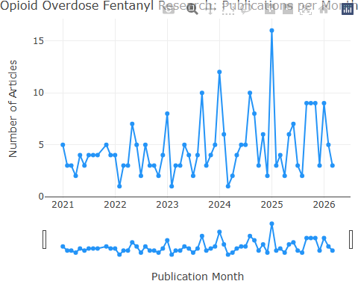

Research Themes in Article Titles
The word cloud below visualizes the most frequent terms appearing in the titles of all 317 retrieved PubMed articles. This provides a quick thematic overview of the research landscape.
# Tokenize article titles into individual words
pubmed_title_words <- tibble(text = articles$title) |>
filter(!is.na(text), text != "") |>
unnest_tokens(word, text) |>
anti_join(stop_words, by = "word") |>
filter(
!word %in% c("study", "analysis", "among", "associated",
"united", "states", "results", "based",
"findings", "using", "related", "data"),
nchar(word) > 2,
!grepl("^[0-9]+$", word)
) |>
count(word, sort = TRUE)
ggplot(pubmed_title_words |> head(80), aes(label = word, size = n, color = n)) +
geom_text_wordcloud_area(family = "sans", shape = "square") +
scale_size_area(max_size = 28) +
scale_color_gradient(low = "#204d70", high = "#2494f7") +
theme_minimal() +
theme(
plot.background = element_rect(fill = "white", color = NA),
plot.margin = margin(0, 0, 0, 0)
)
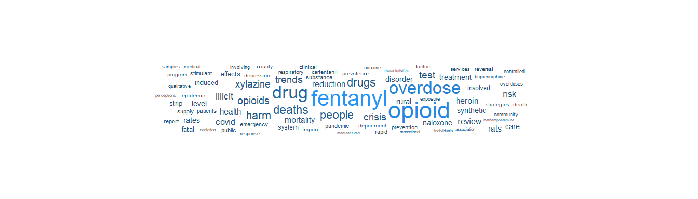

Publication Detail
The table below lists all retrieved articles. Use the search box to filter by keyword, journal, or date, and click column headers to sort.
library(DT)
articles |>
mutate(
# Create clickable PubMed link
PMID = ifelse(
!is.na(pmid),
paste0('<a href="https://pubmed.ncbi.nlm.nih.gov/', pmid,
'/" target="_blank">', pmid, '</a>'),
pmid
),
# Create clickable DOI link
DOI = ifelse(
!is.na(doi),
paste0('<a href="https://doi.org/', doi,
'" target="_blank">', doi, '</a>'),
""
)
) |>
select(
PMID, Title = title, Journal = journal,
`Publication Date` = pub_date, DOI
) |>
datatable(
caption = paste0(
"PubMed: Opioid Overdose Fentanyl Research (",
format(date_start, "%Y"), "-", format(date_end, "%Y"), ")"
),
filter = "top",
escape = FALSE,
options = list(
pageLength = 10,
scrollX = TRUE,
order = list(list(3, "desc")),
columnDefs = list(
list(width = "400px", targets = 1)
)
),
rownames = FALSE
)
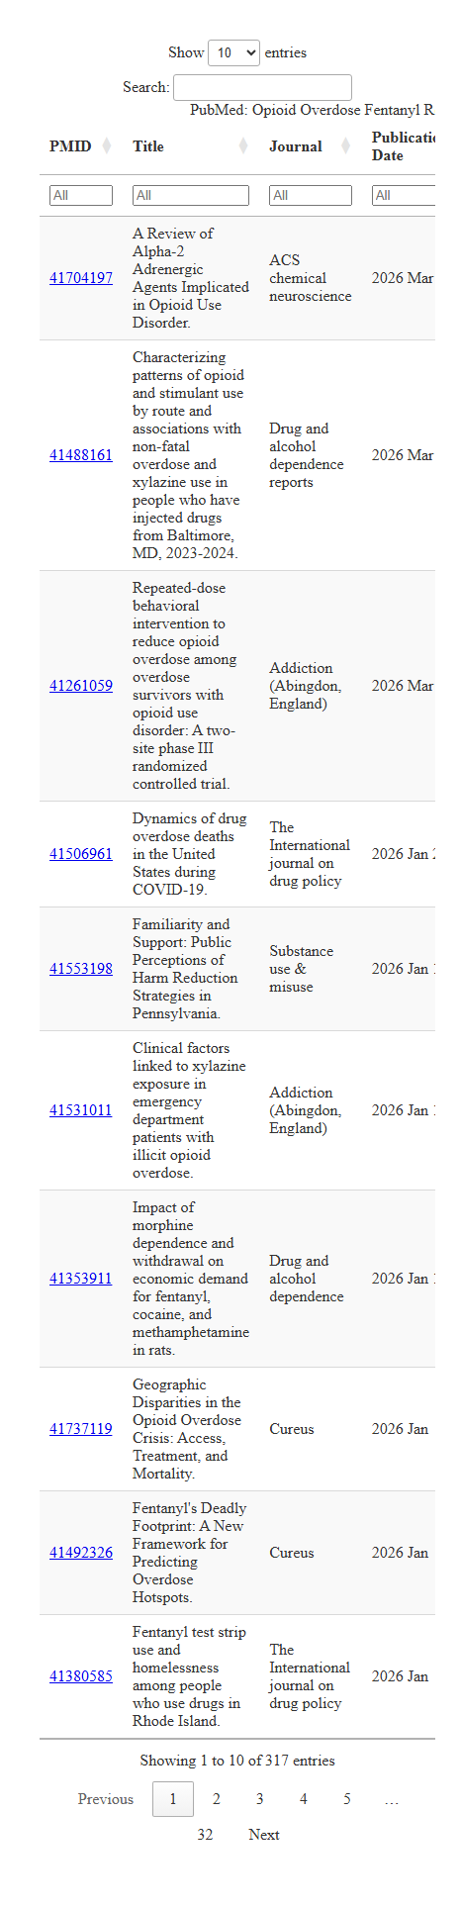
 Reproducibility
For higher rate limits, register for a free NCBI API key at ncbi.nlm.nih.gov/account and append &api_key=YOUR_KEY to requests. The E-utilities support complex Boolean queries using MeSH terms (e.g., "Opiate Overdose"[MeSH] AND "Fentanyl"[MeSH]) for more precise results.

NIH RePORTER (Funded Research Projects)
NIH RePORTER tracks all NIH-funded research projects, including active grants, publications, patents, and clinical trials. Its API supports POST-based queries to identify what research is currently being funded on any topic.
# NIH RePORTER API: find funded opioid overdose research projects
# Documentation: https://api.reporter.nih.gov/
reporter_url <- "https://api.reporter.nih.gov/v2/projects/search"
# Paginate to collect all available projects
all_projects <- list()
for (pg in 0:99) {
reporter_body <- list(
criteria = list(
advanced_text_search = list(
operator = "and",
search_field = "projecttitle,terms",
search_text = "opioid overdose fentanyl"
),
fiscal_years = as.list((year_end - 4L):year_end),
exclude_subprojects = TRUE
),
offset = pg * 100,
limit = 100,
sort_field = "FiscalYear",
sort_order = "desc"
)
reporter_response <- request(reporter_url) |>
req_body_json(reporter_body) |>
req_perform()
reporter_data <- reporter_response |>
resp_body_json()
if (length(reporter_data$results) == 0) break
all_projects[[pg + 1]] <- reporter_data$results
if (length(reporter_data$results) < 100) break
}
reporter_total <- reporter_data$meta$total
# Parse all results into a dataframe
projects <- lapply(unlist(all_projects, recursive = FALSE), function(p) {
tibble(
project_num = p$project_num %||% NA_character_,
fiscal_year = p$fiscal_year %||% NA_integer_,
title = p$project_title %||% NA_character_,
pi_name = {
if (!is.null(p$principal_investigators) && length(p$principal_investigators) > 0)
p$principal_investigators[[1]]$full_name
else NA_character_
},
organization = p$organization$org_name %||% NA_character_,
award_amount = p$award_amount %||% NA_real_,
abstract_text = p$abstract_text %||% NA_character_
)
}) |>
bind_rows()
The search matched 815 projects. 815 were retrieved, representing $598,433,634 in total funding.

NIH Opioid Research Funding Over Time
The chart below shows the distribution of NIH-funded opioid research project awards by fiscal year. Hover over each point to see the project title, PI, and award amount.
library(plotly)
# Summarize funding by fiscal year
nih_annual <- projects |>
filter(!is.na(award_amount), !is.na(fiscal_year)) |>
group_by(fiscal_year) |>
summarise(
total_funding = sum(award_amount, na.rm = TRUE),
n_projects = n(),
.groups = "drop"
) |>
arrange(fiscal_year)
nih_timeline_plot <- plot_ly() |>
add_trace(
data = nih_annual,
x = ~fiscal_year,
y = ~total_funding,
type = "bar",
marker = list(color = "#2494f7"),
text = ~paste0(
"<b>FY ", fiscal_year, "</b><br>",
"Projects: ", n_projects, "<br>",
"Total funding: $", formatC(total_funding, format = "f",
digits = 0, big.mark = ",")
),
hoverinfo = "text"
) |>
layout(
title = list(
text = "NIH Opioid Overdose Research Funding by Fiscal Year",
font = list(size = 16)
),
xaxis = list(
title = "Fiscal Year",
dtick = 1
),
yaxis = list(
title = "Total Award Amount ($)",
separatethousands = TRUE
),
hovermode = "x unified"
) |>
config(displayModeBar = TRUE)
nih_timeline_plot
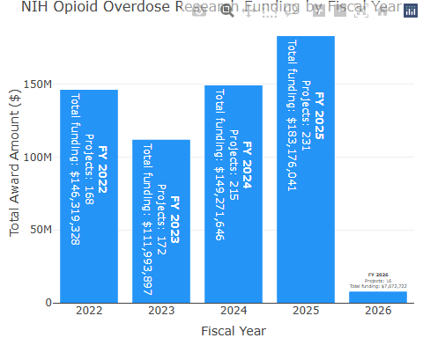

What Is NIH Funding?
The word cloud below visualizes the most frequent terms appearing in project abstracts across all 815 retrieved NIH-funded opioid research projects, revealing the dominant research themes.
# Tokenize abstracts into individual words, remove stop words and generic terms
nih_word_counts <- tibble(text = projects$abstract_text) |>
filter(!is.na(text), text != "") |>
unnest_tokens(word, text) |>
anti_join(stop_words, by = "word") |>
filter(
!word %in% c("study", "research", "project", "aim", "aims",
"specific", "propose", "proposed", "will", "use",
"data", "based", "including", "provide", "develop",
"support", "national", "health", "program", "grant",
"funding", "abstract", "1", "2", "3", "4", "5",
"r01", "r21", "r34", "k01", "k23", "u01", "p50"),
nchar(word) > 2,
!grepl("^[0-9]+$", word)
) |>
count(word, sort = TRUE)
ggplot(nih_word_counts |> head(80), aes(label = word, size = n, color = n)) +
geom_text_wordcloud_area(family = "sans", shape = "square") +
scale_size_area(max_size = 28) +
scale_color_gradient(low = "#204d70", high = "#2494f7") +
theme_minimal() +
theme(
plot.background = element_rect(fill = "white", color = NA),
plot.margin = margin(0, 0, 0, 0)
)
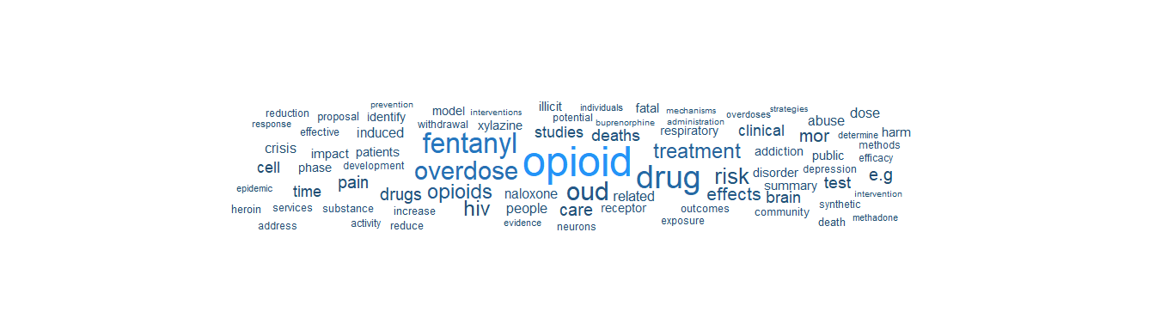

Project Detail
The table below lists all retrieved NIH-funded projects. Use the search box to filter by keyword, PI, organization, or fiscal year, and click column headers to sort.
library(DT)
projects |>
mutate(
# Create clickable link to NIH RePORTER project page
`Project Number` = ifelse(
!is.na(project_num),
paste0('<a href="https://reporter.nih.gov/project-details/',
gsub(" ", "", project_num),
'" target="_blank">', project_num, '</a>'),
project_num
),
`Award Amount` = award_amount,
# Truncate abstracts for display
Abstract = ifelse(
!is.na(abstract_text) & nchar(abstract_text) > 200,
paste0(substr(abstract_text, 1, 200), "..."),
abstract_text
)
) |>
select(
`Project Number`, `Fiscal Year` = fiscal_year,
Title = title, PI = pi_name,
Organization = organization, `Award Amount`, Abstract
) |>
datatable(
caption = paste0(
"NIH-Funded Opioid Overdose Research Projects (",
year_end - 4, "-", year_end, ")"
),
filter = "top",
escape = FALSE,
options = list(
pageLength = 10,
scrollX = TRUE,
order = list(list(5, "desc")),
columnDefs = list(
list(width = "300px", targets = 2),
list(width = "300px", targets = 6)
)
),
rownames = FALSE
) |>
formatCurrency("Award Amount", digits = 0)
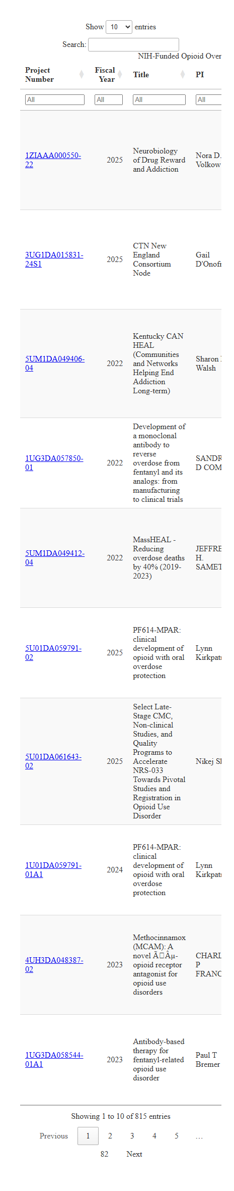
 Data Source
NIH RePORTER is the authoritative source for federally funded biomedical research. It covers grants from NIH, CDC, FDA, AHRQ, SAMHSA, and other HHS agencies. No authentication is required. The API returns project details, funding amounts, and links to resulting publications.

Europe PMC (Open Access Literature)
Europe PMC provides open access to a worldwide collection of life science publications, including all PubMed content plus preprints, patents, and clinical guidelines. Its REST API is particularly useful for retrieving full-text open access articles.
# Paginate to collect all available results (pageSize max is 1000)
epmc_url <- "https://www.ebi.ac.uk/europepmc/webservices/rest/search"
epmc_all <- list()
for (pg in 1:50) {
epmc_response <- request(epmc_url) |>
req_url_query(
query = paste0("(opioid overdose fentanyl) AND (PUB_YEAR:[",
year_start, " TO ", year_end, "])"),
format = "json",
pageSize = 1000,
cursorMark = if (pg == 1) "*" else epmc_cursor,
resultType = "core"
) |>
req_perform()
epmc_data <- epmc_response |>
resp_body_json()
if (length(epmc_data$resultList$result) == 0) break
epmc_all[[pg]] <- epmc_data$resultList$result
epmc_cursor <- epmc_data$nextCursorMark %||% NULL
if (is.null(epmc_cursor) || length(epmc_data$resultList$result) < 1000) break
}
epmc_hit_count <- epmc_data$hitCount
epmc_articles <- lapply(unlist(epmc_all, recursive = FALSE), function(a) {
tibble(
pmid = a$pmid %||% NA_character_,
title = a$title %||% NA_character_,
journal = a$journalTitle %||% NA_character_,
year = a$pubYear %||% NA_character_,
first_pub_date = a$firstPublicationDate %||% NA_character_,
is_open_access = a$isOpenAccess %||% "N",
cited_by_count = a$citedByCount %||% 0L,
doi = a$doi %||% NA_character_,
abstract = a$abstractText %||% NA_character_
)
}) |>
bind_rows()
The search matched 7,092 results. 7,092 articles were retrieved, of which 4500 are open access.

Europe PMC: Publication Timeline
The chart below shows the volume of opioid overdose fentanyl research indexed in Europe PMC by publication year.
library(plotly)
epmc_by_year <- epmc_articles |>
filter(!is.na(.data$year)) |>
mutate(pub_year = as.integer(.data$year)) |>
count(pub_year, name = "n_articles") |>
arrange(pub_year)
epmc_timeline_plot <- plot_ly(
data = epmc_by_year,
x = ~pub_year,
y = ~n_articles,
type = "bar",
marker = list(color = "#00a4bb"),
text = ~paste0("<b>", pub_year, "</b><br>Articles: ", n_articles),
hoverinfo = "text"
) |>
layout(
title = list(
text = "Europe PMC: Opioid Overdose Fentanyl Publications by Year",
font = list(size = 16)
),
xaxis = list(title = "Publication Year", dtick = 1),
yaxis = list(title = "Number of Articles"),
hovermode = "x unified"
) |>
config(displayModeBar = TRUE)
epmc_timeline_plot
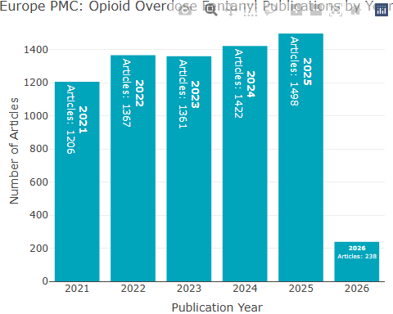

Europe PMC: Research Themes
The word cloud below visualizes the most frequent terms in article titles and abstracts retrieved from Europe PMC.
epmc_word_counts <- epmc_articles |>
mutate(text = paste(title, abstract, sep = " ")) |>
select(text) |>
filter(!is.na(text), text != " ") |>
unnest_tokens(word, text) |>
anti_join(stop_words, by = "word") |>
filter(
!word %in% c("study", "results", "background", "methods",
"conclusions", "objective", "purpose", "findings",
"data", "based", "including", "conclusion",
"aim", "abstract", "introduction"),
nchar(word) > 2,
!grepl("^[0-9]+$", word)
) |>
count(word, sort = TRUE)
ggplot(epmc_word_counts |> head(80), aes(label = word, size = n, color = n)) +
geom_text_wordcloud_area(family = "sans", shape = "square") +
scale_size_area(max_size = 28) +
scale_color_gradient(low = "#204d70", high = "#2494f7") +
theme_minimal() +
theme(
plot.background = element_rect(fill = "white", color = NA),
plot.margin = margin(0, 0, 0, 0)
)
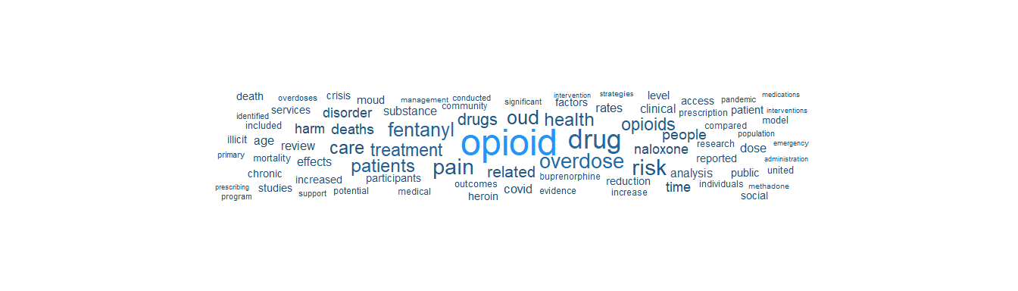

Europe PMC: Article Detail
The table below lists all retrieved articles. Use the search box to filter by keyword, journal, year, or open access status.
library(DT)
epmc_articles |>
mutate(
PMID = ifelse(
!is.na(pmid),
paste0('<a href="https://europepmc.org/article/med/', pmid,
'" target="_blank">', pmid, '</a>'),
""
),
DOI = ifelse(
!is.na(doi),
paste0('<a href="https://doi.org/', doi,
'" target="_blank">', doi, '</a>'),
""
),
`Open Access` = ifelse(is_open_access == "Y", "Yes", "No")
) |>
select(
PMID, Title = title, Journal = journal,
Year = year, `Open Access`, `Cited By` = cited_by_count, DOI
) |>
datatable(
caption = paste0(
"Europe PMC: Opioid Overdose Fentanyl Research (",
year_start, "-", year_end, ")"
),
filter = "top",
escape = FALSE,
options = list(
pageLength = 10,
scrollX = TRUE,
order = list(list(5, "desc")),
columnDefs = list(
list(width = "400px", targets = 1)
)
),
rownames = FALSE
)
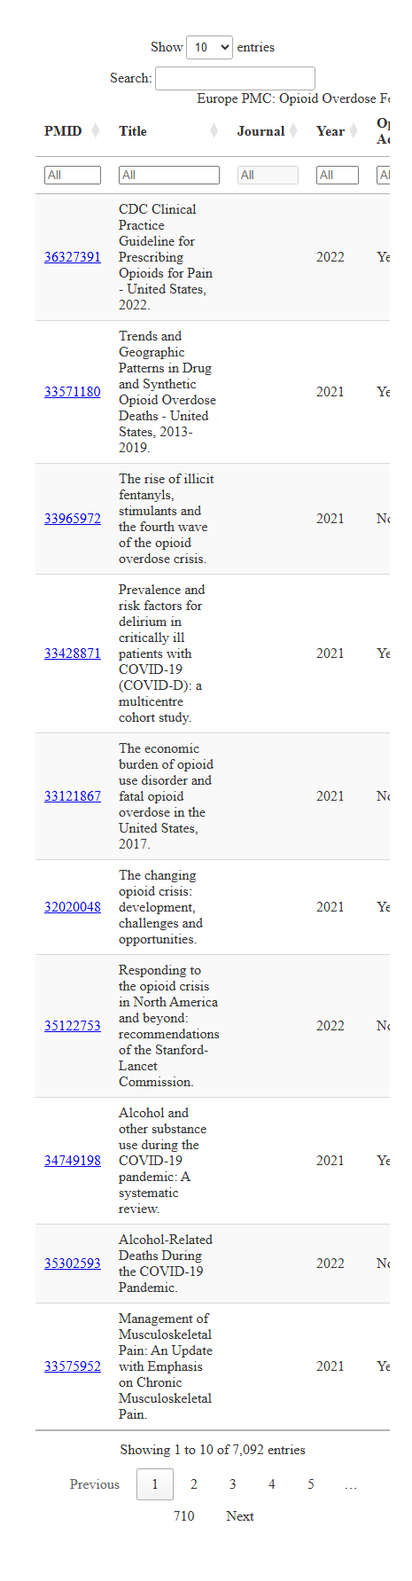

ClinicalTrials.gov (Clinical Research)
ClinicalTrials.gov registers clinical studies on a wide range of conditions, including opioid use disorder treatment trials, naloxone distribution studies, and harm reduction interventions. The v2 API supports structured queries.
# ClinicalTrials.gov v2 API: find opioid-related clinical trials
# Documentation: https://clinicaltrials.gov/data-api/about-api
# Paginate using nextPageToken to collect up to ~200 trials
ct_url <- "https://clinicaltrials.gov/api/v2/studies"
all_trials_raw <- list()
next_token <- NULL
for (pg in 1:10) {
ct_query <- list(
`query.cond` = "opioid overdose",
`query.intr` = "fentanyl OR naloxone OR buprenorphine",
`filter.overallStatus` = "RECRUITING,ACTIVE_NOT_RECRUITING,COMPLETED",
countTotal = "true",
pageSize = 100,
sort = "LastUpdatePostDate:desc"
)
if (!is.null(next_token)) ct_query$pageToken <- next_token
ct_response <- request(ct_url) |>
req_url_query(!!!ct_query) |>
req_perform()
ct_data <- ct_response |>
resp_body_json()
if (length(ct_data$studies) == 0) break
all_trials_raw[[pg]] <- ct_data$studies
next_token <- ct_data$nextPageToken
if (is.null(next_token)) break
}
ct_total <- ct_data$totalCount
trials <- lapply(unlist(all_trials_raw, recursive = FALSE), function(s) {
proto <- s$protocolSection
id_mod <- proto$identificationModule
status_mod <- proto$statusModule
sponsor_mod <- proto$sponsorCollaboratorsModule
design_mod <- proto$designModule
desc_mod <- proto$descriptionModule
tibble(
nct_id = id_mod$nctId %||% NA_character_,
title = id_mod$briefTitle %||% NA_character_,
status = status_mod$overallStatus %||% NA_character_,
start_date = status_mod$startDateStruct$date %||% NA_character_,
sponsor = sponsor_mod$leadSponsor$name %||% NA_character_,
enrollment = design_mod$enrollmentInfo$count %||% NA_integer_,
description = desc_mod$briefSummary %||% NA_character_
)
}) |>
bind_rows()
The search matched 66 studies. 66 trials were retrieved for analysis.

Clinical Trials Over Time
The chart below shows the number of opioid-related clinical trials by their start year, broken down by status.
library(plotly)
trials_timeline <- trials |>
mutate(
start_year = as.integer(substr(start_date, 1, 4))
) |>
filter(!is.na(start_year)) |>
count(start_year, status, name = "n_trials") |>
arrange(start_year)
# Brand-aligned status colors
status_colors <- c(
"COMPLETED" = "#2494f7",
"ACTIVE_NOT_RECRUITING" = "#00a4bb",
"RECRUITING" = "#204d70"
)
ct_timeline_plot <- plot_ly(
data = trials_timeline,
x = ~start_year,
y = ~n_trials,
color = ~status,
colors = status_colors,
type = "bar",
text = ~paste0(
"<b>", start_year, "</b><br>",
status, ": ", n_trials, " trials"
),
hoverinfo = "text"
) |>
layout(
title = list(
text = "Opioid-Related Clinical Trials by Start Year and Status",
font = list(size = 16)
),
xaxis = list(title = "Start Year", dtick = 1),
yaxis = list(title = "Number of Trials"),
barmode = "stack",
legend = list(
title = list(text = "Trial Status"),
orientation = "h",
y = -0.2, x = 0
),
hovermode = "x unified"
) |>
config(displayModeBar = TRUE)
ct_timeline_plot
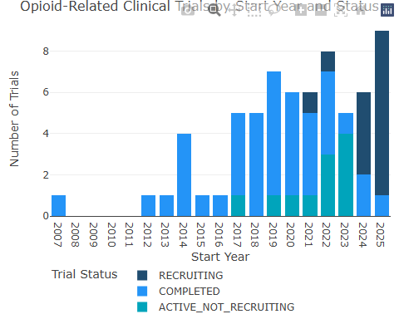

Clinical Trial Research Themes
The word cloud below visualizes the most frequent terms in trial titles and descriptions, revealing the dominant intervention and population themes in clinical research.
ct_word_counts <- trials |>
mutate(text = paste(title, description, sep = " ")) |>
select(text) |>
filter(!is.na(text), text != " ") |>
unnest_tokens(word, text) |>
anti_join(stop_words, by = "word") |>
filter(
!word %in% c("study", "trial", "clinical", "phase",
"participants", "purpose", "determine",
"evaluate", "assess", "including", "based",
"aims", "aim", "objective", "primary"),
nchar(word) > 2,
!grepl("^[0-9]+$", word)
) |>
count(word, sort = TRUE)
ggplot(ct_word_counts |> head(80), aes(label = word, size = n, color = n)) +
geom_text_wordcloud_area(family = "sans", shape = "square") +
scale_size_area(max_size = 28) +
scale_color_gradient(low = "#204d70", high = "#2494f7") +
theme_minimal() +
theme(
plot.background = element_rect(fill = "white", color = NA),
plot.margin = margin(0, 0, 0, 0)
)
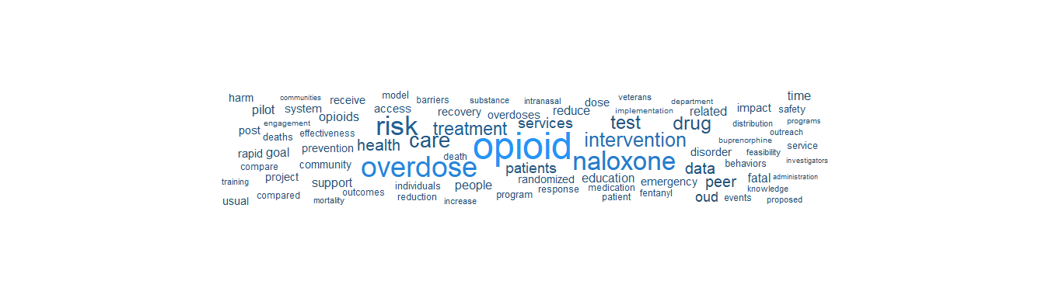

Clinical Trial Detail
The table below lists all retrieved clinical trials. Use the filters to explore by status, sponsor, or keyword.
library(DT)
trials |>
mutate(
`NCT ID` = ifelse(
!is.na(nct_id),
paste0('<a href="https://clinicaltrials.gov/study/',
nct_id, '" target="_blank">', nct_id, '</a>'),
nct_id
),
# Truncate descriptions for display
Description = ifelse(
!is.na(description) & nchar(description) > 200,
paste0(substr(description, 1, 200), "..."),
description
)
) |>
select(
`NCT ID`, Title = title, Status = status,
`Start Date` = start_date, Sponsor = sponsor,
Enrollment = enrollment, Description
) |>
datatable(
caption = "ClinicalTrials.gov: Opioid Overdose Intervention Trials",
filter = "top",
escape = FALSE,
options = list(
pageLength = 10,
scrollX = TRUE,
order = list(list(3, "desc")),
columnDefs = list(
list(width = "300px", targets = 1),
list(width = "300px", targets = 6)
)
),
rownames = FALSE
)
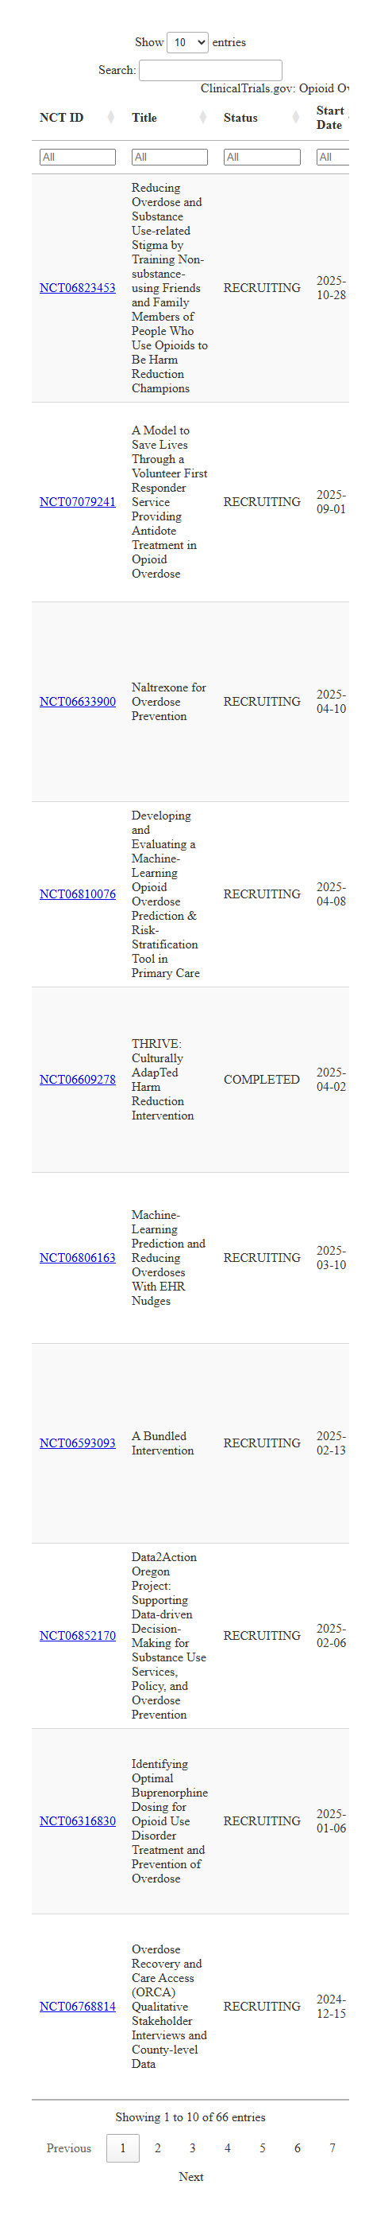
 Reproducibility
ClinicalTrials.gov does not require authentication. The v2 API returns JSON by default and supports filtering by condition, intervention, status, location, and date range. This is useful for mapping the research landscape around specific interventions (e.g., naloxone distribution, buprenorphine access).

References

Development Tools

Development Tools
 Appendix Status
This appendix documents the tools and technologies used to build this book. These tools are not the focus of the book’s content; they are documented here for transparency and for contributors who wish to reproduce or extend the work.

Tools Used
Tool | Purpose
Quarto | Reproducible document and book generation
R / RStudio | Data analysis, visualization, and Shiny dashboards
Python | API access, data engineering, PDF extraction
VS Code | Primary editor for development
GitHub | Version control and publishing (GitHub Pages)
GitHub Copilot | AI-assisted development
Mermaid | Text-based diagrams for data flows and frameworks
Tableau Public | Interactive dashboard publishing

Local Development
To build this book locally:
# Render the book
quarto render
# Preview with live reload
quarto preview

Glossary

Glossary
Key terms used throughout this book, organized alphabetically.

C
CDC WONDER
Wide-ranging ONline Data for Epidemiologic Research. The primary federal system for querying mortality and other public health data from the National Vital Statistics System. Accessible at wonder.cdc.gov.
ClinicalTrials.gov
A database of privately and publicly funded clinical studies conducted around the world. Maintained by the National Library of Medicine (NLM), it registers trials on conditions including opioid use disorder treatments and harm reduction interventions. Accessible via a public v2 API at clinicaltrials.gov.

D
DALY (Disability-Adjusted Life Year)
A composite measure of disease burden combining years of life lost (YLLs) due to premature mortality with years lived with disability (YLDs). One DALY represents one lost year of healthy life.
Data Sovereignty
The principle that data is subject to the laws and governance of the nation or community from which it originates. Particularly relevant for Indigenous data, where tribal nations assert authority over data collection, ownership, and use.
Data Use Agreement (DUA)
A formal agreement governing the terms under which restricted datasets may be accessed and used, specifying permitted uses, security requirements, and reporting obligations.

E
E-utilities (NCBI Entrez Programming Utilities)
A set of server-side programs providing a stable interface to the Entrez query and database system at the National Center for Biotechnology Information (NCBI). Used for programmatic access to PubMed and other NCBI databases. Documentation at ncbi.nlm.nih.gov/books/NBK25501.
Europe PMC
An open science platform that provides access to a worldwide collection of life science publications, including all PubMed content plus preprints, patents, and clinical guidelines. Offers a REST API for programmatic search and retrieval at europepmc.org.

F
Fentanyl
A synthetic opioid 50 to 100 times more potent than morphine. Illicitly manufactured fentanyl is the primary driver of drug overdose deaths in the United States since approximately 2013.

G
Global Burden of Disease (GBD)
A comprehensive epidemiological study managed by the Institute for Health Metrics and Evaluation (IHME) that provides estimates for over 375 diseases and injuries across 204 countries.

H
Health Expenditure
The total spending on health by all financing agents (government, private, out-of-pocket, external aid) within a jurisdiction.

I
ICD-10
The International Classification of Diseases, 10th Revision. The standard diagnostic coding system used worldwide for mortality and morbidity classification.

M
MOUD (Medications for Opioid Use Disorder)
Evidence-based pharmacological treatments for opioid use disorder, including buprenorphine, methadone, and naltrexone. Previously referred to as medication-assisted treatment (MAT).
Morbidity
The state of having a disease or medical condition. Measured through incidence (new cases) and prevalence (existing cases) rates.
Mortality Rate
The frequency of death in a defined population over a specified time period, typically expressed per 100,000 population.

N
Naloxone
An opioid antagonist medication that rapidly reverses the effects of opioid overdose. Available as a nasal spray (Narcan) or injectable formulation. A core component of harm reduction strategies.
NCD (Non-Communicable Disease)
Chronic diseases not transmitted from person to person, including cardiovascular disease, cancer, diabetes, and chronic respiratory disease.
NIH RePORTER
Research Portfolio Online Reporting Tools. A searchable database of federally funded biomedical research projects maintained by the National Institutes of Health. Covers grants from NIH, CDC, FDA, AHRQ, SAMHSA, and other HHS agencies. Accessible via a public API at reporter.nih.gov.

O
OData
Open Data Protocol. A REST-based data access protocol used by WHO Global Health Observatory and other data portals for programmatic querying.

P
PubMed
A free search engine maintained by the National Library of Medicine (NLM) that indexes over 37 million citations and abstracts of biomedical literature. The primary resource for searching peer-reviewed public health and medical research. Accessible at pubmed.ncbi.nlm.nih.gov.

S
Socrata
A data platform used by many U.S. state and local governments to host open data portals with built-in API access.
SUDORS (State Unintentional Drug Overdose Reporting System)
A CDC surveillance system that collects detailed toxicological and death scene information on unintentional and undetermined-intent drug overdose deaths, providing more substance-specific detail than death certificates alone.

V
VSRR (Vital Statistics Rapid Release)
A CDC program that publishes provisional mortality data, including monthly drug overdose death counts, before finalized annual data are available.

Y
YLD (Years Lived with Disability)
The number of years lived in less than ideal health, weighted by the severity of the disability.
YLL (Years of Life Lost)
The number of years of potential life lost due to premature death, calculated from a reference life expectancy.
Centers for Disease Control and Prevention. (2024a). 2022 CDC clinical practice guideline for prescribing opioids for pain. https://www.cdc.gov/overdose-prevention/hcp/clinical-guidance/
Centers for Disease Control and Prevention. (2024b). Reverse opioid overdose to prevent death. https://www.cdc.gov/overdose-prevention/reversing-overdose/index.html
Centers for Disease Control and Prevention. (2024c). State unintentional drug overdose reporting system (SUDORS). https://www.cdc.gov/overdose-prevention/data-research/facts-stats/sudors-dashboard-fatal-overdose-data.html
Centers for Disease Control and Prevention. (2024d). Strengthening syringe services programs (SSPs). https://www.cdc.gov/hepatitis-syringe-services/php/about/index.html
Centers for Disease Control and Prevention. (2025). Understanding the opioid overdose epidemic. https://www.cdc.gov/overdose-prevention/about/understanding-the-opioid-overdose-epidemic.html
Commonwealth Fund. (2025a). 2025 scorecard on state health system performance. https://www.commonwealthfund.org/publications/scorecard/2025/jun/2025-scorecard-state-health-system-performance
Commonwealth Fund. (2025b). U.s. Overdose deaths remain higher than in other countries — trend-tracking and harm-reduction policies could help. https://www.commonwealthfund.org/blog/2025/us-overdose-deaths-remain-higher-other-countries-trend-tracking-and-harm-reduction
Dowell, D., Brown, S., Gyawali, S., Hoenig, J., Ko, J., Mikosz, C., Ussery, E., Baldwin, G., Jones, C. M., Olsen, Y., Tomoyasu, N., Han, B., Compton, W. M., & Volkow, N. D. (2024). Treatment for opioid use disorder: Population estimates — united states, 2022. MMWR Morbidity and Mortality Weekly Report, 73(25), 567–574. https://doi.org/10.15585/mmwr.mm7325a1
National Center for Health Statistics. (2024a). Drug overdose deaths – health, united states. https://www.cdc.gov/nchs/hus/topics/drug-overdose-deaths.htm
National Center for Health Statistics. (2024b). Leading causes of death – FastStats. https://www.cdc.gov/nchs/fastats/leading-causes-of-death.htm
U.S. Department of Health and Human Services. (2025). HHS provides more than $1.5 billion in state and tribal opioid response grants. https://www.hhs.gov/press-room/hhs-state-tribal-opioid-response-grants-2025.html

