- Editors

  - Default editor
- Right click on the table -> Create Documents -> Empty File
- Rename the file, ending with .c
- Double left click on the file, open with default editor Pluma, or right click to use other editors.
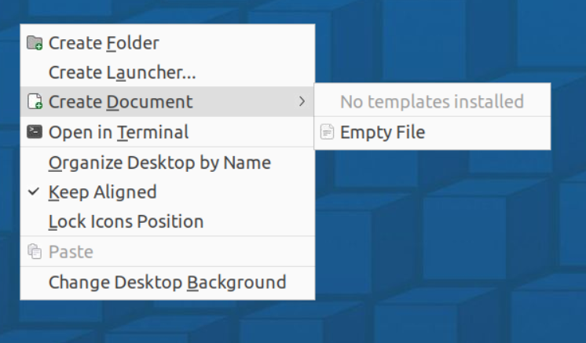
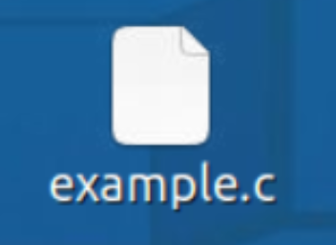
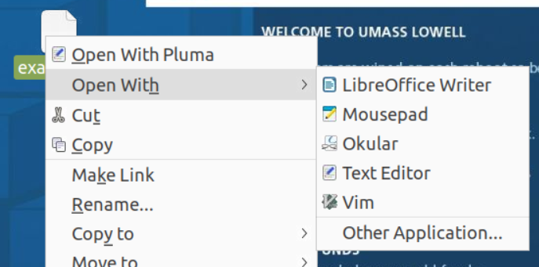

  - Emacs: https://www.gnu.org/software/emacs/tour/index.html

  - Vi: https://www.tutorialspoint.com/unix/unix-vi-editor.htm

- Example of C code with argc and argv.

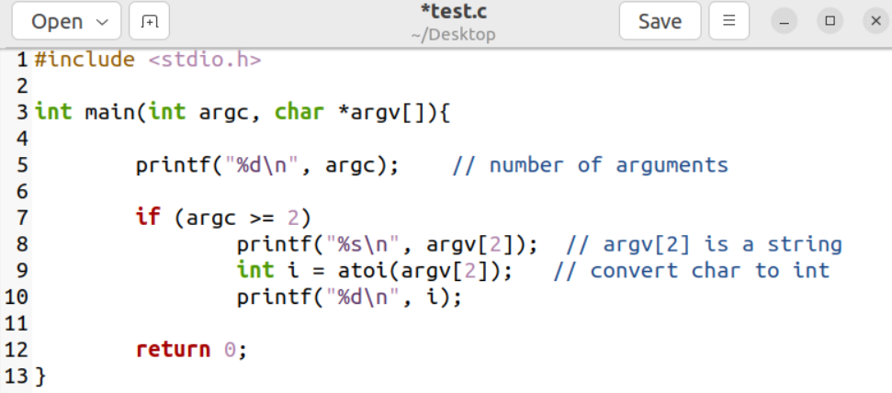

Blue circle is the C file name, and the red circle is the executable file name.

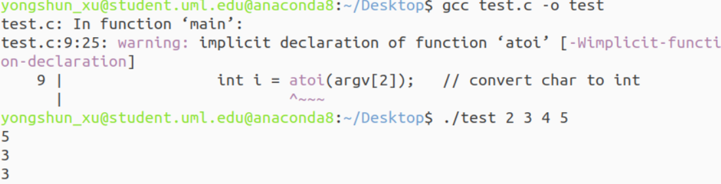

In this example, there are total 5 arguments, the third argument is argv[2], which is 3.

- Example of makefile
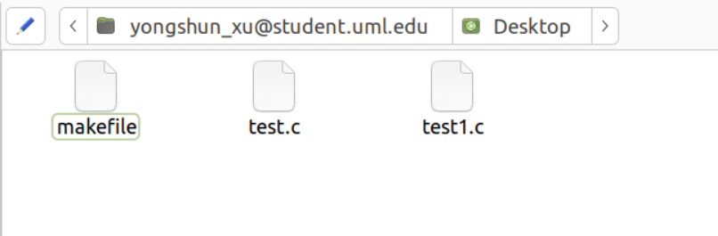

Enter make in the terminal:
