Buhai Andreia Veronica-grupa 2117-semigrupa1-fişă evaluare-UNIT1

1.a)

**La acest exercitiu au participat:**

* **Buhai Andreia**
* **Tania Gorgan**
* **Gatej Stefan**
* **Doana Gabriel**

Procesor:AMD Ryzen 7 7800X3D 4.2GHz box

|  |  |  |  |  |  |  |  |  |  |  |  |  |  |  |  |  |  |  |  |  |  |  |  |  |  |  |  |  |  |  |  |  |  |  |  |  |  |  |  |  |  |  |  |  |  |  |  |  |
| --- | --- | --- | --- | --- | --- | --- | --- | --- | --- | --- | --- | --- | --- | --- | --- | --- | --- | --- | --- | --- | --- | --- | --- | --- | --- | --- | --- | --- | --- | --- | --- | --- | --- | --- | --- | --- | --- | --- | --- | --- | --- | --- | --- | --- | --- | --- | --- | --- |
| |  |  |  | | --- | --- | --- | | Recomandat pentru Gaming |  | Da | | Socket |  | AM5 | | Serie |  | Ryzen 7 7000 Series | | Nucleu |  | Raphael | | Numar nuclee |  | 8 | | Numar thread-uri |  | 16 | | Frecventa |  | 4200 Mhz | | Frecventa turbo pana la |  | 5000 Mhz | | Cache level 2 |  | 8 MB | | Cache level 3 |  | 96 MB | | Tehnologie de fabricatie |  | 5 nm | | Putere totala disipata |  | 120 W | | Deblocat |  | Da | | Tip  Memorie maxima  Frecventa  Suport |  | DDR5  128 Gb  5200 MHz  Dual Channel | |  |  |  | |  |  |  | |

b) Se va construi o arhitectură hardware PC pornind de la componenta pct.1 cu respectarea compatibilității între componente. Arhitectura va include:

**i.** CPU: Procesor AMD Ryzen 7 7800X3D 4.2GHz box

**ii.** Placa de bază: Placa de baza ASUS ROG STRIX X670E-F GAMING WIFI

**iii**. RAM: Memorie Kingston FURY Beast 32GB DDR5 6000MHz CL30 Dual Channel Kit

**iv**. Placă Grafică: Placa video PowerColor Radeon RX 7900 XT Hellhound 20GB GDDR6 320-bit

# **v**. Placă rețea: Placa de retea wireless ASUS PCE-AX3000 Dual-Band WiFi 6

# **vi.** Cooler: Cooler CPU Noctua NH-D15

**vii**. Sursă: Corsair RMx Series RM750x 2021, 80+ Gold

**viii.** Stocare: SSD-ul Samsung 980 PRO 1TB PCI Express 4.0 x4 M.2 2280

**ix.** Carcasă: Fractal Design Meshify C

**x.** Dispozitive gaming (opțional):

**-** Casti Gaming Logitech G PRO X

- Tastatura Gaming Razer BlackWidow V3 TKL Yellow Switch Mecanica

- Mouse Gaming Logitech G502 HERO

- Monitor LED ASUS Gaming ROG Swift PG27AQDM 27 inch QHD OLED 0.03 ms 240 Hz HDR FreeSync Premium & G-Sync Compatible

**xi.** Sistem de operare: Windows 10

c)

|  |  |  |  |  |
| --- | --- | --- | --- | --- |
| *Denumire Componenta* | *Denumire Completă* | *Producător* | *Specificații* | *Conectori De Alimentare/Date/Interfață I/O* |
| **CPU** | Procesor AMD Ryzen 7 7800X3D 4.2GHz box | *Cod Producator:*  *100-100000910WOF* | *Socket: AM5*  *Numar nuclee:8*  *Frecventa: 4200 Mhz*  *Frecventa turbo pana la: 5000 Mhz*  *Numar thread-uri: 16* | *PCIe 5.0: Ryzen 7 7800X3D suportă PCIe 5.0*  *Socket: AM5*  *USB , Audio* |
| **Placa de bază** | Placa de baza ASUS ROG STRIX X670E-F GAMING WIFI | *ROG STRIX X670E-F GAMING WIFI* | *Format: ATX*  *Soclu procesor: AM5*  *Producator chipset:AMD*  *Model chipset: X670E*  *Procesoare suportate: AMD AM5 Socket Ryzen 7000 Series*  *Interfata grafica: PCI Express x16 5.0*  *RAID 0,1,10* | *Optical S/PDIF out*  *Clear CMOS*  *HDMI*  *Display Port*  *USB 2.0*  *USB 3.2 Gen2 tip A*  *USB 3.2 Gen2 tip C* |
| **RAM** | Memorie Kingston FURY Beast 32GB DDR5 6000MHz CL30 Dual Channel Kit | *Cod Producator:*  *KF560C30BBK2-32* | *Capacitate: 32 GB*  *Frecventa: 6000 MHz*  *Tensiune alimentare:1.4V*  *Standard: PC5-48000*  *Tip: DDR5* | *Tip: Conectorul este de tip DIMM*  *Sloturi: Kingston FURY Beast DDR5* |
| **Placă Grafică** | PowerColor Radeon RX 7900 XT Hellhound 20GB GDDR6 320-bit | *Cod Producator:*  *RX 7900 XT 20G-L/OC* | *Seria: Radeon RX 7000*  *Tehnologie de fabricatie: 5nm*  *Procesor graphic: Navi 31 XT*  *GPU Boost clock 2500 MHz*  *Tip memorie GDDR6*  *Dimensiune memorie 20 GB*  *BUS memorie 320 bit*  *Frecventa memorie efectiva 20000 MHz* | *Alimentare separata:*  *2x 8-pin PCI-E*  *HDMI:1*  *Display port:3*  *PCI Express x16 4.0* |
| **Placă rețea** | Placa de retea wireless ASUS PCE-AX3000 Dual-Band WiFi 6 | *Cod Producator:*  *PCE-AX3000* | *Interfata PCI express x1*  *Standarde 802.11 ax*  *Antene 2x antenna*  *Frecventa 2,4 Ghz , 5 Ghz*  *Viteza de transfer 5Ghz: 2402 Mbps*  *2.4 Ghz: 574 Mbps* | *PCI Express x1* |
| **Cooler** | Cooler CPU Noctua NH-D15 | *Cod Producator:*  *CPNTD15* | *Tip racire Aer*  *Racire Activ*  *Bearing ventilator SSO 2*  *Numar heatpipe-uri 6*  *Inaltime 165 mm*  *Numar ventilatoare 2*  *Dimensiune ventilator 140 mm*  *Tip radiator: Dublu*  *PWM ventilator: Da*  *Viteza de rotatie ventilator 300-1500 RPM*  *Flux aer 115.5 –*  *140.2 m3/h*  *Conector ventilator 4 pin , greutate 1320g* | *NH-D15 include două ventilatoare de 140 mm, fiecare având un conector de alimentare de tip PWM*  *Coolerul nu are conectori de date propria*  *NH-D15 nu are interfețe de intrare/ieșire (I/O)* |
| **Sursă** | Corsair RMx Series RM750x 2021, 80+ Gold | *Cod Producator:*  *CP-9020199-EU* | *Recomandat pentru Gaming Da*  *Tip ATX 2.4*  *Putere 750 W*  *Numar ventilatoare1x 135 mm*  *Voltaj/Amperaj 100-240Vac*  *Caracteristici*  *Cabluri negre plate*  *PFC Active*  *Eficienta 90 %*  *Certificare 80+ Gold*  *Dimensiune 150 x 160 x 86 mm*  *Modulara*  *Da, Full Modulara*  *Protectii OVP, UVP, SCP, OTP, OPP* | *4+4 Pin ATX/EPS: 2*  *SATA: 10* |
| **Stocare** | SSD Samsung 980 PRO Heatsink 1TB PCI Express 4.0 x4 M.2 2280 | *Cod Producator:*  *MZ-V8P1T0CW* | *Tip Serie*  *Consumer*  *Recomandat pentru Gaming Da*  *Seria 980 PRO Heatsink*  *Compatibil PS5 Da*  *Tip SSD Intern*  *Form factor M.2*  *Interfata PCI Express 4.0 x4*  *Suport NVMe Da*  *Capacitate 1 TB*  *DRAM Cache 1 GB*  *Controller Samsung Elpis* | *Conector de alimentare: SSD-urile M.2*  *Conector de date: Utilizând slotul M.2 2280, SSD-ul se conectează la placa de bază*  *PCIe 4.0 x4* |
| **Carcasă** | Carcasa Fractal Design Meshify 2 Compact RGB Black | *Cod producator:*  *FD-C-MES2C-06* | *Tip carcasa Middle Tower*  *Pozitionare sursa Jos*  *Culoare Negru*  *Sursa Fara sursa*  *Bays 3.5 interne 2*  *Bays 2.5 interne 4 (2 convertite din 3.5)*  *Dimensiuni (H x D x W) 475 x 424 x 210 mm*  *Greutate 8.10 kg*  *Mesh frontal Full*  *Panou lateral transparent Da, tempered glass*  *Sloturi expansiune x7*  *Suport radiator*  *Fata - 1 x 120/240/280/360mm*  *Tavan - 1x 120/240mm*  *Spate - 1x 120mm*  *Inaltime cooler CPU169 mm (Max)*  *Lungime video GPU 345 mm (Max)* | *USB 3.0: 1*  *USB Type C: 1*  *3.5 mm jack: 1* |
| **Dispozitive gaming (opțional)** | - Casti Gaming Logitech G PRO X  - Tastatura Gaming Razer BlackWidow V3 TKL Yellow Switch Mecanica  - Mouse Gaming Logitech G502 HERO  - Monitor LED ASUS Gaming ROG Swift PG27AQDM 27 inch QHD OLED 0.03 ms 240 Hz HDR FreeSync Premium & G-Sync Compatible | *Cod producator:*  *981-000818*  *Cod producator:*  *RZ03-03491800-R3M1*  *Cod producator:*  *910-005470, 910-005471*  *Cod producator:*  *PG27AQDM* | *Tehnologie Wired*  *Sunet 7.1 Surround*  *Tip Externe*  *Diametru difuzoare 50 mm*  *Impedanta 35 Ohm*  *Frecventa raspuns 20 - 20.000 Hz*  *Sensibilitate 91.7 dB*  *Lungime cablu 2 m*  *Culoare Negru - Argintiu*  *Caracteristici*  *DTS HEADPHONE:X 2.0*  *Form factor Compact (TKL)*  *Culoare Negru*  *Tehnologie Cu fir*  *Interfata USB*  *Dimensiuni 362 x 154.8 x 41mm*  *Greutate 849 g*  *Tastatura mecanica Da*  *Switch Razer Yellow*  *Palm rest*  *Fara Iluminata Da*  *Culoare LED RGB*  *Tehnologie Wired*  *Interfata USB*  *Tip senzor Optic*  *Rezolutie maxima 25600 dpi*  *Numar butoane 11*  *Culoare Negru*  *Iluminare Da*  *Culoare LED RGB*  *Dimensiuni 132 x 75 x 40 mm*  *Greutate 121 g*  *Altele Iluminare RGB*  *Microprocessor: 32bit*  *USB data format: 16 bits/axis*  *USB report rate: 1000 Hz (1ms)*  *Resolution: 100 – 16,000 dpi*  *Max. acceleration: >40G*  *Max. speed: >400 ips*  *Tip panel OLED*  *Diagonala 27 inch*  *Anti-Glare Da*  *Rezolutie 2560 x 1440 pixeli*  *Timp de raspuns 0.03 ms*  *Refresh Rate 240 Hz*  *Rata de aspect 16:9*  *Contrast 15.000.000:1 (typical)*  *Luminozitate 1000 cd/m²*  *Unghi de vizibilitate 178/178 grade*  *Dimensiune punct0.229 mm*  *Nr. biti de culoare 10 bits*  *Standarde sRGB: 135% Coverage*  *DCI-P3: 99% Coverage*  *Culoare Negru*  *Putere consumata*  *10 W*  *Dimensiuni Cu suport: 605 x 438-548 x 274 mm*  *Fara suport: 605 x 351x 50 mm*  *Greutate Cu suport: 6.9 kg*  *Fara suport: 2.8 kg* | *Conectare USB*  *Conectare Jack: 1x Jack 3.5 mm*  *Conectare: Cablu USB Type-C detasabil*  *Conectivitate: Cablu USB 3.0*  *HDMI: 2*  *Display Port: 1*  *USB: 3x USB 3.0*  *Jack: 1* |
| **Sistem de operare** | *Sistem de operare Microsoft Windows 10 Pro, OEM DSP OEI, 64-bit, engleza* | *Microsoft* | *Mod comercializare: DVD Licentiere: OEM DSP OEI*  *Licenta pentru: PC nou*  *Versiune: Windows 10*  *Editie: Windows 10 Pro*  *Platforma: 64-bit Limba: Engleza* | *Software* |

d) Procesorul este compatibil cu placa de baza amandoua avand acelasi tip de socket si soclu(AM5). Idem si la placa video, cooler, SSD, placa de retea, si dispozitivele anexe de gaming(monitor, tastatura, mouse si casti). De asemenea sistemul de operare este compatibil cu placa de baza. Iar monitorul cu placa grafica pentru ca placa grafica suporta HDMI

2.a)i. 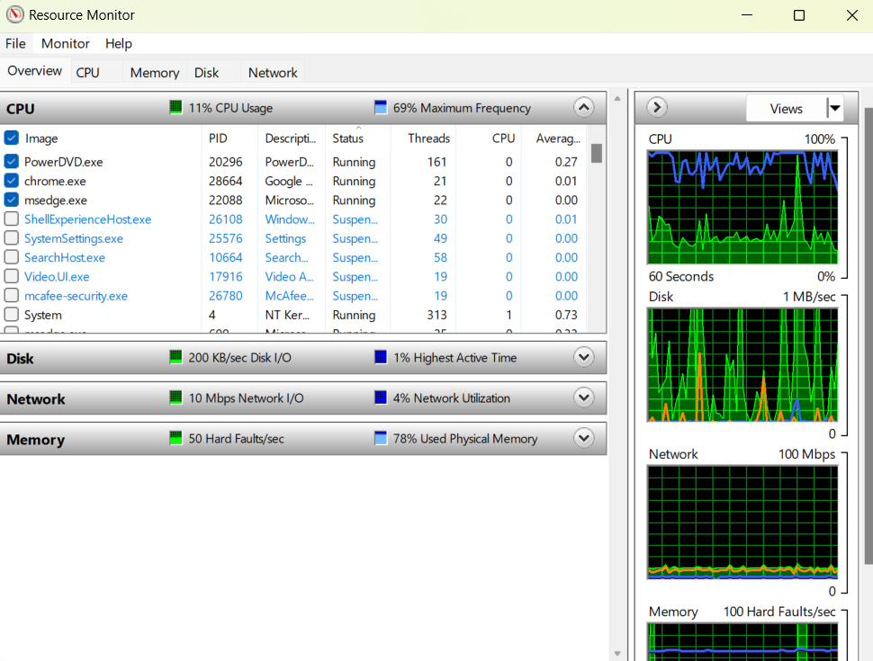

ii.

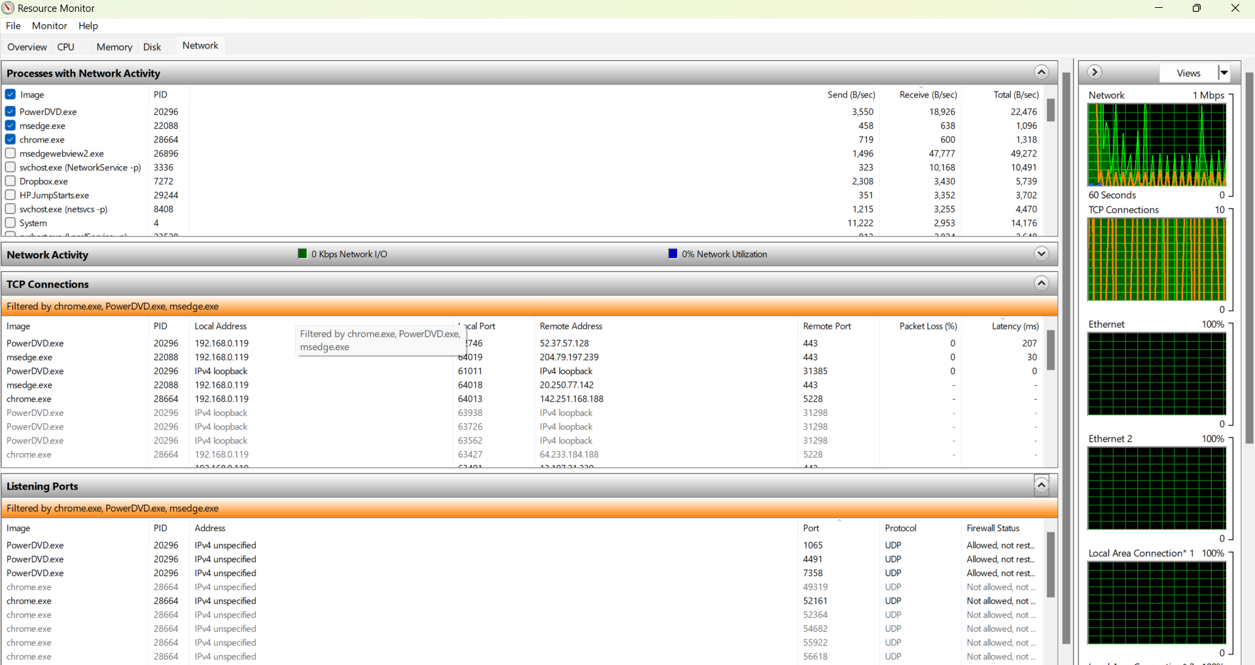

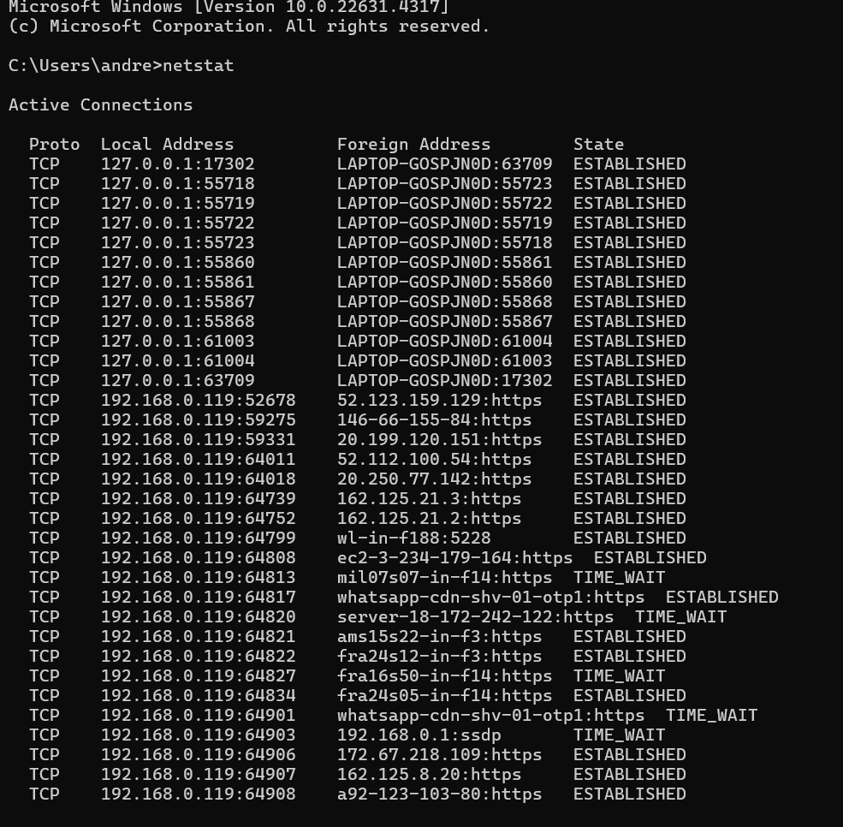

b) 