MANUSCRIPT DATA IDENTIFICATION FORM

[SGG / SP]

Please fill out this form on the computer and store it in the directory with your programs.

*Title:* **Association of Vitamin D level and maternal gut microbiome during pregnancy: Findings from a randomized controlled trial of antenatal vitamin D supplementation**

Senior Author: Kathleen Lee-Sarwar, Yang-Yu Liu

*Authors:* Andrea Aparicio, Diane R. Gold, Scott T. Weiss, Augusto A. Litonjua, Kathleen Lee-Sarwar, Yang-Yu Liu

*Date:* 02/15/2023

***Directory of Analysis:*** /udd/spaap/Projects/Maternal_Microbiome_VitD/msPackage/codePackage/main.R

***ChanGit Repository OR LabArchive Project:***

https://changit.bwh.harvard.edu/spaap/MaternalMicrobiome_VitaminD

/udd/spaap/Projects/Maternal_Microbiome_VitD/msPackage/

Table/Figure # Program Name Date of Run

|  |  |  |
| --- | --- | --- |
| Fig.1 | main.R, other_plots.R | 02/15/2023 |
| Fig2.a | main.R, plots_alpha_diversity.R | 02/15/2023 |
| Fig2.b | main.R, plots_beta_diversity.R | 02/15/2023 |
| Fig2.c | main.R, plots_alpha_diversity.R | 02/15/2023 |
| Fig2.d | main.R, plots_beta_diversity.R | 02/15/2023 |
| Fig3.a | main.R | 02/15/2023 |
| Fig3.b-c | main.R, other_plots.R | 02/15/2023 |
| FigS1.a | main.R, other_plots.R | 02/15/2023 |
| FigS1.b | main.R, plots_alpha_diversity.R | 02/15/2023 |
| FigS1.c-d | main.R, plots_beta_diversity.R | 02/15/2023 |
| FigS2 | main.R, other_plots.R | 02/15/2023 |
| FigS3 | main.R, other_plots.R | 02/15/2023 |
| Table 1 | main.R | 02/15/2023 |
| Table 2 | main.R | 02/15/2023 |
| Table S1 | main.R | 02/15/2023 |
| Table S2 | main.R | 02/15/2023 |

Data in Text(pg/para) Program Name Date of Run

|  |
| --- |
|  |
|  |
|  |
|  |

New Derived Variables Program Name Date of Run

|  |  |  |
| --- | --- | --- |
| vitDdiff | process_data.R | 02/15/2023 |
| vitDch | process_data.R | 02/15/2023 |
| ChBase | process_data.R | 02/15/2023 |
| baseC2 | process_data.R | 02/15/2023 |

Special Files Program Name Date of Run

|  |
| --- |
|  |
|  |
|  |

Study Documentation Files

|  |
| --- |
|  |
|  |
|  |

Programming Review by:

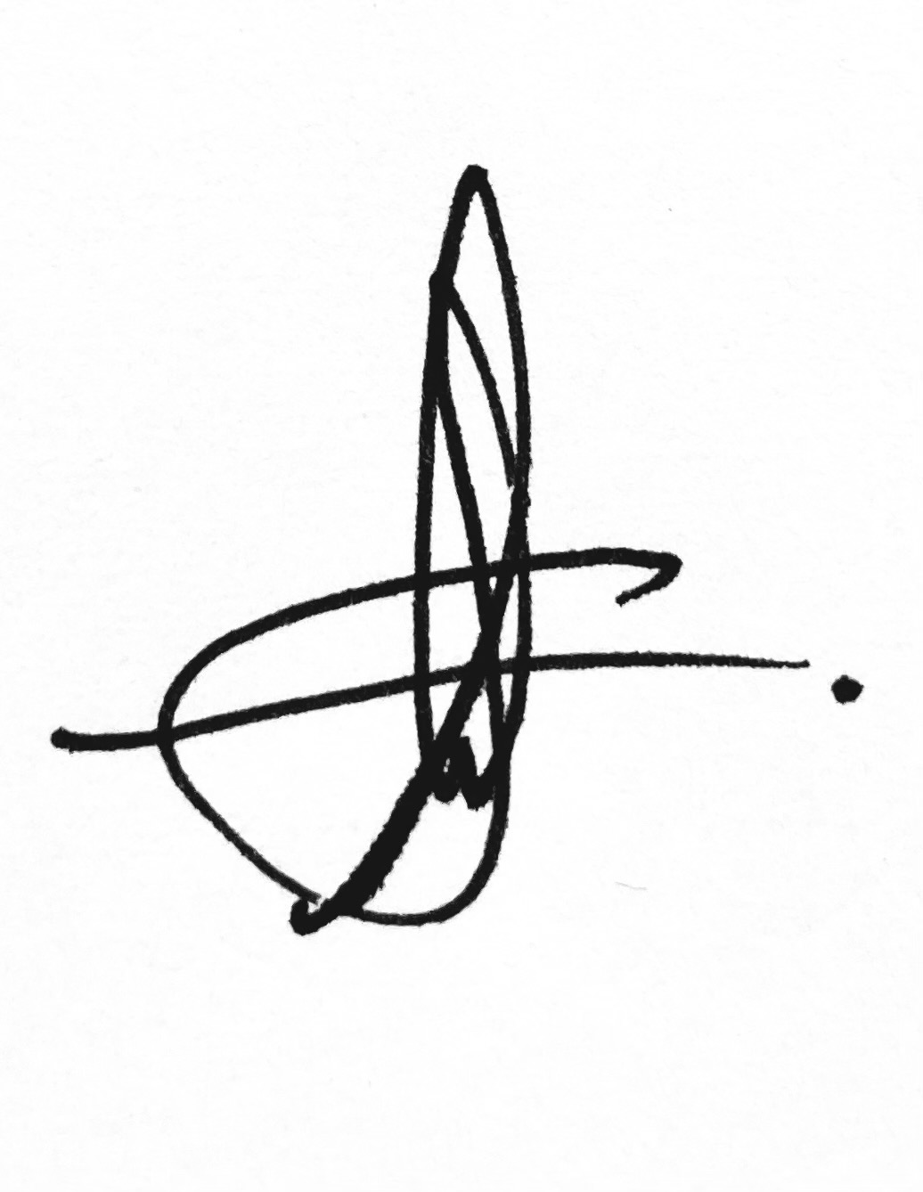

|  |  |  |  |  |
| --- | --- | --- | --- | --- |
| Andrea Aparicio Martinez |  |  |  | 02/15/2023 |

Programmer (Type or Print) Programmer (Signature) Date

|  |  |  |  |  |
| --- | --- | --- | --- | --- |
|  |  |  |  |  |

Investigator (Type or Print) Investigator (Signature) Date