Real-Time Bridge Monitoring

Design Description

Version 1.0

GENERAL REMARK: THIS DOCUMENT MUST EVOLVE DURING PROJECT WORK (AS YOUR UNDERSTANDING OF PRODUCT GROWS) AND ITS LATEST VERSION MUST REFLECT THE CURRENT STATE OF DESIGN !!! (DELETE THIS NOTE FROM PUBLISHED DOCUMENTS ☺)

Revision History

Date | Version | Description | Author
2002-00-00 | 0.01 | Initial Draft
2013-11-04 | 1.0 | First version of Design | Andrea Bottoli, Lorenzo Pagliari, Marko Brčić, Ghazal Shojaee

Table of Contents
1. Introduction 4
1.1 Purpose of this document 4
1.2 Intended Audience 4
1.3 Scope 4
1.4 Definitions and acronyms 4
1.4.1 Definitions 4
1.4.2 Acronyms and abbreviations 4
1.5 References 4
2. Software architecture 4
2.1 Conceptual design 4
2.1.1 Design component 1 5
2.1.2 Design component 2 5
2.2 System specification 5
2.3 External Components 5
3. External interfaces 5
3.1 Hardware Interfaces 5
3.2 Software Interfaces 5
3.3 Communication Interfaces 5
3.4 User Interfaces 5
4. Detailed software design 6
4.1 Implementation modules / components 6
4.1.1 Structured view 6
4.1.2 Deployment 6
4.2 Data flow / Interactions / Dependencies 6
4.3 Data Types / Formats 6
4.4 Database Model 6
4.5 Web site organization 6
4.6 Protocols 6
4.7 Interfaces to External Systems 6
4.8 Algorithms 7
4.9 Other section(s) necessary to describe some aspect of product design 7

Introduction
Real-Time Bridge Monitoring is a project for the Distributed Software Development course held by Politecnico ti Milano, Malardalen University and University of Zagreb.

Purpose of this document
The purpose of this document is to assist in the development of the project 'Real-Time Bridge Monitoring”, as a part of the Distributed Software Development course. This document specify the entire architecture and design of the “RTBM”-Software. These design decisions directly relate to the requirements, use-cases, attributes and interfaces of the system, as they are mentioned in the Software Requirements Specification document.

Purpose of the software design document. At what phase of the project work is this document defined, and revised. When its contents should be frozen? What other documentation and product artifacts are based on this document?

Intended Audience
This document is written mainly for the developer team. It will assist the team during the development-phase and will be updated, if any design-decision will be changed.

Define who and why should use this document, in what phases of the project work?

Scope
Define what will be covered by this document? What artifacts/functionality/software product(s) (in general) shall be covered by this document and what shall not (is not part of the developed project). What the product(s) will do and will not do. Describe the application of product(s), objectives, benefits of their use (in short!)

The scope of this document it to present the overall architecture, then go into the details of each model, interface, technology that we used

Definitions and acronyms

Definitions

Keyword | Definitions
Real-Time Bridge Monitoring | Project Title
Web App | The web application of the project

Acronyms and abbreviations

Acronym or  abbreviation | Definitions
HTTP | Hyper Text Transfer Protocol
HTTPS | Hyper Text Transfer Protocol Secure
HTML | HyperText Markup Language
GUI | Graphical User Interface
AJAX | Asynchronous Javascript And XML
JSON | JavaScript Object Notation
MVC | Model View Controller
DB | Database

References

The main reference to this project is:
www.fer.unizg.hr/rasip/dsd/projects/real-time_bridge_monitoring

Other useful references:
- Project Plan: http://www.fer.unizg.hr/_download/repository/Project_Plan_v1.1.pdf

Software architecture

Conceptual design
Identify components that constitute the developed system and external components/systems that surround the developed system. Use diagram(s) to depict the components (and subcomponents?), external components/systems, their interactions, and clearly mark the border between system components and external components/systems not belonging to the developed system. Briefly describe the system design and rationale behind such a design (alternatives?). Briefly describe the deployment of system components on hardware resources (servers, handhelds, PC-s etc.), present a diagram.

“RTBM”-Software will mainly consists of four components: a web-service, a calculation-engine, a database and parsing script.

SensoreDataParser
The data from the sensors are delivered as raw text-files. These text-files has to be parsed and written into the database. During this process the script will detect and compensate inconsistent data. This script will be automatically running in certain intervals.
The script will be divided into four submodules:
- The parsing-submodule will parse the data-files
- The consistence-check will validate the read data and patch inconsistency
- The SQL-submodule will write all data into the database.

This component required access to the data-files and the database. The format of the required data-files will be described in chapter 8.

How to deal with Photos, we have to create certain Videos, writing Meta-Data to DB etc.

MySQL-Database
As Database we will use MySQL. The Database will, except of the media-data like photos and videos, contain all necessary data of the software. These data are:
- the raw-data from the sensors
- the pre-calculated sensore and danger-level data
- user-data
- assistance-data for the SensorDataParser

The database model will be descriped detailed in Chapter 9.

Calculation-Engine
The Calculation-Engine will the main-part of the software. It will process the calculations of the danger-level and other additional parameters based on the raw-data from the database. The calculations will be performed in certain time-invtervalls. The calculated results will be stored in the database. The performed calculation will be described in chapter 4.8.

Webservice
The webservice will present all data to the user. It will be the only way how the user interact with the system. To use the webservice the user will use a common browser.

Please discribe a good structure of the webservice..

Should we introduce MVC-Pattern, include template System, etc...

System specification

Describe technologies used for each component of the product, and technologies/platform the product relies on for proper operation. For example, operating systems/platforms for hosting different product components (for example Debian for server component, windows7 for clients), programming languages/platforms (Java, c++, python), drivers etc.

Linux Debian 6.0

Java
Python

External Components
Describe external / COTS components that will form the integral part of the product, but will not be developed as part of the product development effort. For example RDBMS system (name, version etc.), third party libraries, drivers, components, GUI components, frameworks, web servers etc.

Apache with Tomcat
Cron
MySQL

External interfaces
This section should provide an overview of interfaces for communication between the product and the systems/entities/humans outside the system borders. Communication interfaces among components of the system should not be described in this section.

Hardware Interfaces
Describe hardware interfaces/resources the product requires to function, for example access to GPS positioning system data, to specific sensors, smart card readers , serial ports, indoor navigation systems etc.

Nothing???
The system gathers values from some sensors and cameras:
- Anemometer: to measure wind speed and direction
- Hydrometer: to measure the water height
- Echo sonar: to measure the height of the bottom of the river and its changes
- Camera: two camera that periodically take a photo of the bridge

By the way this hardware part is out of our control and we can't manage the sensors, the camera and also the way which the data is gather and send to the system.

Software Interfaces
Existence of software interfaces the product will provide for communication with external (known, yet unforeseen?) systems (for example: web services, REST-style access to system, open data access etc.).

Communication Interfaces
Access to ZigBee or Bluetooth, NFC, 3G network …

User Interfaces
Describe various interfaces, their types and specifics the product is going to use to communicate with various user types (for example: web pages, touchscreen, gesture recognition, standard GUI on PC,). Describe, if any, specific properties of such interfaces, for example multi-language support etc.). Present initial designs of user interfaces (screenshots of android application GUI, design of web pages, example of information embedded within the Google Maps view etc.)

Detailed software design
This section must provide detailed insight into product structure and (intended) implementation. Delete unnecessary sections; add sections required to provide a complete and detailed design description for the developed product.

When describing detailed design, use the formal and graphical description methods as much as possible (E-R, UML diagrams in particular). Always provide rationale behind design decisions.

Implementation modules / components
Present all the main modules of the product, describe their functionality. Describe the rationale of such a design, used design patterns, layers etc.

Structured view
Present the main components of each implementation module (classes and interfaces using UML class diagram, sequence diagrams of interactions among components).

Deployment
Describe deployment of product modules. Explain the rationale behind the described deployment, compare to alternative deployments (if possible).

Data flow / Interactions / Dependencies
Describe data flows and interactions among components of the product, characteristics of the flows, data formats, communication mechanisms used (for example push/pull, REST, synchronous/asynchronous, remote procedure calls/message exchange etc.). Depict interactions with UML diagrams. Analyze dependencies (coupling) among components, how sensitive components are to changes in data formats/calls/changes in implementations of other components.

Data Types / Formats
As datasource for the Database adf.

There are three kind of inputs in two kind of formats:
- analog****.txt
- sonar*****.txt
- picture****.jpg

The analog file contains:
- Wind speed (unity measure mA)
- Distance between the Hydrometer and the level of water (unity measure mA)
- Wind direction (unity measure mA)
- Timestamp of the detection of the sample (Labview encode → see before)[decimals can be dropped]
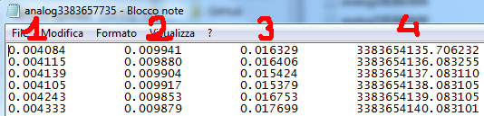

The sonar file contains 2 columns of values, offset of a line (fig.5):
- Distance between the sonar and the bottom of the river (unity measure meters)
- Timestamp of the detection of the sample (Labview encode → see before)
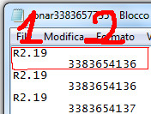

The images are two, one for each direction (Mantova – Modena):
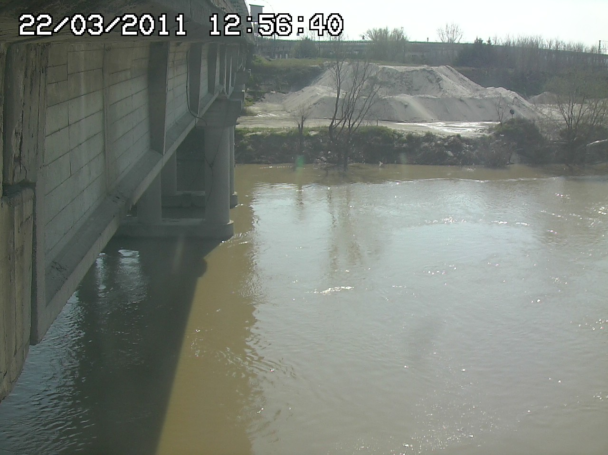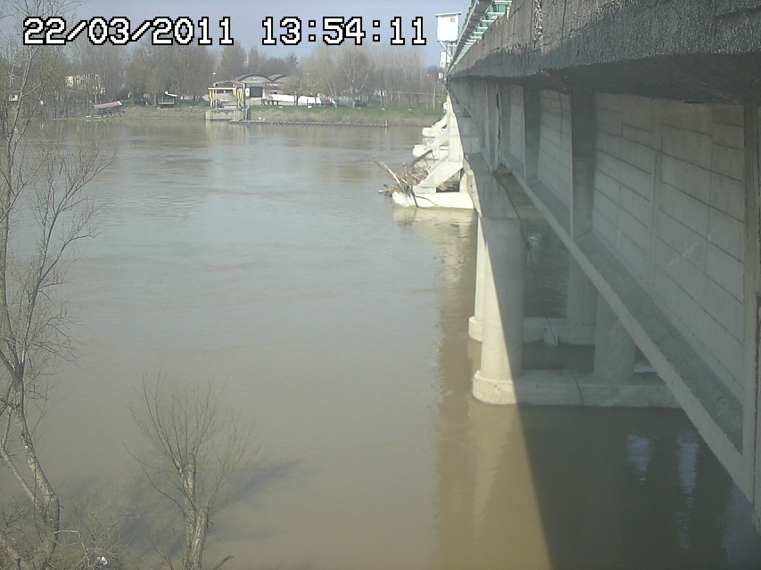
(Mantova) (Modena)

Database Model
Provide diagram(s) documenting the database schema, describe each table (rationale, data types), relation, view, index, stored procedure, trigger etc. Describe other DB artifacts needed for product implementation (drivers, database users and permissions etc.)

Web site organization
Organization of the web site, static and dynamic pages, scripts, configuration settings, security considerations etc.

Protocols
Describe custom protocols defined in the product (message types, message exchange - sequence diagrams, state diagrams, error handling etc.)

The protocols we use are http/https: for access to the web services by the users.

Interfaces to External Systems
Describe interfaces exposed by the product, functionality of those interfaces.

The only external interfaces of the system is the http

Algorithms
Description of key algorithms and their properties (for example, routing algorithm, recommender system etc.)

Other section(s) necessary to describe some aspect of product design

