1 Abstract
This document describes the design of RedditPix, an Android client for images for the reddit.com website.

2 Mockup
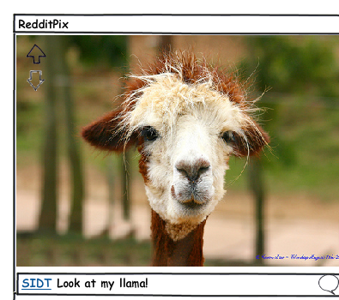

3 User scenarios

3.1 Display images
- the user launches the app
- the app displays at full screen the first image, with the OP and title
- the user scrolls right
- the app displays the next image

3.2 Up/downvote
- the app displays an image
- the user scrolls up/down
- the image is up/downvoted
- the arrow on the top/left is shown

3.3 Show comments
- the app displays an image
- the user clicks on the balloon icon
- the comments interface is shown

3.4 Choose subreddits
- the user opens the settings menu
- the user choose the subreddits menu item
- the subreddits selection dialog is shown

