Random Taco Cookbook

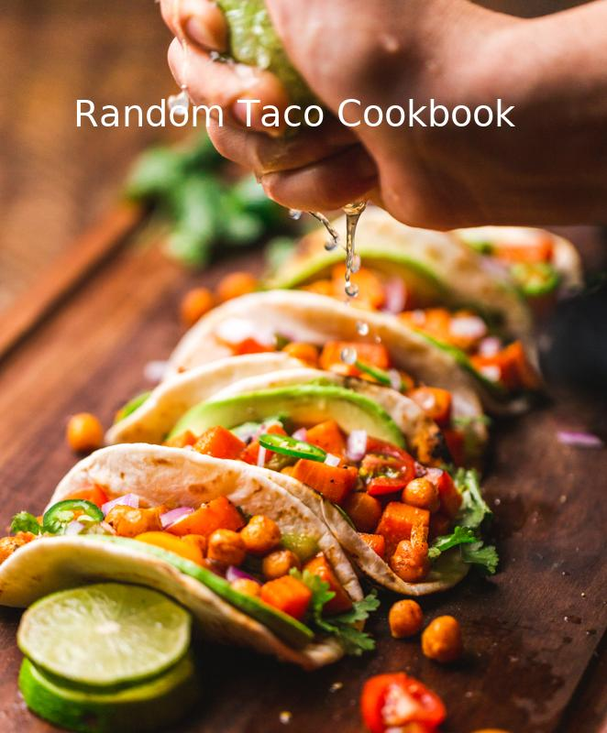

# Credits

• Taco image: Photo by Chad Montano on Unsplash

• Taco recipes from: https://taco-1150.herokuapp.com/random/?full_taco=true

• Code by Andrea Pratt

# Moroccan Lamb with Sriracha Salt, Cheese (Traditional; US) and Baja White Sauce in Fresh Corn Tortillas

#### Moroccan Lamb

Moroccan Lamb  
=============  
  
A Differently Spiced Meat Than Your Usual Taco  
----------------------------------------------  
  
* 500 g ground lamb  
* 20 g Ras al Hanout spice. My mix contains:  
 * Paprika  
 * Cinnamon  
 * Allspice  
 * Clove  
 * Toasted Mustard  
 * Cumin  
 * Caraway  
 * Black Pepper  
* 10 g fresh lemon zest or 10 g finely ground Black Lemon Omani (Moroccoan dried preserved lemon)  
  
Mix together and brown.

#### Sriracha Salt

Sriracha Salt  
=============  
  
I actually received this as a gift, but I found a recipe to make your own.  
  
__Ingredients__  
  
* 1 cup Salt  
* 10 tsp. Sriracha  
  
Mix the two ingredients together in a bowl. Spread it out on a baking sheet lined with foil or parchment paper. Put in a 200-degree oven, then turn the oven off and let it sit overnight inside. It will clump, but place in ziplock bag and attack it with a rolling pin. Tada!  
  
The effect on most food is as awesome as you'd expect but it is especially amazing with eggs. Add it to your breakfast tacos.

#### Cheese (Traditional; US)

Cheese (Traditional; US)  
======================  
  
A major flavor component of a traditional American taco, select a cheese that's firm and sharp.  
  
* Cheddar (shredded)  
* Jack/Pepper Jack (shredded)

#### Baja White Sauce

Baja White Sauce  
================  
  
This is a traditional white sauce for [Baja fish tacos](../full_tacos/baja_fish_tacos.md).  
  
* 1/4 cup mayo  
* 2 tbsp sour cream  
* 1 tbsp lime juice  
* 1/4 tsp celery salt (or garlic salt, etc)  
  
Mix, and refrigerate for an hour if possible.

#### Fresh Corn Tortillas

Fresh Corn Tortillas  
===================  
  
This is the only way to go. So worth it. Makes roughly 15 tortillas.  
  
* 1 3/4 cups masa harina  
* 1 1/8 cups water  
  
1. In a medium bowl, mix together masa harina and hot water until thoroughly combined. Turn dough onto a clean surface and knead until pliable and smooth. If dough is too sticky, add more masa harina; if it begins to dry out, sprinkle with water. Cover dough tightly with plastic wrap and allow to stand for 30 minutes.  
2. Preheat a cast iron skillet or griddle to medium-high.  
3. Divide dough into 15 equal-size balls. Using a tortilla press, a rolling pin, press each ball of dough flat between two sheets of wax paper.  
4. Place tortilla in preheated pan and allow to cook for approximately 30 seconds, or until browned and slightly puffy. Turn tortilla over to brown on second side for approximately 30 seconds more, then transfer to a plate. Repeat process with each ball of dough. Keep tortillas covered with a towel to stay warm and moist (or a low temp oven) until ready to serve.

# @deezthugs' Smokey Turkey Tacos with Mahi Mahi Rub, Corn Salad and Simple Salsa Verde in Hard Corn Shells (Traditional; US)

#### @deezthugs' Smokey Turkey Tacos

@deezthugs' Smokey Turkey Tacos  
===============================  
  
These tacos have and will blow minds.  
  
(Note: I cannot separate the base_layer here from the seasoning, it is all integral)  
  
* 2 Packages ground Turkey or Chicken (1.5 to 2 lbs) - not the lean stuff for Chrissake!  
* Several slices of cooked bacon, diced  
* 2 Tbs Coconut oil  
* 2 Tbs Bacon Grease. That's right, Bacon Grease. (What you don't keep it? Might as well just quit now)  
* 1 Medium sweet onion  
* (The following dry ingrediants can be increased depending on amount of meat)   
* 4 Garlic Cloves, smashed  
* 1 tsp Cumin  
* 2 tsp Onion powder  
* 1 tsp Chipotle powder (use as much as required)  
* 1 tsp (cool smokey) Paprika  
* 1 tsp Cinnamon  
* 1 tsp Ground Ginger  
* 1/2 - 1 tsp Black Pepper  
* 1 tsp Kosher Salt  
* 3 Limes, juiced  
* [optional] 1/2 can low-salt Chicken broth  
  
Combine all dry seasonings in bag, shake up and combine well with raw turkey meat. return to fridge for an hour or more.   
  
Melt the Bacon Grease over medium heat, add Coconut oil and diced onion, cook down till onions are, well, you know, awesome. Add the smashed garlic. Add the bacon. Add the turkey meat and break it down into medium/small bits with a spatula or butter knife. After cooking for a few minutes and the meat has begun to brown, drizzle 2 of limes' juice onto the meat.  
  
Cook well, adding optional chicken broth to shape the consistency as needed. (Generally not needed unless you accidentally buy low-fat meat. Shame on you.)  
  
Finally, transfer amount for a meal to a frying pan, frying for a few minutes to create some crispy bits (This is the key step:)), adding lime juice as it cooks. Spoon onto favorite tortillas add condiments and devour.

#### Mahi Mahi Rub

Mahi Mahi Rub  
==============  
  
A rub for Mahi Mahi, if fish tacos be what you're fancying:  
  
* 1 Part spicy chili powder  
* 1 Part salt  
* 1 Part ground cumin  
* 1/2 Part chopped cilantro  
* 1/2 Part cayenne  
* 1/2 Part pepper  
* 1/2 Part oregano  
* 1/2 Part onion powder  
* 1/2 Part garlic powder  
  
You choose your measurements and enjoy!

#### Corn Salad

Corn Salad  
==========  
  
* 2 Ears of corn  
* 1 Lime, juiced  
* Small handful of Cilantro, chopped  
* A few green onions, chopped  
* Garlic salt, or Garlic AND salt. I use Trader Joe's Garlic Salt in the grinder usually.   
  
Cut the corn off of the cob, and in a mixing bowl mix together corn, lime juice, chopped cilantro and garlic salt. You can tweak any of this stuff as desired.  
  
---  
This is my first Github commit. I'm glad it's taco related.

#### Simple Salsa Verde

Simple Salsa Verde  
==================  
  
I got this base recipe from a vegan friend. If you can't find one of these peppers, swap in another one!  
  
* 6 Average-sized tomatillos  
* 1 Poblano pepper  
* 1 Serrano pepper  
* 1 Jalapeno pepper  
* 1 Sweet red pepper  
* Juice of 1 or 2 fresh-squeezed limes (to taste)  
* Pinch or two kosher salt (to taste)  
  
You're in charge of the heat here. For a milder salsa, remove all the ribs and seeds inside the peppers. For medium, leave in a few ribs, and for hot, go nuts. Rough chop the peppers and tomatillos, then throw into a blender or food processor with salt and lime juice. Pulse to desired consistency.  
  
As with most salsas, this will taste better if you let it sit in the fridge for a few hours before eating. It's great on chips or drizzled over steak or pork tacos.

#### Hard Corn Shells (Traditional; US)

Hard Corn Shells (Traditional; US)  
======================  
  
Mistakenly thought by many to be traditionally Mexican, hard shells were actually popularized in the US in the mid-20th century.  
  
While they can certainly be made at home (if you have access to a deep-fryer), the best method of obtaining hard taco shells is to head to the grocery store.

# Better Than Powder Groundbeef with Packaged Seasonings, Veggies for Fish Tacos and Phoning it in Pico de Gallo in Hard Corn Shells (Traditional; US)

#### Better Than Powder Groundbeef

Did you grow up on Old El Paso ground beef taco seasonings?  
  
I'm sorry. So did I. They're terrible, right? Here's something better:  
  
Dice a half-onion, sautee and season liberally with salt, pepper, and ground cumin.  
  
Brown a pound of ground beef, seasoning liberally with ground cumin, salt, pepper. Add tabasco/other hot sauce if you like.  
  
When beef is browned, add a small jar of salsa (any kind! i like corn/black bean tomato salsa), and simmer for 5-10 minutes.  
  
Enjoy. Serve with crispy taco shells for nostalgia.

#### Packaged Seasonings

Packaged Seasonings  
==============  
  
Lest we be accused of snobbery, let's acknowledge that a taco is a taco, and taco night can be well-served by not having to think at all.  
  
Feel free to use the pre-packaged seasoning of your choice. When I'm in an old-school mood, I head straight for...  
  
* Old El Paso Taco Seasoning

#### Veggies for Fish Tacos

Veggies for Fish Tacos  
======================  
  
Fish tacos are a special breed, requiring different vegetable options.  
  
__Assemble your veg from the following options:__  
  
* Cabbage, purple, shredded  
* Cabbage, other shades, shredded  
* Radishes, sliced into thin slices  
* Red peppers, diced  
* Cherry tomatoes, sliced (if you're a heathen)  
* Cilantro, if it doesn't taste like soap to you  
  
And one requirement:  
* Limes, sliced for juicing over tacos.  
  
Place out your selections and assemble into your taco. Then squeeze a lime over the top.

#### Phoning it in Pico de Gallo

Phoning it in Pico de Gallo  
===========================  
  
_Super Quick & Easy Pico_  
  
  
* 1 pint grape tomatoes, quartered (make your kids do this part)  
* 3 tablespoons finely chopped white onion  
* Coarse salt  
* Squeeze of lime  
* As many finely chopped red (or green) jalapeños as you want (optional)  
  
Combine the tomatoes, cilantro and onion together in a bowl. Season to taste with salt and lime.  
  
Reserve some of this mixture for kids, and then add as much jalapeño as you like to the remaining mixture for the non wimps.

#### Hard Corn Shells (Traditional; US)

Hard Corn Shells (Traditional; US)  
======================  
  
Mistakenly thought by many to be traditionally Mexican, hard shells were actually popularized in the US in the mid-20th century.  
  
While they can certainly be made at home (if you have access to a deep-fryer), the best method of obtaining hard taco shells is to head to the grocery store.