##### ---1.创建学生表student----

create table student

(

id char(3) primary key not null,

name varchar2(20),

age number,

sex char(3) check (sex = '男' or sex = '女')

);

##### ---2.创建考试科目表subject---

create table subject

(

id char(4) primary key not null,

subject varchar(20),

teacher varchar(20),

description varchar(50)

);

alter table subject modify (teacher varchar(100));

##### ---3.创建成绩表score---

create table score

(

id number primary key not null,

student_id char(3) references student(id),

subject_id char(4) references subject(id),

score decimal

);

##### ---4.学生表插入数据---

insert into student values ('001', '张三', 18, '男');

insert into student values ('002', '李四', 20, '女');

##### ---5.考试科目表插入数据---

insert into subject values ('1001', '语文', '王老师', '本次考试比较简单');

insert into subject values ('1002', '数学', '刘老师', '本次考试比较难');

##### ---6.成绩表插入**数据**---

insert into score values (1, '001', '1001', 80);

insert into score values (2, '002', '1002', 60);

insert into score values (3, '001', '1001', 70);

insert into score values (4, '002', '1002', 60.5);

##### ---7.查询表的数据---

SELECT * FROM student;

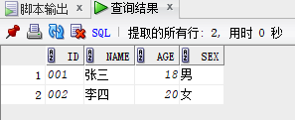

SELECT * FROM subject;

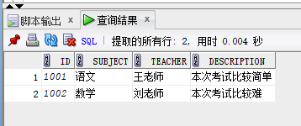

SELECT * FROM score;

