INTRODUCTION

This is the university project I worked on during the second semester of the 2018/2019 academic year for the “**Artificial** Intelligence for Video **Games**” exam.

This project represents the natural evolution of “Hypogeum” , a multiplayer driving / shooting / battle car game made with Unity for PC & Mac.

In the game, four teams of two players face each other in an enormous arena (called, in fact, Hypogeum), trying to defeat their enemies and be the last standing. Each team belongs to one of the four existing factions and is composed of two players from the same species, that represent the champions. The battles are fought on cars, with one player as driver and one as shooter, each of them equipped with a faction-specific weapon.

The teams, in addition to the other players, have to pay attention to the surrounding environment: different traps and NPCs could interfere with the battle and increase the difficulty of the match. However, the heroes are not alone: each team has its supporters in the audience and, through thrilling actions, can increase their excitement up to push them to help their favorites with useful power-ups.

Hypogeum participated to the New Game Designer 2019and won the “Best Multiplayer Game” and “EDI Special Award” awards.

SPECIFICS

The challenge and the purpose of this project are to develop a believable AI for enemies’ cars for several reasons:

* Fill the lobbies if there aren’t enough players;
* Substitute a disconnected driver player in order to let the shooter one continue his match;
* Play in a training mode with “bots” where players can explore the map and develop new skills and strategies;

MOVEMENT

To develop the movement of the cars I used the solutions presented by Professor Dario Maggiorini during the Artificial Intelligence for Video Games course, in particular the classes used are (slightly modified to fit at best with the underlying game):

* MovementStatus

Simple class representing the actual movement status of the object

* MovementBehaviour

Abstract class that works as an interface for the other behaviours

* DragBehaviour

Adds linear and angular drag

* FleeBehaviour

Responsible of the flee from an enemy

* SeekBehaviour

Responsible of chasing down something (an Object or a Player)

* AvoidBehaviourVolume

Takes care to avoid incoming obstacles

* DDelegatedSteering

Blends everything together

(mettere qualche immagine?)

DECISION MAKING

In order to develop a simple, effective and believable Decision Making system I adopted and combined 2 different techniques: Finite States Machines and Behaviour Trees.

For both I used again the code provided by professor Dario Maggiorini during the course.

FINITE STATES MACHINE

Since the actions a driver player can make are:

* Chase / Flee from the opponent car
* Pick an Instinct or Reason Coin
* Execute a Jump to increase the Audience Hype
* Moving around the map

I thought that a FSM was the technique that fitted best to describe the status of a car.

The FSM I built is very simple: there are 4 states and 8 transitions, with 2 states that are more common than the others, in particular Move around map is the base state where the FSM starts, and the natural return state when the actions in the other states are completed.

Attack, on the contrary, has the highest priority, in fact if the car detects an enemy in its range, no matter what it’s doing, it leaves immediately the current state and enters the Attack state.

Pick Coin refers to the game mechanic that allows players to choose between a Reason and an Instinct coin, that when taken boost different statistics of the car.

Jump For Hype is another game mechanic that is about doing stylish moves, such as jumps and drifts, to raise the Hype of the Audience, and when the Hype bar is full, it will throw a power-up to the team.

To cycle between the states I used a coroutine that awakes every 0.5 seconds and checks if in the current state there are Transitions to be fired.

BEHAVIOUR TREES

Each state of the FSM has an associated BT describing the actions the car has to do to reach its goal and to act in a believable way.

Since the code provided from professor Dario Maggiorini is coroutine compliant and BTs keep track of the “state” they arrived, the solution FSM + BTs required some work to actually run correctly.

In fact just stopping and restarting the specific BT’s coroutine wasn’t enough, so I figured out that the whenever the car leaves a state and enters in a new one in the FSM, the old state’s BT must be rebuilt to erase the memory and let the car executing it again, when it’s needed, from the beginning.

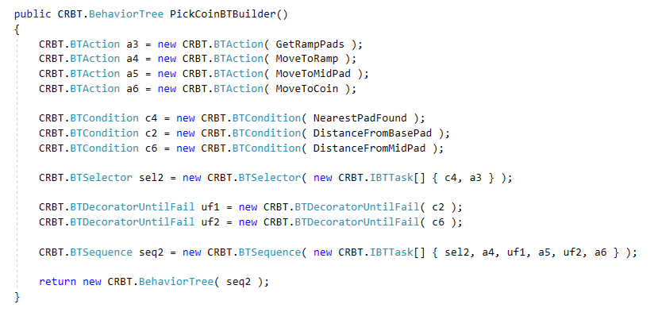

Figure : example of the creation of a Behaviour Tree

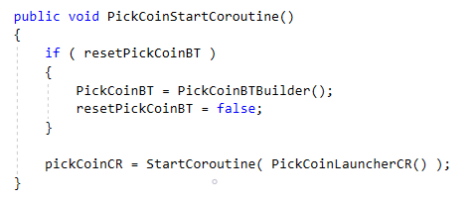

Figure : method starting the coroutine specific to the BT

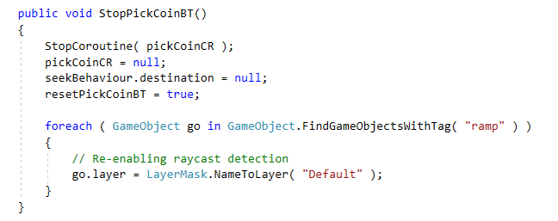

Figure : method stopping the coroutine and setting the boolean value resetPickCoinBT to true, in order to build it back again

MOVE AROUND THE MAP

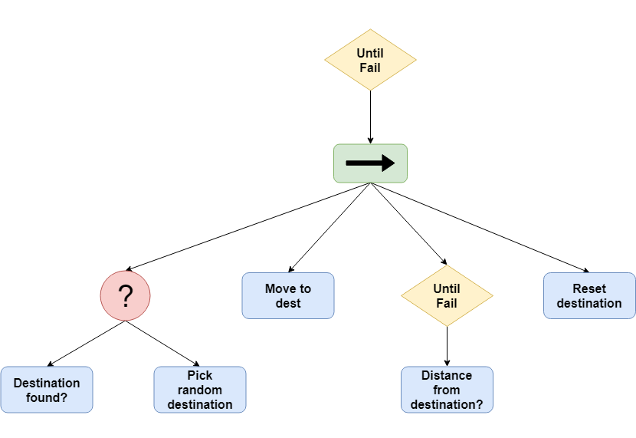

Figure : Move around the map BT scheme

Since all the BTs are launched in the FSM states entry actions and Move around the map must be repeated until another state is entered, except for “Destination found?” condition, the other tasks cannot return false, making the BT a loop, thanks to the Until Fail at the top.