General information

Team name: Lama

Team members: Andrea Carrarini, 927539

Loris Cerrato, 894173 Polimi

Andrea De Cosmo, 939930

Michele Maione, 931468

__________________________________

# Your “constraints”

Card(s): – Both

Game Genre(s): Action: Shooter – Sport/Simulation: Racing – Both

“Time”: Future

Player mindset: Mid-core

Bartle’s type: Killer

Mode: Multiplayer

__________________________________

Game Design – part 1: concept

Concept: Hypogeum

Logline: Choose your side, race against your opponents and defeat them for the supremacy!

## Introduction

Since humans had left the Earth, centuries have passed and the blue Planet is now inhabited only by the animals, that have learned to manage the technology of our descendants and to create their own. From that moment, a long war among the different species has taken act, to establish which was the best one. Inspired by the ancient books on “mythology”, they decided to set their battles in a huge arena: the Hypogeum. Rather than kill each other in “primitive” ways, they clashed each other using different cars, depending on the species they belong. Now, only four teams have left – Eagles, Lions, Rhinos and Sharks – and the outcome is more uncertain than ever. Who will be the audience’s favourite? Who will win the war? And, most important, who will obtain the supremacy?

## Description (of the game)

In a huge arena, teams of 2 players (where one is the driver and the other is the shooter) face each other in a car-shooting battle.

The goal is to destroy the enemies and to be the last standing species in the battlefield but, to further worsen the situation, the players must pay attention to traps, enemies and unexpected events that may occur.

Even the audience has an important role: randomly or not, it can influence the outcome of the battle, dropping power-ups or maluses that can be collected and used by the teams.

## Key features

The game is based on the synergic collaboration between the players (of same team) that have to face, at the same time, both the environment (traps, obstacles, enemies and unexpected events) and other player that from their part try to kill them.

Depending on the chosen species, each team has its unique skills, weapons, cars and abilities that can use during the battle. Players’ actions may even involve the audience, rising its hype and obtaining rewards or punishments.

Periodically, the different species compete for supremacy and exclusive rewards.

Platform(s): PlayStation 4, Xbox One X, Nintendo Switch, PC

Concept Art

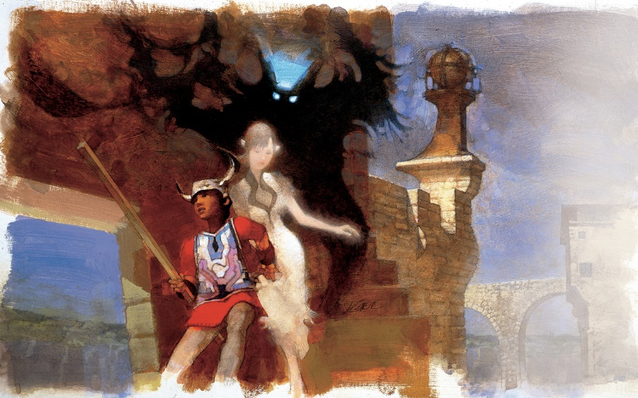(…. Optional FOR CURRENT RELEASE, MUST BE INCLUDED IN THE FINAL RELEASE OF THE CONCEPT!)

Notes

Game Design – part 2: formal and dramatic elements

Try to describe the game you are conceiving in terms of:

## Formal elements

1. Players

------------------------------------------------------------------------------------------------------------------------------------------------------------------------------------------------------------------------------------------------------------------------------------------------------------------------------------------------------------------------------------------------------------------------------------------------------------------------------------------------------------------------------------------------

1. Objectives

------------------------------------------------------------------------------------------------------------------------------------------------------------------------------------------------------------------------------------------------------------------------------------------------------------------------------------------------------------------------------------------------------------------------------------------------------------------------------------------------------------------------------------------------

1. Procedures

------------------------------------------------------------------------------------------------------------------------------------------------------------------------------------------------------------------------------------------------------------------------------------------------------------------------------------------------------------------------------------------------------------------------------------------------------------------------------------------------------------------------------------------------

1. Rules

------------------------------------------------------------------------------------------------------------------------------------------------------------------------------------------------------------------------------------------------------------------------------------------------------------------------------------------------------------------------------------------------------------------------------------------------------------------------------------------------------------------------------------------------

1. Resources

------------------------------------------------------------------------------------------------------------------------------------------------------------------------------------------------------------------------------------------------------------------------------------------------------------------------------------------------------------------------------------------------------------------------------------------------------------------------------------------------------------------------------------------------

1. Conflict

------------------------------------------------------------------------------------------------------------------------------------------------------------------------------------------------------------------------------------------------------------------------------------------------------------------------------------------------------------------------------------------------------------------------------------------------------------------------------------------------------------------------------------------------

1. Boundaries

------------------------------------------------------------------------------------------------------------------------------------------------------------------------------------------------------------------------------------------------------------------------------------------------------------------------------------------------------------------------------------------------------------------------------------------------------------------------------------------------------------------------------------------------

1. Outcomes

------------------------------------------------------------------------------------------------------------------------------------------------------------------------------------------------------------------------------------------------------------------------------------------------------------------------------------------------------------------------------------------------------------------------------------------------------------------------------------------------------------------------------------------------

## Dramatic Elements

1. Challenge

------------------------------------------------------------------------------------------------------------------------------------------------------------------------------------------------------------------------------------------------------------------------------------------------------------------------------------------------------------------------------------------------------------------------------------------------------------------------------------------------------------------------------------------------

1. Play

------------------------------------------------------------------------------------------------------------------------------------------------------------------------------------------------------------------------------------------------------------------------------------------------------------------------------------------------------------------------------------------------------------------------------------------------------------------------------------------------------------------------------------------------

1. Premise

------------------------------------------------------------------------------------------------------------------------------------------------------------------------------------------------------------------------------------------------------------------------------------------------------------------------------------------------------------------------------------------------------------------------------------------------------------------------------------------------------------------------------------------------

1. Character(s)

------------------------------------------------------------------------------------------------------------------------------------------------------------------------------------------------------------------------------------------------------------------------------------------------------------------------------------------------------------------------------------------------------------------------------------------------------------------------------------------------------------------------------------------------

1. Story

------------------------------------------------------------------------------------------------------------------------------------------------------------------------------------------------------------------------------------------------------------------------

------------------------------------------------------------------------------------------------------------------------------------------------------------------------------------------------------------------------------------------------------------------------